**INTERNSHIP REPORT**

**ON**

# PYTHON COMPITATIVE CODEING

**A internship Report is submitted**

**In accordance with requirement of degree of**

**BACHELOR OF TECHNOLOGY**

**IN**

**COMPUTER SCIENCE AND INFORMATION TECHNOLOGY**

Submitted by

N.NagaVinay

21KQ1A0748

Under the Mentorship of

## M.SRAVAN KUMAR



**DEPARTMENT OF COMPUTER SCIENCE AND**

**INFORMATION TECHNOLOGY**

PACE INSTITUTE OF TECNOLOGY AND SCIENCES

(AUTONOMOUS)

(Affiliated to Jawaharlal Nehru Technological University Kakinada, Kakinada & Accredited by NAAC ‘A’ GRADE,An ISO 9001-2015 Certified Institution)

NH-16, Valluru Post , Prakasam District, A.P-523272.

Project title

(Rail connect pro)

Name: N.Nagavinay

Date:11-06-2024

**Abstract**:

The Data of the trains and people who is travelling with train everyday in IRCTC. different people has different comforts of travels depends on the money and their travelling destination.

Time also plays main role here. travelling times like morning and evening trains and destination trains

1. Passenger
2. Reservation
   * A/c Train
   * NonA/c Train
3. golden class
4. premium Tatkal

The IRCTC introducing new methods in travelling like Vande Bharath express in that train include of food.

**Description:**

Rail Connect Pro is a software solution designed to enhance the efficiency, and profitability of rail reservation operations. Whether you're managing freight, passenger, Rail Connect Pro provides comprehensive tools to reserve the seats of different classes with different prices, over the different trains trough different places.

**Requirments:**

* Train name and train number in database.
* Prices, timings of the particular trains.
* Distances through the places.

**Functional Requirements**

User Registration and Authentication

* Sign Up: Allow new users to create an account with personal details and credentials.
* Login: Enable existing users to log in using their credentials.
* Train Information Management
* Add/Update Trains: Admins can add new train schedules or update existing ones.
* View Train Schedules: Users can view available train schedules and details.
* Search and Booking
* Search Trains: Users can search for trains based on date, time, origin, and destination.
* View Availability: Display available seats and ticket classes.
* Book Tickets: Users can book tickets, select seats, and enter passenger details.
* Payment: Provide options for payment processing (e.g., credit card, digital wallet).
* Ticket Management
* Generate Ticket: Issue a ticket with details such as train number, date, time, seat number, and passenger details.
* Cancel Ticket: Allow users to cancel their reservations and process refunds.
* User Account Management Profile Management: Users can update personal information and view booking history.
* Password Management: Allow users to reset or change passwords.
* Notifications

**Security:**

Data Protection: Safeguard personal and payment information of users.

* Authentication and Authorization: Ensure that only authorized users can access certain functionalities.
* User-Friendly Interface: Design intuitive interfaces for both passengers and administrators.
* Accessibility: Ensure the system is accessible to users with disabilities.
* Reliability
* System Availability: The system should be available with minimal downtime.
* Error Handling: Provide meaningful error messages and handle exceptions gracefully.

**Maintainability:**

* Modular Design: Ensure the code is modular for easy updates and maintenance.
* Documentation: Provide comprehensive documentation for both the system and codebase.
* Regulations: Comply with relevant legal and industry regulations, such as data privacy laws.

**Benefits for Passengers:**

1. **Convenience and Accessibility**
   * 24/7 Access: Passengers can book tickets anytime from anywhere using online platforms.
   * Ease of Use: Simple and user-friendly interfaces make booking straightforward without needing to visit physical counters.
2. **Time Efficiency**
   * Quick Search and Booking: Fast search options and streamlined booking processes reduce the time spent on finding and booking train tickets.
   * Instant Confirmation: Immediate confirmation of booking ensures peace of mind for travelers.
3. **Real-Time Information**
   * Live Seat Availability: Passengers can view real-time seat availability and make informed choices.
   * Schedule Updates: Users receive up-to-date information on train schedules, delays, or cancellations.
4. **Enhanced Choice**
   * Seat Selection: Ability to choose preferred seats or classes.
   * Multiple Payment Options: Support for various payment methods such as credit/debit cards, digital wallets, or net banking.
5. **Cost Savings**
   * Promotions and Discounts: Access to online-exclusive promotions, discounts, and loyalty rewards.
6. **Booking Flexibility**
   * Cancellation and Modification: Easy cancellation and modification of bookings as per user needs.

**Benefits for the Environment and Society:**

1. **Reduced Carbon Footprint**
   * Less Paper Use: Digital processes minimize the need for paper, supporting environmental conservation.
   * Efficient Travel Planning: Encourages the use of trains over less environmentally friendly travel options.
2. **Enhanced Mobility**
   * Accessibility for All: Makes train travel more accessible to a wider range of passengers, including those in remote areas or with limited mobility.

**Flow Example:**

1. **Input Locations:**
   * User enters "ongole" in "From" and "Chennai" in "To."
2. **Search Trains:**
   * User searches for trains on June 15, 2024.
   * The system lists available trains.
3. **Book Tickets:**
   * User selects Train #101, chooses 3 seats.
   * Enters passenger details, makes a payment.
4. **Update Counters:**
   * The system reduces available seats from 50 to 47.
   * Booking confirmation is sent to the user.

#### **Future Enhancements:**

1. **Real-Time Updates**: Integration with real-time train tracking systems to provide live updates on train schedules and delays.
2. **Mobile Application**: Developing a mobile app version for greater accessibility and ease of use.
3. **Personalization**: Adding features like booking history, recommendations based on past travels, and loyalty programs.

#### **Technical Aspects:**

* **User Interface**: A user-friendly interface enhances the user experience, making navigation and interaction intuitive and efficient.

#### **Key Features:**

1. **User Authentication**: The system includes secure user registration and login mechanisms, ensuring that only authorized users can access booking functionalities.
2. **Train Schedule Management**: Users can view available train schedules, including departure and arrival times, which facilitates informed booking decisions.
3. **Ticket Booking**: The core feature allows users to search for trains, select desired routes, and book tickets with options for seat selection.
4. **Payment Integration**: Secure payment processing is incorporated, providing multiple payment options to users for convenience.
5. **Booking Confirmation**: Upon successful payment, users receive a booking confirmation with ticket details, ensuring clarity and transparency.

#### **Sorting Methods**

**Purpose**: Sorting is crucial for organizing data such as train schedules, available seats, or booking records. This enhances user experience by presenting information in an ordered manner.

1. **Python's Built-in Sort (sort() and sorted())**:
   * **Usage**: The system uses Python’s built-in sort() method for in-place sorting of lists or the sorted() function to return a new sorted list.

**Custom Sorting**:

1. Usage: For more complex sorting criteria, custom sorting logic is implemented using lambda functions or comparator functions.

#### **Loop Methods:**

**Purpose**: Loops facilitate iterating over data collections to perform tasks such as searching for available trains, updating booking statuses, or generating reports.

1. **for Loops**:
   * **Usage:** The for loop is extensively used for iterating over lists, dictionaries, or ranges. It is applied in scenarios like displaying available trains, processing booking requests, and generating reports.

**Approach:**

### 1. ****Define Requirements and Features****

#### Core Features

* **User Registration and Login**: Secure user authentication.
* **Train Search**: Find trains by source, destination, and date.
* **Seat Availability**: Check availability of seats.
* **Booking Tickets**: Book seats on available trains.
* **Cancellation**: Cancel booked tickets.
* **Payment Processing**: Integration of a simple payment system.
* **Ticket Printing**: Provide an option to print or save the ticket.
* **Admin Panel**: For managing trains, schedules, and monitoring bookings.

### 2. ****Design the System****

#### Components

* **Database**: To store users, trains, bookings, etc.
* **Backend Logic**: Handle the business logic.
* **Frontend**: User interface (console-based, GUI using Tkinter, or web-based using Flask/Django).

#### Database Schema

* **Users**: user_id, username, password, email, phone
* **Trains**: train_id, train_name, source, destination, departure_time, arrival_time, total_seats, available_seats
* **Bookings**: booking_id, user_id, train_id, booking_date, seat_numbers, status
* **Payments**: payment_id, booking_id, amount, payment_date.

### 4. ****Develop the System****

#### **Database Setup**

* Create tables for Users, Trains, Bookings, and Payments.
* Initialize with some train data.

**Program:**

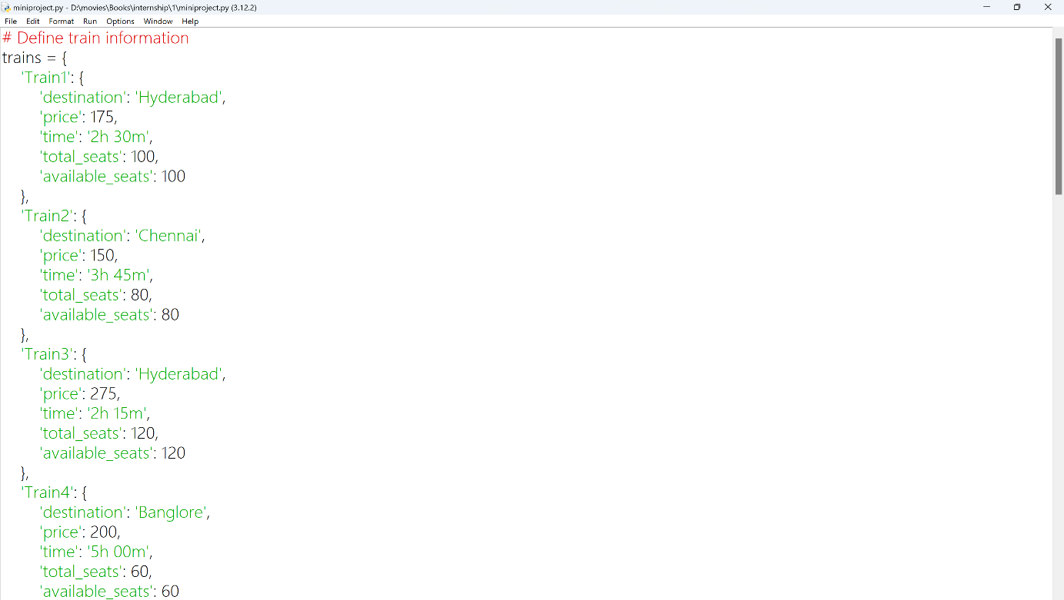

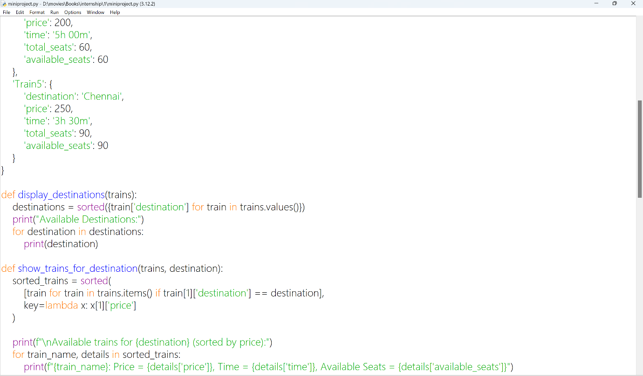

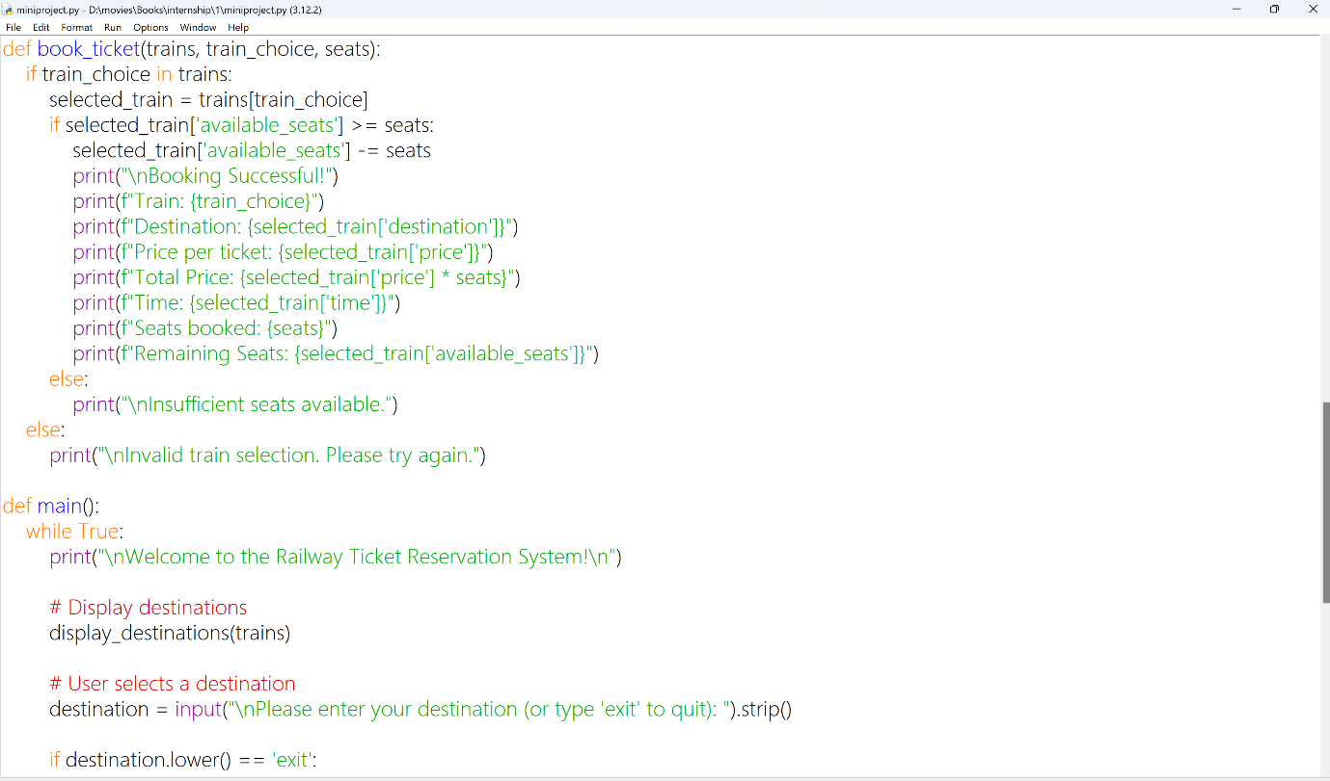

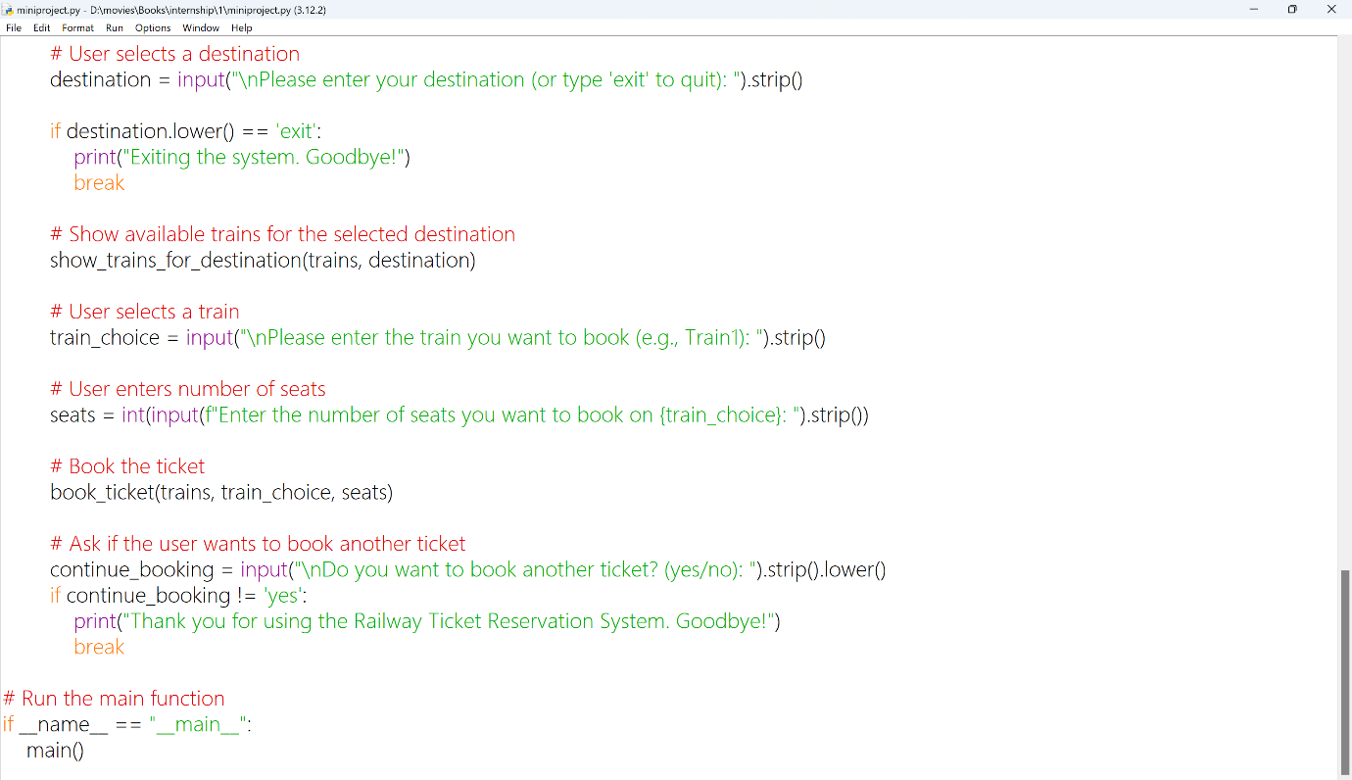

**Output:**

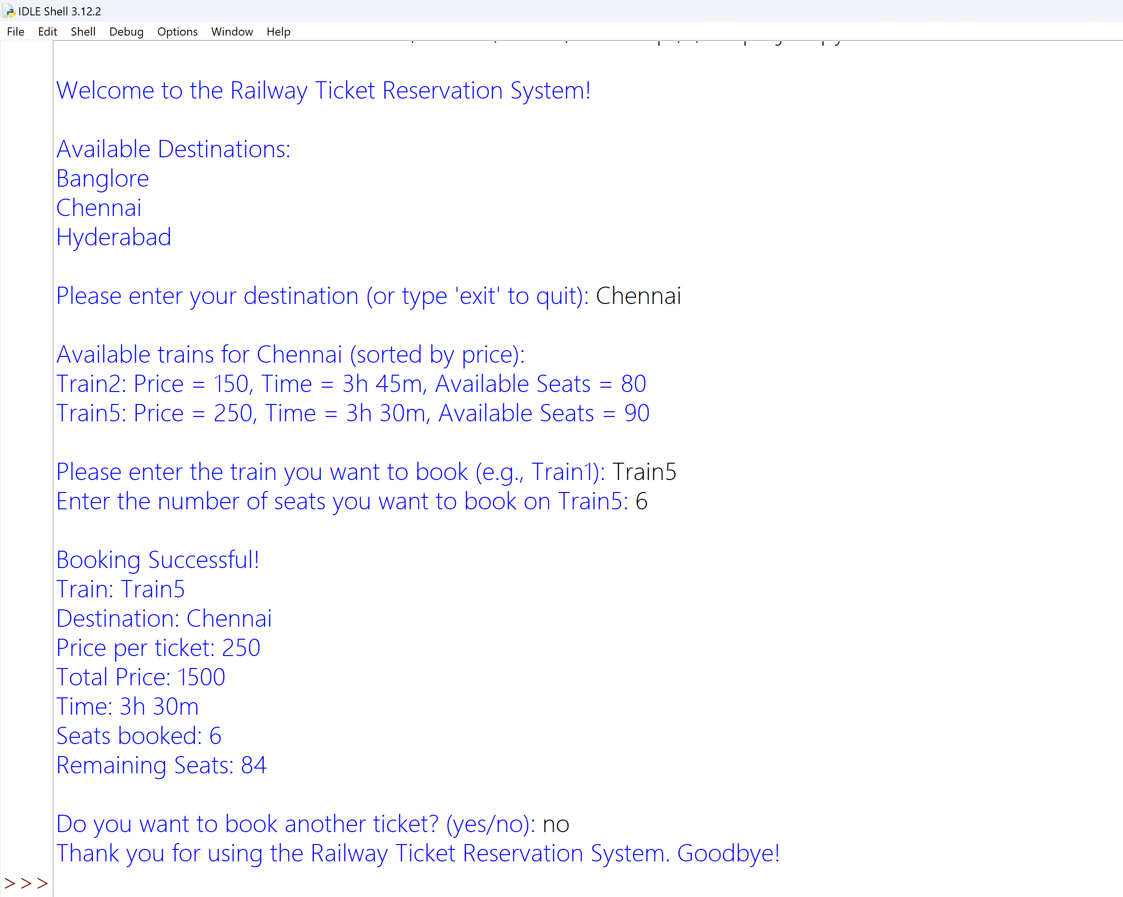

**Conclusion:**

The railway ticket booking system serves as a comprehensive solution for the modern needs of railway ticket reservations, combining ease of use, security, and efficiency. Its scalable and adaptable design ensures that it can evolve with advancements in technology and changes in user requirements, making it a robust choice for railway ticketing needs.