Understanding Data Engineering Foundations and Getting Started with Databricks

Introduction
What Happens Before a Dashboard Shows an Insight?
Imagine ordering food through an online delivery application.
You select a restaurant, place your order, make a digital payment, and track your delivery. Within seconds, the application records information about your order, payment, restaurant, delivery partner, and estimated delivery time.
Now imagine millions of customers doing the same thing every day.
Where is all this information stored? How does the company identify its best-selling restaurants? How does it calculate delivery times? How can it determine why revenue decreased last month?
The answer involves more than just collecting data.
Before businesses can turn raw information into meaningful insights, they need systems that collect, process, validate, organize, and deliver data reliably.
This is where Data Engineering becomes essential.
In this article, I will explore the foundations of Data Engineering, understand how Data Engineers and Data Analysts work together, and explain how Databricks provides an environment for building and managing data solutions.

1. What Is Data Engineering?
Data Engineering is the process of designing, building, and maintaining systems that make data available, reliable, organized, and ready for analysis.
In simple words, Data Engineering builds the infrastructure that allows businesses to use their data effectively.
Consider an e-commerce company that receives thousands of orders every minute. Its data may come from several sources:
- Customer registration systems
- Online orders and shopping carts
- Payment gateways
- Product inventory databases
- Website and mobile application activity
- Delivery and logistics systems
Each source produces different types of data, often in different formats.
A Data Engineer builds systems that bring this information together, clean and transform it, and store it in a suitable destination where analysts and other teams can use it.
What Does a Data Engineer Do?
A Data Engineer typically performs the following tasks:
1. Data Collection
Collects data from databases, APIs, application logs, files, and other sources.
2. Data Ingestion
Moves data from its source into a data platform. Depending on the business requirement, this may happen continuously or in scheduled batches.
3. Data Cleaning and Transformation
Handles missing values, duplicate records, inconsistent formats, and incorrect data. The engineer also transforms raw information into useful structures.
4. Data Storage
Organizes data in databases, data warehouses, data lakes, or lakehouse platforms.
5. Data Pipeline Development
Builds automated workflows that move and transform data from one stage to another.
6. Data Quality and Reliability
Implements checks to identify invalid records, unexpected changes, and processing failures.
7. Performance and Cost Optimization
Improves the efficiency of data processing and storage while managing infrastructure costs.
The objective is to make sure that the right data reaches the right people at the right time.

A Real-World Example: Food Delivery
Suppose a food delivery company wants to calculate its daily revenue.
Its order system contains order details, its payment system records transactions, and its delivery system stores delivery information.
A Data Engineer creates a pipeline that:
- Collects order and payment records.
- Checks for missing identifiers and duplicate transactions.
- Standardizes timestamps and other fields.
- Matches orders with their payment records.
- Calculates the required business metrics.
- Stores the prepared data in an analytics platform.
The processed information can then be used by a Data Analyst to calculate daily revenue, identify peak ordering hours, and investigate changes in customer demand.
The important lesson is that useful insights depend on reliable data infrastructure.

2. Why Do Businesses Need Data Engineering?
Data is valuable only when it can be trusted and used effectively.
Imagine a retail company with millions of sales records collected from 50 stores.
Some stores record product prices in different formats. A few transactions appear twice. Certain records have missing customer identifiers, and some systems use different date formats.
If the company directly analyzes this information without checking it, the results may be misleading.
Common Problems Without Data Engineering
1. Duplicate Records
Suppose an order worth ₹2,000 is recorded twice. If both records are counted as separate purchases, the reported sales revenue could be overstated.
2. Missing Information
If important fields such as product IDs or transaction dates are missing, analysts may struggle to calculate accurate business metrics.
3. Inconsistent Data
One system might store a date as 2026-10-26, while another stores it as 26/10/2026. Inconsistent formats can create problems when combining datasets.
4. Data Scattered Across Multiple Systems
Customer information, transactions, inventory, and marketing data may exist in separate databases. Combining them manually is time-consuming and error-prone.
5. Slow Reporting
When employees repeatedly collect and clean data manually, business reports take longer to prepare.
6. Incorrect Business Decisions
If a company uses inaccurate sales figures, it may purchase too much inventory, underestimate customer demand, or invest money in the wrong marketing campaigns.

How Data Engineering Solves These Problems
Data Engineering introduces structured and automated processes for handling data.
Data pipelines can validate records, remove duplicates according to defined business rules, standardize formats, combine datasets, and make processed information available to analytics systems.
Data quality checks can also identify unexpected changes before they affect reports.
However, data cleaning is not simply about deleting every incomplete record. Sometimes missing values are meaningful, and duplicate-looking records may represent legitimate transactions. Business rules must determine how these situations should be handled.
Understanding a Data Pipeline
A data pipeline is a sequence of steps that moves data from its source to a destination, often transforming or validating it along the way.
The pipeline can be automated so that new data is processed regularly without requiring someone to perform every step manually.
This improves consistency, reduces repetitive work, and makes business reporting more dependable.
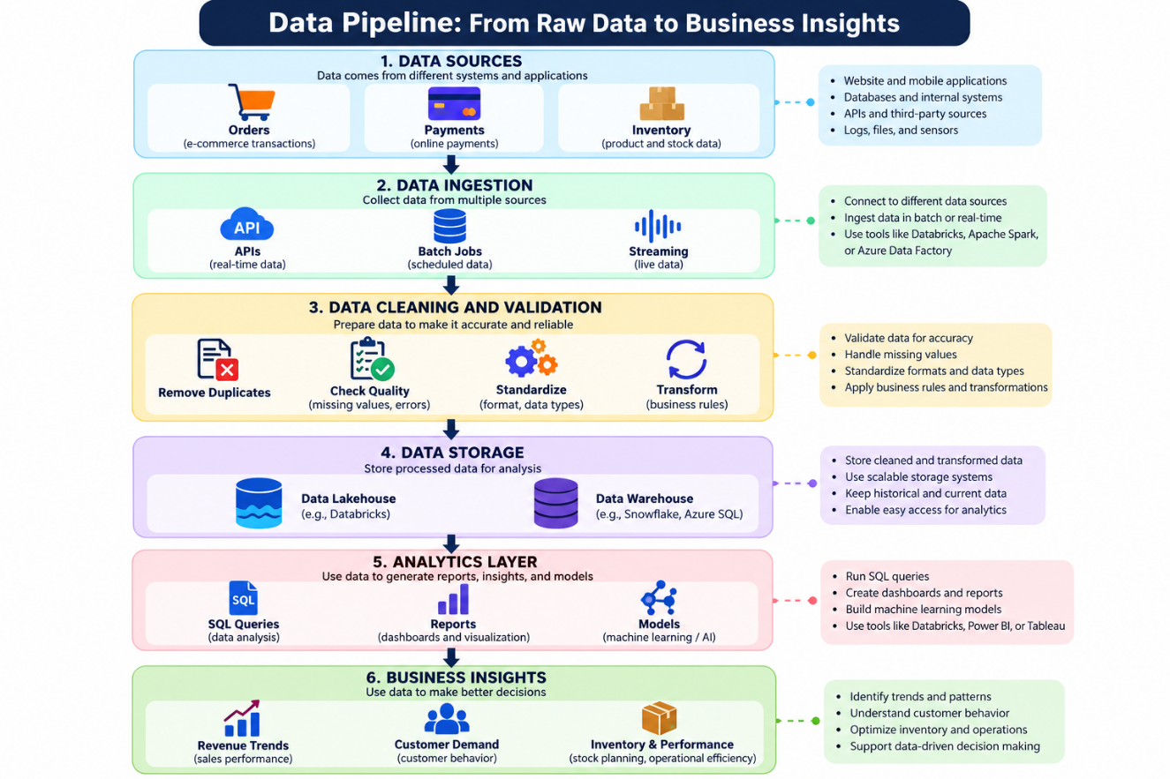
Suggested diagram title: From Raw Data to Business Insights: A Data Engineering Pipeline.
For a more professional appearance, use separate colors for data sources, processing, storage, and analytics. Add arrows to show the direction of data flow.

3. Data Engineer vs. Data Analyst
Data Engineers and Data Analysts work toward the same business goal: helping organizations make better decisions using data.
However, their responsibilities are different.
Imagine a retail company whose sales have decreased by 15% compared with the previous month.
The company wants to understand why this happened.
What Does the Data Engineer Do?
The Data Engineer ensures that the sales data is collected and prepared correctly.
They may combine information from store transactions, online orders, product inventory, and marketing campaigns.
They also build pipelines, maintain data quality checks, and ensure that the resulting datasets are available to the analytics team.
What Does the Data Analyst Do?
The Data Analyst uses the prepared information to investigate the decline.
They may compare sales across regions, identify underperforming products, examine customer purchasing patterns, and evaluate marketing campaign performance.
Their findings may reveal that sales declined because a popular product was out of stock in several regions.
The business can then use this insight to improve inventory planning.

How Do They Work Together?
The relationship can be summarized as follows:
Data Engineer: Makes the data reliable and accessible.
Data Analyst: Uses the data to discover what is happening and why.
Business Team: Uses the findings to decide what actions to take.
For example, a Data Engineer may prepare a reliable sales dataset, while a Data Analyst discovers that a particular region has experienced a significant decline in sales.
The business team can then investigate the causes and develop a response.
Neither role replaces the other. Reliable analytics requires both well-prepared data and meaningful interpretation.
4. Understanding OLTP vs. OLAP
Two important concepts in data systems are OLTP and OLAP.
They serve different purposes, although modern data architectures can integrate information from both.
What Is OLTP?
OLTP stands for Online Transaction Processing.
OLTP systems are designed to process everyday transactions efficiently. These include placing orders, transferring money, updating inventory, and booking tickets.
For example, when a customer purchases a phone online, the application may create an order, record payment information, and update the available stock.
The system must process these operations reliably and quickly.
What Is OLAP?
OLAP stands for Online Analytical Processing.
OLAP systems support analysis across large amounts of data. They help businesses examine trends, compare performance, and answer complex questions.
For example, a retail company may analyze three years of sales to determine which products perform best during festival seasons.
OLTP vs. OLAP: Comparison Table
Feature
  OLTP
  OLAP
 | Process business transactions | Analyze business data
  Primary purpose
 | Customers, operational staff, applications | Analysts, managers, data scientists
  Typical users
 | Insert, update, delete, and retrieve individual records | Aggregate, filter, group, and analyze large datasets
  Common operations
 | Current operational records | Historical and consolidated data
  Data focus
 | Usually short, transaction-oriented queries | Often complex analytical queries
  Query patterns
 | Recording an online payment | Comparing monthly revenue across regions
  Example
 | PostgreSQL, MySQL, SQL Server | Analytical warehouses and lakehouse platforms
  Common technologies

5. Getting Started with Databricks
Now that we understand why data needs to be collected, processed, and organized, the next question is:
Which platforms can help us build data pipelines and work with large datasets?
One platform worth exploring is Databricks.
Databricks provides a unified environment for data engineering, analytics, and AI. It supports technologies and workflows used to process large datasets, develop pipelines, and collaborate on data projects.
Let's understand three foundational concepts: Workspace, Compute, and Notebooks.
A. Databricks Workspace
A Databricks Workspace is an environment where users organize and work on data-related projects.
Think of it as a digital office for a data team.
In a physical office, employees have desks, documents, shared resources, and meeting spaces. In a Databricks Workspace, users have tools and resources for writing code, collaborating, accessing data, and managing their work.
Depending on the configuration and permissions, workspace resources can include:
- Notebooks for writing and running code.
- Folders for organizing project files.
- Git folders for working with version-controlled repositories.
- Jobs and workflows for scheduling and orchestrating tasks.
- SQL-related resources for querying and analyzing data.
- Compute resources for executing supported workloads.
Not every resource is available in every workspace configuration, and permissions determine what users can access.
Practical example:
Suppose you are building a sales analytics project.
You could organize your work into folders or repositories containing notebooks for data ingestion, cleaning, transformation, and analysis.
This organization makes the project easier to maintain and helps team members understand how the different components fit together.
B. Compute in Databricks
Writing code and executing code are two different activities.
When you write a Python program, you are describing the operations that should happen. To execute that program, a suitable computing environment must run the instructions.
In Databricks, compute resources provide the processing environment needed to execute supported workloads.
Depending on the task and configuration, compute may involve clusters or serverless compute.
A Real-World Analogy
Imagine a restaurant kitchen.
The recipe represents your code. The kitchen equipment, workstations, and available staff represent the resources needed to prepare the food. Cooking is the execution process.
Writing a recipe does not produce a finished meal. Similarly, writing a data transformation does not process a dataset until the code is executed.
For example, consider this PySpark code:
from pyspark.sql import SparkSession

spark = SparkSession.builder.getOrCreate()

df = spark.createDataFrame(
[
("Laptop", 50000),
("Phone", 25000),
("Tablet", 15000)
],
["product", "price"]
)

df.show()
This example creates a small DataFrame and displays its records.
When executed in a compatible Spark environment, the code creates a dataset containing three products and their prices.
For a small example, local Python or a lightweight environment may be sufficient. Larger workloads may require more compute resources.
The amount of compute required depends on the dataset, workload, execution engine, and configuration.
C. Databricks Notebooks
A Databricks Notebook is an interactive environment where users can write code, execute it, document their work, and inspect results.
Notebooks are particularly useful for learning because they allow you to work through a data problem step by step.
A notebook contains cells. Each cell can hold code or explanatory content, depending on the cell type and notebook interface.
How Workspace, Compute, and Notebooks Work Together
These three concepts serve different purposes:
- Workspace: Organizes the resources used for your project.
- Notebook: Provides an interactive place to write and execute code.
- Compute: Supplies the resources needed to run supported workloads.
For example, you can create a notebook in a workspace, connect it to suitable compute, and execute Python or SQL code to process a dataset.
Understanding this relationship is a useful first step toward learning data engineering with Databricks.

6. Connecting Everything in a Real Business Scenario
Let's bring these concepts together using an online retail company.
Imagine the company wants to understand why its monthly sales have declined.
Step 1: Data Generation
Customers place orders, make payments, browse products, and interact with marketing campaigns.
These activities generate data across multiple systems.
Step 2: Data Ingestion
A Data Engineer creates processes to collect data from the relevant sources.
Depending on business needs, the data may arrive in scheduled batches or through streaming systems.
Step 3: Data Processing
The engineer validates the records, handles duplicates according to business rules, standardizes formats, and combines related information.
Step 4: Data Storage
The processed data is stored in an appropriate analytical environment, such as a data warehouse or lakehouse.
Step 5: Data Analysis
A Data Analyst uses SQL or analytical tools to compare sales by product, region, customer segment, and time period.
Step 6: Business Insights
The analysis may reveal that several popular products were unavailable during a major sales period.
The company can use this information to improve inventory planning and reduce the likelihood of future lost sales.
Step 7: Continuous Improvement
The company monitors the data pipelines and the resulting business metrics. If data quality problems occur, the responsible teams investigate and correct them.
This scenario illustrates how data engineering, analytics, and business decision-making work together.
Databricks can support several parts of this process, including data transformation, notebook-based development, and workflow orchestration, depending on the architecture and services selected.
7. My Key Takeaways
While exploring Data Engineering foundations, I learned that collecting data is only the beginning of the process.
The real challenge is building systems that transform raw information into reliable, accessible, and useful data.
I also understood the distinction between Data Engineers and Data Analysts. Data Engineers focus on building and maintaining dependable data systems, while Data Analysts use prepared data to identify patterns and support business decisions.
Learning about OLTP and OLAP helped me understand why systems designed for everyday transactions differ from systems designed for analytical workloads.
Finally, exploring Databricks Workspace, Compute, and Notebooks helped me understand the basic environment in which data engineering work can be organized and executed.
As someone building a foundation in data technologies, I see these concepts as important steps toward developing practical skills in SQL, Python, data processing, and pipeline development.
My biggest takeaway is simple: a meaningful business insight is only as dependable as the data and processes behind it.
Conclusion
Data Engineering is a fundamental part of modern data-driven businesses.
From online shopping and digital payments to banking and streaming platforms, organizations rely on well-designed data systems to make information useful.
Data Engineers build the pipelines and infrastructure that prepare reliable data. Data Analysts use that data to uncover insights, explain business performance, and support better decisions.
Platforms such as Databricks provide an environment for developing data pipelines and working with data at scale.
For anyone beginning a journey in Data Engineering, understanding these foundations is an important first step. The next step is to put the concepts into practice by building small projects, working with real datasets, and learning how to create reliable data pipelines.
Every insight has a story behind it. Often, that story begins with Data Engineering.
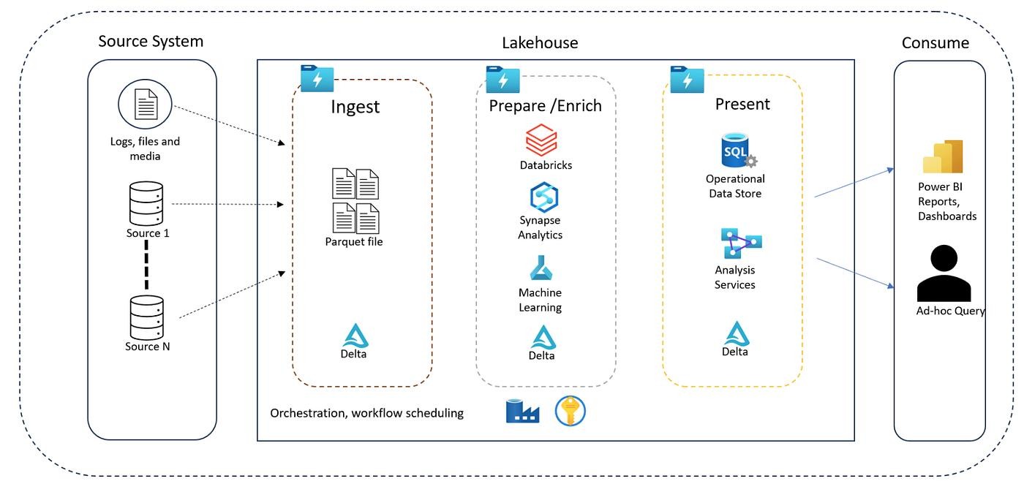
References and Further Learning
The following official resources can help you explore these concepts further:
- Databricks Documentation — Learn about the Databricks platform and its capabilities:
https://docs.databricks.com/
- Databricks Notebooks — Explore notebook functionality and development workflows:
https://docs.databricks.com/aws/en/notebooks/
- Databricks Compute — Understand the compute options available on Databricks:
https://docs.databricks.com/aws/en/compute/
- Apache Spark Documentation — Learn about distributed data processing and Spark DataFrames:
https://spark.apache.org/docs/latest/
- PostgreSQL Documentation — Explore relational databases and SQL concepts:
https://www.postgresql.org/docs/
- Microsoft Learn: Power BI — Explore data visualization and business intelligence:
https://learn.microsoft.com/en-us/power-bi/
Note: Databricks documentation paths and available features may vary by cloud provider, product configuration, and platform version. These references are starting points for further learning.

