K.S.R.M. COLLEGE OF ENGINEERING

(UGC- AUTONOMOUS)

A Major project report on

“Smart Weather Monitoring and Environmental Data Acquisition System Using LPC1768”
Submitted in partial fulfillment for the award of the degree of
Bachelor of Engineering In
Electronics and Communication Engineering

Submitted by

P V Yoga Vinay Kumar Reddy | CL20260526011520332
V. Jaswanth | CL20260526011521948
C. Salma | CL2026052601151787
D. Mamatha | CL2026052601151809
P. Pradhyumna Reddy | CL20260526011520433

Under the Guidance of
S. Naga Sravani
Software Engineer Faculty,
Cranes Varsity Institute.

DEPARTMENT OF ELECTRONICS & COMMUNICATION ENGINEERING

K.S.R.M. COLLEGE OF ENGINEERING

(UGC- AUTONOMOUS)
(Approved by AICTE, New Delhi & Affiliated to JNTUA, Ananthapuramu) (Accredited by NAAC with A+ Grade & B. Tech (EEE, ECE, CSE, CE & ME) Programs by NBA)
(An ISO 9001:2015, 14001:2015, 50001:2018 Certified Institution) KADAPA – 516005 (A.P.)
2026- 2027

K.S.R.M. COLLEGE OF ENGINEERING

(UGC- AUTONOMOUS)
Department of Electronics and Communication Engineering

CERTIFICATE
Certified that the project work entitled “ Smart Weather Monitoring and
Environmental Data Acquisition System Using LPC1768” carried out
By

P V Yoga Vinay Kumar Reddy | CL20260526011520332
V. Jaswanth | CL20260526011521948
C. Salma | CL2026052601151787
D. Mamatha | CL2026052601151809
P. Pradhyumna Reddy | CL20260526011520433

Bonafide students of K.S.R.M. COLLEGE OF ENGINEERING, in partial fulfilment for the award of Bachelor of Engineering in Electronics and Communication under affiliated to Jawaharlal Nehru Technological University, Anantapur during the year 2026-2027. It is certified that they have completed the project satisfactorily at K.S.R.M. COLLEGE OF ENGINEERING, KADAPA.

Signature of Principal
Dr. T. Nageswara Prasad
Principal
KSRMCE
Signature of HOD
Dr. B. Bhaskar Reddy
Professor and Head
Dept. of ECE, KSRM

Signature of Guide

S. Naga Sravani
Software Engineer Faculty
Cranes Varsity Institute

External VIVA

Internal Examiner External Examiner
Signature: Signature:
Name: Name:
Date: Date:

ABSTRACT

The Smart Weather and Environmental Monitoring System is an embedded system developed using the LPC1768 ARM Cortex-M3 microcontroller for real-time monitoring and control of environmental parameters. The system integrates multiple sensors including DHT11 for temperature and humidity measurement, MQ2 for gas detection, an LDR sensor for light intensity monitoring, a rain sensor for rainfall detection, and the onboard LM35 temperature sensor for additional temperature sensing. Sensor data is acquired through GPIO and ADC interfaces, processed by the LPC1768 microcontroller, and displayed on a 16×2 LCD and a 4-digit 7-segment display.

A 4×4 keypad is used to navigate and view different sensor readings as well as configure threshold values for environmental parameters. The configured threshold values are stored in the LPC1768 internal Flash memory, ensuring data retention even after power loss. The system employs a multi-level alert mechanism using green, orange, and red LEDs along with a buzzer to indicate normal, warning, and critical environmental conditions.

An automatic control mechanism is implemented using a relay module and DC fan. Whenever the measured temperature exceeds the predefined threshold value, the relay is activated to turn ON the fan automatically, helping maintain safe environmental conditions. By integrating sensing, display, storage, alert generation, and automatic control features, the proposed system provides a reliable, cost-effective, and user-friendly solution for weather monitoring, industrial safety, smart agriculture, greenhouse monitoring, and environmental management applications.

ACKNOWLEDGEMENT

We would like to express our sincere gratitude to all those who have supported and guided us throughout the successful completion of the project titled "Smart Weather Monitoring and Environment Data Acquisition System Using LPC1768."
We are deeply thankful to our Principal and the Management of the institution for providing the necessary facilities and a conducive environment for carrying out this project work.
We express our heartfelt gratitude to the Head of the Department of Electronics and Communication Engineering for the valuable encouragement, support, and guidance provided during the development of this project.
We would like to convey our sincere thanks to our project guide and faculty members for their continuous guidance, technical suggestions, constructive feedback, and motivation throughout the project. Their expertise and encouragement played a vital role in the successful completion of this work.
We are also grateful to the laboratory staff and technical assistants for providing the required equipment, resources, and support during the implementation and testing phases of the project.
We extend our appreciation to our classmates and friends for their cooperation, discussions, and valuable suggestions, which helped improve the quality of the project.
Finally, we express our deepest gratitude to our parents and family members for their constant encouragement, moral support, and belief in our abilities throughout our academic journey. Their support has been a source of inspiration and strength in successfully completing this project.

P V Yoga Vinay Kumar Reddy
V. Jaswanth
C. Salma
D. Mamatha
P. Pradhyumna Reddy

DECLARATION

We hereby declare that the project entitled “Smart Weather Monitoring and Environmental Data Acquisition System using LPC1768” is a bonafide work carried out by us in partial fulfillment of the requirements for the award of the Degree of Bachelor of Technology at KSRM College of Engineering, Kadapa – 516003, Andhra Pradesh.
This project has been developed under the valuable guidance and supervision of Ms. S. Naga Sravani, Software Engineer Faculty, Cranes Varsity, Bangalore. The project involves the design and implementation of a Smart Weather Monitoring and Environmental Data Acquisition System using the LPC1768 ARM Cortex-M3 microcontroller, various environmental sensors such as DHT11, LM35, MQ2, Rain Sensor, and LDR, internal Flash memory for threshold storage, keypad-based user interaction, display modules, automated alert mechanisms using LEDs and buzzer, and relay-based DC fan control.
We declare that the work presented in this project report is original and has been carried out by our project team. This report has not been submitted previously, either wholly or partially, for the award of any degree, diploma, or other academic qualification in any university or institution.
This project reflects our understanding, practical implementation skills, and knowledge gained during the course of study at KSRM College of Engineering, Kadapa – 516003, Andhra Pradesh.
Place: KADAPA P V Yoga Vinay Kumar Reddy
V. Jaswanth
C. Salma
D. Mamatha
P. Pradhyumna Reddy

CHAPTER NO | TITLE | PAGE NO.
1 | INTRODUCTION | 2
 | 1.1. Scope of Work | 3
 | 1.2. Problem Statement | 4
 | 1.3. Objectives | 4
 | 1.4. Literature Survey | 5
2 | METHODOLOGY | 8
 | 2.1. Block Diagram of Smart Weather Monitoring and Environmental Data Acquisition System | 8
 | 2.2. Workflow Automation | 9
3 | SOFTWARE AND HARDWARE COMPONENTS | 12
 | 3.1. Software Components | 12
 | 3.2. Hardware Components | 14
4 | IMPLEMENTATION | 20
5 | RESULTS | 30
6 | APPLICATIONS, ADVANTAGES & DISADVANTAGES | 33
 | 6.1. Applications | 33
 | 6.2. Advantages | 34
 | 6.3. Disadvantages | 34
7 | CONCLUSION & FUTURE SCOPE | 35
 | REFERENCES | 37

Figure No. | Title | Page No.
1.1 | Smart Weather Monitoring | 02
2.1 | Methodology Flow | 08
2.2 | Workflow Automation | 09
3.1 | Software Components | 12
3.2 | Hardware Components | 14
4.1 | Header File | 21
4.2.1 | Delay and LCD Functions | 24
4.2.2 | Sensor Interface Functions | 25
4.2.3 | Control and Alert Functions | 27
4.3 | Main Program | 29

Chapter 1: INTRODUCTION

“Smart Weather Monitoring and Environmental Data Acquisition System using LPC1768” is an embedded system designed to monitor and analyze real-time environmental parameters using the LPC1768 ARM Cortex-M3 microcontroller. The system acquires data such as temperature, humidity, gas concentration, rainfall, and light intensity through various sensors including DHT11, LM35, MQ2, Rain Sensor, and LDR. The collected sensor data is processed by the microcontroller and displayed on a 16×2 LCD and a 4-digit 7-segment display for local monitoring.
The system provides intelligent monitoring and control features through a keypad-based user interface, allowing users to view sensor data and configure threshold values. These threshold values are stored in the internal Flash memory of LPC1768, ensuring data retention even after power interruptions. A multi-level alert mechanism using green, orange, and red LEDs along with a buzzer is implemented to indicate normal, warning, and critical environmental conditions.
An automatic control feature is incorporated using a relay module and a DC fan. Whenever the temperature exceeds the predefined threshold value, the relay activates the fan automatically to maintain safe environmental conditions. This project integrates sensing, data acquisition, display, storage, alert generation, and automatic control into a single embedded platform.
The proposed system provides a reliable, cost-effective, and user-friendly solution for environmental monitoring applications such as weather stations, smart agriculture, greenhouse monitoring, industrial safety systems, and environmental management. The LPC1768 microcontroller ensures efficient processing, reliability, and scalability for future enhancements.

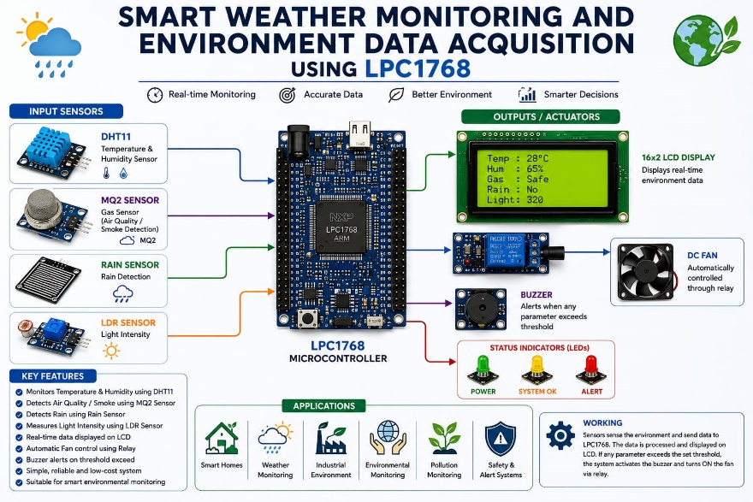

Fig 1.1 Smart Weather Monitoring

Scope of Work

The “Smart Weather Monitoring and Environmental Data Acquisition System using LPC1768” project is designed to provide an efficient and intelligent solution for monitoring environmental conditions in real time. The system continuously acquires data from various sensors to measure temperature, humidity, gas concentration, rainfall, and light intensity, and processes the information using the LPC1768 ARM Cortex-M3 microcontroller. It provides real-time display of environmental parameters through a 16×2 LCD and a 4-digit 7-segment display, while allowing users to view sensor data and configure threshold values using a 4×4 keypad. The threshold values are stored in the internal Flash memory of LPC1768, ensuring data retention even after power interruptions. The project also incorporates an alert mechanism using LEDs and a buzzer to indicate abnormal environmental conditions and includes automatic fan control through a relay whenever the temperature exceeds the predefined threshold. Due to its reliability, low cost, and ease of implementation, the system can be applied in weather monitoring stations, smart agriculture, greenhouse monitoring, industrial safety systems, educational laboratories, and environmental monitoring applications. The modular architecture of the system also provides opportunities for future enhancements through the addition of new sensors, advanced control features, and data logging capabilities.

Problem Statement

Environmental conditions such as temperature, humidity, gas concentration, rainfall, and light intensity play a crucial role in agriculture, industries, research laboratories, and day-to-day human activities. Conventional monitoring methods often require manual observation and are not capable of providing continuous monitoring, instant alerts, or automatic control actions. As a result, abnormal environmental conditions may go unnoticed, leading to safety risks, reduced productivity, and inefficient resource utilization.

Therefore, there is a need for a reliable, cost-effective, and automated environmental monitoring system that can continuously monitor multiple environmental parameters, display real-time data, generate alerts during abnormal conditions, and perform automatic control actions whenever required. The proposed Smart Weather Monitoring and Environmental Data Acquisition System using LPC1768 addresses these challenges by integrating multiple sensors, display units, internal Flash memory, alert mechanisms, and relay-based fan control into a single embedded platform for efficient real-time environmental monitoring and management.

1.3 Aim:

To design and implement a Smart Weather Monitoring and Environmental Data Acquisition System using LPC1768 for real-time environmental monitoring, alert generation, and automatic control.

1.4 Objectives

- To design and develop a Smart Weather Monitoring and Environmental Data Acquisition System using the LPC1768 ARM Cortex-M3 microcontroller.
- To monitor environmental parameters such as temperature, humidity, gas concentration, rainfall, and light intensity in real time using various sensors.
- To acquire, process, and display environmental data on a 16×2 LCD and a 4-digit 7-segment display.
- To generate alerts using LEDs and a buzzer and automatically control a DC fan through a relay based on predefined threshold values.
- To store user-defined threshold values in the internal Flash memory and provide a keypad-based interface for system configuration and monitoring

Literature Survey
[1] A. Kumar, R. Singh, and P. Sharma, “Microcontroller-Based Weather Monitoring System,” International Journal of Electronics and Communication Engineering, 2023.
This research presents a weather monitoring system designed to measure environmental parameters such as temperature, humidity, and atmospheric conditions using a microcontroller-based platform. The system utilizes multiple sensors to collect real-time environmental data and displays the information on an LCD module. The authors emphasize the importance of continuous monitoring for weather forecasting and environmental analysis. Experimental results demonstrated improved accuracy and reliability compared to traditional manual monitoring methods. The study concludes that automated weather monitoring systems can significantly enhance environmental observation and decision-making processes.
[2] V. Reddy, P. Kumar, and S. Rao, “ARM Cortex-M3 Based Environmental Monitoring System Using LPC1768,” International Journal of Embedded Systems Research, 2021.
This research focuses on the development of an environmental monitoring system using the LPC1768 ARM Cortex-M3 microcontroller. The system interfaces multiple sensors to monitor temperature, humidity, gas concentration, and light intensity. The LPC1768 processes sensor data and displays information on LCD modules while generating alerts during abnormal conditions. The authors highlight the advantages of ARM-based controllers, including high processing speed, low power consumption, and advanced peripheral support. Experimental results indicate reliable performance and accurate environmental monitoring suitable for industrial and agricultural applications.
[3] N. Sharma and D. Jain, “Smart Environmental Monitoring with Automatic Control Mechanisms,” International Journal of Advanced Engineering and Technology, 2020.
This paper discusses an automated environmental monitoring system that incorporates sensing, alert generation, and control mechanisms. The proposed system continuously evaluates environmental parameters and activates warning indicators whenever threshold values are exceeded. The study demonstrates the effectiveness of integrating relay-based control devices such as fans and alarms to maintain safe environmental conditions. The authors report improved operational efficiency and reduced manual intervention through automation. The system is recommended for industrial safety and greenhouse monitoring applications.

[4] K. Mohan, T. Rajesh, and P. Srinivasan, “Real-Time Monitoring and Automation Using LPC1768 ARM Cortex-M3 Microcontroller,” International Journal of Electronics and Embedded Applications, 2019.
This study explores the capabilities of the LPC1768 microcontroller in real-time monitoring and automation systems. The LPC1768 offers multiple ADC channels, GPIO interfaces, communication peripherals, and Flash memory support, making it suitable for sensor-based applications. The authors developed monitoring systems involving sensor data acquisition, automated decision-making, and actuator control. Experimental results demonstrate the reliability and flexibility of LPC1768 in handling multiple sensors and control operations simultaneously. The study concludes that LPC1768 is an effective platform for implementing intelligent environmental monitoring systems.
[5] S. Kumar and A. Verma, “Wireless Environmental Monitoring and Alert System,” International Journal of Communication and Control Systems, 2018.
This research introduces a wireless environmental monitoring system that enables remote supervision of environmental parameters. The system integrates temperature, humidity, gas, and light sensors with wireless communication modules for data transmission. The controller continuously processes sensor readings and generates alerts when abnormal conditions are detected. The authors emphasize the advantages of wireless communication in improving system flexibility and reducing installation complexity. Experimental analysis demonstrates reliable performance and effective environmental monitoring, making the system suitable for smart agriculture and industrial applications.

Literature Survey Summary
The rapid growth of environmental monitoring systems has increased the need for real-time weather and pollution monitoring. Traditional weather stations are expensive and difficult to deploy in remote areas. Embedded systems based on microcontrollers provide a cost-effective and efficient solution for collecting and analyzing environmental data.
Several researchers have developed weather monitoring systems using sensors such as temperature, humidity, gas, rain, and light sensors. These systems continuously monitor environmental conditions and provide timely information to users. The integration of sensors with microcontrollers enables automatic data acquisition and decision-making based on predefined thresholds.
The DHT11 sensor is widely used for measuring temperature and humidity due to its low cost and simple interface. The LM35 temperature sensor provides accurate analog temperature measurements, while the MQ2 gas sensor is commonly used for detecting smoke and harmful gases. Similarly, rain sensors and LDR sensors help monitor weather conditions and ambient light intensity.
Recent studies have focused on implementing smart environmental monitoring systems using advanced microcontrollers. The LPC1768 ARM Cortex-M3 microcontroller offers high processing speed, multiple communication interfaces, ADC channels, and GPIO resources, making it suitable for environmental monitoring applications. It enables simultaneous interfacing of multiple sensors and peripheral devices.
In this project, a “Smart Weather Monitoring and Environmental Data Acquisition System using LPC1768” is developed. The system integrates DHT11, LM35, MQ2, rain sensor, LDR, keypad, LCD display, MAX7219 seven-segment display, buzzer, LEDs, relay, and fan control. The system continuously monitors environmental parameters and provides alerts during abnormal conditions such as high temperature, gas leakage, or rainfall. This approach offers a reliable, low-cost, and efficient solution for real-time environmental monitoring and safety applications.

Chapter 2: METHODOLOGY

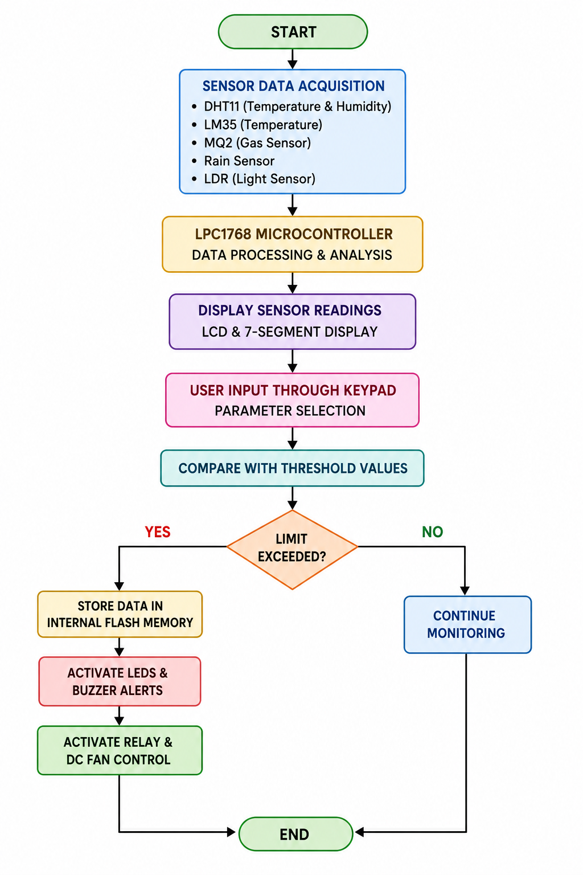
Fig. 2.1: Block Diagram of Smart Weather Monitoring and Environmental Data Acquisition System
The proposed Smart Weather Monitoring and Environmental Data Acquisition System utilizes the LPC1768 ARM Cortex-M3 microcontroller as the central processing unit to monitor and manage various environmental parameters in real time. The system integrates multiple sensors, including DHT11 for temperature and humidity measurement, MQ2 for gas detection, LDR for light intensity measurement, and a rain sensor for rainfall detection.
The data acquisition process begins with the sensors continuously sensing environmental conditions. The analog and digital sensor outputs are collected by the LPC1768 microcontroller through its input interfaces and Analog-to-Digital Converter (ADC) channels. The microcontroller processes the acquired data and compares the measured values with predefined threshold limits stored in its internal Flash memory.
The processed sensor data is displayed on a 16×2 LCD module and a 4-digit 7-segment display, enabling users to monitor environmental conditions in real time. A 4×4 keypad is provided to allow users to navigate through system menus, view sensor readings, and configure threshold values according to application requirements. The configured threshold values are permanently stored in Flash memory to ensure data retention even during power interruptions.
To enhance safety and monitoring efficiency, the system incorporates a multi-level alert mechanism using green, orange, and red LEDs along with a buzzer. Whenever any environmental parameter exceeds its predefined threshold value, the corresponding alert indication is activated to notify the user about abnormal conditions.
In addition to monitoring and alert generation, the system performs automatic control operations. When the temperature exceeds the specified threshold value, the LPC1768 activates a relay module that controls a DC fan. The fan operates automatically to reduce temperature levels and maintain safe environmental conditions.
The integrated system provides continuous environmental monitoring, real-time data display, intelligent alert generation, threshold-based decision making, and automatic control. The proposed methodology ensures reliable, cost-effective, and efficient environmental management suitable for applications such as weather monitoring stations, smart agriculture, greenhouse monitoring, industrial safety systems, and environmental research laboratories.
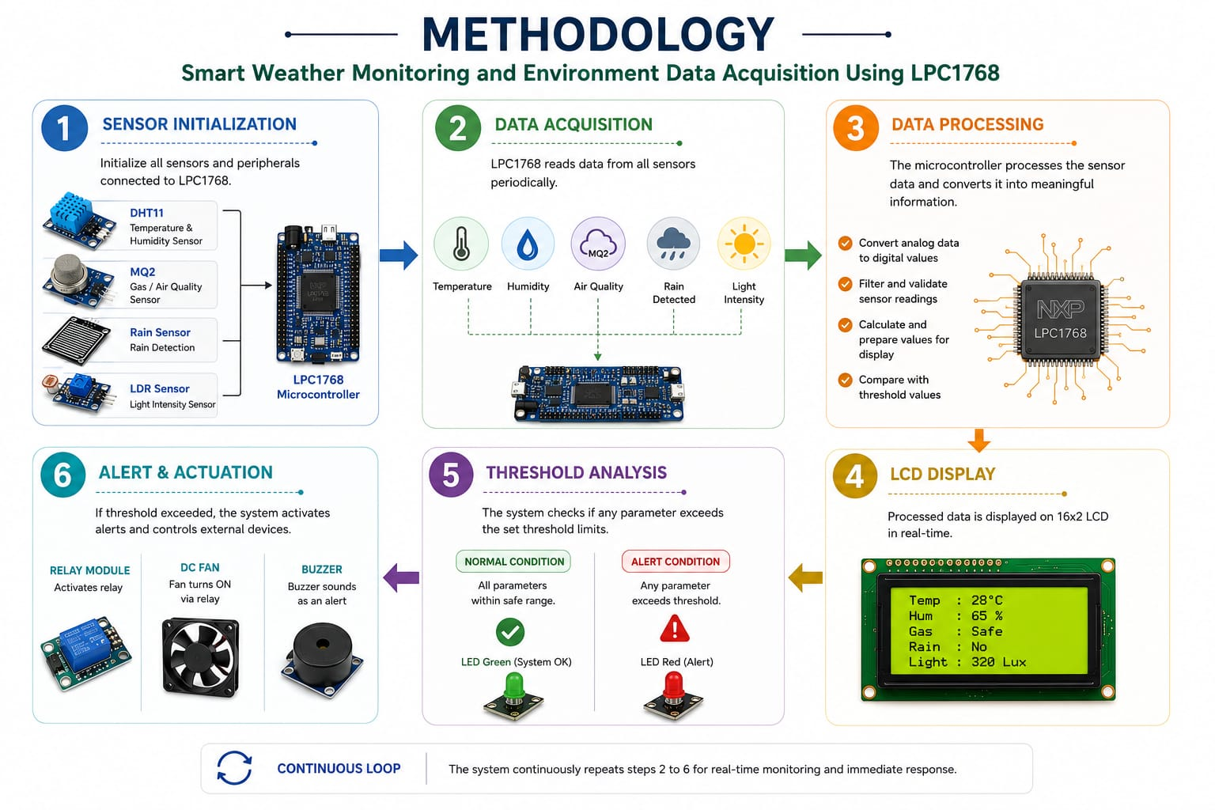

Functions of Smart Weather Monitoring System

1. Sensor Data Acquisition
• The system utilizes multiple sensors including DHT11, MQ2, LDR, and Rain Sensor to continuously monitor environmental conditions.
• DHT11 measures temperature and humidity, MQ2 detects gas concentration, LDR measures light intensity, and the Rain Sensor detects rainfall.
• Sensor outputs are interfaced with the LPC1768 microcontroller through digital and analog input channels.

2. Data Processing and Analysis
• The LPC1768 ARM Cortex-M3 microcontroller continuously acquires sensor data and processes the received information.
• The measured environmental parameters are compared with predefined threshold values stored in the internal Flash memory.
• Appropriate decisions are made based on the comparison results to determine normal, warning, or critical environmental conditions.

3. User Interface and Display
• A 16×2 LCD is used to display real-time environmental parameters such as temperature, humidity, gas level, rainfall status, and light intensity.
• A 4-digit 7-segment display provides numerical representation of selected sensor values and threshold settings.
• A 4×4 keypad allows users to navigate menus, monitor sensor readings, and modify threshold values.

4. Threshold Storage
• User-defined threshold values are stored in the LPC1768 internal Flash memory.
• The stored threshold values are retained even during power failures or system restarts.
• This feature eliminates the need for repeated configuration after every power cycle.

5. Alert Generation
• The system continuously monitors environmental conditions against predefined threshold limits.
• Green LED indicates normal conditions.
• Orange LED indicates warning conditions.
• Red LED and buzzer indicate critical environmental conditions requiring immediate attention.

6. Automatic Control Operation
• When the measured temperature exceeds the configured threshold value, the LPC1768 activates a relay module.
• The relay automatically switches ON the DC fan to reduce the temperature and maintain safe environmental conditions.
• Once the temperature returns below the threshold level, the fan is automatically turned OFF.

7. System Integration
• All sensing, monitoring, display, alert generation, threshold storage, and automatic control operations are integrated into a single embedded platform.
• The system provides reliable, cost-effective, and real-time environmental monitoring suitable for weather stations, smart agriculture, greenhouse monitoring, industrial safety systems, and environmental management applications.

Chapter 3: SOFTWARE USED HARDWARE USED

3.1 Software Requirement

3.1.1 Keil μVision IDE

3.1.2 Embedded C

3.1.3 Flash Magic

3.1.1 Keil μVision IDE :


Fig 3.1.1: Keil μVision IDE

Keil μVision is an Integrated Development Environment (IDE) used for developing embedded applications for ARM-based microcontrollers. In this project, Keil μVision is used for writing, compiling, debugging, and testing the Embedded C program developed for the LPC1768 ARM Cortex-M3 microcontroller. The IDE provides a user-friendly environment with code editing, project management, simulation, and debugging facilities. After successful compilation, Keil generates a HEX file that is used to program the LPC1768 microcontroller. The software helps in efficient firmware development and ensures reliable implementation of the Smart Weather Monitoring and Environmental Data Acquisition System.

3.1.2 Embedded C



Fig 3.1.2: Embedded C
Embedded C is a specialized programming language used for developing software for embedded systems. In this project, Embedded C is used to program the LPC1768 microcontroller for sensor interfacing, data acquisition, processing, display management, alert generation, and automatic control operations. The program continuously reads data from the DHT11, MQ2, LDR, and Rain sensors, compares the values with predefined thresholds, and controls the LCD display, LEDs, buzzer, relay, and DC fan. Embedded C provides direct access to hardware resources, making it suitable for real-time environmental monitoring applications.

Flash Magic
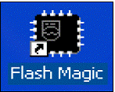

Fig 3.1.3: Flash Magic

Flash Magic is a programming tool used for downloading the compiled HEX file into the LPC1768 microcontroller. It provides a simple and reliable interface for serial programming of NXP ARM microcontrollers. After the program is compiled in Keil μVision, the generated HEX file is loaded into Flash Magic and transferred to the LPC1768 through a serial communication interface.

3.2 Hardware Requirement

3.2.1 LPC1768 Microcontroller

3.2.2 DHT11 Sensor

3.2.3 MQ2 Gas Sensor

3.2.4 LDR Sensor

3.2.5 Rain Sensor

3.2.6 16×2 LCD Display

3.2.7 4-Digit 7-Segment Display

3.2.8 4×4 Keypad

3.2.9 Relay Module

3.2.10 DC Fan

3.2.11 LEDs and Buzzer

3.2.1 LPC1768 Microcontroller

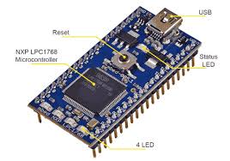
Fig. 3.2.1: LPC1768 Microcontroller
The LPC1768 is a high-performance ARM Cortex-M3 based 32-bit microcontroller
manufactured by NXP Semiconductors. It serves as the central processing unit of the
Smart Weather Monitoring and Environmental Data Acquisition System. The microcontroller
collects data from various sensors, processes environmental parameters, compares them
with predefined threshold values, and controls output devices such as LCD displays, LEDs,
buzzer, relay, and DC fan. The LPC1768 provides multiple GPIO pins, ADC channels,
communication interfaces, timers, and internal Flash memory, making it suitable for real-
time embedded applications

3.2.2 DHT11 Sensor

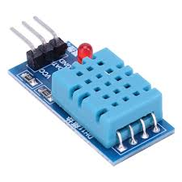
Fig. 3.2.2: DHT11 Sensor
The DHT11 is a digital temperature and humidity sensor used to measure environmental conditions. It contains a humidity sensing component and a thermistor for temperature measurement. The sensor provides calibrated digital output data directly to the LPC1768 microcontroller, eliminating the need for additional signal conditioning circuits. In this project, the DHT11 continuously monitors temperature and humidity levels and helps maintain safe environmental conditions through alert generation and automatic fan control.

3.2.3 MQ2 Gas Sensor

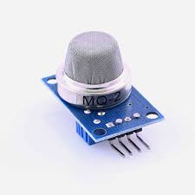
Fig. 3.2.3: MQ2 Gas Sensor
The MQ2 is a gas and smoke detection sensor capable of detecting combustible gases such as LPG, methane, propane, hydrogen, and smoke. The sensor changes its electrical resistance in the presence of gases, producing an analog output proportional to gas concentration. The LPC1768 reads the sensor output through its ADC channel and generates warning or critical alerts whenever gas levels exceed predefined threshold values. The MQ2 sensor improves safety by enabling early detection of hazardous environmental conditions.

3.2.4 LDR Sensor

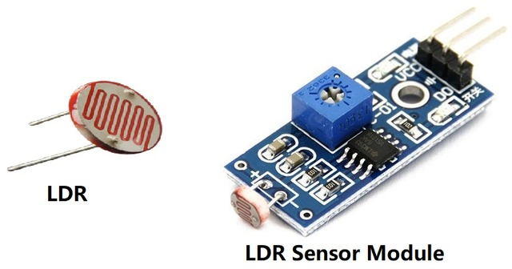
Fig. 3.2.4: LDR Sensor
The Light Dependent Resistor (LDR) is used to measure ambient light intensity. The resistance of the LDR decreases as light intensity increases and increases when light intensity decreases. This change in resistance is converted into a measurable voltage and read by the LPC1768 microcontroller. The LDR enables the system to monitor environmental lighting conditions and provides valuable information for weather and environmental analysis.

3.2.5 Rain Sensor

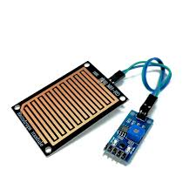
Fig. 3.2.5: Rain Sensor
The Rain Sensor is designed to detect the presence of rain or water droplets on its sensing surface. When rainwater comes into contact with the sensor plate, the conductivity of the sensing tracks changes, generating a signal that can be read by the LPC1768 microcontroller. The sensor allows the system to detect rainfall conditions in real time and display the rainfall status on the LCD screen for environmental monitoring purposes.

3.2.6 16×2 LCD Display

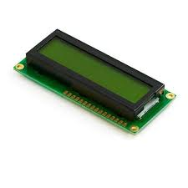
Fig. 3.2.6: 16×2 LCD Display
The 16×2 LCD display is used to present real-time environmental information to the user. It can display 16 characters per line across two lines, making it suitable for showing sensor readings and system status messages. In this project, the LCD continuously displays temperature, humidity, gas concentration, light intensity, rainfall status, and alert information. The display provides an easy-to-read interface for local monitoring.

3.2.7 4-Digit 7-Segment Display

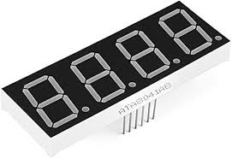
Fig. 3.2.7: 4-Digit 7-Segment Display
The 4-digit 7-segment display is used for displaying numerical values in a compact and clear format. It provides quick visualization of sensor readings, threshold settings, or other important numerical data. The display is controlled by the LPC1768 microcontroller and enhances user interaction by providing additional visual representation of environmental parameters.

3.2.8 4×4 Keypad

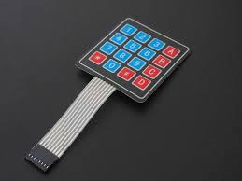
Fig. 3.2.8: 4×4 Keypad
The 4×4 keypad serves as the user input interface for the system. It allows users to navigate system menus, view sensor readings, and modify threshold values according to application requirements. The keypad communicates with the LPC1768 through matrix scanning techniques, enabling efficient user interaction. The configured threshold values are stored in Flash memory for future use.

3.2.9 Relay Module

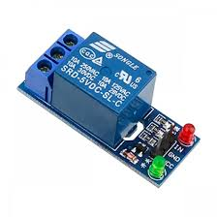
Fig. 3.2.9: Relay Module
The relay module acts as an electrically controlled switch that enables the microcontroller to control higher-power devices. In this project, the LPC1768 activates the relay whenever the temperature exceeds the predefined threshold value. The relay isolates the low-voltage control circuit from the higher-power DC fan circuit, ensuring safe and reliable operation of the automatic control system.

3.2.10 DC Fan

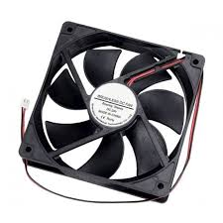
Fig. 3.2.10: DC Fan
The DC fan is used as an automatic cooling device in the environmental monitoring system. When the temperature sensor detects a temperature higher than the configured threshold value, the LPC1768 activates the relay, which switches on the DC fan. The fan helps reduce temperature levels and maintain safe environmental conditions. Once the temperature returns to normal, the fan is automatically switched off.

3.2.11 LEDs and Buzzer

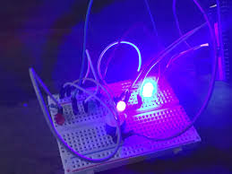
Fig. 3.2.11: LEDs and Buzzer
The LEDs and buzzer form the alert generation unit of the system. Green LED indicates normal operating conditions, orange LED indicates warning conditions, and red LED indicates critical conditions. The buzzer generates an audible alarm whenever environmental parameters exceed their threshold limits. This multi-level alert system ensures that users are immediately informed about abnormal environmental situations.

Chapter 4 :Implementation

The Smart Weather Monitoring and Environmental Data Acquisition System using LPC1768 is implemented using Embedded C programming in Keil µVision. The system is designed to continuously monitor environmental parameters and provide real-time information about weather and surrounding conditions. The implementation combines both sensing and control functionalities, enabling efficient data acquisition, processing, display, and alert generation.

The LPC1768 ARM Cortex-M3 microcontroller serves as the core processing unit of the system. It interfaces with multiple sensors including the DHT11 temperature and humidity sensor, LM35 temperature sensor, MQ2 gas sensor, rain sensor, and LDR sensor. These sensors continuously collect environmental data which is processed by the microcontroller and displayed to the user through an LCD display and a MAX7219-based seven-segment display.

The system also incorporates several output devices such as LEDs, buzzer, relay module, and DC fan to provide visual and audible indications during abnormal environmental conditions. When the measured temperature exceeds the predefined threshold, the relay activates the cooling fan and the buzzer generates an alert. Similarly, gas leakage and rainfall conditions are indicated through LEDs and warning notifications.

A 4×4 keypad is used as a user interface for selecting and displaying different environmental parameters. The keypad allows users to navigate through various monitoring options such as temperature, humidity, gas concentration, rain status, light intensity, fan status, and buzzer status. This interactive feature improves system usability and provides quick access to real-time sensor information.

To ensure modularity, readability, and ease of maintenance, the software implementation is divided into three major source files namely project.h, functions.c, and main.c. The header file contains pin configurations, macro definitions, global variables, and function declarations. The functions file contains all peripheral drivers and application-specific routines, while the main program coordinates system initialization, sensor monitoring, keypad handling, display management, and alert generation.

The implementation methodology follows a modular programming approach in which individual hardware modules are first tested independently and then integrated into a single embedded application. This approach improves system reliability, simplifies debugging, and ensures accurate operation of all sensors and peripherals. The completed system provides a low-cost, efficient, and reliable solution for smart weather monitoring and environmental data acquisition applications.

4.1 Header File Implementation (project.h)

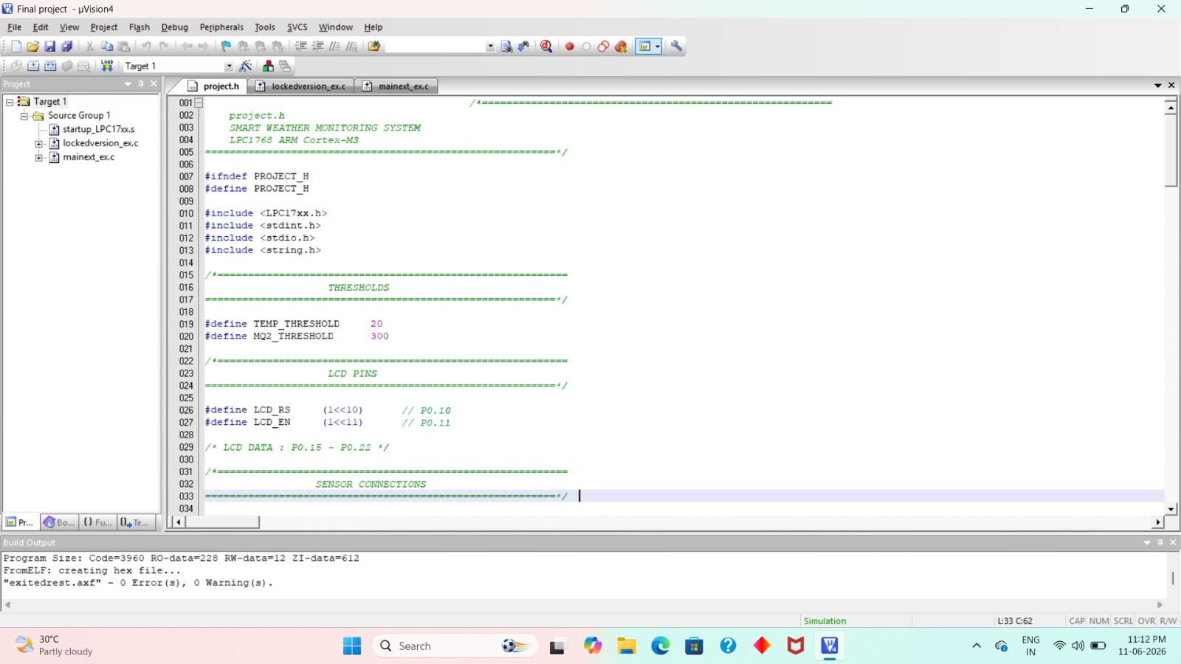
Fig 4.1 Header File Implementation (project.h)

The header file (project.h) is an important component of the software architecture. It contains all macro definitions, pin configurations, threshold values, global variable declarations, and function prototypes required for the implementation of the Smart Weather Monitoring and Environmental Data Acquisition System. The use of a separate header file improves code organization, readability, and maintainability by allowing common definitions to be shared across multiple source files.

The header file defines the pin assignments for various sensors and peripheral devices connected to the LPC1768 microcontroller. These include the DHT11 temperature and humidity sensor, LM35 temperature sensor, MQ2 gas sensor, rain sensor, LDR sensor, LCD display, MAX7219 seven-segment display, keypad, LEDs, buzzer, relay module, and DC fan. By defining the hardware connections using macros, any future modification in pin assignments can be performed easily without affecting the remaining program.

The file also contains threshold values used for environmental monitoring and alert generation. These threshold values determine when the system should activate warning indicators such as LEDs, buzzer, relay, and fan. Global variables required for storing sensor readings and system status information are declared in the header file and accessed throughout the project.

In addition, function prototypes for all modules are declared in the header file. These prototypes provide the compiler with information regarding the functions used in the project and facilitate communication between different source files. The header file therefore serves as a central repository for all system definitions and declarations.

The major sections included in the header file are:

• LCD Pin Definitions

• DHT11 Sensor Definitions

• LED Definitions

• Buzzer and Relay Definitions

• Rain Sensor and LDR Definitions

• MAX7219 Display Definitions

• ADC Channel Definitions

• Threshold Value Definitions

• Keypad Definitions

• Global Variable Declarations

• Function Prototypes

The modular structure of the header file significantly improves software development efficiency and ensures proper integration of all hardware modules used in the system.

4.2 Functions File Implementation (functions.c)

The functions file (functions.c) contains all the driver functions, sensor interfacing routines, display functions, control algorithms, and alert generation functions required for the operation of the Smart Weather Monitoring and Environmental Data Acquisition System. To improve readability and maintainability, the functions file is divided into multiple sections, each responsible for a specific operation of the system.

The functions file acts as the core software component that manages communication between the LPC1768 microcontroller and the connected sensors and peripherals. It performs data acquisition, processing, display management, and control operations based on the environmental conditions detected by the sensors.

4.2.1 Part A – Delay and LCD Functions

Part A contains delay routines and LCD control functions used for displaying information to the user. These functions initialize the LCD, send commands, display characters, strings, and numerical values, and manage cursor positioning. The LCD functions provide a user-friendly interface for monitoring environmental parameters and system status.

Functions implemented in Part A include:

• delay_ms()

• delay_us()

• LCD_Init()

• LCD_Command()

• LCD_Data()

• LCD_String()

• LCD_Number()

• LCD_Clear()

• LCD_Goto()

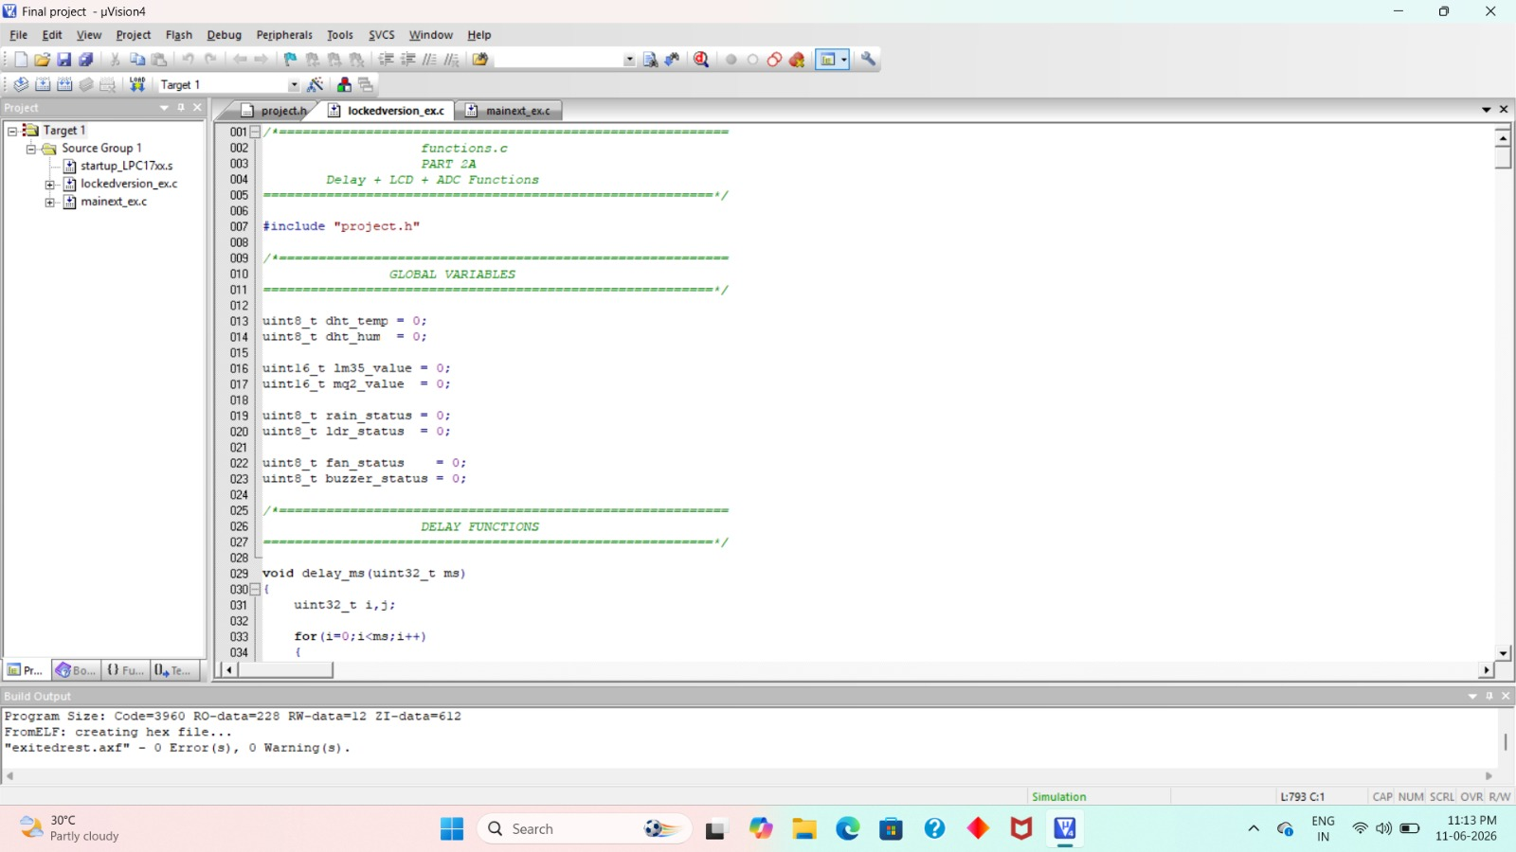

Figure 4.2.1: Part A – Delay and LCD Functions

4.2.2 Part B – Sensor Interface Functions

Part B contains functions responsible for sensor interfacing and data acquisition. The ADC functions are used to read analog values from the LM35 temperature sensor and MQ2 gas sensor. The DHT11 functions communicate with the temperature and humidity sensor using a single-wire protocol. Additional functions are implemented for rain sensor and LDR sensor data acquisition.

Functions implemented in Part B include:

• ADC_Init()

• ADC_Read()

• Read_LM35()

• Read_MQ2()

• DHT11_Start()

• DHT11_CheckResponse()

• DHT11_ReadByte()

• DHT11_Read()

• Read_Rain()

• Read_LDR()

• Update_All_Sensors()

These functions continuously monitor environmental conditions and update sensor values for further processing.

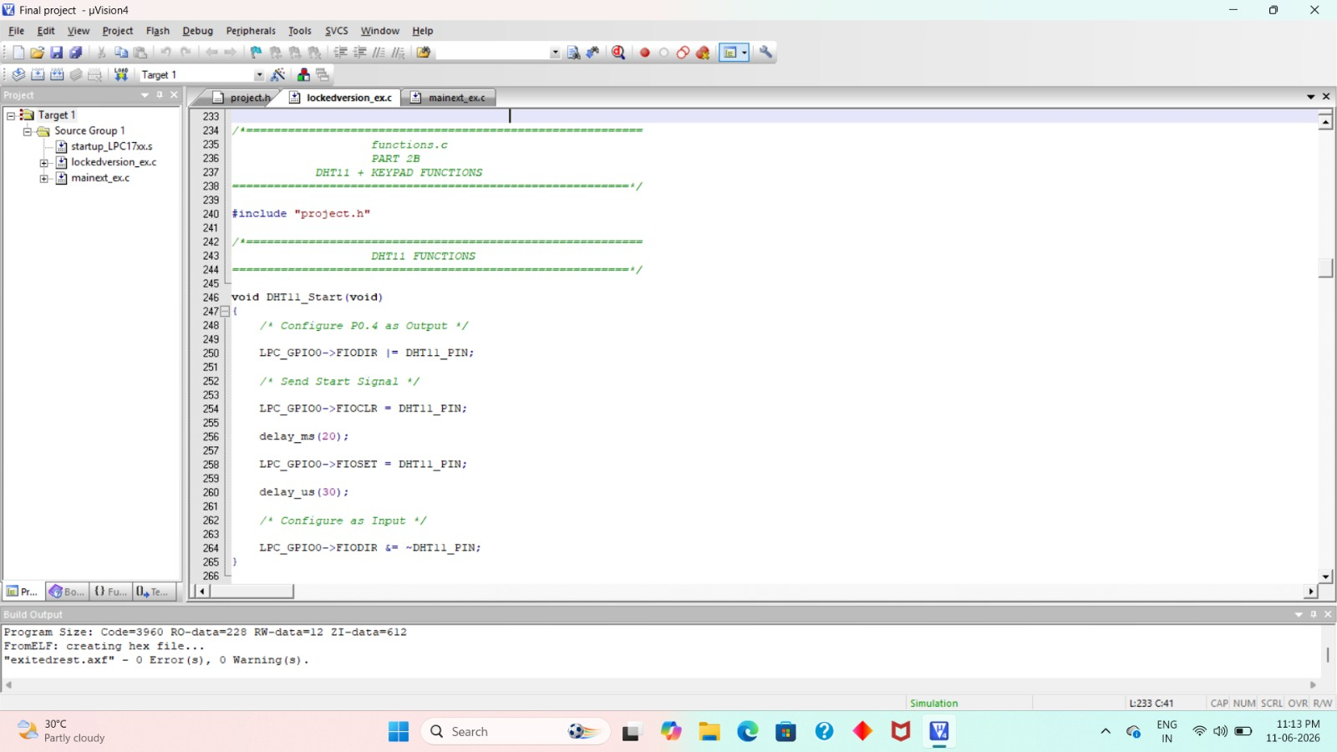

Figure 4.2.2: Part B – Sensor Interface Functions

4.2.3 Part C – Keypad, Display and Control Functions

Part C contains keypad interfacing routines, MAX7219 seven-segment display control functions, GPIO configuration routines, and alert generation functions. These functions provide interaction between the user and the monitoring system while also controlling external devices such as LEDs, buzzer, relay, and fan.

Functions implemented in Part C include:

• Keypad_Init()

• Keypad_Scan()

• ssp_spi_config()

• spi_data_write()

• MAX7219_Init()

• MAX7219_Display()

• GPIO_Init()

• Fan_Control()

• Gas_Control()

• Temperature_Alert()

• MQ2_Alert()

• Rain_Alert()

• Normal_Condition()

• Check_Conditions()

These functions automatically activate warning indicators whenever abnormal environmental conditions are detected.

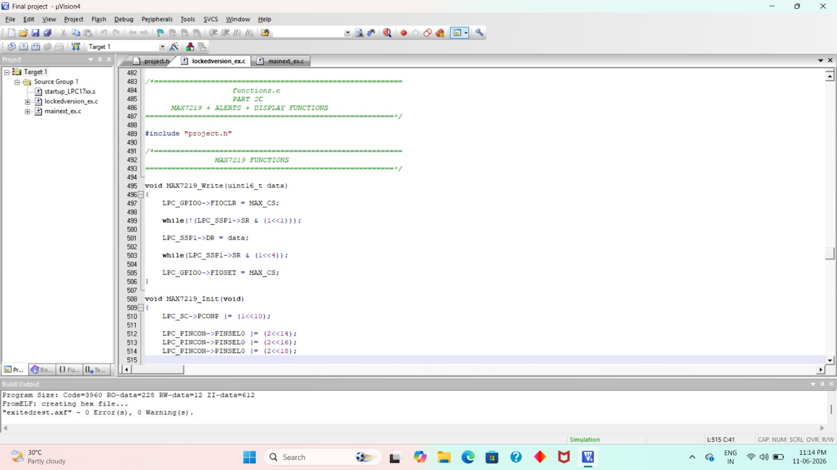

Figure 4.2.3: Part C – Control and Alert Functions

4.2.4 Part D – Display Functions

Part D contains all display-related functions used to present sensor readings and system information on the LCD display. These functions improve user interaction by allowing environmental parameters to be viewed through keypad-based menu selection.

Functions implemented in Part D include:

• Display_DHT_Temp()

• Display_DHT_Humidity()

• Display_LM35()

• Display_MQ2()

• Display_Rain()

• Display_LDR()

• Display_Fan()

• Display_Buzzer()

• Display_Project()

• Display_MainScreen()

The display functions provide a simple and organized method for viewing environmental data and system status information.

Summary

The functions file serves as the primary software layer responsible for sensor interfacing, display management, user interaction, environmental monitoring, and automatic alert generation. The modular organization of functions into different sections improves code maintainability and simplifies future modifications and upgrades to the system.

4.3 Main File Implementation (Main.c)
The main program (main.c) serves as the central control unit of the Smart Weather Monitoring and Environmental Data Acquisition System. It coordinates the operation of all sensors, displays, control devices, and user interface modules. The main program is responsible for system initialization, continuous monitoring of environmental parameters, keypad handling, display management, and automatic alert generation.
Initially, the program performs the initialization of all hardware peripherals including the LCD display, ADC module, GPIO ports, keypad, DHT11 sensor interface, and MAX7219 seven-segment display. After successful initialization, the system displays a welcome screen indicating that the Smart Weather Monitoring System is ready for operation.
The program then enters an infinite loop where it continuously acquires data from all connected sensors. The temperature, humidity, gas concentration, rainfall status, and light intensity values are periodically updated and stored in global variables. These sensor readings are compared against predefined threshold values to determine the environmental condition of the surrounding area.
The keypad serves as the user interface for selecting different monitoring options. Based on the key pressed, the corresponding environmental parameter is displayed on the LCD screen and, where applicable, on the MAX7219 seven-segment display. This menu-driven approach enables users to access sensor information quickly and efficiently.
The main program also implements an automatic alert mechanism. Whenever the measured temperature exceeds the specified threshold, the relay is activated to switch on the cooling fan, while the buzzer and warning LEDs indicate the abnormal condition. Similarly, gas leakage and rainfall conditions are detected and appropriate warning indications are generated automatically.
The continuous execution of the main loop ensures real-time environmental monitoring, data acquisition, display updating, and safety alert generation. The integration of all hardware modules through the main program provides an efficient and reliable embedded monitoring system.
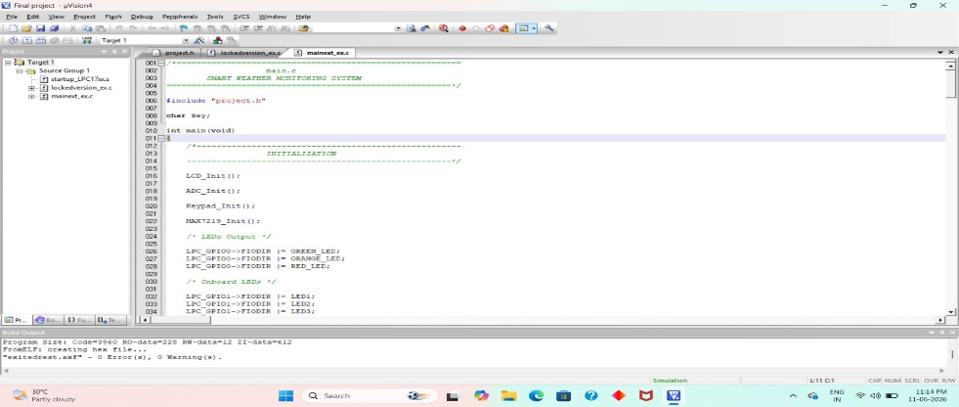
Fig 4.3 Main Program Implementation
Chapter 5: RESULTS

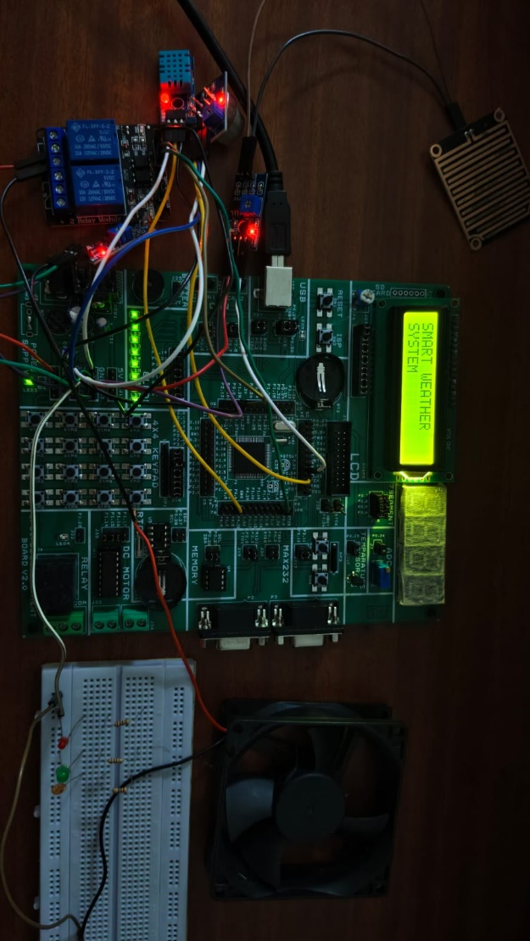

Fig 5.1 Smart Weather Monitoring System – System Initialization Screen
The Fig. 5.1 shows the startup screen of the Smart Weather Monitoring and Environmental Data Acquisition System using LPC1768. When the system is powered ON, the LPC1768 microcontroller initializes all peripherals including the DHT11 sensor, MQ2 gas sensor, LDR sensor, Rain sensor, LCD display, keypad, LEDs, buzzer, and relay module. The LCD displays a welcome message indicating that the system is ready for environmental monitoring operations.

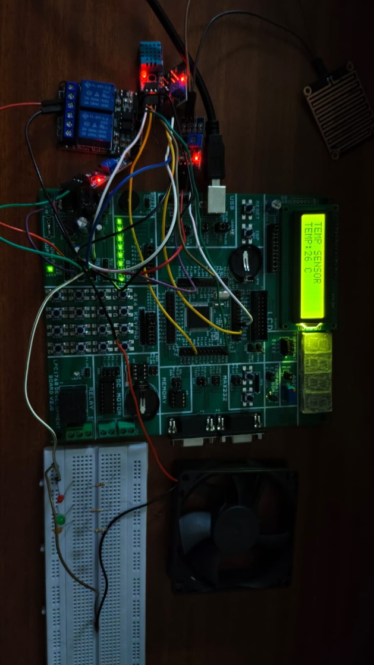

Fig 5.2 Temperature Monitoring Using DHT11 Sensor
The Fig. 5.2 shows the real-time temperature monitoring function of the proposed system. The DHT11 sensor continuously measures the surrounding temperature and transmits the data to the LPC1768 microcontroller. The measured temperature value is displayed on the 16×2 LCD screen. This feature enables users to monitor environmental temperature conditions accurately and supports automatic fan control when the temperature exceeds the predefined threshold value.
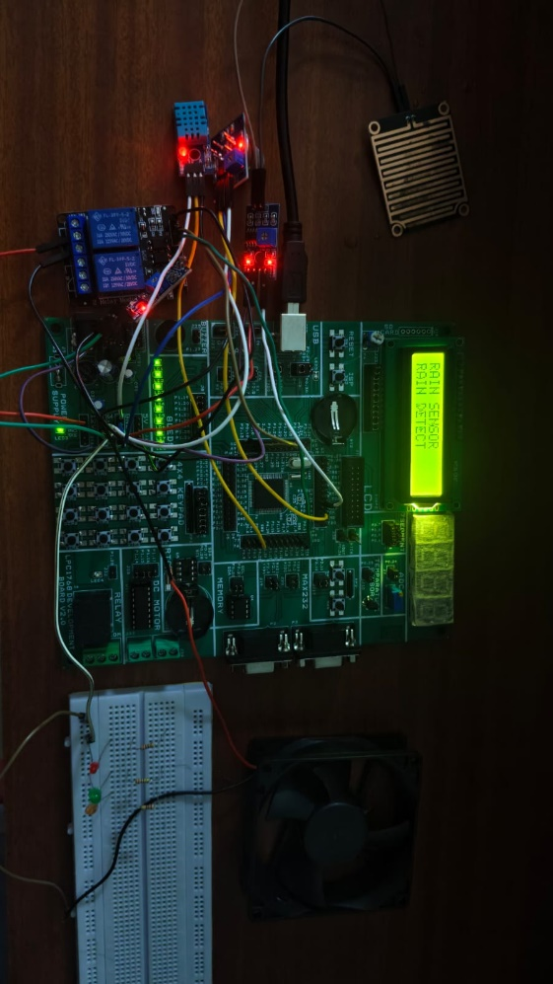

Fig 5.3 Rain Detection Condition Using Rain Sensor
The Fig. 5.3 shows the rain detection functionality of the system. The Rain Sensor detects the presence of water droplets on its sensing surface and sends a signal to the LPC1768 microcontroller. Upon detecting rainfall, the LCD displays a rain detection message and the system activates the alert mechanism using LEDs and buzzer to notify the user about changing weather conditions.

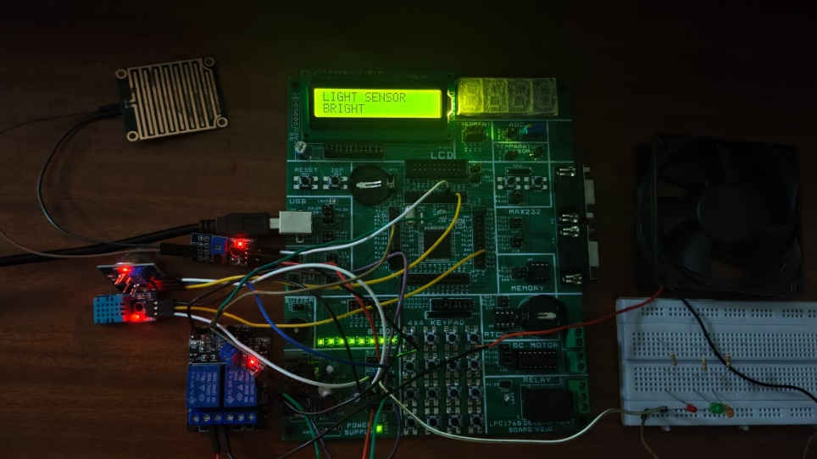

Fig 5.4 Light Intensity Monitoring Using LDR Sensor

The Fig. 5.4 illustrates the monitoring of ambient light intensity using the LDR sensor. The sensor measures the surrounding light level and provides corresponding input to the LPC1768 microcontroller. The measured light intensity status is displayed on the LCD screen, indicating bright or low-light environmental conditions. This information assists in environmental analysis and weather monitoring applications.
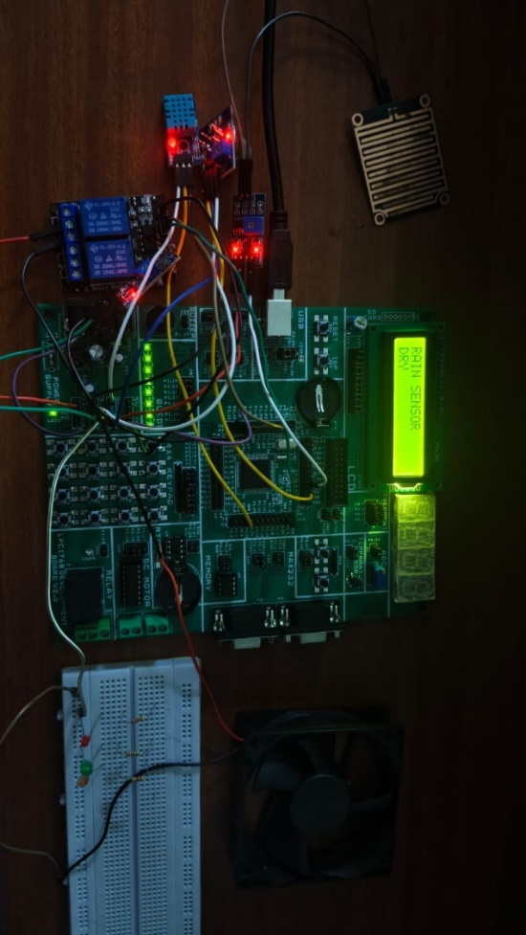

Fig 5.5 Dry Weather Condition Detection

The Fig. 5.5 shows the system operating under dry weather conditions. When the Rain Sensor does not detect any rainfall, the LPC1768 identifies the environment as dry and displays the corresponding status message on the LCD screen. The absence of rainfall indicates normal weather conditions, and the system continues monitoring other environmental parameters in real time.
The system continuously compares sensor readings with user-defined threshold values stored in the LPC1768 internal Flash memory. Under normal environmental conditions, the green LED remains active, indicating safe operation. When a parameter approaches its threshold value, the orange LED provides a warning indication. If any parameter exceeds the critical threshold value, the red LED and buzzer are activated to alert the user.
Additionally, the system successfully performs automatic temperature control. When the temperature exceeds the predefined threshold, the LPC1768 activates the relay module, which automatically switches ON the DC fan. Once the temperature falls below the threshold value, the fan is automatically turned OFF.
The obtained results demonstrate that the system accurately acquires environmental data, provides real-time monitoring, generates timely alerts, and performs automatic control operations. The successful integration of sensing, processing, display, storage, and control functionalities confirms the effectiveness and reliability of the proposed Smart Weather Monitoring and Environmental Data Acquisition System for applications such as weather stations, smart agriculture, greenhouse monitoring, industrial safety, and environmental management.

Chapter 6 :

APPLICATIONS, ADVANTAGES AND DISADVANTAGES

6.1 Applications
- Smart Agriculture: Monitors temperature, humidity, rainfall, and light intensity for efficient crop management. Helps farmers optimize irrigation and improve agricultural productivity.
- Weather Monitoring Stations: Collects and analyzes real-time weather data for local weather forecasting and climate studies.
- Greenhouse Monitoring: Automatically controls ventilation and cooling systems based on sensor readings.
- Industrial Environmental Monitoring: Monitors air quality, temperature, and humidity in factories and manufacturing units.
- Smart City Applications: Assists municipal authorities in pollution control and environmental management.
- Air Quality Monitoring Systems: Detects harmful gases and poor air quality levels using the MQ2 gas sensor.
- Disaster and Rainfall Monitoring: Provides early indication of rainfall and changing weather conditions.
- Educational and Research Laboratories: Serves as a practical platform for studying embedded systems, sensor interfacing, and environmental monitoring.
- Residential and Smart Home Monitoring: Enables automatic control of appliances such as fans and ventilation systems.
- Healthcare and Public Spaces: Helps maintain healthy indoor environments in hospitals, schools, offices, and public buildings by monitoring air quality and environmental parameters.

6.2 Advantages
- Provides real-time monitoring of multiple environmental parameters.
- Supports automatic temperature control using relay-operated DC fan.
- Generates instant alerts through LEDs and buzzer during abnormal conditions.
- Stores user-defined threshold values in internal Flash memory.
- Reduces manual monitoring and human intervention.
- Improves environmental safety and operational efficiency.
- Cost-effective and easy to implement.
- Low power consumption due to efficient LPC1768 microcontroller operation.
- User-friendly interface through LCD display and keypad.
- Can be expanded with additional sensors and communication modules for future enhancements.

6.3 Disadvantages
- Limited monitoring range due to local sensor deployment.
- Sensor accuracy may vary depending on environmental conditions.
- DHT11 provides moderate accuracy compared to advanced sensors.
- Does not provide remote monitoring without additional IoT modules.
- Requires periodic sensor calibration and maintenance.
- Environmental factors such as dust and moisture may affect sensor performance.
- Limited data storage capability when using only internal Flash memory.
- System performance depends on proper power supply regulation.
- Additional hardware is required for cloud connectivity and remote access.
- Sensor replacement may be necessary after prolonged usage.

Chapter 7: CONCLUSION AND FUTURE SCOPE

7.1 Conclusion

The Smart Weather Monitoring and Environmental Data Acquisition System using LPC1768 was successfully designed, implemented, and tested. The developed system is capable of continuously monitoring important environmental parameters such as temperature, humidity, gas concentration, rainfall, and light intensity using various sensors interfaced with the LPC1768 ARM Cortex-M3 microcontroller.

The system effectively acquires real-time data from the DHT11, LM35, MQ2, Rain Sensor, and LDR Sensor and displays the measured values on an LCD display and MAX7219 seven-segment display. A keypad-based menu interface was implemented to allow users to conveniently access different environmental parameters and system information.

An automatic alert mechanism was also incorporated into the system. When abnormal environmental conditions are detected, the system activates warning devices such as LEDs, buzzer, relay, and DC fan. This feature improves environmental safety and enables timely response to hazardous situations such as excessive temperature, gas leakage, or rainfall conditions.

The project demonstrates the capability of the LPC1768 microcontroller in handling multiple sensors and peripheral devices simultaneously while providing reliable real-time monitoring and control. The modular software architecture adopted in the implementation improves code maintainability, flexibility, and future scalability.

Overall, the developed Smart Weather Monitoring and Environmental Data Acquisition System provides a low-cost, efficient, and reliable solution for environmental monitoring applications. The successful integration and testing of all hardware and software modules confirm the effectiveness of the proposed system for real-time weather monitoring, environmental data acquisition, and safety monitoring applications.

7.2 Future Scope
The proposed system offers several opportunities for future enhancement and expansion. Some of the possible future developments include:
- Integration of IoT modules such as Wi-Fi or GSM for remote monitoring and control.
- Cloud-based data storage for long-term environmental data analysis and record maintenance.
- Development of a mobile application for real-time monitoring and notifications.
- Integration of GPS modules for location-based environmental monitoring.
- Addition of advanced sensors for monitoring atmospheric pressure, wind speed, air quality, and soil moisture.
- Implementation of AI and machine learning algorithms for weather prediction and environmental trend analysis.
- Solar-powered operation for improved energy efficiency and sustainability.
- Data logging using SD cards or external memory devices for historical data analysis.
- Wireless sensor network integration for large-scale environmental monitoring applications.
- Enhanced graphical user interfaces and dashboard systems for improved visualization and decision-making.
These future enhancements can significantly improve the functionality, scalability, and intelligence of the Smart Weather Monitoring and Environmental Data Acquisition System, making it suitable for next-generation environmental monitoring applications

REFERENCES
- NXP Semiconductors, LPC1768/1769 ARM Cortex-M3 Microcontroller User Manual, NXP Semiconductors, 2024.
- NXP Semiconductors, UM10360: LPC17xx User Manual (LPC1768 ARM Cortex-M3 Microcontroller), Rev. 2, August 2010.
- Aosong Electronics, DHT11 Temperature and Humidity Sensor Datasheet, Aosong Electronics Co., Ltd.
- Winsen Electronics Technology Co., Ltd., MQ2 Gas Sensor Technical Datasheet, Zhengzhou Winsen Electronics, China.
- Sunrom Technologies, Rain Sensor Module Technical Specifications and Application Guide.
- Vishay Semiconductors, Light Dependent Resistor (LDR) Datasheet and Application Notes.
- Hitachi Ltd., HD44780 LCD Controller Datasheet for 16×2 LCD Display Module.
- Keil Software, Keil μVision IDE User Guide and Development Tools Documentation.
- NXP Semiconductors, LPC1768 Product Data Sheet, NXP Embedded Solutions.
- https://manualmachine.com
- https://www.mouser.com
- https://www.alldatasheet.com
- https://www.winsen-sensor.com
- https://www.sparkfun.com

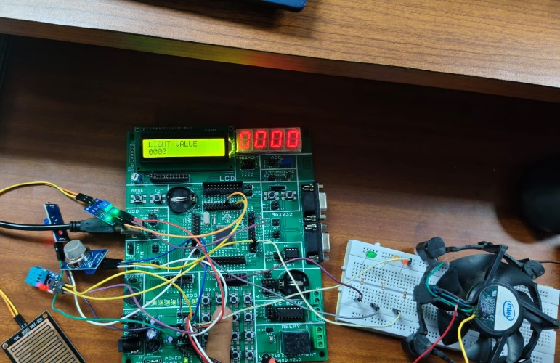
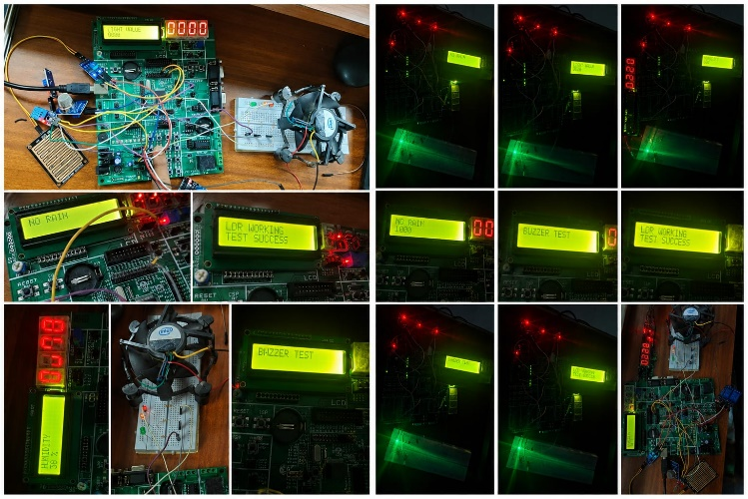
Output Photos :

