1.select Month(HireDate),count(*) from [HumanResources].[Employee] group by Month(HireDate;

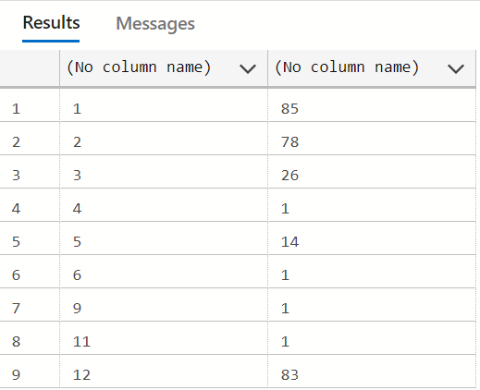

select * from employee

DECLARE @date datetime2 = '2018-07-01';

SELECT FORMAT(@date, 'MMMM') AS ;

10.select Name from Production UNION select CreditCardID from Sales where OrderDate=ExpMonth ;

9.select CountryRegionCode RANK() OVER (ORDER BY EndOfDayRate) rank from Sales;

8.

7.select concat(FirstName,' ',MiddleName,' ',LastName) as

Name from Person UNION select top 25 percent * from Sales order by UnitPriceDiscount DESC;

6.

5.select ProductID,Name from Production UNION select sum(ActualCost),sum(Quantity) from Production group by TransactionDtae;

4.select concat(FirstName,' ',MiddleName,' ',LastName) as

Name from Person UNION select JobTitle,OrganizationLevel from HumanResources;

3.

2.select Name from Department UNION select count(BusinessEntityID) group by DATE_FORMAT(HireDate,'%y');

1.select Month(HireDate),count(LoginID) from Employee group by DATE_FORMAT(HireDate,'%m');