ARIMA-powered Smart Recommendations: A Personalized Approach for Owners

Marisetti Harshini
Department of Artificial Intelligence
&Machine Learning Vardhaman College of Engineering Hyderabad-Telangana, 501286, India
marisettiharshini2005@gmail.com

Durgam Nikitha
Department of Artificial Intelligence
&Machine Learning Vardhaman College of Engineering Hyderabad-Telangana, 501286, India
nikithadurgam9631@gmail.com

Naveen Nandigam
Department of Artificial Intelligence
&Machine Learning Vardhaman College of Engineering Hyderabad-Telangana, 501286, India
naveennandhoge@gmail.com

Kantekar Pavan
Department of Artificial Intelligence
&Machine Learning Vardhaman College of Engineering Hyderabad-Telangana, 501286, India
kantekarpavan@gmail.com

Enjamuri Vamshi
Department of Artificial Intelligence
&Machine Learning Vardhaman College of Engineering Hyderabad-Telangana, 501286, India
Vamshienjamuri1@gmail.com

Dr. Popuri Ramesh Babu
Dean & professor Department of Computer Science and Engineering
Malineni Lakshmaiah Women's Engineering College Pulladigunta Guntur- 522017
popuri.ramesh2006@gmail.com

Abstract—Loss of revenue for retail owners is often caused because of stockouts or excess stocks. So our idea is to predict the product sales and demand forecasts for the owners. Our paper presents a smart recommendation system that not only provides sales forecasting but also connects demand prediction with inventory management guidance. Smart recommendation system we designed can be adjusted according to the users preference, like recommendations based on product category wise or month wise. We tested and evaluated the model using a public sales dataset The ARIMA model achieves an MAE of 1.15, a MAPE of 8.62%, and an RMSE of 2.34. It also reduces stockout occurrences by about 12% when compared to a seasonal-naive baseline. These metrics show the practicality and effectiveness of our approach in helping retailers make data-driven inventory decisions.
Keywords—ARIMA model, smart recommendation system, demand forecasting, sales management

Introduction
Sales management has been a major challenge for retail owners because stock outs and excess stocks effect the daily business, profits, customer- satisfaction. More stock leads to increase of storage costs and unnecessary waste and running out of items can cause missed sales and loss of customers trust. Traditional forecasting approaches usually fail in capturing seasonal variations and also sudden changes in demand this creates more difficulties for small and medium-sized retailers. These businesses require accurate forecasting solutions which are simple to use, and easy to understand, also practical for daily decisions.
AIMA models are usually known for its effectiveness in time series forecasting. But in recent times this model is used only for demand forecasting without making those forecasts into key insights. So to bridge this gap between sales forecasting and demand prediction our idea takes over. Our smart recommendation system not only forecasts the sales but also predicts the demand of the products.
The goal of the project is to develop an recommendation system that will utilize ARIMA for precise demand forecasting as well as for making inventory quantity recommendations. The intelligent recommendation system employed a publicly available retail dataset with rolling- origin out-of-sample validation technique that generated a mean absolute error of 1.15, mean absolute percentage error of 8.62%, and root mean squared error of 2.34. Our smart recommendation system reduced stockout occurrences by an improvement of 12% - in comparison to a seasonal naive baseline. Based on these outcomes we can say that this recommendation system can be for making effective decisions and it offers actionable insights hat can be used by retail owners to increase their revenue, profits and stability.

Literature Review
RSs have been an essential tool that can enable unwanted content removal and push personalized information through context-rich, mobile, personalized, and action-oriented applications [1]. Smart Recommendations are precious to the property owner as an Intelligent Recommendation System combining text mining and image recognition in a developer- centric fashion. Smart recommendation systems have the ability to find the ideal property for renovation in just two minutes [2].
In contrast to ARIMA's prowess in modeling linear time- series patterns, Chatterjee et al. (2021) used NLP and LSTM for stock prediction [3]. Utilizing the power of Smart Recommendations, the system acts as your personal farm advisor in the interim. In keeping with the spirit of Smart Recommendations elsewhere, the system provides a customized and intelligent approach to crop farming.
Because it considers the specific circumstances of your land as well as prior experience, it goes beyond simple recommendations [4]. The basic idea of using data analysis to optimize decision-making connects SARIMA wind speed forecasting to the broader concept of Smart Recommendations, despite the fact that applications vary [5]. In a broader sense, a review article explains how employing cognitive and neural modeling of the user's behavior can make Smart Recommendations even more powerful. To find the right products, Smart Recommendations use user data. Because they consider the psychological and emotional aspects of decision-making, Smart Recommendations generally have a wider scope than traditional recommendation systems. Incorporating neural models into the Smart Recommendations process makes personalized recommendations much more effective and highly targeted while also improving the user experience during product shopping [6].

Title (with Author) | Key Features | Limitations This Paper Addresses
Katarya- Towards the significance of taxi recommender systems in smart cities | Focuses on taxi-based recommender systems integrated with smart city infrastructure. | Lacks time-series forecasting; this paper integrates  ARIMA for dynamic, time-aware personalization.
Ou et al.- An Intelligent Recommendation System for Real Estate Commodity | Uses rule-based and multi-criteria decision techniques for real estate. | Static logic; this methodology introduces dynamic, data- driven recommendations using time series analysis.
Chatterjee et al.- An NLP and LSTM based stock prediction and recommender system | Combines NLP and LSTM for financial market prediction. | High computational cost and less interpretability; this approach uses lightweight, interpretable ARIMA.
Hasan et al.- Ensemble ML-based recommendation for agriculture | Ensemble-based ML model to recommend crops based on agricultural factors. | Complex and domain-specific; this paper presents a simpler, adaptable model for broader recommendation use cases.
Liu et al.- Short-term offshore wind speed forecast by seasonal ARIMA, GRU, and LSTM | Compares ARIMA with deep learning models for weather forecasting. | Focused on environmental forecasting only; this methodology applies ARIMA in a recommendation context.
Skulimowski - Cognitive content recommendation in digital repositories | Surveys cognitive and semantic recommendation systems. | Lacks concrete implementation; this paper offers a  practical and time-series-based solution.
Sheng & Hu- A Multi-Stage Planning Method for Distribution Networks Based on ARIMA | Energy source load prediction using ARIMA and error scanning. | This method, which is restricted to energy planning, uses ARIMA to provide tailored user recommendations.
Anagnostopoulos - A predictive vehicle ride- sharing recommendation system for smart cities | Predictive system for ride-sharing in smart cities. | Focuses on public transport; this paper targets owner- centric recommendations with time-aware forecasting.
Latif et al. - A smart technique to forecast Karachi stock market share-values using ARIMA | Forecasts stock values using the ARIMA model. | Solely forecasting; this methodology embeds ARIMA into a full recommendation framework.
Nasution et al. - Contextual route recommendation system in heterogeneous traffic flow | Context-aware routing based on traffic patterns. | Spatially dependent; this paper focuses on non-spatial, ownership-driven personalization.

Intelligent recommendations have been associated with source-load prediction methods that enhance grid evolution planning [7]. Additionally, they are used to analyze user movement patterns and suggest the most suitable partners for commuting [8]. Numerous studies highlight their potential to improve user convenience and recommendation accuracy [9]. By guiding users toward better travel routes, knowledge-driven approaches increase efficiency [10]. Compared to memory-based methods, these systems provide more accurate search results [11].
Seasons, demographics, purchasing patterns, profits, and reviews are all taken into consideration when making smart retail recommendations, as Chatzidimitris et al. showed [12]. Recommendations are tailored by deep learning and decision analytics based on user profiles and future behavior [13]. Expert systems were not as accurate as case studies [14]. In order to extract seasonality and trends for effective demand forecasting, Raza et al. used ensemble learning with ARIMA [15].
By modifying model parameters to produce an optimized recommendation system, John Joseph et al. demonstrated the efficacy of ARIMA in market-specific predictions [16]. ARIMA was used by Kumar et al. to predict COVID-19 cases [17]. Its use in hybrid frameworks for wind power forecasting was demonstrated by Haque et al. [18]. ARIMA was utilized by Bessa et al. to forecast solar power for smart grids [19]. Because of its domain-independency, Yang et al. highlighted its applicability in intelligent recommendation systems [20]. The impact of ARIMA on forecasting electricity consumption and its potential for broad industrial applications were highlighted by Gellert et al. [21]. Han et al. compared deep learning methods with ARIMA and clarified that while neural networks can understand complex temporal patterns, ARIMA is still easier to use in real-world scenarios [22]. Its pillar status in financial time series was confirmed by Ariyo et al.'s testing of its efficacy in stock price forecasting [23]. Alzahrani et al. illustrated the appropriateness of ARIMA in forecasting COVID-19 spread in Saudi Arabia [24], while Khan and Gupta used it to enhance its predictability by combining it with nonlinear autoregressive neural networks to better analyse trends [25].

Existing Methodology
The ARIMA system emphasizes the statistical advantages of the ARIMA model, but current models alone can employ a variety of explanations of methodologies for machine learning. More general inventory management features, like the equity prosecutor, are offered by the ML-based system. It might be necessary to use more sophisticated data technologies and algorithms. Periodic patterns were extracted using seasonal ARIMA variations, and extensions like ARIMA were taken into consideration to increase accuracy. By identifying nonlinear patterns in continuous data, machine learning algorithms such as LSTM (long short-term memory) and GRU (gate recurrence units) perform better than traditional methods for complex time-range tasks. In fields like agriculture, ensemble learning models combine multiple factors to produce compelling suggestions.

Flow Chart
The Fig.1 is the flowchart that represent a modular and layered structure of the ARIMA-driven Smart Recommendation System, allowing for personalized and data-based inventory management for the owners of retail stores.
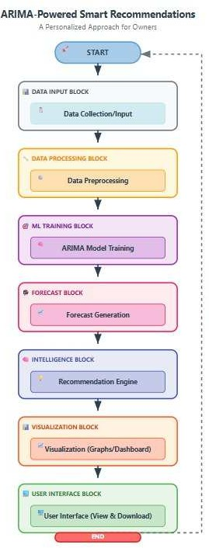
- Workflow of Model

Proposed Methodology
This application uses the ARIMA model to predict upcoming sales and suggest ideal stock quantities. Interactive visualizations are incorporated to graphically present forecasted sales patterns and stock suggestions. ARIMA was chosen due to its statistical explainability, simple deployment, and appropriateness for small and medium-sized businesses over deep learning methods like LSTM or GRU.

Data Collection and Preprocessing
Historical sales data with timestamps, product IDs, sales quantities, and inventory sizes are gathered. Preprocessing involves missing value handling, outlier removal, timestamp normalization, and product categorization in a consistent manner. Seasonal and trend parts are isolated, and the preprocessed dataset is reshaped to a time-indexed series suitable for ARIMA modeling.
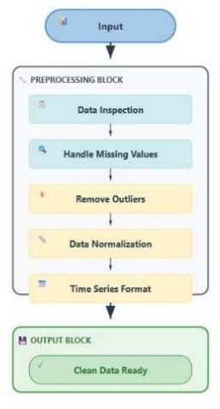
- Data preprocessing
The pipeline shows that raw data are feature-engineered (lag values, rolling means, season indices), normalized, and cleaned prior to storage for ARIMA-based forecasting and recommendations.

ARIMA Model
ARIMA (Auto Regressive Integrated Moving Average) is chosen for statistical interpretability, minimal computational complexity, and robust performance in univariate time- series prediction. Against deep learning techniques like LSTM or GRU, ARIMA provides more transparency, quicker training times, and simpler deployment and is thus a good choice for small and medium-scale organizations. The parameters (p, d, q) are chosen by applying ACF/PACF plots and auto-ARIMA search strategies to minimize error based on AIC/BIC values.

Experimental Setup
We evaluate our system using the Kaggle Retail Sales Forecasting dataset, which contains monthly product-level sales records. We produce projections for the upcoming time frame. We collect forecast errors for every window. ARIMA is contrasted with two baselines: Naive forecast: This makes the assumption that demand will be the same as it was in the previous period. The seasonal-naive forecast is based on the assumption that demand will be the same as it was at the same point in the previous season. We use evaluation metrics like root mean square error (RMSE), mean absolute error (MAE), and mean absolute percentage error (MAPE). These metrics assess accuracy as both scale dependent and scale independent.

Time Series Forecasting
We use three well-accepted time-series error metrics – root mean square error (RMSE), mean absolute error (MAE) and mean absolute percentage error (MAPE) – to evaluate the suggested system's forecasts accuracy. RMSE weighs larger errors more heavily; it demonstrates the discrepancy between the forecasts and actual values. RMSE shows the error distance between the forecasts and actual values and it weighs larger errors significantly more. MAE as an average absolute forecast error is scale dependent. MAPE demonstrates forecast accuracy as a percentage which allows an implied comparison of results across different product categories.
We evaluate the model using a rolling-origin out-of-sample validation methodology. At each step, we generate forecasts of the next period by fitting the ARIMA model on an expanding window of historical data. All forecast errors are considered in the final accuracy scores.

Smart Recommendation Engine
The forecast results are fed into a recommendation engine that compares the predicted demand with the stock currently available. From this, the system suggests how much needs to be updated and includes a small safety margin to handle unexpected increases in demand. The products are then ordered by priority, focusing first on items that are close to running out or showing a sharp rise in demand. Figure 3 illustrates how the system compares predicted sales with the available inventory to generate useful restocking suggestions, which are then presented through simple reports and dashboards.
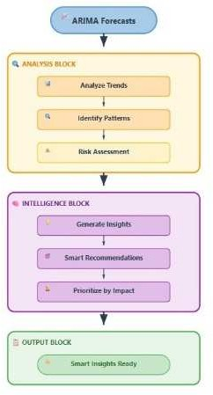
- Steps involved in the smart recommendation system

Interactive Visualization and Reporting
To help users interpret the results more easily, the system provides interactive visualizations built with tools such as Matplotlib and Plotly. These charts present past sales trends, expected future demand, and the current stock levels for each product. Important insights are displayed through user-friendly dashboards that give business owners an easy-to-use interface.

System Integration and User Interface
The ARIMA-based recommendation engine is presented through a simple, easy-to-use interface where store owners can upload their data or connect it to their existing sales systems. The interface offers simple features like uploading data, running forecasts, and checking the visual outputs. As our smart recommendation system doesn’t need any complex technical setup it can be used by any small and medium retail stores.

Performance Evaluation and Continuous Improvement
We evaluated the performance of our ARIMA- based smart recommendation system by few metrics like Mean Absolute Error, Root Mean Square Error and Mean Absolute Percentage Error. Continuous evaluation of these metrics helps us understand the consistency of models performance. Our recommendation system is updated regulary so that it can adapt to new data and the change in data patterns. In future we can integrate this ARIMA model with machine lerning techniques, so that it can handle complex data.
Overall, our smart recommendation system is easy to handle for shop owners who want to track their sales and understand the future sales to improve their business. Our recommendation system gives them a detailed information on what products to be stored in the strore, so they don’t end up storing more or less stocks. This model adjusts itself whenever new sales numbers come in so it keeps up with the latest trends instead of depending only on old data. This smart recommendation system gives businesses a competitive advantage when they understand the predictive capabilities of the model.

Results
We implemented the ARIMA-based smart recommendation system forecasting future sales of products in each product category, for upcoming ten months, through the best-selling items. The structured dataset is collected and processed for the testing of smart recommendation system[26]. The ARIMA model was able to point out which products in each category were likely to sell the best in the mall. As we explored the data and trained the model, certain patterns and trends became clear, helping us make more accurate predictions. The list of products expected to have higher demand gave mall owners and other stakeholders useful information across different departments, including groceries, electronics, fashion, and several others.
- Forecasting Performance of ARIMA vs. Baselines
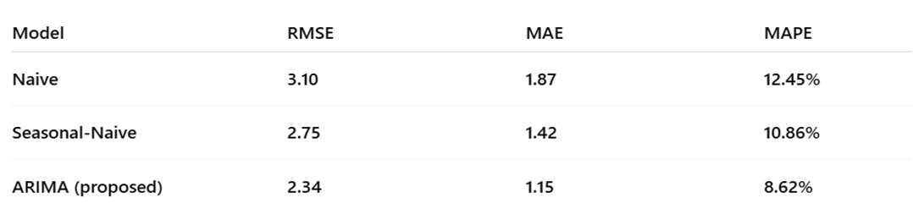
Table II compares ARIMA with baseline forecasting methods. Across all error measures, ARIMA shows better performance than both the naive and seasonal-naive models. For example, the seasonal-naive approach records an RMSE of 2.75, MAE of 1.42, and MAPE of 10.86%, while ARIMA achieves lower values of 2.34, 1.15, and 8.62% respectively. Using ARIMA also reduces stockout occurrences by nearly 12% compared with seasonal-naive forecasting. 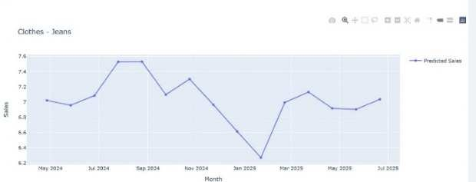
- Monthly sales trends

- Statistical analysis of sales
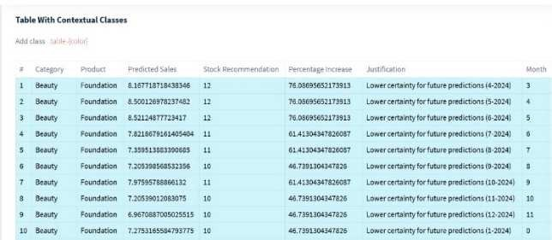
- predicted sales trends across product categories
As shown in Fig. 4, the model successfully tracks monthly sales patterns, which improves demand forecasting. Fig. 5 shows the spread and variation of sales among different products, that helps to identify fluctuations. Fig. 6 presents predicted sales trends across several product groups, highlighting times of high demand and encouraging more effective inventory management. Overall, these findings show how the system can influence restocking choices and improve the effectiveness of inventory management.
The ARIMA model predictions can be taken as a strategic choice for mall managers and owners to predict their most- selling products. Moreover, they can replenish the high- speed sellers and avoid overstocking the slower moving products or the out-of-fashion products; utilizing the shelf space more efficiently, cutting costs, and avoiding possible stockouts. In any case, when mall operators manage their inventory according to demand as well as buying habits, they will enhance customer satisfaction, loyalty and, finally, profitability. For this purpose, predictive analytics will allow managers to shift from reactive inventory strategies to a proactive strategy for long-term success in a competitive environment.

Conclusion
In conclusion, this study has proposed an intelligent recommendation engine powered by ARIMA. For retail businesses, it turns time-series forecasting into practically- able inventory usefulness. The system showed good predictive accuracy with an RMSE of 2.34, an MAE of 1.15, and a MAPE of 8.62 percent. In comparison to seasonal- naive forecasting, it also decreased stockout incidents by 12%. These results demonstrate that by enhancing stock stability and lowering overstock, ARIMA-based forecasting can offer significant advantages. Although the forecasting engine's validation was the main goal of this study, future research will add time-aware personalization and richer baselines to the system. This will enhance its application in actual retail settings even more.

References
- Katarya, R. (2023). Towards the significance of taxi recommender systems in smart cities. Concurrency and Computation: Practice and Experience, 35(2), e7475.
- Ou, T. Y., Lin, G. Y., Fu, H. P., Wei, S. C., & Tsai, W. L. (2022). AnIntelligent Recommendation System for Real Estate Commodity. Comput. Syst. Sci. Eng., 42(3), 881-897.
- Chatterjee, I., Gwan, J., Kim, Y. J., Lee, M. S., & Cho, M. (2021). An NLP and LSTM based stock prediction and recommender system for KOSDAQ and KOSPI. In Intelligent Human Computer Interaction: 12th International Conference, IHCI 2020, Daegu, South Korea, November 24–26, 2020, Proceedings, Part I 12 (pp. 403-413). Springer International Publishing.
- Hasan, M., Marjan, M. A., Uddin, M. P., Kardy, S., & Nam, Y. (2023). Ensemble machine learning-based recommendation system for effective prediction of suitable agricultural crop cultivation. Frontiers in Plant Science, 14, 1234555.
- Liu, X., Lin, Z., & Feng, Z. (2021). Short-term offshore wind speed forecast by seasonal ARIMA-A comparison against GRU and LSTM. Energy, 227, 120492.
- Skulimowski, A. M. (2017). Cognitive content recommendation in digital knowledge repositories–a survey of recent trends. In Artificial Intelligence and Soft Computing: 16th International Conference, ICAISC 2017, Zakopane, Poland, June 11-15, 2017, Proceedings, Part II 16 (pp. 574-588). Springer International Publishing
- Sheng, Y., & Hu, M. (2022). A Multi-Stage Planning Method for Distribution Networks Based on ARIMA with Error Gradient Sampling for Source–Load Prediction. Sensors, 22(21), 8403.
- Anagnostopoulos, T. (2021). A predictive vehicle ride sharing recommendation system for smart cities commuting. Smart Cities, 4(1), 177-191.
- Latif, R. M. A., Naeem, M. R., Rizwan, O., & Farhan, M. (2021, December). A smart technique to forecast karachi stock market share- values using ARIMA model. In 2021 International Conference on Frontiers of Information Technology (FIT) (pp. 317-322). IEEE.
- Nasution, S. M., Husni, E., Kuspriyanto, K., Yusuf, R., & Yahya, B. N. (2021). Contextual route recommendation system in heterogeneous traffic flow. Sustainability, 13(23), 13191.
- Satapathy, S. M., Jhaveri, R., Khanna, U., & Dwivedi, A. K. (2020). Smart rent portal using recommendation system visualized by augmented reality. Procedia Computer Science, 171, 197-206.
- Chatzidimitris, T., Gavalas, D., Kasapakis, V., Konstantopoulos, C., Kypriadis, D., Pantziou, G., & Zaroliagis, C. (2020). A location history-aware recommender system for smart retail environments. Personal and Ubiquitous Computing, 24, 683-694.
- Manikandan, K. N., Saranya, A., Deetshiha, D. J., Sushmitha, K., Dharani, D., Anitha, V., & Kalaiselvi, S. (2022, March). Intelligent sales prediction using ARIMA techniques. In AIP Conference Proceedings (Vol. 2444, No. 1). AIP Publishing.
- Colomo-Palacios, R., García-Peñalvo, F. J., Stantchev, V., & Misra, S. (2017). Towards a social and context-aware mobile recommendation system for tourism. Pervasive and Mobile Computing, 38, 505-515.
- Raza, M. Q., Nadarajah, M., & Ekanayake, C. (2017). Demand forecast of PV integrated bioclimatic buildings using ensemble framework. Applied energy, 208, 1626-1638.
- Hernandez, R. M., Castillo, J. J., Ragasa, A. A., Mendez, C., & Agdon, F. (2023, October). Energy Consumption Forecasting for Smart Industry Using Auto-Regressive Integrated Moving Average (ARIMA) and Vector Auto-Regression (VAR) Model. In Proceedings of the 8th International Conference on Sustainable Information Engineering and Technology (pp. 129-136).
- Kumar, M., Gupta, S., Kumar, K., & Sachdeva, M. (2020). Spreading of COVID-19 in India, Italy, Japan, Spain, UK, US: a prediction using ARIMA and LSTM model. Digital Government: Research and Practice, 1(4), 1-9.
- Haque, A. U., Mandal, P., Nehrir, H. M., Bhuiya, A., & Baker, R. (2014, November). A hybrid intelligent framework for wind power forecasting engine. In 2014 IEEE Electrical Power and Energy Conference (pp. 184-189). IEEE.
- Bessa, R. J., Trindade, A., & Miranda, V. (2014). Spatial-temporal solar power forecasting for smart grids. IEEE Transactions on Industrial Informatics, 11(1), 232-241.
- Yan, S. R., Pirooznia, S., Heidari, A., Navimipour, N. J., & Unal, M. (2022). Implementation of a product-recommender system in an IoT- based smart shopping using fuzzy logic and apriori algorithm. IEEE Transactions on Engineering Management.
- Gellert, A., Fiore, U., Florea, A., Chis, R., & Palmieri, F. (2022). Forecasting electricity consumption and production in smart homes through statistical methods. Sustainable Cities and Society, 76, 103426.
- Han, Z., Zhao, J., Leung, H., Ma, K. F., & Wang, W. (2019). A review of deep learning models for time series prediction. IEEE Sensors Journal, 21(6), 7833-7848.
- Ariyo, A. A., Adewumi, A. O., & Ayo, C. K. (2014, March). Stock price prediction using the ARIMA model. In 2014 UKSim-AMSS 16th international conference on computer modelling and simulation (pp. 106-112). IEEE.
- Alzahrani, S. I., Aljamaan, I. A., & Al-Fakih, E. A. (2020). Forecasting the spread of the COVID-19 pandemic in Saudi Arabia using ARIMA prediction model under current public health interventions. Journal of infection and public health, 13(7), 914-919.
- Khan, F. M., & Gupta, R. (2020). ARIMA and NAR based prediction model for time series analysis of COVID-19 cases in India. Journal of safety science and resilience, 1(1), 12-18.
- Kaggle, Retail Sales Forecasting Dataset, available at: https://www.kaggle.com/datasets/tevecsystems/retail-sales- forecasting

