The Lead Management System is a robust platform designed to streamline the management and tracking of leads within an organization.
- Seamless Lead Flow: Centralizes lead data for easier management and tracking across roles.
- Role-based Access: Ensures that admins and counsellors only have access to the relevant data.
- Performance Tracking: Admin dashboard provides key metrics for better decision-making.
- Task Management: Counsellors can efficiently follow up on leads and update statuses.
- Automation & Notifications: Automates key processes like email communication and instant feedback.
- Security & Integrity: Strong password recovery, validation rules, and role-based security ensure data safety and system reliability.

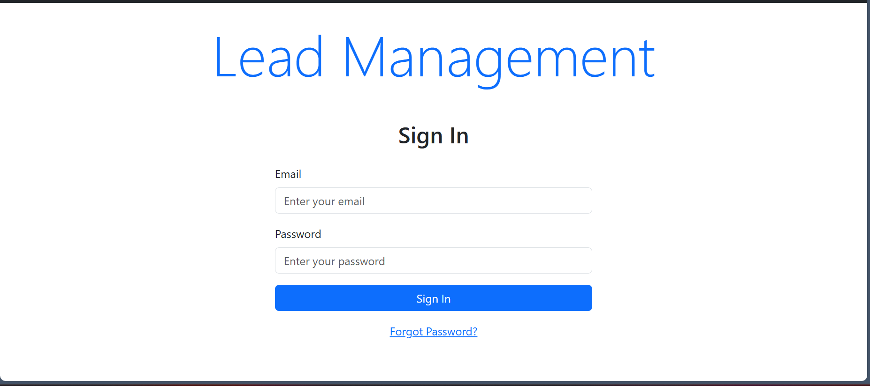
Login Form:
- Email Field: Enter your email address here.
- Password Field: Enter your password here securely.
- Sign In Button: Click this blue button to log in.
- Forgot Password Link: If you forget your password, click this link to reset it.

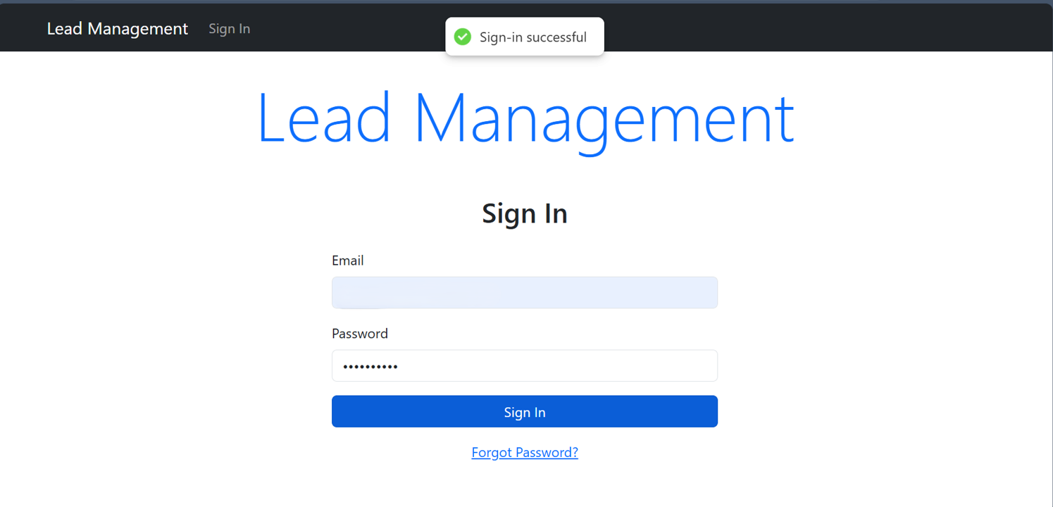
After successful login we can see a sign-in successful message and it will redirect to the logged in respective dashboard.
If the logged in user is ADMIN then it will redirect to admin dashboard or if the user is COUNSELLOR then it will redirect to counsellor dashboard.

Admin Dashboard
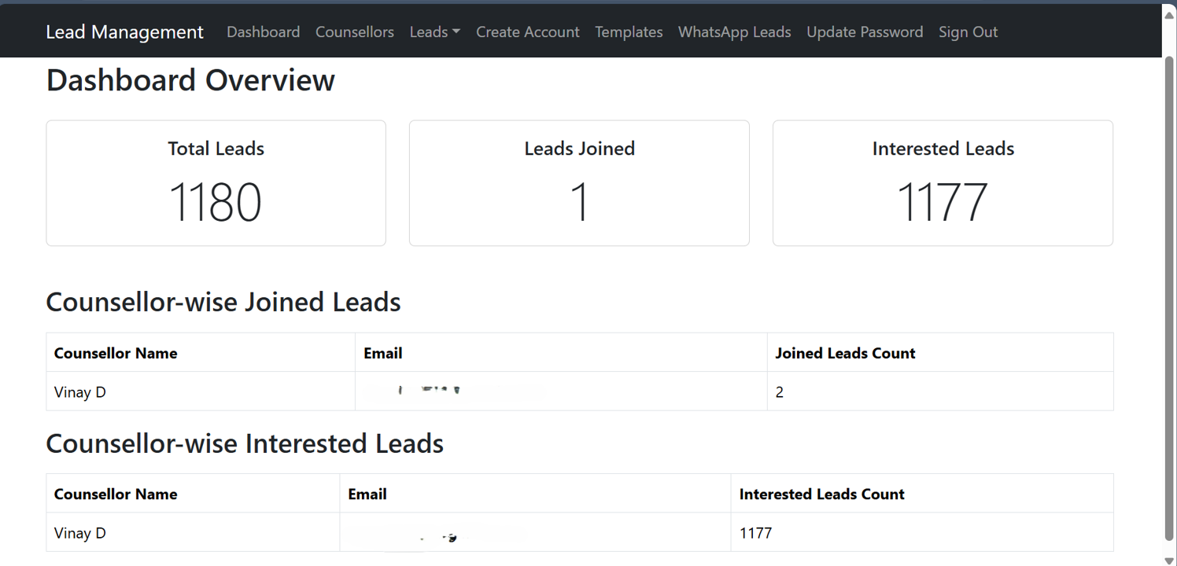
After successful login the system will redirect to admin dashboard where the admin can see the overview of the leads and counsellors.
Dashboard Overview :
- Total Leads: Displays the total number of leads present in the system (e.g., 1180).
- Leads Joined: Shows the total number of leads that have joined (e.g., 1).
- Interested Leads: Displays the number of leads marked as interested (e.g., 1177).
Counsellor-Wise Joined Leads:
- Counsellor Name: Lists the names of counsellors handling the leads.
- Email: Shows the counsellor's email for identification.
- Joined Leads Count: Displays the number of leads joined under each counsellor
Counsellor-Wise Interested Leads:
- Counsellor Name: Lists the counsellors.
- Email: Displays the email addresses of the counsellors.
- Interested Leads Count: Shows the count of leads marked as interested for each counsellor

Counsellor menu
Navigation bar > Counsellor menu
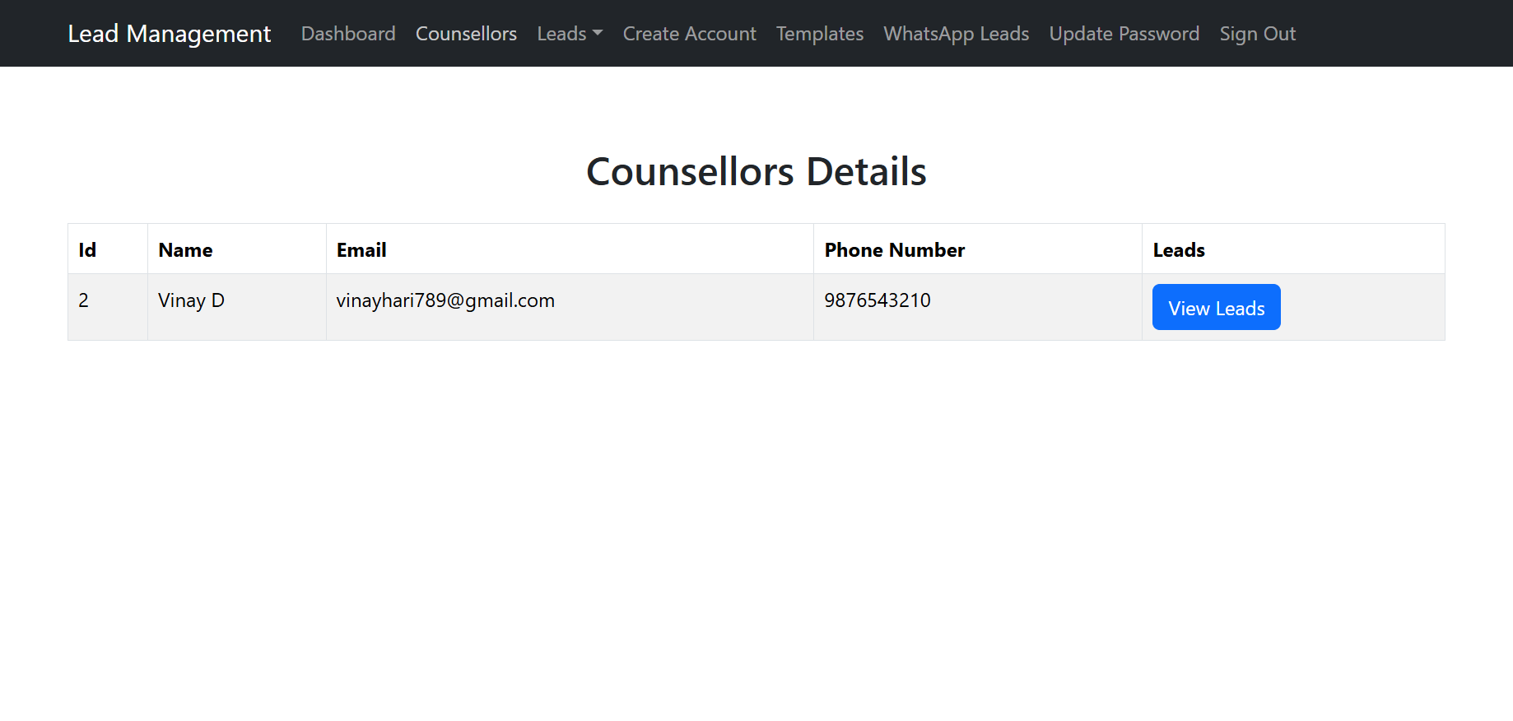
From the counsellor tab we can see all the counsellor details like name, email, phone number.
To view the leads who are assigned to this specific counsellor click on “View Leads” button.

Counsellor Details
Navigation bar > Counsellor Details table > View Leads button
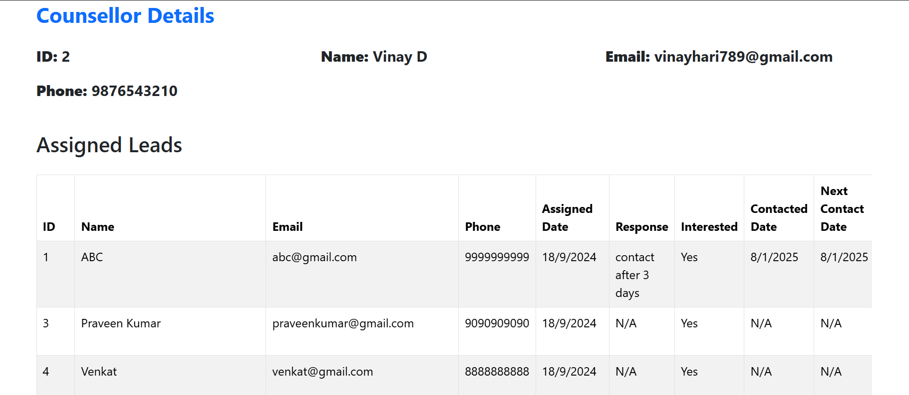
On clicking the button view leads from the View Leads button it will navigate to another page where all the leads who are assigned to this counsellor will be visible.
In this Assigned leads table admin can able to see and get to know lead wise progress of the counsellor.
Leads Dropdown

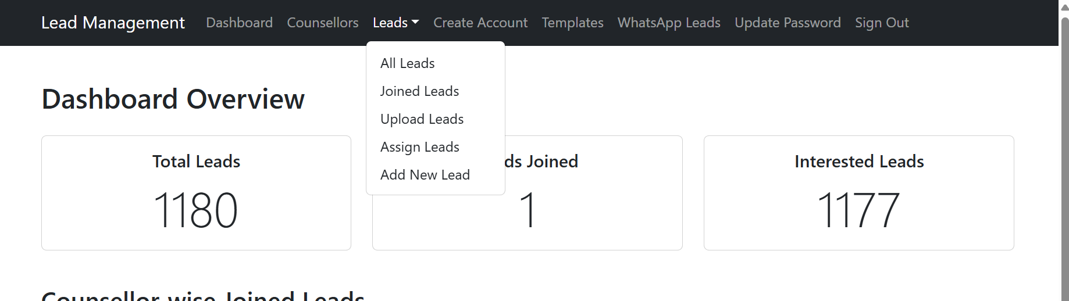

From the navigation click on Leads Dropdown and select “All Leads”

All Lead Details

Navigation Bar > All leads
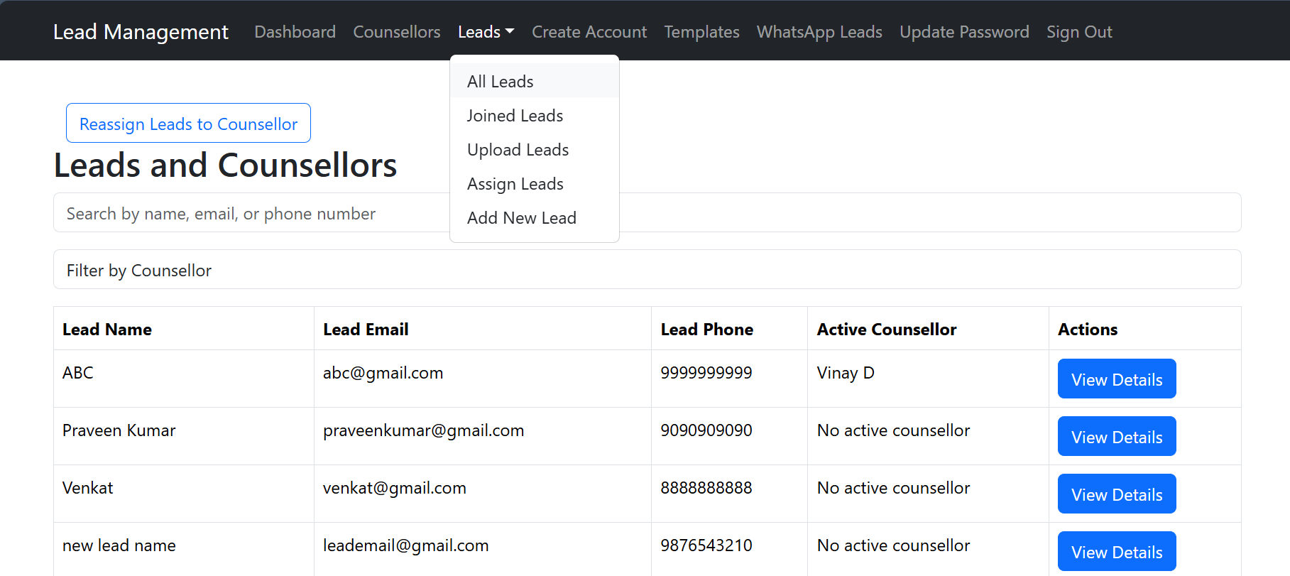
To view the lead wise counsellor details click on “View Details” button.
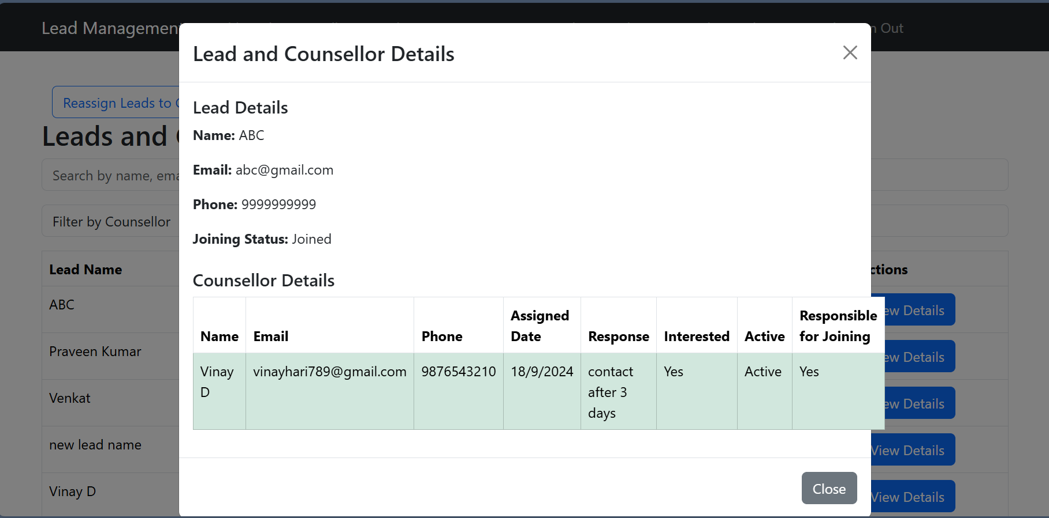

Reassign lead to a counsellor
Navigation bar > Leads (dropdown) > All Leads (click on Rassign Leads to Counsellor ) button
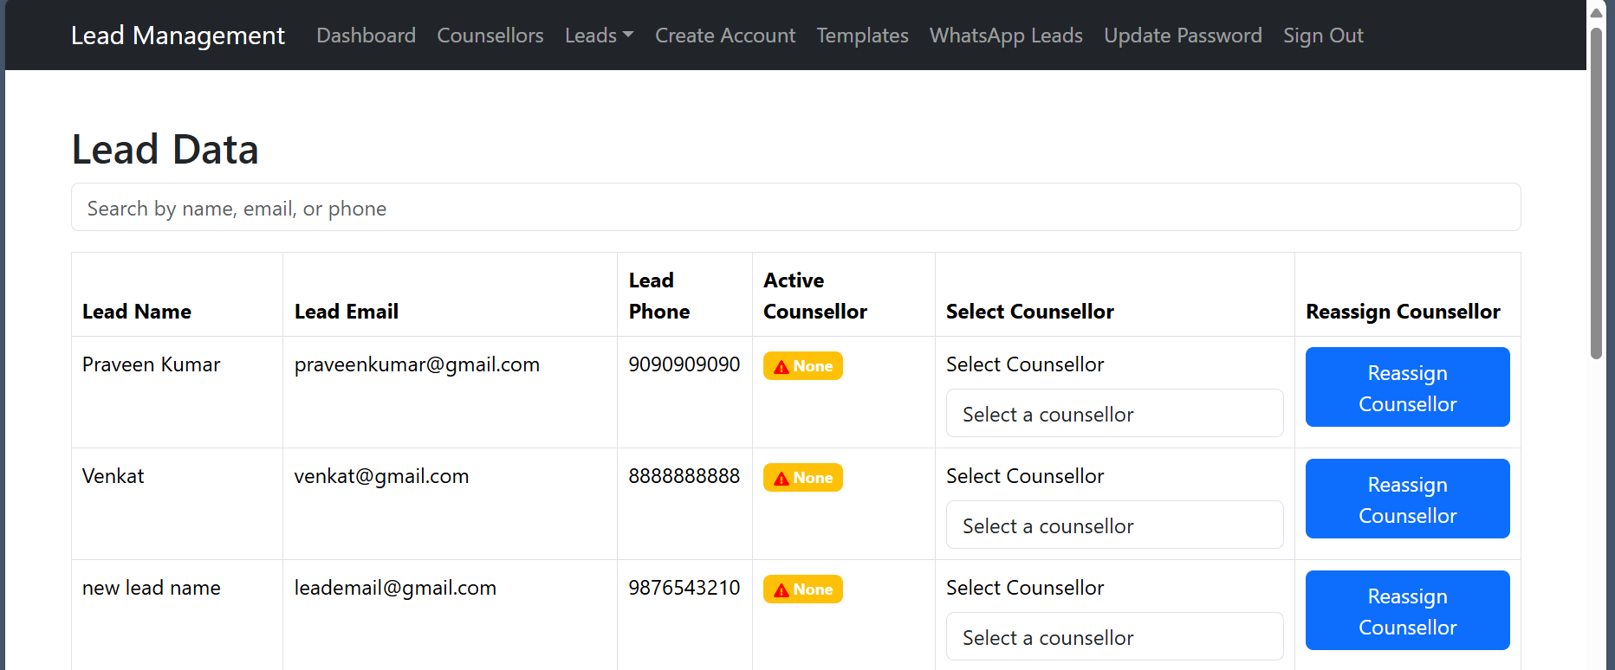

To reassign a lead to a counsellor:
Select the counsellor from the select menu and click on Reassign Counsellor button

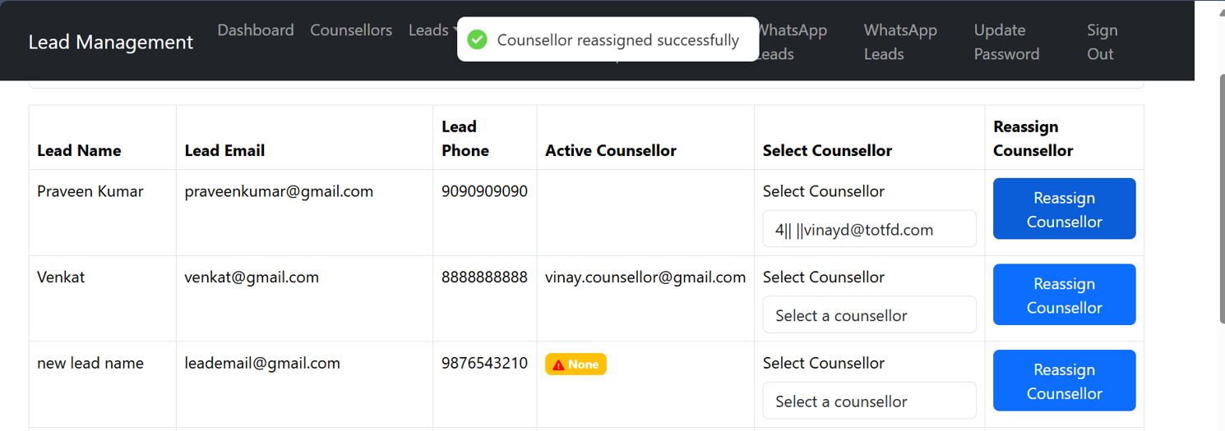
After successfully assigning the lead to a counsellor a success message will be displayed.

Joined Leads Details
Leads (dropdown)> Joined Leads
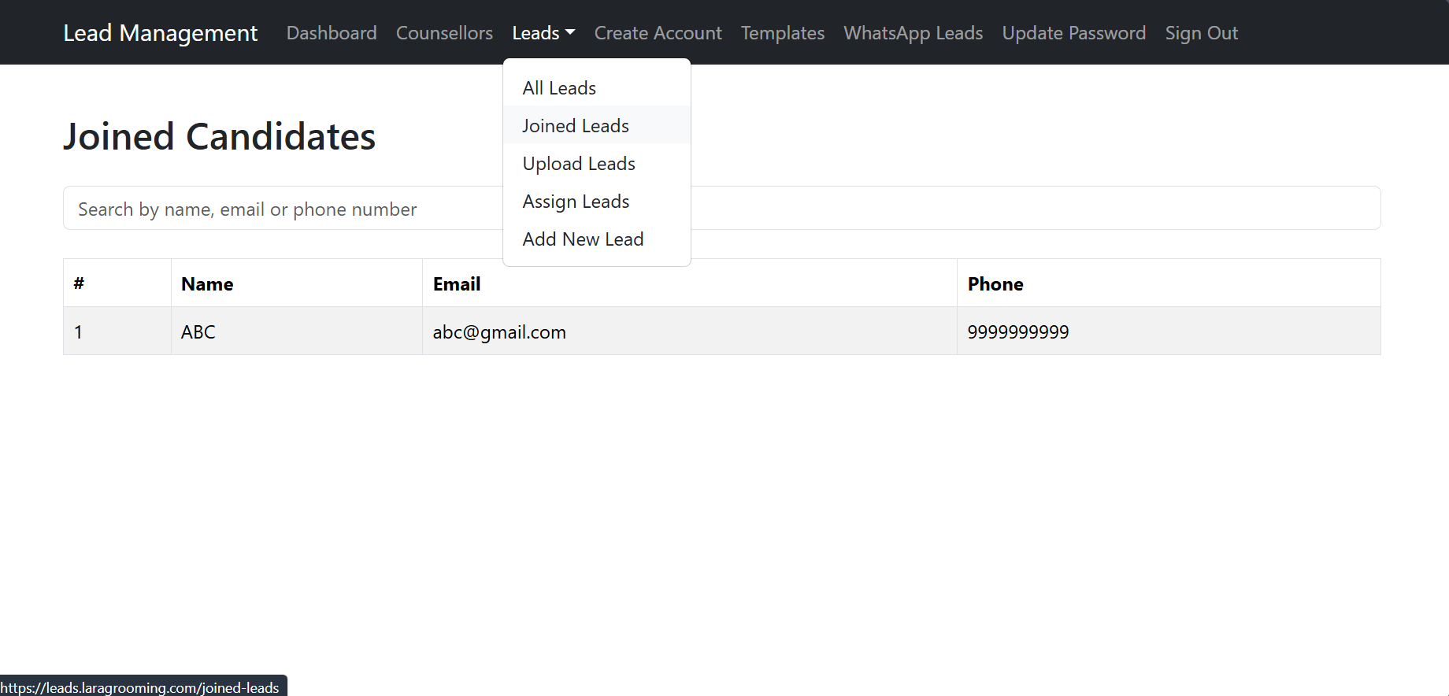
To see all the leads that were joined to the business or purchased the product related the business.

Upload leads through Excel sheet
Leads(dropdown) > Upload Leads
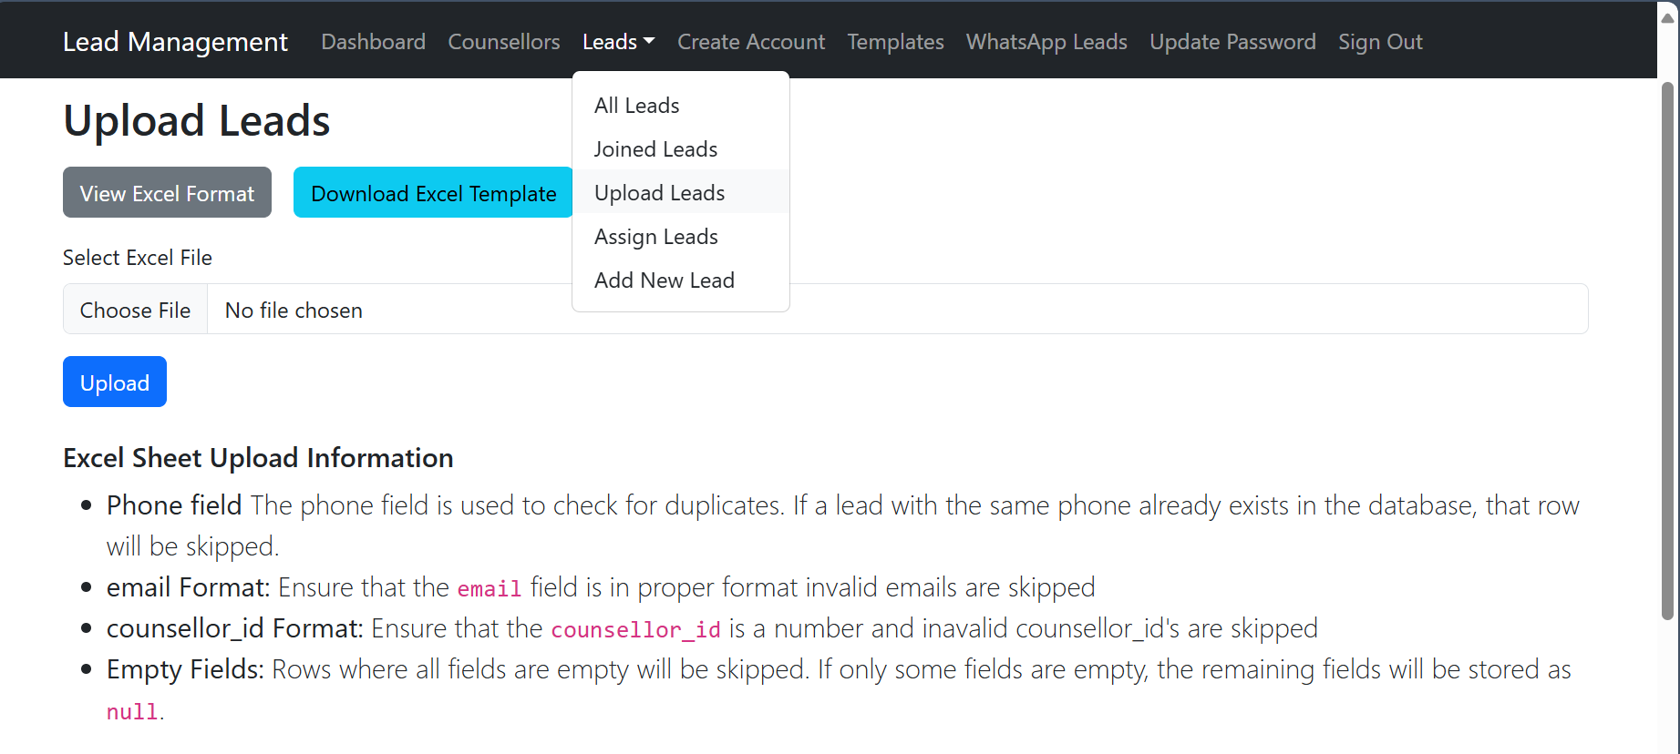
View Excel Format : Displays example excel sheet format image.
Download Excel Template : Downloads the excel file in the given format.
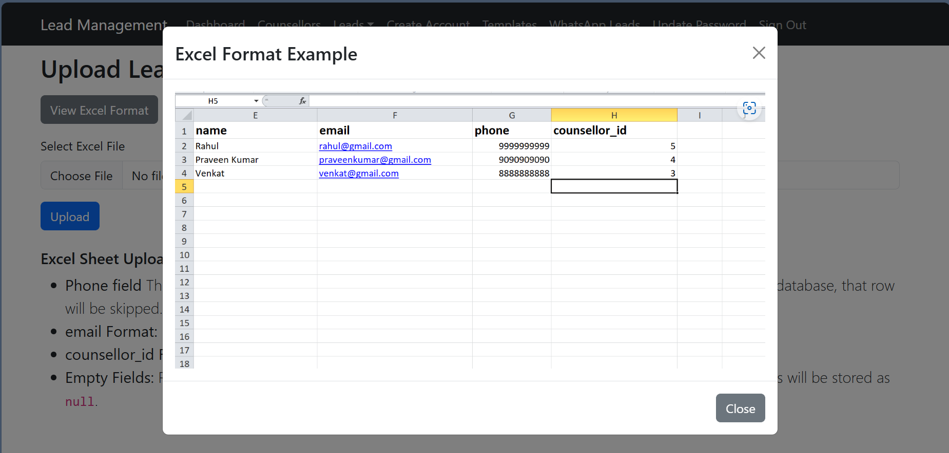

For the excel sheet we have to provide the counsellor_id.
Here counsellor id the unique number given for a counsellor based on this id from the excel sheet the leads for counsellor will be assigned.
Counsellor Details with id for reference
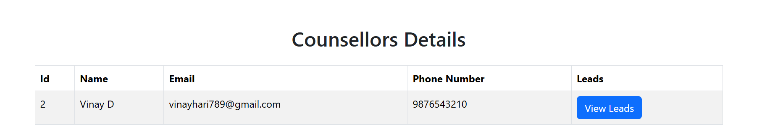

Adding the lead one by one
Leads(dropdown) > Add New Lead
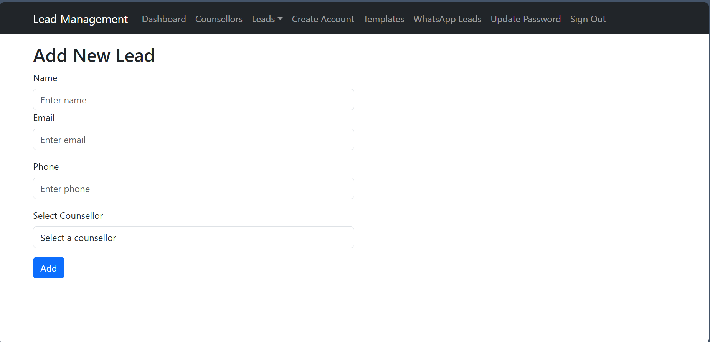
After adding the lead successfully a message will be displayed.
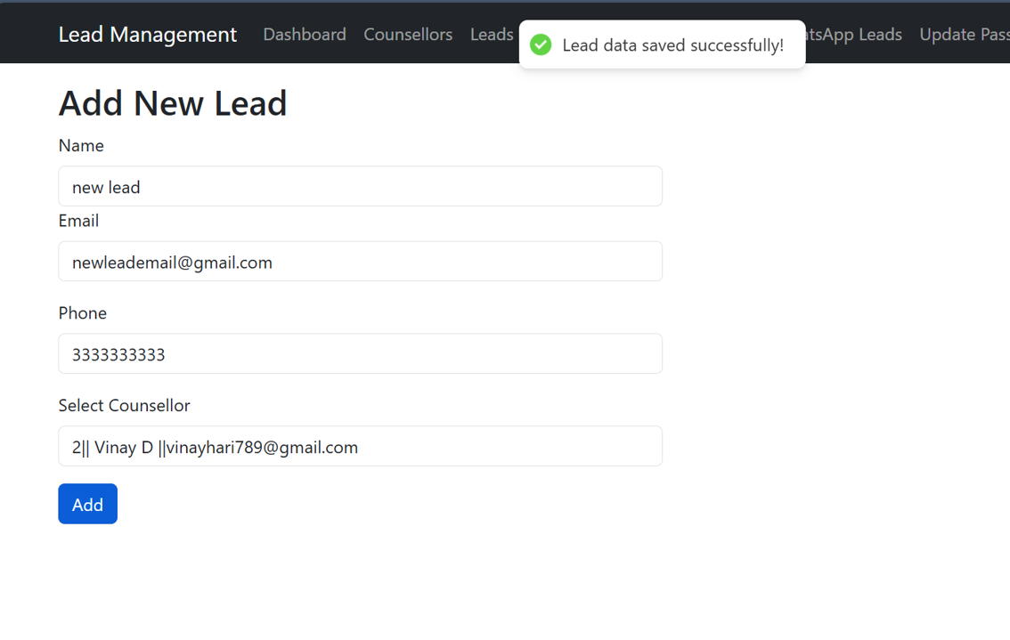

Create Account for counsellor
Navigation bar > Create Account
When a counsellor's email address and phone number are provided, the system will automatically create an account for the counsellor with a temporary dummy password. A confirmation email containing the counsellor's login credentials (including the dummy password) will be sent to the provided email address.
Upon receiving the email, the counsellor will need to log in using the temporary credentials. To ensure account security, the counsellor must update their password upon first login before accessing the dashboard features.
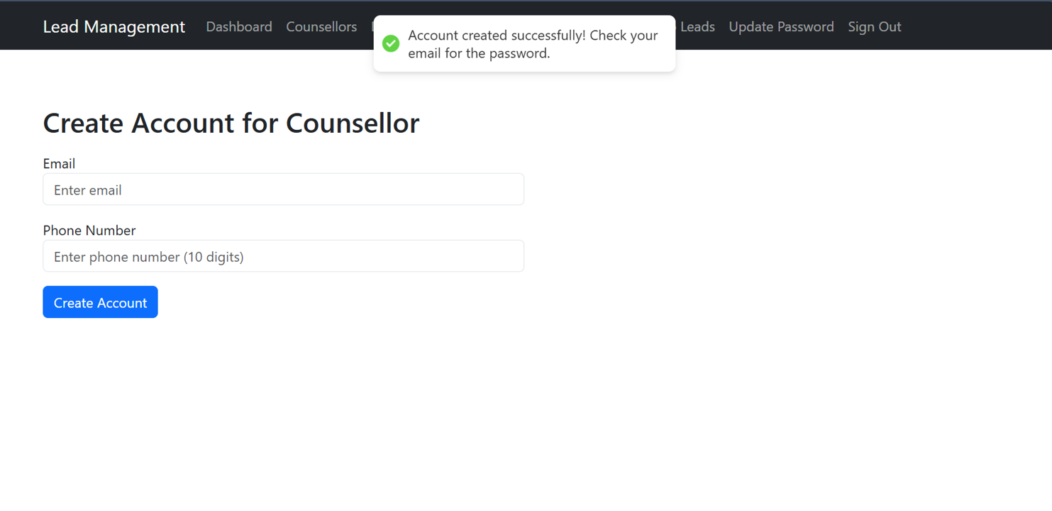
Upon successful creation of the account and sending the email message will be displayed.

Templates
Navigation bar > Templates
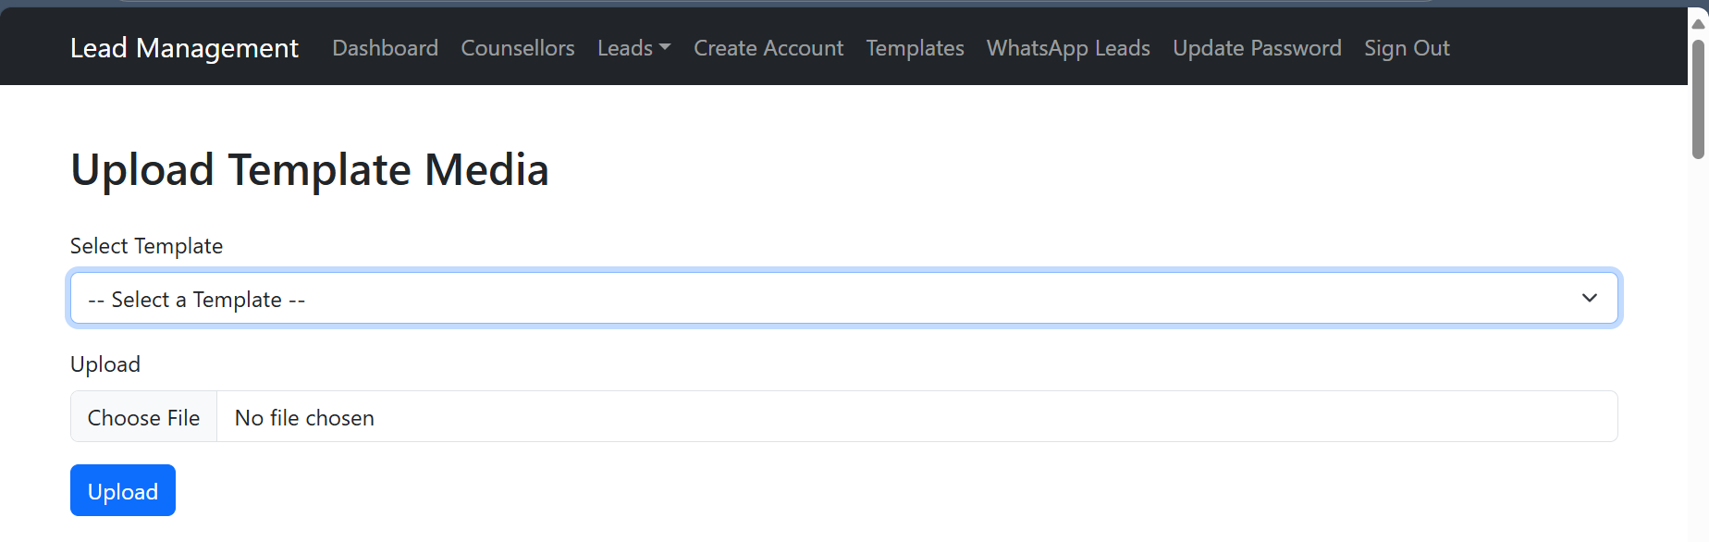
This feature allows users to upload media (images or videos) associated with specific WhatsApp templates. The available template are displayed in the select template dropdown. The uploaded media is then linked to the selected template and can be used when sending WhatsApp template messages that require media attachments.
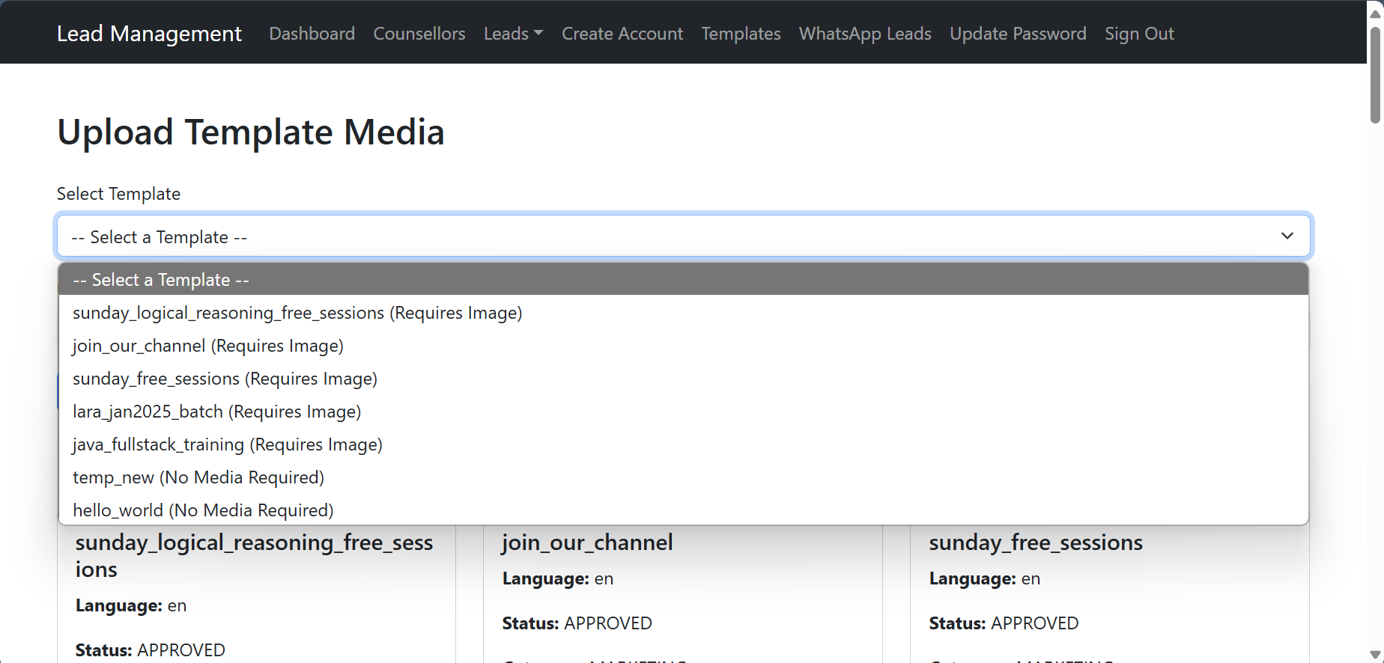
Select the template for which you want to upload the media files(the allowed media type will be displayed along with the template name)

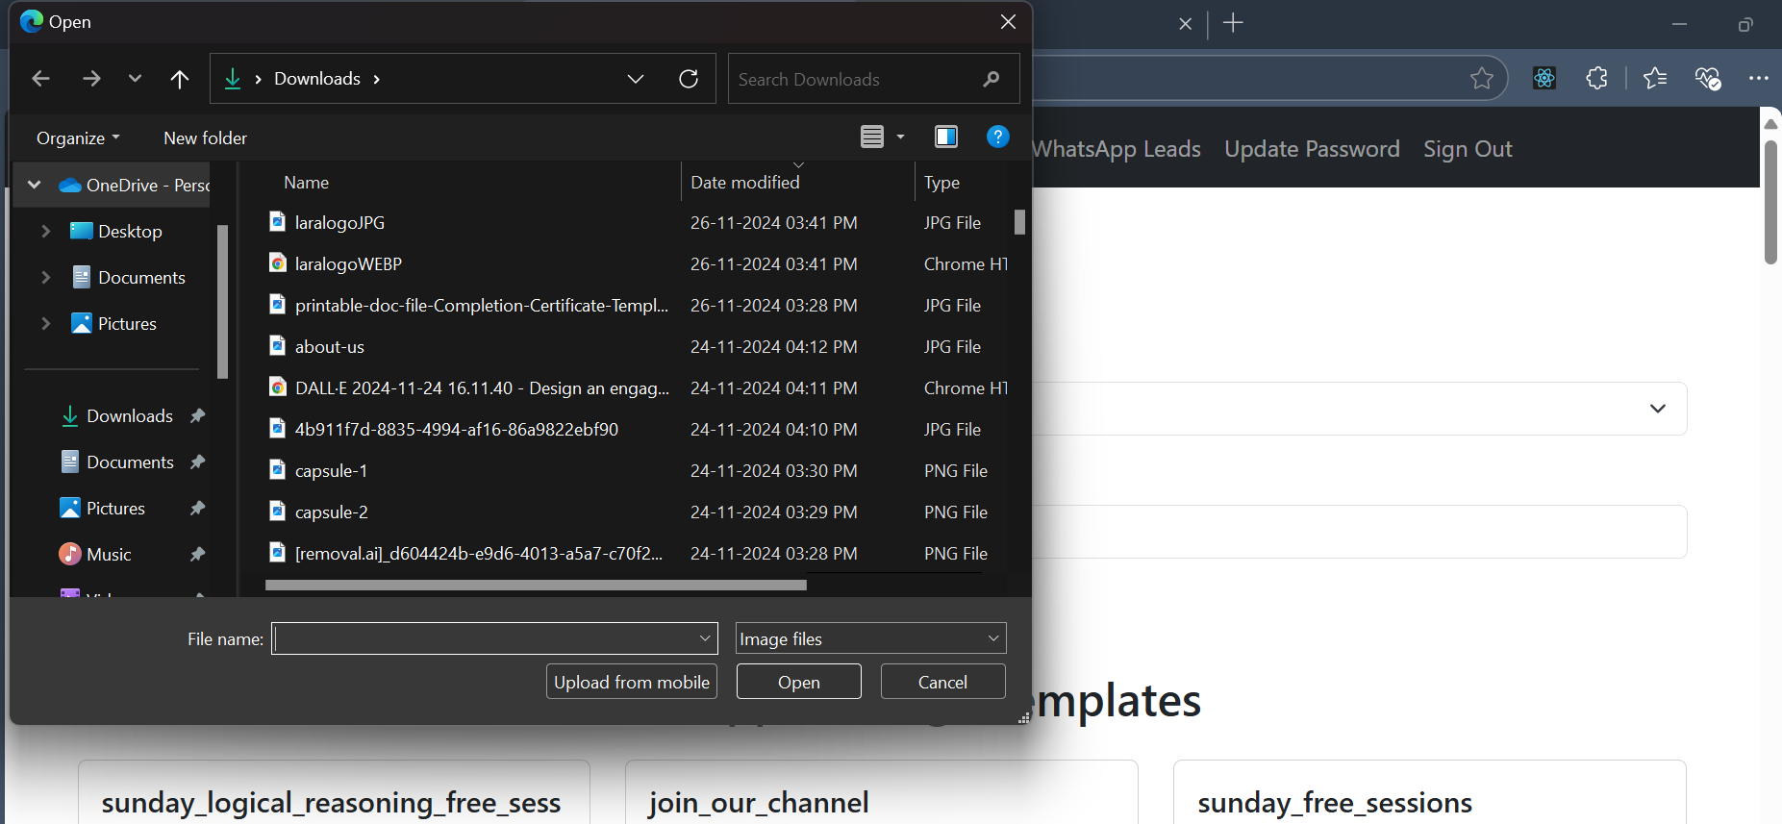
Select the media file from your system and click on upload upon successful upload of the media a message will be displayed.

Sending whatsapp template messages to the leads
- Navigate to the "Templates" section.
- Choose your desired template from the available list of templates fetched from the Facebook API.
- Click on "Select Template", which will redirect you to another page where:
- All media files uploaded for this template are displayed.
- You can choose the specific media file to attach to the template

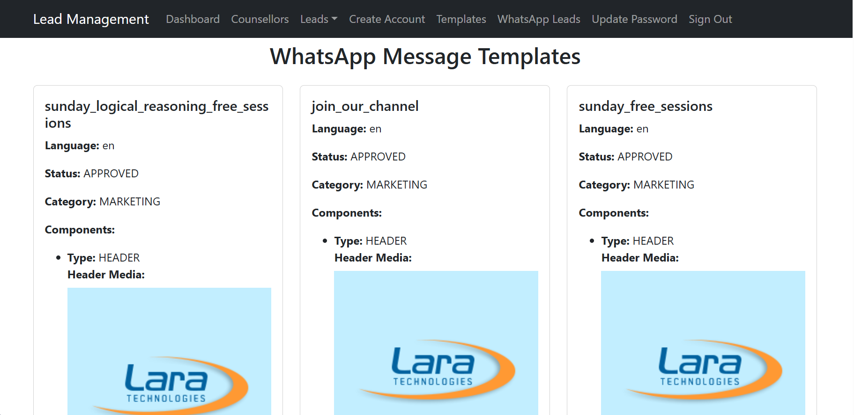

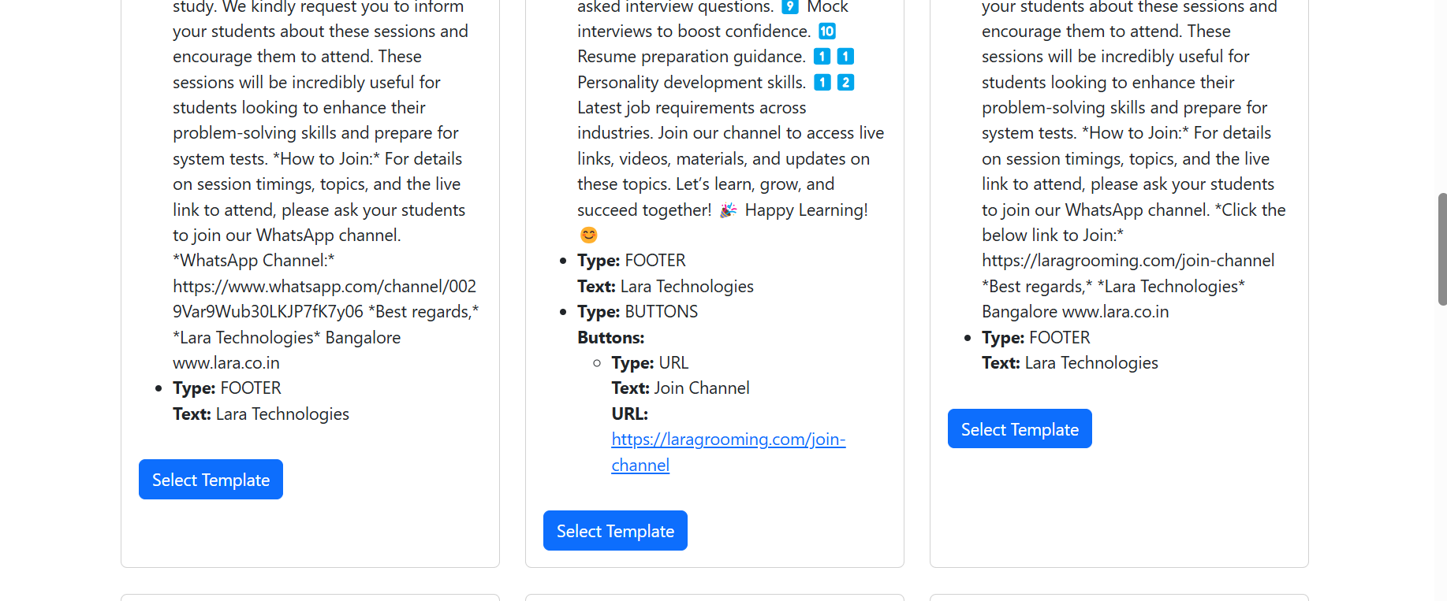

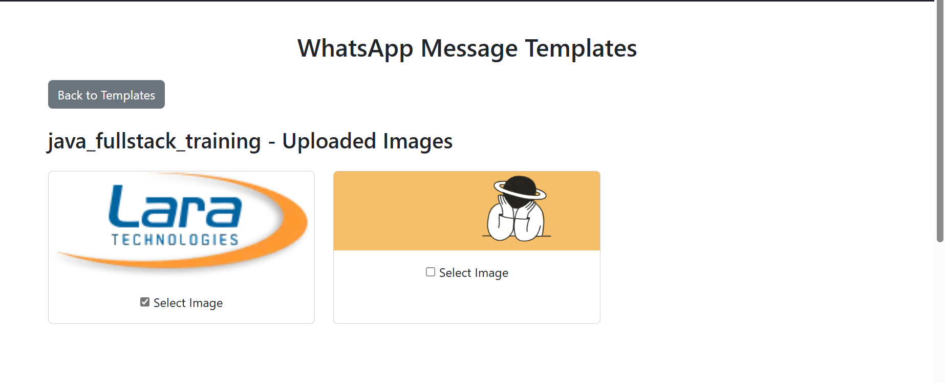

- View all the media (images or videos) associated with the selected template.
- Choose one media file to attach with the template message.

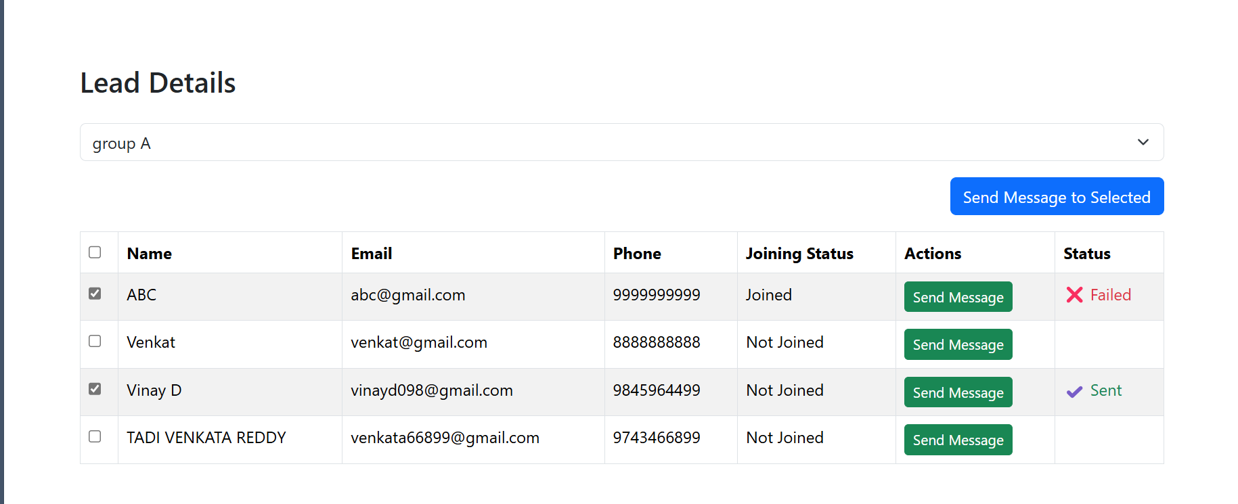

Select Leads
- Below the media selection section, a list of all available leads will be displayed.
- Features for lead selection:
  - Select All Leads: Choose all leads at once for sending the template message.
  - Select Specific Leads: Individually select leads from the displayed list.

Send Message
- After selecting the template, media, and leads:
  - Click on "Send Message to Selected".
  - The selected template message with the chosen media will be sent to the selected leads via WhatsApp.
  - Upon sending the message successfully a “Success” or “Failed “ status displayed.
Counsellor
The Counsellor Dashboard is designed to display leads assigned to a counsellor after a successful login. The counsellor can view, manage, and update lead details, including interaction history, response status, joining status, and next contact date.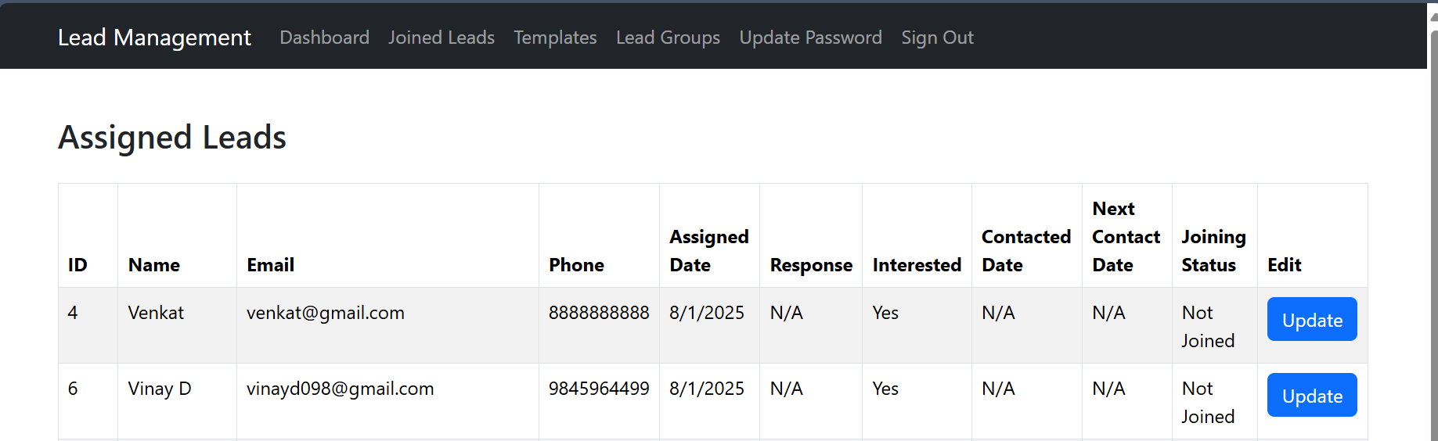

The leads are displayed in table format
Each lead entry includes the following details:
- Interaction Date: The last date of contact with the lead.
- Response: The current response or feedback provided by the lead.
- Joining Status: The lead’s status regarding joining (e.g., Interested, Joined, Not Interested).
- Next Contact Date: The planned date for the next interaction with the lead
To update details for a lead:
- Click on the "Update" button next to the specific lead.
- A detailed form opens with pre-filled fields for:
  - Interaction Date
  - Response
  - Joining Status
  - Next Contact Date
- Counsellors can modify any field as needed.
- Click "Save" or "Update" to save changes.

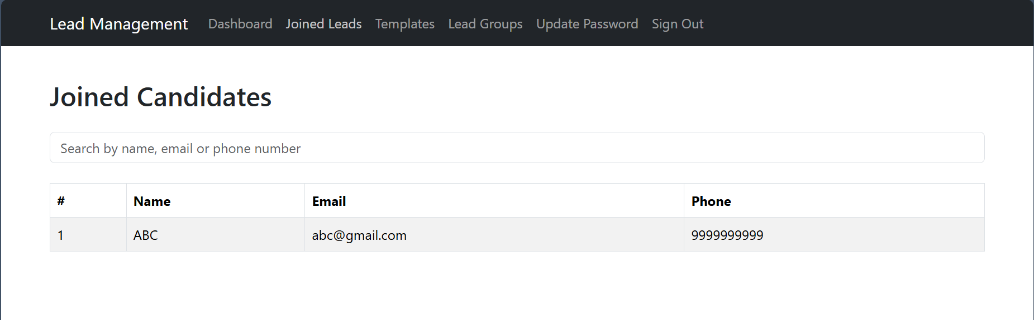
From the joined leads menu the counsellor can see the leads who are joined or purchased the products.

Update Password and details
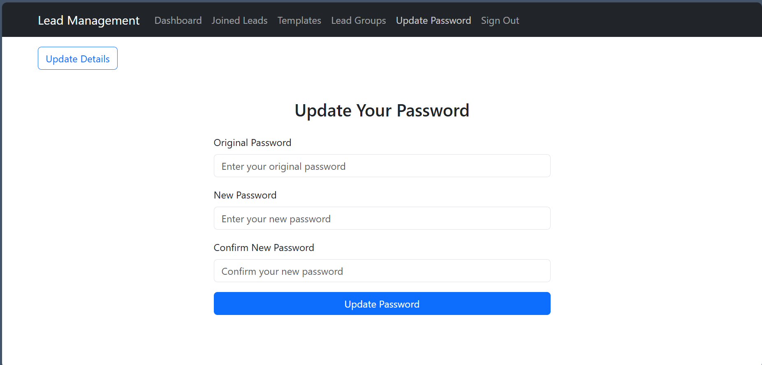
To update password and update the details of the logged in user
