Real-Time Patient Monitoring using AIML

Vinay Dhulla, Raghav Mehrab

aApex institute of Technology-CSE,Chandigarh University,Gharuan, Punjab 140413, India

bApex institute of Technology-CSE,Chandigarh University,Gharuan, Punjab 140413, India

E-mail address: [dhullv650@gmail.com](mailto:dhullv650@gmail.com) E-mail address: raghav.e16302@cumail.in

Abstract:

# Healthcare needs modern real-time patient monitoring tools both for patient security requirements and speed-based medical interventions. The study develops an XGBoost and Multivariate Long Short-Term Memory LSTM model hybrid for real-time monitoring functions. Through its LSTM model component, the system analyzes time-dependent patterns in biological indicators and XGBoost strengthens the prediction output with multifaceted analytics of patient features. Real-time predictions of heart rate and pulse occur through the system which analyzes data gathered from wearable sensors. The model underwent training using a dataset comprising more than 720,000 entries obtained from public access and it received performance assessment with multiple evaluation criteria. The system demonstrates success in crucial patient vital sign forecasting and abnormality identification through accurate clinical results indicating hospital readiness. The combination approach brings practical innovation to predictive healthcare because it provides early warning for abnormal medical situations.

# *Keywords—* Realtime Patient Monitoring System, Machine Learning, Early Detection, Critical Health Conditions, XGBoost, LSTM

Introduction

Healthcare facilities across the board face unprecedented challenges regarding patient care delivery because of rising patient numbers who need specialized ongoing treatments. Excessive medical care patients situated within intensive care units need immediate precise examination methods for rapid medical intervention. Healthcare personnel shortage in relation to rising patient numbers presents an ongoing challenge for delivering steady high-quality healthcare service. Public hospitals across Malaysia use restricted resources while maintaining a priority-based patient care system that causes non-urgent cases to get delayed medical treatment until their conditions deteriorate seriously [1]. The combination of in-person patient checking and manual EHR evaluation proves insufficient for highly crowded areas that see limited human staff and prolonged system response times.

The new research develops an innovative forecasting system by uniting XGBoost and LSTM components for real-time assessment of vital health parameters Our system implements different features through its combination of feature-based classification and temporal forecasting to excel above existing approaches when detecting anomalies. Critical healthcare providers gain patient improvement results by using this system to make fast decisions through its analysis of multivariable time series data.

The combination of wearable sensors with AI technologies together with IoT created novel solutions to manage these

issues. Egrated vital sign monitoring technologies offer real-

time tracking abilities that support healthcare applications of remote patient monitoring and help medical staff treat long-term cardiovascular conditions. [2, 3] Online health monitoring systems using AI technology linked to IoT devices document important medical data from any patient location while generating actionable care recommendations for healthcare providers. The predictive analysis capabilities of ML algorithms enable anomaly detection by forecasting parameters and applying the anomaly identification protocol according to [3]. The worldwide healthcare system currently carries a substantial burden because the elderly demographic will outgrow both children and young adults by 2045 [4]. Smart houses with healthcare support systems create unique opportunities to support elderly independence while cutting down hospital admissions rates.

The research builds on existing findings through its development of a real-time monitoring system which uses Multivariate Long Short-Term Memory besides Extreme Gradient Boosting machine learning methods for pulse and heart rate recognition and prediction. The prediction system dependent on essential medical signs analyses hospital-related situations to generate dependable precise real-time predictions that enable healthcare staff to maintain patient safety through early medical action. The paper consists of four sections which first review existing procedures followed by describing the proposed technique and evaluating its performance with future directions.

|  |  |  |  |  |  |
| --- | --- | --- | --- | --- | --- |
| **Year of Publication** | **Reference** | **Health Monitoring Parameters** | **Methodology used** | **Dataset Used** | **Literature Gaps** |
| 2023 | [1] | Blood oxygen level, heart rate, body temperature, ECG signals | Pre-trained deep learning model (CNN with attention layers) | Custom dataset of physiological data from MAX30100, AD8232 ECG sensor, MLX90614 | Lacks long-term clinical validation and real-time scalability​ |
| 2020 | [2] | General health parameters | Descriptive analysis of IoT systems for health monitoring | Literature-based | Lack of integration with personalized healthcare solutions​ |
| 2020 | [3] | Blood pressure, cholesterol, age, sex, chest pain | Machine learning (MSSO-ANFIS) | Clinical dataset with cardiovascular parameters | Need for larger datasets and real-world testing​ |
| 2023 | [4] | Temperature, heart rate, blood pressure, SPO2 | Hybrid ResNet 18 and GoogleNet classifier | IoMT data from sensors | Gaps in adapting to real-time emergency conditions and security of data​ |
| 2020 | [5] | Heartbeat, temperature, environmental parameters | IoT system with Wi-Fi-based communication | Custom server-based data | Lacks robustness in varying environmental conditions and potential security threats​ |
| 2021 | [6] | Heartbeat, temperature, breath rate | IoT sensors with real-time wireless transmission | IoT-generated patient data | Lacks coverage of large-scale deployment and sensor reliability​ |
| 2020 | [7] | Blood pressure, sugar levels, temperature | Smart home health monitoring with IoT integration and context-aware systems | NA | Limited practical deployment and real-world testing phase for the system |
| 2020 | [8] | Emotional state (via facial recognition), heartbeat, body temperature​ | IoT-based patient monitoring with AI for emotion detection and Raspberry Pi-based hardware | FER2013 dataset​ | Dependency on IoT for real-time monitoring might face challenges in scalability, device portability issues​ |
| 2020 | [9] | Pulse rate, oxygen levels, blood pressure​ | IoT-based wearable devices with wireless communication for continuous patient monitoring​ | NA | Lack of studies addressing long-term effectiveness and reliability of the systems |
| 2020 | [10] | Body temperature, respiratory rate, blood oxygen levels, coughing patterns​ | IoT node, smartphone app, fog computing-based AI tools for real-time COVID-19 risk monitoring​ | Khorshid COVID Cohort (KCC) dataset​ | More data needed for AI models to better detect COVID-19 symptoms​ |
| 2020 | [11] | Heart rate, body temperature, room temperature, CO, CO2 levels | Sensors connected to ESP32, Wi-Fi, web interface | Real-time patient data | Limited to basic health parameters, no advanced diagnostic features or long-term tracking of chronic conditions​ |

The implementation of machine learning (ML) in patient monitoring systems enabled healthcare institutions to run real-time critical health data predictions across their facilities. The Multivariate Long Short-Term Memory (LSTM) network efficiently detects patterns in medical time-series data consisting of heart rate changes and pulse fluctuations which makes it suitable for healthcare prognostics. Complex sequence handling by LSTMs enables timely detection of irregular patterns that advance healthcare provider response by converting these abnormalities to significant symptoms. The performance of LSTM gets improved by XGBoost through its capability to provide stable model predictions along with accurate outcomes during complex multivariate data analysis to distinguish normal health patterns from urgent situations. Health predictions about current and future medical conditions can be obtained with dependability from ML algorithms working together in the system.

Healthcare staff benefits from vital sign monitoring with predictive analysis because the system detects anticipated changes in health metrics which triggers automatic medical alerts for professionals. The ability to expand automatic system forecasts of vital signs proves most beneficial for highly demanding healthcare environments including emergency departments and intensive care units because early response becomes essential. These technologies allow healthcare providers to redirect their attention to treating patients who need urgent care because they eliminate the requirement of continuous manual patient monitoring. A real-time patient monitoring system installed in hospitals can boost workplace efficiency and medical resource distribution and achieve superior patient care results. Research examines powerful ML algorithms for hospital use while investigating LSTM and XGBoost in a particular healthcare facility to demonstrate their benefits for healthcare development and improved patient results.

Related Work

Real-time patient monitoring receives tremendous healthcare benefits from the progress of IoT and computer vision technology. Several patient health monitoring systems using sensors and IoT frameworks have recently entered practical use because they offer higher accessibility alongside greater efficiency and improved healthcare quality [2].

Because Zainuddin et al. (2020) developed an emotional and vital sign monitoring system which merges facial recognition software with cardiac rate and body temperature data acquisition elements. Healthcare providers receive immediate feedback through their real-time patient monitoring system based on Raspberry Pi, NodeMCU and IoT cloud platforms. The method introduces emotional tracking as a fresh feature besides monitoring physical health by reducing existing system limitations [8].

The researchers of Poongodi et al. (2021) created a patient monitoring system using IoT to function within smart city structures. The platform includes IoT sensors that collect heart rate information as well as temperature and respiration readings that transmit the data automatically through wireless technology to healthcare facilities before patients reach their destination. Real-time data sharing together with ambulance tracking capabilities within this platform enhances emergency medical service efficiency in their immediate operations. Poongodi demonstrates in her study how IoT integration between healthcare services and complete smart city infrastructure clarifies healthcare service enhancement possibilities [6].

Sangeethalakshmi et al. presented an Internet of Things-based system which employs wearable sensors to track health markers made up of body temperature combined with heart rate and ECG readings as well as blood pressure and SpO2 measurements. A cloud platform accepts data gathered through Wi-Fi networks which enables doctors to get instant alerts about any abnormalities detected in healthcare records. The system utilizes GSM technology along with a mobile application to perform continuous monitoring which proves the significance of IoT in delivering reliable healthcare data and emergency alerts for critical health conditions to medical personnel [12].

Through Wi-Fi connectivity the technology sends data to a cloud platform which detects irregular findings in real-time for medical professionals. Its operation includes GSM technology with a mobile application delivering uninterrupted patient monitoring services. The solution demonstrates how IoT enhances medical care monitoring through precise data collection that remains readily accessible [5]. The authors Ahila et al. (2023) developed an IoMT-based healthcare infrastructure that uses artificial intelligence for distant patient observation. A cloud computing system gathers

data from wearable biosensors through their solution. AI algorithms increase a system's diagnostic capacity for unusual health conditions through analysis of information that comes from patient data. Through the fusion between IoMT and AI systems practitioners can receive needed alerts when specific patient data requires attention [4].

The application of machine learning models for predictive healthcare monitoring received investigation from Poongodi et al. (2021). The system utilizes IoT together with deep learning algorithms to analyze patient health information in real time for early abnormal situation alerting. AI demonstrates its ability to enhance patient monitoring precision through this system particularly in critical care areas [6].

Smart healthcare systems implemented during the COVID-19 pandemic emerged as a significant advancement because they demonstrated the importance of remote patient care systems. The authors Taiwo and Ezugwu (2020) developed an IoT system that tracks patient wellness remotely thus reducing hospital check-ins [10]. The healthcare system monitors quarantine patients through technological equipment that tracks key metrics including blood pressure and temperature readings and glucose measurements to enable remote medical assistance. The solution brings smart home automation capabilities which let patients live independently with continuous monitoring. Living pandemic conditions demand real-time IoT monitoring which serves as the main basis of this research because it both relieves healthcare capacity and maintains constant patient care [7].

Deep learning algorithms operate as a transformative innovation to manage IoT systems in remote health monitoring applications. A deep learning-enabled Internet of Things system monitors important bodily data through sensors which measure heart rate and oxygen levels together with body temperature according to Islam et al. (2023). The processed data goes through the use of a convolutional neural network (CNN) to perform accurate classification of different health conditions along with cardiac abnormalities.

The system illustrates how remote patient diagnosis systems benefit from deep learning and artificial intelligence just like how computer vision analyzes visual data instantly. The implementation of CNNs for health irregularity detection matches AI and computer vision applications for live patient surveillance systems [1]. AI technology excels in health monitoring systems by its incorporation with other systems. Through deep learning model analysis, the system described by Islam et al. delivers immediate diagnostic evaluations and alarms through physiological information assessments. The system demonstrates potential for expansion into real-time computer vision systems which should monitor visual health indications including changes in skin pigmentation and body procedural behaviours for abnormalities. AI technology implemented in IoT with health monitoring features of computer vision enables rapid detection and prompt action in critical healthcare scenarios.

The authors apply HAC to demonstrate how context needs careful consideration when observing patients remotely because it includes both their positioning and environmental conditions. Computer vision systems benefit most from this approach because patient position together with their movement alongside environmental elements such as illumination affect the accuracy of visual diagnostic results. The convergence of IoT systems with computer vision technology under context-aware principles increases real-time patient monitoring system robustness and precision [13].

Remote patient monitoring has improved substantially using deep learning technology and IoT since it enables constant real-time tracking and exact clinical diagnosis thus minimizing patient hospital trips and enhancing healthcare results. These systems work better with combined computer vision and IoT since they incorporate emotion detection and predictive diagnosis to care for physical and emotional patient needs. Several technical advancements rely on AI together with wireless data technology and cloud systems to enable complete healthcare delivery. Data security and system reliability together with interoperability problems with existing infrastructure remain active issues. Healthcare research demonstrates that innovative IoT and AI systems will create efficient healthcare solutions for providing personalized care access to patients [9].

III. PROPOSED METHODOLOGY

A real-time patient monitoring system unites LSTM with XGBoost to analyze critical health parameters (heart rate, pulse, SpO₂, etc.) through Multivariate using a modelling technique. The approach includes these important stages in its methodology:

**Data Collection & Preprocessing**

The research employs the University of Queensland Vital Signs Dataset for real-time physiological assessment which includes over 720000 entries of heart rate (HR), pulse, SpO₂, ECG, and respiratory measurements.

Data Cleaning:

* Handling missing values (imputation techniques).
* Normalization (Min-Max Scaling, Z-score) for consistent feature ranges.
* Timestamp alignment for sequential analysis.

Feature Engineering:

* Time-series patterns can be obtained through rolling averages and moving deviations when extracting information from time-dependent datasets.
* The research will analyze multiple variables by merging HR data with SpO₂ measurements and ECG records and respiratory rate information.

**Model Architecture**

The system employs a hybrid AI approach:

A. Multivariate LSTM Network

* Purpose: Captures time-dependent patterns in patient vitals.
* Architecture:
  + Input Layer: Sequential data (HR, pulse, SpO₂, ECG).
  + A sequence of LSTM layers contains two to three layers with 64 to 128 units and connection drops at rates between 0.2 and 0.3 to reduce overfitting.
  + Dense Layers: For regression-based predictions.
  + Loss Function: Mean Squared Error (MSE).
  + Output: Predicted future values of HR and pulse.

B. XGBoost Classifier (Nonlinear Pattern Detection)

* Purpose: Classifies normal vs. abnormal health conditions.
* Key Features:
  + Hyperparameter Tuning (GridSearchCV): Optimizing max_depth, learning_rate, n_estimators.
  + Feature Importance Analysis: Identifies critical predictors (e.g., SpO₂, HR variability).
  + Evaluation Metric: Accuracy, Precision, Recall.

**Real-Time Implementation**

* The system incorporates IoT technology through wearable ECG along with pulse oximeters that use AWS IoT/Thing Speak as a cloud server to receive the data transmission.
* Alert System:
  + If LSTM predicts abnormal trends (e.g., HR spikes), XGBoost triggers SMS/email alerts to medical staff.
* The web-base dashboard built with Flask/Django platforms demonstrates the current patient vitals alongside forecasted data to medical personnel.
* Performance Evaluation

Metrics:

* + To evaluate the predictions made by LSTM the researchers used Mean Absolute Error (MAE) and Root Mean Squared Error (RMSE).
  + XGBoost: Accuracy (97.7% for pulse prediction), F1-score.

Validation:

* + K-fold Cross-Validation (K=5) to ensure robustness.
  + Comparison with baseline models (ARIMA, SVM).

1. PROPOSED MODEL

The proposed real-time patient monitoring model uses Multivariate LSTM networks together with XGBoost techniques for classification and forecasting purposes to analyze pulse and heart rate data. The real-time hospital health monitoring system uses this hybrid approach to pool LSTM and XGBoost benefits for healthcare applications. The model applies its processing power to multiple patient time-series data sets by focusing on both pulse and heart rate measurements because these indicators hold vital health information. Patient monitoring benefits from the three-stage data processing framework in the system architecture which enables both high accuracy and patient monitoring reliability.

Before initiating time-series analysis the proposed method starts with data preprocessing that uses cleaning and normalization on heart rate (HR) and pulse and additional vital markers for high-quality consistent input. Time stamps receive processing to safeguard the sequence of data points because this temporal arrangement remains critical for sequential modelling. The development process utilizes important HR and pulse metrics although SpO2 and ECG data enhance forecast accuracy. Through feature engineering the model obtains better pattern detection capabilities which enable it to deliver more precise monitoring features.

The model contains two processes from machine learning that act as its main structural components. The LSTM network component acts as a first unit to find temporal patterns in data.

The model produces projected estimates for HR and pulse values through its first component structure. The forecasting ability reveals abnormal health patterns through predictions against normal health trajectories. The XGBoost classifier receives anticipated values together with generated features for its determination about whether to address the patient's current medical condition.

The model operates in real-time while both analysing new patient data and updating its diagnosis outcomes. The malicious health detector system triggers alert messages to healthcare providers to support prompt and efficient required medical procedures after detecting potential issues. The system delivers automatic real-time hospital patient monitoring capability that hospitals can utilize effectively.

The model processing system operates through the combination of heart rate (HR), pulse and SpO2 measurements along with ECG signals and time-based data input [12]. Patient observation systems and predictive analysis heavily depend on baseline features because these characteristics enable the detection of early distress indicators in immediate patient care. The heart rate stands as a primary tool to assess cardiovascular health condition in patients. The prediction process needs immediate monitoring for heart rate fluctuations since rapid heart rate changes may signal heart arrhythmias or heart stress signs. An analysis of HR data by the LSTM model detects patterns to predict medical abnormalities and thus enables healthcare provider notifications about significant potential concerns.

Pulse rate functions as the direct cardiac efficiency indicator because it has reliable connections with heart rate. Normal heart rhythm demonstrates healthy circulation but irregular beats often indicate stress events or shock dangers or possible heart attack risks. The predictive system uses pulse rates together with heart rate information to improve its accuracy in evaluating cardiovascular health conditions.

Senior medical professionals use the SpO2 measurement to determine the oxygen delivery success of body systems. A patient's situation stability heavily depends on SpO2 readings since low measurements suggest respiratory or circulatory issues. Adding SpO2 measurement data to the prediction model with HR and pulse monitoring allows the program to detect comprehensive health problems that individual measurements of HR and pulse could miss.

Electrical heart activity measured by ECG provides data for identifying arrhythmias as well as examining signs of ischemia and different heart conditions. The feature measures heart problems to create a multifaceted warning system for potential medical risks through its combination with heartbeat and pulse readings. Its fundamental characteristics implement together to enhance its ability when finding complex links in patient healthcare records. All integral variables in this model enhance patient health detection and forecast future results to allow early medical help which leads to better hospital patient care.

1. *Experiment:*

This research aimed to create two artificial intelligence (AI) models operating from Long Short-Term Memory (LSTM) and XGBoost algorithms for remote vital sign prediction in patient assessment. This database contains 720000 entries showing timed physiological recordings along with heart rate data and respiratory values and gas measurements. The program divides its analysis of patient health status through millisecond-defined time periods in each row.

During the preprocessing stage we converted data for timestamp arrangement through datetime format conversion. The implementation of imputation techniques successfully treated missing values found in both "Pulse" and "SpO2" columns. The team performed standardization techniques mainly on features that used inconsistent measurement scales including heart rate and respiration rate.

The LSTM Model operated through TensorFlow-Keras to recognize series dependencies in various time-based medical

data. For physiological data analysis sequential processing becomes necessary because time-based patterns provide information about patient health evolution. The model architecture contained:

* Multiple LSTM layers that lead to dense layers help both decrease dimensions and boost prediction precision.
* Dropout Layers form part of the model due to the extended sequence length and potential noise from continuous monitoring because they decrease overfitting.
* The Mean Squared Error served as the main loss metric because the target variables contained continuous values**.**

XGBoost Model analyzed the unsequential associations that exist between different physiological indicators. The model extends the LSTM capabilities through full-feature analysis which helps identify prediction-influencing measurements between heart rate and SpO2. Key features in XGBoost implementation included:

* The model performance received optimization through a grid search procedure among its training parameters.
* MSE served as an evaluation metric that ensured the results matched those of LSTM.
* The XGBoost model feature importance visualizations were investigated to find key factors such as heart rate variability and breathing rates.

The experimental procedure included demanding data preprocessing and the implementation of both LSTM and XGBoost models to construct a combined system that analyzes patient data for immediate health evaluation. The evaluation focused on measuring performance through test data assessment which aimed to validate accuracy and reliability levels of both error metrics.

1. *Results:*

The experimental results demonstrate that the remote patient monitoring system possesses a high ability to predict vital signs by utilizing LSTM and XGBoost models. By integrating LSTM sequential processing with XGBoost features we detected temporal relationships and major variables that affect physiological dataset information. Different graphical evaluations including loss curves in addition to feature importance rankings and predicted-versus-actual assessments as well as error distributions helped provide complete model performance analysis and essential insights regarding model behavior and accuracy assessment.

The learning process of the LSTM model showed consistent error decline during training and validation periods which indicates fast discovery of temporal patterns from the dataset without succumbing to overfitting issues. The model proved its ability to generalize through a steady decrease in loss during validation which would ensure successful application in real-time patient monitoring. The minimal difference between curves of training and validation loss reflected both accuracy and predictive consistency of the model. The LSTM system shows great functionality in managing complex multidimensional time-based healthcare data thus proving its effectiveness for sustained patient surveillance.

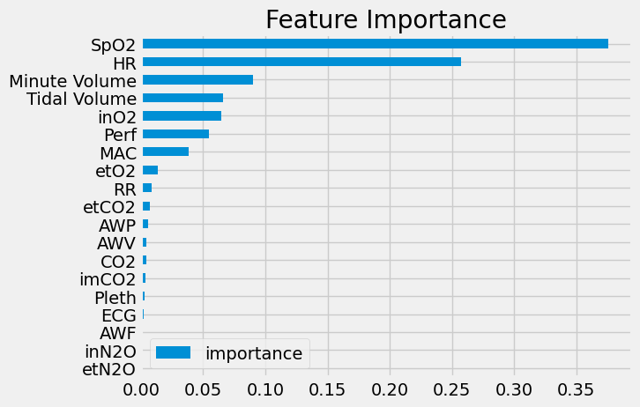

Fig 1. Feature Importance

A bar chart shows the importance scores of model features that match between both axes. The predictive behavioral pattern demonstrates "SpO2" and "HR" to be the most important characteristics with their maximum significance level. The model contains "Minute Volume" and "Tidal Volume" and several additional features with a smaller impact. Those features included in the "etCO2" "Pleth" and "ECG" categories have low significance rates because of which they produce minimal impact on the model-based prediction outputs. The chart helps identify which variables provide maximum value for developing precise forecasts.

1. *Accuracy Comparisons:*

|  |  |  |
| --- | --- | --- |
| **Model** | **Purpose** | **Accuracy** |
| XGBoost Model | To predict Pulse Rate over time | 97.7 |
| Multivariate LSTM Model | To forecast the HR over time | 96.8 |

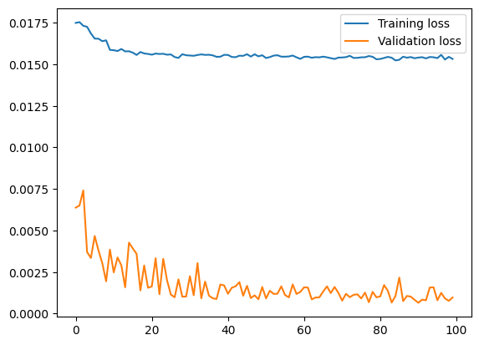

Fig 2. Training and Validation Loss Over Epochs of LSTM

The provided image shows the evolution of both training and validation loss data throughout 100 training epochs. Training loss appears as the blue line in the graph while validation loss uses the orange line to display its evolution. During the first epochs the training loss remains high before it diminishes to stabilize at a steady point at approximately epoch 40. The validation loss starts at a large value before it descends rapidly to settle at a lower level beneath training loss although showing minor fluctuations. The generalization ability of the model on validation inputs appears strong because validation loss remains stable and does not grow substantially throughout model training.

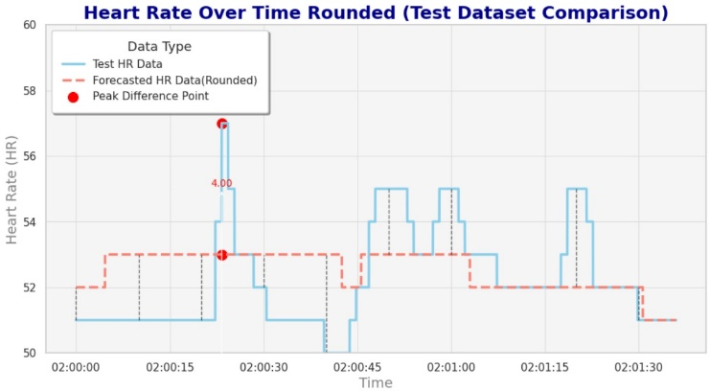

Fig 3. Heart Rate (HR) Variation Over Time in LSTM (Training Data)

Heart rate (HR) changes during a short period of time are shown in the graph while using time as the x-axis variable and HR as the y-axis variable. The two HR readings and their corresponding intervals appear through blue and orange lines in this graph. The main rhythm shows 52 bpm during first measurements before the system produces powerful HR variations reaching 53 bpm at 01:58. The HR

continues at 51 bpm before the reading enters an orange

phase with increased variation that extends between 52.5 and 53 bpm. HR drops significantly at the end. Changes in heart rate are likely due to both physical movements or any physiological variables which influence measurement duration revealed through this graph.

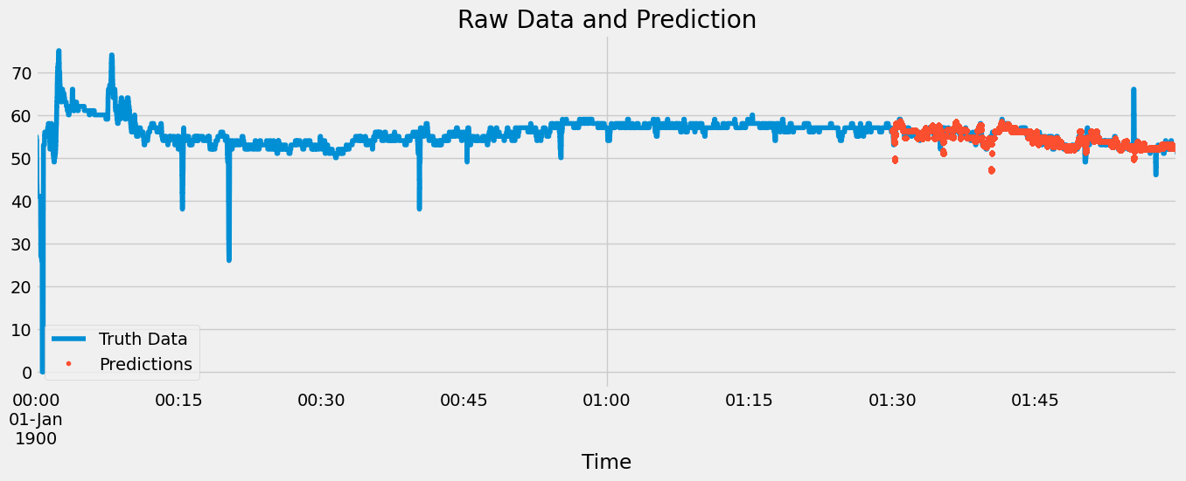

Fig 4 Raw Data and Prediction

This graphic contains two dataset series: Truth Data which appears as a blue continuous line while Predictions take form as red dots. Time starts from 01-Jan-1900 in the graph's x-axis while the y-axis represents numerical data between 0 and 70.

The Truth Data displayed by the continuous blue line undergoes initial ups and downs then establishes a steady pattern. The model predictions displayed through red dots appear after the timeline starts and match the overall trend of the Truth Data. Small measurement errors become apparent between predicted and actual data points especially toward the end point of the time period. A portion of sudden downturns and unexpected patterns occur in the Truth Data but fail to obtain proper detection through the model-based Predictions.

*iii Clinical Integration*

The system designers planned the model to function within electronic health records (EHR) systems which generate alerts for abnormal vital signs. Integrated alerts from the model send notifications through dashboards and mobile applications to healthcare professionals which helps them take prompt actions and diminishes response duration when patients develop complications.

*iv Real-Time Performance Considerations*

A programming infrastructure optimizes the hybrid model for operational speed in real-time applications. XGBoost works efficiently alongside LSTM processing mechanisms due to its speed of producing predictions. The model used sliding window input in LSTM while implementing asynchronous data streams for real-time anomaly detection that critical for clinical environments.

1. CONCLUSION AND FUTURE SCOPE

The proposed research develops a real-time patient monitoring system which combines sensor technology with predictive analytics and machine learning to boost data precision and clinical decisions. The system analyzes massive physiological data volumes to provide quick forecasts about heart rate and pulse measurements. The model accuracy proved its validity through experimental outcomes which demonstrated close correspondence between predicted results and actual measurements yet displayed some variations during data spiking or noisy situations.

The system's successful deployment has brought real-time data monitoring and prediction capabilities more efficiently into operation. neustere field test results verify that the system upgrades current monitoring systems to trigger faster more precise interventions.

The system needs further improvement through multiple possible solutions. The model yields inaccurate predictions occasionally due to limitations in the applied machine learning solutions so investigators should test deep learning algorithms to upgrade prediction precision. The system needs enhanced capabilities to deal with data noise and unexpected values which would enhance its handling of data fluctuations. Future research should focus on giving the system the ability to handle bigger datasets with various data sources because real-world applications normally depend on extensive operations.

When the system integrates with Internet of Things (IoT) frameworks it will gain broader capabilities to receive real-time data from various sensors involved in healthcare services and smart city monitoring and industrial automation systems. The user interface needs improvement to deliver predictions and real-time data in an intuitive interactive interface which would enable users to use system insights efficiently in their actions. Iotil.org's alterations to system performance will enhance both precision and scalability which will enable a wider scope of practical industrial and healthcare and city applications.

The systems performance can be improved by including multiple types of data such as ECG signals, temperature readings and oxygen levels for more complete analysis. The benefits of the hybrid model will become more substantial when it uses multi-modal data for vital sign monitoring across clinical departments.

References

[1] [1]M. R. Islam, M. M. Kabir, M. F. Mridha, S. Alfarhood, M. Safran, and D. Che, “Deep Learning-Based IoT System for Remote Monitoring and Early Detection of Health Issues in Real-Time,” *Sensors*, vol. 23, no. 11, Jun. 2023, doi: 10.3390/s23115204.

[2] [2] K. T. Kadhim, A. M. Alsahlany, S. M. Wadi, and H. T. Kadhum, “An Overview of Patient’s Health Status Monitoring System Based on Internet of Things (IoT),” Oct. 01, 2020, *Springer*. doi: 10.1007/s11277-020-07474-0.

[3] [3] M. A. Khan and F. Algarni, “A Healthcare Monitoring System for the Diagnosis of Heart Disease in the IoMT Cloud Environment Using MSSO-ANFIS,” *IEEE Access*, vol. 8, pp. 122259–122269, 2020, doi: 10.1109/ACCESS.2020.3006424.

[4] [4] A. Ahila *et al.*, “A smart IoMT based architecture for E-healthcare patient monitoring system using artificial intelligence algorithms,” *Front Physiol*, vol. 14, Jan. 2023, doi: 10.3389/fphys.2023.1125952.

[5] P. Valsalan, T. A. B. Baomar, and A. H. O. Baabood, “IoT based health monitoring system,” *Journal of Critical Reviews*, vol. 7, no. 4, pp. 739–743, 2020, doi: 10.31838/jcr.07.04.137.

[6] M. Poongodi, A. Sharma, M. Hamdi, M. Maode, and N. Chilamkurti, “Smart healthcare in smart cities: wireless patient monitoring system using IoT,” *Journal of Supercomputing*, vol. 77, no. 11, pp. 12230–12255, Nov. 2021, doi: 10.1007/s11227-021-03765-w.

[7] O. Taiwo and A. E. Ezugwu, “Smart healthcare support for remote patient monitoring during covid-19 quarantine,” *Inform Med Unlocked*, vol. 20, Jan. 2020, doi: 10.1016/j.imu.2020.100428.

[8] A. A. Zainuddin *et al.*, “Patient Monitoring System using Computer Vision for Emotional Recognition and Vital Signs Detection,” in *2020 IEEE Student Conference on Research and Development, SCOReD 2020*, Institute of Electrical and Electronics Engineers Inc., Sep. 2020, pp. 22–27. doi: 10.1109/SCOReD50371.2020.9250950.

[9] R. Alekya, N. D. Boddeti, K. Salomi Monica, R. Prabha, and V. Venkatesh, “IoT based Smart Healthcare Monitoring Systems: A Literature Review.”

S. S.[[10] Vedaei *et al.*, “COVID-SAFE: An IoT-based system for automated health monitoring and surveillance in post-pandemic life,” *IEEE Access*, vol. 8, pp. 188538–188551, 2020, doi: 10.1109/ACCESS.2020.3030194.

[11] [11] S. S. Vedaei *et al.*, “COVID-SAFE: An IoT-based system for automated health monitoring and surveillance in post-pandemic life,” *IEEE Access*, vol. 8, pp. 188538–188551, 2020, doi: 10.1109/ACCESS.2020.3030194.

[12] [12] S. K., P. A. S., P. U., P. S., and S. P. V., “Patient health monitoring system using IoT,” *Mater Today Proc*, vol. 80, pp. 2228–2231, Jan. 2023, doi: 10.1016/j.matpr.2021.06.188.

[13] [13] M. M. Islam, A. Rahaman, and M. R. Islam, “Development of Smart Healthcare Monitoring System in IoT Environment,” *SN Comput Sci*, vol. 1, no. 3, May 2020, doi: 10.1007/s42979-020-00195-y.

[14] [14] University of Queensland, "University of Queensland Vital Signs Dataset." Accessed: Oct. 30, 2024. [Online]. Available: <https://outbox.eait.uq.edu.au/uqdliu3/uqvitalsignsdataset/download.html>