Clone a Git Repo
To clone a git repo
- First Initiate a repo with
git init
- Clone repo with command
git clone <repository-url>
Ex: git clone https://github.com/Vinay-K-Y/MLOPs

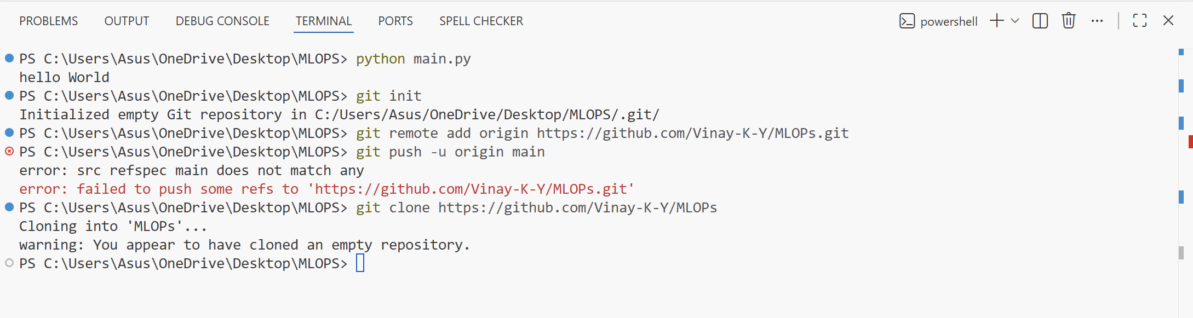
Make a new file and push it to GitHub
make a new file in your code editor
Stage Changes with
- git add .
Commit file with
- git commit -m "commit message "
push files
- git push origin main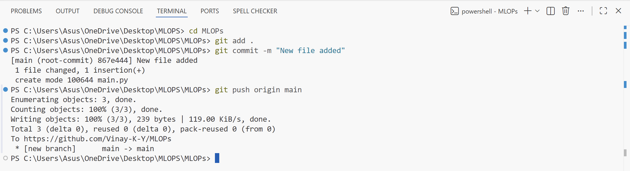
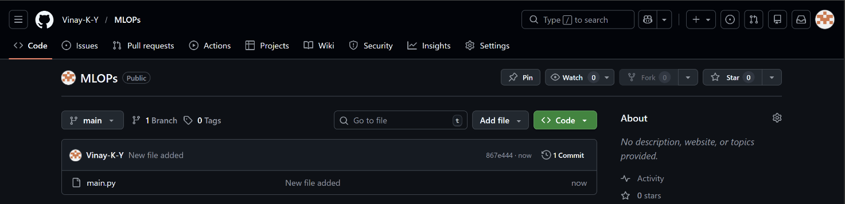

Make changes in existing file and push it to git
Stage new Changes with
- git add .
Commit file with
- git commit -m "new commit message "
push files
- git push origin main
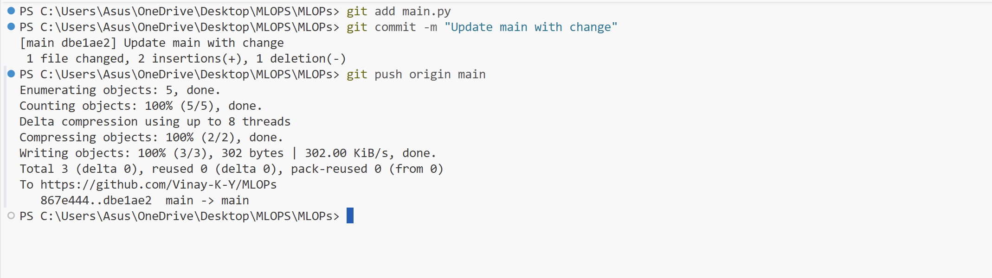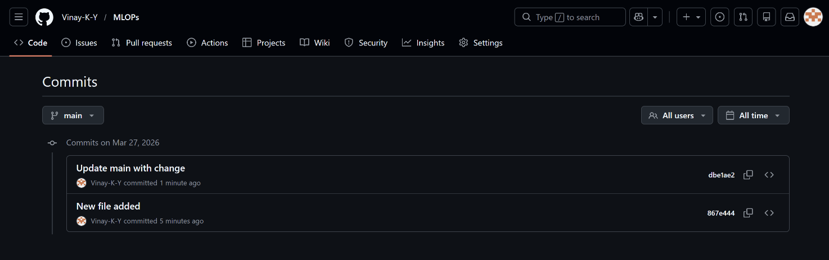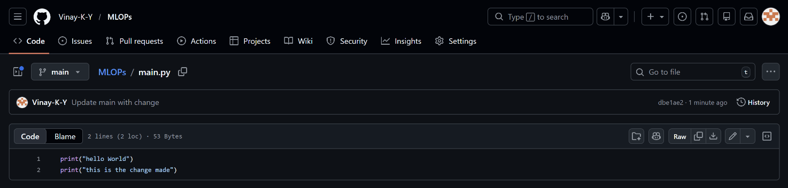
Create a new Branch
to create a new branch follow,
Create new branch with
- git branch branch-name
Switch to new branch with
- git checkout -b branch-name
Push the new branch to git with
- git push -u origin branch-name
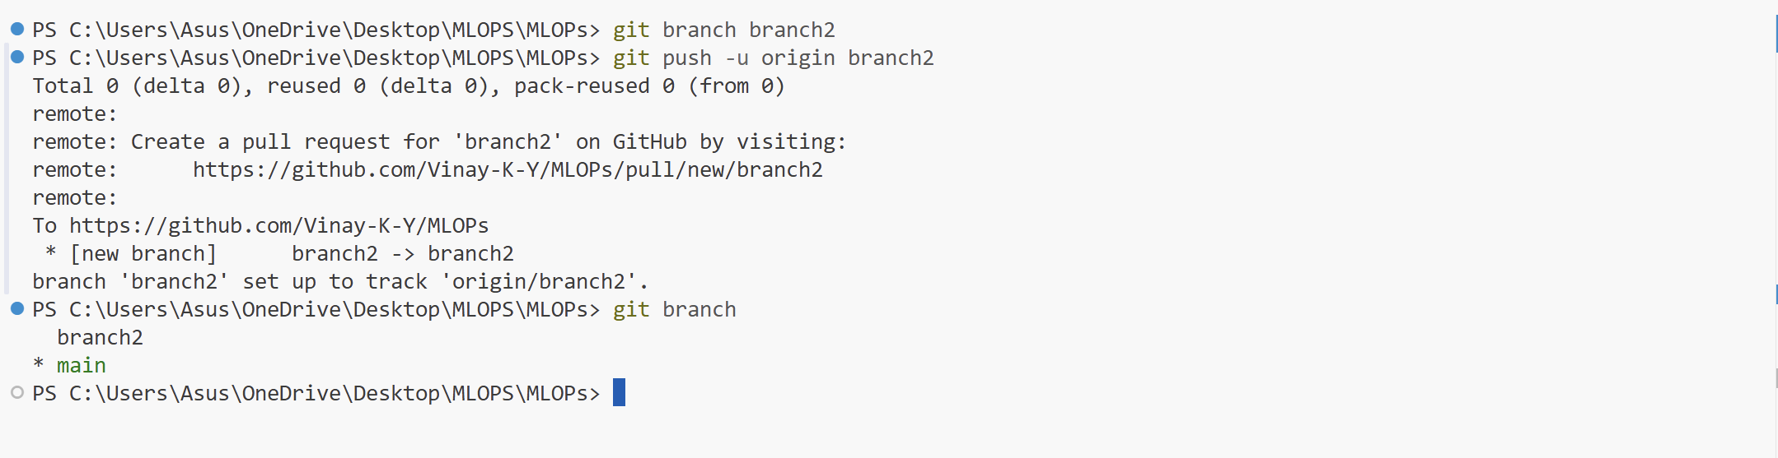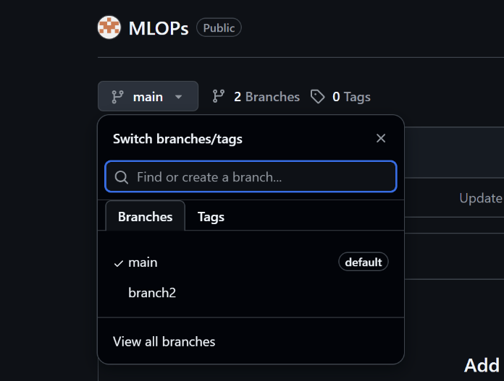
Add file to new branch
- git checkout -b branch-name
- git add .
- git commit -m "Add new file to branch-name"
- git push -u origin branch-name

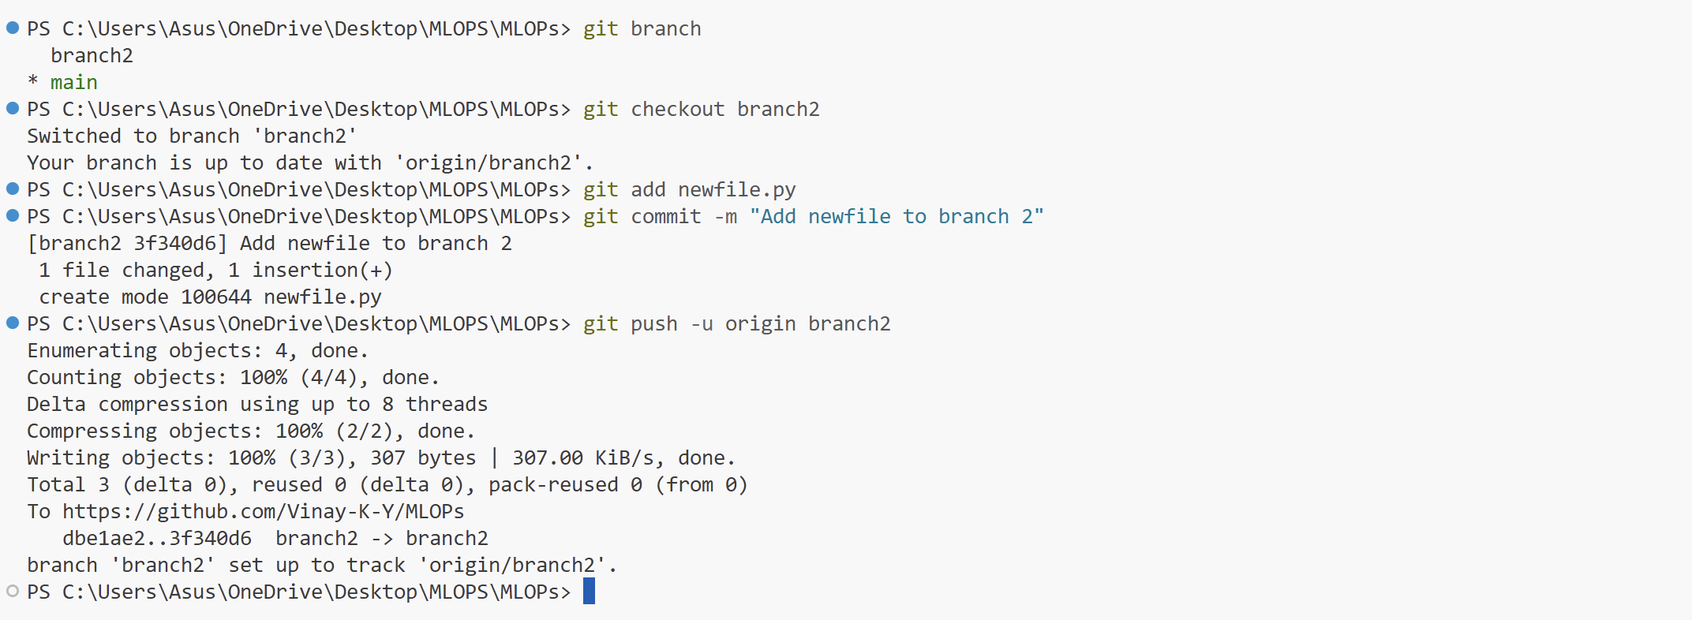
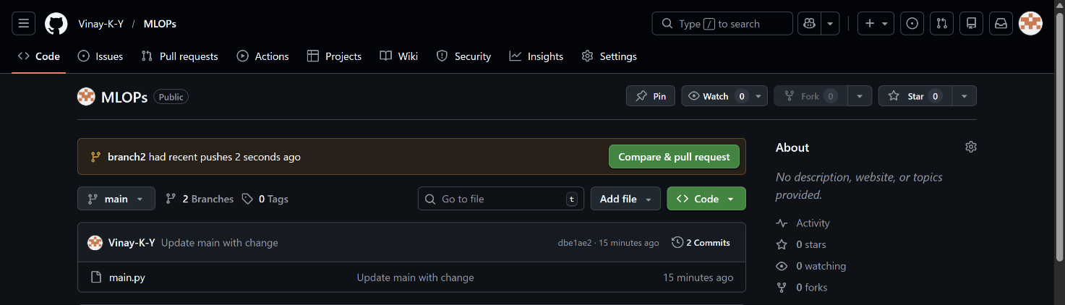
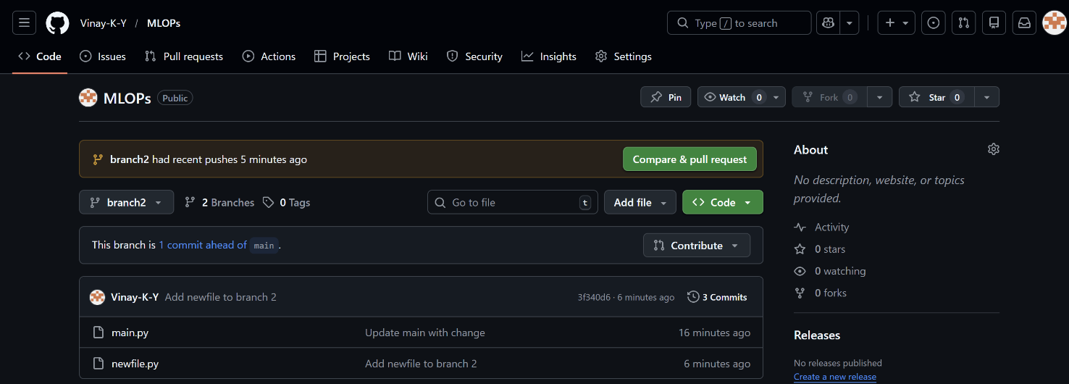

Git Conflict
Change a line in main.py from branch 2 as print("Hello from Branch 2") then push the changes
- git add main.py
- git commit -m "Update main.py in branch2"
- git push origin branch2
Switch the branch and make changes in the same line as print("Hello from Main Branch") and commit changes
git add main.py
- git commit -m "Update main.py in main"
- git push origin main
Now trigger merge conflict with

- git merge branch2

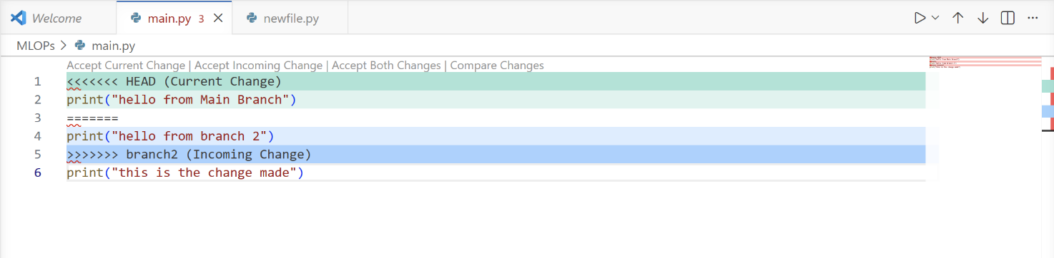
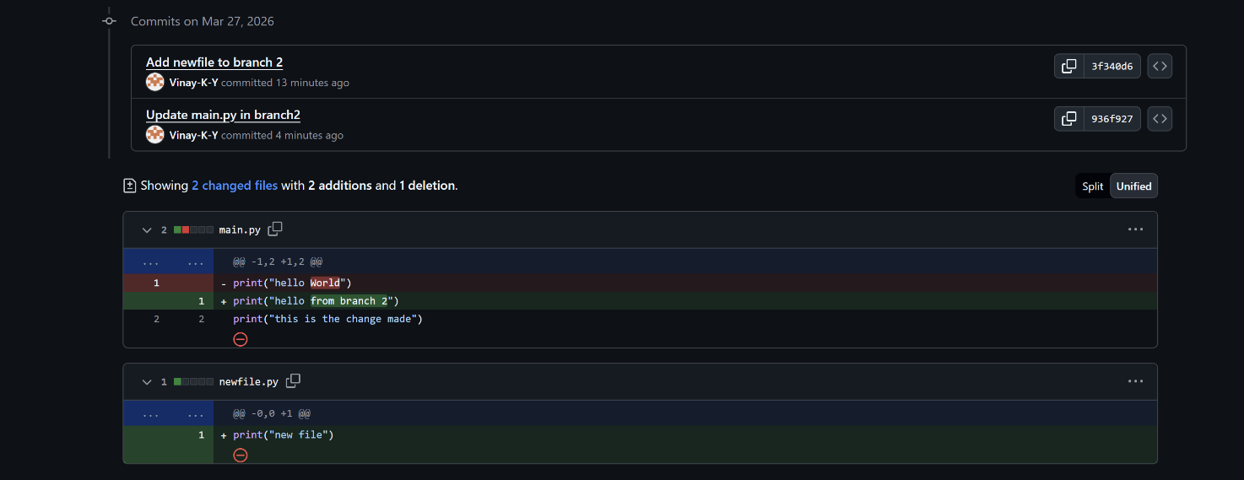
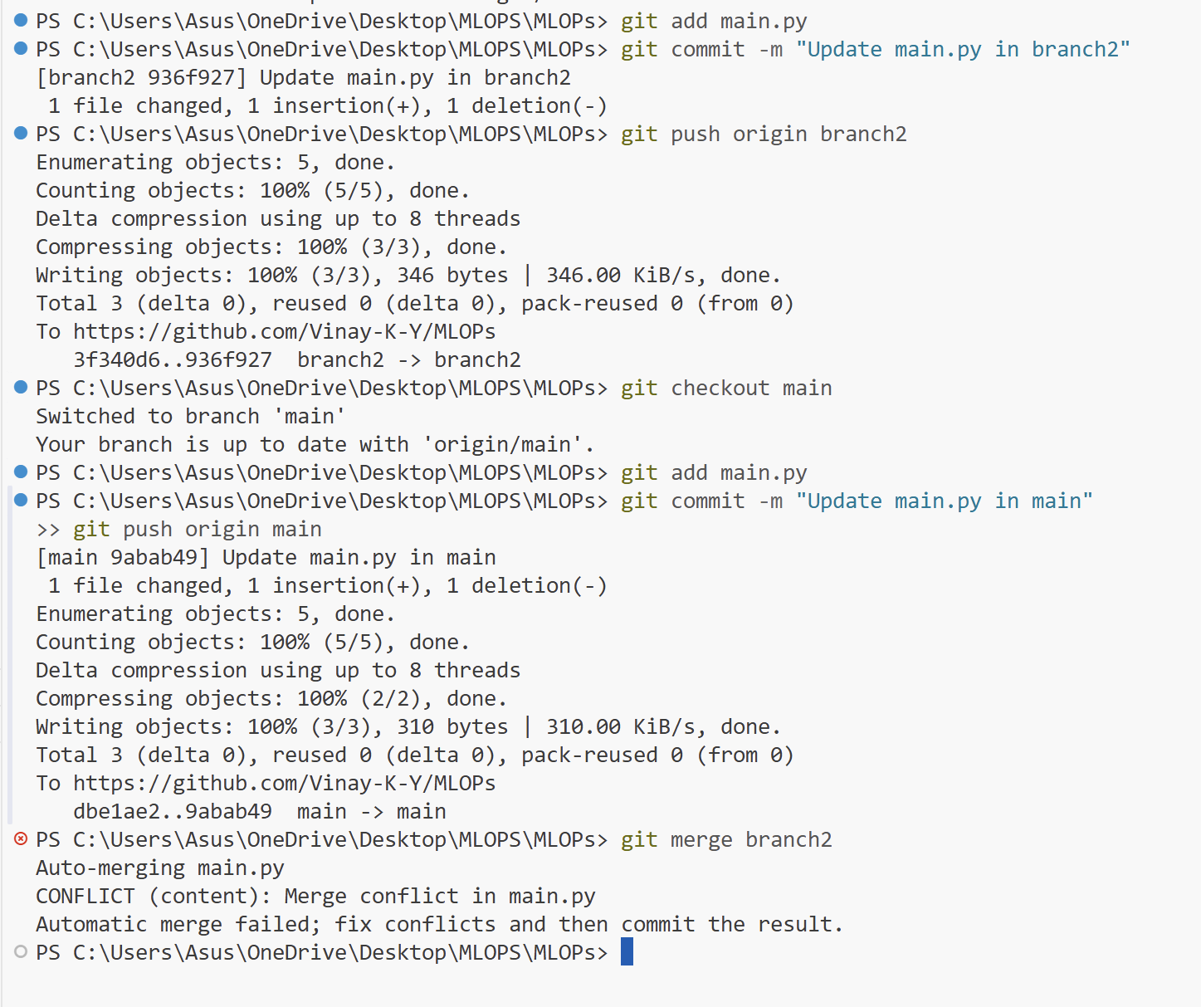
Resolving the Git conflict
Delete the markers in the main.py file and keep the code which you require and save the file. Then commit the changes to git using
- git add main.py
- git commit -m "Resolved merge conflict between main and branch2"
- git push origin main
To merge the branches we use command
git merge branch-name
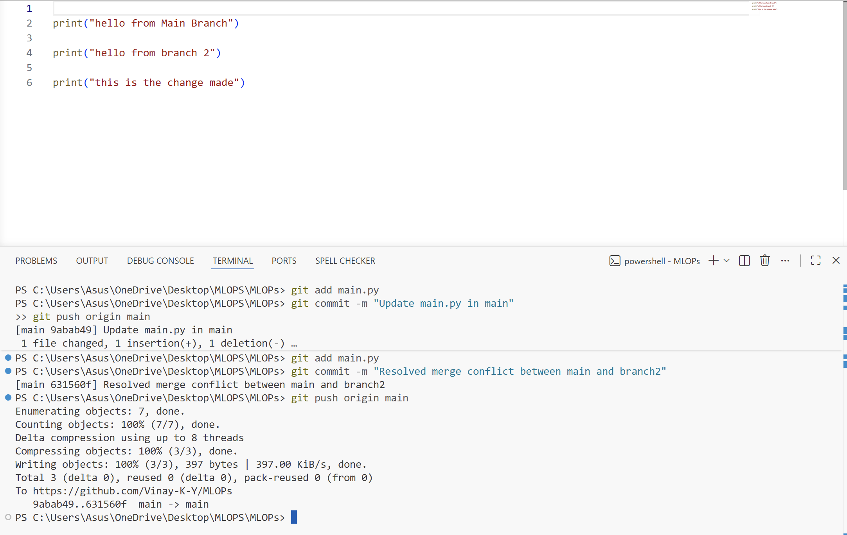
Git Commits
