*Predicting Electric Bike Usage in the D.C. area using weather data: A machine learning approach*

Vinay Kota

And

Sanathkumar Chiluveru

[GitHub Repo Link](https://github.com/Vinaykota81/Data606CapstoneProject)

***Abstract***

*Electric bikes have become a popular mode of transport due to their ease of use and environment-friendly nature. Many cities in the U.S. have already established E-bike sharing programs that are available for a certain rent for the consumers. These E-bikes are very convenient as you could pick them up anywhere and park them anywhere necessary. Due to the increasing demand, companies need to understand usage patterns. Capital Bikeshare, a bike rental company operating in Washington D.C. by the company LYFT is a popular one. Every year CaBi users rent bikes over 1 million times. Because of this constant demand, the company must understand how people are renting bikes and what factors are affecting the rentals. This project aims to analyze this issue. This project couples Cabi’s data and the Washington D.C. weather data. We collected the rental data from Capital Bikeshare for the year 2022 along with the weather data from an API Visual Crossing. We performed feature engineering to add additional features to the dataset.*

**Introduction**

With the increase in awareness among the people regarding the effects of pollution caused due to fuel vehicles, people are more than interested in looking for alternate options for their daily commute. One such way is to use bikes. Big cities in the USA have been taking initiatives to launch more and more electric bikes in highly populated cities with many industries. Bike sharing provides various convenient factors such as different pickup and drop-off locations. You could be able to simply rent it using your mobile phone and an app. Capital Bikeshare has an app where users can select if they want to be a member or just need a one-time ride. It provides flexible plans for a mass commute. The bikes can be used as a one-way transport or two ways [1].

With all these use cases and advantages that these bike-sharing programs have, it is becoming necessary to cope with the demand. This project proposes a detailed analysis of the bike rentals which includes time taken by each renter, distance covered, and minutes traveled for each quarter hour. The paper by Egzi Eren (2020), gives some essential factors that contribute to rental demand fluctuations. This includes weather conditions like heat, precipitation, and snow, type of roadways, public transport in that area, etc. Of these weather plays a prominent role in the reduction of rental demands. This project aims to combine the existing Cabi bike rental data with the weather to find out how can one make informed decisions while setting up additional docks and also putting in additional bikes in that locality [2].

We also aim to predict the rental demand based on the hour and also the quarter hour in which rentals are happening. One way to find the usage patterns is through the use of machine learning algorithms on data gathered from bike-sharing programs. For example, Wang (2016) used data from New York City's bike-sharing program to analyze the impact of weather and holidays on bike rentals. The author found that variables such as temperature, wind speed, and humidity have a significant impact on the number of rentals and that people tend to use bikes more during weekdays when offices are open and in the evenings on weekends. By using machine learning algorithms, the author was able to predict the demand for bike rentals, which could help eliminate surprises for bike rental companies [3].

Another study by Gao and Chen (2020) explored the impact of pollution, traffic, and COVID-19 on bike rental demand using data from Seoul's bike-sharing program. The authors found that pollution, traffic accidents, and weather variables such as visibility and humidity were positively correlated with bike rentals, while COVID-19 cases and deaths had a negative correlation. By using machine learning algorithms to analyze these factors, the authors were able to identify which factors had the most impact on bike rental demand [4].

Another study by Tien Dung Tran and Nicolas Ovtracht (2015), aimed to investigate the impact of built environment factors such as land use, population density, and transportation infrastructure on bike-sharing demand. The research was carried out by analyzing data from a bike-sharing system in a French city. The findings of the study revealed that built environment factors play a significant role in bike-sharing demand and that transportation infrastructure has the strongest influence on bike-sharing usage [5]. The study concluded that policymakers and city planners should consider these factors when implementing bike-sharing systems in urban areas.

**Methods**

This project uses two main data sources: Capital Bikeshare rental data and Weather data of Washington D.C.

Capital Bikeshare company has an open data portal where we could be able to download the data from 2015 [6]. Here for this project, we are choosing just the year 2022 since the number of records for that single year is around 500k. This huge number of records is making this substantial enough to run analytics and get information. The dataset contains fields like the ride rideable type (electric or normal), start time, end time, start location, end location, corresponding latitude and longitude, rented by a registered member or casual member. In this project, electric bikes are the area of focus.

The second is the weather data. To get Washington D.C.'s weather data, we used an API by visual crossing [7]. This API provides different weather-related fields like temperature, snow, weather conditions, etc. The API can only retrieve data for 20 days at a time. A Python script was created to retrieve essential data for every hour throughout the year with around 8760 records.

The whole project was done using jupyter notebook with Python. Additional Python libraries like pandas, matplotlib, and seaborn and machine learning libraries like sci-kit learn are used for prediction.

The raw rental data is first collected, there are two fields with a lot of missing values i.e., station names. This data is assumed to dock less and renters parked them with no specific station. So, the null values are replaced by “Not Docked”. The columns start_hour, start_quater, and time_travelled are created to better understand the problem. There is a statistical method called haversine distance which gives us the distance between two points on the globe. Though it may not be reliable since people don’t commute from point to point in a straight line, it will be a useful factor to understand what distance a renter might cover.

There are around 750 stations in Washington D.C. which would be a redundant task to predict demand at each station as every hour has only 1 or 2 rentals at most of the stations, we divided them into 7 clusters using the K-Means algorithm. We are going to predict and analyze the rental patterns based on these clusters. Since we now have hourly weather data to add to the existing data, we chose to group by date and hour. Additional fields like minutes traveled and distance traveled are aggregated using group by functions and a new dataset is created.

We obtained station-wise data that was incorporated into the final data frame based on the corresponding clusters. This additional data includes information such as the number of available docks, the number of disabled docks, and the number of e-bikes available at each station. To enhance the clarity of our analysis, we have also organized the station-wise data into clusters. This enables us to conduct a cluster-wise analysis and identify distinct characteristics and patterns within each cluster. By comparing e-bike availability, dock availability, and other relevant variables across clusters, we can uncover similarities and differences that contribute to our understanding of the rental demand.

In this project, we employed four different types of models: Linear Regression, KNN Regressor, Random Forest Regressor, and Gradient Boosting Regressor. The selection of these models was based on our understanding that ensemble methods tend to perform well on tabular data.

To evaluate and compare the performance of these models, we utilized the cross-validation technique with 5 folds. By using cross-validation, we aimed to mitigate the potential bias or variance issues that can arise from a single train-test split.

The choice of 5-fold cross-validation was based on its common usage and effectiveness in estimating model performance while striking a balance between computational resources and accuracy. This allowed us to assess their performance across multiple train-test splits, providing a better overall estimate of their generalization ability and mitigating potential overfitting.

It is important to note that our default expectation was for the ensemble methods (Random Forest Regressor and Gradient Boosting Regressor) to outperform the Linear Regression and KNN Regressor models due to their ability to capture complex relationships in the data.

**Results and Analysis**

In Washington, D.C., the bike-sharing program was initially launched in 2010, marking the beginning of a growing trend. Over the years, the program has expanded by adding more bicycles to meet the increasing demand. In 2018, the introduction of electric bikes into the system provided an additional transportation option for users. These electric bikes gained popularity due to their convenient and efficient mode of transportation, requiring less human effort compared to traditional bikes. As a result, the usage of electric bikes has been steadily increasing each year.

By the year 2022, electric bikes accounted for approximately 15% of the total bike rentals in Washington, D.C. This significant proportion demonstrates the growing acceptance and adoption of electric bikes among the users of the bike-sharing program.

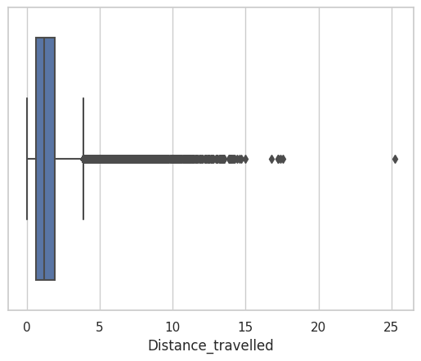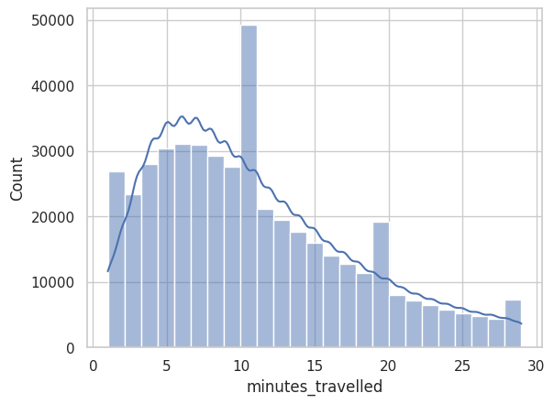On average, people renting bikes in Washington, D.C. typically use them for short commutes, with rental durations ranging from 10 to 20 minutes. The majority of rentals fall within the range of 5 to 10 minutes, indicating that many users rely on bike sharing as a convenient mode of transportation for short-distance trips. This pattern of short rental durations suggests that the bike-sharing program is well suited for quick and efficient journeys, such as short commutes between nearby locations.

Based on the graph observations, it is evident that the majority of bike rentals in Washington, D.C. are for distances of less than 5 miles. The distance mentioned refers to the point to point distance between the start and end of each rental, rather than the actual distance covered during the ride. This finding further reinforces the notion that bike sharing is primarily utilized for short-distance trips and serves as a convenient transportation option for shorter commutes within the city.

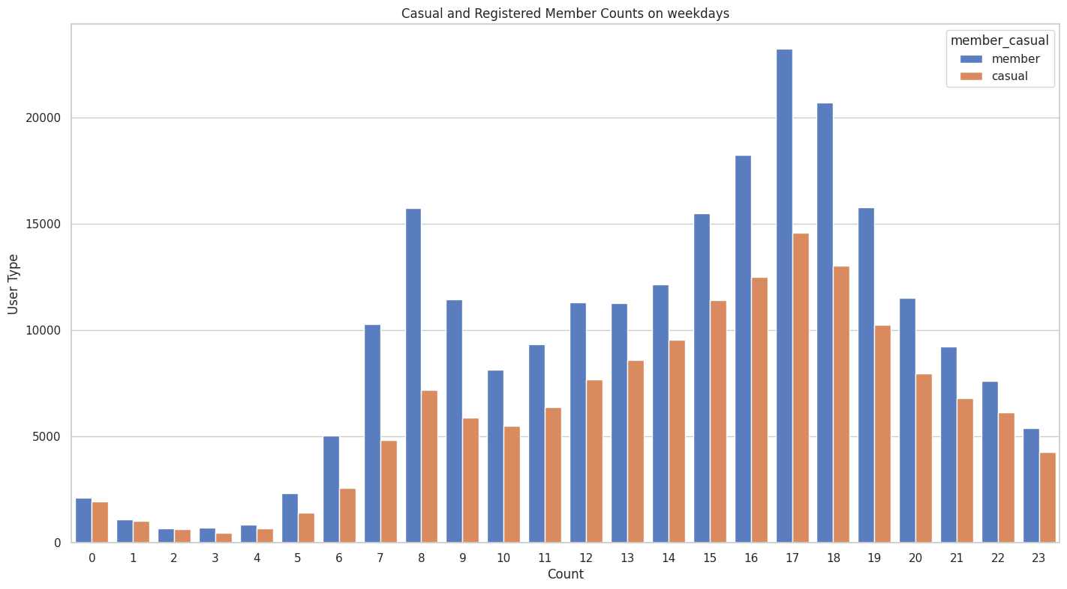

During weekdays, Monday to Friday, the rental patterns exhibit distinct peak periods. In the morning, typically between 8 am and 9 am, there is a surge in bike rentals, coinciding with the start of office hours. This suggests that many individuals utilize the bike-sharing service as a means of commuting to work during the morning rush hours. Similarly, in the evening, around 5 pm to 6 pm, there is another peak in bike rentals. This aligns with the end of office hours, indicating that people rely on electric bikes to travel back home after work. 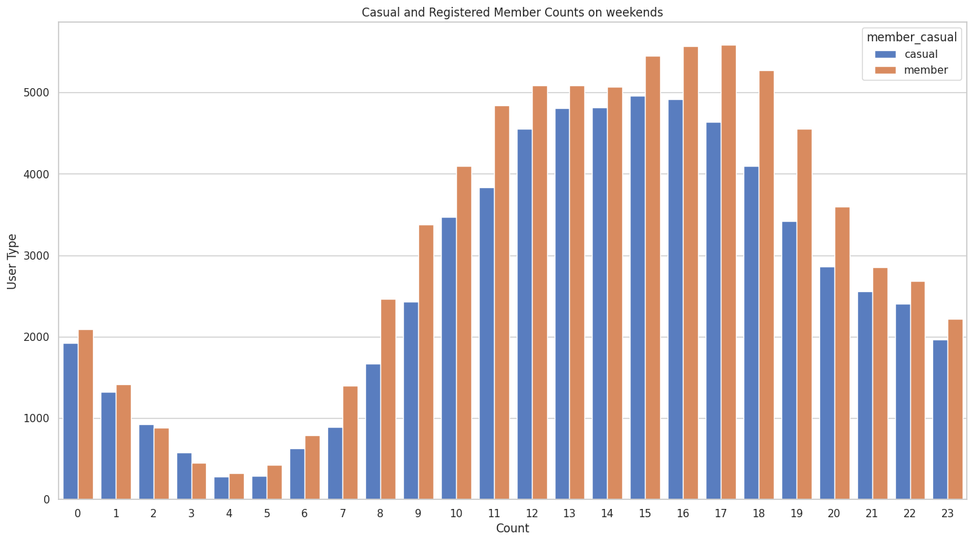

Conversely, on weekends, a different trend emerges. The count of rentals gradually increases as the day progresses, suggesting that individuals utilize electric bikes for leisurely activities and exploration. As the day transitions into the night, the rental count decreases, indicating that people tend to use bikes less frequently during evening hours.

Understanding these temporal usage patterns can assist in optimizing bike availability, station management, and resource allocation. By aligning the distribution and availability of electric bikes with the peak commuting hours during weekdays and adapting to the evolving rental patterns on weekends, the bike-sharing program can better cater to the needs of its users and enhance the overall user experience. 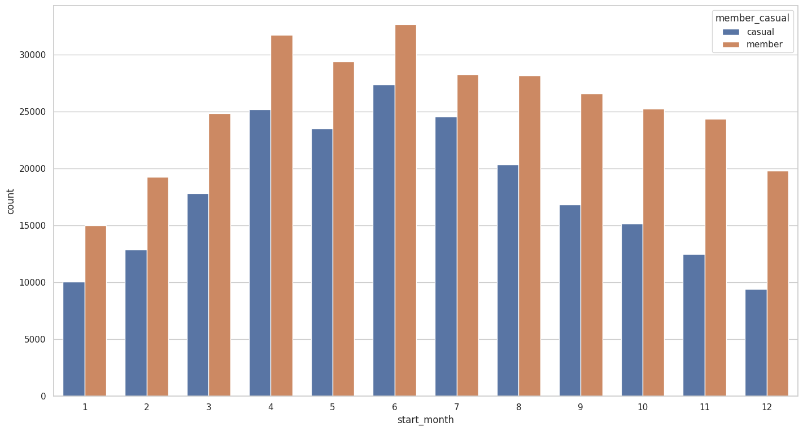

Analyzing the monthly statuses of electric bike usage reveals a noticeable trend. There is a slight decline in usage after the summer season, followed by an increase during the months of March and April. The increase in bike usage during March and April can be attributed to the city's renowned cherry blossom season, attracting a surge of tourists and locals alike.

As the cherry blossoms bloom, many individuals are drawn to the scenic beauty and cultural events associated with this time of the year. Consequently, the demand for electric bikes rises as people opt for this eco-friendly and convenient mode of transportation to enjoy the cherry blossoms and explore the city.

However, as the summer months progress, the usage of electric bikes experiences a slight decline. This may be attributed to various factors such as increasing temperatures, vacations, or a shift in commuting patterns due to seasonal changes. Despite the slight decrease, electric bikes continue to serve as a popular transportation option in Washington, D.C.

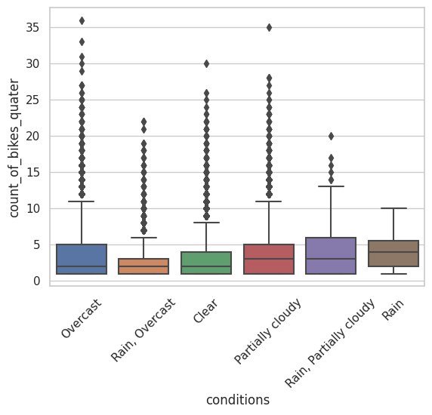Upon analyzing the plot, a clear pattern emerges regarding the relationship between weather conditions and bike rentals. The majority of rentals occur when the sky is cloudy or partially cloudy, while rentals are significantly lower during rainy conditions. This observation suggests that weather, particularly temperature, and cloud cover, plays a crucial role in influencing the demand for bike rentals. During the spring and summer months, when the weather is generally warmer, people tend to opt for electric bikes more frequently when the sky is filled with clouds rather than on clear days. This implies that individuals may perceive overcast conditions as more comfortable for outdoor activities, including bike riding. The presence of clouds likely provides shade and a cooler environment, making it more appealing for users to engage in bike rentals.

Interestingly, this trend holds across other seasons as well. Overcast conditions consistently coincide with the highest number of bike rentals, while rentals decline significantly during rainy weather

Understanding the influence of weather conditions on bike rental demand can be valuable for operational and marketing purposes. It allows bike-sharing programs to anticipate fluctuations in demand based on weather forecasts and optimize resource allocation accordingly. Additionally, it underscores the importance of considering weather patterns and their impact on user preferences when designing marketing campaigns and promoting bike rentals during specific weather conditions.

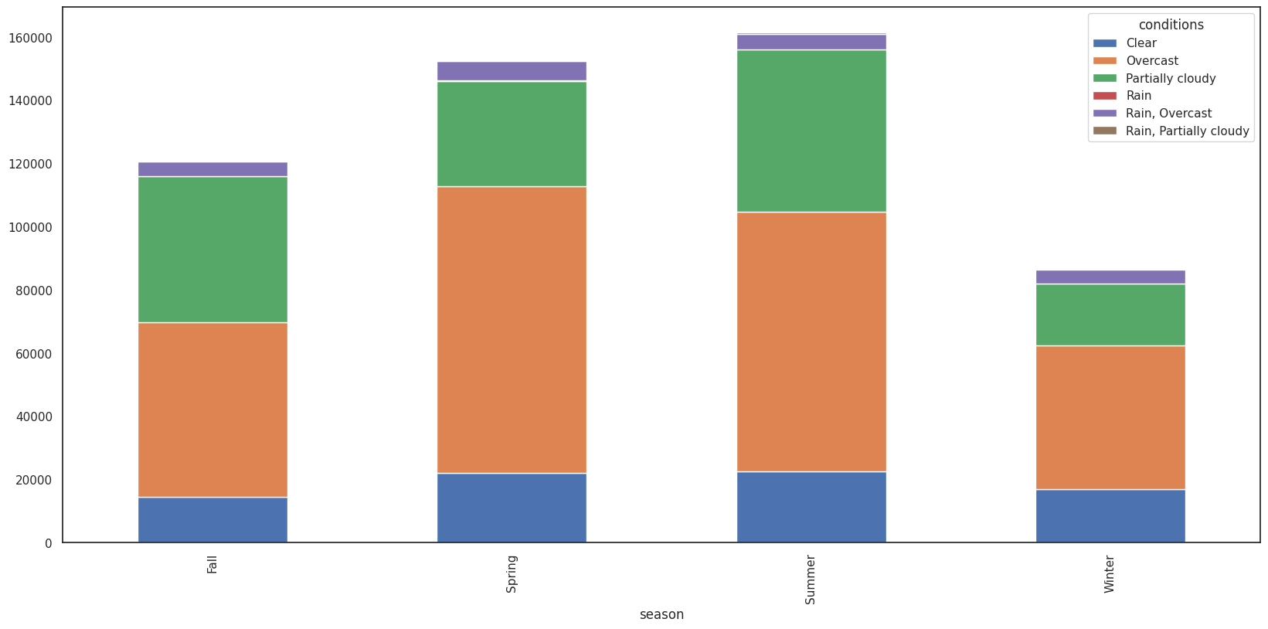

The correlation coefficients in the table indicate the strength and direction of the linear relationship between each pair of variables. Here's a summary of the observed correlations:

Temperature (temp) has a positive correlation (0.181257) with the count of bikes rented per quarter (count_of_bikes_quater), indicating that higher temperatures are associated with increased bike rentals.

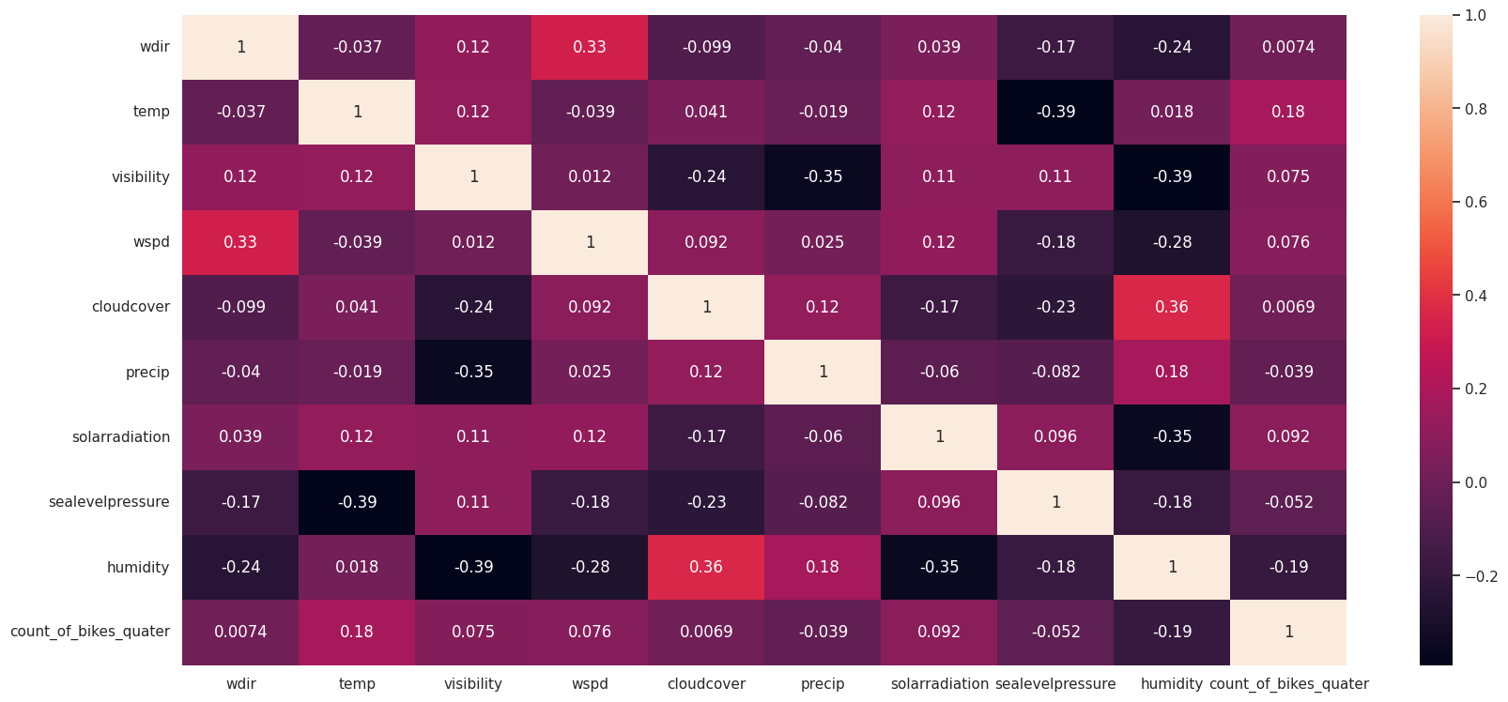Humidity (humidity) has a negative correlation (-0.190753) with bike rentals, suggesting that higher humidity levels are slightly associated with fewer rentals.

Visibility (visibility) and wind speed (wspd) have weak positive correlations (0.074916 and 0.075996, respectively) with bike rentals, indicating a slight influence of these factors on rental counts.

Other factors such as wind direction (dir), cloud cover (cloud cover), precipitation (precip), solar radiation (solar radiation), and sea level pressure (sea level pressure) show weak correlations (close to zero) with bike rentals, suggesting a minimal impact on rental counts.

Temperature and humidity appear to be the most influential factors affecting bike rentals, with higher temperatures and lower humidity levels associated with increased rental activity. Other weather factors such as visibility, wind speed, cloud cover, precipitation, solar radiation, and sea level pressure have weaker or negligible correlations with bike rental counts.

Based on the scatter plots depicting the relationship between weather variables and the count of rentals, it is evident that three factors significantly contribute to the fluctuations in bike demand: temperature, precipitation, and solar radiation.

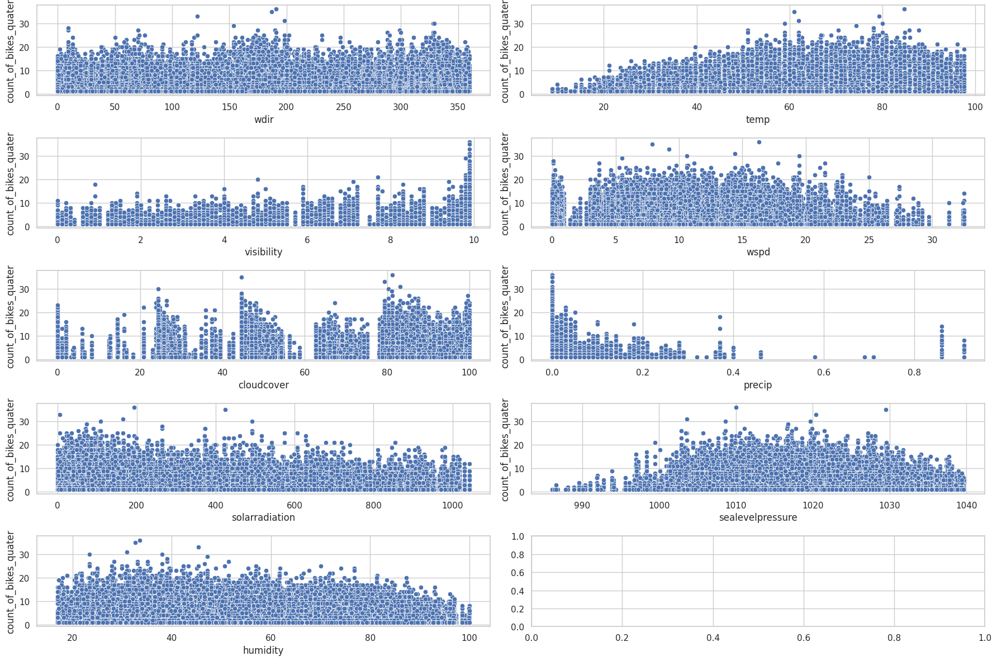

**Temperature:** The scatter plot shows a clear positive trend between temperature and the count of rentals. As temperature increases, there is a corresponding increase in bike rentals, indicating that warmer weather attracts more people to use bikes for transportation.

**Precipitation:** The scatter plot reveals a negative relationship between precipitation and the count of rentals. As precipitation levels rise, the number of bike rentals decreases. This suggests that rainy conditions deter people from renting bikes, likely due to concerns about riding in wet weather and reduced overall convenience.

**Solar Radiation:** The scatter plot demonstrates a positive correlation between solar radiation (sunlight intensity) and the count of rentals. Higher levels of solar radiation coincide with increased bike rentals, indicating that sunny conditions encourage people to choose biking as a mode of transportation.

Given the factors considered, including weather variables and docking station information, we chose to employ four different regression models to compare their performance: Linear Regression, Random Forest Regression, KNN Regression, and Gradient Boosting Regression. Based on previous studies and recommendations, it has been suggested that Random Forest Regression tends to yield superior results in similar contexts.

| **Model** | **Mean Square Error** | **Root Mean Square Error** | **R-Square Value** |
| --- | --- | --- | --- |
| Linear Regression | 414.98132399574905 | 20.371090397810054 | 0.7847564616011757 |
| KNN Regression | 4.698329088615971 | 2.167562937636638 | 0.5184173052130958 |
| Random Forest Regression | 1.3425534877484666 | 1.1586861040629022 | 0.8623871350152861 |
| Gradient Boosting Regression | 1.372411349351133 | 1.171499615600079 | 0.8593266790148696 |

The results indicate that the Random Forest Regression model outperformed the other models based on all three-evaluation metrics. It achieved the lowest MSE and RMSE values, indicating better accuracy in predicting e-bike rental demand. Additionally, it demonstrated a higher R-Square value, suggesting that a larger proportion of the variance in the rental demand is explained by the model's predictions. [3][4]

These findings support previous works that have also found Random Forest Regression to be a suitable model for predicting e-bike rental demand. The model's ability to capture complex relationships and handle non-linear patterns likely contributes to its superior performance in this context.

Below is a sample graph of the correct predictions made for the 100 data points on the test set:

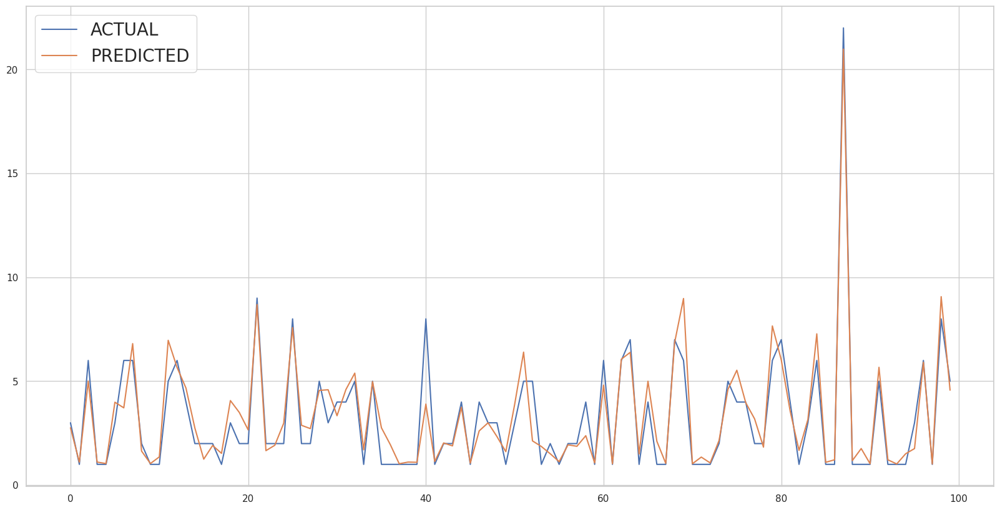

**Conclusion**

In conclusion, this project has provided valuable insights into the relationship between weather patterns and e-bike rental demand. The findings highlight the significance of weather variables, including temperature, precipitation, and solar radiation, in influencing the usage patterns of e-bikes. By leveraging machine-learning techniques, particularly the Random Forest Regression model, accurate predictions of rental demand can be achieved.

The study has implications for companies like Capital One Bikeshare, where integrating weather data and predictive models can optimize resource allocation, marketing strategies, and overall operational efficiency. These findings can inform decision-making processes and contribute to the development of sustainable urban transportation initiatives.

Looking ahead, prospects for this project include incorporating additional data sources, implementing dynamic pricing strategies, exploring integration with other mobility services, and enhancing the user experience through technological advancements. By pursuing these opportunities, companies can further optimize their business models and contribute to the growth and success of e-bike rental programs.

Overall, this project emphasizes the promising potential of e-bikes in reshaping urban transportation, reducing reliance on traditional modes of travel, and promoting greener, more efficient alternatives. It underscores the importance of considering weather factors and utilizing predictive models to drive informed decision-making in the bike-sharing industry.

**References**

[1] Qiu, L.-Y., & He, L.-Y. (2018). Bike sharing and the economy, the environment, and health-related externalities. *Sustainability*, *10*(4), 1145. https://doi.org/10.3390/su10041145

[2] Eren, E., & Uz, V. E. (2020). A review on bike-sharing: The factors affecting bike-sharing demand. *Sustainable Cities and Society*, *54*, 101882. https://doi.org/10.1016/j.scs.2019.101882

[3] Wang, W. (n.d.). Forecasting bike rental demand using New York Citi Bike Data. ARROW@TU Dublin. Retrieved March 10, 2023, from https://arrow.tudublin.ie/scschcomdis/79/

[4] Gao, C., & Chen, Y. (1970, January 1). Using machine learning methods to predict demand for bike sharing. SpringerLink. Retrieved March 10, 2023, from https://link.springer.com/chapter/10.1007/978-3-030-94751-4_25

[5] Tran, T. D., Ovtracht, N., & d’Arcier, B. F. (2015). Modeling bike sharing system using built environment factors. *Procedia CIRP*, *30*, 293–298. https://doi.org/10.1016/j.procir.2015.02.156

[6] https://opendata.dc.gov/

[7] <https://www.visualcrossing.com/resources/documentation/weather-api/weather-api-documentation/>

[8] ChatGPT(chat.openai.com)