Lab-5 Group 8 19/02/2026
1. show version
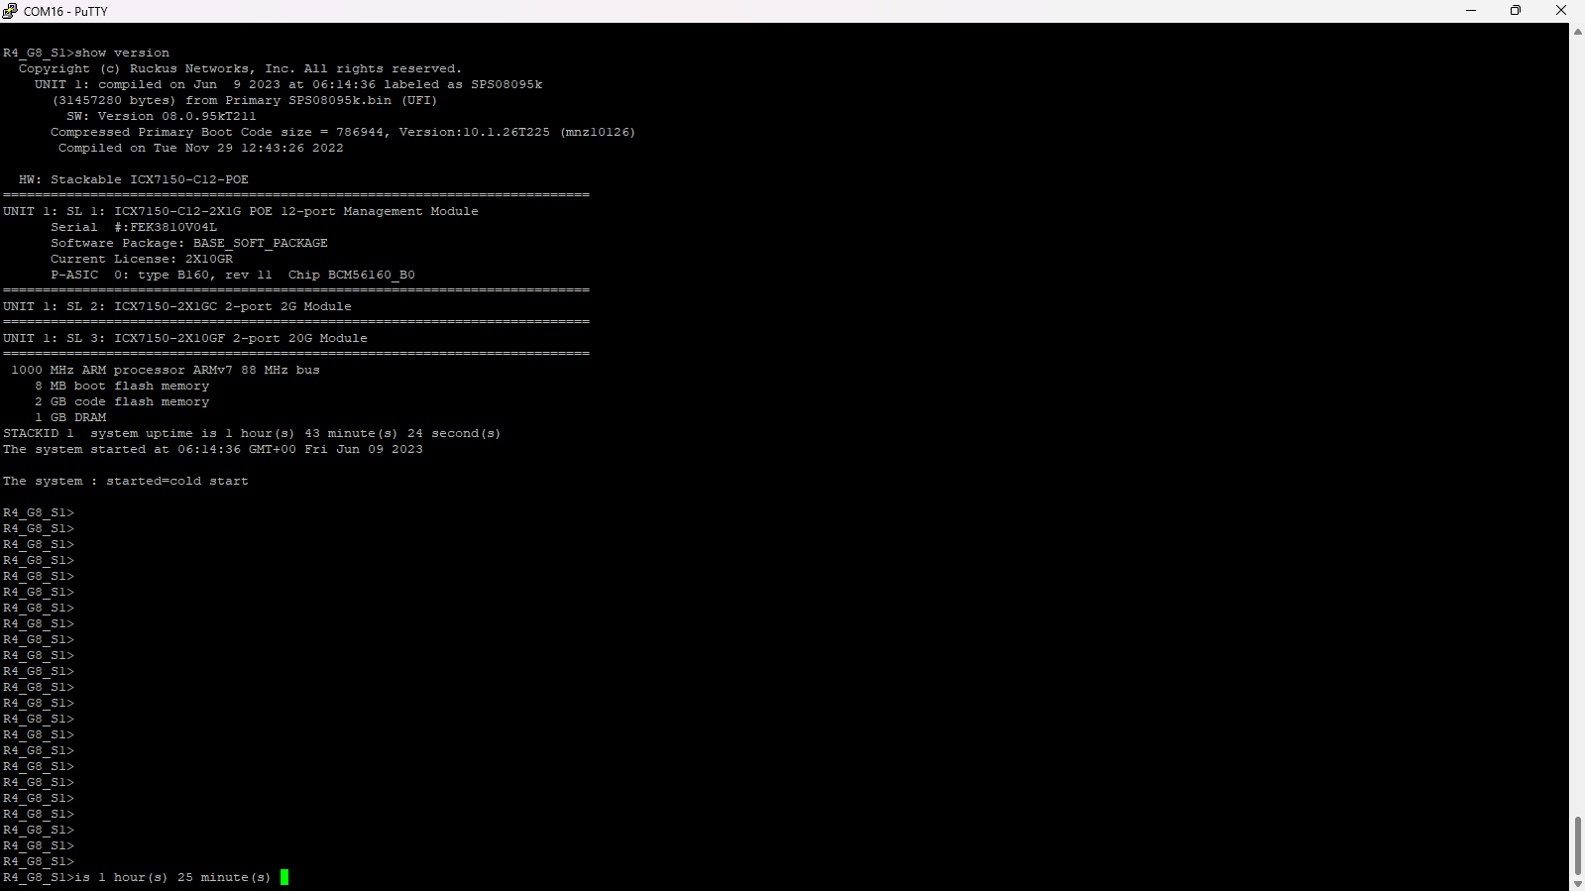
2. show ip
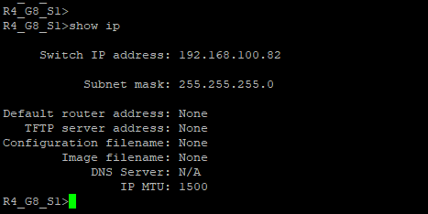
3. show int brief
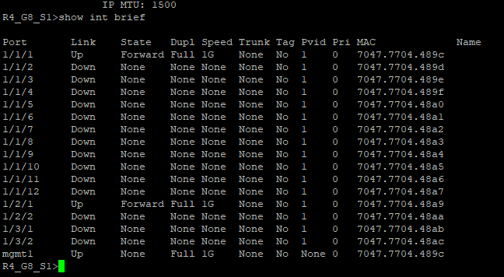
4. show run
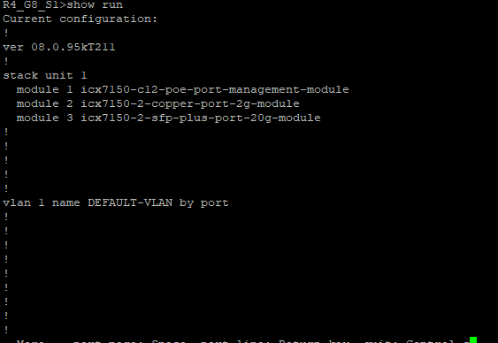
5. show user
6. show mac-address
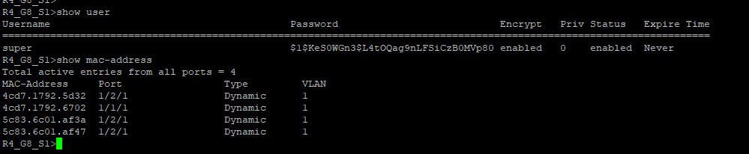
7. show ip tcp connections
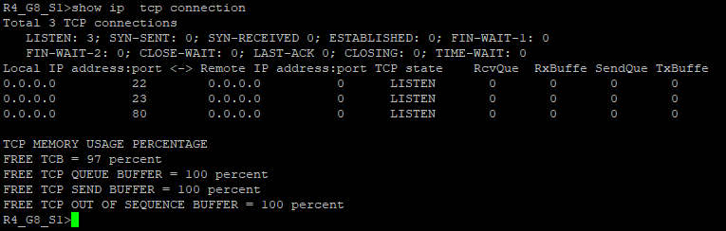
8. show ip tcp traffic
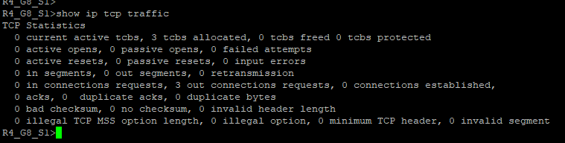

Rack connections Image
