Lab-5 Group 8 26/02/2026
1. Putty Commands
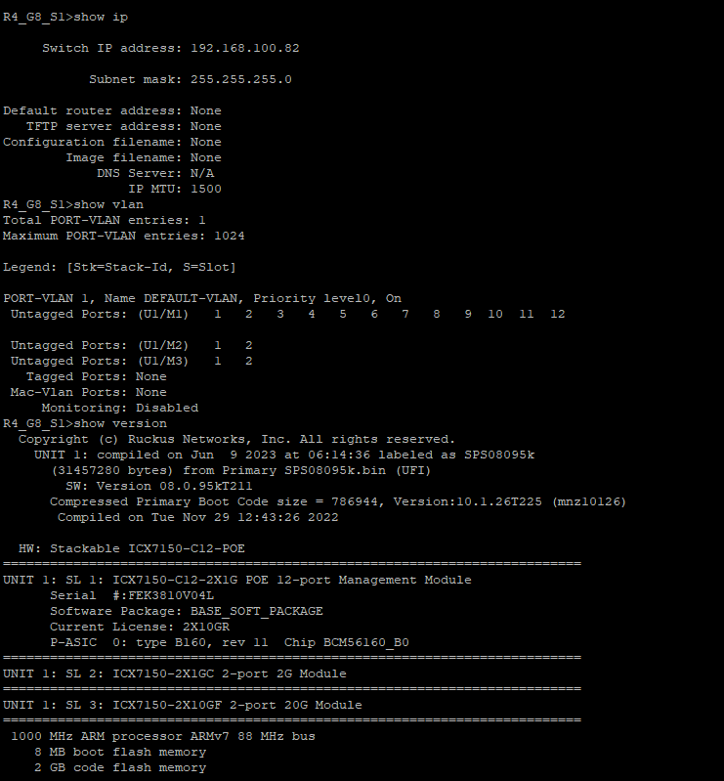
2. Creating VLANS 10 and 20
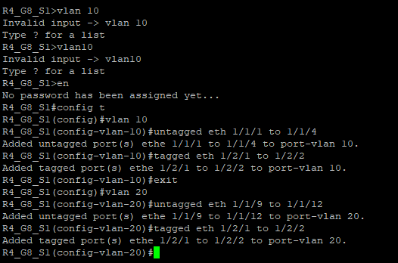
3. Now Pinging from those VLAN to other VLAN
3.1 Same VLAN same switch
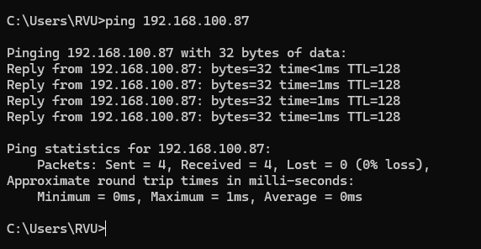
3.2 Same VLAN same switch 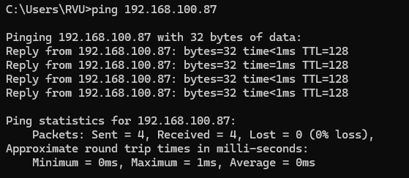
  - Different VLAN same switch
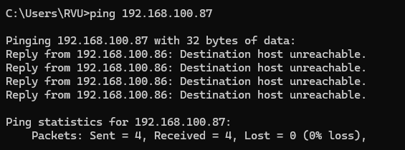

3.4 Different VLAN different Switch
