Lab-4-Exp-1 Client & Server
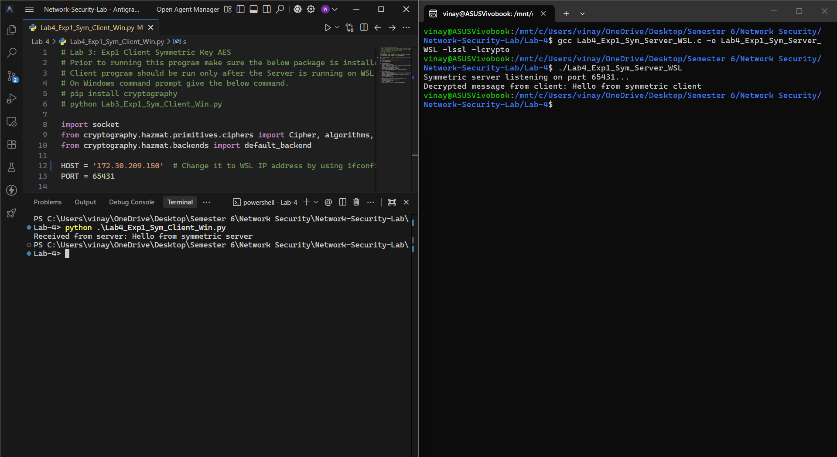
Lab-4-Exp-2 Client & Server
