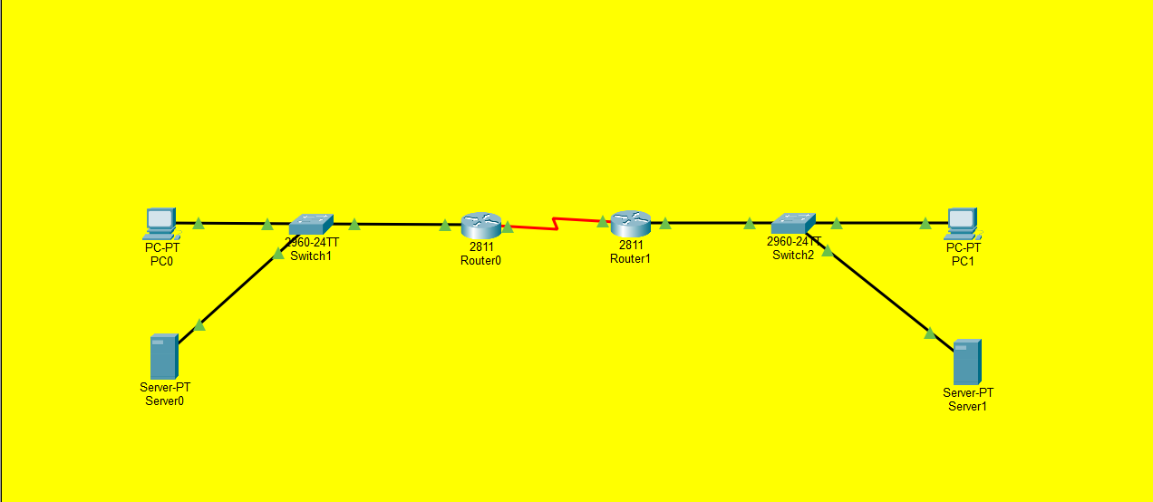
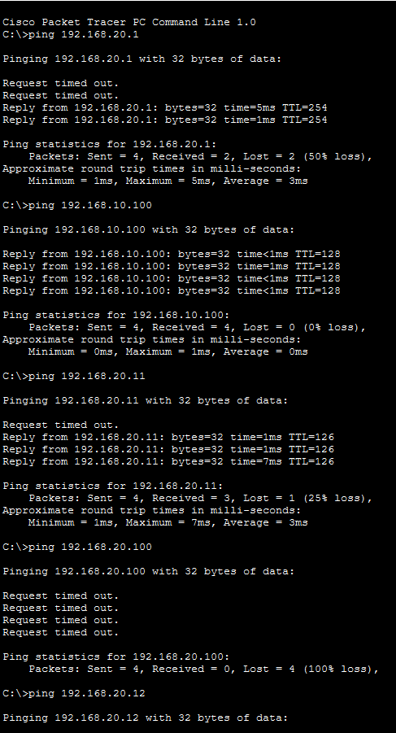
Ping from PC 0 to Server 0 & 1 and to PC 1
Configuration of Router 0 Interface
R0> enable
R0# configure terminal
R0(config)# interface FastEthernet0/0
R0(config-if)# ip address 192.168.10.1 255.255.255.0
R0(config-if)# no shutdown
R0(config)# interface Serial0/0/0
R0(config-if)# ip address 10.0.0.1 255.255.255.252
R0(config-if)# clock rate 64000
R0(config-if)# no shutdown

Configuration of Router 1 Interface
R1> enable
R1# configure terminal
R1(config)# interface Serial0/0/0
R1(config-if)# ip address 10.0.0.2 255.255.255.252
R1(config-if)# no shutdown
R1(config)# interface FastEthernet0/0
R1(config-if)# ip address 192.168.20.1 255.255.255.0
R1(config-if)# no shutdown

Configuration of DHCP on Router 0
R0(config)# ip dhcp pool LEFT
R0(config-dhcp)# network 192.168.10.0 255.255.255.0
R0(config-dhcp)# default-router 192.168.10.1
R0(config-dhcp)# dns-server 8.8.8.8
R0(config-dhcp)# exit
R0(config)# ip dhcp excluded-address 192.168.10.1 192.168.10.10

Configuration of DHCP on Router 1
R1(config)# ip dhcp pool RIGHT
R1(config-dhcp)# network 192.168.20.0 255.255.255.0
R1(config-dhcp)# default-router 192.168.20.1
R1(config-dhcp)# dns-server 8.8.8.8
R1(config-dhcp)# exit
R1(config)# ip dhcp excluded-address 192.168.20.1 192.168.20.10

Configuration of Server 0
IP address (Static)
IP Address: 192.168.10.100
Subnet mask: 255.255.255.0

Configuration of Server 1
IP address (Static)
IP Address: 192.168.20.100
Subnet mask: 255.255.255.0

