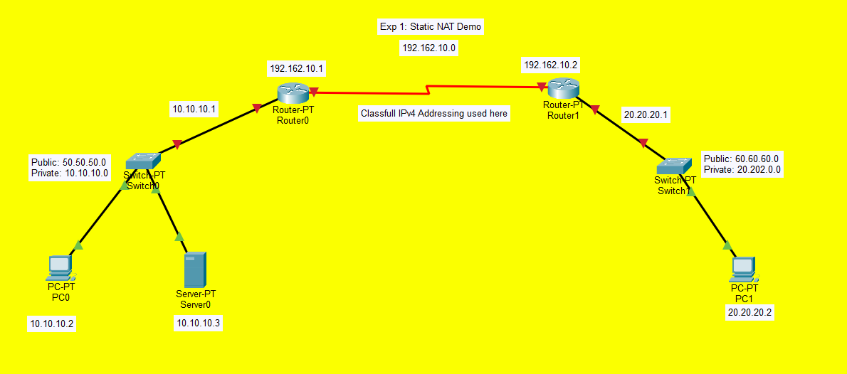
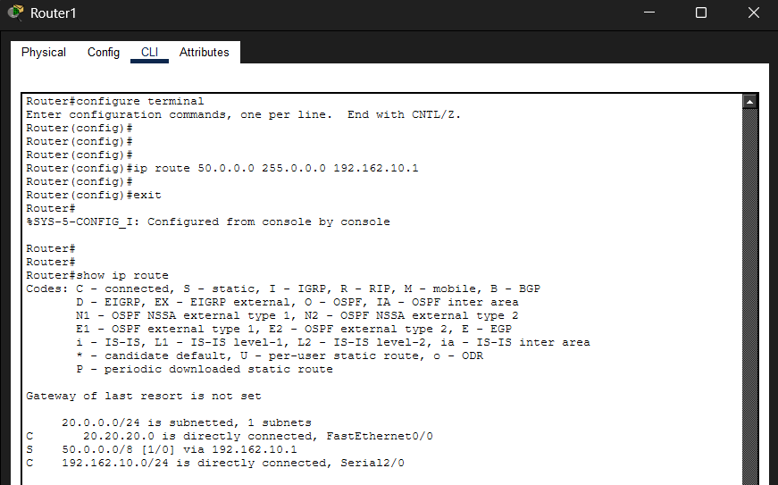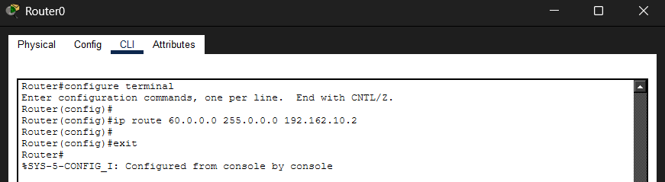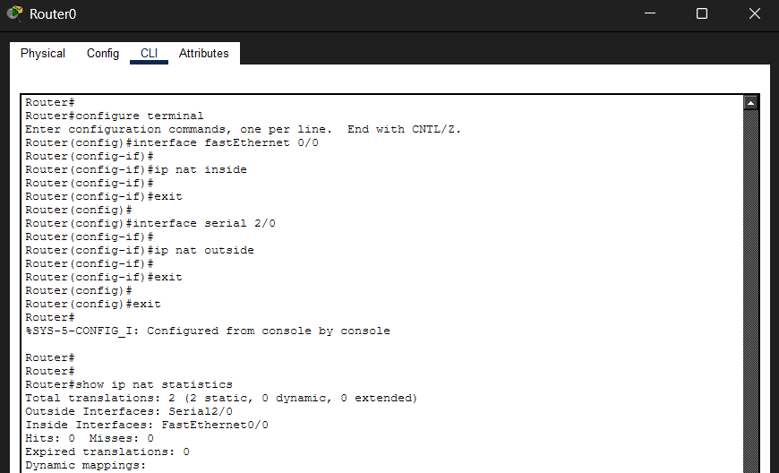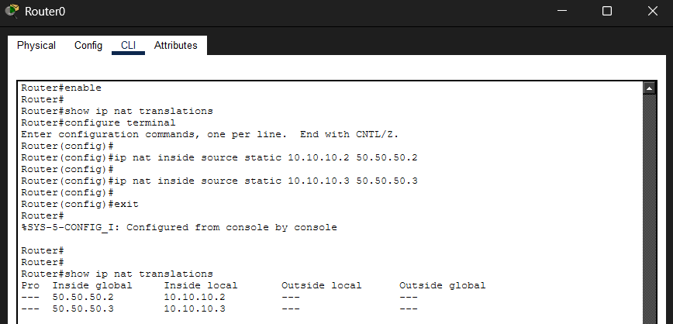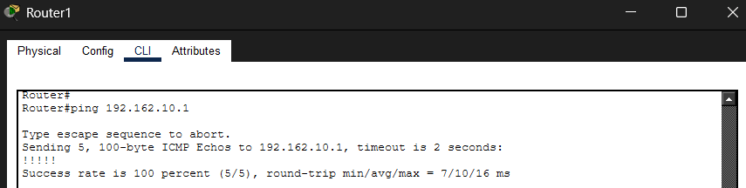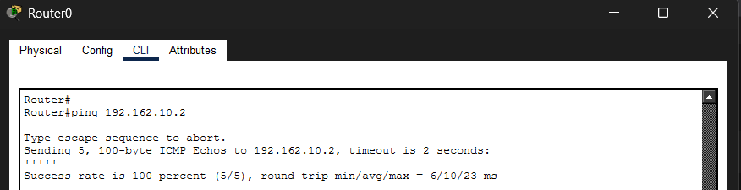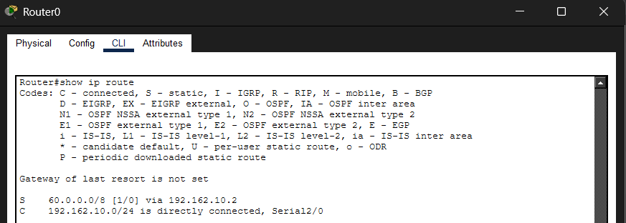
Show IP Routes (Router 0)
Router#show ip route
Codes: C - connected, S - static, I - IGRP, R - RIP, M - mobile, B - BGP
D - EIGRP, EX - EIGRP external, O - OSPF, IA - OSPF inter area
N1 - OSPF NSSA external type 1, N2 - OSPF NSSA external type 2
E1 - OSPF external type 1, E2 - OSPF external type 2, E - EGP
i - IS-IS, L1 - IS-IS level-1, L2 - IS-IS level-2, ia - IS-IS inter area
* - candidate default, U - per-user static route, o - ODR
P - periodic downloaded static route
Gateway of last resort is not set
S 60.0.0.0/8 [1/0] via 192.162.10.2
C 192.162.10.0/24 is directly connected, Serial2/0

Show IP Routes (Router 1)
Router#show ip route
Codes: C - connected, S - static, I - IGRP, R - RIP, M - mobile, B - BGP
D - EIGRP, EX - EIGRP external, O - OSPF, IA - OSPF inter area
N1 - OSPF NSSA external type 1, N2 - OSPF NSSA external type 2
E1 - OSPF external type 1, E2 - OSPF external type 2, E - EGP
i - IS-IS, L1 - IS-IS level-1, L2 - IS-IS level-2, ia - IS-IS inter area
* - candidate default, U - per-user static route, o - ODR
P - periodic downloaded static route
Gateway of last resort is not set
20.0.0.0/24 is subnetted, 1 subnets
C 20.20.20.0 is directly connected, FastEthernet0/0
S 50.0.0.0/8 [1/0] via 192.162.10.1
C 192.162.10.0/24 is directly connected, Serial2/0

