Skills Observatory
Handoff Notes — What's Next
July 2026
branch: skill-gap — 2 commits ahead of origin, not yet pushed

Where Things Stand
The skill-gap branch (Nigeria curriculum-gap analysis, ESCO skill taxonomy) and the main branch (7 new job data sources, several dashboard fixes) have been merged. A full sync has been run: the database now holds 8,696 real job postings from 12 live sources, up from 515 across 5 sources. The dashboard is working end-to-end against this larger dataset.
Metric | Before | Now
Job postings | 515 | 8,696
Active data sources | 5 | 12 (2 more coded but not yet keyed — see below)
Unique companies | 301 | 1,949

Urgent — Do These First
- SQLite parameter-limit crash — FIXED, but check for it elsewhere. Pulling in the real data from the merge (8,696 jobs) immediately triggered a SQLite "query parameter limit exceeded" crash on the Overview page and API. Two functions (getSkillMentionsInPeriod, getSyllabusGap in lib/analytics.ts) were building an SQL IN(...) list from every matching job's ID — fine at 500 jobs, breaks past a few thousand. Already fixed by filtering through the relation instead of an ID list (same pattern already used elsewhere in the codebase). If you see this error again anywhere else, it's the same root cause — search for prisma.job.findMany(...).map(j => j.id) followed by an IN(...) filter.
- Push to GitHub. This branch has a merge commit plus a second round of fixes sitting locally, 2 commits ahead of origin/skill-gap, not pushed. Decide whether to push directly or open a PR, and whether skill-gap merges into main next or main gets rebased onto it.
- Verify the Freehire volume is real, not a filter leak. Freehire alone returned 8,067 of the 8,696 total jobs after the last sync — that's 93% of the entire dataset from one source. Worth a quick sanity check: is Freehire's "regions=africa" filter actually restricting to Africa, or is it returning a broader set that happens to pass the country-detection logic? If it's legitimate, no action needed — just flagging because a single source dominating this heavily changes what "average salary," "top skills," etc. really represent.

Data Completion
- Activate the last 2 sources — Two sources are fully coded and registered in lib/sync-jobs.ts but return nothing because .env is missing the keys:
- JOOBLE_COUNTRY_KEYS — needs a free per-country key from each country's Jooble site (e.g. ng.jooble.org). A single generic key returns false positives (US towns sharing African country names).
- RELIEFWEB_APPNAME — one free appname covers all of Africa, register at apidoc.reliefweb.int.
- Once keys are added, run npm run sync again and confirm both show up in the Overview page's source badges with real counts.
- Re-check salary coverage after the volume increase — Salary coverage dropped to 0.6% of postings after the sync (most new volume is from sources that don't report salary). Not a bug — just means the Salary Insights page is now working off a much smaller, possibly less representative slice of the data. Worth keeping in mind if salary figures get quoted externally.

Still Blocked — Needs a Real Data Source
These two features were removed or never built because no real data source exists for them yet. Don't rebuild them with placeholder numbers — that was tried earlier and explicitly undone. Only revisit once a genuine source is identified.
- Regional/state-level Nigeria map — No state/region field exists on the Job model, and the recorded city values for Nigeria postings are mostly unusable (foreign cities from mis-tagged remote listings, not real Nigerian states). Would need a real source such as Nigeria's National Bureau of Statistics before any state-by-state map or index can be built honestly.
- Skills Gap by Demographics panel — No source — not World Bank, not job postings (no demographic tagging on job data), not curriculum data — currently reports skill gaps broken down by gender, age, education level, or urban/rural. This is an open research question, not a coding task.

Lower Priority / Future
- Multi-country curriculum-gap coverage — Currently Nigeria-only (NUC CCMAS 2022). Extend to other countries as their official computing/ICT syllabi are sourced.
- World Bank data caching — World Bank indicators are cached 24h server-side. Fine at current traffic; revisit caching strategy if this page gets meaningfully more traffic.
- General: watch for the same SQLite pattern elsewhere — With 8,696 jobs and growing, keep an eye on any other prisma query building an IN(...) list from a job-count-sized array — the same class of bug as the urgent fix above.

Current State
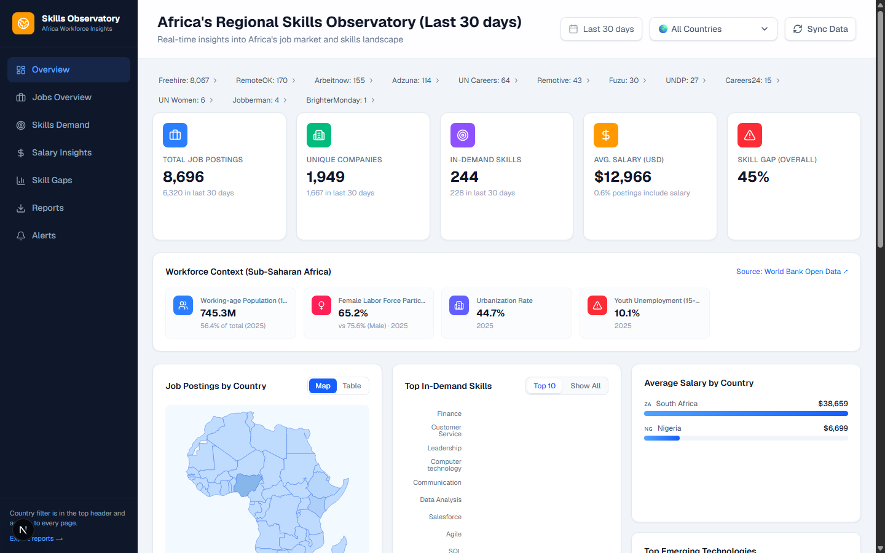
Overview page after the merge, bug fix, and full sync — 12 real sources, 8,696 real jobs, live World Bank data.

