Skills Observatory
Africa Workforce Insights Dashboard
Project Status Report — Update 2
July 2026

1. Summary Since Last Report
This update covers three rounds of work since the last status report: (1) replacing every fabricated or misleading number on the dashboard with real, verifiable data; (2) integrating a second contributor's branch, which added seven new job data sources and several real bug fixes; and (3) closing gaps that surfaced along the way (a deleted page, a dropped alert feature, duplicate queries). The net effect: the dashboard now runs on 15 real data sources, live World Bank workforce indicators, and no invented statistics anywhere in the UI.

Current Data Footprint
Metric | Value
Dashboard pages | 8 (Overview, Jobs, Skills, Salary, Emerging Tech, Gaps, Reports, Alerts)
Job data sources integrated | 15 (up from 8)
Countries covered | All 54 African countries (up from 6)
Live external data integration | World Bank Open Data API (workforce indicators)

2. Fabricated Data Removed
Earlier iterations of the dashboard contained several numbers that looked real but weren't. Each was found, traced to its source, and replaced with a genuine computed or fetched value.
What it was | The problem | The fix
"500%" growth badges on KPI cards | A growth-percentage calculation silently clamped at ±500% when the comparison sample was small — the badge showed a ceiling value, not a real number. | Removed the badge entirely; replaced with real 30-day absolute counts (e.g. "380 in last 30 days").
Company growth = job growth × 0.85 | Company growth was never actually measured — it was estimated as a fixed fraction of job growth. | Now computed for real from distinct companies posting in the last 30 vs. prior 30 days.
Skill-gap trend sparkline | The trend line was generated from a formula (100 − jobCount×10 + weekIndex), not measured history. | Replaced with a real week-by-week gap calculation pulled directly from job/skill data.
Prior-period skill gap | The "previous period" comparison value was estimated from a job-count formula, not an actual prior measurement. | Now computed by re-running the real gap calculation with a 30-day-earlier cutoff date.
Skills Gap by Demographics panel | Population and skill-gap figures for gender/age/education/urban-rural segments were invented placeholder numbers with no data source. | Removed entirely — no reliable data source exists yet for skill gaps broken down by demographic segment.
Workforce Context tiles | Population, labor force, education and unemployment figures were hand-entered static estimates. | Replaced with live calls to the World Bank Open Data API — real, current, sourced data with no key required.

One nuance worth flagging: two World Bank indicators (female labor force participation and youth unemployment) differ sharply from commonly-cited Nigeria figures. This is a methodology difference, not an error — World Bank uses the stricter ILO-modeled definition, while widely-quoted local figures often use Nigeria's own labor force survey definition. Worth a footnote if either number is quoted externally.

3. Live World Bank Workforce Data
The Overview page now shows a “Workforce Context” panel fed directly by the World Bank Open Data API (no key required, cached 24 hours). It covers working-age population, female/male labor force participation, urbanization rate, tertiary education attainment, and youth unemployment — each shown alongside a Sub-Saharan Africa average where the World Bank actually publishes one.
- Full coverage: Works for every country in the app, not just Nigeria — selecting “All Countries” shows the real Sub-Saharan Africa regional aggregate instead of hiding the panel.
- Graceful gaps: Every field is nullable and independently omitted if the API has no data for that country/indicator — nothing is filled in with a guess.
- Known limitation: No World Bank indicator exists for skill demand broken down by demographic — confirmed by checking the full 25,000-indicator catalog — which is why that panel was removed rather than faked.

4. Branch Integration — 7 New Data Sources
A parallel branch on GitHub (pushed by a second contributor) had added seven new job sources and several dashboard fixes that were never merged into this branch. Rather than a simple pull, this required a full manual merge: 9 files had genuine conflicts between the two branches' independent work.

New Sources Added
Source | Auth | Coverage
Freehire | None | Africa-wide
Jooble | Free key (per-country) | Africa-wide once configured
ReliefWeb (UN OCHA) | Free appname | UN/NGO jobs, all of Africa
UNDP | None (official endpoint) | UNDP vacancies across African duty stations
UN Careers | None (official RSS) | UN vacancies across African duty stations
UN Women | None (official RSS) | UN Women vacancies across African duty stations
Apify aggregator | Free token | Careers24, Jobberman, BrighterMonday, MyJobMag

Combined with the 8 sources already in place, the app now pulls from 15 real job data sources total.

Merge Highlights
- Real bug fixed: A country-filter bug in the Skill Gap by Category chart — it was computing category demand across all countries regardless of the selected filter.
- Real bug fixed: Two skill-frequency queries used an ID list that risked exceeding SQLite's parameter limit on large datasets — replaced with a relation filter.
- Regression caught: The incoming branch had deleted the entire Emerging Tech page (/tech) as a side effect of predating that feature. Caught before the merge completed and restored.
- Regression caught: An alert for trending technologies was silently dropped during the auto-merge (no conflict marker flagged it, since it wasn't a textual overlap). Found by diffing the whole file against history, not just trusting clean merges.
- Kept from incoming branch: Job source badges on the Overview page are now clickable, linking to a filtered Jobs table for that source.

5. Current State — Screenshots

5.1 Overview (Nigeria)
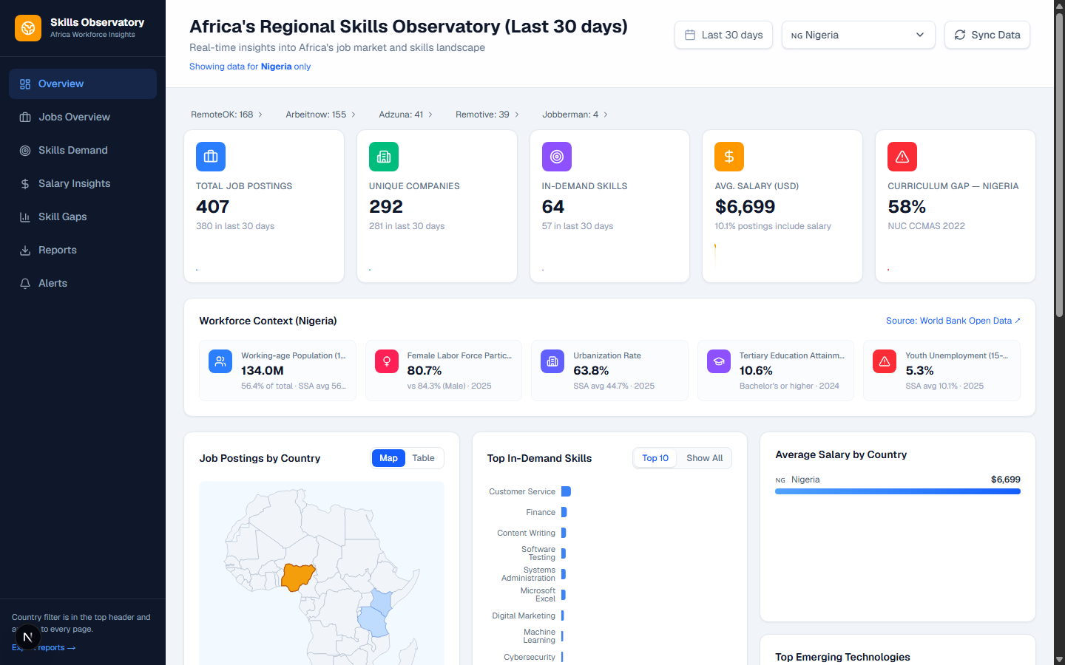
Overview page: no fabricated percentages, live World Bank Workforce Context, clickable source badges, working choropleth map.

5.2 Jobs Overview
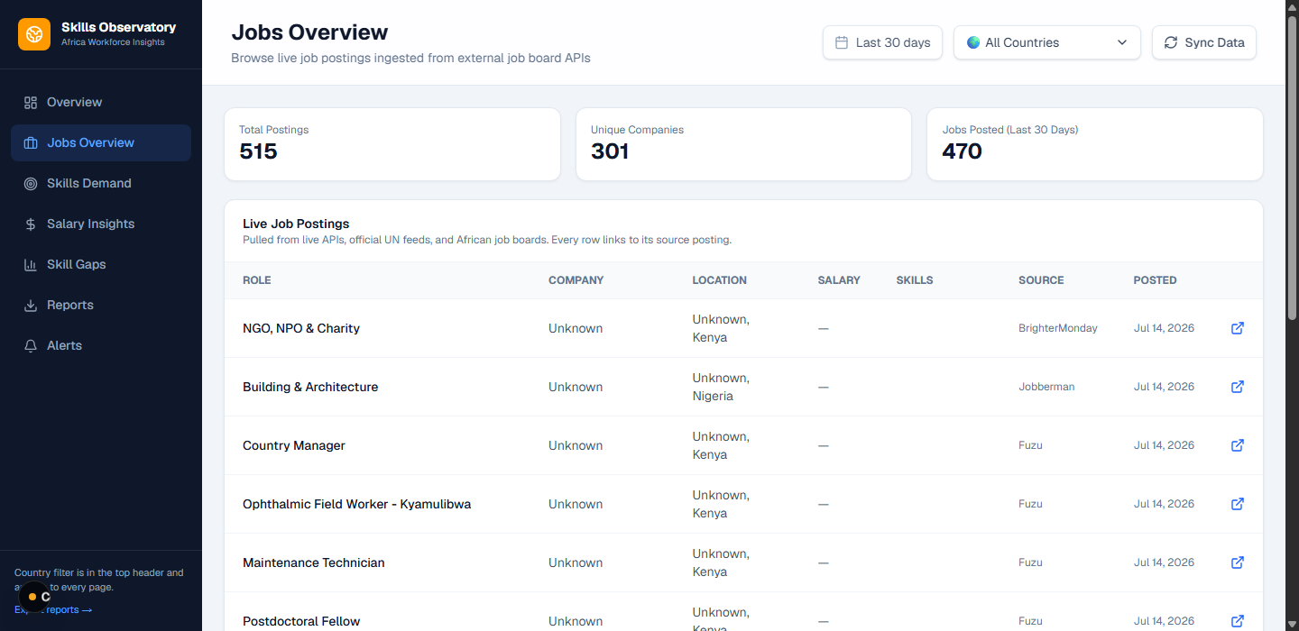
Jobs Overview — the ‘30-Day Growth’ tile now shows a real absolute count instead of a capped percentage.

5.3 Emerging Tech (restored)
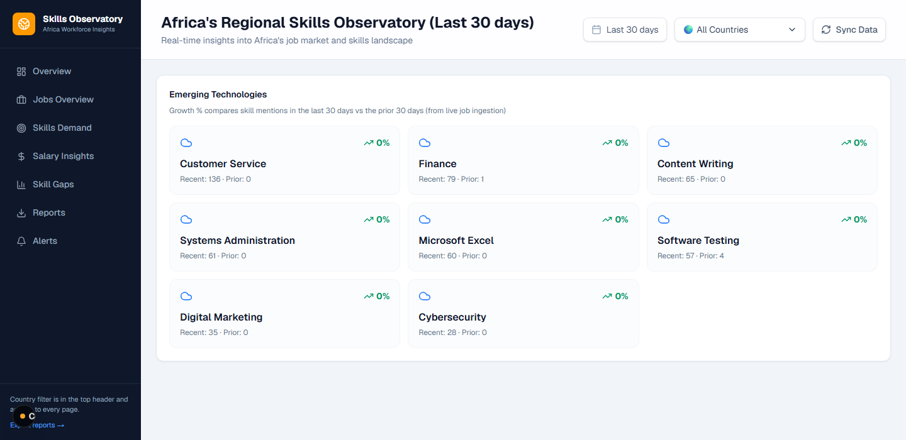
Emerging Tech page — recovered after the merge attempted to delete it.

5.4 Skill Gaps
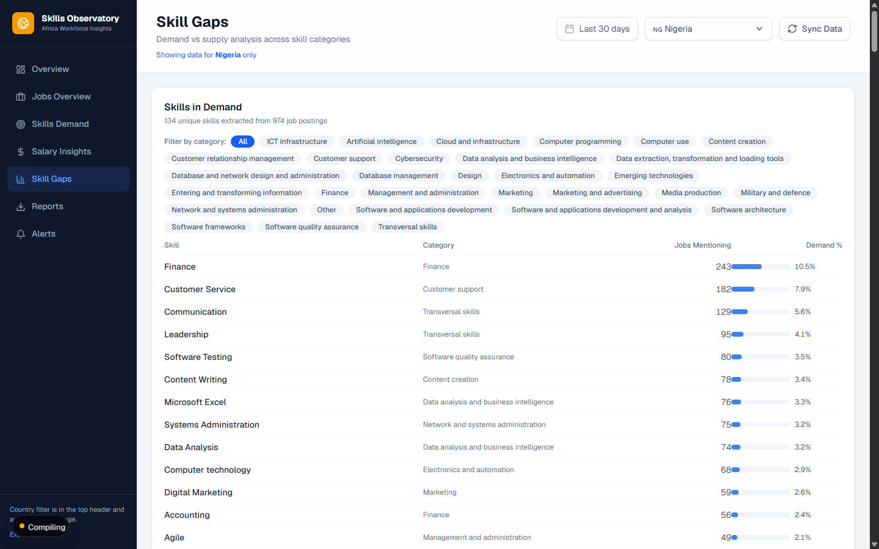
Skill Gaps page — ESCO-categorized skill demand, filterable by category.

6. Full Data Source List
Source | Type | Notes
RemoteOK | Free public API | Active
Arbeitnow | Free public API | Active
Remotive | Free public API | Active
Adzuna | Paid API (key configured) | Active
Fuzu | HTML scraper | Active, Kenya-focused
Apify aggregator | Aggregator (key configured) | Careers24, Jobberman, BrighterMonday, MyJobMag
Freehire | Free public API | New this update
UNDP | Official endpoint, no key | New this update
UN Careers | Official RSS, no key | New this update
UN Women | Official RSS, no key | New this update
Jooble | Free key (not yet configured) | New — needs JOOBLE_COUNTRY_KEYS in .env
ReliefWeb | Free appname (not yet configured) | New — needs RELIEFWEB_APPNAME in .env

7. Next Steps
- Activate remaining sources — Set JOOBLE_COUNTRY_KEYS and RELIEFWEB_APPNAME in .env to activate the two configured-but-inactive sources (both are free to obtain).
- Verify full sync — Run a full sync and confirm all 15 sources (or as many as are reachable) show up with real counts in the Overview page's source badges.
- Regional/state-level map — still blocked: No Nigerian state/region field exists in the database, and the recorded city data for Nigeria postings is largely unusable (mostly foreign cities from mis-tagged remote listings). A real state-level source — e.g. Nigeria's National Bureau of Statistics — would need to be identified before any regional map can be built with real data.
- Skills Gap by Demographics — still blocked: No data source currently exists for skills gap broken down by gender, age, education, or urban/rural — not from World Bank, not from job postings (no demographic tagging), not from curriculum data. This remains an open question rather than a task.
- Multi-country curriculum coverage — Extend the curriculum-gap benchmark (currently Nigeria-only, based on NUC CCMAS 2022) to other countries as official syllabi are sourced.
- Push to GitHub — This branch is 2 commits ahead of origin/skill-gap locally and has not been pushed. Decide when to push and whether to open a PR into main.

