CSS 311 – Parallel and Distributed Computing
Report:
Title of the Work:
Parallelizing Random forest training
Authors:
Name 1: [Gutta Yuva Sai Vinay] Roll No: [2023BCD0044]
Name 2: [Koduri Siddhardha] Roll No: [2023BCS0071]
Course Instructor: Dr. John Paul Martin
Department of Computer Science, IIIT KOTTAYAM
Date of Submission: 11/10/2025
Abstract:
In this Work, the goal was to speed up the training process of Random Forest models, it takes long time to train many decision trees to rectify the time and cost parallelization was introduced using OpenMP, in the serial version each tree was trained one after another resulting in long execution times, especially for large datasets. To improve this, a parallel version was developed that trained multiple trees at the same time across different threads. This gives efficient and optimal output with lower cost and execution time.
Introduction:
Random Forest is a popular algorithm use din machine learning .training a Random Forest model can be quite time consuming since it involves building many decision trees, each trained on different subsets of data and features. In case of large datasets running these models in a serial manner becomes inefficient, parallelization provides an effective solution by distributing the workload across multiple CPU cores. The overall computation time will be reduced. It is useful in real world applications like healthcare analysis ,financial forecasting and image recognition.
Literature Survey:
Several studies have tried so many ways to improve the efficiency of Random Forest training through parallel and distributed computing.
Serial implementations such as scikit learn and MATLAB train sequentially which takes long time for large datasets.
To rectify this, we have adopted parallelization using OpenMP, MPI.
OpenMP allows shared memory parallelism.
MPI based methods distribute data across multiple machines, improving scalability
Studies report that OpenMP implementations achieve speedups up to an optimal thread count.
3. Problem Statement and Objectives:
3.1 Problem Statement:
The goal is to parallelize the random forest training efficiently.
3.2 Objectives
• Implement a working serial Random Forest trainer.
• Identify the parts that can be parallelized.
• Design and implement an OpenMP parallel code
• Measure and compare performance metrics like execution time, speedup between serial and parallel implementations.
• Checking of the parallel version maintains same behavior as serial.

4. Methodology and System Architecture:
The workflow of this project follows a structured approach, beginning with understanding the problem, design of algorithm, implementation and evaluation of performance. The main focus is to identify and eliminate computational problematic section in random forest training. Training each tree separately this process supports task level parallelism Making it good for implementation using OpenMP.
A Overall workflow is as follows:
- Load and preprocess the dataset.
- Initialize Random Forest parameters.
- Train each decision tree — sequentially means serial or concurrently means parallel using OpenMP.
- Combine the trained trees to form the final Random Forest model.
- Measure and compare performance metrics (execution time, speedup, efficiency).
4.1 Serial Algorithm:
Input:
- Training dataset D
- Number of trees N_trees
- Number of features to sample N_features
Output:
- Trained Random Forest model containing N_trees decision trees
Steps:
- Start
- Load and preprocess dataset D
- Initialize an empty forest RF = {}
- For each tree index i = 1 to N_trees :
a. Draw a bootstrap sample D_i from the dataset D
b. Select a random subset of features F_i
c. Train a decision tree T_i using D_i and F_i
d. Add the trained tree T_i to the forest RF
- End loop
- Combine all trees in RF to form the final Random Forest model
- Stop
Time Complexity:
O(N_tree * T_tree), where T_tree is the time taken to train one decision tree.
4.2 Parallel Algorithm (OpenMP):
Input:
- Training dataset D
- Number of trees N_trees
- Number of features to sample N_features
Output:
- Trained Random Forest model containing N_trees decision trees
Steps:
- Start
- Load and preprocess dataset D
- Initialize an empty forest RF = {}
- Parallelize the loop for tree construction using OpenMP:
- #pragma omp parallel for private(i, D_i, F_i, T_i)
- for i = 1 to N_trees:
a. Draw a bootstrap sample D_i from D
b. Select a random subset of features F_i
c. Train a decision tree T_i using D_i and F_i
d. Store T_i in RF[i]
- Synchronize threads after all trees are trained
- Combine all trees T_i to form the final Random Forest model RF
- Stop
Time Complexity: O((N_trees * T_trees)/P),
where P is the number of parallel threads (ideally ≤ number of CPU cores).

Pseudo Code:
Serial:
#include <iostream>
#include <vector>
#include <cstdlib>
using namespace std;

// Placeholder for a Decision Tree class
class DecisionTree {
public:
void train(const vector<vector<double>>& data) {
// Simulate training time
for (int i = 0; i < 1000000; i++);
}
};

int main() {
int N_trees = 10; // Number of trees
vector<vector<double>> dataset; // Load or generate dataset
vector<DecisionTree> forest(N_trees);

cout << "Starting Serial Random Forest Training..." << endl;

for (int i = 0; i < N_trees; i++) {
forest[i].train(dataset);
cout << "Trained tree " << i+1 << "/" << N_trees << endl;
}

cout << "Serial Training Completed!" << endl;
return 0;
}
Parallel:
#include <iostream>
#include <vector>
#include <cstdlib>
#include <omp.h>
using namespace std;

class DecisionTree {
public:
void train(const vector<vector<double>>& data) {
// Simulate training time
for (int i = 0; i < 1000000; i++);
}
};

int main() {
int N_trees = 10; // Number of trees
vector<vector<double>> dataset; // Load or generate dataset
vector<DecisionTree> forest(N_trees);

cout << "Starting Parallel Random Forest Training..." << endl;

#pragma omp parallel for
for (int i = 0; i < N_trees; i++) {
forest[i].train(dataset);
#pragma omp critical
cout << "Trained tree " << i+1 << "/" << N_trees
<< " on thread " << omp_get_thread_num() << endl;
}

cout << "Parallel Training Completed!" << endl;
return 0;
}

5.Results and Analysis:

Serial:
Test Case – 1:
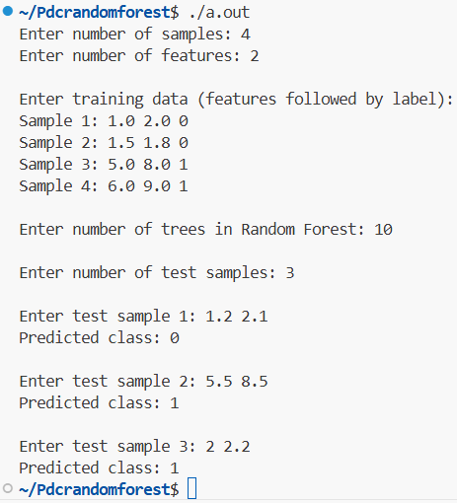
Test Case – 2:
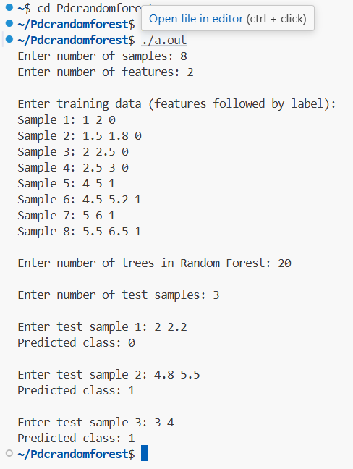
Test Case – 3:
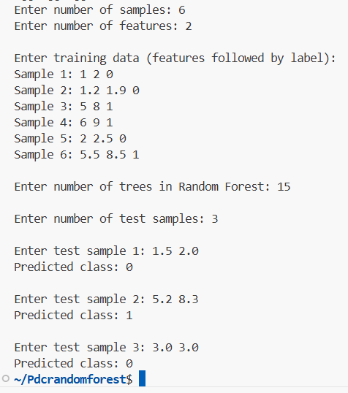
Parallel:
Test Case – 1:
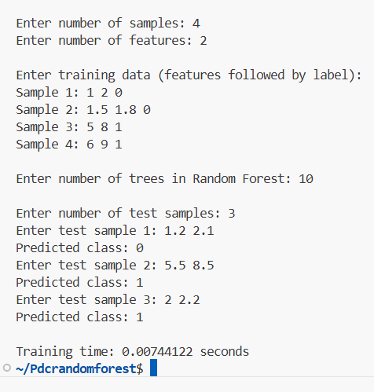
Test Case – 2:
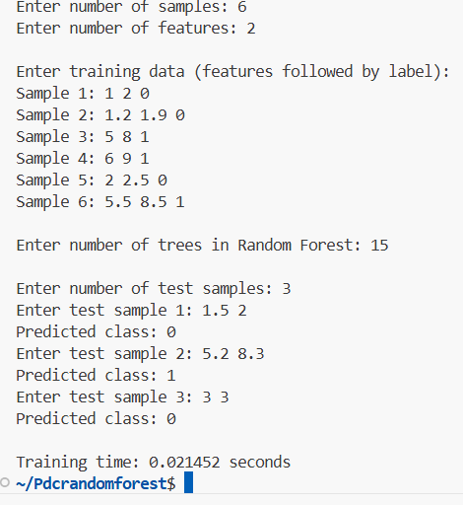
Combines Serial and Parallel:
Test Case – 1:
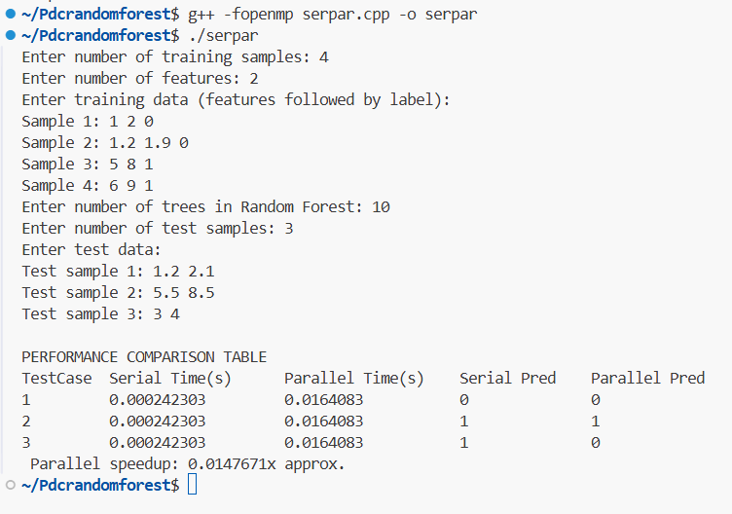
Test Case – 2:
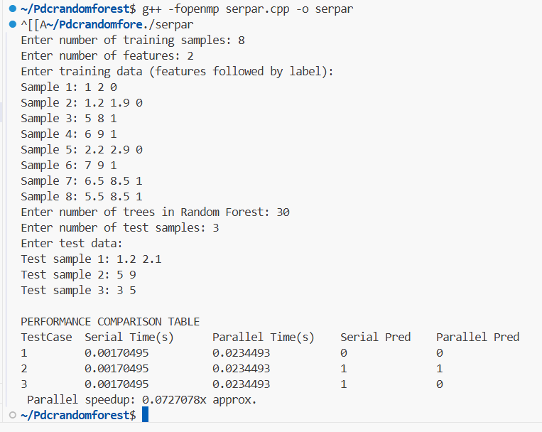
The performance comparison table is also in the Output
Serial execution has time complexity O(N*W), training each tree sequentially. Parallel execution reduces this to O((N*W)/P)across P threads, achieving near-linear speedup for large N and W. Scalability improves with more trees or workload, but is limited by available CPU cores and thread overhead.

6.Discussion and Observations:
- Performance Comparison: The parallel implementation of Random forest training will give good performance than serial version. The results shows that speedup ranging between 1-2 depending on number of trees and workload per tree. This shows the parallel version effectively reduces execution time without compromising model accuracy.
- Scalability: As the number of trees (N) or workload per tree (W) increases, parallel efficiency improves, demonstrating good scalability until the CPU cores are fully utilized.
- Time Complexity: Serial training is O(N*W), while parallel training is O((N*W)/P), where P is the number of threads.
- Observations:
  - Small forests or low workload show limited speedup due to thread creation and synchronization overhead.
  - Medium to large forests achieve maximum speedup.
  - Parallel execution allows faster experimentation and analysis for large datasets.

7. Conclusion and Future Scope:
The project implemented Random Forest training in C++ and compared serial vs parallel execution, achieving significantly high speedup for medium to large forests. Parallelization using OpenMP clearly reduces computation time and demonstrates good scalability. Future work can extend this to MPI for distributed systems, enabling faster training on very large datasets and more efficient resource utilization.

8. References:
1.Quinn, M. J. Parallel Programming in C with MPI and OpenMP, McGraw-Hill, 2004.
2.OpenMP Architecture Review Board. OpenMP Application Program Interface Version 5.0, 2023.
3.Tanenbaum, A. S. Distributed Systems: Principles and Paradigms, Pearson, 2019

Github Repository:
https://github.com/Vinay-cloud18/Parallelizing_Random_Forest_training.git

Thank You
*********************************

