Experiment -2.2

**Student Name:** Vinay **UID:** 22BDO10040

**Branch:** AIT-CSE(DevOps) **Section/Group**: 22BCD-1/A

**Semester:** 4th **Date of Performance:** 21/01/2024

**Subject Name**: Git and Hub **Subject Code:** 22CSH-293

1. **Aim/Overview of the practical:** To merge pull requests and update local repositories.
2. **Software Used:** Git Bash, GitHub.

# Steps for experiment/practical:

* 1. Create or clone a repository on your local machine after opening GIT BASH.
  2. Move to the directory using the **cd** command.

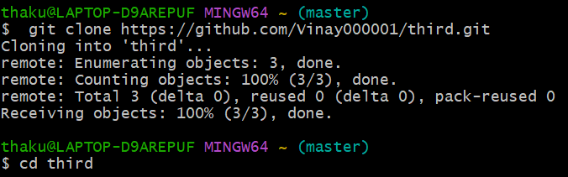

* 1. Create or open a file in the master or main branch , eg , **file.txt** and add some text to the file.
  2. Add the file to the staging area using **git add** and then commit the changes using the **git commit** command **OR** you can use the command **git commit -a -m “<commit_msg>”** or **git commit -am “<commit_msg>”**.

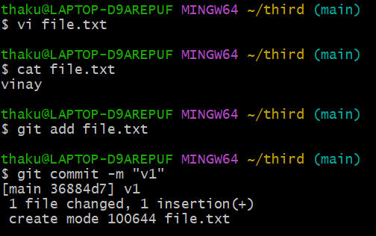

* 1. Create a new branch and checkout to it using the **git checkout -b** command , eg , **b1**.
  2. Open the **file.txt** on the **vi** editor and make some changes in it.

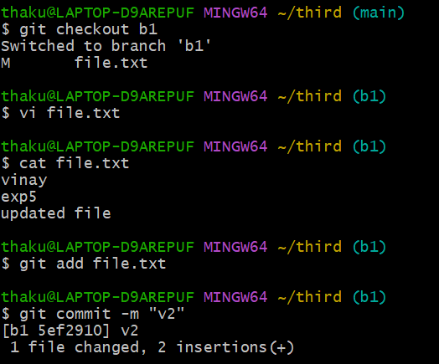

* 1. Merge the changes made in the **b1** branch with the **main** branch and resolve the conflicts manually if necessary using the **git merge** command.

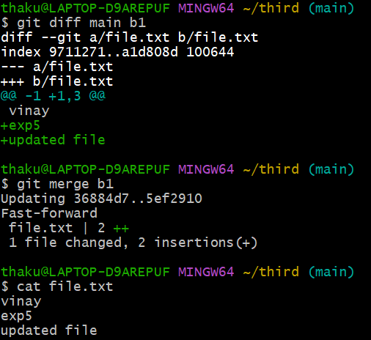

* 1. Now, Go to github, open the repository and move to the **b1** branch and make some changes in a file.

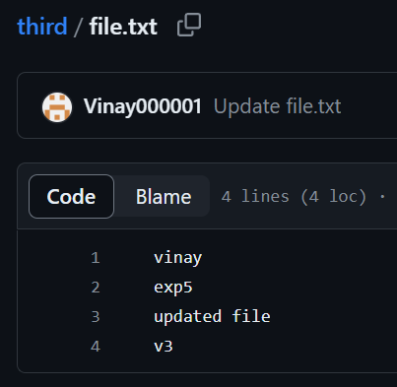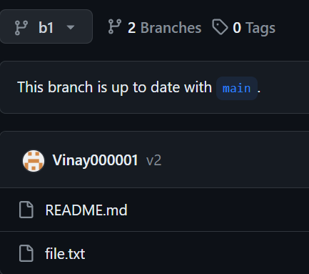

* 1. Commit the changes and move to the **main** branch. Click on the **Compare & Pull request**.



* 1. **Create the pull request,** resolve the merge conflicts (if any) and then **merge pull request**.

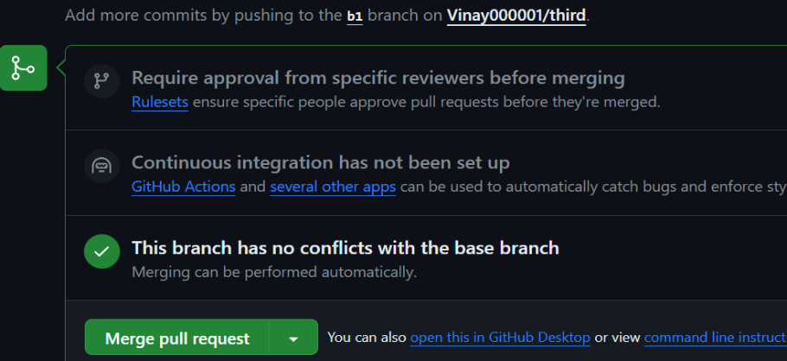

* 1. After the merging, you may choose to delete your branch , i.e , **b1**

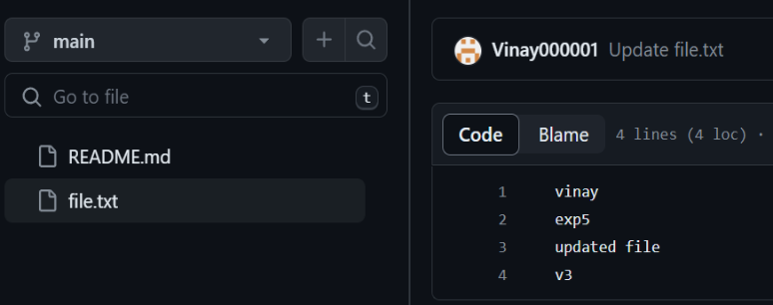

# Result/Output/Writing Summary:

In this experiment, we have merged a file in a branch to the master or main branch on both the local and remote repositories/environment.

# Learning outcomes (What I have learnt):

1. Learnt how to create a branch.
2. Learnt how to clone a remote repo to our local system.
3. Learnt how to create a pull request and handle their merging.
4. Learnt to merge two branches.
5. Learnt how to resolve merge conflicts.

**Evaluation Grid (To be created as per the SOP and Assessment guidelines by the faculty):**

|  |  |  |  |
| --- | --- | --- | --- |
| Sr. No. | Parameters | Marks Obtained | Maximum Marks |
| 1. |  |  |  |
| 2. |  |  |  |
| 3. |  |  |  |
|  |  |  |  |