# m.vinay

# 192311146

Edit the code so that it prints a message other than “Hello World!”.  
• Compile and run your code to verify your changes work.

Code: package helloworld;

public class helloworld {

public static void main(String[] args){

System.out.println("hello world");

}

}

Output:

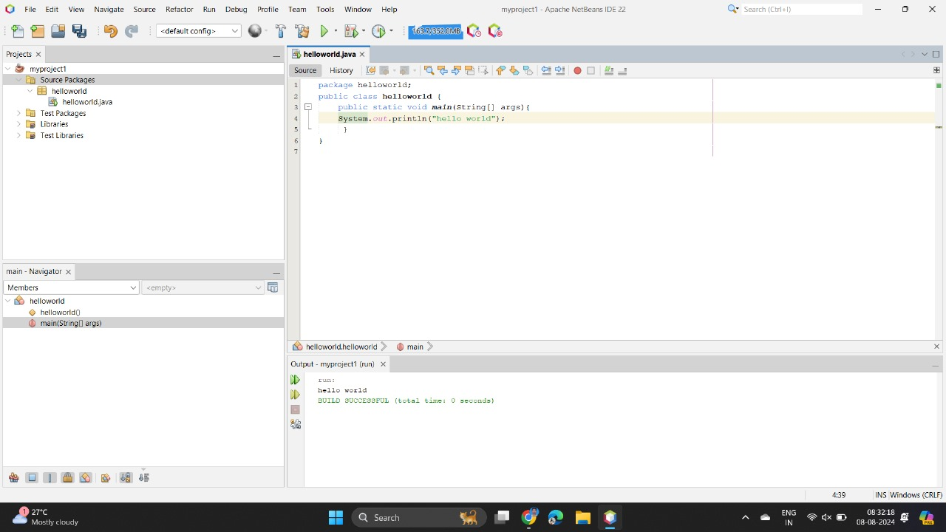

2. Change the ‘S’ in “System” to lower-case and try to compile.  
• Is Java syntax case-sensitive?

Code:

package helloworld;

public class helloworld {

public static void main(String[] args){

system.out.println("hello world");

}

}

Output:

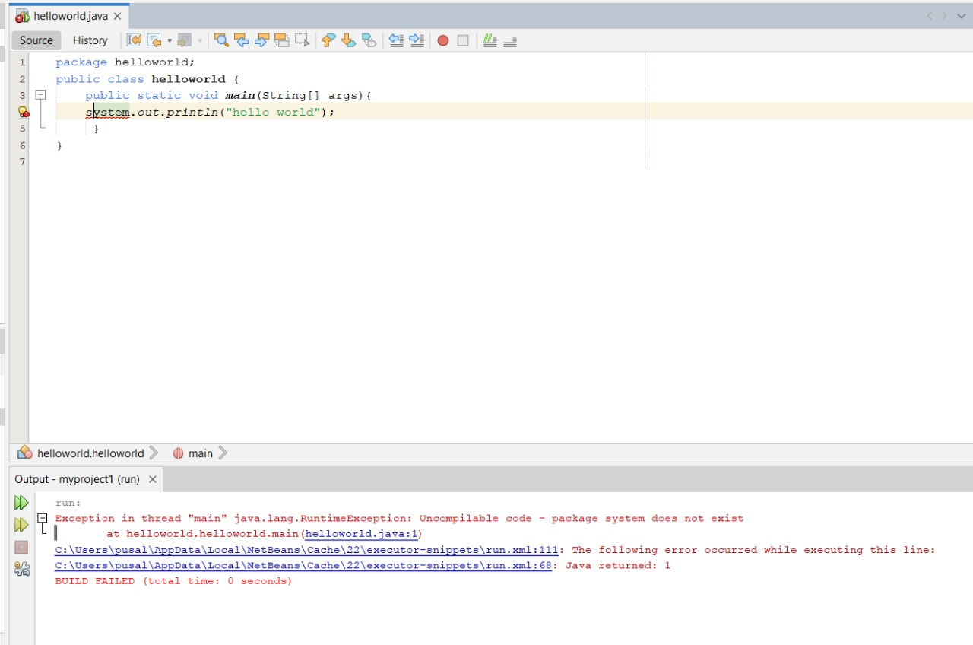

3. Remove the semicolon (;) and try to compile.  
• Is the semicolon important to Java syntax?

Code:

package helloworld;

public class helloworld {

public static void main(String[] args){

System.out.println("hello world")

}

}

Output:

