EXPERIMENT-1
1.Image Mapping in Html
<!DOCTYPE html> OUTPUT:
<html>
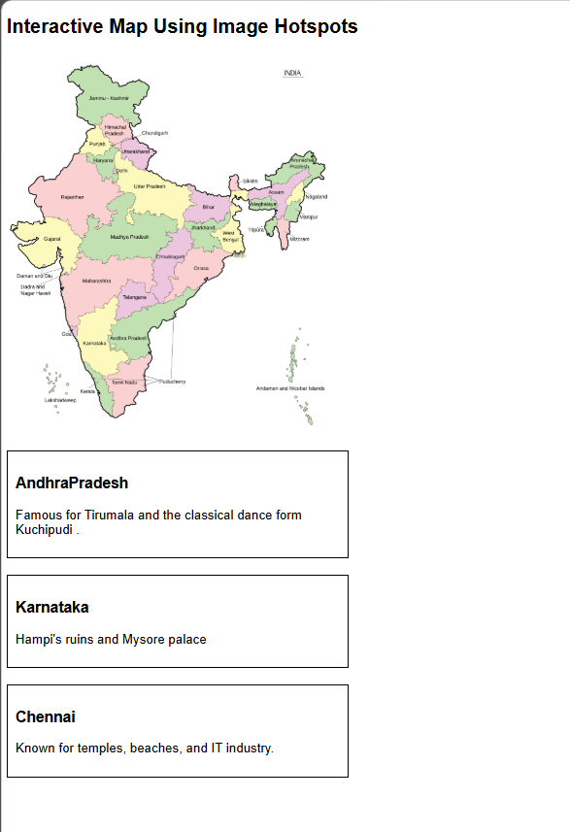
<head>
<title>Map with Hotspots</title>
<style>
body {
font-family: Arial, sans-serif;
}
.info {
margin-top: 20px;
padding: 10px;
border: 1px solid #000;
width: 400px;
}
</style>
</head>

<body>

<h2>Interactive Map Using Image Hotspots</h2>

<!-- a. Embed a map -->
<img src="india Map.png" alt="India Map" usemap="#indiamap" width="400">

<!-- b. Fix hotspots on the map
<map name="indiamap">
<area shape="circle" coords="210,120,15" href="#Andhra Pradesh" alt="Andhra Pradesh">
<area shape="circle" coords="170,260,15" href="#Karnataka" alt="Karnataka">
<area shape="circle" coords="240,310,15" href="#chennai" alt="Chennai">
</map> -->

<!-- c. Related information -->
<div id="AndhraPradesh" class="info">
<h3>AndhraPradesh</h3>
<p> Famous for Tirumala and the classical dance form Kuchipudi .</p>
</div>

<div id="Karnataka" class="info">
<h3>Karnataka</h3>
<p>Hampi's ruins and Mysore palace</p>
</div>

<div id="chennai" class="info">
<h3>Chennai</h3>
<p>Known for temples, beaches, and IT industry.</p>
</div>

</body>
</html>

