EXPERIMENT-19
Create a Website for an Online Hospital Appointment Booking System
<!DOCTYPE html>
<html lang="en">
<head>
<meta charset="UTF-8">
<meta name="viewport" content="width=device-width, initial-scale=1.0">
<title>Saveetha Hospital - Appointment Booking</title>

<style>
*{
margin:0;
padding:0;
box-sizing:border-box;
font-family:Arial, sans-serif;
}

body{
background:#f5f7fa;
color:000;
}

header{
background:#0d95fd;
color: #000;
padding:20px 50px;
}

nav{
display:flex;
justify-content:space-between;
align-items:center;
}

.logo{
font-size:28px;
font-weight:bold;
}

.hero{
text-align:center;
padding:70px 20px;
background:linear-gradient(135deg,#d5d757,#5dff3d);
color:white;
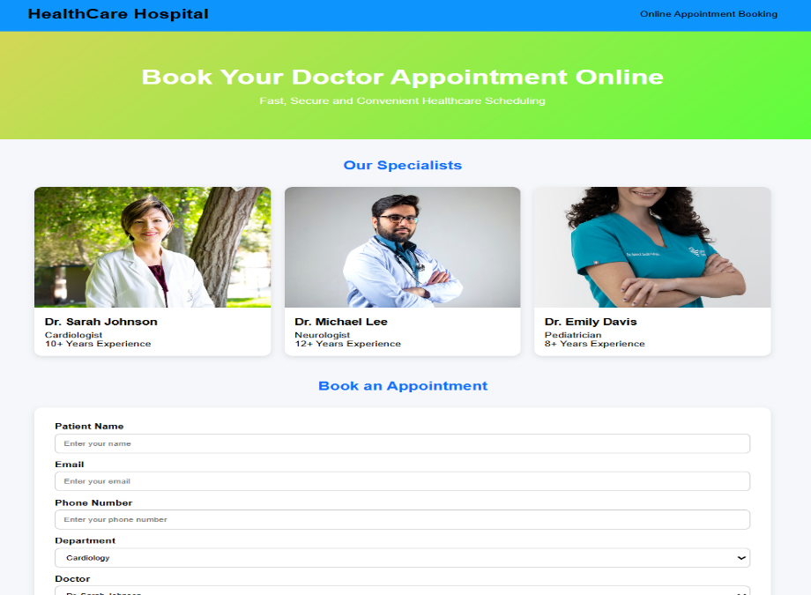
}

.hero h1{
font-size:42px;
margin-bottom:15px;
}

.hero p{
font-size:18px;
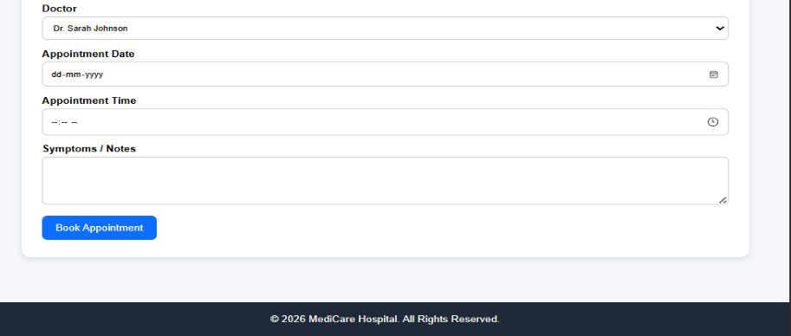
}

.container{
width:90%;
max-width:1200px;
margin:auto;
padding:40px 0;
}

.section-title{
text-align:center;
margin-bottom:30px;
color:#0d6efd;
}

.doctors{
display:grid;
grid-template-columns:repeat(auto-fit,minmax(250px,1fr));
gap:20px;
margin-bottom:50px;
}

.card{
background:white;
border-radius:12px;
box-shadow:0 4px 10px rgba(0,0,0,0.1);
overflow:hidden;
}

.card img{
width:100%;
height:250px;
object-fit:cover;
}

.card-content{
padding:15px;
}

.card-content h3{
margin-bottom:8px;
}

.booking-form{
background:white;
padding:30px;
border-radius:12px;
box-shadow:0 4px 12px rgba(0,0,0,0.1);
}

.form-group{
margin-bottom:15px;
}

label{
display:block;
margin-bottom:5px;
font-weight:bold;
}

input, select, textarea{
width:100%;
padding:12px;
border:1px solid #ccc;
border-radius:8px;
}

button{
background:#0d6efd;
color:white;
border:none;
padding:12px 20px;
border-radius:8px;
cursor:pointer;
font-size:16px;
}

button:hover{
background:#0b5ed7;
}

.success{
margin-top:15px;
color:green;
font-weight:bold;
}

footer{
background:#1f2937;
color:white;
text-align:center;
padding:20px;
margin-top:40px;
}

@media(max-width:768px){
.hero h1{
font-size:30px;
}

nav{
flex-direction:column;
gap:10px;
}
}
</style>
</head>
<body>

<header>
<nav>
<div class="logo"> HealthCare Hospital</div>
<div>Online Appointment Booking</div>
</nav>
</header>

<section class="hero">
<h1>Book Your Doctor Appointment Online</h1>
<p>Fast, Secure and Convenient Healthcare Scheduling</p>
</section>

<div class="container">

<h2 class="section-title">Our Specialists</h2>

<div class="doctors">

<div class="card">
<img src="https://images.unsplash.com/photo-1559839734-2b71ea197ec2?w=800" alt="Doctor">
<div class="card-content">
<h3>Dr. Sarah Johnson</h3>
<p>Cardiologist</p>
<p>10+ Years Experience</p>
</div>
</div>

<div class="card">
<img src="https://images.unsplash.com/photo-1612349317150-e413f6a5b16d?w=800" alt="Doctor">
<div class="card-content">
<h3>Dr. Michael Lee</h3>
<p>Neurologist</p>
<p>12+ Years Experience</p>
</div>
</div>

<div class="card">
<img src="https://images.unsplash.com/photo-1594824476967-48c8b964273f?w=800" alt="Doctor">
<div class="card-content">
<h3>Dr. Emily Davis</h3>
<p>Pediatrician</p>
<p>8+ Years Experience</p>
</div>
</div>

</div>

<h2 class="section-title">Book an Appointment</h2>

<div class="booking-form">

<div class="form-group">
<label>Patient Name</label>
<input type="text" id="name" placeholder="Enter your name">
</div>

<div class="form-group">
<label>Email</label>
<input type="email" id="email" placeholder="Enter your email">
</div>

<div class="form-group">
<label>Phone Number</label>
<input type="tel" id="phone" placeholder="Enter your phone number">
</div>

<div class="form-group">
<label>Department</label>
<select id="department">
<option>Cardiology</option>
<option>Neurology</option>
<option>Pediatrics</option>
<option>Orthopedics</option>
<option>Dermatology</option>
</select>
</div>

<div class="form-group">
<label>Doctor</label>
<select id="doctor">
<option>Dr. Sarah Johnson</option>
<option>Dr. Michael Lee</option>
<option>Dr. Emily Davis</option>
</select>
</div>

<div class="form-group">
<label>Appointment Date</label>
<input type="date" id="date">
</div>

<div class="form-group">
<label>Appointment Time</label>
<input type="time" id="time">
</div>

<div class="form-group">
<label>Symptoms / Notes</label>
<textarea id="notes" rows="4"></textarea>
</div>

<button onclick="bookAppointment()">Book Appointment</button>

<div id="confirmation"></div>

</div>

</div>

<footer>
<p>© 2026 MediCare Hospital. All Rights Reserved.</p>
</footer>

<script>
function bookAppointment() {

let name = document.getElementById("name").value;
let email = document.getElementById("email").value;
let doctor = document.getElementById("doctor").value;
let date = document.getElementById("date").value;
let time = document.getElementById("time").value;

if(!name || !email || !date || !time){
alert("Please fill all required fields.");
return;
}

document.getElementById("confirmation").innerHTML =
`<p class="success">
Appointment Confirmed!<br>
Patient: ${name}<br>
Doctor: ${doctor}<br>
Date: ${date}<br>
Time: ${time}
</p>`;
}
</script>

</body>
</html>

