EXPERIMENTS-2
<!DOCTYPE html>
<html>
<head>
<title>Use of Internal and External Stylesheets</title>
<!-- External Stylesheet -->
<link rel="stylesheet" href="style.css" type="text/css">
<!-- Internal Stylesheet -->
<style> OUTPUT:
body {
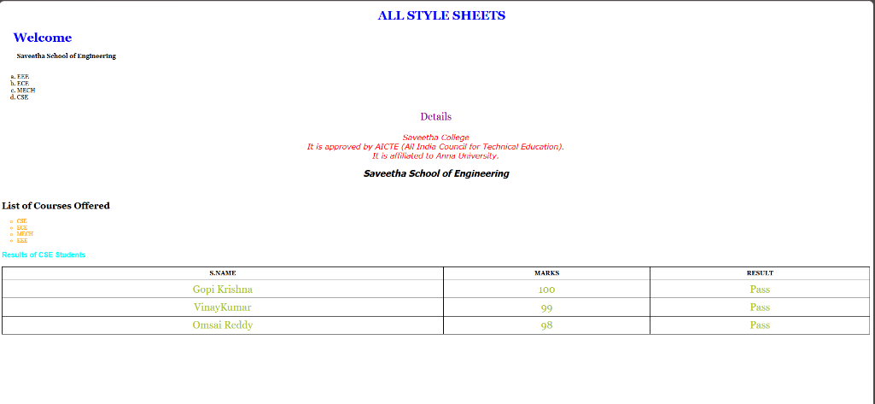
font-family: Georgia, serif;
}

.vid {
font-family: Tahoma, sans-serif;
font-style: italic;
text-align: center;
}
.ani {
font-family: Verdana, sans-serif;
font-style: italic;
color: red;
text-align: center;
}
ul {
list-style-type: circle;
font-size: 14px;
color: #ff9900;
}

p {
font-size: 20px;
text-align: center;
color: blue;
}

hr {
height: 1px;
}

a:hover {
color: #ff0000;
text-decoration: none;
}

table {
width: 100%;
border-collapse: collapse;
}

table, th, td {
border: 2px solid black;
}

th, td {
padding: 8px;
text-align: center;
}
</style>
</head>

<body>

<h1 style="color:blue; margin-left:30px; text-align:center;">
ALL STYLE SHEETS
</h1>

<h1 style="color:blue; margin-left:30px;">Welcome</h1>
<!-- In-line style sheet -->

<ol style="list-style-type: lower-alpha;">
<b>Saveetha School of Engineering</b>
<br><br><br>
<li>EEE</li>
<li>ECE</li>
<li>MECH</li>
<li>CSE</li>
</ol>

<p style="font-size:20pt; color:purple;">Details</p>

<p class="ani">
Saveetha College <br>
It is approved by AICTE (All India Council for Technical Education). <br>
It is affiliated to Anna University.
</p>

<h2 class="vid">Saveetha School of Engineering</h2>

<br>

<h2>List of Courses Offered</h2>

<ul>
<li>CSE</li>
<li>ECE</li>
<li>MECH</li>
<li>EEE</li>
</ul>

<h3>Results of CSE Students</h3>

<table>
<tr>
<th>S.NAME</th>
<th>MARKS</th>
<th>RESULT</th>
</tr>
<tr>
<td>Gopi Krishna</td>
<td>100</td>
<td>Pass</td>
</tr>
<tr>
<td>VinayKumar</td>
<td>99</td>
<td>Pass</td>
</tr>
<tr>
<td>Omsai Reddy</td>
<td>98</td>
<td>Pass</td>
</tr>
</table>

</body>
</html>

