create a website for an online shopping system for electronic gadgets
<!DOCTYPE html>
<html lang="en">
<head>
<meta charset="UTF-8">
<meta name="viewport" content="width=device-width, initial-scale=1.0">
<title>TechStore - Electronic Gadgets Shop</title>

<style>
*{
margin:0;
padding:0;
box-sizing:border-box;
font-family:Arial, sans-serif;
}

body{
background:#f4f6f9;
}

/* Header */
header{
background:#111827;
color:white;
padding:15px 50px;
display:flex;
justify-content:space-between;
align-items:center;
flex-wrap:wrap;
}

.logo{
font-size:28px;
font-weight:bold;
}

.search-box{
padding:10px;
width:300px;
border:none;
border-radius:5px;
}

.cart-btn{
background:#2563eb;
color:white;
border:none;
padding:10px 15px;
border-radius:5px;
cursor:pointer;
}

/* Hero */
.hero{
background:linear-gradient(135deg,#2563eb,#06b6d4);
color:white;
text-align:center;
padding:60px 20px;
}

.hero h1{
font-size:48px;
}

.hero p{
margin-top:10px;
font-size:18px;
}

/* Products */
.products{
padding:40px;
}

.section-title{
margin-bottom:20px;
font-size:30px;
}

.product-grid{
display:grid;
grid-template-columns:repeat(auto-fit,minmax(250px,1fr));
gap:25px;
}

.product-card{
background:white;
border-radius:12px;
overflow:hidden;
box-shadow:0 3px 12px rgba(0,0,0,.1);
transition:.3s;
}

.product-card:hover{
transform:translateY(-5px);
}

.product-card img{
width:100%;
height:220px;
object-fit:cover;
}

.product-info{
padding:15px;
}

.product-info h3{
margin-bottom:10px;
}

.price{
color:#2563eb;
font-size:22px;
font-weight:bold;
margin:10px 0;
}

.btn{
background:#2563eb;
color:white;
border:none;
width:100%;
padding:10px;
border-radius:5px;
cursor:pointer;
}

/* Cart */
.cart{
position:fixed;
top:0;
right:-400px;
width:400px;
height:100%;
background:white;
box-shadow:-3px 0 10px rgba(0,0,0,.2);
padding:20px;
transition:.4s;
overflow-y:auto;
}

.cart.active{
right:0;
}

.cart-header{
display:flex;
justify-content:space-between;
margin-bottom:20px;
}

.cart-item{
border-bottom:1px solid #ddd;
padding:10px 0;
}

.cart-total{
font-size:22px;
font-weight:bold;
margin-top:20px;
}

.checkout{
width:100%;
margin-top:15px;
background:green;
color:white;
padding:12px;
border:none;
border-radius:5px;
}

footer{
background:#111827;
color:white;
text-align:center;
padding:20px;
margin-top:40px;
}

@media(max-width:600px){
.search-box{
width:100%;
margin:10px 0;
}

.cart{
width:100%;
}
}
</style>
</head>
<body>

<header>
<div class="logo">TechStore</div>

<input
type="text"
class="search-box"
id="search"
placeholder="Search gadgets..."
onkeyup="searchProducts()">

<button class="cart-btn" onclick="toggleCart()">
Cart (<span id="cartCount">0</span>)
</button>
</header>

<section class="hero">
<h1>Electronic Gadgets Store</h1>
<p>Smartphones, Laptops, Headphones, Watches & More</p>
</section>

<section class="products">
<h2 class="section-title">Featured Products</h2>

<div class="product-grid" id="productGrid"></div>
</section>

<div class="cart" id="cartPanel">
<div class="cart-header">
<h2>Shopping Cart</h2>
<button onclick="toggleCart()">✖</button>
</div>

<div id="cartItems"></div>

<div class="cart-total">
Total: ₹<span id="total">0</span>
</div>

<button class="checkout" onclick="checkout()">
Checkout
</button>
</div>

<footer>
<p>© 2026 TechStore - Electronic Gadgets Shopping System</p>
</footer>

<script>

const products = [
{
id:1,
name:"Gaming Laptop",
price:75000,
image:"https://images.unsplash.com/photo-1496181133206-80ce9b88a853?w=800"
},
{
id:2,
name:"Smartphone",
price:25000,
image:"https://images.unsplash.com/photo-1511707171634-5f897ff02aa9?w=800"
},
{
id:3,
name:"Wireless Headphones",
price:5000,
image:"https://images.unsplash.com/photo-1505740420928-5e560c06d30e?w=800"
},
{
id:4,
name:"Smart Watch",
price:8000,
image:"https://images.unsplash.com/photo-1523275335684-37898b6baf30?w=800"
},
{
id:5,
name:"Bluetooth Speaker",
price:3500,
image:"https://images.unsplash.com/photo-1589003077984-894e133dabab?w=800"
},
{
id:6,
name:"Tablet",
price:18000,
image:"https://images.unsplash.com/photo-1544244015-0df4b3ffc6b0?w=800"
}
];

let cart = [];

function displayProducts(items){

const grid = document.getElementById("productGrid");

grid.innerHTML = "";

items.forEach(product => {

grid.innerHTML += `
<div class="product-card">
<img src="${product.image}" alt="${product.name}">
<div class="product-info">
<h3>${product.name}</h3>
<div class="price">₹${product.price}</div>
<button class="btn"
onclick="addToCart(${product.id})">
Add to Cart
</button>
</div>
</div>
`;
});
}

displayProducts(products);

function addToCart(id){

const product = products.find(p => p.id === id);

cart.push(product);

updateCart();
}

function updateCart(){

const cartItems = document.getElementById("cartItems");

cartItems.innerHTML = "";

let total = 0;

cart.forEach((item,index)=>{

total += item.price;

cartItems.innerHTML += `
<div class="cart-item">
<h4>${item.name}</h4>
<p>₹${item.price}</p>
<button onclick="removeItem(${index})">
Remove
</button>
</div>
`;
});

document.getElementById("total").innerText = total;
document.getElementById("cartCount").innerText = cart.length;
}

function removeItem(index){
cart.splice(index,1);
updateCart();
}
function toggleCart(){
document.getElementById("cartPanel")
.classList.toggle("active");
}
function checkout(){
if(cart.length === 0){
alert("Your cart is empty!");
return;
}
alert("Order placed successfully!");
cart = [];
updateCart();
}
function searchProducts(){
let keyword = document
.getElementById("search")
.value
.toLowerCase();
let filtered = products.filter(product =>
product.name.toLowerCase().includes(keyword)
);
displayProducts(filtered);
}
</script>
</body>
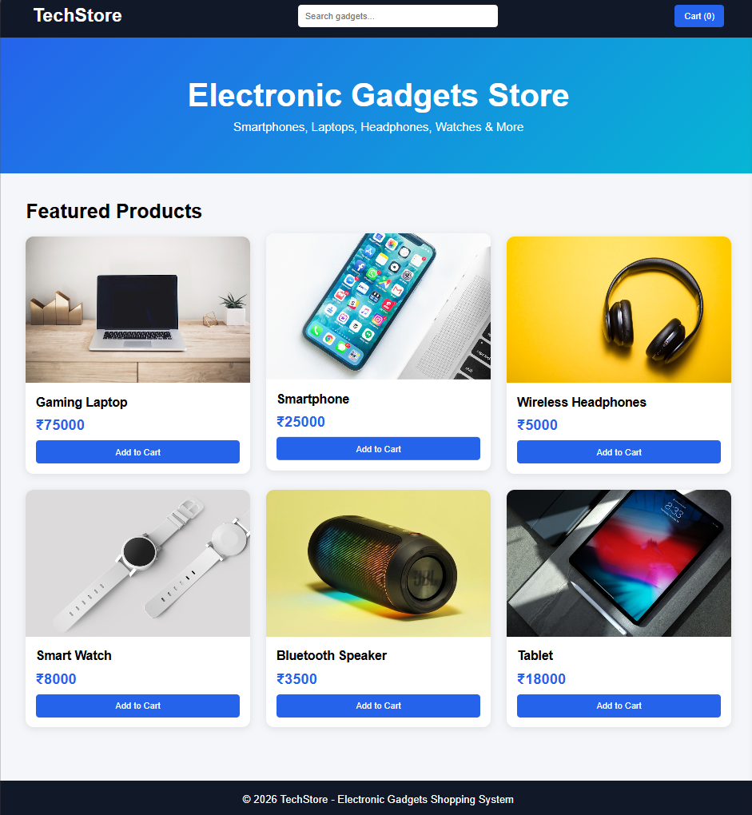
</html>

