DATA SCIENCE TOOLBOX: PYTHON PROGRAMMING
PROJECT REPORT
(Project Semester January-April 2026)

TITLE:
Student Performance Analysis and Prediction Using Linear Regression

Submitted by

ARIGELA VINAY SRIKAR

Registration No 12410019

Programme and Section - 2MO35
Course Code INT375

Under the Guidance of

Dr. BALJINDER KAUR (UID: 27952)

Discipline of CSE/IT

Lovely School of Computer Science

Lovely Professional University, Phagwara

DECLARATION

I, ARIGELA VINAY SRIKAR, student of B. Tech Computer Science and Engineering under CSE/IT Discipline at, Lovely Professional University, Punjab, hereby declare that all the information furnished in this project report is based on my own intensive work and is genuine.

Date: 04/22/2026 Signature
Registration No. 12410019 Arigela Vinay Srikar

CERTIFICATE
This is to certify that Arigela Vinay Srikar (student’s name) bearing Registration no. 12410019 has completed INT375 <Course Code> project titled, “Student Performance Analysis and Prediction Using Linear Regression”. under my guidance and supervision. To the best of my knowledge, the present work is the result of his/her original development, effort and study.

Signature and Name of the Supervisor
Designation of the Supervisor
School of Computer Science and Engineering
Lovely Professional University
Phagwara, Punjab.

Date: 22-04-2026

ACKNOWLEDGEMENT
I would like to express my sincere gratitude to my faculty guide for their guidance and support during the completion of this project. I also thank Lovely Professional University for providing resources to complete this project successfully.

Table of Content:
S. No. Title
Cover Page
Certificate
Declaration
Table of Contents
1 Introduction
2 Source of Dataset
3 EDA Process
4 Analysis of Dataset
4.1 Line Graph
4.2 Bar Graph
4.3 Box Plot
4.4 Heatmap
4.5 Scatter Plot
4.6 Histogram
4.7 Actual vs Predicted
5 Machine Learning Model
6 Conclusion
7 Future Scope
8 References
9 Source Code

1.INTRODUCTION
Data Science is an important field that focuses on analyzing data to extract useful information and patterns. In this project, student performance data is analyzed using Python programming language. The main objective of this project is to understand student academic performance and predict writing scores using linear regression techniques.

Various data science techniques such as data preprocessing, exploratory data analysis (EDA), visualization, and regression analysis were used. Python libraries such as Pandas, NumPy, Matplotlib, Seaborn, and Scikit-learn were used to perform the analysis. This project helps in understanding relationships between different academic factors and student performance.

2.SOURCE
The dataset used in this project was obtained from the Kaggle website. The dataset titled "Students Performance in Exams" contains academic performance data of students.

The dataset includes various attributes such as gender, parental level of education, lunch type, test preparation course, math score, reading score, and writing score. It contains 1000 rows and multiple columns suitable for data analysis and prediction.

Source:
Kaggle Dataset – Students Performance in Exams
https://www.kaggle.com/datasets/spscientist/students-performance-in-exams

3.EDA PROCESS
Exploratory Data Analysis (EDA) was performed to understand the structure and characteristics of the dataset. The following steps were performed during the EDA process:

• Dataset was loaded using Pandas library
• First five rows of the dataset were displayed
• Dataset information such as column names and data types was checked
• Statistical summary such as mean, minimum, maximum, and standard deviation was calculated
• Missing values were checked
• Data visualization techniques were applied

Several graphs such as histograms, scatter plots, bar charts, and box plots were created to visualize the dataset and identify patterns.

FIGURE1 – Shape Of Data

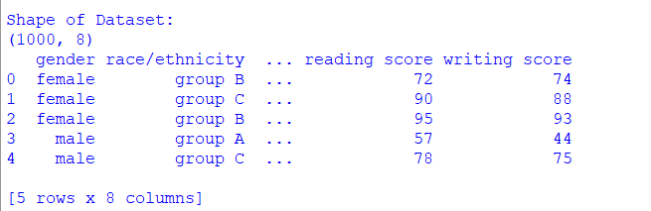

The dataset shape shows the total number of rows and columns present in the dataset. The dataset contains 1000 rows and 8 columns, which indicates sufficient data for analysis and prediction.

FIGURE2-
- Dataset Info
- Statistical Summary
- Missing Values

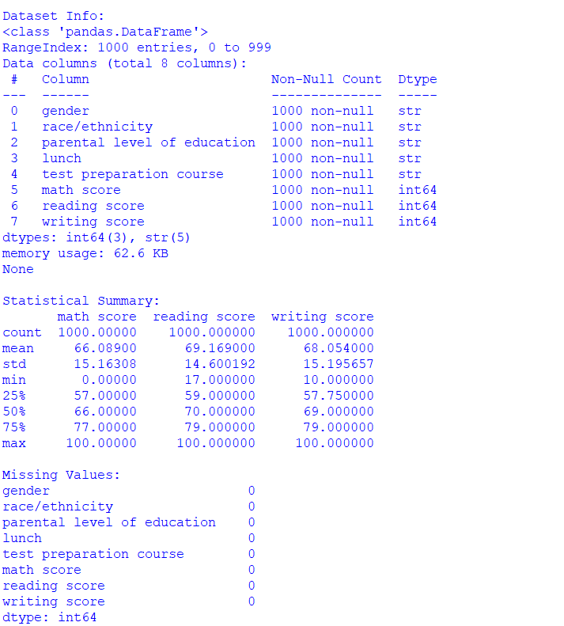

- The dataset information provides details about column names, data types, and non-null values. This confirms that the dataset contains proper data types required for analysis.
- The statistical summary displays important statistical measures such as mean, minimum, maximum, and standard deviation values of numeric columns.
- The missing values check confirms whether any null values exist in the dataset. The dataset shows no missing values, ensuring data reliability.

4.ANALYSIS ON DATASET
Introduction:
Data analysis was performed to understand the relationship between different variables present in the dataset.

General Description:
The dataset contains student academic information including gender, parental education level, lunch type, and test preparation course. It also includes subject scores such as math, reading, and writing.

Specific Requirements:
Various statistical formulas were used during analysis.

Mean = Sum of all values / Number of values

Standard Deviation = √Variance

Correlation = Measure of relationship between two variables

Analysis Results:
The analysis showed that reading scores and writing scores are strongly correlated. Students who performed well in reading also performed well in writing.
Visualization:
Various visualizations such as histograms, scatter plots, heatmaps, and box plots were used to understand data distribution and relationships.

HISTOGRAM
FIGURE3-Distribution of Math Scores
The histogram shows the distribution of math scores among students. It helps to understand how scores are spread across different ranges. Most students scored in the medium range, indicating average performance in mathematics.
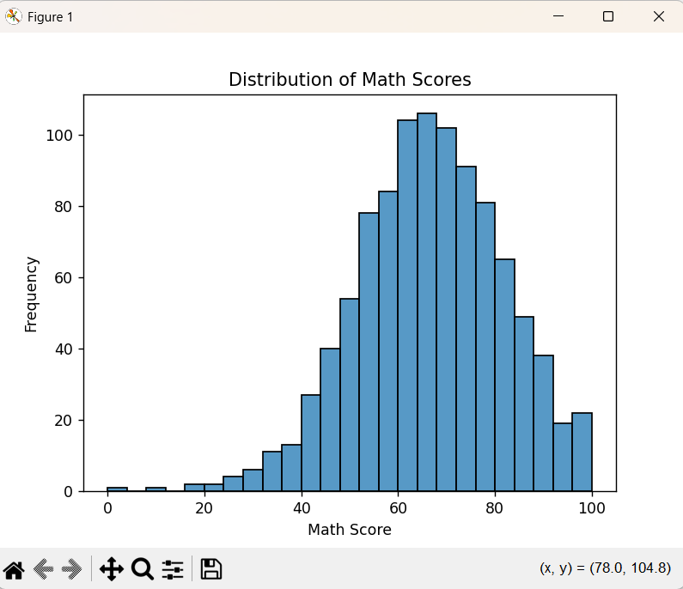

FIGURE4-Distribution of Reading Scores
The histogram of reading scores shows how reading scores are distributed among students. The majority of students achieved moderate to high reading scores.
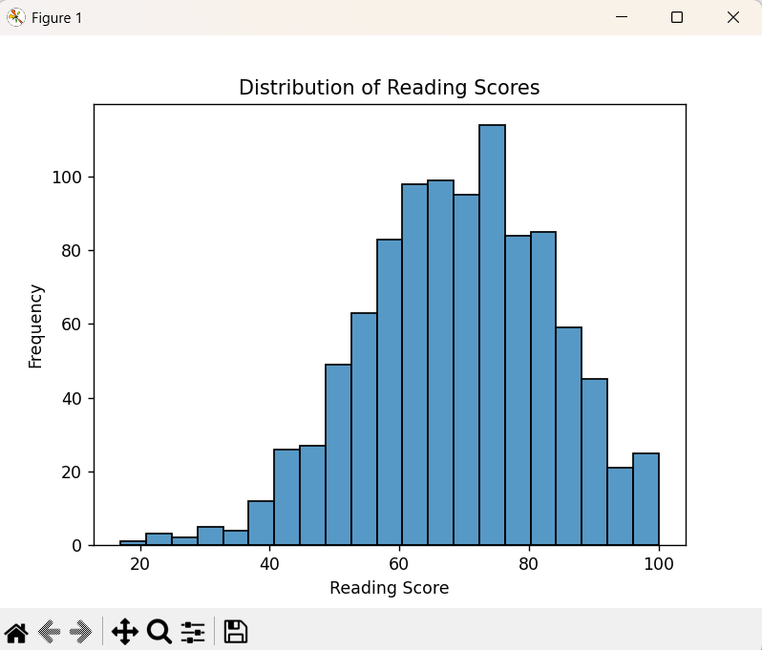

FiGURE5-Distribution of Writing Scores
This histogram represents the distribution of writing scores. It helps identify patterns and score ranges among students.

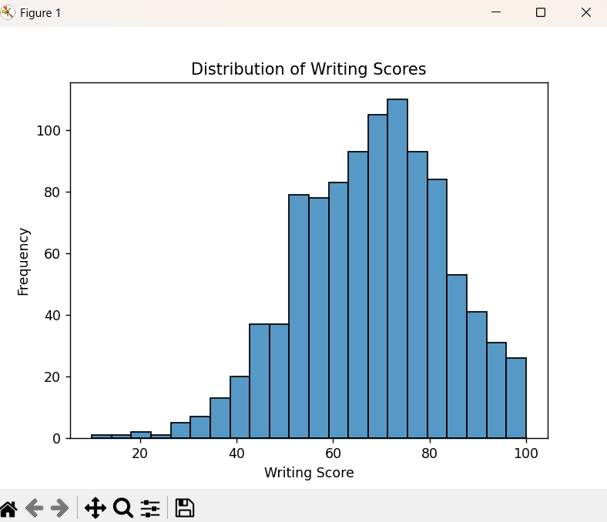

SCATTER PLOTS
Figure 9: Relationship between Math and Reading Scores
The scatter plot shows the relationship between math and reading scores. A positive trend is observed, indicating that students who perform well in math also perform well in reading.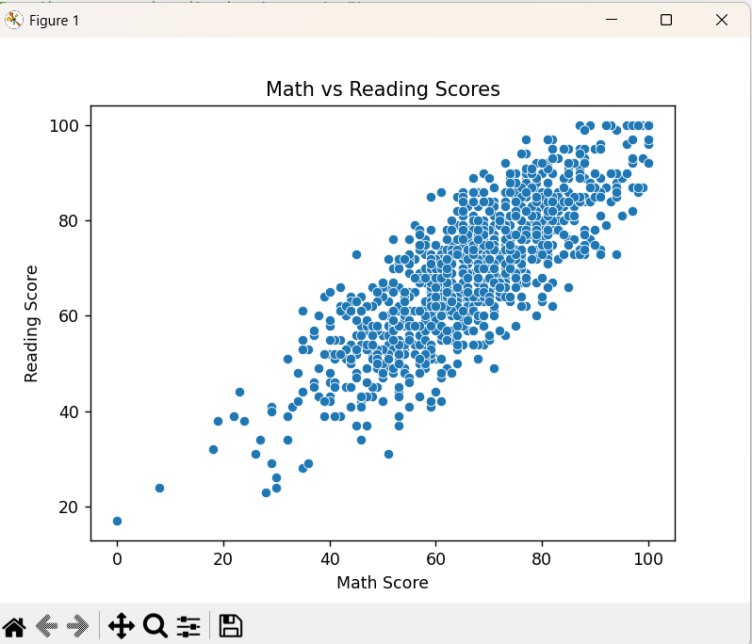
Figure 10: Relationship between Reading and Writing Scores
This scatter plot shows a strong positive relationship between reading and writing scores. Students with higher reading scores tend to have higher writing scores.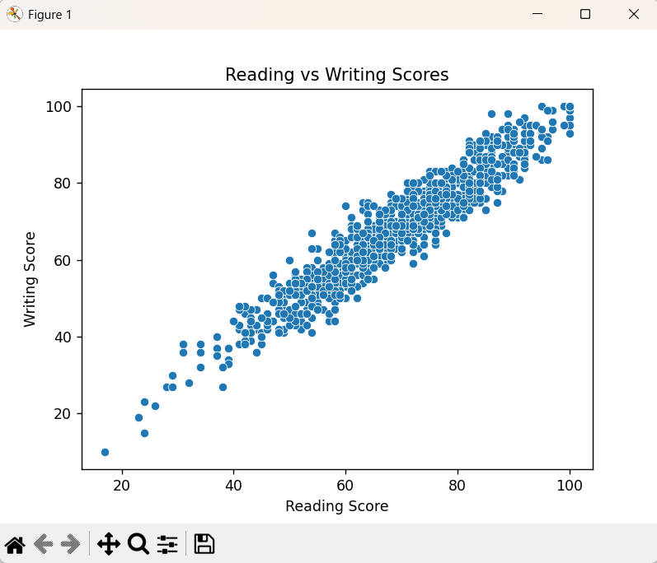

Figure 11: Relationship between Math and Writing Scores
This graph shows the relationship between math and writing scores. A moderate positive relationship is observed between these two subjects.

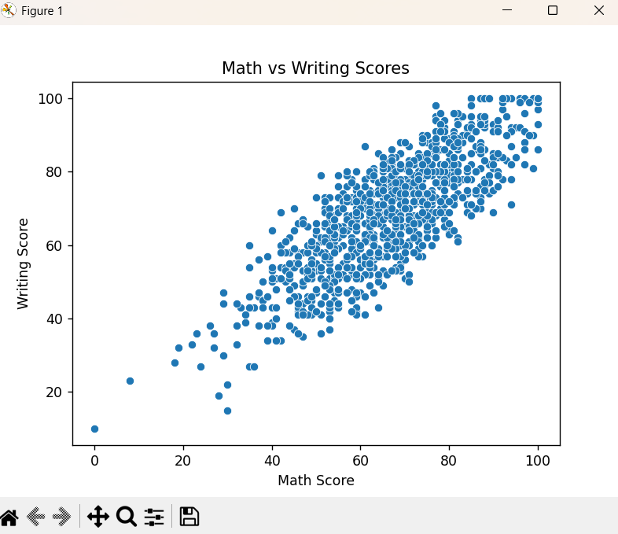

COUNT PLOT
Figure 12: Gender Distribution
This plot shows the number of male and female students present in the dataset. It helps analyze the distribution of students by gender.
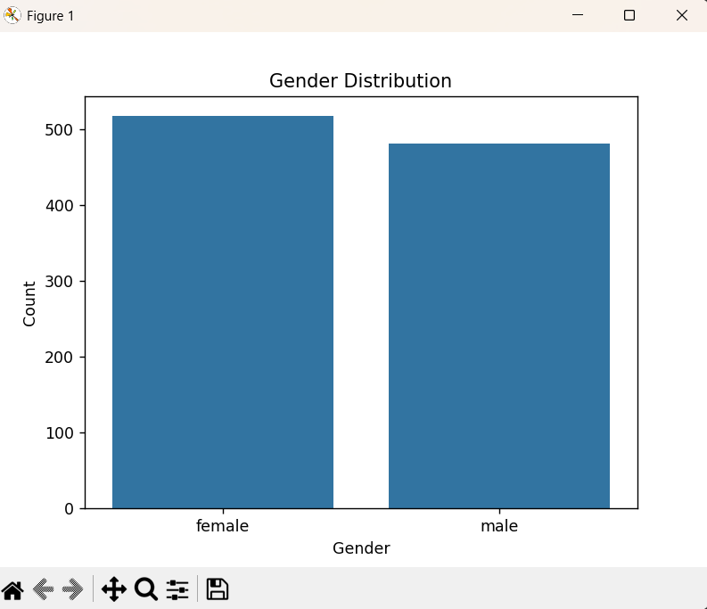
BARPLOT
Figure 13: Average Math Score by Gender
This bar plot represents the average math score of students grouped by gender. It helps compare the mathematical performance of male and female students. The visualization clearly shows the difference in average math scores between genders and helps identify performance patterns.

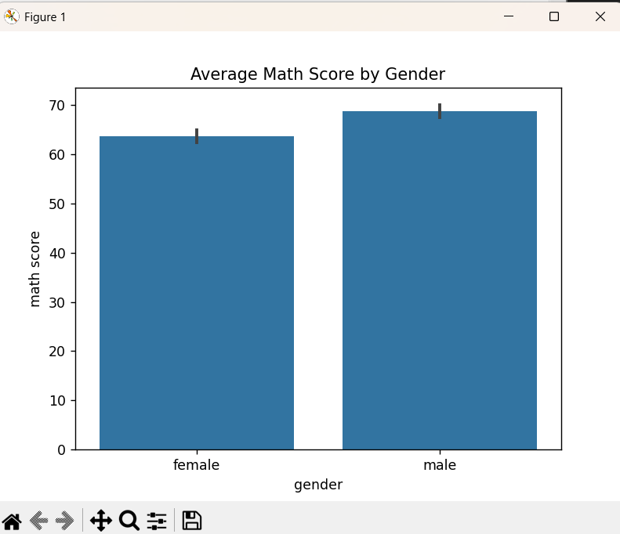

Figure 14: Average Reading Score by Gender
This bar plot displays the average reading scores of students based on gender. It helps in comparing reading abilities between male and female students. The visualization helps identify differences in academic performance across genders.

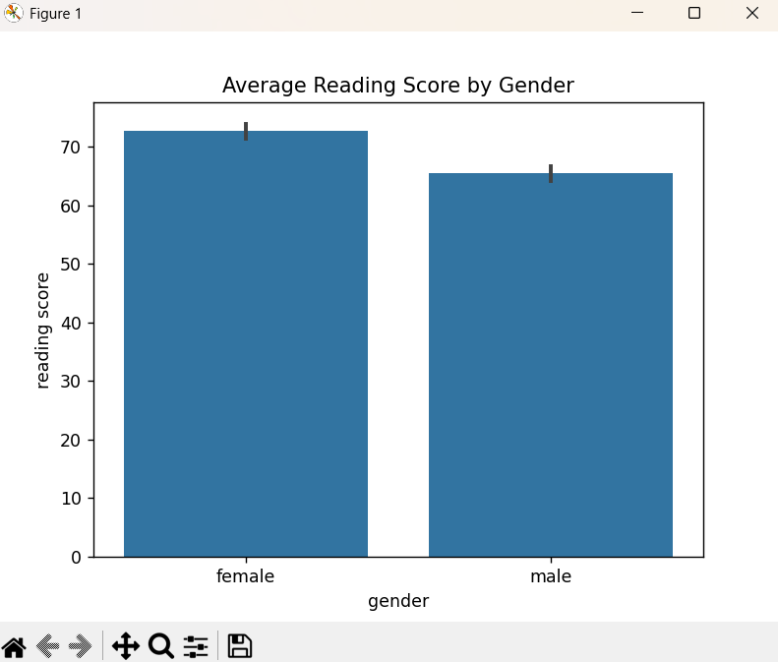

Figure 15: Average Writing Score by Gender
This graph shows the average writing scores of students categorized by gender. It helps analyze how gender influences writing performance. The comparison highlights variations in average writing scores between male and female students.
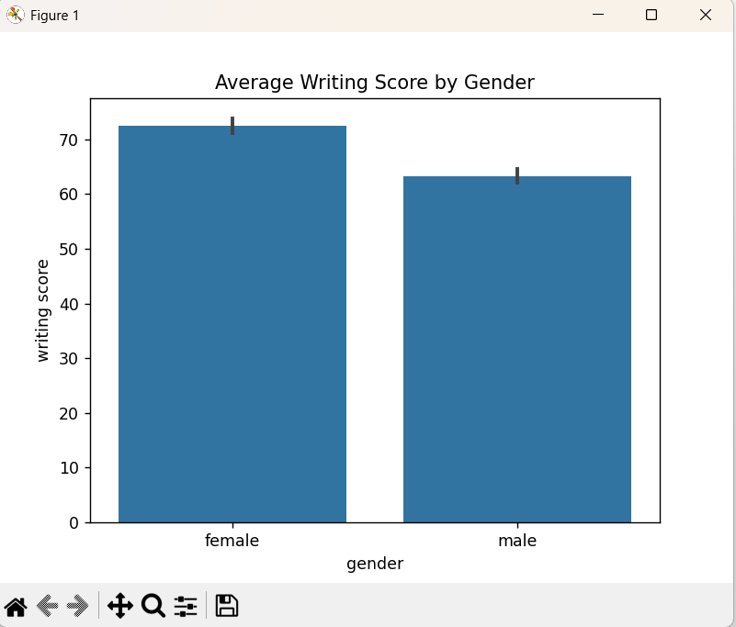

BOX PLOT
Figure 16: Math Score Box Plot
The box plot displays the spread of math scores and helps identify median values and outliers.

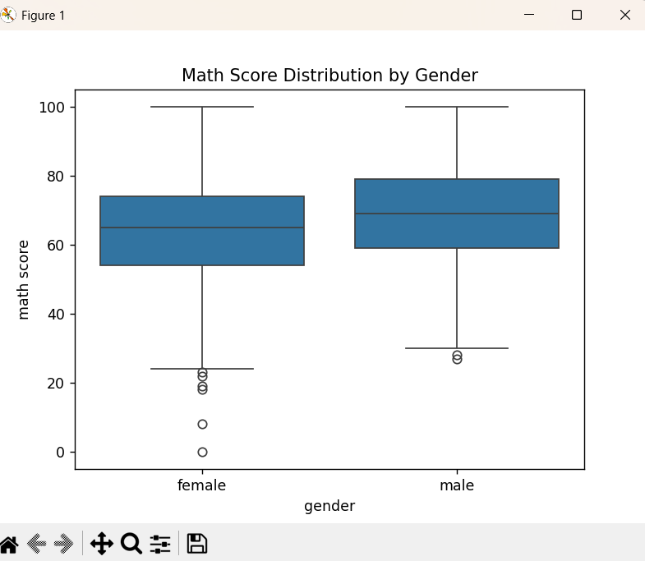

Figure 17: Reading Score Box Plot
This box plot illustrates variation and distribution of reading scores.

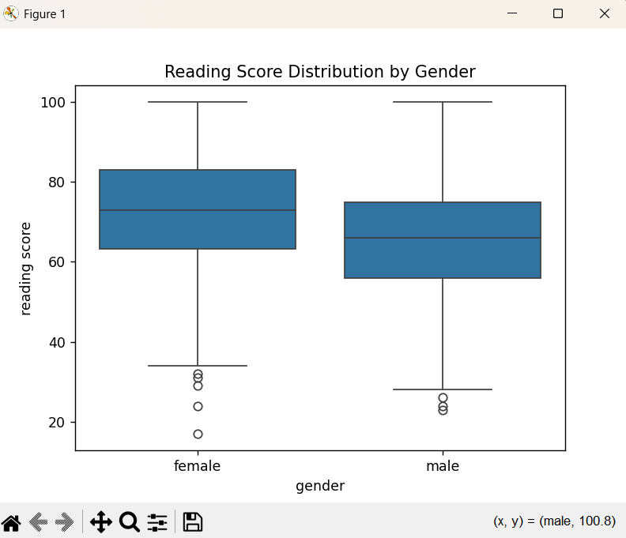

Figure 18: Writing Score Box Plot
The box plot shows how writing scores vary among students.
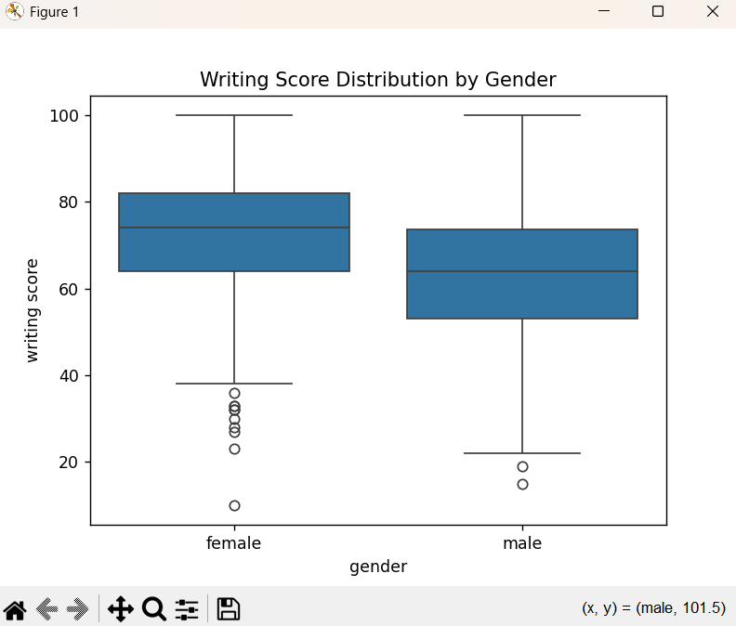

CORRELATION HEATMAP
Figure 19: Correlation Heatmap
The heatmap shows relationships between numeric variables. Reading and writing scores show strong correlation.
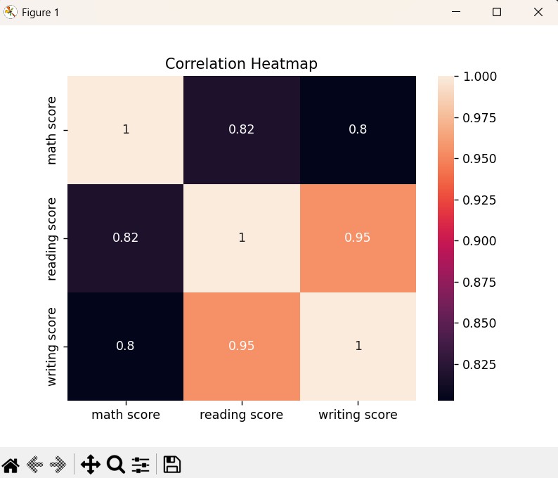
PAIRPLOT
Figure 20: Pairplot Visualization
The pairplot displays relationships between multiple variables simultaneously and helps identify patterns.

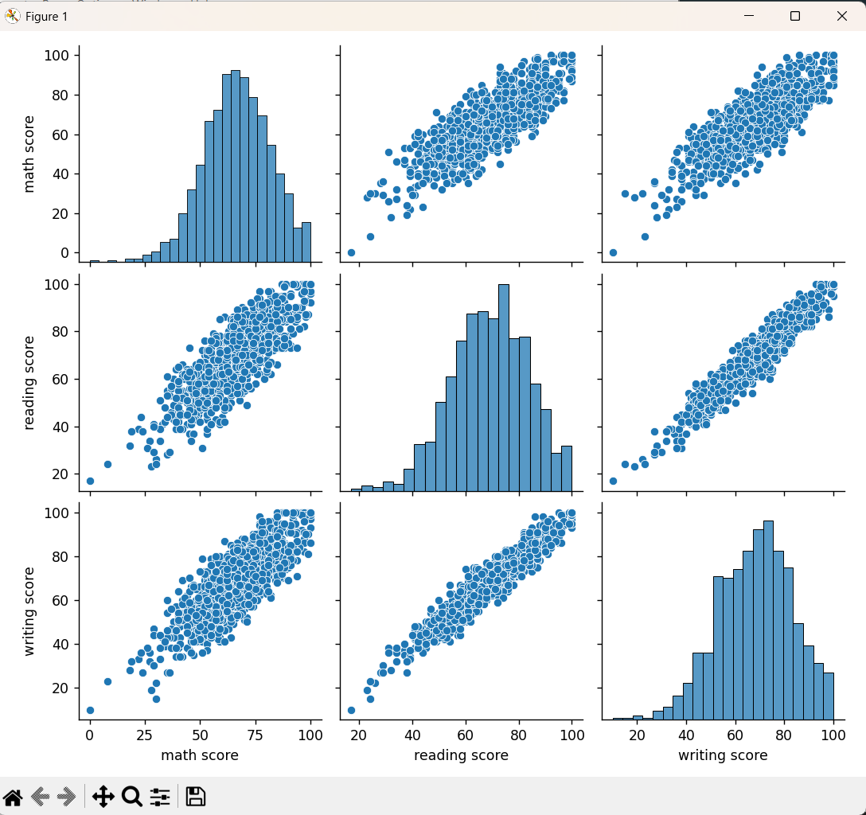

5.NUMERIC PREDICTION USING LINEAR REGRESSION
Linear Regression is a machine learning algorithm used to predict numeric values based on independent variables. In this project, writing score was predicted using reading score.

The dataset was divided into training and testing datasets. The model was trained using training data and predictions were made using testing data.

Formula used in Linear Regression:

Y = mX + c

Where:
Y = Dependent variable (Writing Score)
X = Independent variable (Reading Score)
m = Slope of the line
c = Intercept of the line

The performance of the model was evaluated using Mean Squared Error (MSE) and R² Score. The regression line was plotted to visualize prediction accuracy.
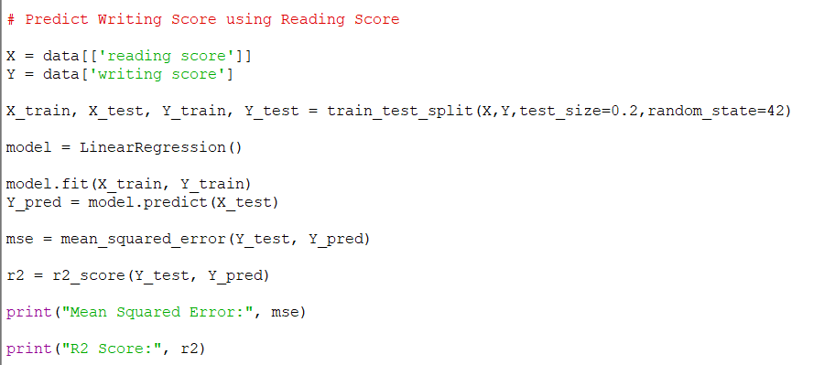

Figure 21: Linear Regression Model Implementation
This figure shows the implementation of the linear regression model using Python. The dataset was divided into training and testing sets. The model was trained using the training dataset and predictions were generated for the testing dataset.

OUTPUT OF THE MODEL

Figure 22: Model Evaluation Output
This figure displays the evaluation metrics used to measure model performance. Mean Squared Error (MSE) measures prediction error, while R² Score indicates how well the model fits the data.

Figure 23: Linear Regression Line
This graph represents the regression line showing the relationship between reading score and writing score. The straight line indicates the predicted values generated by the linear regression model. The graph confirms a strong relationship between reading and writing performance.
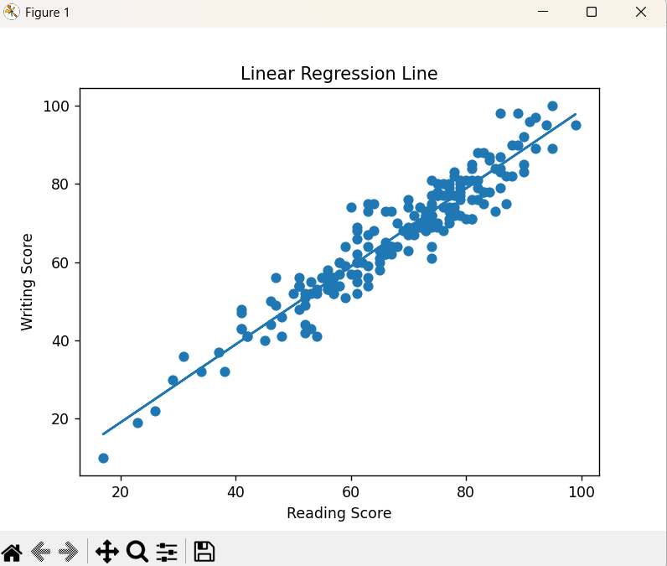

Analysis Results
The regression model showed a strong relationship between reading scores and writing scores. Students who performed well in reading also tended to perform well in writing. The R² score indicates that the model successfully explains a significant portion of the variation in writing scores.

The Mean Squared Error value indicates that prediction errors are minimal, showing good model accuracy.

6.CONCLUSION
The project successfully demonstrated the use of data science techniques to analyze student performance data. Various visualization methods were used to understand patterns in the dataset. Linear regression was successfully applied to predict writing scores based on reading scores.

The results show that data science techniques are useful in predicting academic performance and understanding relationships between different variables.

7.FUTURE SCOPE
In the future, advanced machine learning techniques such as decision trees, random forests, and neural networks can be used to improve prediction accuracy. Larger datasets can be used to enhance model performance. More features such as attendance and study hours can also be included to improve predictions.

8.REFERENCES

[1] Kaggle Dataset – Students Performance in Exams
https://www.kaggle.com/datasets/spscientist/students-performance-in-exams

[2] Python Documentation
https://docs.python.org

[3] Pandas Library Documentation
https://pandas.pydata.org

[4] Scikit-learn Documentation
https://scikit-learn.org

PROJECT REFERENCES:

LinkedIn Project Post – Student Performance Analysis and Prediction Using Linear Regression
Available at: https://www.linkedin.com/posts/vinay-arigela-19a9b431b_datascience-python-machinelearning-ugcPost-7449116322736656384-hN80?utm_source=share&utm_medium=member_desktop&rcm=ACoAAFEgswYBPp7H2dioo4MvWzAT-DDS9-mepL8

Github Project Post – Student Performance Analysis and Prediction Using Linear Regression
Available at: https://github.com/Vinay13072007/Student-Performance-Analysis-Using-Linear-Regression

Google Drive link for Project:
Available at: https://drive.google.com/drive/folders/1yOCLGvKXTC5oekiQxMmRuBuZH0nwtJC6?usp=sharing

