**ASSUMPTIONS:-**

* All the Business Rules are to be entered manually and it should consists of two days Business Rules from present day.
* For Friday, Saturday and Sunday the Divya Darshan(VQC-1) will not open for the Darshan Slots.
* On Thursday the Divya Darshan (VQC-1) if slots are completed it will shows the alert (today darshan slots are over).

|  |
| --- |
| Untitled4.png |

* While entering the people in VQC1 & VQC2 at 05.00 PM it shows a alert that "Please Enter the Day after tomorrow's Business Rule" (For Everyday), then enter the Business Rules for that particular day and then proceed.

|  |
| --- |
| Untitled3.png |

* If the 'User' want to change the Business Rule then they have to remove the rules upto the particular time and then enter the new Business Rule.
* There is a possibility of changing or updating the values of VQC-I & VQC-II for particular Business Rule (for that no need to remove the Business rules).
* For every Business rules the 'From' Time will be automatically detects from previous 'To' Time shown in below diagram.

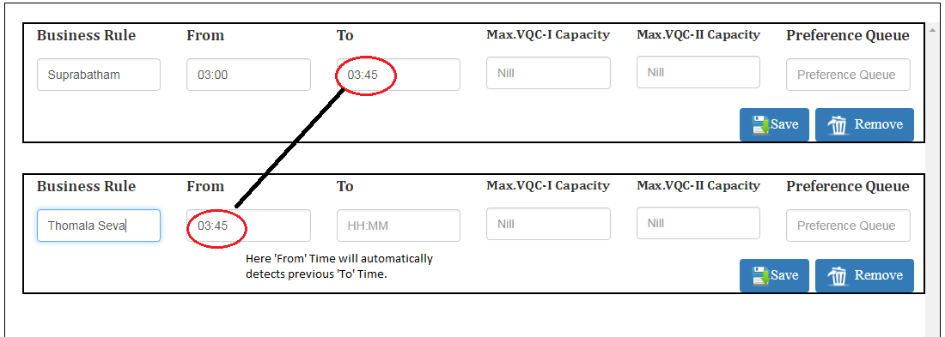

* If 'To' Time is in between 23:00 to 23:59 then it shows below information as proceed with the next day.

|  |
| --- |
| Untitled2.png |