PROJECT REPORT
Intelligent Supply Chain Risk Prediction
and Vendor Management Platform
AI-Enabled Risk Prediction & Vendor Analytics for Resilient Supply Chains

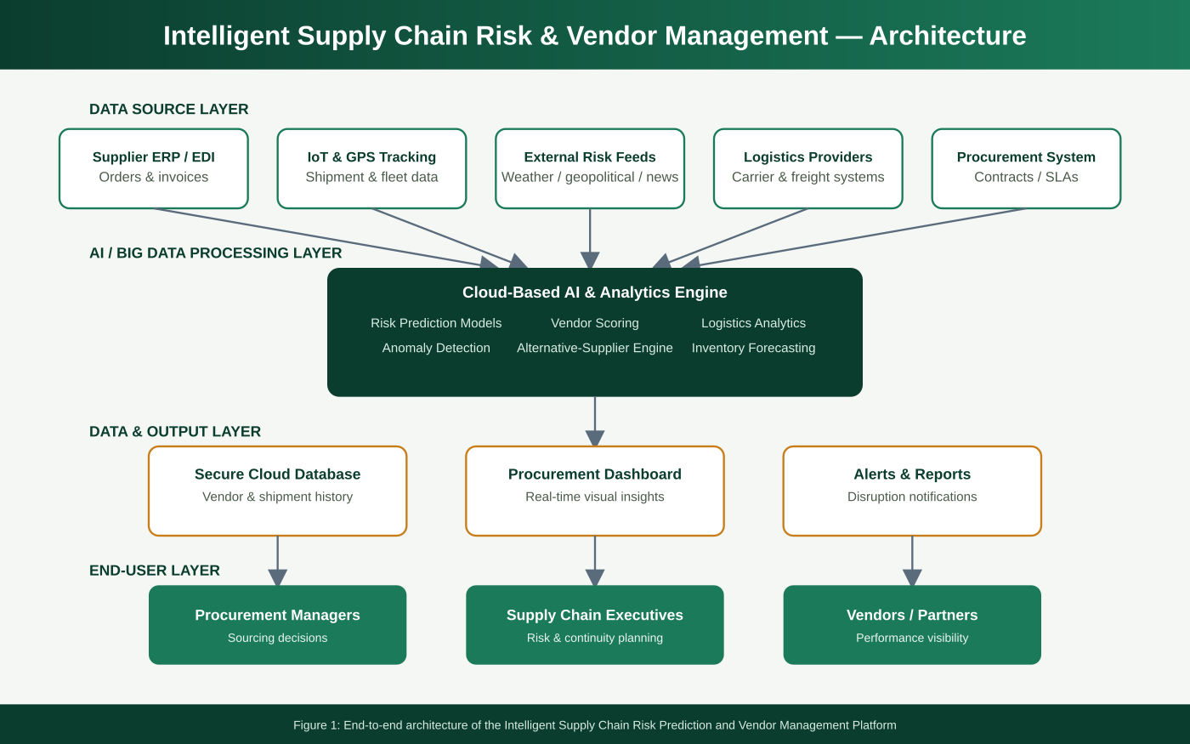

Industry: Supply Chain & Logistics Technology
Domain: AI, Big Data Analytics, Cloud Computing, IoT
July 2026

Table of Contents
1. Executive Summary 3
2. Industry Context 3
3. Problem Statement 4
4. Objectives 4
5. Proposed System Overview 5
6. Risk Prediction Workflow 6
7. Key Features and Modules 6
8. Sample Procurement Dashboard 7
9. Technology Stack 8
10. Expected Outcomes 8
11. Traditional vs. Intelligent Supply Chain Management 8
12. Implementation Roadmap 9
13. Challenges and Considerations 9
14. Conclusion 9

1. Executive Summary
Global supply chains are increasingly exposed to disruption from natural disasters, geopolitical events, transportation bottlenecks, and supplier failures, yet most organizations still rely on systems that react only after a disruption has already caused financial loss or delivery delays. This report presents an Intelligent Supply Chain Risk Prediction and Vendor Management Platform — a cloud-based system that continuously monitors supplier performance, evaluates vendor reliability and compliance, applies AI models to predict disruptions before they occur, and recommends alternative suppliers or logistics strategies. The platform is designed to give procurement managers real-time, data-driven visibility into supply chain risk and to support faster, more resilient sourcing decisions.
The sections that follow outline the industry context, problem statement, system objectives, proposed architecture, workflow, feature set, technology stack, expected outcomes, and an implementation roadmap for organizations considering adoption of this platform.

2. Industry Context
Modern supply chains span multiple suppliers, logistics providers, and distribution centers across geographies, which makes them inherently vulnerable to disruption. Artificial intelligence, Big Data analytics, cloud computing, and IoT-based tracking are increasingly deployed to give organizations continuous visibility into supplier performance and shipment status. This shift is driven by the need to move from reactive crisis management toward proactive risk management — anticipating disruptions before they occur, and having contingency plans and alternative suppliers ready in advance to preserve operational resilience and business continuity.

3. Problem Statement
Modern supply chains face frequent disruptions from supplier delays, inventory shortages, transportation bottlenecks, and shifting market conditions. Traditional supply chain management systems primarily react to disruptions after they occur, resulting in financial losses, delayed deliveries, and strained customer relationships. There is a need for an intelligent platform that continuously monitors supplier performance, evaluates operational risk, predicts supply chain disruptions using AI models, and recommends alternative suppliers or logistics strategies — while giving procurement managers real-time dashboards that support informed, timely decision-making.

4. Objectives
The system is designed around eight core objectives that together support a complete monitoring-to-mitigation risk management cycle:
# | Objective | Description
1 | Monitor Supplier Performance | Continuously track supplier delivery, quality, and responsiveness metrics.
2 | Predict Supply Chain Risks | Apply AI models to forecast disruptions before they materialize.
3 | Evaluate Vendor Reliability | Assess vendor compliance, reliability, and contractual adherence.
4 | Recommend Alternative Suppliers | Suggest backup suppliers or routes automatically during disruptions.
5 | Monitor Logistics & Delivery | Track shipment status, transit times, and carrier performance in real time.
6 | Generate Procurement Dashboards | Present real-time, visual analytics for procurement decision-making.
7 | Improve Inventory Planning | Enhance demand forecasting and inventory allocation across the network.
8 | Enhance Supply Chain Resilience | Strengthen the organization's ability to absorb and recover from shocks.

5. Proposed System Overview
The platform is organized into four functional layers: a data-source layer (supplier ERP/EDI feeds, IoT and GPS shipment tracking, external risk feeds such as weather and geopolitical news, logistics providers, and procurement systems), a cloud-based AI and Big Data processing layer (risk prediction models, vendor scoring, logistics analytics, anomaly detection, and an alternative-supplier recommendation engine), a data and output layer (secure database, procurement dashboard, and automated alerts), and an end-user layer serving procurement managers, supply chain executives, and vendors or partners. This layered design allows new data feeds or predictive models to be added without disrupting existing operations.

Figure 1: End-to-end system architecture

6. Risk Prediction Workflow
Data flows through the system in five stages: continuous monitoring of supplier, logistics, and market data; vendor risk evaluation covering reliability and compliance; AI-based disruption prediction; recommendation of alternative suppliers or logistics strategies; and finally, procurement decision and action. A continuous feedback loop feeds the outcomes of each decision back into the model, improving prediction accuracy over successive planning cycles.
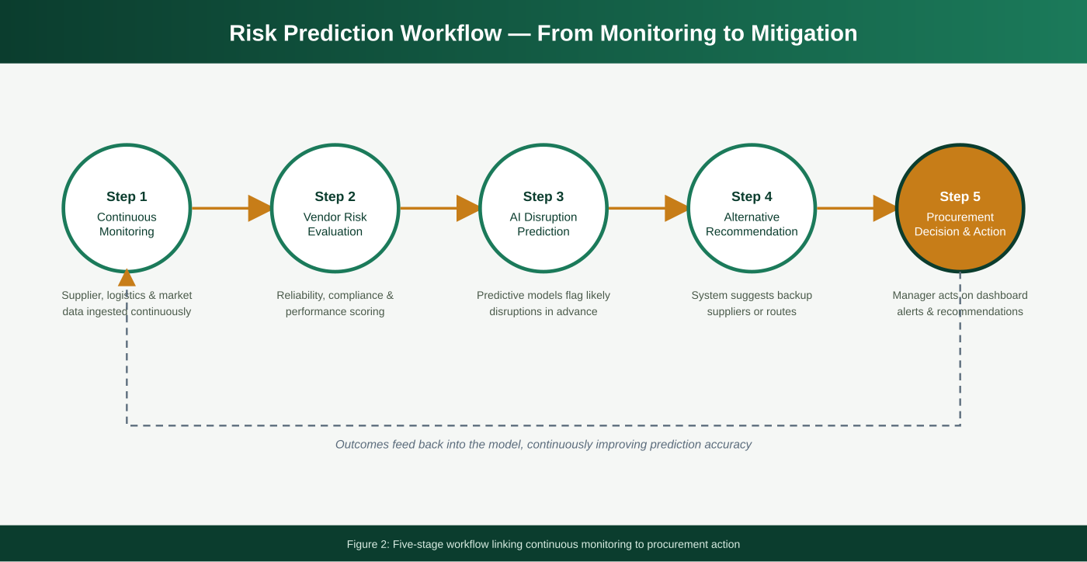
Figure 2: Five-stage risk prediction and mitigation workflow

7. Key Features and Modules
Module | Key Capabilities
Supplier Performance Monitoring | Continuous tracking of delivery timeliness, quality metrics, and responsiveness.
Vendor Risk & Compliance Scoring | Automated evaluation of vendor reliability, financial health, and contractual compliance.
AI Disruption Prediction | Machine learning models that forecast disruptions using historical and external risk signals.
Alternative Supplier Engine | Recommends qualified backup suppliers or alternative logistics routes during disruptions.
Logistics & Delivery Tracking | Real-time shipment visibility via IoT/GPS integration with carriers and freight systems.
Procurement Analytics Dashboard | Real-time visual dashboards with drill-down by vendor, region, or product category.
Inventory Planning Support | Demand forecasting and inventory optimization recommendations across the network.
Reporting & Alerts | Automated report generation and instant alerts to procurement managers and executives.

8. Sample Procurement Dashboard
The dashboard consolidates supplier performance, logistics, and risk metrics into a single real-time view. Procurement managers can see network-wide KPIs at a glance, drill into regional risk exposure, and review a prioritized list of at-risk vendors along with system-recommended actions.
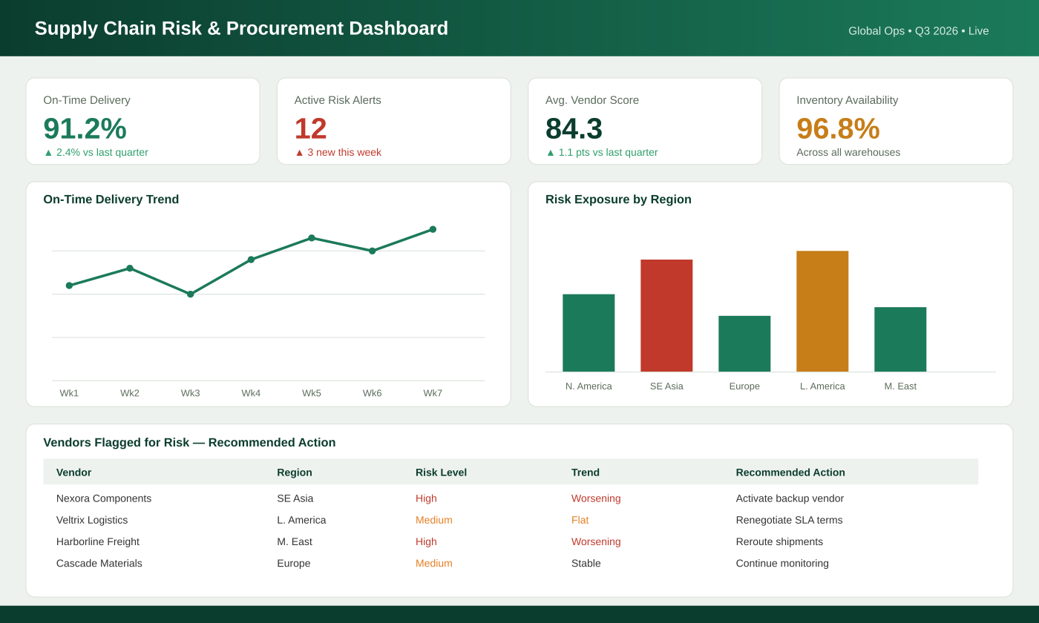
Figure 3: Sample supply chain risk and procurement dashboard view

9. Technology Stack
Layer | Recommended Technologies
Data Capture & Tracking | IoT sensors, GPS/RFID shipment tracking, EDI integration with supplier ERPs
Backend & AI/ML | Python, TensorFlow / PyTorch, time-series forecasting models, cloud ML services, REST APIs
Big Data Processing | Distributed data pipelines (e.g., Spark/Kafka-style streaming), data lakes for historical analytics
Data Storage | Cloud databases (SQL/NoSQL), encrypted vendor and shipment data warehouse
Frontend / Dashboard | Web and mobile dashboards (React / Flutter), data visualization libraries
Integration | ERP/SCM integration, carrier and logistics APIs, notification services (SMS/email/app)
Security & Compliance | Role-based access control, data encryption, regulatory and trade-compliance controls

10. Expected Outcomes
# | Expected Outcome
1 | Reduced frequency and impact of supply chain disruptions
2 | Improved, continuous supplier performance monitoring
3 | Better, faster procurement decisions
4 | Increased inventory availability across the network
5 | Reduced operational costs from disruptions and inefficiencies
6 | Enhanced vendor collaboration and transparency
7 | Improved business continuity during disruptive events
8 | Higher customer satisfaction through reliable delivery

11. Traditional vs. Intelligent Supply Chain Management
Parameter | Traditional System | Intelligent Risk & Vendor Platform
Disruption Handling | Reactive, after impact has occurred | Proactive, AI-based early prediction
Supplier Monitoring | Periodic, manual reviews | Continuous, automated performance tracking
Vendor Risk Evaluation | Ad-hoc, inconsistent criteria | Standardized, data-driven compliance scoring
Alternative Sourcing | Manually identified during a crisis | System-recommended in advance of disruption
Reporting | Manual compilation, delayed | Automated, real-time dashboards
Inventory Planning | Static forecasts, infrequent updates | Continuously updated, demand-driven forecasting

12. Implementation Roadmap
Phase | Duration | Key Activities
Phase 1: Requirements & Design | 4-6 weeks | Stakeholder consultation, supplier data audit, system architecture design
Phase 2: Pilot Deployment | 6-8 weeks | Integrate select suppliers and carriers, configure AI models, initial data collection
Phase 3: Dashboard & Analytics Rollout | 4-6 weeks | Deploy dashboards, train predictive models on pilot data, procurement team training
Phase 4: Network-wide Rollout | 8-10 weeks | Scale to all suppliers and regions, integrate with existing ERP/SCM systems
Phase 5: Monitoring & Optimization | Ongoing | Continuous model refinement, feedback collection, feature enhancement

13. Challenges and Considerations
- Data quality and integration: supplier and logistics data often reside in disparate systems with inconsistent formats, requiring robust integration and cleansing.
- External data dependency: risk prediction relies on external feeds (weather, geopolitical, market news) whose quality and timeliness vary by region.
- Change management: procurement teams need training and time to trust and adopt AI-driven recommendations over established manual processes.
- Vendor data sensitivity: performance and compliance scoring involves sensitive commercial data that must be handled under strict confidentiality agreements.
- Model accuracy and bias: predictive risk models must be regularly validated and audited to avoid unfairly penalizing vendors based on incomplete data.

14. Conclusion
The Intelligent Supply Chain Risk Prediction and Vendor Management Platform addresses the long-standing reactive posture of traditional supply chain management by giving organizations continuous visibility into supplier performance and early warning of potential disruptions. By combining AI-based risk prediction with automated vendor scoring and alternative-sourcing recommendations, the platform enables procurement teams to act before disruptions escalate — ultimately reducing costs, improving business continuity, and strengthening customer satisfaction.

