1

CASE STUDY ANALYSIS REPORT
CSA1013 - Software Engineering — Problem Statement 16
Name:Ch.B.Vinay
Register number:192425148
Branch :B.Tech - AI& ML
Faculty : Latha R

Understanding the Problem Statement

Problem Explanation
Modern supply chains span multiple suppliers, manufacturers, logistics providers, and distribution centers spread across regions and, frequently, across borders. This interconnected structure leaves organizations exposed to disruption from natural disasters, geopolitical instability, transportation bottlenecks, and outright supplier failure. Traditional supply chain management systems are largely reactive: they record what has already happened rather than anticipating what is about to happen. By the time a delay or shortage becomes visible in an ERP system, procurement teams have often already lost the window to respond without incurring cost or schedule impact.
The proposed Intelligent Supply Chain Risk Prediction and Vendor Management Platform addresses this gap by combining continuous supplier performance monitoring with AI-driven risk prediction, automated vendor evaluation, and real-time procurement dashboards. The goal is to shift organizations from reactive firefighting to proactive, data-driven supply chain resilience.

Objectives of the Proposed System
- Continuously monitor supplier performance across cost, quality, and delivery dimensions.
- Predict supply chain disruptions and risks using AI-based forecasting models.
- Evaluate vendor reliability, financial stability, and regulatory compliance.
- Recommend alternative suppliers or logistics strategies during active disruptions.
- Monitor logistics and delivery performance across the transportation network.
- Generate real-time procurement analytics dashboards for decision-makers.
- Improve inventory planning through demand and risk-aware forecasting.
- Enhance overall supply chain resilience and business continuity.

Scope of the Problem
The scope of this system covers end-to-end supplier and vendor risk management, spanning procurement, logistics, and inventory-adjacent functions for manufacturing, retail, and distribution organizations. It includes integration with existing ERP and procurement systems, IoT-based shipment and warehouse tracking, third-party data feeds (weather, geopolitical, financial), predictive analytics for disruption forecasting, and dashboards for procurement managers, executives, and supplier-relationship teams. The scope excludes direct control of physical logistics operations (e.g., fleet dispatch) and does not replace an organization's core ERP or warehouse management system — it complements them by adding a predictive risk and vendor-intelligence layer.

Key Stakeholders and Challenges

Stakeholder Roles and Responsibilities

Stakeholder | Role / Responsibility | Key Challenges Faced
Procurement Managers | Select vendors; place and track purchase orders; act on risk alerts. | Limited visibility into supplier risk until disruption occurs.
Suppliers / Vendors | Fulfil orders; report capacity and compliance status. | Inconsistent performance evaluation; delayed feedback from buyers.
Logistics Providers | Transport and deliver goods across the supply network. | Poor real-time visibility into delays; limited rerouting guidance.
Supply Chain Analysts | Monitor risk indicators; build mitigation strategies. | Manual data aggregation across disconnected systems.
Executive Management | Set sourcing strategy; oversee business continuity. | Late awareness of disruptions; reactive decision-making.
IT / System Administrators | Deploy, integrate, and secure the platform. | Integrating with legacy ERP and diverse vendor data formats.

Major Challenges Summary
Across stakeholders, three challenges recur consistently: (1) supplier and logistics data is fragmented across ERP systems, spreadsheets, and vendor portals, preventing a unified view of risk; (2) disruptions are typically identified only after they materially affect delivery, leaving little room for mitigation; and (3) vendor evaluation is often subjective and infrequent, making it difficult to compare alternative suppliers quickly during a crisis. The proposed system is designed specifically to resolve these three challenges.

Analysis of the Current Approach

Existing Process
Most organizations currently rely on one of the following: (a) manual or spreadsheet-based supplier scorecards updated periodically by procurement staff, (b) ERP modules that track purchase orders and deliveries but offer little predictive insight, or (c) ad-hoc communication with logistics partners during active disruptions. Risk assessment, in almost all cases, is reactive — triggered only after a delay, shortage, or quality issue has already occurred.
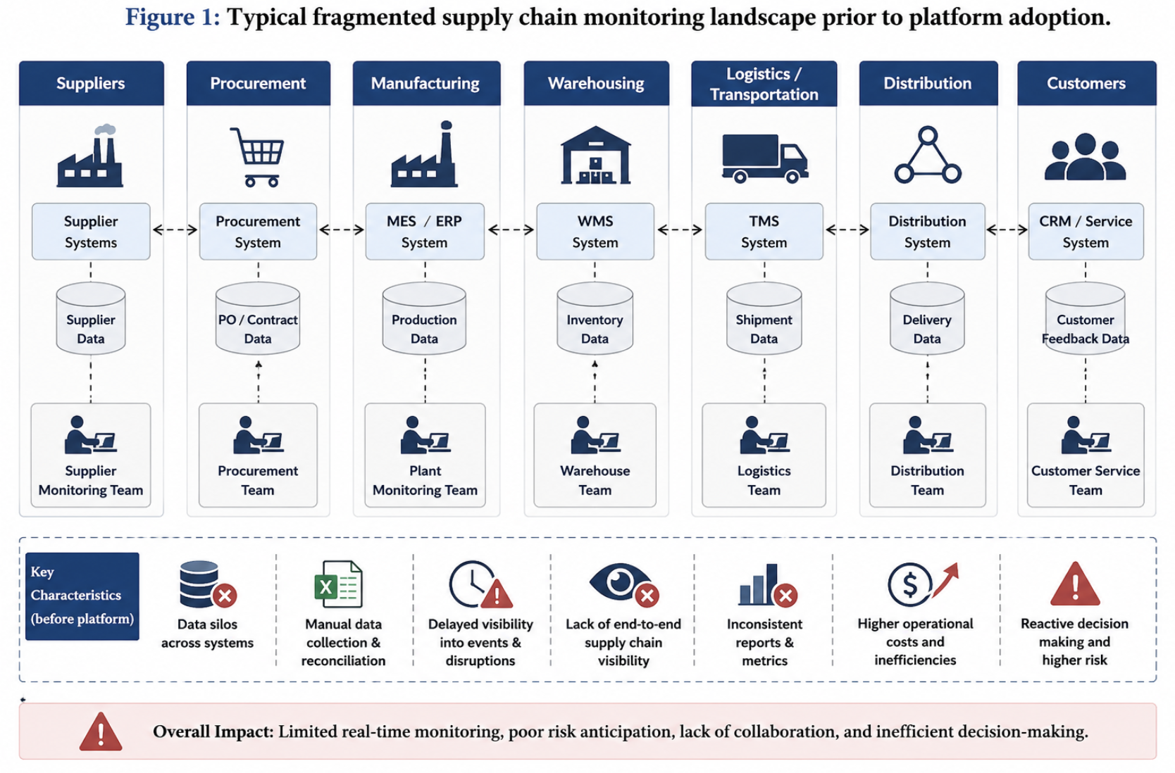

Strengths and Limitations

Aspect | Strengths of Current System | Limitations
 | training overhead. | or predictive risk view.
Supplier Tracking | Familiar spreadsheet/ERP-based process; low | Updated infrequently; no continuous
Logistics Monitoring | Basic shipment status available through carrier portals. | Fragmented across carriers; no unified real-time visibility.
Vendor Evaluation | Established procurement approval workflows. | Subjective scoring; slow to reflect changing vendor conditions.
Reporting | Reports are audit-friendly and institutionally familiar. | Manually compiled; slow, error-prone, rarely real-time.
Risk Response | Escalation paths exist for known issue types. | Reactive rather than proactive; alternatives identified too late.

Gaps to be Addressed
- No continuous, unified view of supplier and logistics risk.
- No predictive mechanism to flag disruptions before they impact delivery.
- No systematic, data-driven vendor reliability and compliance scoring.
- No automated recommendation of alternative suppliers or routes during disruption.
- Heavy manual effort required to compile procurement and risk reports.41

Gaps to be Addressed
- No continuous, unified view of supplier and logistics risk.
- No predictive mechanism to flag disruptions before they impact delivery.
- No systematic, data-driven vendor reliability and compliance scoring.
- No automated recommendation of alternative suppliers or routes during disruption.
- Heavy manual effort required to compile procurement and risk reports.41

Proposed Software Solution

Solution Overview
The proposed system is a cloud-based Supply Chain Risk Intelligence Platform composed of a data-ingestion layer, an AI-driven risk analytics engine, and role-based dashboards. Supplier performance data, logistics tracking feeds, and external risk signals (weather, geopolitical events, financial indicators) are continuously ingested and normalized. A predictive risk engine scores each supplier and shipment lane, triggering early alerts and automatically surfacing alternative-supplier or rerouting recommendations for procurement teams.
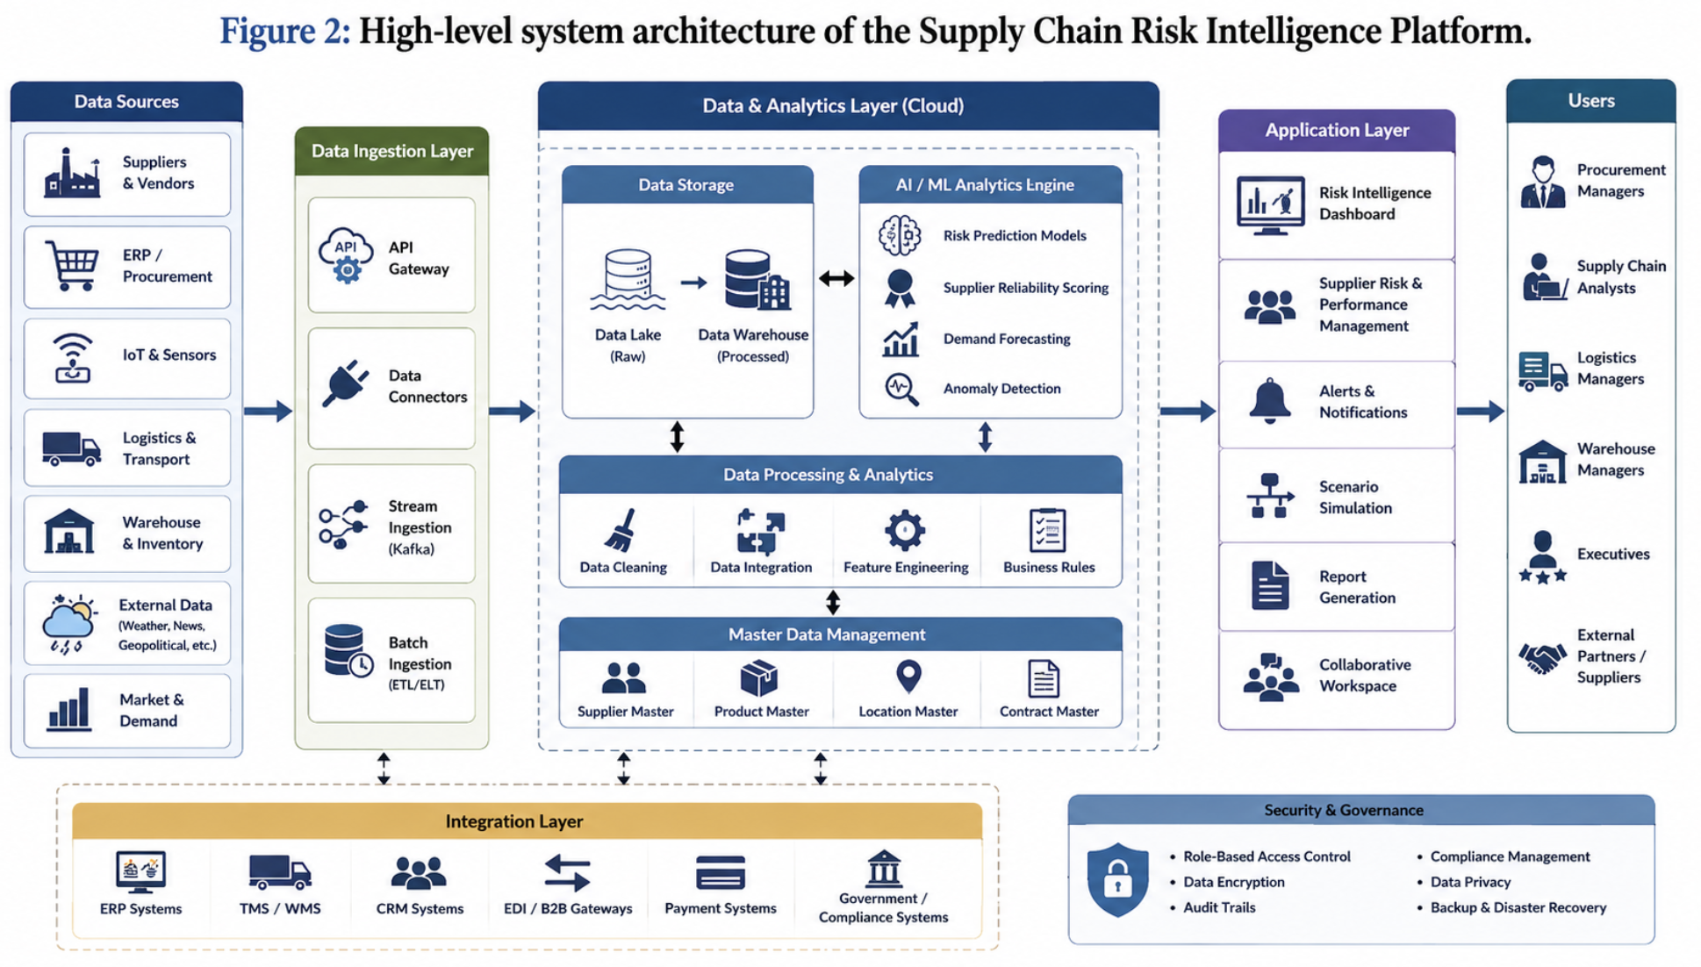

Major Functional Modules

Module | Description
Supplier Monitoring Module | Continuously tracks supplier performance across cost, quality, and delivery metrics.
Risk Prediction Engine | Applies machine learning models to forecast disruptions from internal and external data.
Vendor Evaluation Module | Scores vendor reliability, compliance, and financial stability on an ongoing

Module | Description
 | basis.
Logistics Tracking Module | Monitors shipment and delivery performance using IoT and carrier data feeds.
Alternative Sourcing Engine | Recommends alternative suppliers or logistics strategies during disruptions.
Procurement Dashboard Module | Presents real-time analytics and alerts to procurement managers and executives.
Integration & Access Management Module | Manages ERP integration, authentication, roles, and permissions.

Functional and Non-Functional Requirements

Functional Requirements
      - The system shall continuously ingest supplier, logistics, and external risk data from integrated sources.
      - The system shall compute and update a risk score for each supplier and shipment lane.
      - The system shall generate predictive disruption alerts based on historical and real-time signals.
      - The system shall recommend alternative suppliers or logistics strategies when risk thresholds are exceeded.
      - The system shall provide role-based dashboards for procurement managers, analysts, and executives.
      - The system shall allow export of procurement and risk reports for audit and compliance purposes.

Non-Functional Requirements
      - Scalability: the system shall support monitoring of thousands of suppliers and shipment lanes concurrently.
      - Reliability: the system shall maintain 99.5% uptime during business operating hours.
      - Security & Privacy: vendor and financial data shall be encrypted at rest and in transit, with role-restricted access.
      - Usability: dashboards shall be intuitive enough for procurement staff to use without extensive training.
      - Maintainability: the modular architecture shall allow individual modules to be updated independently.
      - Performance: risk scores shall be recalculated and reflected in dashboards within minutes of new data arrival

4.4 Application of Software Engineering Principles

Principle | How It Is Incorporated
Modularity | The system is decomposed into independent modules (supplier monitoring, risk prediction, vendor evaluation, logistics tracking) developed and deployed separately.
Scalability | Cloud-native, microservices-based deployment allows horizontal scaling as more suppliers and lanes are added.
Maintainability | Clear separation of concerns and documented APIs allow modules to be updated without affecting the whole system.
Reliability | Redundant cloud infrastructure and automated failover ensure consistent data capture and availability.
Usability | Role-specific, visually intuitive dashboards minimize training overhead for procurement staff.
Security | End-to-end encryption, role-based access control, and compliance with data-protection standards safeguard vendor and financial data.

5. Justification of the Chosen Methodology

5.1 Selected Methodology: Agile (Scrum Framework)
The Agile methodology, implemented through the Scrum framework, is recommended for developing the Supply Chain Risk Intelligence Platform. Given the system's multiple independent modules (supplier monitoring, risk prediction, vendor evaluation, sourcing recommendations) and the likelihood of evolving requirements — such as new risk data sources or additional ERP integrations — Agile's iterative, incremental approach is well suited to this project.

5.2 Why Agile/Scrum Is Suitable
- Incremental delivery allows each functional module (e.g., supplier monitoring, then risk prediction, then sourcing recommendations) to be built, tested, and released in independent sprints.
- Frequent stakeholder feedback from procurement managers ensures dashboards and alerts remain genuinely usable in real operational conditions.
- Iterative refinement of the predictive risk model is essential, since machine learning components typically improve through repeated tuning against real supply chain data.
- Sprint reviews allow early detection of integration issues between ERP systems, carrier data feeds, and the cloud backend, reducing late-stage risk.
- Agile's flexibility accommodates organization-specific customization requests without derailing the overall project timeline.

5.3 Comparison with Alternative Models

Model | Suitability for This Project
Waterfall | Not ideal — rigid, sequential phases make it difficult to refine the predictive model or incorporate stakeholder feedback mid-development.
Spiral | Viable given the risk-sensitive nature of vendor and financial data, but adds process overhead not justified for a project of this scale.
Agile / Scrum (Selected) | Best fit — supports modular, iterative delivery, continuous stakeholder feedback, and progressive refinement of AI components.
DevOps | Complementary rather than alternative — recommended for continuous deployment once Agile development stabilizes each module.
In practice, the recommended approach combines Agile/Scrum for iterative development with DevOps practices (continuous integration and deployment) for reliably rolling out updates across multiple business units and supplier networks, ensuring both adaptability during development and operational stability afterward.

6. Expected Outcomes and Limitations

6.1 Expected Benefits

Benefit | Description
Reduced Supply Chain Disruptions | Predictive risk alerts allow proactive mitigation before disruptions materially impact operations.
Improved Supplier Performance Monitoring | Continuous scoring gives procurement teams actionable, real-time visibility.
Better Procurement Decisions | Data-driven vendor comparisons support faster, more confident sourcing choices.
Increased Inventory Availability | Early risk detection supports proactive inventory and reorder planning.
Reduced Operational Costs | Fewer emergency sourcing actions and expedited shipments lower overall cost.
Enhanced Vendor Collaboration | Transparent, ongoing evaluation encourages stronger supplier relationships.
Improved Business Continuity | Alternative-sourcing recommendations reduce single-point-of-failure exposure.
Higher Customer Satisfaction | More reliable delivery performance improves downstream customer experience.

6.2 Potential Risks and Implementation Challenges
- Data integration complexity: synchronizing with diverse ERP, carrier, and vendor data formats may require custom connectors.
- Data quality dependency: predictive risk models require sufficiently large and representative historical data to be reliable.
- Change management: procurement staff must be trained and onboarded to trust and effectively use automated recommendations.
- External data reliance: forecasting accuracy depends partly on third-party feeds (weather, geopolitical, financial) outside organizational control.
- Vendor data sensitivity: financial and compliance data requires strict access control and contractual safeguards.

6.3 Limitations
The system's predictive accuracy is inherently dependent on data quality and historical volume; organizations with limited digitized supplier records may see reduced prediction reliability during the initial rollout period. Additionally, external risk signals such as geopolitical events can be inherently difficult to forecast, which may necessitate continued human judgment alongside automated recommendations in high-stakes sourcing decisions.

6.4 Future Enhancements
- Integration of natural-language analysis of news and regulatory feeds for deeper geopolitical risk insight.
- Mobile app extensions for procurement managers to receive real-time disruption alerts.
- Blockchain-based traceability for enhanced supplier compliance verification.
- Expansion of predictive models with explainable-AI (XAI) techniques to increase transparency for procurement decision-makers.

7. Conclusion

The Intelligent Supply Chain Risk Prediction and Vendor Management Platform addresses a well-defined and pressing gap in current supply chain operations: the absence of real-time, predictive visibility into supplier performance, logistics risk, and vendor reliability. By applying core software engineering principles — modularity, scalability, reliability, usability, and security — within an Agile/Scrum development methodology, the proposed solution is technically feasible, stakeholder-aligned, and positioned to meaningfully improve procurement decision-making and organizational supply chain resilience.

