Module1

PLANTATION AND ADOPTION

1.1. Introduction
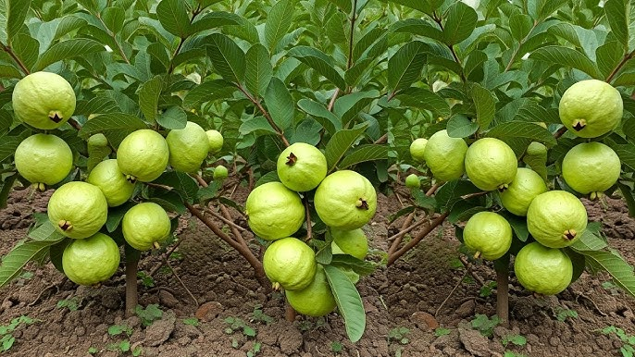
The guava plant (Psidium guajava) is one of the most important and widely cultivated fruit plants in tropical and subtropical regions of the world. It is popularly known as the “Apple of the Tropics” because of its exceptional nutritional value, pleasant flavor, and wide availability at affordable prices. In India, guava is grown in almost all states and plays a crucial role in nutrition security, rural livelihoods, and fruit-based industries.
Guava is highly valued not only for its fruits but also for its medicinal leaves, bark, and roots, which are extensively used in traditional medicine systems such as Ayurveda and folk medicine.
Figure1.3: Guava plant
1.2. Description
The guava plant is a small to medium-sized evergreen or semi-evergreen tree that is hardy and adaptable to a wide range of environmental conditions. It grows rapidly and begins fruiting early compared to many other fruit trees. The fruits are round or pear-shaped with green skin that turns yellow when ripe. The pulp may be white, pink, or red depending on the variety, and it contains numerous small edible seeds.
Due to its low cultivation cost, high yield, and high nutritional value, guava is often referred to as the “poor man’s fruit”, yet it is nutritionally superior to many expensive fruits.

1.3. Botanical Characteristics:
      - Botanical Name: Psidium guajava
      - Family: Myrtaceae
      - Order: Myrtales
      - Genus: Psidium
      - Nature: Evergreen / Semi-evergreen tree
Morphological Characteristics
Root System
- Shallow but extensive root system
- Helps efficient absorption of water and nutrients
- Makes the plant sensitive to strong winds and waterlogging
Stem and Trunk
- Short trunk with spreading branches
- Bark is smooth, thin, and flaky
- Peels off in irregular patches
- Color varies from light brown to grey
Leaves
- Simple, opposite, and oblong or elliptical
- Length: 7–15 cm
- Prominent veins on the lower surface
- Aromatic when crushed due to essential oils
Flowers
- White, fragrant, and bisexual
- Usually solitary or borne in small clusters in leaf axils
- Contain numerous stamens
- Pollination occurs mainly through insects
Fruit
- Type: Berry
- Shape: Round, oval, or pear-shaped
- Skin: Thin, green turning yellow on ripening
- Flesh: White, pink, or red
- Seeds: Numerous, hard but edible
1.4. Plant Growth
Guava is a fast-growing and early-bearing fruit plant.
Climatic Requirements
- Temperature: 15°C–35°C
- Can tolerate mild frost and drought
- Requires bright sunlight for good fruit quality
Soil Requirements
- Well-drained loamy, sandy loam, or alluvial soils
- pH range: 5.0–7.5
- Does not tolerate waterlogging

Growth and Development Stages
- Seed Germination – Occurs in 2–3 weeks
- Seedling Stage – Establishment of roots and shoots
- Vegetative Growth – Rapid development of canopy
- Flowering Stage – Begins in 2–3 years
- Fruit Development – Fruits mature in 4–5 months
- Maturity – Full commercial yield in 4–5 years
The productive lifespan of a guava tree is 30–40 years.

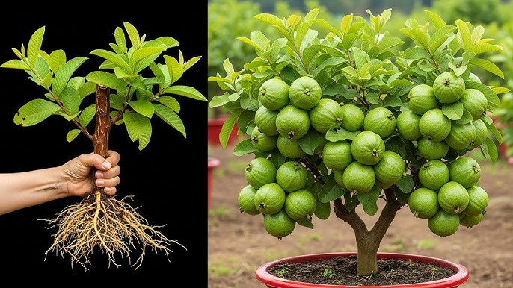
Figure1.3: Guava Plant growth
1.5. Early Cultivation
Guava is believed to be native to Central America and Mexico. It spread to South America and other tropical regions through natural dispersal and human activities. The plant was introduced to India in the 17th century by Portuguese traders.
Initially, guava was grown in home gardens using seed propagation. Over time, improved cultivation practices such as layering, grafting, and budding were adopted to ensure better yield, uniform fruit quality, and disease resistance.
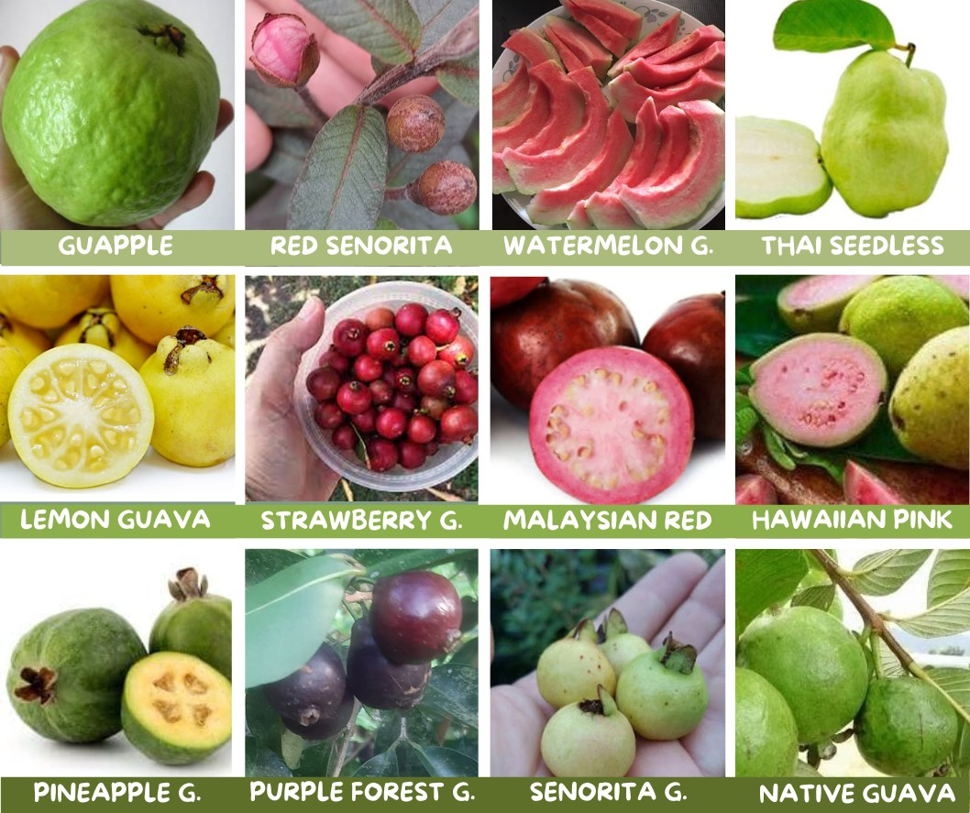
Figure1.4: different types Guava Plants

1.6. Nutrition
Guava is regarded as one of the most nutritious fruits.
Nutritional Value of Guava Fruit
- Vitamin C – Extremely high (3–5 times more than orange)
- Dietary Fiber – Aids digestion and prevents constipation
- Vitamin A – Supports eye health
- Vitamin B-complex – Supports metabolism
- Potassium – Maintains heart health and blood pressure
- Antioxidants – Prevent oxidative damage
Nutritional Value of Leaves
- Rich in tannins and flavonoids
- Possess antibacterial and anti-inflammatory properties
1.7. Uses
Food Uses
- Consumed fresh as a table fruit
- Used in juices, jams, jellies, squashes, and candies
- Used in salads, desserts, and processed foods
Medicinal Uses
- Leaf decoction used to treat diarrhea and dysentery
- Helps in controlling diabetes
- Improves digestion and immunity
- Used in oral care and wound healing
Industrial Uses
- Raw material for fruit processing industries
- Used in pharmaceutical and herbal product manufacturing
Economic Importance
- High yield with minimal input cost
- Suitable for small and marginal farmers
- Provides employment in cultivation and processing sectors
Perfume Industry
- Guava plant is used for its fruity and fresh aroma in perfumes.
- Guava fruit extracts add sweet, tropical fragrance notes.
- Guava leaf oils provide mild herbal and green scents.
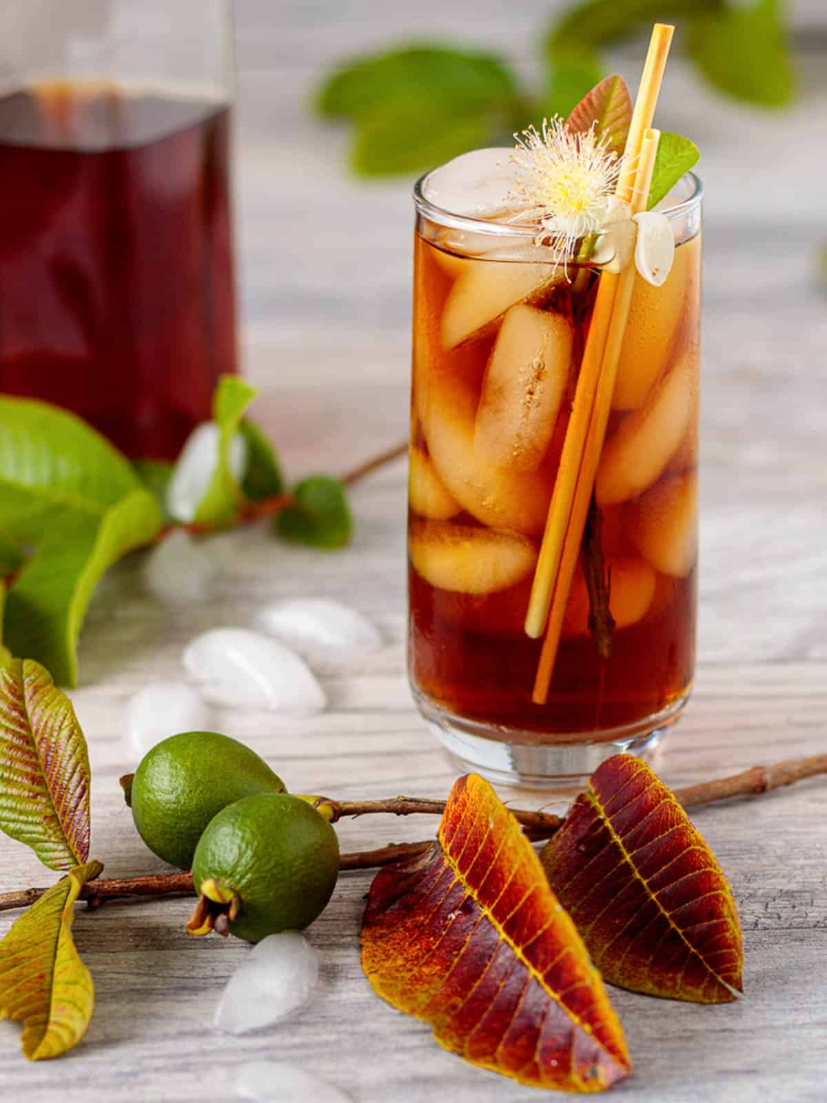
- Used in perfumes, deodorants, soaps, and cosmetics.
Figure 1.5: Guava Leaf Tea
1.8. Conclusion
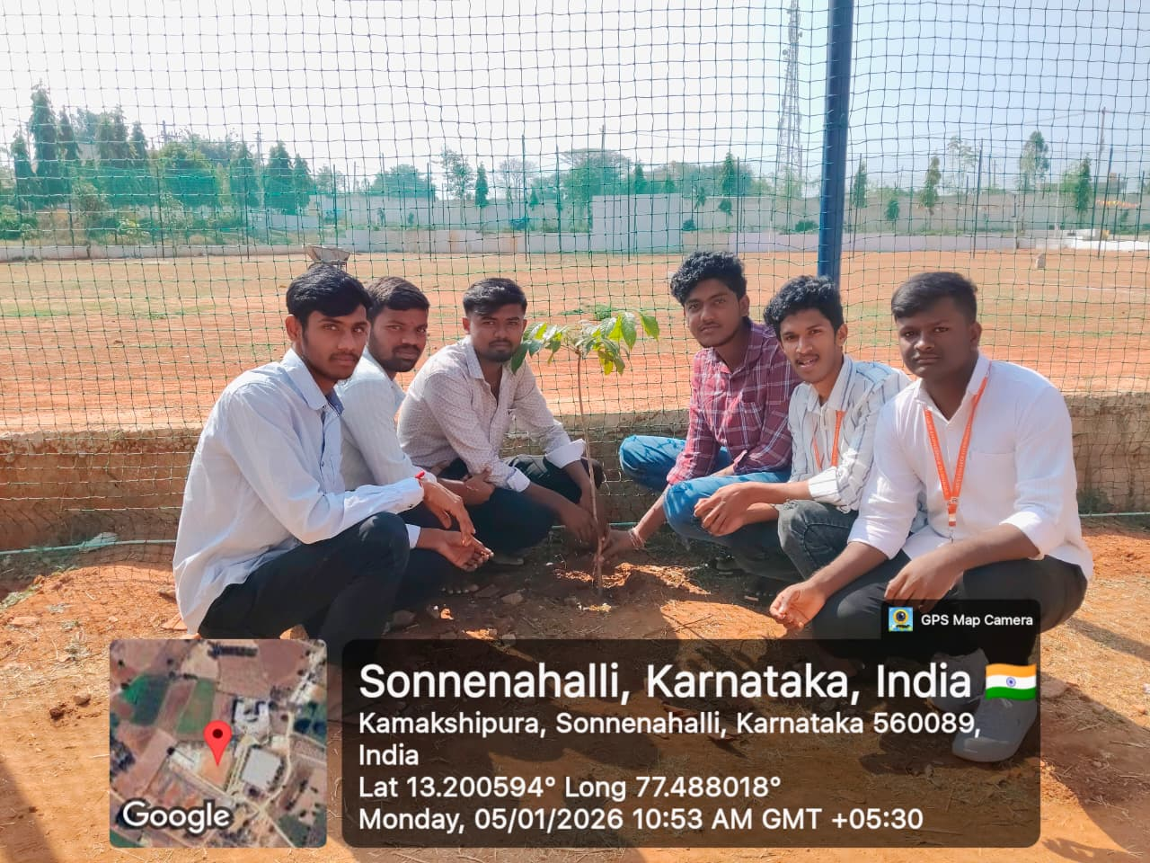
The guava plant is a highly valuable fruit crop due to its nutritional richness, medicinal properties, adaptability, and economic importance. Its ability to grow in diverse conditions and produce fruits at low cost makes it an ideal crop for sustainable agriculture. With scientific cultivation practices, improved varieties, and proper post-harvest management, guava cultivation can significantly contribute to food security, public health, and rural development.
Fig 1.6: Plantation of Guava tree

REFERENCES

https://poppyswildkitchen.com/wild-harvest-guava-leaf-tea/
- https://www.fao.org/home/en
- https://nhb.gov.in (National Horticulture Board, India)
- https://www.ncbi.nlm.nih.gov

Module 2

HERITAGE WALK AND CRAFTS -CORNER

Introduction
Bengaluru, the capital city of Karnataka, is a bustling metropolis with a rich cultural history, blending traditional craftsmanship with modern development. This section will provide an introduction to the importance of Bengaluru’s heritage walk and craft traditions, offering a glimpse into the city's unique cultural and historical legacy.
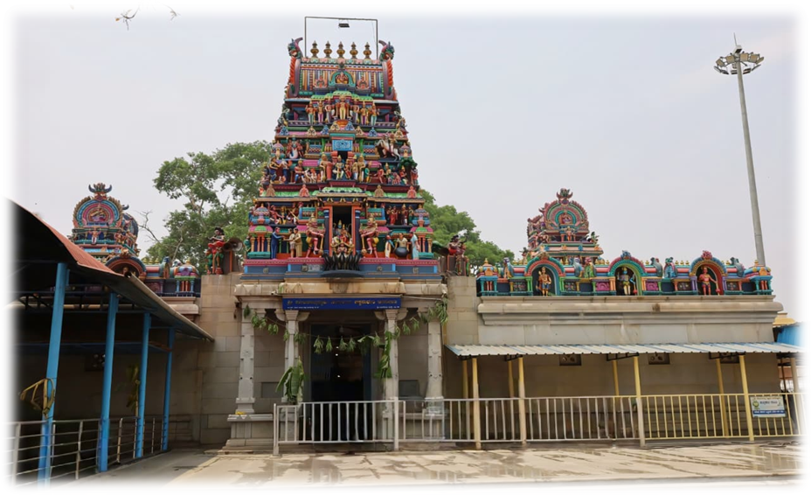
Bengaluru's heritage walk is a journey through time, taking visitors through historical landmarks, ancient temples, and the remnants of colonial architecture. The crafts corner, on the other hand, showcases the city's deep-rooted traditions in arts, crafts, and textiles that have been preserved over generations. This module explores some of the most iconic aspects of Bengaluru’s heritage, including the Chikka Madhure temple Bengaluru, the exquisite Bengaluru silk.

Figure 2.1: Bengaluru city

Etymology
The name "Bengaluru" is derived from the Kannada language, the official language of Karnataka. The term is believed to have originated from "Benda Kal," which means "the town of boiled beans." According to legend, a 9th-century ruler named King Veera Ballal of the Hoysala dynasty visited the area and was offered a simple meal of boiled beans by a local woman. In gratitude, he named the place "Benda kal which eventually evolved into "Bengaluru."
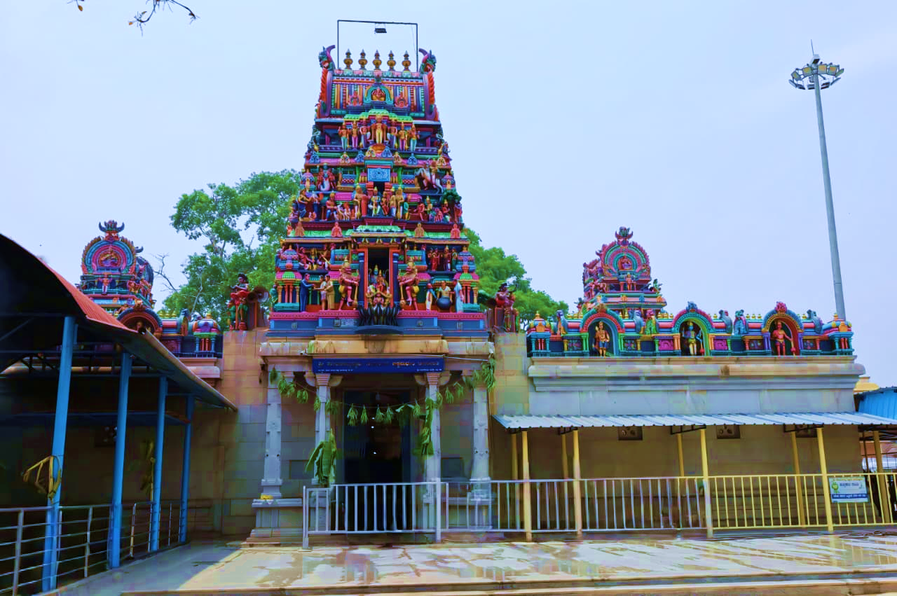
The city's name has undergone various transformations over the centuries, from "Bengaluru" to "Bangalore" under British colonial rule and finally back to "Bengaluru" in 2006 to reflect its original pronunciation in Kannada. The etymology of the city reflects its agricultural past and long-standing connection to the local people and their traditions.
Figure2.2: Chikka Madhure temple

Culture
Bangalore Bengaluru is a melting pot of diverse cultures, a blend of ancient traditions and modern influences. It is known for its cosmopolitan nature, with people from all over India and the world calling it home. The city’s culture is deeply influenced by its history, architecture, cuisine, and arts.
- Festivals: Bengaluru celebrates numerous festivals, including traditional Hindu festivals like Diwali and Makar Sankranti. The city also hosts cultural events like the Bengaluru Karaga, a festival unique to the city, celebrated with processions, dances, and rituals.
- Music and Dance: Bengaluru has a rich tradition of classical music, especially Carnatic music, as well as classical dance forms like Bharatanatyam. The city is home to various cultural organizations and holds annual festivals such as the Habba, which showcase both traditional and contemporary music and dance.
- Cuisine: Bengaluru’s cuisine is also a reflection of its diverse culture. From traditional South Indian dishes like dosa, and vada to cosmopolitan food from all over the world, the city offers an extensive array of flavours and culinary experiences.

Chikka Madhure Temple Bengaluru
On the banks of the Madhure Kere Lake in Chikka Madhure in Kanaswadi is one of the famous pilgrimage centers of Sri Shanimahathma temple (Shree Shani Mahathma Temple). The temple is located Located in the Doddaballapur Taluk, the Sri Shanimahathma Temple in Chikka Madhure (also known as Kanasawadi) is one of the most prominent and visited shrines dedicated to Lord Shaneshwara (Saturn) in Karnataka.
Below is a detailed breakdown of the temple’s history, rituals, and significance:
1. Historical Background
- Founder: Unlike many ancient temples built by royalty, this temple was established by a local farmer named Ganga Hanumaiah. Legend says he built it to appease Lord Shani and alleviate the hardships and "vengeance" often associated with the planet's influence.
- The Deity: The presiding deity is Lord Shani Mahatma. The idol is carved in black stone, typically adorned with elaborate jewelry and draped in black silk clothes, symbolizing the color associated with Saturn.
- Oldest Shrine: It is considered one of the oldest temples dedicated to Shani Mahatma in the region and holds a status similar to the famous Shaneshwara Temple in Pavagada.
2. Architectural Features
- Dravidian Style: The temple follows traditional South Indian architecture. It features a prominent Gopura (entrance tower) with intricate carvings of various deities and mythological scenes.
- Setting: The temple is situated on the banks of the Madhure Kere (Madhure Lake). The proximity to the water body and the surrounding greenery provides a serene and spiritual atmosphere for devotees.
- Expansion: While the original structure is decades old, recent years have seen significant renovations and the addition of a new temple complex adjacent to the old one.
3. Religious Significance & Rituals
- Ellu Batti Offering: The most unique ritual here is the offering of Ellu Batti (Sesame Wicks). Devotees tie black sesame seeds in a small piece of cloth, soak it in gingelly (sesame) oil, and light it or offer it to the dedicated fireplace in front of the temple. This is believed to ward off the ill effects of Sade Sathi (the 7.5-year Saturn cycle).
- Saturday Worship: While the temple is open daily, Saturdays are considered the most auspicious. Thousands of people flock here to seek relief from astrological doshas like Ashtama Shani or Panchama Shani.
- New Vehicle Poojas: The temple is extremely popular for Vahana Pooja (vehicle blessing). Many people from Bengaluru bring their new cars or bikes here to perform a ritual that involves drawing protective symbols and tying black threads to the vehicle.
4. Festivals and Events
- Annual Jathre (Fair): The major highlight is the annual chariot festival (Rathotsavam), usually held around March. During this time, the processional idol of Shani Deva is placed on a grand wooden chariot and pulled through the neighboring areas.
- Shravana Masa: The Saturdays during the Hindu month of Shravana (July–August) see peak crowds, as this entire month is dedicated to special prayers and penance.
- 5. Visitor Information
- Timings: The temple is generally open from 6:00 AM to 8:00 PM. A "Maha Pooja" is performed every evening at 8:00 PM.
- Anna Dasoha (Free Meals): The temple runs a Dasoha Bhavan where free lunch is served to all devotees daily, typically between 12:00 PM and 4:00 PM.
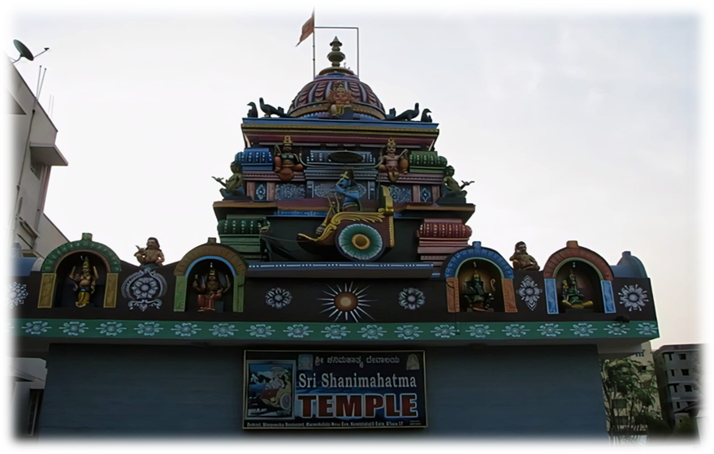
- Location: It is approximately 14–15 km from Nelamangala and about 45 km from
Figure 2.3: Old Madhure temple
2.4.1 Chikka Madhure temple Architecture
The architecture of the Sri Shanimahathma Temple in Chikka Madhure is a blend of traditional South Indian religious design and modern functional expansions. While it began as a humble shrine built by a local farmer, it has evolved into a sprawling complex that retains its spiritual character.
Here are the detailed architectural points:
1. Dravidian Style and Layout
  - The Rajagopuram (Entrance Tower): The temple is identified by its striking Dravidian-style Gopuram. This multi-tiered entrance tower is adorned with numerous stucco figures and colourful sculptures depicting various deities, mythological creatures, and scenes from the Puranas.
  - Intricate Carvings: The workmanship on the Gopuram is noted for its detail. It features traditional floral patterns and guardian figures (Dvarapalas) that welcome devotees into the sacred space.
  - The Mandapa (Hall): Inside the entrance, there is a spacious pillared hall where devotees congregate. The pillars are functional but often decorated with small reliefs of the Navagrahas (nine planets).

2. The Inner Sanctum (Garbhagudi)
  - Presiding Deity: The central focus is the idol of Lord Shanimahathma, which is carved from polished black stone. This choice of stone is deliberate, as black is the color traditionally associated with Shani (Saturn).
  - Alankara (Decoration): The idol is usually seen "clad in black" silk and heavily ornamented with silver or gold jewelry, which provides a sharp, radiant contrast against the dark stone of the deity.
  - Simplicity of the Sanctum: In contrast to the ornate Gopuram, the inner sanctum remains relatively simple, focusing the devotee's attention entirely on the powerful presence of the deity.
3. The Fireplace (Homa Kunda Area)
  - External Ritual Space: A key architectural feature unique to this temple is the large, open fireplace situated directly in front of the main temple structure.
  - Functionality: It is specifically designed to accommodate the thousands of devotees who offer Ellu Batti (sesame wicks). The placement ensures that the smoke and heat from the continuous burning do not damage the main temple's stone interiors.
4. New Temple vs. Old Temple
  - The Dual Structure: The site currently houses both the original (old) shrine and a newer, larger temple complex.
  - Backside Shrine: The original structure is located behind the new one. Many devotees visit the old shrine first to pay respects to the temple’s humble beginnings before moving to the main hall.
  - Modern Expansion: The newer sections use reinforced concrete and modern tiling but adhere to traditional Vastu Shastra (architectural science) to maintain the temple’s spiritual sanctity.
5. Surroundings and Subsidiary Structures
  - Dasoha Bhavan: Adjacent to the main temple is a large dining hall designed for Anna Dasoha (free community meals). It is built to hold hundreds of people simultaneously, reflecting the temple's role as a social hub.
  - Lakeside Setting: The temple is built on the banks of the Madhure Kere (Madhure Lake). The architecture utilizes this natural slope, and the view of the sunset over the water from the temple premises is considered a highlight for visitors.
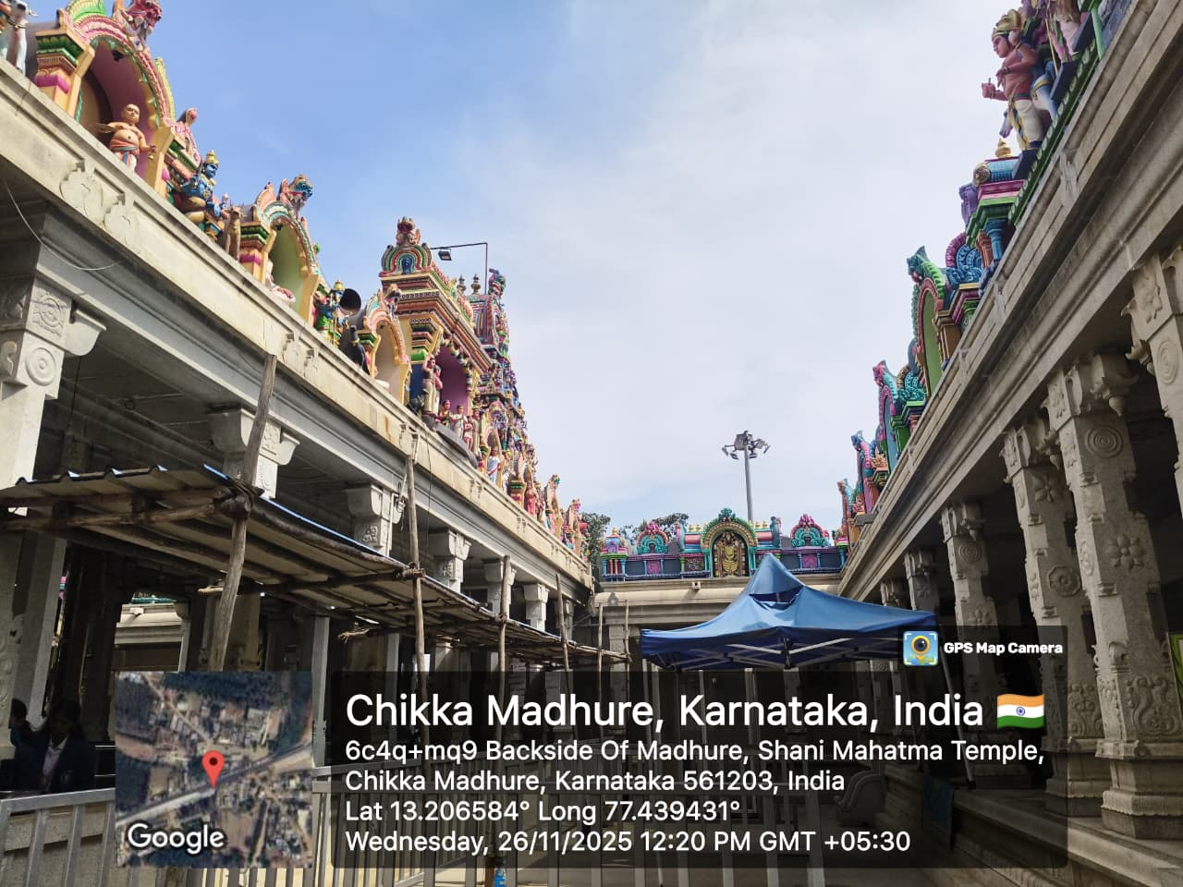
  - Vehicle Pooja Bay: Due to the high demand for vehicle blessings, there is a dedicated, paved area within the complex specifically designed for cars and bikes to be parked and blessed without obstructing pedestrian traffic.
Figure2.4: Madure temple architecture

2.4.2 Chikka Madhure Temple: Today
Today, is a great day to visit the Sri Shanimahathma Temple in Chikka Madhure if you are looking for a relatively peaceful experience compared to the heavy rush of Saturdays.
Here is the essential information for a visit today:
1. Timings and Rituals
- Operating Hours: The temple is open from 6:00 AM to 8:00 PM.
- Maha Pooja: The grand final pooja of the day, known as Maha Pooja, is performed at 8:00 PM every evening.
- Sunday Crowd: Unlike Saturdays, which see massive crowds due to the special significance of Saturn (Shani), Sundays are generally more manageable. However, since it is a weekend, you may still see families and travellers visiting for a day trip.
2. Offerings and Sevas
- Ellu Batti (Sesame Offering): You can perform the signature ritual of lighting Ellu Batti (black sesame seeds tied in cloth and soaked in oil) in the designated fireplace. This ritual is believed to reduce the ill effects of Sade Sathi.
- Vahana Pooja: If you have a new vehicle, today is a good time to get a Vahana Pooja done. There is a dedicated area for this, and the priests will perform the ritual to bless your new car or bike.
- Anna Dasoha (Free Meals): The temple serves free lunch to all devotees at the Dasoha Bhavan. This typically starts around 12:00 PM and continues until 4:00 PM. The food is known to be delicious and is served with great hospitality.
3. Visiting Tips for Today
- Weather & Setting: With the current December weather in Bengaluru, the lakeside location of the temple (next to Madhure Kere) will be very pleasant, especially in the late afternoon.
- Parking: There is ample parking inside the temple complex. However, be cautious of local touts and stick to the official temple parking fees.
- Laddus: If you want to take back some prasadam, the temple's Laddus are highly recommended and are sold at the counter for approximately ₹40 each.
4. How to Get There
- Route: It is about 45 km from Bengaluru. The best route is to drive toward Nelamangala and then take the road toward Doddaballapur.
- Public Transport: You can take a KSRTC or private bus from Majestic/Bengaluru to Nelamangala, and from there, local buses or shared autos frequently go toward Chikka Madhure.

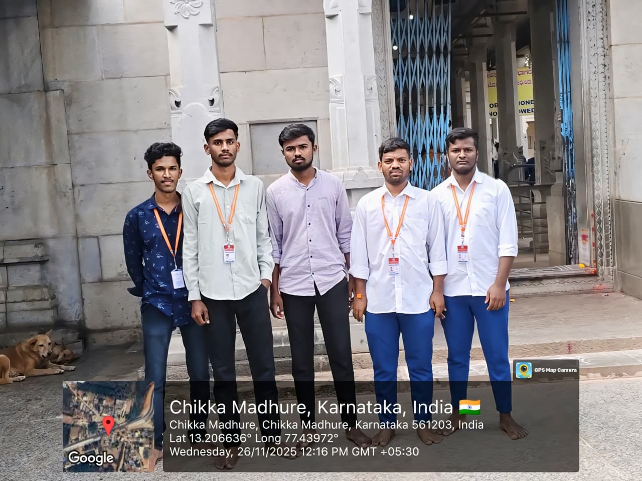
Figure2.5: Temple Visit

2.5 Conclusion
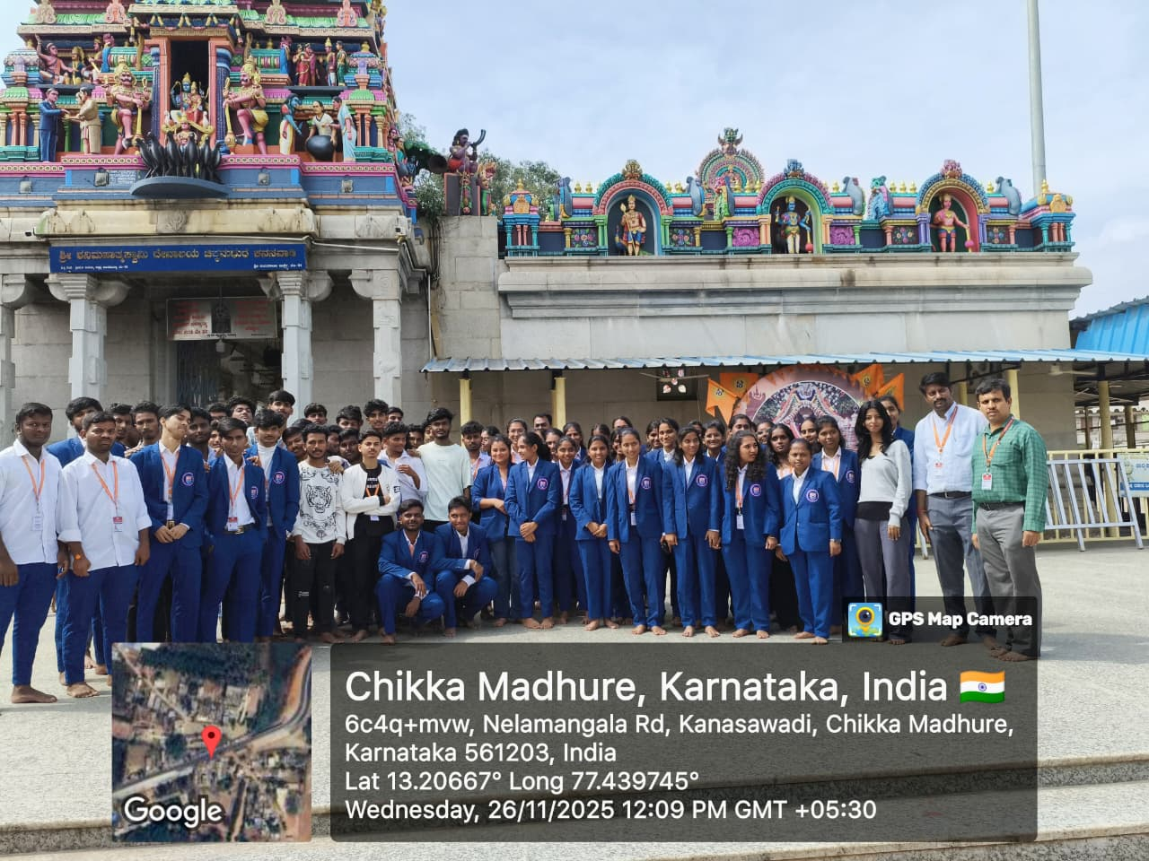
Bengaluru’s heritage walk and crafts corner offer a fascinating insight into the city’s historical and cultural legacy. The Sri Shanimahathma Temple in Chikka Madhure serves as a profound spiritual sanctuary that transcends its humble beginnings as a small village shrine. It has evolved into a significant cultural landmark for the people of Karnataka, offering a unique blend of traditional Dravidian architecture and a serene lakeside atmosphere. Whether devotees are seeking astrological relief through the symbolic lighting of sesame wicks or simply visiting for the community spirit of the Anna Dasoha (free meals), the temple provides a powerful sense of solace and belonging. Its legacy, rooted in the faith of a local farmer rather than royal decree, ensures that it remains an accessible and deeply personal destination for those looking to navigate life's challenges with divine guidance and inner peace.
Figure2.5: Group Photo at Entrance
REFRENCES
1. https://bangalorerural.nic.in/en/tourist-place/sri-shanimahathma-temple-chikka-madhure-2. https://karnatakaexplore.com/district/bengaluru-rural/madhure-shri-shani-mahatma-temple/

Module 3

ORGANIC FARMING

3.1 Introduction
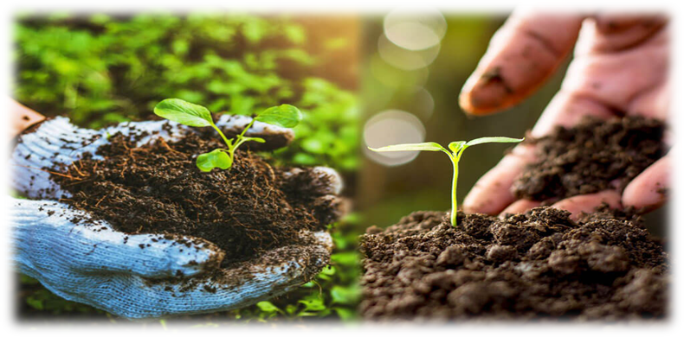
Organic farming is an agricultural system that emphasizes the use of natural inputs and ecological processes to grow crops and rear animals. It avoids synthetic fertilizers, chemical pesticides, herbicides, and genetically modified organisms (GMOs). The main goal of organic farming is to maintain soil health, environmental balance, and sustainable agricultural productivity, while producing safe and nutritious food for humans.
Figure3.1: Organic farming

3.2 History
The concept of organic farming developed in the early 20th century as a response to the negative impacts of chemical-based agriculture. Sir Albert Howard, known as the Father of Organic Farming, studied traditional Indian farming methods and promoted composting, crop rotation, and natural soil management. Later, the movement spread to Europe and America as awareness grew about soil degradation, pollution, and health issues caused by excessive chemical use.

3.3 Terminology
Some important terms used in organic farming are:
- Organic manure – Natural fertilizers such as farmyard manure, compost, and vermicompost
- Green manure – Crops grown and ploughed into the soil to improve fertility
- Biofertilizers – Living microorganisms that enhance nutrient availability
- Biopesticides – Natural substances or organisms used to control pests
- Crop rotation – Growing different crops in a planned sequence
3.4. Methods of Organic Farming
Organic farming uses several eco-friendly practices:
- Crop rotation to maintain soil fertility and reduce pests
- Green manuring to enrich soil nutrients
- Composting and vermicomposting to recycle organic waste
- Biological pest control using natural predators
- Mulching to conserve moisture and suppress weeds
3.5. Soil Management
Soil management is the foundation of organic farming. It focuses on:
- Increasing organic matter in the soil
- Using compost and natural manure instead of chemicals
- Encouraging beneficial soil microorganisms
- Preventing soil erosion and maintaining soil structure
Healthy soil ensures sustainable crop production and better water retention.

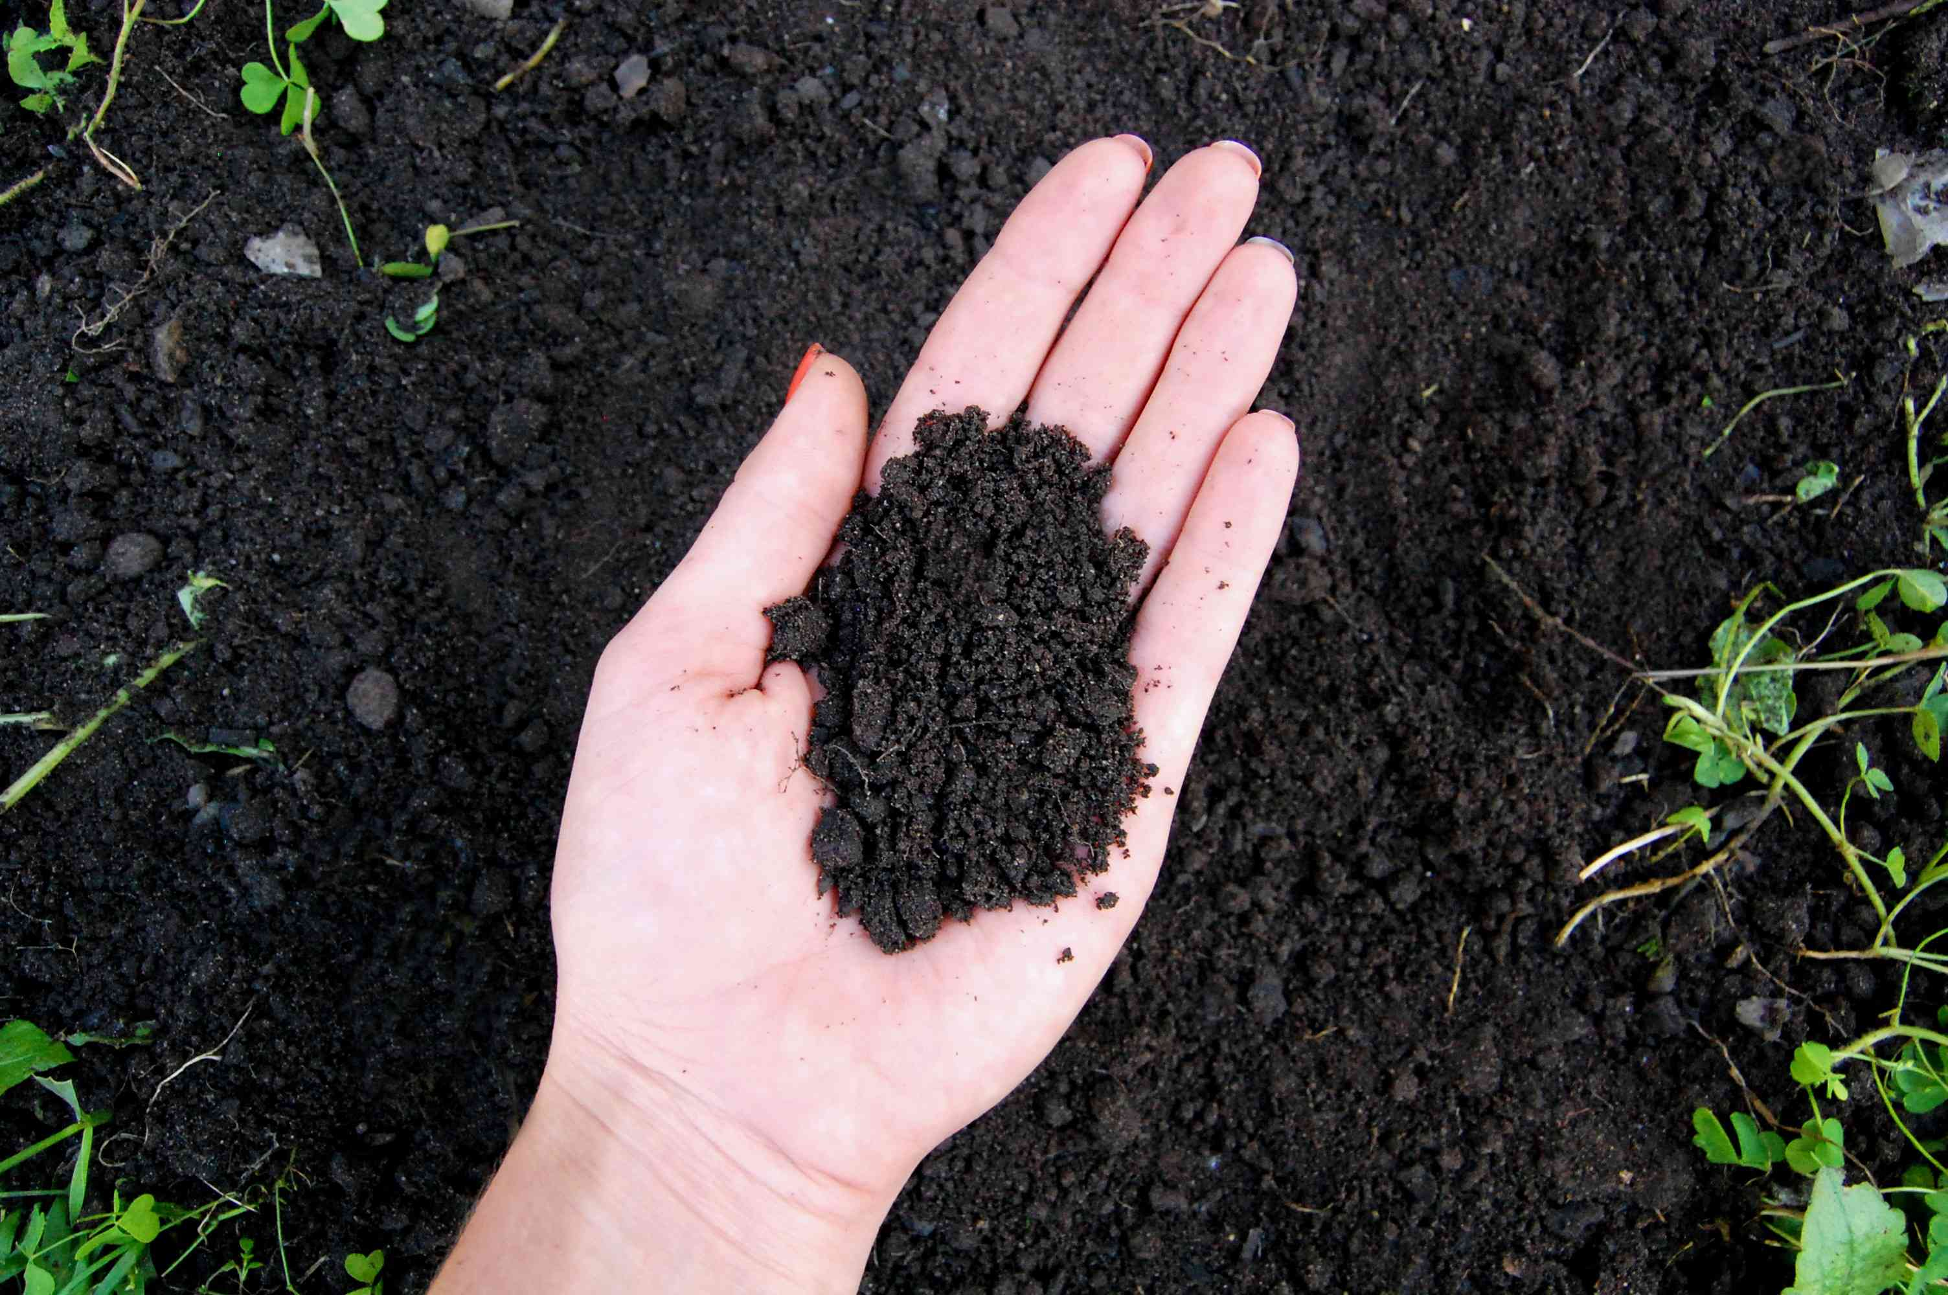
Fig 3.2 Black Soil
3.6. Difference between Organic and Conventional Farming
- Inputs: Organic farming uses natural inputs like compost, green manure, and biofertilizers, whereas conventional farming uses chemical fertilizers and pesticides.
- Pest control: Organic farming uses biopesticides and natural predators, while conventional farming relies on chemical pesticides.
- Soil health: Organic farming improves soil fertility and structure; conventional farming may degrade soil over time.
- Environmental impact: Organic farming is eco-friendly; conventional farming can cause soil, water, and air pollution.
- Crop yield: Organic farming generally has lower initial yields; conventional farming usually gives higher yields.
- Food quality: Organic food is chemical-free and healthier; conventional food may contain chemical residues.
- Sustainability: Organic farming focuses on long-term sustainability; conventional farming focuses on short-term productivity.

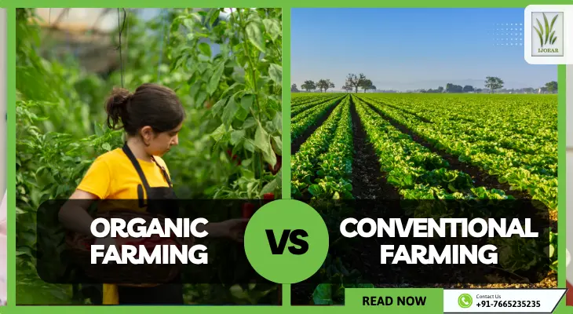
Fig 3.3 Difference between Organic and Conventional Farming
3.7 Reasons for Organic Farming
- Protection of environment and biodiversity
- Increasing demand for safe and healthy food
- Conservation of soil and water resources
- Long-term sustainability of agriculture
3.8 Advantages of Organic Farming
- Improves soil fertility and structure
- Reduces environmental pollution
- Produces nutritious and chemical-free food
- Promotes biodiversity and ecological balance
- Reduces dependency on costly chemical inputs
3.9 Disadvantages of Organic Farming
- Lower crop yield in initial years
- Requires more labour and management skills
- Organic inputs may not be easily available
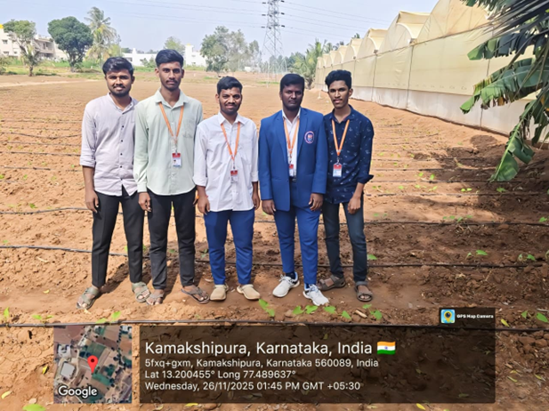
- Higher production cost and certification issues
Fig 3.4 Organic Farming
3.10 Waste Management
Organic farming promotes effective waste management by recycling agricultural and animal waste. Crop residues, animal dung, and kitchen waste are converted into compost or manure, reducing pollution and improving soil fertility.
3.11 Waste Hierarchy
The waste hierarchy followed in organic farming is:
- Reduce – Minimize waste generation
- Reuse – Use materials again
- Recycle – Convert waste into compost
- Recover – Extract useful resources like energy
- Dispose – Safe disposal of remaining waste

3.12 Energy Recovery
Organic waste is used to produce biogas, a renewable source of energy. Biogas is used for cooking and electricity generation, while the remaining slurry serves as an excellent organic fertilizer.

3.13 Conclusion
Organic farming is a sustainable and environmentally friendly agricultural system that focuses on soil health, ecological balance, and safe food production. Although it has some challenges such as lower initial yields and higher labour requirements, its long-term benefits for human health, environment, and sustainable development make it an important alternative to conventional farming.
REFERENCES
- FAO – Organic Agriculture
https://www.fao.org/organicag/
- National Centre of Organic Farming (India)
https://ncof.dacnet.nic.in/
- IFOAM – Organics International
https://www.ifoam.bio/
- Britannica – Organic Farming
https://www.britannica.com/topic/organic-farming

Module 4

WATER CONSERVATION

4.1 Introduction
Water conservation refers to the planned management, protection, and wise use of water resources to prevent wastage and ensure sustainable availability for present and future generations.
- Water is a limited and essential natural resource
- Only 2.5% of Earth’s water is fresh, and less than 1% is easily accessible
- Rapid population growth, industrialization, urbanization, and climate change have increased water demand
- Water conservation helps maintain ecological balance, supports agriculture, and ensures drinking water security
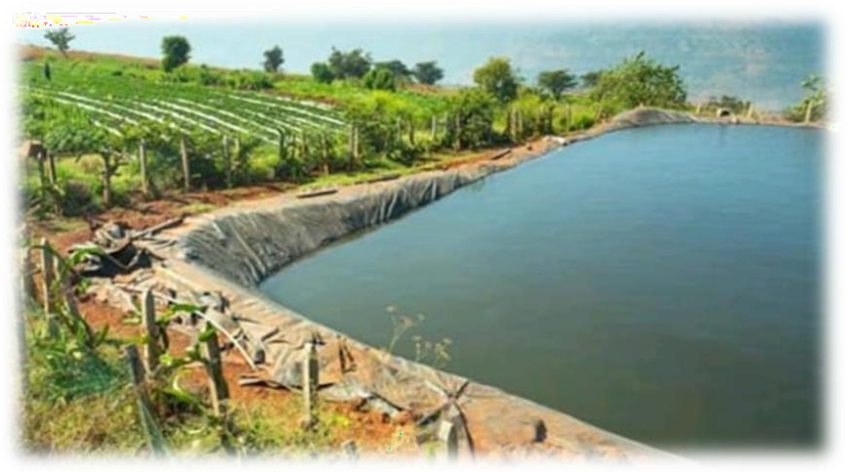
- It promotes efficient use, reuse, and protection of water resources
Figure4.1: Water reservoir
4.2 Conservation of Water
Water conservation involves methods and practices that reduce water loss, improve efficiency, and protect water bodies.
Key Methods:
- Preventing leakage and wastage
- Efficient use in agriculture, industry, and households
- Protection of rivers, lakes, wetlands, and aquifers
- Adoption of modern irrigation techniques
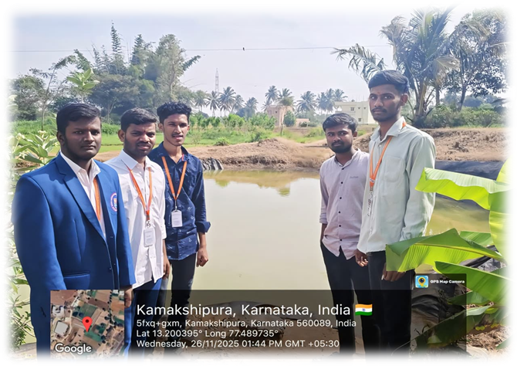
- Recycling and reusing wastewater
Figure 4.2 Organic Farms in Nearby Village
4.3 Aim of Water Conservation
The primary aim of water conservation is to ensure adequate water availability while preserving the environment.
Objectives:
- To reduce water wastage
- To ensure sustainable water supply
- To protect groundwater and surface water
- To meet agricultural, industrial, and domestic needs
- To reduce energy consumption used in water pumping
- To minimize water-related conflicts
4.4 Rainwater Harvesting
Rainwater harvesting is the collection and storage of rainwater for future use instead of allowing it to run off.
Methods:
- Rooftop rainwater harvesting
- Surface runoff collection
- Recharge pits and percolation tanks
- Check dams
Advantages:
- Recharges groundwater levels
- Reduces flooding and soil erosion
- Improves water quality
- Reduces dependence on municipal water
- Cost-effective and eco-friendly

Fig 4.3 Rain Water Harvesting Method
4.5 Irrigation
Irrigation is the artificial application of water to crops to support agricultural production.
Types of Irrigation:
- Surface irrigation (flood irrigation)
- Sprinkler irrigation
- Drip irrigation
- Subsurface irrigation
Importance:
- Ensures timely water supply to crops
- Increases crop yield
- Supports farming in dry and semi-arid regions
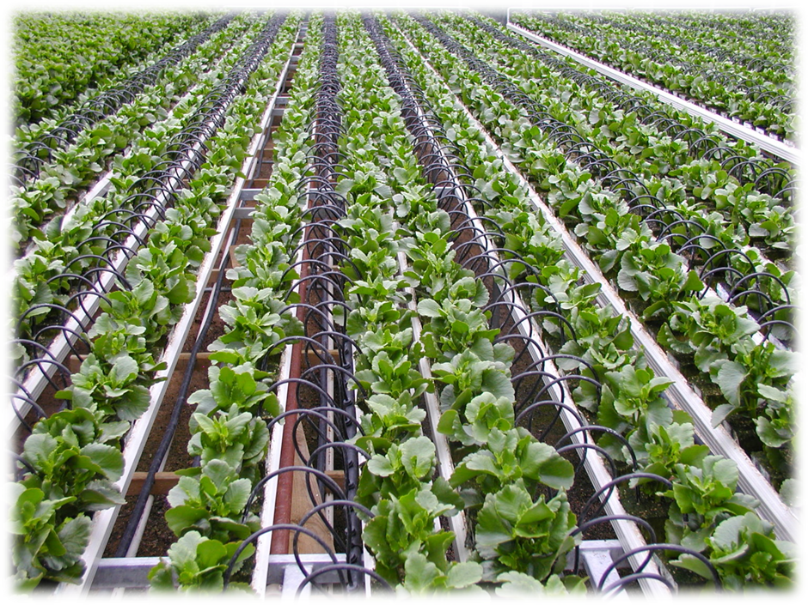
- Reduces dependency on rainfall
Fig 4.4 Drip Irrigation
4.6 Protecting Groundwater Resources
Groundwater is a major source of drinking and irrigation water, but excessive extraction leads to depletion.
Protection Measures:
- Regulating over-extraction
- Promoting rainwater recharge
- Preventing industrial and agricultural pollution
- Using water-efficient appliances
- Monitoring groundwater levels regularly

4.7 Agricultural Applications of Water Conservation
Agriculture consumes nearly 70% of freshwater resources, making conservation crucial.
Practices:
- Drip and sprinkler irrigation
- Mulching to reduce evaporation
- Crop rotation and crop diversification
- Selection of drought-resistant crops
- Proper soil moisture management
- Scheduling irrigation based on crop water requirement
4.8 Water Reuse
Water reuse means treating and reusing wastewater for beneficial purposes.
Applications:
- Irrigation of parks and crops
- Industrial cooling and processing
- Toilet flushing
- Groundwater recharge
Benefits:
- Reduces demand for freshwater
- Decreases pollution
- Cost-effective in the long run
- Supports sustainable development
4.9 The Need for Water Conservation
Water conservation is essential due to increasing water scarcity worldwide.
Reasons:
- Uneven distribution of water
- Over-extraction of groundwater
- Pollution of water bodies
- Climate change and irregular rainfall
- Increasing population and urban demand
- Agricultural and industrial expansion

4.10 Water Conservation Facts
- Only 1% of Earth’s water is usable for humans
- Agriculture uses about 70% of freshwater
- A leaking tap can waste thousands of liters per year
- Groundwater depletion is faster than natural recharge
- Water conservation saves energy and reduces carbon footprint
4.11 Conclusion
Water conservation is not an option but a necessity for sustainable living and development.
- Ensures long-term water security
- Supports agriculture, industry, and ecosystems
- Reduces environmental degradation
- Encourages responsible water use
- Collective efforts by individuals, communities, industries, and governments are required
- “Save water today to secure tomorrow”
REFERENCES
- https://www.unwater.org
- https://www.epa.gov/watersense
- https://www.fao.org/water
- https://www.nationalgeographic.org/encyclopedia/water-conservation/
- https://www.cwc.gov.in (Central Water Commission, India)

Module 5

FOOD WALK

5.1 Introduction of Food Walk
A food walk is a unique cultural and culinary experience that combines walking tours with local food tasting. It allows people to explore the food traditions, heritage, and lifestyle of a particular place by visiting popular food streets, markets, and traditional eateries.
- Food is an important part of culture and identity
- Different regions are known for their unique cuisines and cooking styles
- Food walks help in understanding the social, historical, and cultural background of food
- It promotes local businesses and traditional food practices
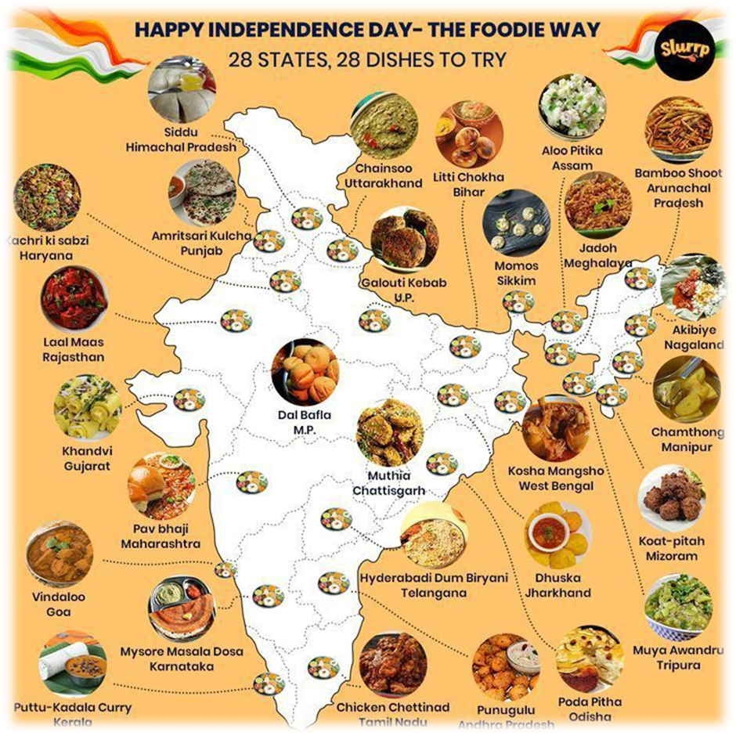
- Food walks are widely used in tourism, education, and cultural studies

Fig 5.1 Traditional Food Map of India

5.2 What is a Food Walk?
A Food Walk is a guided walking tour where participants explore a specific area to experience its local food culture, traditional cuisines, street food, and culinary heritage.
Key Points:
- Conducted in markets, old city areas, heritage streets, or food hubs
- Participants walk short distances and taste food at multiple stops
- Includes stories, history, and cultural significance of dishes
- Helps people understand local ingredients, cooking methods, and food traditions
- Can be guided or self-guided
- Popular among tourists, students, food lovers, and cultural researchers
Purpose of a Food Walk:
- To promote local cuisine and food traditions
- To support small food vendors and local businesses
- To create awareness about food heritage and sustainability

- To encourage community-based tourism
Fig 5.2 Food
5.3 History of Food Walks
The concept of food walks evolved from cultural walking tours and traditional food markets that existed since ancient times.
Early History:
- In ancient civilizations, people gathered in public markets (e.g., Roman forums, Indian bazaars, Middle Eastern souks) where food and culture mixed
- Travelers and traders explored local food as part of their journey
- Food tasting during travel was a natural cultural exchange
Modern Development:
- Organized food walks began in the late 20th century
- Gained popularity in Europe and the United States as part of culinary tourism
- Cities like Rome, Paris, New York, and Bangkok introduced guided food tours
- Focus shifted to storytelling, heritage, and authenticity
Growth in India:
- Food walks became popular in India in the early 2000s
- Cities like Delhi, Mumbai, Bengaluru, Hyderabad, and Kolkata started curated food walks
- Emphasis on street food, traditional recipes, and regional diversity
- Often linked with heritage walks and cultural festivals
Present-Day Scenario:
- Food walks are now part of experiential tourism
- Integrated with sustainability, organic food, and local farming
- Use of digital platforms and social media for promotion
- Customized food walks for students, researchers, and tourists
5.4 Importance of Food Walks
- Preserves culinary heritage
- Encourages local food systems
- Promotes cultural understanding
- Generates employment for local guides and vendors
- Supports sustainable tourism
5.5 DOSA
Dosa is a popular South Indian traditional dish made from a fermented batter of rice and black gram (urad dal). It is a thin, crispy pancake cooked on a hot griddle and commonly served with sambar and chutney. Dosa is known for its unique taste, easy digestibility, and high nutritional value, and it is enjoyed as a breakfast or main meal across India and around the world.

Fig 5.3 Plain Dosa
5.5.1 Preparation of Dosa
Dosa is a traditional South Indian fermented pancake made mainly from rice and black gram (urad dal).
Ingredients:
- Rice (raw rice or parboiled rice)
- Black gram (urad dal)
- Fenugreek seeds (optional)
- Water
- Salt
- Oil or ghee for cooking
Preparation Steps:
- Rice and urad dal are washed and soaked separately for 4–6 hours
- They are ground into a smooth batter
- Batter is mixed and allowed to ferment overnight
- Salt is added after fermentation
- Batter is poured on a hot tawa (griddle) and spread thin
- Cooked until golden and crispy
- Served hot with sambar and chutney
Importance of Fermentation:
- Improves digestibility
- Increases nutritional value
- Enhances flavor and texture
- Produces beneficial probiotics
5.5.2 History of Dosa
Dosa has a rich historical and cultural background.
- Originated in South India, especially Karnataka and Tamil Nadu
- Earliest references found in Tamil Sangam literature (1st century AD)
- Mentions of dosa-like foods appear in ancient texts such as Manasollasa (12th century)
- Traditionally prepared in temples and households
- Spread across India due to migration and urbanization
- Today, dosa is recognized as a global dish, served worldwide
5.5.3 Vitamins in Dosa
Dosa provides several essential vitamins, especially due to fermentation.
Vitamins Present:
- Vitamin B1 (Thiamine) – supports energy metabolism
- Vitamin B2 (Riboflavin) – helps in cell growth
- Vitamin B3 (Niacin) – aids digestion and skin health
- Vitamin B6 – supports brain and immune function
- Folic Acid (Vitamin B9) – important for red blood cell formation
Role of Fermentation:
- Increases bioavailability of B-complex vitamins
- Enhances absorption of nutrients
5.5.4 Nutrients in Dosa
Dosa is a balanced and nutritious food.
Macronutrients:
- Carbohydrates – provide energy
- Proteins – from urad dal, essential for muscle repair
- Fats – from cooking oil or ghee
Micronutrients:
- Iron – helps prevent anemia
- Calcium – supports bone health
- Magnesium and Potassium – regulate body functions
- Dietary fiber – aids digestion
Health Benefits:
- Easily digestible
- Suitable for all age groups
- Low in saturated fat
- Gluten-free (naturally)
5.5.5 Varieties of Dosa
There are many varieties of dosa based on ingredients and preparation methods.
Popular Varieties:
- Plain Dosa – simple, thin, and crispy
- Masala Dosa – filled with spiced potato curry
- Set Dosa – thick and soft, served in sets
- Rava Dosa – made from semolina
- Paper Dosa – extra thin and crispy
- Onion Dosa – topped with chopped onions
- Mysore Masala Dosa – spicy red chutney inside
- Neer Dosa – rice-based, soft, and lacy
- Pesarattu – made from green gram (moong dal)
- Oats Dosa – healthy modern variation
5.6 Palav
Palav, also known as pulao, is a simple and aromatic rice dish commonly prepared in Indian cuisine. It is made by cooking rice with mild spices, vegetables, and sometimes meat, all in one pot. The dish is known for its pleasant aroma, light spices, and fluffy texture. Easy to prepare and nutritious, palav is often served as a main course and enjoyed with raita, curry, or salad.
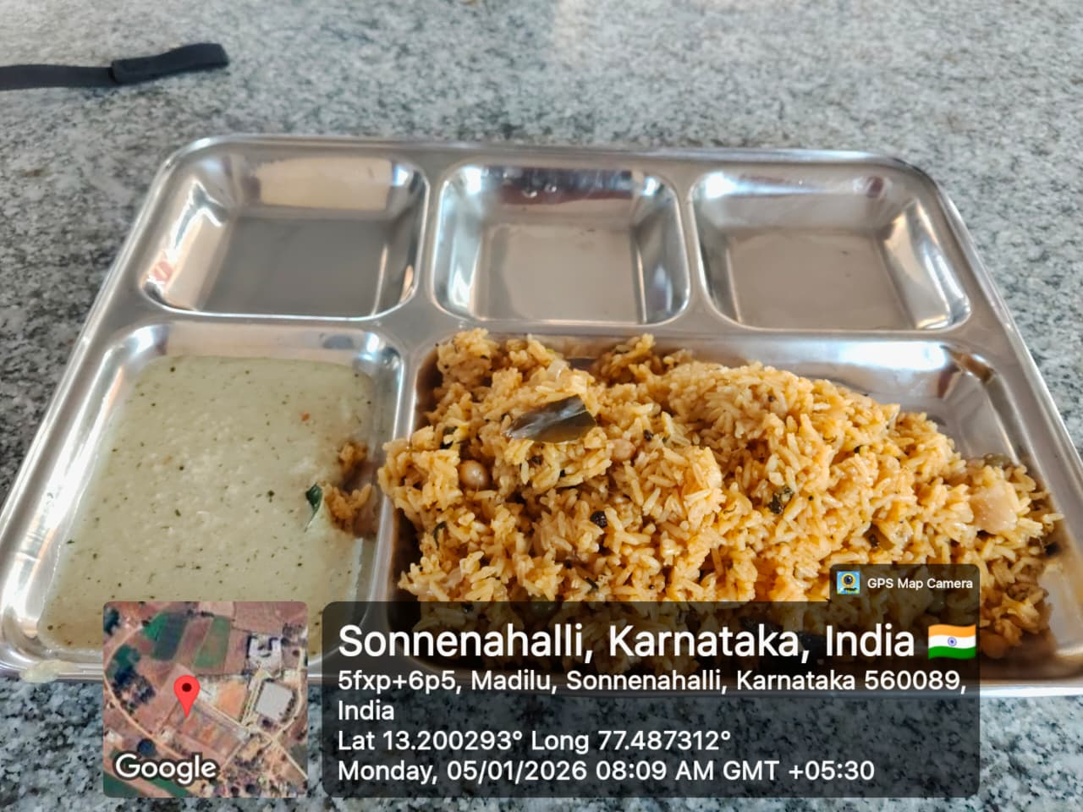
Fig 5.4 Palav
5.6.1 Preparation of Palav
Preparation Steps:
- Rice (usually basmati) is washed and soaked for better texture.
- Vegetables like carrot, beans, peas, potato, or onion are chopped.
- Whole spices such as bay leaf, cloves, cardamom, cinnamon, and cumin are heated in oil or ghee.
- Onions are sautéed until light brown for flavor.
- Vegetables are added and lightly cooked with spices.
- Rice and water/stock are added in proper proportion.
- The mixture is cooked on low flame until rice becomes soft and fluffy.
- Palav is garnished with coriander or mint leaves and served hot.
5.6.2 History of Palav
- Palav originated from Persian cuisine, known as Pilaf.
- It was introduced to India by Mughal rulers.
- Over time, Indian spices and vegetables were added, creating regional variations.
- Palav became a popular every day and festive dish across India.
- Today, it is widely prepared in homes, restaurants, and during celebrations.

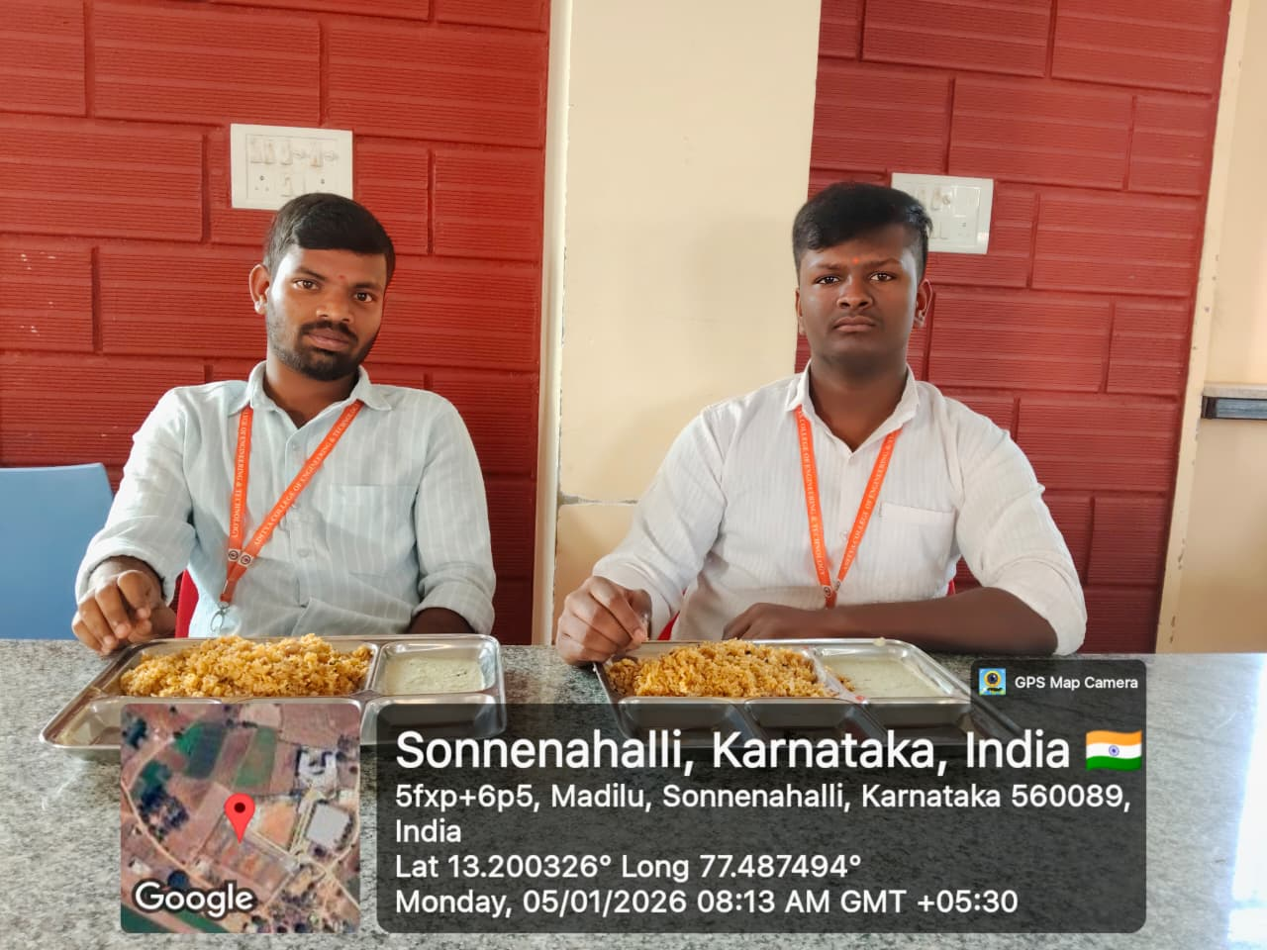
Fig 5.5 Veg Palav
5.6.3 Vitamins in Palav
- Vitamin A – from vegetables like carrots (good for eyesight).
- Vitamin B-complex – from rice (helps in energy production).
- Vitamin C – from vegetables like peas and capsicum (boosts immunity).
- Vitamin K – from green vegetables (helps blood clotting).
5.6.4 Nutrients in Palav
- Carbohydrates – main energy source from rice.
- Proteins – from vegetables and nuts (helps body growth).
- Dietary Fiber – improves digestion.
- Fats – from oil or ghee (provides energy).
- Minerals – iron, calcium, magnesium, and potassium for overall health.
5.6.5 Varieties of Gobi Manchurian
- Vegetable Palav – made with mixed vegetables, healthy and popular.
- Peas Palav – prepared mainly with green peas, mild and sweet in taste.
- Kashmiri Palav – sweet palav with fruits, nuts, and saffron.
- Coconut Palav – made using coconut milk, common in South India.
- Chicken Palav – prepared with chicken pieces and spices.
- Mutton Palav – rich and flavorful, often prepared for special occasions.
- Paneer Palav – vegetarian option made with paneer cubes.
- Healthy/Baked Gobi Manchurian – low-oil version

5.7 Conclusion
A food walk is much more than a simple exploration of local food; it is a cultural and experiential journey that reflects the history, traditions, and lifestyle of a community. By walking through streets, markets, and heritage food zones, participants experience the authentic flavors of a region while understanding the stories, customs, and social values associated with local cuisine.
Food walks play a significant role in preserving culinary heritage, especially traditional and street foods that may otherwise disappear due to modernization and changing food habits. They help in documenting age-old recipes, cooking techniques, and the use of local ingredients, thereby ensuring that this valuable food knowledge is passed on to future generations.
From a social and economic perspective, food walks strongly support local vendors, small eateries, and family-run food businesses. They generate employment opportunities for local guides and encourage community-based tourism, where the benefits directly reach the local population. This also promotes sustainable tourism by reducing over-commercialization and encouraging responsible consumption.
Food walks also have an educational value. They help students, tourists, and researchers understand the connection between food, agriculture, climate, geography, and culture. Participants become more aware of seasonal foods, traditional diets, and sustainable food practices, leading to healthier and more informed food choices.
In conclusion, food walks are an effective way to celebrate and protect culinary diversity and cultural identity. They combine taste, tradition, learning, and sustainability into a single experience. As interest in experiential tourism grows, food walks will continue to play an important role in promoting cultural understanding, preserving food heritage, and strengthening local economies.

REFERENCES
- https://www.unwto.org/tourism-and-gastronomy
- https://www.nationalgeographic.org/encyclopedia/culinary-tourism/
- https://www.britannica.com/topic/dosa
- https://www.ncbi.nlm.nih.gov/pmc/articles/PMC5452224/
- https://www.healthline.com/nutrition/cauliflower

