Relational Operators in C

Relational Operators
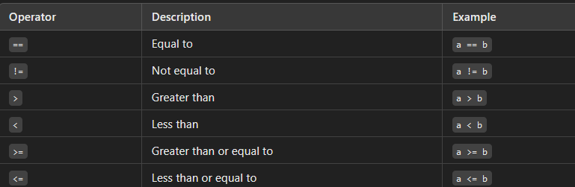
These operators are used to compare two values. They return either 1 (true) or 0 (false).
int a = 5, b = 10;
if (a < b) {
printf("a is less than b\n");
}
Program 1: Relational Operators with Initialization
#include <stdio.h>
int main() {
int a = 10, b = 5;
// Relational operators
printf("a = %d, b = %d\n", a, b);
printf("a > b : %d\n", a > b);
printf("a < b : %d\n", a < b);
printf("a == b : %d\n", a == b);
printf("a != b : %d\n", a != b);
printf("a >= b : %d\n", a >= b);
printf("a <= b : %d\n", a <= b);
return 0;
}
Output:
a = 10, b = 5
a > b : 1
a < b : 0
a == b : 0
a != b : 1
a >= b : 1
a <= b : 0
Explanation:
- In this program, we initialized a and b with values 10 and 5, respectively.
- Then, we used relational operators (>, <, ==, !=, >=, and <=) to compare a and b.
- The result is 1 if the condition is true and 0 if it is false.
Program 2: Relational Operators Using scanf and printf
#include <stdio.h>
int main() {
int a, b;
// Taking input from the user
printf("Enter the first number (a): ");
scanf("%d", &a);
printf("Enter the second number (b): ");
scanf("%d", &b);
// Relational operators
printf("a = %d, b = %d\n", a, b);
printf("a > b : %d\n", a > b);
printf("a < b : %d\n", a < b);
printf("a == b : %d\n", a == b);
printf("a != b : %d\n", a != b);
printf("a >= b : %d\n", a >= b);
printf("a <= b : %d\n", a <= b);
return 0;
}
Output:
Enter the first number (a): 8
Enter the second number (b): 12
a = 8, b = 12
a > b : 0
a < b : 1
a == b : 0
a != b : 1
a >= b : 0
a <= b : 1
Explanation:
- This program prompts the user to input two numbers, a and b.
- It then uses relational operators to compare these values and prints the results.
- The result 1 indicates a true comparison, while 0 indicates false.

