- Res = x*x + 2*x + 1/2*x*x + x + 1, where x = 3.5 and Res is a float
Substitute x=3.5x=3.5 into the expression.
Res=(3.5×3.5)+(2×3.5)+12×(3.5×3.5)+3.5+1
Res=(3.5×3.5)+(2×3.5)+21​×(3.5×3.5)+3.5+1
Calculate each part:
3.5×3.5=12.253.5×3.5=12.25
2×3.5=72×3.5=7
12×12.25=6.12521​×12.25=6.125
The remaining terms are 3.5 and 1.
Combine:
Res=12.25+7+6.125+3.5+1=29.875
Res=12.25+7+6.125+3.5+1=29.875
Answer: Res = 29.875
b) Res = (a > 0) || ((b >= 0) && (a >= 0)) || ((b <= 0)), where a = -1 and b = -a
Substitute a = -1 and b = -(-1) = 1.
Evaluate each part of the expression:
a > 0 evaluates to false (since -1 > 0 is false).
b >= 0 && a >= 0 evaluates to false (since a >= 0 is false).
b <= 0 evaluates to false (since 1 <= 0 is false).
Since all parts are false, the final result is false.
Answer: Res = false
c) 100 % 20 <= 20 - 5 + 100 % 10 - 20 == 5 != 1 != 20
Evaluate 100 % 20, which is 0.
Evaluate 100 % 10, which is also 0.
Now the expression becomes:
0≤20−5+0−20==5!=1!=20
0≤20−5+0−20==5!=1!=20
Calculate 20 - 5 + 0 - 20 = -5.
So we now have:
0≤−5==5!=1!=20
0≤−5==5!=1!=20
Break it down:
0 <= -5 is false.
false == 5 is false.
false != 1 is true.
true != 20 is true.
Answer: The expression evaluates to true.
d) a++ + b-- == c--, where a = 3, b = 5, c = 8
First, substitute the values:
a++ uses 3 (then increments a to 4).
b-- uses 5 (then decrements b to 4).
c-- uses 8 (then decrements c to 7).
The expression becomes 3 + 5 == 8, which is true.
Answer: The expression evaluates to true.
e) 3 * 8 / 4 % 4 * 5
Evaluate from left to right, following operator precedence:
3 * 8 = 24
24 / 4 = 6
6 % 4 = 2
2 * 5 = 10
Answer: The result is 10.
f) int a = 5; a++ == a+++a;
This expression is invalid because of syntax issues with a++ + a++. The compiler would produce an error as the usage is ambiguous.
Answer: Syntax error.
g) int a = 5, b; b = --a + a;
First, --a decrements a to 4.
Then a is used as 4 in the addition.
So, b = 4 + 4 = 8.
Answer: b = 8 and a = 4
h) int a = 3, b; b = a++ + a++ + ++a;
Break it down:
a++ uses 3 and increments a to 4.
The next a++ uses 4 and increments a to 5.
++a increments a to 6 and uses 6.
The expression becomes 3 + 4 + 6 = 13.
Answer: b = 13 and a = 6

To solve the above expressions accurately in C, it's essential to understand the operator precedence and associativity rules, which dictate the order in which operations are evaluated in an expression.
1. Operator Precedence (from highest to lowest)
The following is a simplified list of common operators in C, arranged by precedence (highest first):
Parentheses () - Evaluated first to alter the natural precedence.
Unary Operators ++, --, +, -, !, ~ - Evaluated next. Unary operators like increment (++) and decrement (--) apply to single operands.
Multiplicative Operators *, /, % - Multiplication, division, and modulus have high precedence among binary operators.
Additive Operators +, - - Addition and subtraction are evaluated after multiplicative operators.
Relational Operators <, <=, >, >= - Used for comparisons and have lower precedence than arithmetic operators.
Equality Operators ==, != - Equality and inequality checks.
Logical AND && - Used for logical operations, evaluated before ||.
Logical OR || - Evaluated after &&.
Assignment Operators =, +=, -=, etc. - Have the lowest precedence.
2. Associativity
Associativity determines the order of evaluation when operators of the same precedence level appear in an expression. Here are the rules:
Left-to-right associativity for most binary operators, like *, /, %, +, -, relational (<, >, <=, >=), and equality operators (==, !=).
Right-to-left associativity for unary operators (++, --, !, etc.) and assignment operators (=, +=, -=, etc.).
Applying These Rules
Using these rules, let's see how to solve expressions like those given:
Example Expression: 3 * 8 / 4 % 4 * 5
Steps:
Follow operator precedence for *, /, and % (all have the same precedence and left-to-right associativity).
Evaluate from left to right:
3 * 8 = 24
24 / 4 = 6
6 % 4 = 2
2 * 5 = 10
Final Result: 10
Increment and Decrement: When you have expressions like a++ + ++a, pay attention to when each operation takes effect. a++ (post-increment) uses a's current value before incrementing, while ++a (pre-increment) increments a first and then uses its value.
Logical Operators (&&, ||) and Short-circuiting: When using logical operators like && and ||, remember that evaluation stops as soon as the result is determined:
In &&, if any operand is false, the whole expression is false.
In ||, if any operand is true, the whole expression is true.
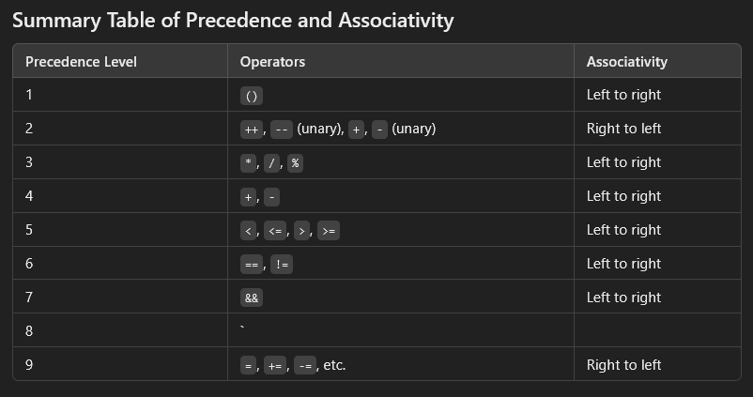
Parentheses for Clarity: When in doubt, use parentheses () to force the order of evaluation, especially when multiple operators are combined.

