YOGA FOR A BETTER LIFE

INTRODUCTION
This practice actually started in ancient India over 5,000 years ago, with clues found even in the super old Indus Valley Civilization.
Over time, it grew from simple spiritual rituals into a deep system for living well. Think of its journey like this:
- Spiritual Roots: It began with a focus on inner connection and sacred practices.
- Wisdom Unfolds: Big philosophical texts like the Upanishads and the Bhagavad Gita added layers of wisdom, emphasizing self-control and inner freedom.
- The Go-To Guide: Then, a wise teacher named Patanjali wrote the Yoga Sutras, essentially creating the ultimate roadmap with his famous "eight limbs" – a full system for how to live.
- Body & Breath Emerge: Later on, styles like Hatha Yoga really brought the physical poses (the ones you probably think of today!) into the spotlight.
- Global Phenomenon: Now, yoga's a worldwide favorite, loved by millions for its incredible benefits for both your body and your mind.

Patanjali’s Ashtanga Yoga: 8-Step Blueprint for a Thriving Life:
Think of Patanjali's Ashtanga Yoga not just as a series of stretches, but as an ancient, incredibly smart operating system for your entire life. It's a proven eight-step framework designed to cut through the daily noise and help you build a solid foundation for inner peace, sharp self-awareness, and lasting freedom from stress.
In today's fast-paced world, we're all looking for ways to handle pressure, find clarity, and connect more deeply with ourselves. Patanjali offers a systematic, time-tested roadmap to do exactly that.
Here's how each "limb" acts as a vital component in your journey:
1. Yamas: Your Ethical Code for Healthy Relationships
This is your personal moral GPS. The Yamas are universal guidelines (like non-violence, truthfulness, and honesty) that teach you how to interact ethically with the world around you – and with yourself. By integrating these, you automatically reduce internal conflict and build a foundation of integrity and compassion, making your relationships smoother and your conscience clearer.
2. Niyamas: Your Internal Habits for Self-Mastery
Consider these your personal development routine. Niyamas are disciplines (such as cleanliness, contentment, and self-discipline) that cultivate inner strength and positive habits. They're about refining your character, building resilience, and fostering a robust, positive mindset from the inside out.
3. Asana: Building a Resilient Body
This is where the physical postures come in – your body's foundational workout. Asanas are crucial for developing a strong, flexible, and healthy body. When your body feels good and is free from discomfort, your mind naturally becomes steadier, preparing you for deeper mental work. Plus, consistent Asana practice significantly boosts your body awareness and overall discipline.
4. Pranayama: Harnessing Your Breath for Mental Calm
Your breath is a direct link to your mind. Pranayama teaches you to control and expand your breath, directly calming your nervous system. By vitalizing your prana (life force), you purify your internal energy channels, providing a clear pathway for sustained focus and mental tranquility.
5. Pratyahara: Reclaiming Your Focus from Distraction
In our hyper-stimulated world, our senses are constantly pulling our attention outward. Pratyahara is the skill of withdrawing your senses inward, pulling your focus away from external distractions. This is a critical step for reducing mental clutter and unlocking your ability to truly concentrate on what matters.
6. Dharana: Training Your Mind to Concentrate
If you struggle with focus, Dharana is your mental training ground. It involves learning to hold your attention steadily on a single point. This deliberate practice builds profound mental stability and the one-pointed concentration essential for advanced meditative states.
7. Dhyana: The Art of Effortless Meditation
This is where concentration deepens into effortless meditation. Dhyana is a continuous, uninterrupted flow of awareness. Moving beyond just focusing, it leads to deep insights, remarkable mental clarity, and a profound sense of peace. It's about experiencing pure awareness, unfiltered by constant thought.
8. Samadhi: Achieving Ultimate Wholeness and Bliss
The ultimate destination on the yoga journey, Samadhi is a state of deep absorption and complete union. It's about transcending the feeling of a separate self and experiencing profound bliss and absolute tranquility. This is the ultimate peak state that all the previous limbs prepare you for.
Patanjali's Ashtanga Yoga offers a clear, actionable, and progressively building pathway for personal transformation. It's a powerful framework that recognizes that true well-being isn't just about physical fitness, but about meticulously nurturing mental, emotional, and spiritual dimensions for a truly fulfilling and balanced life.

Yama: Yoga Starter Kit for Life
Yama is the very first building block of yoga, a practical set of guidelines for being a decent human being. Think of it as your moral compass, guiding your actions and reactions, not just on the mat, but in every part of your day.
These aren't rules set in stone by some ancient guru that you have to follow. Instead, they're smart principles that, when put into practice, naturally lead to a more peaceful, honest, and less complicated life for everyone involved.
There are five key "don'ts" that make up Yama, each designed to make you a better person to yourself and others:
- Ahimsa (Don't Harm): This is the big one. It means actively choosing kindness in your thoughts, words, and actions. Think about the ripple effect of what you say or even what you dwell on internally.
- Satya (Don't Lie): Pretty straightforward: be truthful. But here's the yoga twist: speak your truth kindly and helpfully. No need to blurt out something honest if it's just going to cause unnecessary pain.
- Asteya (Don't Steal): This goes beyond just physical stuff. It means respecting what belongs to others – their ideas, their time, their energy. Don't take advantage, don't hog resources, and definitely don't swipe credit for someone else's hard work.
- Brahmacharya (Don't Waste Energy): It's about being smart with all your energy – physical, mental, emotional. Instead of constantly chasing fleeting pleasures, channel your vitality into things that genuinely contribute to your well-being and purpose.
- Aparigraha (Don't Hoard/Be Greedy): This isn't about being poor, but about emotional freedom. Realize that constantly grasping for things outside yourself won't bring lasting happiness, and learn to be content with what you have.
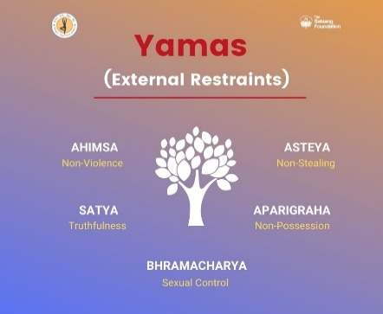
Ultimately, Yama isn't about restriction; it's about liberation. By practicing these guidelines, you shed the burdens of guilt, conflict, and dissatisfaction, creating a clearer path for inner peace. It's about making your life, and the lives of those around you, a whole lot smoother.

Figure 1- Yamas

Niyama: Personal Blueprint for a Better Life:
Think of the Niyamas as five powerful personal practices designed to help you build inner strength, clarity, and lasting contentment. They're not strict rules, but rather gentle yet effective habits you can cultivate for a more fulfilling life.
1. Saucha (Purity): Declutter Your World, Inside and Out
Imagine your life as a canvas. Saucha is about keeping that canvas clean and clear. On the outside, it's the simple act of keeping your body clean, your living and working spaces tidy, and fueling yourself with nourishing food. Internally, it's even more crucial: it's about tidying up your mental space. This means consciously letting go of toxic thoughts like resentment or envy, and minimizing mental "junk food" like endless social media scrolling or negative news cycles. A clear space, a clear mind.
2. Santosha (Contentment): The Art of Being Happy Now
In a world that constantly pushes us to want more, Santosha offers a refreshing counter-narrative. It's not about settling or giving up on your dreams. Instead, it's about finding genuine satisfaction and appreciation for what you have in this very moment. It's learning to truly enjoy the journey, not just the destination. When you cultivate Santosha, you discover that true happiness isn't something you acquire from the outside; it's a feeling you can cultivate from within.
3. Tapas (Self-Discipline): Forging Your Inner Resilience
The word "Tapas" literally means "to burn," and it speaks to the heat of transformation. This Niyama is all about committed effort and disciplined action that builds your inner strength. Whether it's showing up for your workout, dedicating time to learning a new skill, or consistently choosing healthier habits, Tapas is about pushing past comfort zones to forge resilience. It's about "burning away" what doesn't serve your higher self and building the mental fortitude to achieve your goals.

4. Svadhyaya (Self-Study): Becoming Your Own Expert
Consider this your personal research project into you. Svadhyaya is a two-pronged approach to deeper understanding. It involves learning from wisdom sources: reading insightful books, listening to podcasts, or engaging with ideas that expand your perspective on life. It's a continuous process of self-discovery and growth that empowers you to navigate your life with greater awareness.
5. Ishvara Pranidhana (Surrender): Releasing the Burden of Control
We often carry the heavy weight of trying to control every outcome. Ishvara Pranidhana is an invitation to lighten that load by placing your trust in a larger force – be it a spiritual entity, the inherent wisdom of the universe, or simply the natural flow of life. It’s about doing your best, putting in the effort, and then letting go of attachment to specific results. This practice can bring immense peace, reduce anxiety, and free you from the constant pressure of perfection.
By consciously integrating these five personal practices into your daily life, you're not just doing "yoga" in the traditional sense; you're actively building a robust, clear, and peaceful internal foundation. It's a powerful toolkit for continuous personal growth and cultivating a life of greater well-being.

The Dynamic Power of Surya Namaskar (Sun Salutations)
Instead of complicated routines – imagine a single, flowing sequence that stretches, strengthens, and energizes your entire body in minutes. That's the essence of Surya Namaskar, or Sun Salutations. More than just poses, it's a dynamic warm-up and a complete mini-workout designed to kickstart your metabolism and sharpen your focus.
This powerful series moves seamlessly through twelve key positions, each one building on the last to create a full-body experience.

- Start Strong (Prayer Pose): You begin standing tall, grounding yourself with hands at your chest.
- Reach & Expand (Raised Arms Pose): Inhale as you extend upwards and slightly back, opening your front body.
- Release & Lengthen (Hand to Foot Pose): Exhale, folding forward to stretch your hamstrings and spine.
- Open & Ground (Equestrian Pose): Step one leg back into a deep lunge, expanding your hips and building stability.
- Build Core Strength (Plank Pose): Step the other leg back, engaging your entire core in a straight line from head to heels.
- Humble & Connect (Eight-Limbed Salutation): Lower knees, chest, and chin to the mat, finding a moment of surrender and connection.
- Lift & Invigorate (Cobra Pose): Inhale, lifting your chest and arching your back, stimulating your organs and opening your heart.
- Realign & Stretch (Downward-Facing Dog): Exhale, pushing back to lengthen your spine and stretch your entire posterior chain.
- Step Forward (Equestrian Pose): Step the first leg forward again, reigniting the lunge.
- Fold & Center (Hand to Foot Pose): Bring the back foot forward, returning to your deep forward fold.
- Rise & Reach (Raised Arms Pose): Inhale, sweeping your arms up, feeling the full expansion of your breath.
- Complete & Reset (Prayer Pose): Exhale back to your starting position, feeling revitalized and ready to conquer the day.
This sequence is an incredible way to build heat, increase flexibility, and integrate breath with movement, leaving you feeling invigorated and clear-headed.

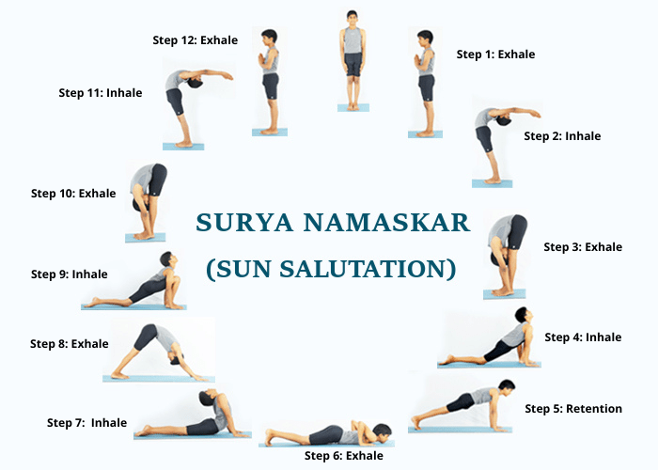

Figure 2- Surya Namaskar
Peak Performance with Surya Namaskar
Physical Edge: Get ready for a body that feels more agile and resilient. This flowing series enhances flexibility, builds core and limb strength, and sharpens your posture. It's also a fantastic cardiovascular workout, improving circulation and even supporting better digestion – giving you that clear, energetic feeling you need to tackle your tasks.
Mental Clarity & Calm: In a world of constant demands, Surya Namaskar offers a vital mental reset. The rhythmic movement and breath quickly melt away stress and anxiety, leaving you with sharper focus and enhanced concentration. It's a practical tool for improving sleep quality and, for women, can even bring a sense of regularity to cycles.
Sustained Energy: Beyond the visible, this practice taps into your deeper energy reserves. It revitalizes your system, pushing away sluggishness and awakening a vibrant inner spark. Think of it as recalibrating your entire energetic flow, ensuring you stay balanced and invigorated throughout your demanding schedule.

Asana
At first, "Asana" just meant a simple, comfy way to sit for meditation. But over hundreds of years, yoga grew, and now Asanas are all the many physical poses we do. They're not just random stretches; they're special movements meant to cleanse and balance both your body and your mind.
Need
Think of it like this: your body and mind are super connected. If your body feels stiff or tired, your mind gets grumpy too! Asanas help this connection:
- Your Body Is Your Ride: You need a healthy body to live well. If your body is sore or tight, it's hard to enjoy life. Asanas help your body feel good.
- Unblock Your Life Energy: Yoga talks about "prana," which is like your body's energy. It flows in special paths called "nadis." When these paths get stuck, you might feel low on energy. Asanas help clear those paths so your energy can flow freely.
- Get Ready for Quiet Time: It's hard to meditate if your back hurts! Asanas make your body strong and flexible so you can sit still and focus more easily.
- Build Your Inner Strength: When you hold a yoga pose, you're not just using muscles. You're learning patience, focus, and how your body moves.
Benefits
Asanas aren't just for getting fit; they really change how you feel:
- Feel Better All Over: They make you strong, flexible, and balanced. They're good for your blood flow, digestion, and even your insides.
- Calm Your Brain: The slow movements and deep breathing in yoga actually calm your nervous system. That means less stress, less worry, and a quieter mind.
- Let Go of Tense Feelings: Sometimes we hold stress in our bodies. Asanas can help release that tightness, making you feel more relaxed and emotionally balanced.
- More Energy! By helping your body's energy flow, regular yoga can make you feel more lively and awake.
- Listen to Your Body: You'll start to understand what your body needs and how it feels, building a stronger connection to yourself.

Different Kinds of Poses
Yoga has many different kinds of Asanas:
- Standing Poses: For feeling strong and steady.
- Sitting Poses: Good for meditation and opening your hips.
- Bending Forward Poses: To relax and stretch your back.
- Bending Backwards Poses: To give you energy and open your chest.
- Twisting Poses: To help your body clean itself and make your spine flexible.
- Upside-Down Poses: To boost blood flow and calm your mind.
- Balancing Poses: To help you focus and balance.
- Lying Down Poses: For deep relaxation.
1. Balasana (Child's Pose)
- Technique: Kneel on your mat, bringing your big toes to touch and spreading your knees wide (or keep them closer if that's comfier). Then, gently fold forward, letting your torso rest between your thighs. Your forehead comes to the mat, and your arms can stretch forward or rest back alongside your body. Just breathe and let everything go.
- Precaution: If your knees are sensitive, put a blanket or pillow under them. And if your head doesn't comfortably reach the floor, stack your hands or use a block under your forehead.
- Benefits: It's super calming for your brain, helps relieve stress and fatigue, and gently stretches your hips, thighs, and ankles. It's often used as a resting pose in between more challenging ones.
2. Setu Bandhasana (Bridge Pose)
- Technique: Lie on your back with your knees bent, feet flat on the floor and hip-width apart, close enough that your fingertips can just graze your heels. Press down through your feet, and on an inhale, lift your hips off the floor towards the ceiling. You can clasp your hands underneath your back or keep your arms by your sides. Lift your chest towards your chin.
- Precaution: Go easy if you have neck or back injuries – don't push too hard. And make sure your knees aren't splaying out to the sides; keep them in line with your hips.
- Benefits: It's great for strengthening your back, glutes, and hamstrings. It also stretches your chest, neck, and spine, which feels amazing if you sit a lot. Plus, it can help calm your brain and ease stress.
3. Vrikshasana (Tree Pose)
- Technique: Start standing tall. Shift your weight onto one foot, then lift the other foot and place its sole on your inner thigh, calf, or even your ankle (avoid placing it directly on your knee joint). Bring your hands to your heart in prayer position, or if you feel stable, reach your arms overhead like branches. Find a spot to focus your gaze.
- Precaution: If balance is tricky, you can stand near a wall for support. Never press your foot directly into your knee; go above or below it.
- Benefits: This pose is a fantastic way to improve your balance and focus, which are skills you can take off the mat too. It strengthens your standing leg, opens your hips, and makes you feel grounded and calm.
4. Garudasana (Eagle Pose)
- Technique: Stand tall. Bend your knees slightly and lift one leg, wrapping it over the other so your thighs cross. If you can, tuck your top foot behind your standing calf. Then, do the same with your arms, crossing one arm under the other, bending elbows, and trying to bring your palms or backs of hands to touch. Lift your elbows up and draw your hands away from your face.
- Precaution: If full arm wrap is too much, just hug your opposite shoulders. For the legs, if wrapping isn't possible, just cross your thighs. Take it slow if you have knee or shoulder issues.
- Benefits: It seriously boosts your balance and concentration! It also gives a good stretch to your hips, thighs, shoulders, and upper back. It's a great way to release tension in those hard-to-reach places.
5. Ardha Matsyendrasana (Half Lord of the Fishes Pose)
- Technique: Sit with your legs extended. Bend one knee and place that foot flat on the floor outside the opposite thigh. The other leg can either stay extended or bend, bringing its heel towards your opposite hip. Place the hand of the leg that's bent behind you for support. Inhale, lengthen your spine. Exhale, twist your torso towards the bent knee, hooking your opposite elbow outside that knee or wrapping your arm around it.
- Precaution: Go gently if you have a back or spinal injury – no forceful twisting. Keep your spine long; don't round your back. Pregnant individuals should avoid deep twists.
- Benefits: It's excellent for improving spinal mobility and flexibility. It also massages your abdominal organs, which can aid digestion and detoxification. Plus, it's a wonderful way to release tension in the upper back and shoulders.

Discovering Yoga Poses
Seated Poses: Finding Your Calm Center
These poses are all about grounding yourself and discovering a deep sense of peace from the inside out.
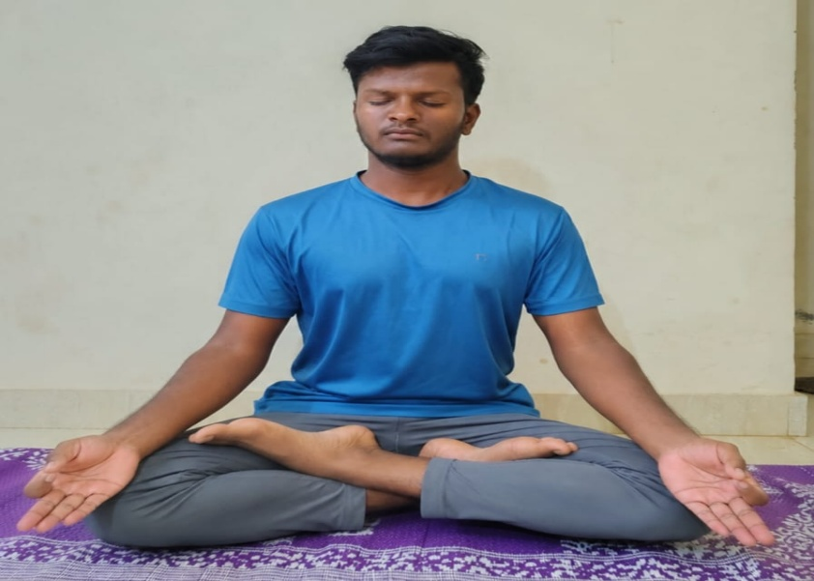
1. Sukhasana (Easy Pose)
Figure 3- Sukhasana
- Your Personal Cushion: Imagine settling into your most comfortable spot. It's truly the "easy" pose, designed for you to sit still and feel completely at ease.
- Technique: Just cross your legs, maybe on a comfy cushion to lift your hips a bit. Let your knees gently fall open, lengthen your spine as if a string is pulling you upwards, and rest your hands softly on your knees.
- Precaution: If your knees feel a bit tight, slide a blanket or block underneath them for support. If your hips are calling for more space, a slightly higher cushion works wonders.
- Benefits: This pose is a secret weapon for calming your mind, melting away stress, and giving your ankles and knees a gentle stretch. It builds strength in your back, improving your posture effortlessly, and naturally opens your hips. It's the perfect stable foundation for any breathing exercise or meditation practice.
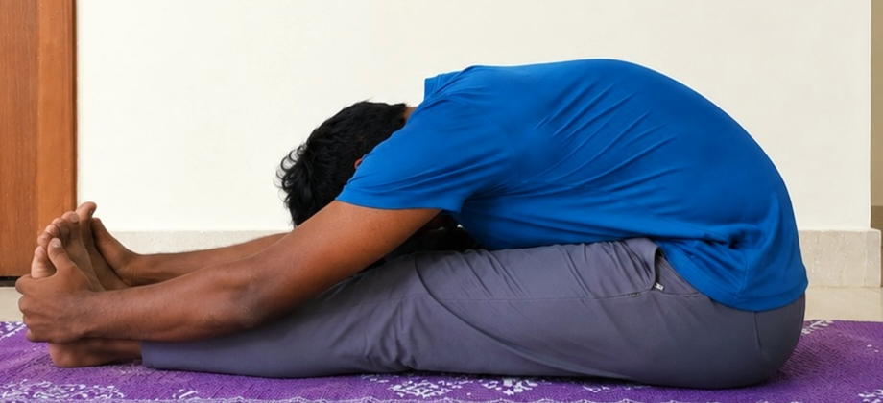
2. Paschimottanasana (Seated Forward Bend)
Figure 4- Paschimottanasana
- The Ultimate Back Stretch: Picture stretching out long and reaching for that "back" or "west" side of your body. This pose is all about creating delicious length through your entire backside.
- Technique: Sit with your legs straight out, feet alive and flexed (toes pointing up). Take a big, juicy breath, growing tall through your spine. Then, as you exhale, gently fold forward from your hips – not your waist! Imagine your torso is a long board, hinging at the hips. Reach for whatever feels comfortable – your shins, ankles, or even your feet. Keep that beautiful long spine, and let your head softly release.
- Precaution: If you have a serious back concern (like a slipped disc), it's wise to skip this one. For tight hamstrings, simply bend your knees generously – no need to push! If you're pregnant, be mindful of your belly and avoid deep compression.
- Benefits: Beyond the amazing stretch for your back, hamstrings, and calves, this pose is incredibly calming. It's a fantastic antidote to stress and can even lift your spirits if you're feeling a bit down.
Standing Poses: Building Resilience & Flexibility
These dynamic poses are all about harnessing your inner strength and finding graceful movement in your torso.
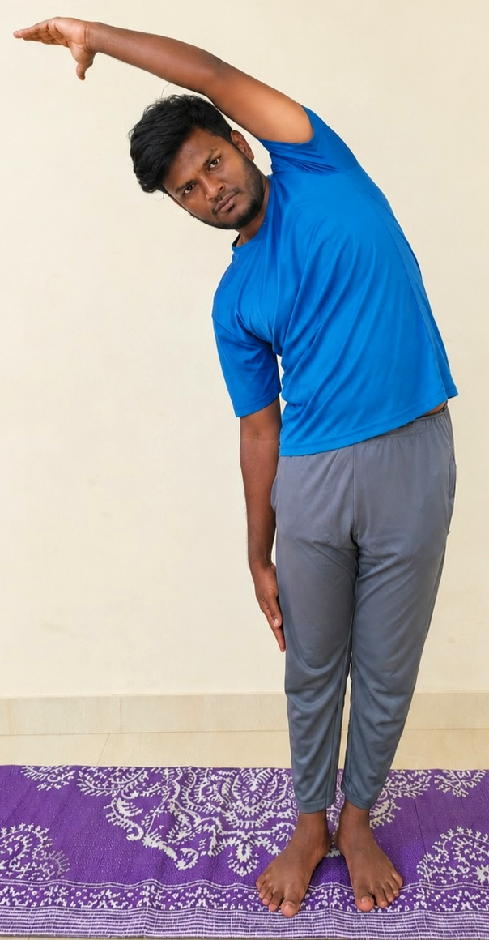
1. Ardhakati Chakrasana (Half Waist Rotating Pose)
Figure 5- Ardhakati Chakrasana
- The Side Lengthener: Think of this as a "half-moon" stretch for your side body – it's about creating space and movement in your waist.
- Technique: Start standing tall, like a mountain. Inhale, sweeping your left arm high overhead. As you exhale, gently arc your body to the right, keeping your hips stable and your body perfectly aligned, as if between two panes of glass. Your right hand can softly rest on your thigh. Inhale to return to center, then enjoy the stretch on the other side.
- Precaution: If your back feels sensitive, keep the bend subtle. Always relax your shoulders away from your ears and resist the urge to collapse into your lower side.
- Benefits: This pose offers a fantastic stretch for the sides of your torso and spine, gently waking up your core muscles and enhancing your spine's flexibility. It's wonderful for releasing everyday stiffness in your back.
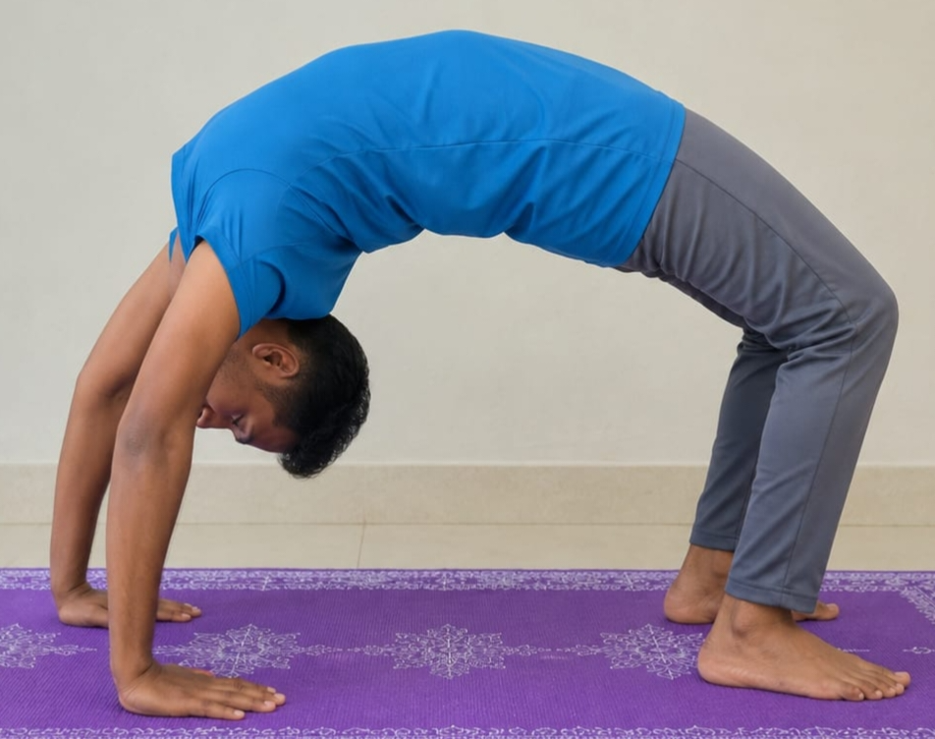
2. Parshva Chakrasana (Lateral Wheel Pose)
Figure 6- Parshva Chakrasana
- Deeper Side Release: This is your chance for an even more expansive side stretch, often involving both arms reaching. It's about opening up your entire "flank" or side body.
- Technique: Stand with your feet comfortably hip-width apart. Lift both arms overhead, maybe interlacing your fingers for an extra reach. Inhale to create maximum length through your body. Then, as you exhale, arc deeply to one side, extending through your fingertips while keeping your hips steady and rooted. Inhale back to your strong center, then switch sides.
- Precaution: If you have any acute lower back pain or significant spinal concerns, approach this with extra care. Ensure your weight is evenly distributed through both feet and avoid crunching into your neck.
- Benefits: Prepare for an invigorating stretch that runs from your ankles all the way to your fingertips! It significantly boosts flexibility in your spine and waist, strengthens your core, and gently opens your chest and shoulders.
Prone Pose (On Your Stomach): Igniting Your Back Power
This pose is all about opening the front of your body and building powerful strength in your back.
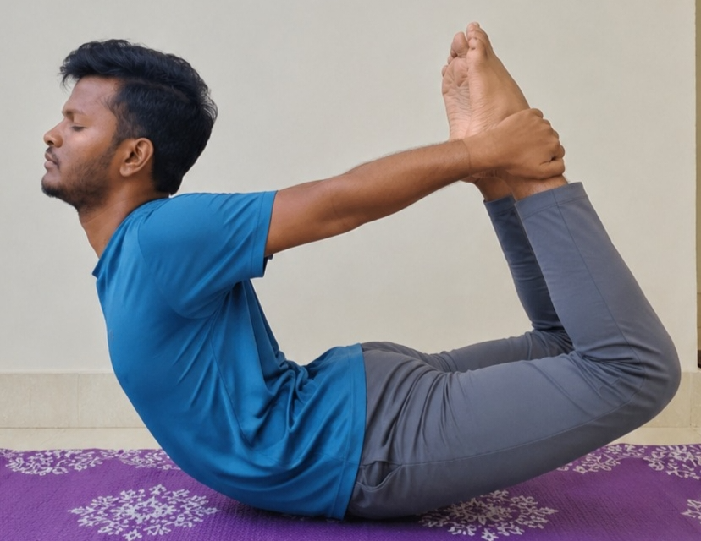
1. Dhanurasana (Bow Pose)
Figure 7- Dhanurasana
- Embrace Your Inner Archer: Imagine your body transforming into a strong, graceful archer's bow – your torso and legs forming the curve, and your arms holding the "string."
- Technique: Lie on your stomach. Bend your knees, reaching back to grasp your ankles or feet. On an inhale, lift your chest and thighs away from the floor, simultaneously pulling your heels away from your buttocks. This creates that beautiful arch in your back. Look gently forward. Hold for a few breaths, then softly release on an exhale.
- Precaution: It's best to skip this if you have serious back or neck injuries, high or low blood pressure, heart issues, or headaches. This pose is also not recommended during pregnancy or if you've had recent abdominal surgery.
- Benefits: This is a powerhouse for strengthening your entire spine and back muscles. It creates a fantastic stretch for your chest, abdomen, and thighs, and can even stimulate your internal organs, giving your digestion a helpful boost.
Supine Poses (On Your Back): Deep Relaxation & Unique Stretches
These poses playfully defy gravity and offer chances for profound stretches or ultimate relaxation.
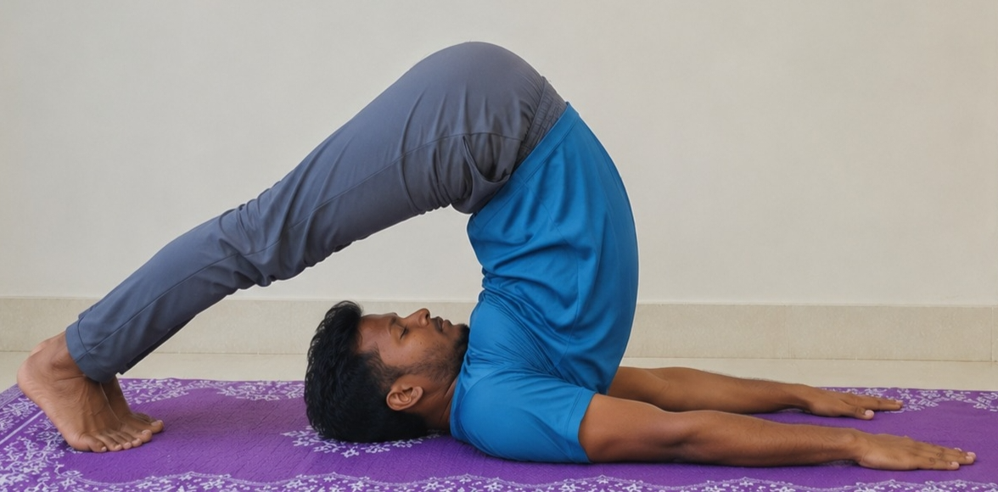
1. Halasana (Plow Pose)
Figure 8- Halasana
- The Grounding Plow: Just like a sturdy farm plow, this pose brings your legs gracefully overhead, creating a deep connection with the earth through your shoulders.
- Technique: Lie on your back, arms alongside your body, palms down. Inhale as you lift your legs straight up to 90 degrees. As you exhale, press your palms down, lift your hips, and slowly guide your legs over your head until your toes softly touch the floor behind you. Keep your legs straight. You can support your lower back with your hands or interlace them on the floor.
- Precaution: This pose is NOT for you if you have any neck or recent back injuries, or severe spinal concerns. Avoid if you have high blood pressure, asthma, diarrhea, headaches, or if you are menstruating or pregnant.
- Benefits: It's an incredible stretch for your shoulders, spine, and hamstrings. It has a deeply calming effect on your brain, helping to melt away stress and fatigue. It also stimulates your abdominal organs and your thyroid gland.
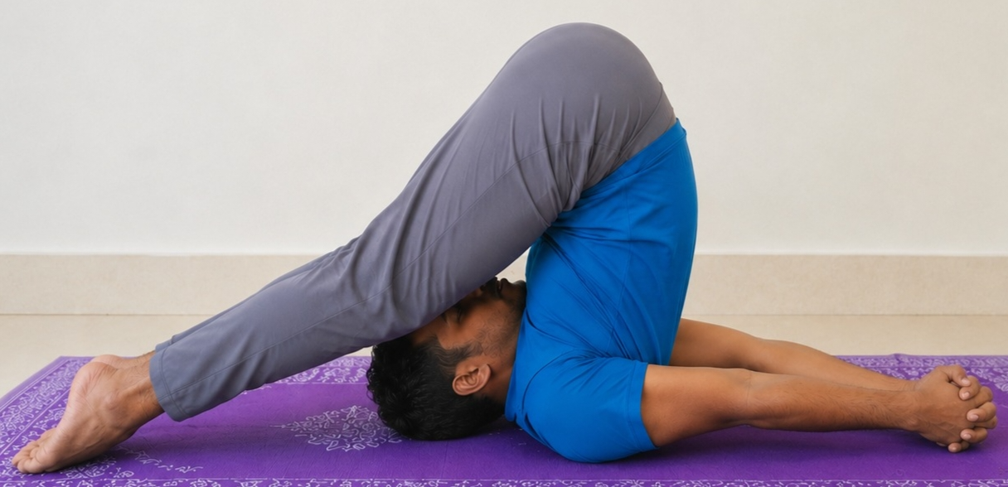
2. Karna Peedasana (Ear-Pressure Pose)
Figure 9- Karna Peedasana

- The Deep Embrace: This is a beautiful variation of Halasana, where your knees gently press towards your ears, creating a comforting sense of introspection.
- Technique: From your Halasana position, simply bend your knees and guide them towards your head, letting them rest gently near your ears on the floor. Your arms can either stay interlaced or continue to support your lower back.
- Precaution: Every precaution for Halasana applies here, but with even greater emphasis. Please seriously avoid this if you have any neck, spine, or knee issues. This is a very deep and intense pose that requires significant flexibility and must be approached with utmost care.
- Benefits: It offers an incredibly profound stretch for your spine, neck, shoulders, and hips. It provides a gentle internal massage for your abdominal organs, and its deep nature is wonderfully calming for your nervous system, significantly reducing stress. Many find this pose to be incredibly therapeutic for quieting the mind.

The Power of Kapalabhati:
This isn't just any old breathing exercise. Often called the "Skull Shining Breath," it's a dynamic yoga technique that uses quick, sharp pushes from your belly to breathe out. The inhale? It just happens on its own. Think of it like a rapid, rhythmic pumping.
Significance
- Instant Refresh: It's like hitting a reset button for your brain and lungs. You literally feel clearer and more awake.
- Body Cleanse: This unique breath helps clear out stale air from your lungs and can even clear up your sinuses. Imagine a gentle internal spring cleaning!
- Energy Booster: It gets your vital energy (what yogis call "prana") flowing smoothly, chasing away that sluggish feeling.
- Sharper Focus: By improving circulation to your brain, Kapalabhati can help you ditch brain fog and think more clearly.
- Inner Warm-up: The action gently "massages" your insides, which can give your digestion a helpful nudge.
Benefits
- Clearer head and sinuses
- More natural energy, less fatigue
- Better digestion
- A stronger core
- Reduced stress and better focus
- A great way to get ready for any meditation or relaxation practice
Precautions
Because Kapalabhati is quite powerful, it's not for everyone without guidance. Avoid it or be very cautious if you have.
- High blood pressure or heart problems
- A hernia, a slipped disc, or recently had belly surgery
- Epilepsy or ulcers
- Serious neck or back injuries
- Are pregnant or currently menstruating.
Always start slowly, and if anything feels off, just stop. The best way to learn is with a good yoga instructor who can show you the ropes safely.

Practice of Pranayama
Overview of Pranayama
Pranayama, derived from Sanskrit terms "Prana" (vital life force) and "Ayama" (extension/control), refers to the systematic control and expansion of the breath. This practice extends beyond basic respiratory exercises, aiming to consciously influence the flow of Prana within the body's subtle energetic framework.
Rationale for Pranayama Integration
The integration of Pranayama is predicated on the inherent connection between an individual's respiratory patterns and mental states.
- Mental State Regulation: Respiratory patterns exhibit direct correlation with mental activity. Through the disciplined regulation of breath, Pranayama provides a mechanism for stabilizing and reducing mental agitation.
- Energetic Pathway Optimization: Pranayama facilitates the clearance of obstructions within the body's subtle energetic channels (Nadis). This process supports the unimpeded flow of Prana, contributing to enhanced physiological and psychological equilibrium.
- Preparatory Phase for Concentration: As an integral component of yogic methodology, Pranayama serves as a preparatory discipline. It stabilizes the nervous system and refines attentional capacity, thereby facilitating deeper states of concentration and meditation.
- Physiological Enhancement: Beyond its energetic implications, Pranayama optimizes pulmonary function. It contributes to increased respiratory efficiency, enhanced oxygen assimilation, and improved elimination of metabolic waste products.

Impact and Significance of Pranayama
Pranayama exerts a multifaceted impact on an individual's physiological and psychological well-being.
- Physiological Health: Regular Pranayama practice contributes to the strengthening of the respiratory system, potential regulation of cardiovascular parameters, and modulation of immune responses.
- Cognitive and Emotional Stability: Through its influence on the nervous system, Pranayama can mitigate symptoms associated with stress and anxiety. It also supports enhanced focus, attentional clarity, and emotional regulation.
- Energetic Vitalization: By activating and balancing the subtle energy pathways, Pranayama is associated with increased vitality and a general sense of energetic well-being.
- Enhanced Self-Awareness: The deliberate practice of breath regulation fosters heightened internal proprioception, contributing to a more nuanced understanding of internal bodily sensations and mental states.

Pranayama Methodologies
The following sections detail specific Pranayama techniques, outlining their nomenclature, procedural aspects, critical contraindications, and observed benefits.
1. Nadi Shodhana (Alternate Nostril Breathing)
- Nomenclature: "Nadi" denotes energetic channels; "Shodhana" signifies purification. The technique aims to purify and balance these channels.
- Methodology: Involves the sequential alternation of inhalation and exhalation between the left and right nostrils, typically utilizing a specific hand gesture (Vishnu Mudra) to regulate airflow. The breath is characterized by its slow, steady, and rhythmic nature.
- Contraindications: Individuals with pregnancy, cardiac conditions, or hypertension should abstain from breath retention phases during this practice. Execution should be gentle, avoiding any forceful respiratory effort.
- Benefits: Promotes energetic balance, reduces sympathetic nervous system arousal (stress and anxiety), enhances cognitive focus, and contributes to the purification of nasal passages. It serves as a preparatory practice for meditation.

2. Kapalabhati (Skull Shining Breath)
- Nomenclature: "Kapala" signifies skull; "Bhati" indicates shining or illumination, referencing its perceived clarifying effect on the mind.
- Methodology: Characterized by forceful, rapid, and active exhalations, driven by vigorous contraction of the abdominal musculature. Inhalation occurs passively and spontaneously. A consistent rhythm is maintained.
- Contraindications: This technique is a vigorous practice. It is contraindicated for individuals who are pregnant, menstruating, or have conditions such as hypertension, cardiac disease, hernia, slipped disc, epilepsy, gastric ulcers, or have undergone recent abdominal surgery. Practice must commence gradually, adhering to a slow pace. Immediate cessation is advised if dizziness, pain, or discomfort manifests. This practice mandates an empty stomach.
- Benefits: Facilitates respiratory system and sinus clearance, promotes energetic invigoration, generates internal thermogenesis beneficial for metabolic processes, and may enhance cognitive clarity.
3. Ujjayi (Victorious Breath / Ocean Breath)
- Nomenclature: "Uj" denotes expansion, "Jaya" signifies victory, reflecting the expansive sensation. Alternatively termed "Ocean Breath" due to the subtle auditory quality of the respiration.
- Methodology: Respiration occurs nasally, accompanied by a gentle constriction at the posterior pharyngeal wall. This constriction produces a soft, consistent sound, analogous to ocean waves or a whisper.
- Contraindications: Generally considered safe. Avoid any forceful respiratory effort. A transient scratchiness in the throat may occur initially, which typically resolves with continued practice.
- Benefits: Induces parasympathetic nervous system activation, potentially aiding in blood pressure regulation. It enhances pulmonary capacity, generates mild internal warmth, and supports sustained attentional focus during physical yoga practice.

Analysis of Key Pranayama Techniques
Pranayama, the regulation of vital energy (prana) through controlled respiration, is a component of yogic practice. Its application is associated with physiological and neurological effects, impacting energy distribution, cognitive function, and homeostatic balance. The following outlines five common Pranayama techniques, detailing their methodology, contraindications, and documented outcomes.

1. Surya Anuloma-Viloma (Solar Alternate Breathing)
- Description: This technique emphasizes the activation of the Pingala Nadi, an energy channel associated with solar or stimulating qualities. It is reported to generate internal warmth and heightened alertness.
- Methodology: Utilize the right hand in Vishnu Mudra (thumb occludes right nostril, ring finger occludes left nostril). Respiration involves consistent inhalation through the right nostril and exhalation through the left nostril. The sequence is systematically repeated.
- Contraindications: Individuals exhibiting hyperthermia, fever, acute agitation, or hypertension should exercise caution or avoid this practice.
- Reported Outcomes:
  - Enhances physiological energy levels.
  - Increases internal body temperature.
  - Improves cognitive focus.
  - May mitigate symptoms of lethargy or mild depressive states.

2. Chandra Anuloma-Viloma (Lunar Alternate Breathing)
- Description: This technique is the inverse of Surya Anuloma-Viloma, stimulating the Ida Nadi, an energy channel linked to lunar or calming attributes. It is associated with inducing coolness and relaxation.
- Methodology: Employ the right hand in Vishnu Mudra. Respiration involves consistent inhalation through the left nostril and exhalation through the right nostril. The sequence is systematically repeated.
- Contraindications: Individuals experiencing hypothermia or significantly reduced energy levels may find this technique counterproductive. Caution is advised for individuals with hypotension.
- Reported Outcomes
  - Induces systemic relaxation.
  - Facilitates bodily cooling.
  - Reduces anxiety and may improve sleep latency.
  - Contributes to autonomic nervous system balance.
3. Surya Bhedana (Solar Stimulation Breath)
- Description: A potent energizing technique, Surya Bhedana aims to intensively stimulate the solar energy principle within the physiological system.
- Methodology: Inhalation is exclusively through the right nostril (left nostril occluded by ring finger). Exhalation is exclusively through the left nostril (right nostril occluded by thumb). This cycle is performed continuously.
- Contraindications: This technique is contraindicated for individuals with hypertension, cardiac pathologies, epilepsy, gastric ulcers, hyperacidity, fever, or during pregnancy. It is also not recommended for states of anger, acute agitation, or prolonged use in hot environmental conditions.
- Reported Outcomes
  - Substantially increases endogenous heat and energy.
  - Invigorates the central nervous system.
  - Enhances digestive function and appetite.
4. Chandra Bhedana (Lunar Stimulation Breath)
- Description: This technique serves as a strong cooling and calming counterpart to Surya Bhedana, specifically activating the lunar energy for deep systemic relaxation.
- Methodology: Inhalation is exclusively through the left nostril (right nostril occluded by thumb). Exhalation is exclusively through the right nostril (left nostril occluded by ring finger). This cycle is performed continuously.
- Contraindications: Avoid if experiencing respiratory infections (e.g., cold, cough), cold-induced asthma, hypothermia, or pre-existing low energy/depressive states.
- Reported Outcomes:
  - Induces significant physical and mental relaxation and cooling.
  - Mitigates mental tension, anxiety, and psychological stress.
  - May assist in the management of hypertension.
  - Facilitates mental calmness and improved sleep quality.
5. Nadi Shodhana (Energetic Channel Purification)
- Description: This widely practiced technique aims to purify and harmonize the nadis, or subtle energy channels, thereby balancing the entire energetic system.
- Methodology: Utilize the right hand in Vishnu Mudra. The sequence involves:
  - Occluding the right nostril with the thumb, inhaling through the left.
  - Occluding the left nostril with the ring finger, releasing the thumb, and exhaling through the right.
  - Inhaling through the right.
  - Occluding the right nostril, releasing the ring finger, and exhaling through the left. This sequence constitutes one complete round and is repeated alternatingly. Breath retention (kumbhaka) may be incorporated by advanced practitioners.
- Contraindications: Breath retention is contraindicated during pregnancy, cardiac conditions, hypertension, or glaucoma. Practice should be gentle, non-forceful, and immediately ceased if dizziness or discomfort is experienced.

- Outcomes
  - Achieves balance within the Ida and Pingala Nadis, fostering systemic harmony.
  - Significantly modulates the autonomic nervous system, reducing stress and anxiety.
  - Enhances cognitive function, including concentration and memory.
  - Cleanses respiratory passages and increases pulmonary capacity.
  - Prepares the practitioner for advanced meditative states.

Conclusion
Yoga, an ancient practice originating in India, constitutes a systematic methodology for addressing human well-being. It operates as a comprehensive framework designed to integrate physical, mental, and spiritual components, drawing upon established traditions spanning millennia.
Patanjali's Eight Limbs delineate the structured progression of this discipline. Initial stages involve the cultivation of ethical conduct (Yamas) and personal observances (Niyamas), which establish a foundation for internal and external order. Subsequently, Asana (physical postures) are employed not merely for physical conditioning, but for the purification of bodily energy systems and the development of physical stability.
A pivotal element, Pranayama (breath regulation), functions as an interface between physiological and psychological states. Its application influences mental activity, contributes to stress reduction, and facilitates enhanced cognitive focus. The consistent application of these principles within the yogic framework aims to cultivate internal equilibrium, physiological vitality, and mental discipline.

