PROJECT REPORT – FIRST PHASE

KAMI
AI-Based Water Monitoring and Anomaly Detection System

Project Members
Vinay Ananda – 24BCB0131
Kandi Jeevitesh – 24BCE0350

1. INTRODUCTION

1.1 Background and Motivation
The original KAMI abstract proposed a broad knowledge-driven artificial intelligence platform for predictive water governance, infrastructure intelligence, and smart resource management. It combined RAG, LLMs, multimodal AI, computer vision, geospatial intelligence, IoT sensor networks, predictive analytics, digital twins, reinforcement learning, and optimization. Although this created an ambitious vision, the methodology feedback correctly identified that implementing all of these AI subfields within one project would make the design difficult to execute and evaluate.
The revised project therefore focuses on one specific problem: interpreting abnormal behaviour in water-system data. Water distribution systems generate measurements that are naturally multivariate and time-dependent. A change in flow or pressure may be normal in one operational context and suspicious in another. Similarly, a change in monitored water-quality indicators may require greater attention when it occurs together with unusual infrastructure behaviour. The project investigates how these different sources of evidence can be organized and interpreted in a focused AI pipeline.

1.2 Problem Statement
Conventional monitoring commonly uses independent thresholds for individual measurements. Such monitoring is easy to implement, but it does not necessarily capture relationships among multiple variables or the temporal context in which they occur. Machine-learning research in smart water systems has demonstrated the value of multivariate anomaly analysis, while recent work on water-quality management highlights challenges related to integrated models, interpretability, real-time response, and limited datasets.
The problem addressed by KAMI is therefore: how can infrastructure behaviour, monitored water-quality behaviour, and temporal context be analysed in a structured manner to produce a more interpretable anomaly assessment than isolated sensor-threshold alerts?

1.3 Modifications Made Based on Abstract and Methodology Feedback
The project has been deliberately narrowed in response to the feedback received. The final design does not attempt to cover vision, RAG, LLMs, multilingual voice, digital twins, reinforcement learning, routing, GIS intelligence, and public-service applications simultaneously.
Original Abstract Direction | Final Refined Decision
Multi-agent AI platform covering many AI subfields | One focused AI problem: contextual anomaly intelligence
RAG and multilingual citizen interaction | Removed from core scope
Computer vision and satellite/GIS analysis | Removed from core scope
Predictive governance and resource optimization | Removed from core scope
Digital twin and reinforcement learning | Removed from core scope
IoT as one of many major subsystems | Retained only as the real-time input layer
Existing algorithms as separate technologies | Used as baselines/supporting methods
Broad water-governance platform | Focused on water infrastructure and quality anomaly assessment

This focused scope addresses the feedback on feasibility and originality.

1.4 Final Project Idea
The final KAMI design is an AI-based anomaly detection system that analyses water infrastructure, water-quality, and time-based patterns to identify abnormal events.
The core contribution is therefore the KAMI contextual methodology and system organization, not a claim that Isolation Forest, One-Class SVM, or any other existing algorithm is itself novel.

1.5 Aim and Objectives
Aim: To design and evaluate a context-aware, multi-stage AI framework for interpreting anomalies in water infrastructure and monitored water-quality data, with a lightweight IoT prototype for real-time integration.
- Develop a preprocessing and feature-engineering pipeline for water-system time-series data.
- Establish simple and machine-learning baseline approaches for anomaly detection.
- Analyse infrastructure behaviour and water-quality behaviour as separate evidence domains.
- Incorporate temporal characteristics such as suddenness, persistence, and recurrence.
- Develop the KAMI contextual fusion stage to produce interpretable incident categories and priorities.
- Evaluate the proposed design against baseline approaches and controlled scenarios.
- Integrate the validated pipeline with a lightweight ESP32-based IoT prototype.

1.6 Significance of the Work
The project is significant because it aims to improve the interpretability of anomaly monitoring without making the system unnecessarily complex. Rather than building a large smart-city platform, KAMI focuses on a single practical question: what does the combination of multiple abnormal signals mean in context?
The AI pipeline is developed first, followed by lightweight IoT integration, keeping the project feasible and easy to evaluate.

2. LITERATURE REVIEW

2.1 Machine Learning for Water-System Anomaly Detection
A systematic review of machine-learning applications for anomaly detection in smart water metering networks reports the use of techniques such as k-nearest neighbours, autoencoders, DBSCAN, Random Forest, Decision Trees, and Support Vector Machines. The review also identifies data availability and robust evaluation as important concerns. This indicates that using an existing model alone is not sufficient to establish originality; the research contribution must also lie in how the problem is formulated and evaluated [1].

2.2 Water Infrastructure and Multivariate Behaviour
Water-distribution anomalies are inherently multivariate because flow, pressure, energy consumption, environmental conditions, and operational variables can change together. A recent publicly available multisource dataset for urban water-distribution research combines one year of operational flow and pressure data with additional variables and confirmed leak information, demonstrating the practical value of multivariate datasets for anomaly detection and early-warning research [2].
This supports the infrastructure component of KAMI, in which flow and pressure are analysed jointly rather than treated only as unrelated threshold signals.

2.3 Machine Learning for Water-Quality Behaviour
A critical review of machine learning for drinking-water quality management identifies anomaly detection as an important application area and notes that changes in one or more surrogate water-quality parameters measured by low-cost sensors can indicate anomalous events. The review also identifies dataset availability, interpretability, generalization, integrated models, and real-time response as major challenges [3].
These findings justify the inclusion of monitored quality behaviour in KAMI. However, the project does not claim that turbidity and TDS alone certify drinking-water safety or identify a specific contaminant. They are treated as monitored indicators of deviation that may contribute evidence to an anomaly assessment.

2.4 Gap Identified from the Literature
The literature demonstrates that anomaly detection, hydraulic monitoring, water-quality analysis, and IoT-based sensing are individually well-studied. The practical challenge for a student project is therefore not to combine every available technology, but to create a focused methodology that is technically feasible and academically defensible.
KAMI addresses this by proposing a multi-stage interpretation framework. Infrastructure and water-quality signals are first analysed separately so that the origin of the evidence remains visible. Temporal context is then considered before a final fusion stage produces an interpretable output.

2.5 Relationship to the Water Access Navigator Project
The incomplete Water Access Navigator project that inspired the broader idea addressed a different problem: improving access to water-related information through multilingual interaction, RAG, speech processing, complaint support, and analytics. KAMI does not replicate that project. Instead of information-access intelligence, KAMI focuses on physical water-system intelligence based on sensor and time-series data.
Water Access Navigator | KAMI
Primary focus: citizen information access | Primary focus: water-system anomaly interpretation
RAG and multilingual interaction | Time-series and anomaly intelligence
Queries, documents and complaints | Flow, pressure and monitored quality data
Citizen-facing service | AI monitoring and incident assessment
Information retrieval problem | Multivariate contextual anomaly problem

3. DESIGN FIGURE
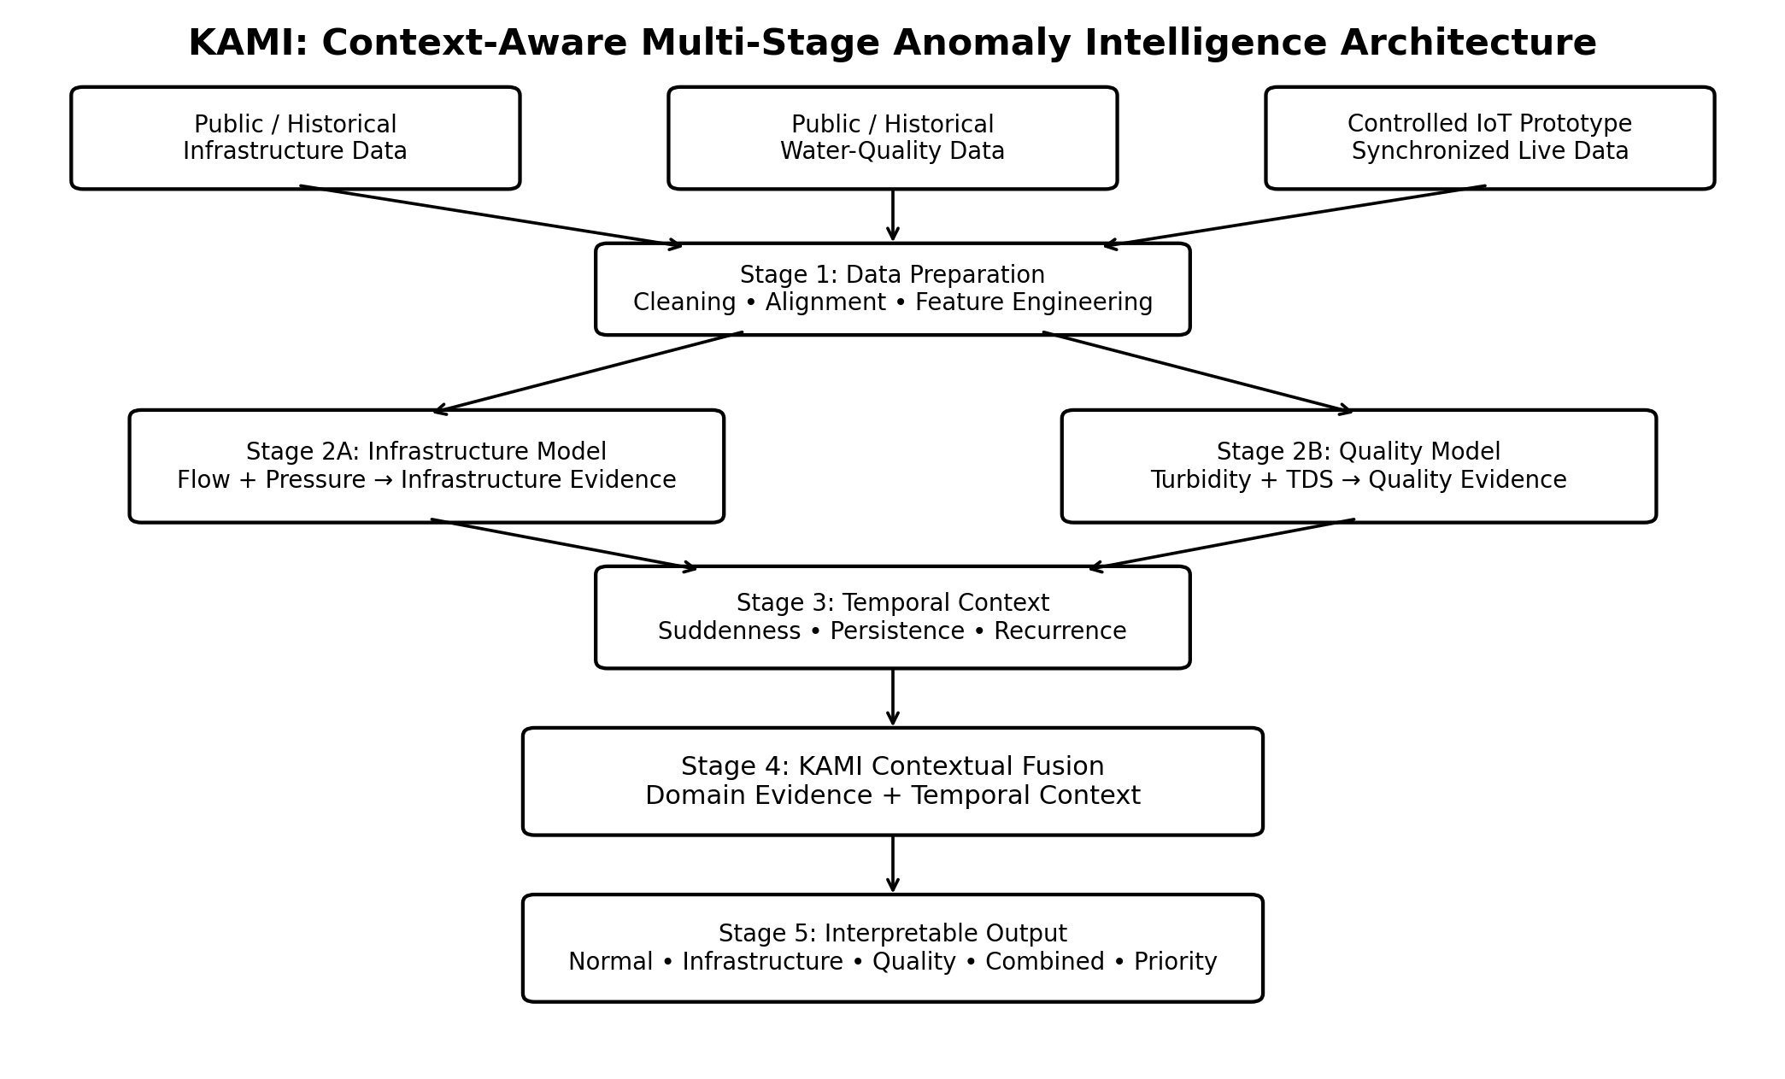
Figure 1. Final refined architecture of the KAMI system.

3.1 Detailed Explanation of the Design
The system is divided into clear stages for easier implementation and understanding.
Stage 1 prepares the data. Historical and public datasets are used to develop the individual analysis modules. A controlled IoT prototype later provides synchronized measurements for end-to-end testing. This distinction is important: separate public datasets can validate individual infrastructure and water-quality modules, but they should not be used to claim real cross-domain correlation unless the variables are synchronized in the same time-series environment.
Stage 2 contains two domain analyses. The infrastructure branch analyses flow and pressure behaviour. The water-quality branch analyses turbidity and TDS behaviour. Each branch produces domain-specific anomaly evidence rather than immediately generating one final alarm.
Stage 3 evaluates temporal context. The system examines whether evidence is sudden, persistent, recurring, or short-lived. This prevents the final output from treating every isolated spike as equally important.
Stage 4 is the KAMI contextual fusion stage. It receives the domain-level evidence and temporal characteristics and generates a final interpretable assessment.
Stage 5 presents the result as a category and priority level. The system can distinguish, for example, between infrastructure-only evidence, quality-only evidence, combined evidence, and persistent higher-priority events.

4. MODULE DESCRIPTION

Module 1: Data Acquisition and Ingestion
Purpose: Collect historical/public data for model development and live synchronized measurements during prototype integration.
Functions: Accept timestamped flow, pressure, turbidity, TDS and available metadata; convert inputs into a common structured format.
Interaction: Sends standardized observations to preprocessing.

Module 2: Data Preprocessing
Purpose: Improve data consistency before analysis.
Functions: Handle missing values, remove duplicates, flag invalid readings, align timestamps and normalize variables where required.
Interaction: Sends cleaned data to feature engineering.

Module 3: Contextual Feature Engineering
Purpose: Represent changes and short-term behaviour in addition to raw sensor values.
Functions: Generate rolling statistics, rates of change, slopes, deviations from recent behaviour and temporal-window features.
Interaction: Supplies features to both domain analysis modules and temporal analysis.

Module 4: Infrastructure Behaviour Analysis
Purpose: Identify unusual joint behaviour in flow and pressure.
Functions: Produce an infrastructure anomaly score/evidence signal using selected baseline and proposed analysis pipelines.
Interaction: Sends infrastructure evidence to temporal analysis and KAMI fusion.

Module 5: Water-Quality Behaviour Analysis
Purpose: Identify unusual behaviour in monitored turbidity and TDS measurements.
Functions: Produce a quality-deviation score/evidence signal; does not independently certify water safety.
Interaction: Sends quality evidence to temporal analysis and KAMI fusion.

Module 6: Temporal Context Analysis
Purpose: Determine whether anomaly evidence is sudden, persistent, recurring or transient.
Functions: Evaluate duration, rolling behaviour and change patterns.
Interaction: Supplies temporal context to KAMI fusion.

Module 7: KAMI Contextual Fusion
Purpose: Combine infrastructure evidence, quality evidence and temporal context.
Functions: Produce an interpretable incident category and priority level using a transparent, testable fusion strategy.
Interaction: Receives outputs from Modules 4–6 and sends the final assessment to visualization.

Module 8: IoT Integration and Visualization
Purpose: Demonstrate real-time input and presentation of KAMI outputs.
Functions: ESP32 collects prototype sensor data and transmits it to the backend; dashboard displays measurements, evidence and final assessment.
Interaction: Supplies live input to Module 1 and receives final outputs from Module 7.

5. DATASET AND METHOD DESCRIPTION

5.1 Dataset Strategy
The final dataset strategy has been refined to avoid a methodological weakness in the earlier design. It is unlikely that one public dataset will contain synchronized flow, pressure, turbidity, TDS, and reliable labels for every anomaly type. Therefore, KAMI uses a three-level strategy.
Level | Data Use | Purpose
Level A | Public/historical infrastructure data | Develop and evaluate the infrastructure-analysis module
Level B | Public/historical water-quality data | Develop and evaluate the water-quality-analysis module
Level C | Controlled synchronized IoT prototype data | Evaluate end-to-end contextual fusion with all selected variables

This is academically more defensible than artificially merging unrelated datasets and claiming that their variables represent one real physical event.

5.2 Candidate Features
Domain | Core Features | Derived Context
Infrastructure | Flow, pressure, timestamp | Rate of change, rolling mean, slope, deviation
Water quality | Turbidity, TDS, timestamp | Trend, short-term change, rolling deviation
Temporal | Timestamp and anomaly history | Persistence, duration, recurrence

5.3 Preprocessing Method
- Inspect the source, sampling interval, available variables and limitations of each dataset.
- Remove duplicate records and identify missing or invalid observations.
- Align synchronized prototype measurements using timestamps.
- Apply normalization or standardization where required by the selected model.
- Generate rolling and rate-of-change features without using future observations during evaluation.
- Use time-aware train/test separation where possible to reduce data leakage.

5.4 Baseline Methods
Method | Role | Reason
Fixed thresholds | Conventional baseline | Represents independent sensor monitoring
Isolation Forest | Primary ML baseline | Suitable for multivariate anomaly detection with limited labels
One-Class SVM | Optional secondary benchmark | Provides an additional one-class comparison if feasible

The baseline methods are included for comparison and evaluation. They are not the claimed novelty of KAMI.

5.5 Proposed KAMI Methodology
The proposed method is a context-aware multi-stage workflow rather than a claim of a completely new underlying machine-learning algorithm.
- Generate domain-specific anomaly evidence from infrastructure data.
- Generate domain-specific anomaly evidence from monitored water-quality data.
- Characterize temporal behaviour of the evidence, including persistence and suddenness.
- Combine the evidence through the KAMI contextual fusion stage.
- Produce an interpretable incident category and priority level.
- Compare the final behaviour against simple threshold-based alerts and selected ML baselines.

5.6 Contextual Fusion Logic
The fusion mechanism will initially be implemented transparently so that its behaviour can be tested and justified during review. The final priority is based on the strength of infrastructure evidence, quality evidence and temporal persistence. The project will avoid claiming a learned causal diagnosis unless sufficient labelled data is available.
Observed Evidence | Illustrative KAMI Output
No significant evidence | Normal
Infrastructure evidence only | Infrastructure anomaly
Quality evidence only | Water-quality deviation
Both domains abnormal in synchronized data | Combined anomaly
Evidence persists or intensifies | Higher-priority event

5.7 Evaluation Method
Evaluation will be adapted to the available labels. Public datasets with confirmed events can support quantitative detection metrics. The synchronized prototype can support controlled scenario testing.
Evaluation Measure | Use
Precision / Recall / F1 | Evaluate labelled anomaly detection
False-positive rate | Measure unnecessary alerts
Detection latency | Measure time required to identify controlled events
Module-level comparison | Compare individual domain modules with baselines
End-to-end controlled scenarios | Test contextual fusion on synchronized prototype data
Interpretability review | Verify that the output identifies the contributing evidence

5.8 IoT Implementation Scope
The IoT implementation is intentionally lightweight. The prototype will use an ESP32 as the edge controller and selected flow, pressure, turbidity and TDS sensors. The purpose is not to build a production-grade municipal IoT network. The purpose is to generate live synchronized measurements and demonstrate that the AI pipeline can operate on real-time input.
The proposed real-time flow is: Sensors → ESP32 → MQTT or HTTP/API → Backend/Data Receiver → KAMI Pipeline → Dashboard/Alert.

5.9 Feasibility and Risk Control
Risk | Final Refinement / Control
Project becomes too broad | Core scope limited to contextual anomaly intelligence
No single complete public dataset | Separate module validation plus synchronized prototype data
Weak novelty claim | Existing algorithms are baselines; contribution is the staged contextual methodology
Hardware delays AI development | AI pipeline developed offline before IoT integration
Low-cost quality sensors are noisy | Prototype used for anomaly indication, not regulatory certification
Fusion becomes arbitrary | Use transparent rules first and justify/test every fusion decision

CONCLUSION
After reviewing the original KAMI abstract, the Water Access Navigator source project, the professor's methodology feedback, and the First Phase report requirements, the strongest final direction is a focused AI-first project rather than another broad smart-water platform.
The most important refinement in this final version is the dataset and evaluation design. Infrastructure and water-quality modules may be developed on suitable separate public datasets, but true combined contextual fusion should be evaluated only on synchronized data. The controlled IoT prototype provides a feasible way to create that synchronized end-to-end test environment.
This makes KAMI more technically honest, easier to implement, and easier to defend. The project remains sufficiently AI-oriented while the IoT layer provides a realistic path to live deployment.

REFERENCES
[1] M. N. Kanyama, F. Bhunu Shava, A. M. Gamundani, and A. Hartmann, “Machine learning applications for anomaly detection in Smart Water Metering Networks: A systematic review,” Physics and Chemistry of the Earth, vol. 134, 2024, Art. no. 103558. doi: 10.1016/j.pce.2024.103558.
[2] J. Babela, M. Munk, and D. Munkova, “A multisource dataset for anomaly detection and fault prediction in urban water distribution networks,” Scientific Data, vol. 13, Art. 901, 2026. doi: 10.1038/s41597-026-07203-5.
[3] Z. Li, W. Ma, D. Zhong, J. Ma, Q. Zhang, Y. Yuan, X. Liu, X. Wang, and K. Zou, “Applications of machine learning in drinking water quality management: A critical review on water distribution system,” Journal of Cleaner Production, vol. 481, Art. 144171, 2024. doi: 10.1016/j.jclepro.2024.144171.
[4] Project Report First Phase Submission Instructions, provided course document.
[5] “Water Access Navigator: An AI-Driven Multilingual Chatbot for Accessible Water Information Dissemination in India,” source project document reviewed as conceptual background.
[6] “KAMI: A Knowledge-driven Artificial Intelligence Platform for Predictive Water Governance, Infrastructure Intelligence, and Smart Resource Management,” original project abstract.

FINAL PROJECT POSITIONING
KAMI is an AI-based water monitoring system that analyses infrastructure and water-quality data to detect and prioritize abnormal events. Existing AI methods are used as baselines, while IoT provides real-time data.

