# **Project 4**

# **Assignment 4b**

# **Database Systems**

**NAME : VINAY BATHULA**

**STUDENT ID : L30080730**

**SCHOOL : LEWIS UNIVERSITY**

**PROFESSOR : MATTHEW CLAVELLI**

**Step 1: Adding a New ENUM Column**

**SQL Query:**

***ALTER TABLE customers***

***ADD COLUMN status ENUM('Active', 'Inactive') NOT NULL;***

**Before**

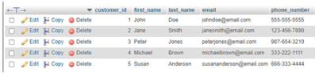

**After**

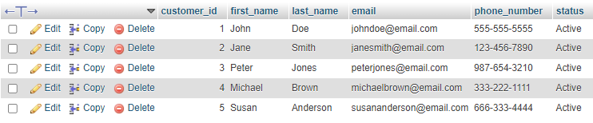

**Step 2: Inserting a New Record**

**SQL Query:**

***INSERT INTO customers (first_name, last_name, email, phone_number, status)***

***VALUES ('Michael', 'Brown', 'michaelbrown@email.com', '333-222-1111', );***

**Error**

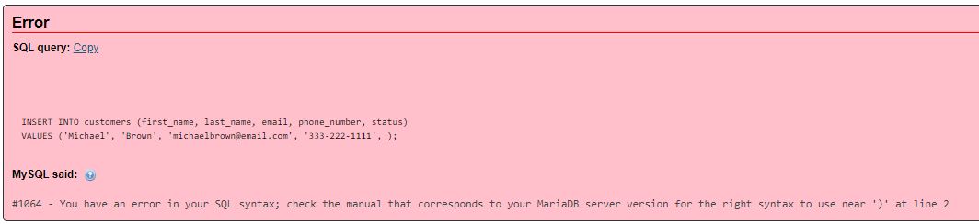

**After**

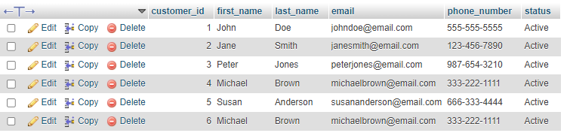

**Step 3: Modifying the Newly Added Record**

**SQL Query:**

***UPDATE customers***

***SET first_name = 'Michael',***

***last_name = 'Brown',***

***email = 'michaelbrown@email.com',***

***phone_number = '333-222-1111',***

***status = 'Inactive'***

***WHERE customer_id = 4;***

**Before**



**After**

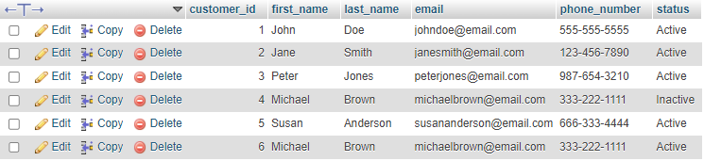

**Step 4: Deleting the Newly Added Record**

**SQL Query:**

***DELETE FROM customers***

***WHERE customer_id = 4;***

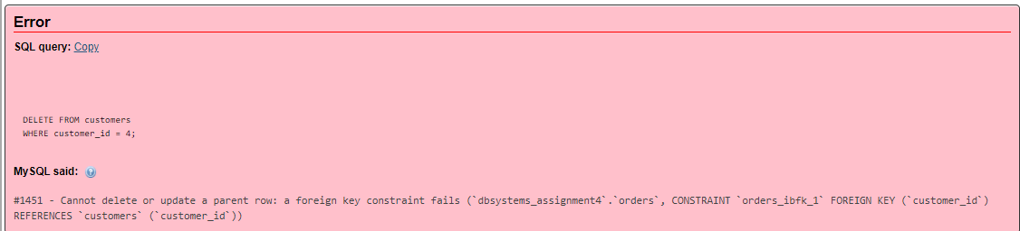

**Step 5: Demonstrating the Use of the AUTO_INCREMENT Constraint**

The AUTO_INCREMENT constraint is a constraint that automatically increments a column by 1 each time a new record is inserted into the table. This constraint is typically used for primary key columns.

To demonstrate the use of the AUTO_INCREMENT constraint, we will add a new record to the customers table. The customers table already has a primary key column called customer_id, which is an INT type with the AUTO_INCREMENT constraint.

**SQL Query:**

***INSERT INTO customers (first_name, last_name, email, phone_number, status)***

***VALUES ('David', 'Williams', 'davidwilliams@email.com', '444-111-2222', 'Active');***

**Before**

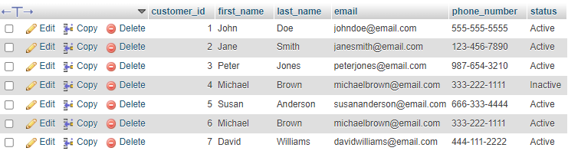

**After**



**Step 6: Demonstrating the Use of the DEFAULT Constraint**

The DEFAULT constraint is a constraint that specifies a default value for a column. This value will be used if no value is specified when a new record is inserted into the table.

To demonstrate the use of the DEFAULT constraint, we will add a new record to the customers table. The customers table already has a status column, which is an ENUM type with a default value of 'Active'.

**SQL Query:**

***INSERT INTO customers (first_name, last_name, email, phone_number)***

***VALUES ('Susan', 'Anderson', 'susananderson@email.com', '666-333-4444');***

**Before:**



**After**

