# **Project 3**

# **ERD Model Part 3**

**Name: Vinay Bathula**

**Student ID: L30080730**

**ERD using UML**

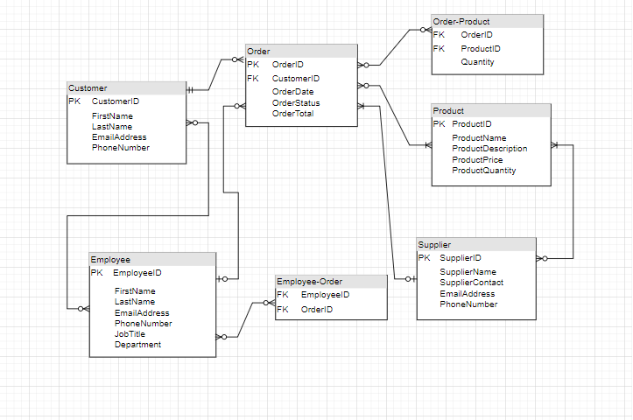

***Product***

***ProductID (PK)***

***ProductName***

***ProductDescription***

***ProductPrice***

***ProductQuantity***

***Customer***

***CustomerID (PK)***

***FirstName***

***LastName***

***EmailAddress***

***PhoneNumber***

***Order***

***OrderID (PK)***

***CustomerID (FK)***

***OrderDate***

***OrderStatus***

***OrderTotal***

***Employee***

***EmployeeID (PK)***

***FirstName***

***LastName***

***EmailAddress***

***PhoneNumber***

***JobTitle***

***Department***

***Supplier***

***SupplierID (PK)***

***SupplierName***

***ContactName***

***EmailAddress***

***PhoneNumber***

***Order-Product***

***OrderID (FK)***

***ProductID (FK)***

***Quantity***

***Employee-Order***

***EmployeeID (FK)***

***OrderID (FK)***

**ERD using Crow’s Foot notation**

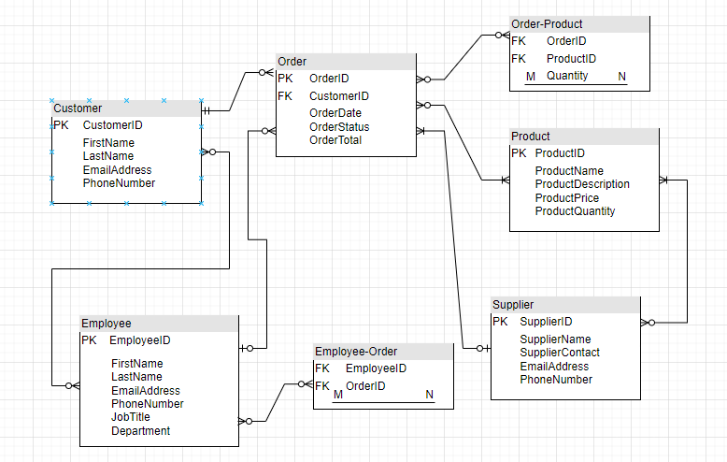

***Product***

***- ProductID (PK)***

***- ProductName***

***- ProductDescription***

***- ProductPrice***

***- ProductQuantity***

***Customer***

***- CustomerID (PK)***

***- FirstName***

***- LastName***

***- EmailAddress***

***- PhoneNumber***

***Order***

***- OrderID (PK)***

***- CustomerID (FK)***

***1:N***

***- OrderDate***

***- OrderStatus***

***- OrderTotal***

***Employee***

***- EmployeeID (PK)***

***- FirstName***

***- LastName***

***- EmailAddress***

***- PhoneNumber***

***- JobTitle***

***- Department***

***Supplier***

***- SupplierID (PK)***

***- SupplierName***

***- ContactName***

***- EmailAddress***

***- PhoneNumber***

***Order-Product***

***- OrderID (FK)***

***- ProductID (FK)***

***M:N***

***- Quantity***

***Employee-Order***

***- EmployeeID (FK)***

***- OrderID (FK)***

***M:N***

**Descriptions of the relationships**

* Product-Customer: A customer can order one or more products.
* Product-Order: An order can have one or more products.
* Order-Employee: An employee can be assigned to one or more orders.
* Customer-Order: A customer can place one or more orders.
* Employee-Supplier: An employee can be assigned to one or more suppliers.
* Supplier-Order: A supplier can be assigned to one or more orders.
* Order-Product: An order can have one or more products.
* Product-Order-Product: An order-product record is used to track the quantity of a product that was ordered.
* Employee-Order-Employee: An employee-order record is used to track the employee who was assigned to an order.
* Supplier-Order-Supplier: A supplier-order record is used to track the supplier who was assigned to an order.