**Capstone-Project**

**AUTOMATION TESTING FOR LUMA WEBSITE**

**Name:** CHINTHA VINAY KUMAR

**Email:** [**vinay.chinta36@gmail.com**](mailto:vinay.chinta36@gmail.com)

**Batch:** 4

**Website Name: Magento Luma Website**

**Website Url:** https://magento.softwaretestingboard.com/

**1. Introduction**

The Automation Testing Capstone Project focused on the website marked as significant milestone in the participants' learning journey. The project provided an opportunity to apply knowledge and skills acquired during the automation testing training, incorporating Selenium, TestNG, Cucumber, Apache POI, a hybrid framework, and advanced reporting tools like Allure/Extent. The objective is to create a comprehensive automation testing solution, fostering practical experience and showcasing participants' abilities to potential employers.

**Problem Statement & Expectation:**

In an online shopping/pet portal, where participants are going to work on different projects. Where user can register, login and buy any of the available items. Users can search for the item and add to the cart. Update the cart with quantity or with another item if required and make the payment. Objective is to Automate these workflows using Selenium with TestNG, Page Object Model and getting the data from data sheet/properties file. There by, we are testing faster and accurate using automation technique.

**3. Tools & Technologies Used**

- Programming Language: Java 17

- Automation Framework: Selenium WebDriver

- Testing Frameworks: TestNG, JUnit

- Behavior-Driven Testing (BDD): Cucumber

- Build Tool: Maven

- Reporting Tools: Extent Reports, Allure Reports

- IDE: Eclipse

- Data Handling: Excel, Properties Files

- Version Control / CI-CD: GitHub / Jenkins

- Cross-Browser Testing: Chrome & Firefox

**4. Project Objective**

The objective of this project is to automate the testing of key functionalities of an e-commerce Demo Web Shop website. The project covers the following test cases:

* **User Registration**
* **User Login**
* **Adding Books to Cart**

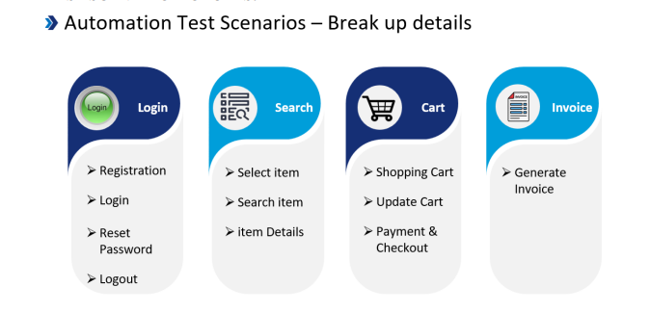

**5. Project Structure**

The project is organized into multiple packages and classes for better maintainability and readability.

src/test/java

|── base # Base class for WebDriver initialization

|── pages # Page Object Model (POM) classes for UI interactions

|── testpages # Test classes for different scenarios

|── utilities # Utility classes (configreader, Extent Report generator)

|── data #here we have the properties file

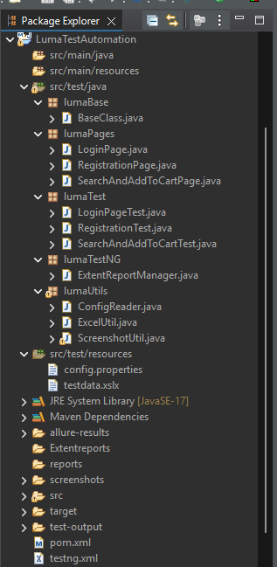

**6. Key Components**

**6.1. Base Class**

* The BaseClass.java handles the WebDriver initialization , browser configurations and taking a screenshot of the current page using Screenshot.

**1. Browser Initialization**

* Accepts a browser name as input (chrome, firefox, or edge).
* Launches the specified browser using WebDriver and maximizes the window.
* Displays an error message for invalid browser names.

**2. Screenshot Capture (screenshot)**

* Takes a screenshot of the current page using Screenshot.
* Saves the screenshot in the ./screenshot/ folder with a timestamped filename.

**6.2. Utility Classes**

* **ConfigReader.java:**
  + Used for reading test data from a properties file.
* **ExtentReport.java:**
  + The ExtentReport.java file is responsible for generating detailed HTML reports for the test execution.
* **Report Initialization:**
  + Uses ExtentReports and ExtentSparkReporter to generate reports.
* **Report Creation:**
  + Creates a new HTML report named ExtentReport.html.
  + Adds test cases dynamically to the report using createTest().
* **Report Attachment:**
  + Attaches the sparkReporter to the ExtentReports instance.
  + Allows tracking of test execution status with visual logs.

**7. Test Cases**

**7.1. User Registration Test**

**Class:** RegisterTest.java  
**Description:** Automates the registration process using Selenium WebDriver ,TestNG and Page Object Model.

**Steps:**

1. **Reading Properties File:**

* The @BeforeTest method reads the **URL** from the config.properties file using FileInputStream

2.**Launching the Browser:**

* The @Test method uses the @Parameters annotation to run on different browsers.
* It invokes the browser, navigates to the URL, and applies **implicit wait** for stable execution and maximizing the window.

3.**Registering a User:**

* Uses the RegisterPage class to interact with the **registration page** elements.
* Reads **user details** (first name, last name, email, password, and confirm password) from a properties file.
* Fills the form and clicks the **register button**.
* Then it displays **My Account with** user details. (Successful Registration)

4. **Logging Execution Status:**

* The test logs execution status using **ExtentReport**, marking the test as **PASS** if registration is successful.

5.**Closing the Browser:**

* The @AfterTest method closes the browser using driver.quit() and flushes the Extent Report data.

**7.2. User Login Test**

**Class:** LoginPageTest.java  
**Description:** Automates the login process.  
**Steps:**

1. **Reading Properties File:**

* The @BeforeTest method reads data from the LoginData.xslx file using FileInputStream(FIS).
* It extracts the **URL, email, and password** for the test and initializes.

2. **Launching the Browser:**

* The @Test method uses the @Parameters annotation to run the test on different browsers.
* The setUp() method opens the specified browser and navigates to the URL.
* It applies **implicit wait** for smooth execution.

3.**Performing Login Actions:**

* Uses LoginPage to interact with the **login page** elements.
* Enters the **email and password**, clicks and logs in.

4. **Validating and Logging Test Status:**

* Uses ExtentReport.createTest() to log the execution status as **PASS**.
* Sleeps for 2 seconds to allow the actions to complete.

5. **Closing the Browser:**

* The @AfterTest method closes the browser using driver.quit() and flushes the Extent Report data.
* This ensures proper cleanup after the test execution.

**7.3.Search And Add to Cart Test**

**Class:** CartTest.java  
**Description:** The CartTest.java file contains the test cases to automate the "Search And Add to Cart" functionality for fitness products using Selenium and TestNG.  
**Steps:**

1. **Property File Reading:**
   * Reads the application URL from the config.properties file using FileInputStream and Properties class.
   * Initializes the Extent Report instance for test logging.
2. **Browser Launching:**
   * Uses the @Parameters annotation to run tests on multiple browsers.
   * Opens the specified browser and navigates to the given URL.
3. **Homepage Navigation:**
   * Instantiates the HomePage class.
   * Hover over on the **Mens**.
4. **Product Filtering & Sorting:**
   * After Hover over Mens -> Hover over **Tops** section.
   * After Hover over **Tops ->** Click on Jackets section.
   * In **Jackets** section search for **“Jupiter – All Weather Trainer”** using linkText.
5. **Add to Cart Functionality:**
   * Adds Jacket product to the cart.
   * Verifies the **success message** and logs the result in the Extent Report.
6. **Browser Cleanup & Report Generation:**
   * Closes the browser after the test execution.
   * Flushes the Extent Report to save the results.

**8. Reporting**

* **Extent Reports**:
  + The project uses Extent Reports to generate detailed and customizable test reports.
  + Each test execution generates a new report with the pass/fail status, execution time.

**9. Execution Flow**

1. **Execution :**
   * The project uses TestNG for test execution, with parameters for browser configuration.
   * Execute with .xml file.
2. **Reports:**
   * After execution, Extent Reports are generated in the test-output folder.
   * Reports include details of each test case, execution time.

**10. Challenges and Solutions**

* The test script fails intermittently due to elements not being available immediately after page navigation or actions.
  + Implemented **Explicit Wait** using WebDriverWait to wait for specific conditions before interacting with elements. Example:
    - WebDriverWait wait = new WebDriverWait(driver, Duration.ofSeconds(10));
    - WebElement element = wait.until(ExpectedConditions.visibilityOfElementLocated(By.id("exampleElement")));
* **Synchronization Issues:**
  + Handled using Thread.sleep() and driver.manage().timeouts().implicitlyWait() for stability.

**11. Conclusion**

This Selenium-based Java automation project demonstrates the ability to perform end-to-end testing of a Magento Luma website. It effectively uses TestNG, Selenium WebDriver, and Extent Reports to automate and validate key functionalities. The project is modular, easy to maintain, and generates detailed reports for efficient debugging and test case validation.