# Hands-on #12 : AWS Services Lambda & Glue & Athena : Serverless ETL Pipeline

1. S3 file upload screenshot:

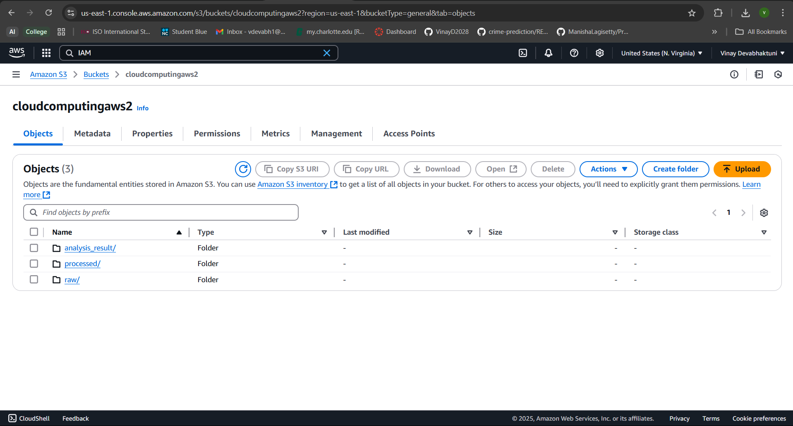

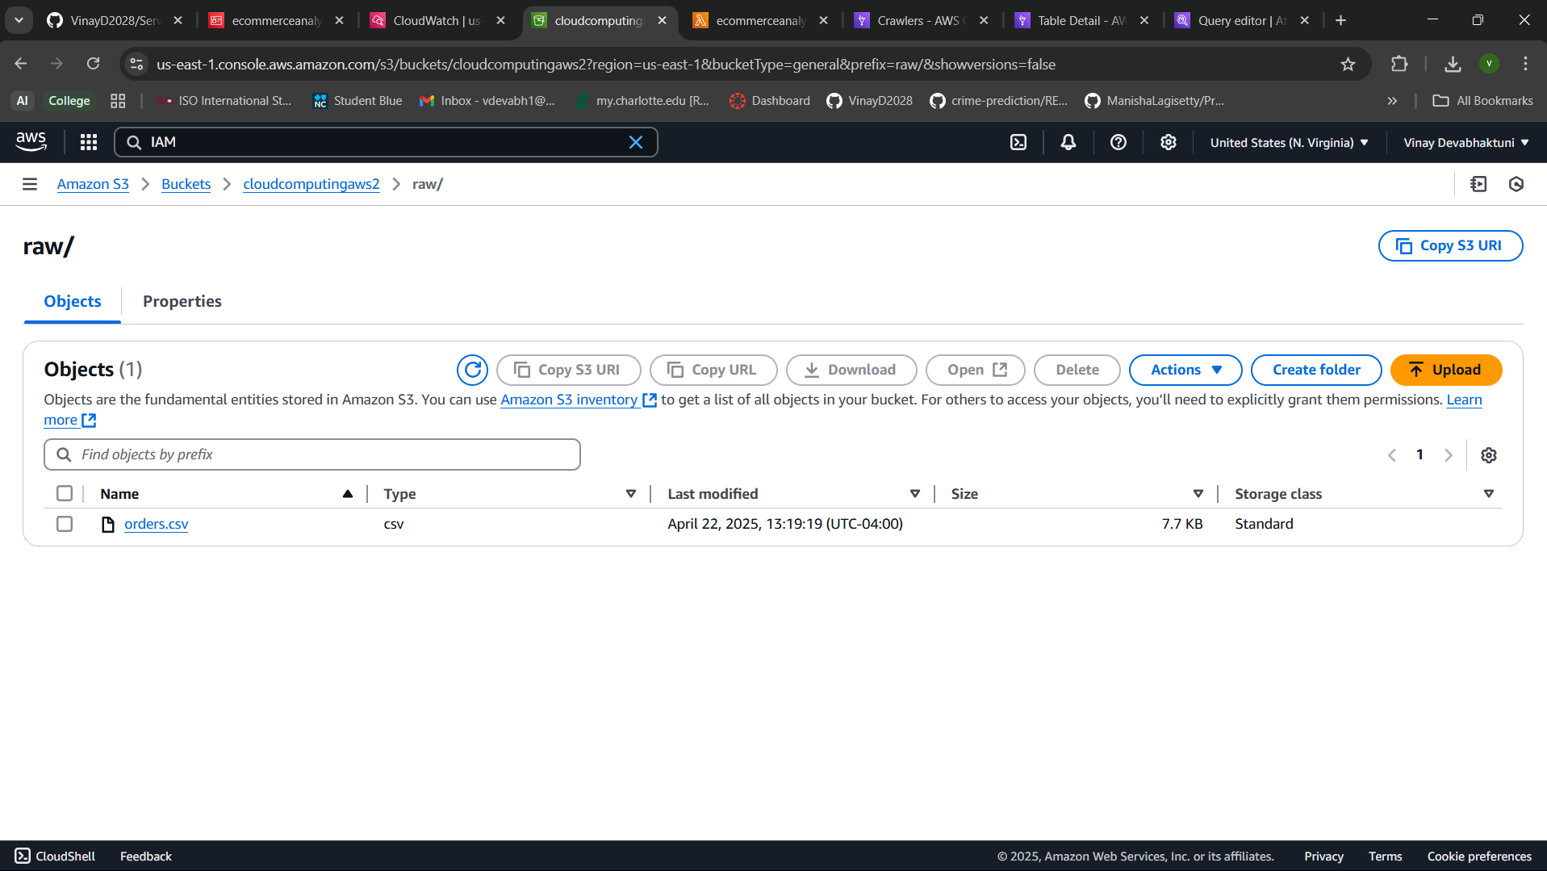

1. Lambda execution screenshot:

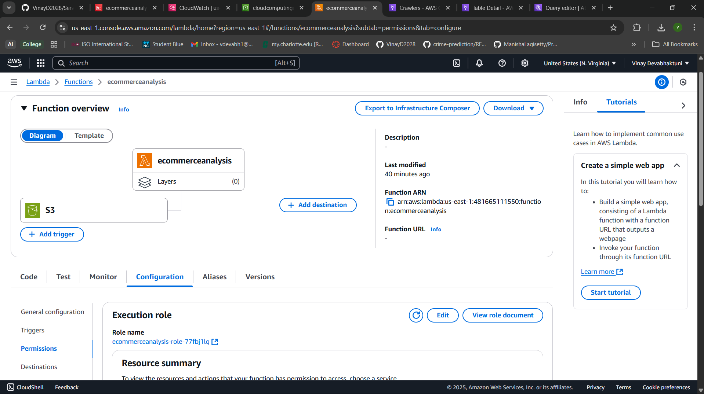

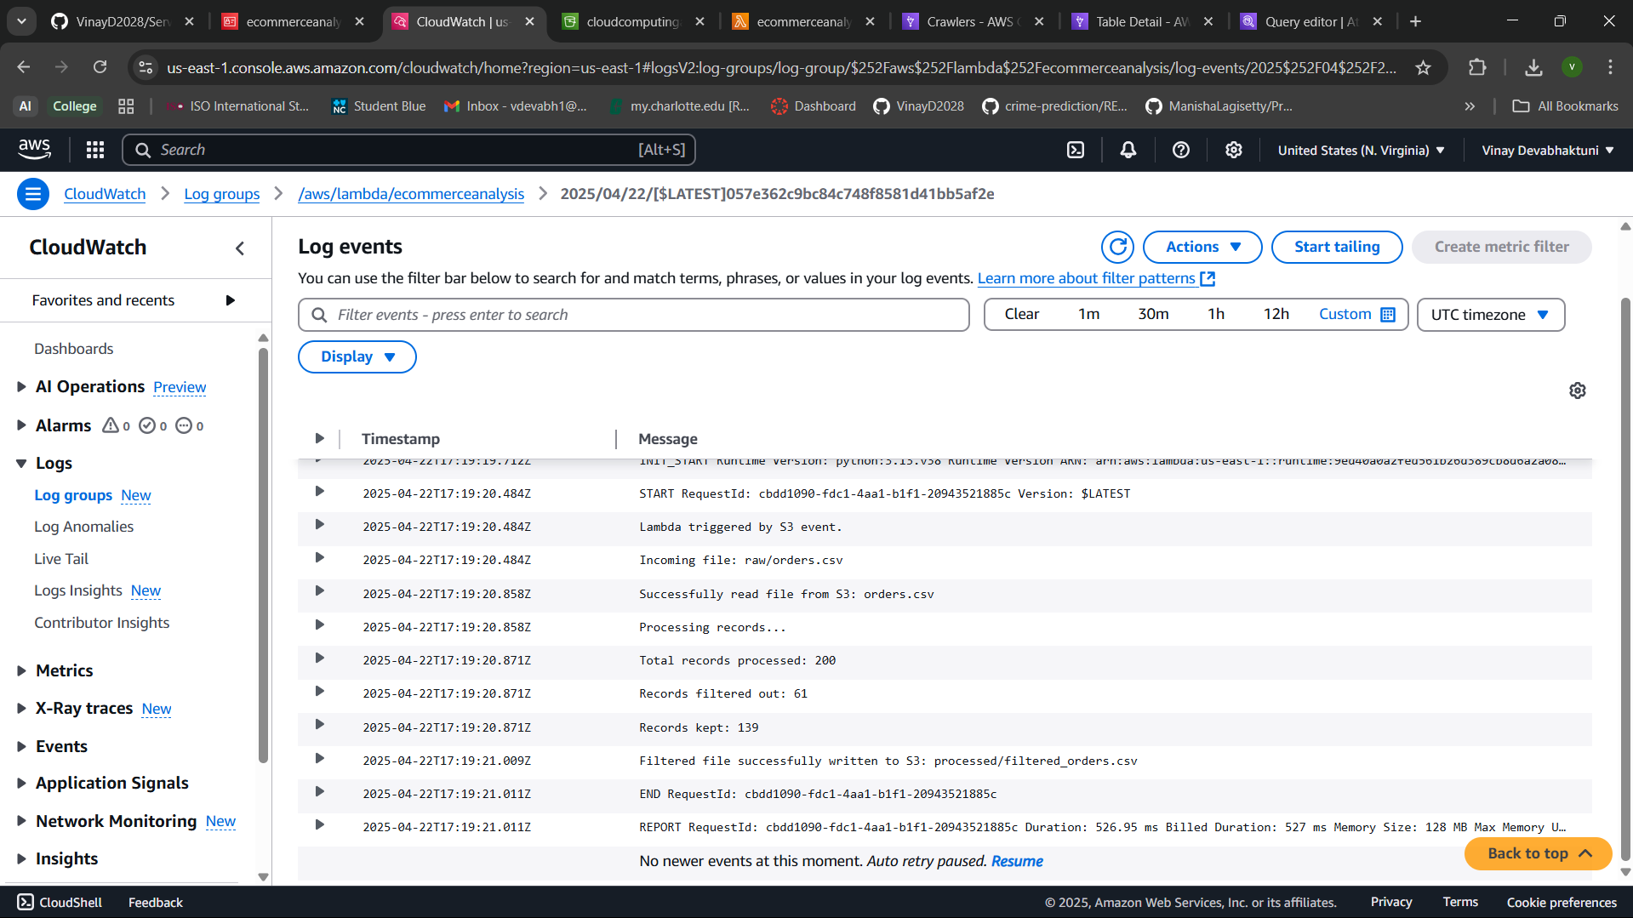

1. Glue crawler screenshot:

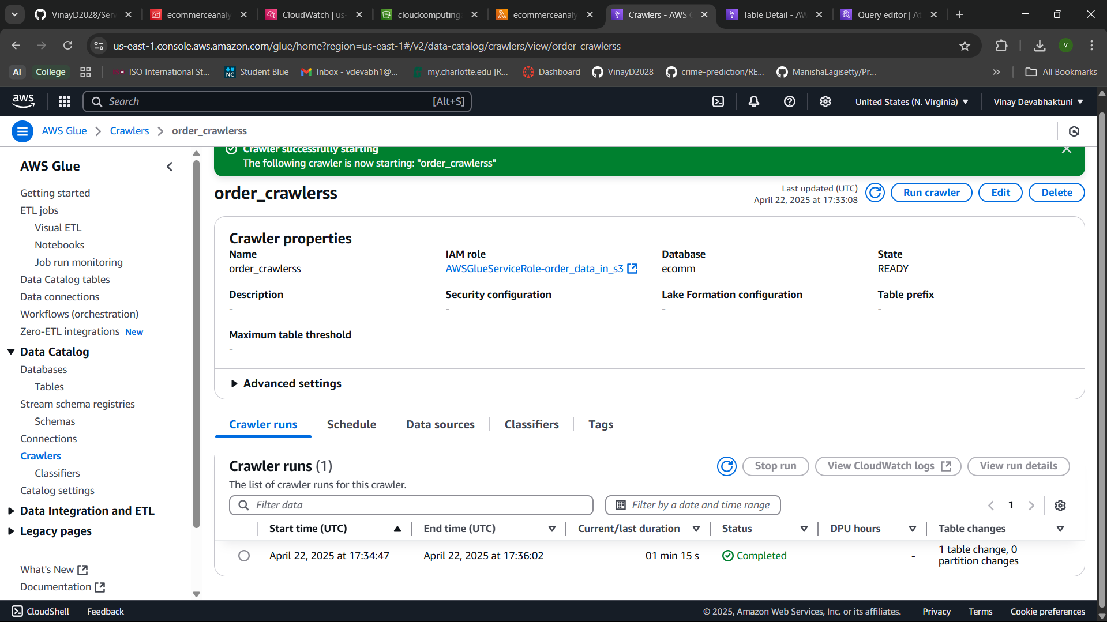

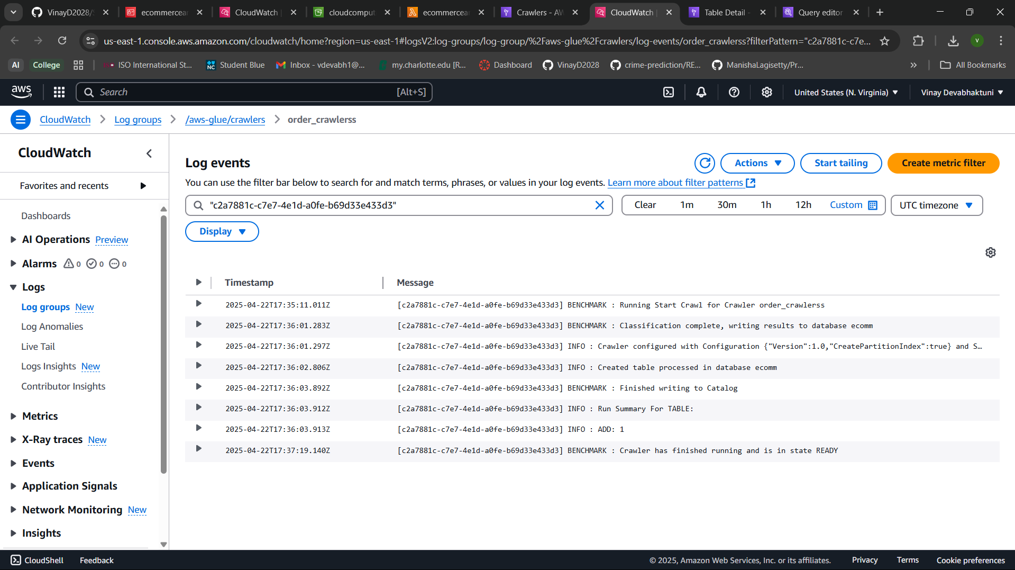

1. Athena queries screenshot

Recent 10 orders:

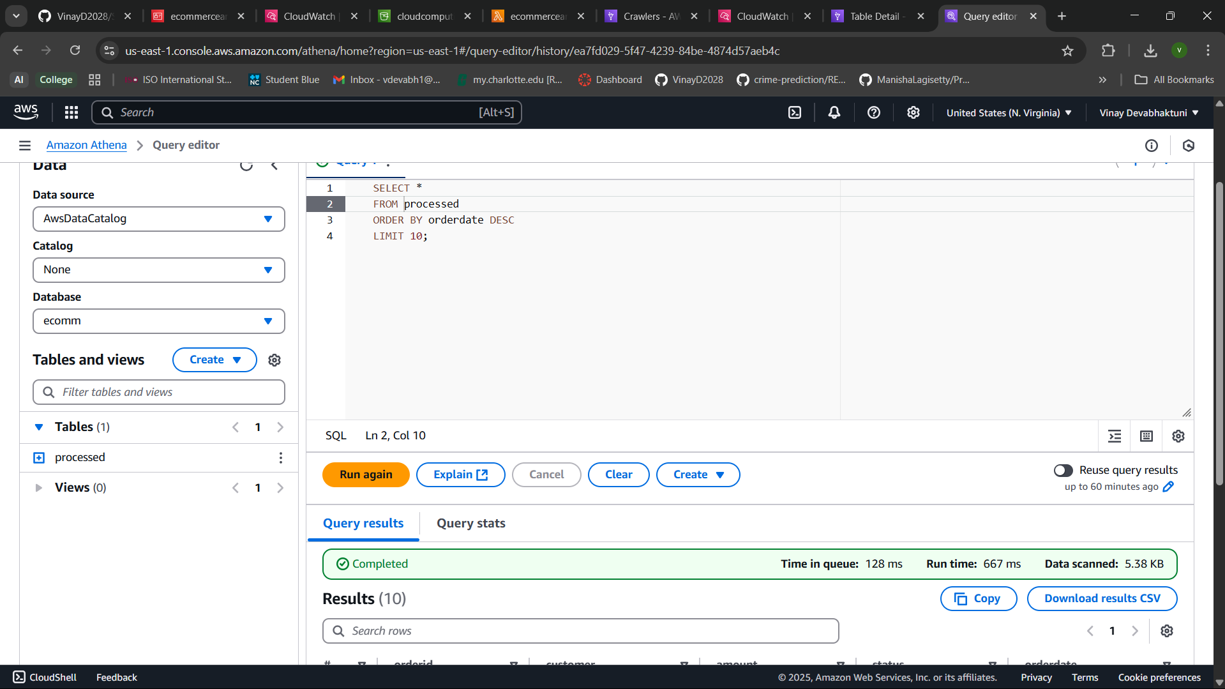:

Total revenue of fulfilled orders:

