1. Load the NWH temperature dataset and calculate the means of the first ten columns. What is the maximum mean temperature value?

Dataset: NWH_temp_data_25_1901_2017_cru_data

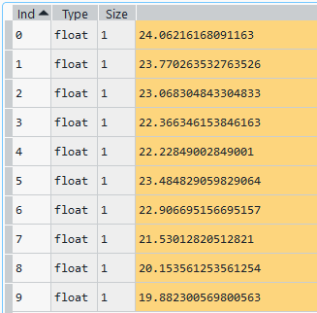



1. Plot the annual mean temperature of the above dataset. (To plot annual mean temperature, first you need to find the average temp of each year).

Dataset: NWH_temp_data_25_1901_2017_cru_data

Different colour indicates different location.

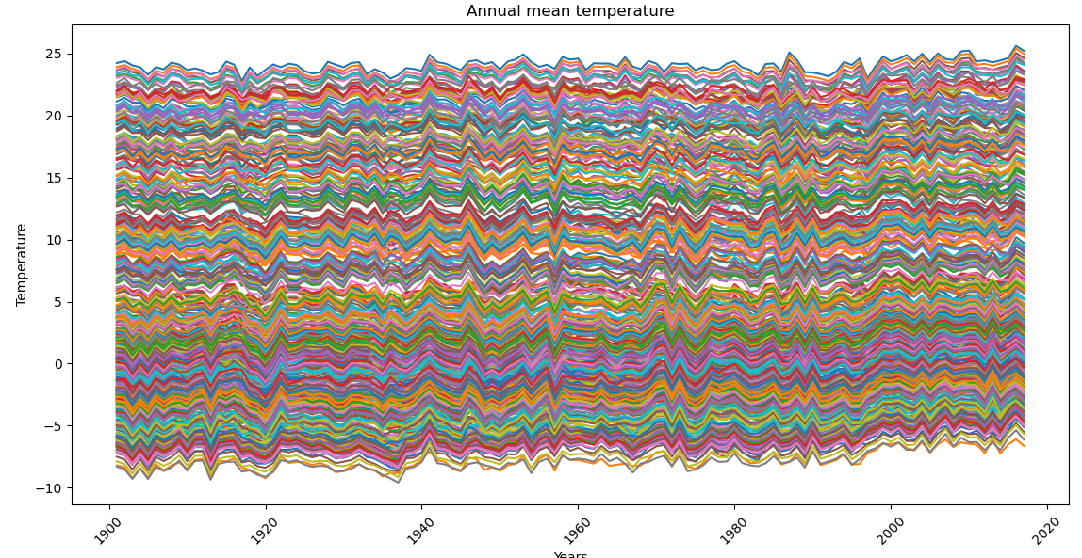

1. Find the temperature of the hottest month for each year. (This dataset contains average monthly temp from 1901-2017).

Dataset: NWH_temp_data_25_1901_2017_cru_data

Different colour indicates different location.

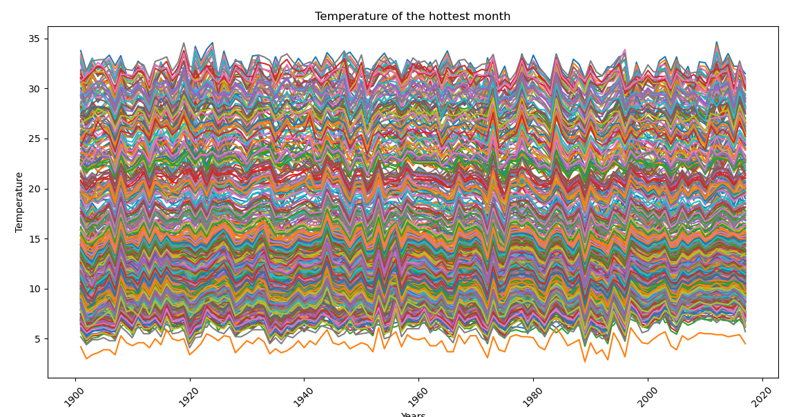

1. Store the hottest temperature of the month (which is calculated in the above question) in a data frame and export it to your working directory).

Dataset: NWH_temp_data_25_1901_2017_cru_data

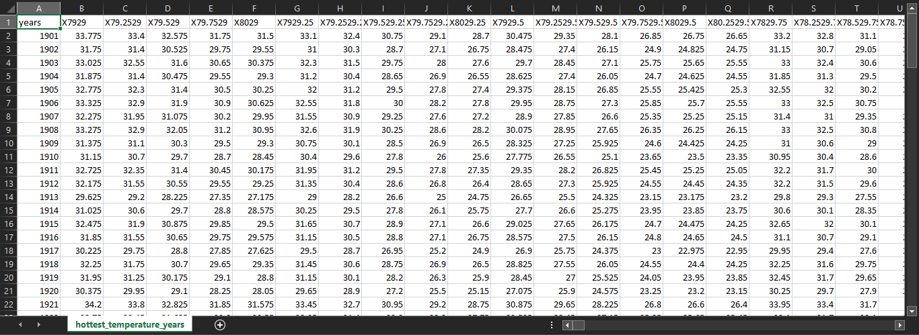

1. Find the range (difference between maximum and minimum value) of monthly temperature for the last ten years. Also, plot it.

Dataset: NWH_temp_data_25_1901_2017_cru_data

Different colour indicates different location.

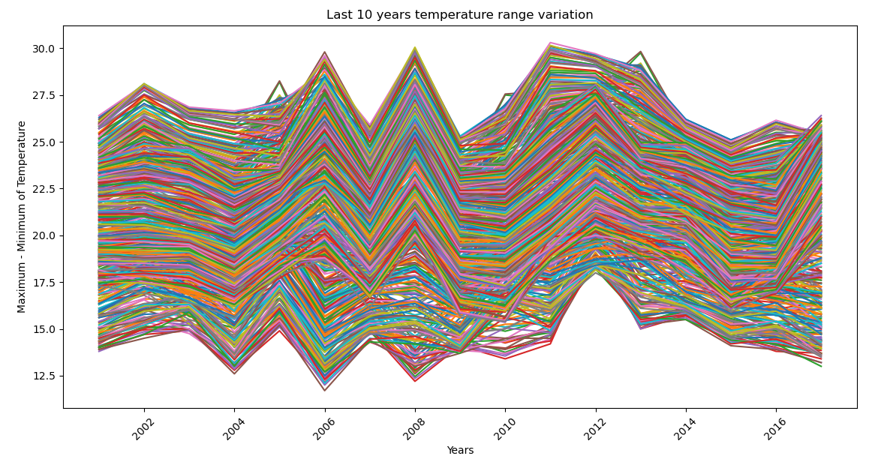

1. Plot the shape file of north-western Himalaya region.

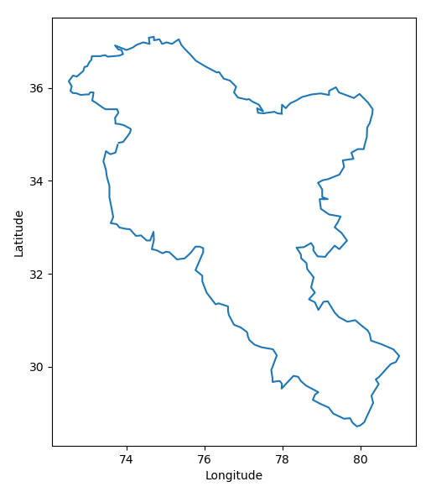

1. Plot the shape file of India.

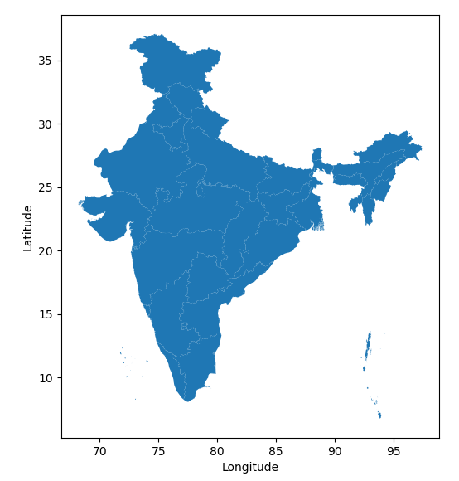

1. Plot the mean temperature over 528 grids of North-Western Himalayas.

