

**TITLE OF THE PROJECT**

**PyTypingTest**

**PROJECT BY:**

NAME: VINAY KUMAR SHUKLA

ENROLLMENT NUMBER: **186877428**

COURSE SESSION: 6TH SEMESTER

MOBILE NUMBER: 9910837119

COURSE CODE: BCSP-064

STUDY CENTRE CODE: 38040 ( A-CUBE CENTRE FOR EXCELLENCE )

REGIONAL CENTRE: RC-DELHI-03

EMAIL ID: vk21677@gmail.com

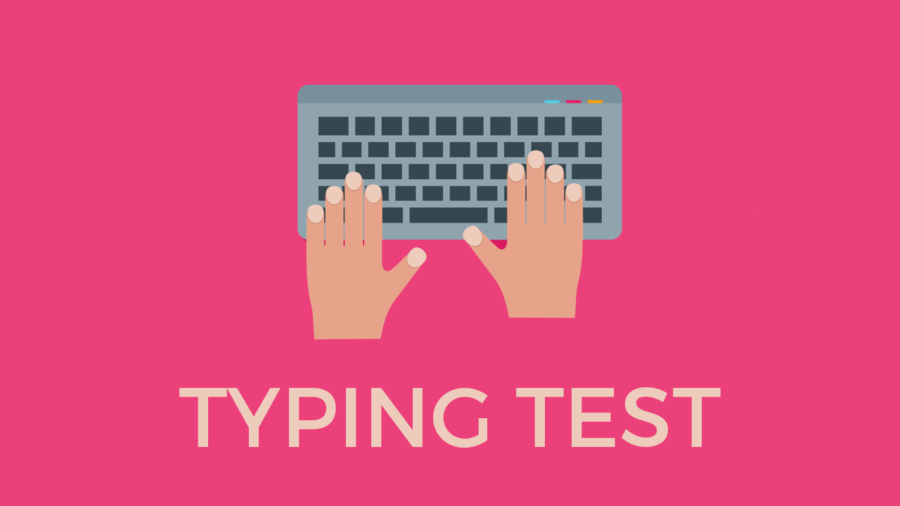

**UNDER GUIDANCE OF:**

MR. THEJAS N

**CONTENTS**

1 Introduction and Objectives ................................................................

2. Project Category ..................................................................................

3. Analysis ...............................................................................................

**1. INTRODUCTION AND OBJECTIVE:**

In this computer systems dominating world, Everyone wants to increase their typing speed in the computer so to do this they oftenly practice their typing speed by using a tool, Most commonly refer to as “Typing Test”. As It is very common application to be in use. I decided to give a try to this application.

The Main Objective of developing this application is to test the ability of the User to increase it’s typing speed and can effieciently use every key present in the keyboard.

In this application, I will try to test the User skills by giving him/her those sentences which consist of all the keys combination present in the keyboard. So that User can optimize use of all keys present in the keyboard.

After the test, I will also provide them Statistics of their test, So that the User will know it’s weakness and the area he/she needs to improve in order to increase his/her speed in the keyboard.

I will try to make the GUI as simple So that age level of user will find’s it’s attractive and will also enjoy using this application, along with developing it’s skills.

I have decided to give to allow the user to test his skills according to his knowledge like I will provide three levels of **dificulty** in the application which are described below:

* **Beginner:** I have decided to make this level very simple. In this level, The Sentences given to the user will combine only the alphabets and numbers key present on the keyboard. So that the Beginner level of user can test his skills on the primary keys of the keyboard. The length of the sentence in this level will be very short so that user can test his skills for short sentences.
* **Intermediate:** In this level, The Sentences given to the user will combine the special keys also from the keyboard. So that the user now can test his skill against the more broad area of the keyboard. The sentences in this level will include all the special symbols of the keyboard and the length of the sentences will also be more compare to the previous level.
* **Hard:** I have decided to make this level the hardest among the other two levels. The length of sentences in this level will be more, The Sentences will combine all the keys of the keyboard.

I will also try to add the time functinality in the application so that user can set the timing also for which amount of period. He wants to attempt certain sentences.

The timing slots will be given like 1 min, 2 min, 5 min, 30 min, 1 hour.

I think that much functionality can be easily developed within the time limit to make the project and will also serve good purpose for its use.

**2. PROJECT CATEGORY (OOPS)**

I will formulate all the implementation of this project using the concept of OOPS, So that my application can easlily reflect real world entities into the application and security will be higher as we know in OOPS, objects communicates by sending message to each other without knowing each other details.

So using OOPS concept will ensure my application flexibility. I will try to develop the functionality independant of each other using the modular approach of the developement. So that each module will be responsible for performing it’s task without taking much care about other modules.

**3. ANALYSIS**