Micro‑Burst Fusion Reactor (MBFR)

Scalable D–T inertial fusion for low‑cost electricity

Last updated: 2025-08-11 10:23 IST

# Figures

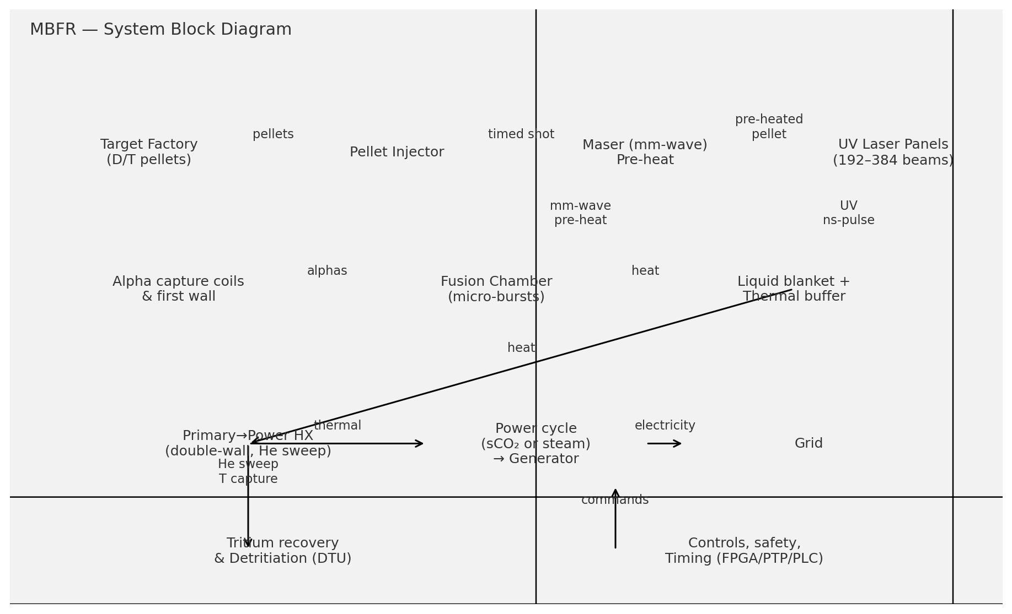

*Figure A — System block diagram*

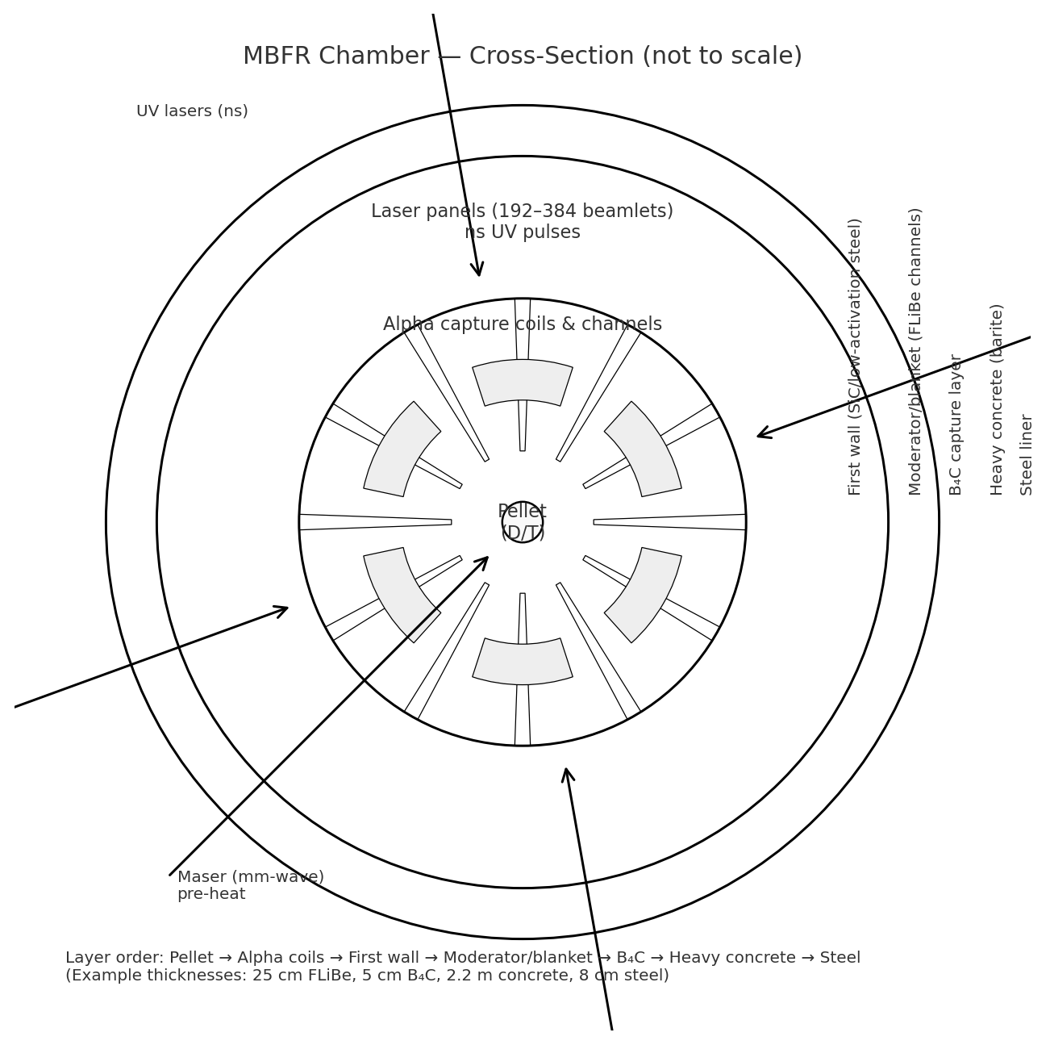

*Figure B — Chamber cross‑section (schematic)*

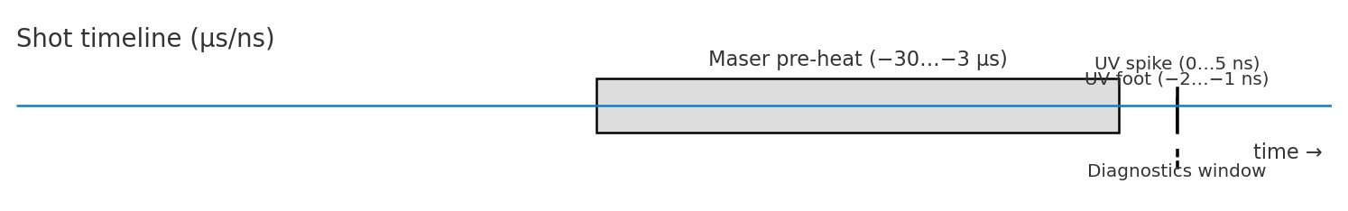

*Figure C — Shot timing (µs/ns)*

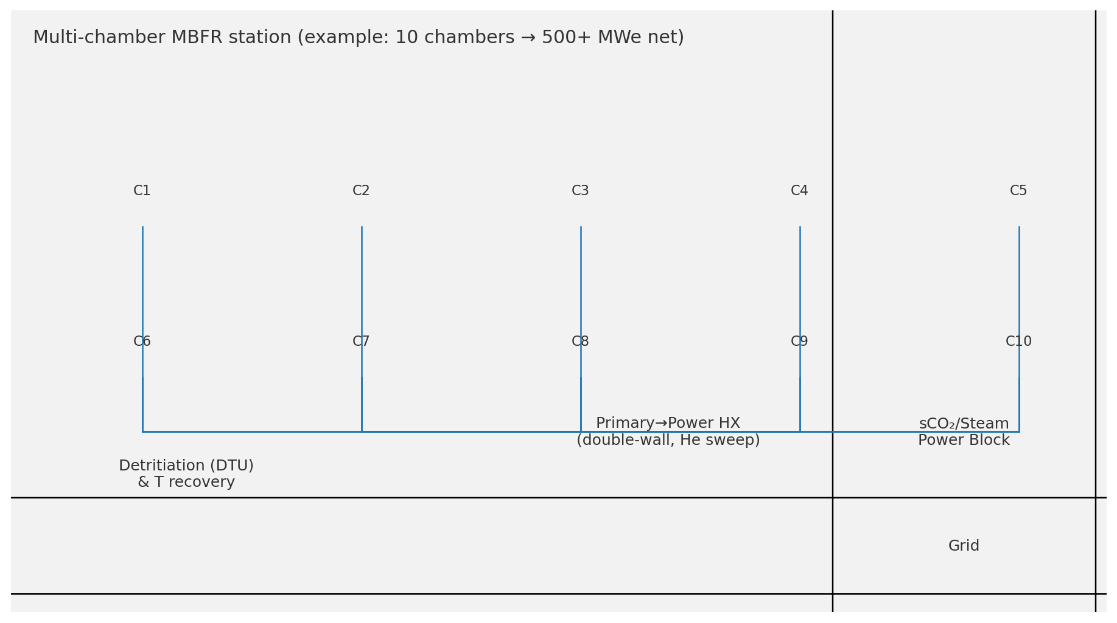

*Figure D — Multi‑chamber station layout*

## Plain‑language overview (for non‑specialists)

* **What MBFR is:** a power plant that makes heat by firing many **tiny fusion bursts each second**. There is **no big, continuous plasma** to confine. The heat then runs a standard turbine to make electricity.
* **How one burst works:** a **small frozen fuel pellet** (deuterium + tritium) flies through the chamber. A **millimetre‑wave maser** gives it a gentle, even pre‑heat so the main **ultraviolet lasers** couple better. The lasers fire for a few **nanoseconds**, the pellet fuses, and the energy appears as **helium nuclei (alphas)** and **neutrons**. Nearby structures and a **liquid blanket** absorb this energy as heat.
* **Why bigger plants are cheaper:** the fuel‑pellet cost per MWh barely changes with size, but **big plants spread fixed costs** (drivers, shielding, tritium systems, turbine island, staff) over far more output. That’s why we aim for **400–600 megawatts electric (MWe)**.
* **Safety in plain terms:** thick shielding cuts radiation to **background‑like levels at the site fence**; tritium stays in sealed loops with **detritiation** and **permeation barriers**; double‑wall heat‑exchangers have a monitored **helium sweep** to catch leaks. This is **not “no radiation”**—it is **radiation contained on‑site**.
* **Status:** the numbers here are **reference design points** to guide engineering and costing. The path is: bench tests → single‑chamber demonstrator → multi‑chamber commercial plant.

## Acronyms & units (quick glossary)

* **D / T:** deuterium / tritium (forms of hydrogen; **T is radioactive**).
* **α (alpha):** helium‑4 nucleus made by fusion; **n:** neutron.
* **kJ / MJ:** kilo / mega‑joule (1 MJ = 1,000,000 J). **MeV:** million electron‑volts (a particle‑energy unit).
* **Hz / ns / µs / ps:** per‑second / nanosecond / microsecond / picosecond.
* **MW(th) / MWe:** thermal / electric megawatts.
* **Gain (G):** fusion energy out divided by laser optical energy in.
* **η_laser / η_th→e:** laser wall‑plug efficiency / thermal‑to‑electric efficiency.
* **Rep‑rate:** shots per second per chamber.
* **FLiBe:** lithium‑fluoride–beryllium‑fluoride molten salt; **PbLi:** lead–lithium alloy.
* **DPSSL:** diode‑pumped solid‑state laser (frequency‑tripled to UV for direct drive).
* **Maser / gyrotron:** high‑power millimetre‑wave source used here for pre‑heating the pellet surface.
* **sCO₂:** **supercritical carbon dioxide** power cycle (a high‑efficiency turbine system).
* **LCOE:** levelised cost of electricity ($/MWh over the plant life). **O&M:** operations & maintenance. **WACC:** weighted average cost of capital. **CF:** capacity factor (percent of time at full power, on average). **NOAK:** nth‑of‑a‑kind plant (after the first‑of‑a‑kind).
* **ALARA:** “as low as reasonably achievable” (safety principle for radiation exposure).
* **TVL:** tenth‑value layer—thickness that cuts radiation by 10×.
* **MCNP / Serpent:** standard neutron‑transport simulation codes.
* **FPGA / PTP / PLC / RTOS:** field‑programmable gate array / Precision Time Protocol / programmable logic controller / real‑time operating system.

## PART 1: Theoretical foundation & system concept

1. Principle

* No sustained plasma or magnetic confinement. Energy is produced by **repeated micro‑bursts** of D–T fusion:

(D + T → α (3.5 MeV) + n (14.1 MeV), Q = 17.6 MeV).

* Bursts occur at **rep‑rate** (5–20 Hz per chamber nominal; plant‑level aggregate via multiple chambers), yielding quasi‑steady thermal output.
* Each burst is followed immediately by **thermal absorption** in engineered structures; heat is buffered, then converted to electricity.

2. Core design objectives

* **Public safety:** near‑zero off‑site radiation dose with conservative shielding; **low‑activation** structural materials.
* **No plasma confinement systems:** only beam/optics for ignition and local magnetic optics for **charged‑particle energy management** (alpha steering). No global magnetic confinement.
* **Commercial parts first:** drivers, pumps, heat‑exchangers, control hardware sourced from existing vendors where possible.
* **Modular & scalable:** replicate identical chambers to scale plant output.

3. Quantities & terms (for reference)

* **Fusion gain (G):** fusion energy out / laser optical energy in.
* **η_laser:** laser wall‑plug efficiency (target 15–20% NOAK).
* **η_th→e:** thermal‑to‑electric efficiency (30–40% depending on cycle).
* **Net‑power condition (rule‑of‑thumb):** G > 1/(η_laser × η_th→e). With 15%×30% ⇒ **G > 22**.

## PART 2: Reference design points (keep numbers consistent)

We distinguish (A) a subsystem demonstrator (tens of kWe) from (B) a plant‑scale module (~50 MWe/chamber). Mixing these previously caused contradictions.

### A) Subsystem demonstrator (non‑economic prototype)

* Purpose: validate injector, alignment, final optics survival, alpha‑capture geometry, blanket heat paths, controls.
* Notional operating point:
* **Per‑shot fusion yield:** 10 kJ
* **Rep‑rate:** 20 Hz
* **Thermal power:** 200 kW(th) ⇒ **Electric ≈ 60 kWe** (at 30%).
* **Reactions/shot:** ~3.55×10^15.
* Comment: Demonstrator proves physics & engineering at modest energies. LCOE is not a goal at this scale.

### B) Plant‑scale chamber (economic module)

* Purpose: form the building block of a commercial station by clustering identical chambers.
* Notional operating point:
* **Per‑shot fusion yield:** 16–33 MJ
* **Rep‑rate:** 10–5 Hz
* **Thermal power:** 160–330 MW(th) ⇒ **Net ≈ 50 MWe/chamber** (30–35% conversion after parasitics).
* Plant composition: **8–12 chambers ⇒ 400–600 MWe net**.

## PART 3: Fuel, targets, and injector (explicit)

1. Fuel & targets

* D–T in closed loops; detritiation and permeation barriers.
* Target: 0.5–1.0 mm cryo pellets; one geometry across examples.
* For 20 MJ fusion: reactions ≈ 7.1e18; burned mass ≈ ~0.059 g (D+T). Unburned fuel is recovered—no disposal.

2. Injector

* Placement < 100 µm, µs timing; reject‑on‑fault; 5–20 Hz; hot‑swap cassettes.

## PART 4: Driver and final optics (explicit spec)

* DPSSL tripled to ~351 nm; ns foot + spike pulse shaping.
* Example per‑shot optical energy: E_l = 0.333 MJ for 20 MJ fusion at G=60.
* Average optical 3.33 MW at 10 Hz; wall‑plug ~22.2 MWe per chamber at 15% η_laser.
* Peak ~66 TW at 5 ns spike; survivable optics via gas curtain/liquid films and cassettes.
* Scaling: 5 Hz @ 25–33 MJ or 10 Hz @ 16–20 MJ.

## PART 4A: Maser preheat + laser panel ignition (detailed)

* One 170–240 GHz gyrotron maser, 20–200 µs pulses; 50 J at target typical.
* Absorbing skin on pellet (graphitic foil / SiC‑doped varnish / CNT‑aerogel / nano‑mesh).
* Goal: 10–20% reduction in UV optical energy needed; timing −30 to −3 µs before UV foot.
* UV panels: 12 panels, 192–384 beamlets; 351 nm; 5 ns spike; per‑beam 0.87–1.7 kJ depending on count; SSD smoothing; jitter ≤50 ps.

## PART 5: Chamber, alpha management, blanket & shielding

* Chamber: 1–2 m vessel, ~1e‑3 atm; ports for injector/lasers/diagnostics; first‑wall in low‑activation steel or SiC/SiC, B4C coat.
* Alpha management: ~10 T local coils guide alphas into conductive tubes; residual joins blanket heating.
* Shield stack: moderator (FLiBe or borated poly), B4C (≥5 cm), heavy concrete (≥2.0 m), steel liner (5–10 cm). Target ≥1e6 attenuation to bioshield exterior.
* Thermal buffer: molten‑salt or PbLi; surge tanks; double‑wall HX with He sweep and permeation barriers.

## PART 6: Power conversion & BoP

* Per chamber: ~240 MW(th) (20 MJ @ 12 Hz); FLiBe 650→550 °C; ~1000 kg/s with ΔT=100 K.
* Pump power O(0.5–1.0 MW) per chamber.
* sCO₂ option: 35–40% η_th→e; printed‑circuit recuperators; double‑wall HX with He sweep.
* Steam option: 33–37% η_th→e; tight chemistry; sweep‑gas tritium monitoring.
* Aux: parasitics per chamber (excluding lasers) ≈ 1.6–2.1 MWe.

## PART 7: Controls, safety, tritium (ALARA)

* Timing: FPGA + PTP; PLC/RTOS for thermal loops; SIF for trips.
* Trips: injector/targeting/optics/flow/radiation/tritium/power‑block; safe state halts drivers and stabilizes loops.
* Tritium: getter beds, detritiation (5–10 g‑T/day per 10 chambers), permeation barriers; continuous monitoring; no routine releases.
* Availability: ≥90% per chamber; ≥85% CF plant; hot‑swap optics/injectors.

## PART 8: Scaling & economics

* 400+ MWe wins on capex dilution, shared systems, and target‑factory volume; fuel per MWh ~flat vs size.
* See table and charts for LCOE vs size, Base vs Gen‑2 targets.

## PART 9: Worked examples

* Demo: 10 kJ × 20 Hz = 200 kW(th) → ~60 kWe at 30%.
* Reactions per 10 kJ: ~3.55×10^15.
* Daily output (10 kJ @ 10 Hz): 2.4 MWh(th) → 0.72 MWh(e).

## PART 10: Program plan

* Numerics: MCNP/Serpent; CFD; beam/optics survivability.
* Bench: injector; kJ‑class DPSSL segment; alpha‑coil coupon.
* Integrated demonstrator: single chamber ~60 kWe.
* NOAK plant: 8–12 chambers → 400–600 MWe net.

## PART 11: FAQ

* Not aneutronic; we contain radiation.
* No unburnt‑fuel disposal; it is recovered.
* Alphas don’t ignite the next pellet across shots.
* 10 kWe products aren’t economic; MBFR is utility‑class.

## PART 12: 500 MWe reference (12 Hz)

* Inputs: 10 chambers; 12 Hz; 20 MJ/shot; G=60; η_laser=15%; η_th→e=33%; CF=85%; WACC=8%; life=30y.
* Derived: ~52.5 MWe/chamber net; plant 525 MWe; 10.368M shots/day; ~0.611 kg/day D+T burned; ~$0.06/shot targets.
* Economics (Base $0.003/MJ): capex $3,686/kW → $1.94B; LCOE ≈ $111/MWh.
* Gen‑2 ($0.001/MJ): LCOE ≈ $78/MWh.
* Shield options (examples): 25 cm FLiBe + 5 cm B4C + 2.2 m heavy concrete + 8 cm steel; or 35 cm borated poly + 5 cm B4C + 2.0 m heavy concrete + 10 cm steel.
* Beamlet splits: 192→1.73 kJ/beam; 256→1.30 kJ/beam; 384→0.87 kJ/beam (5 ns).
* Wall load aide: neutrons ≈80%; at 20 MJ × 12 Hz → ~192 MW_n per chamber; R = 1.2→10.6 MW/m²; 1.5→6.8; 1.8→4.7; 2.0→3.8 MW/m².
* MCNP/Serpent starter deck: materials m1..m6; spherical source; SDEF 14.1 MeV; F4/*F8 tallies; DE/DF dose; outputs TVL/dose/activation.

### LCOE comparison by plant size (same physics and costs)

|  |  |  |  |  |  |  |  |  |
| --- | --- | --- | --- | --- | --- | --- | --- | --- |
| Net size (MWe) | Capex $/kW | Total capex ($B) | Annualized capex ($M/yr) | Fixed O&M ($M/yr) | Variable O&M ($M/yr) | Fuel (targets) ($M/yr) | Annual MWh (CF) | LCOE ($/MWh) |
| 100 | 6,000 | 0.60 | 53.3 | 18.0 | 2.23 | 36.7 | 0.745 M | 148 |
| 200 | 4,924 | 0.985 | 87.4 | 29.5 | 4.47 | 73.4 | 1.489 M | 131 |
| 400 | 4,000 | 1.60 | 142.1 | 48.0 | 8.94 | 146.5 | 2.978 M | 116 |
| 525 | 3,686 | 1.94 | 172.0 | 58.1 | 11.73 | 193.0 | 3.912 M | 111 |
| 800 | 3,248 | 2.60 | 230.3 | 77.9 | 17.9 | 293.8 | 5.957 M | 104 |

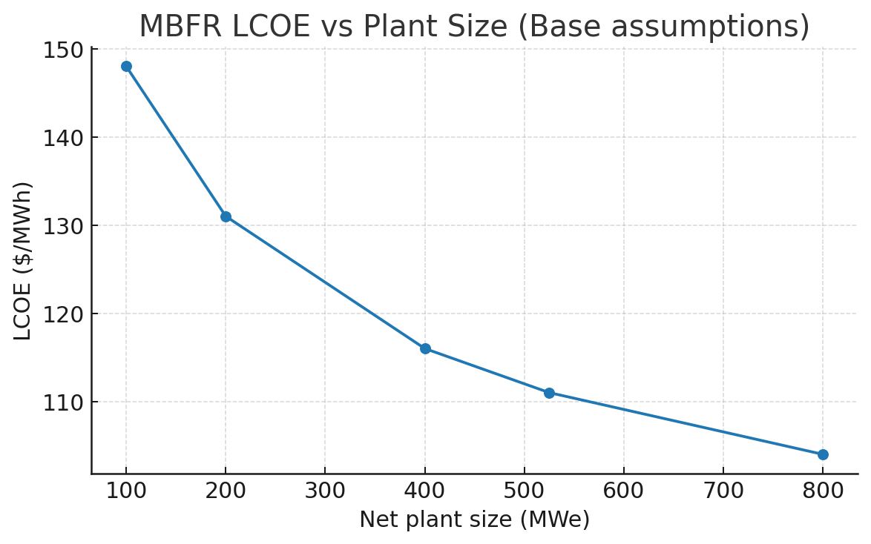

*LCOE vs Plant Size (Base assumptions)*

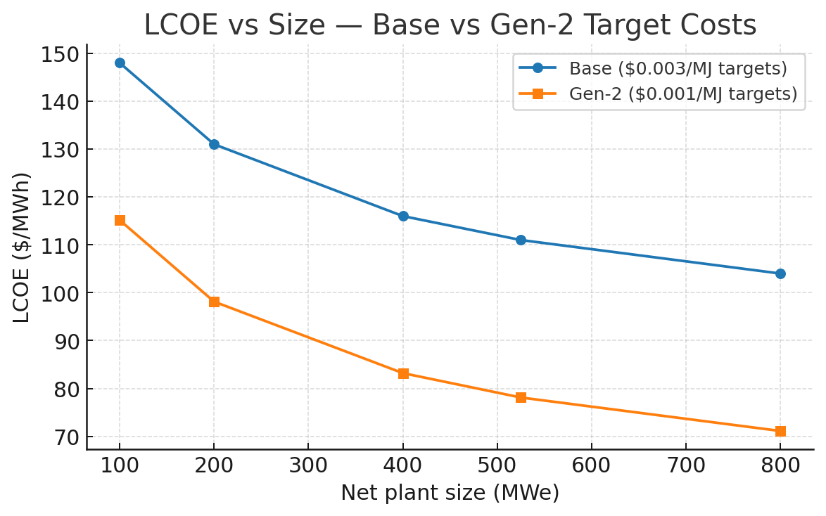

*LCOE vs Plant Size — Base vs Gen‑2 target costs*

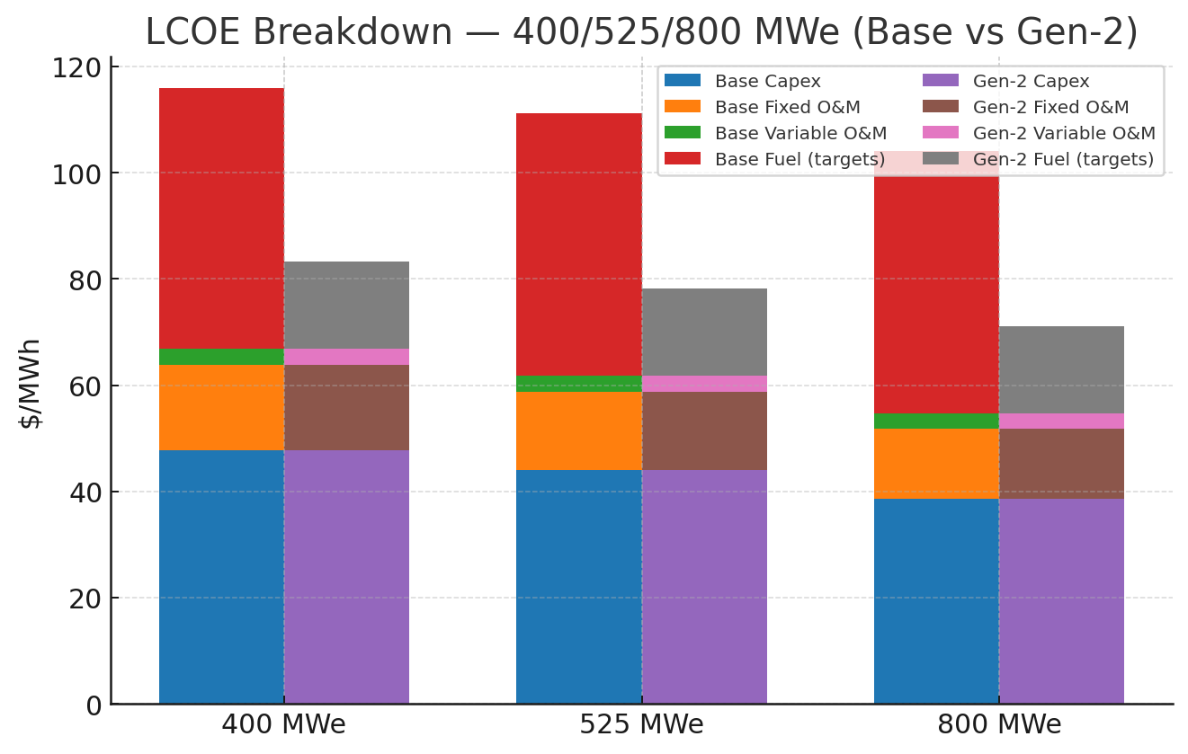

*LCOE breakdown (400/525/800 MWe) — Base vs Gen‑2*