**Enhancing Claims Processing Efficiency in Insurance Company with a Document-Oriented Database Solution**

**Scenario Investigation:**

In the insurance company, prompt policyholder support depends heavily on the effectiveness of claims processing. Nonetheless, a lot of insurance businesses have trouble keeping track of the varied and dynamic data related to claims, from client information to damage estimates. This scenario imagines SwiftClaim Assurance, a sizable insurance company, running into difficulties processing claims because of the drawbacks of conventional relational databases.

**Industry and Organization:**

SwiftClaim Assurance provides a broad range of insurance products and operates globally. The company's dedication to improving its claims processing system stems from the necessity of navigating the complexities of various data sources. These comprise a plethora of records, images, and customer information that are essential to efficient claims handling.

**Information/Data Requirements:**

The data types that SwiftClaim Assurance requires cover a wide range and are necessary for thorough claims processing. These consist of client data, policy specifics, damage evaluations, images, and supplementary records. The main problem is that unstructured data comes in a variety of formats and typical relational databases can't manage it well, which causes delays and inefficiencies in the claims processing process.

**Challenges and Justification for Document-Oriented Database:**

**Unstructured Data Handling:**

By definition, claims data frequently includes images, various formats, and unstructured texts. In a context of incredible diversity, traditional relational databases—which are built with an organized schema—collapse. This is the basis for the rationale behind document-oriented databases: their adaptable schemas make it possible to store and access unstructured data effectively without the requirement for predefined patterns.

**Complex Data Relationships:**

Traditional relational databases face a great deal of difficulty in managing the complex interactions that exist between customers, policies, and damage assessments. However, document-oriented databases better at more organically reflecting these intricate interactions. A popular document-oriented NoSQL database, MongoDB, makes it easy to build and maintain relationships between embedded documents and arrays by supporting them.

**Scalability and Performance:**

Scalability becomes important as claims data volume increases. Because document-oriented databases may scale horizontally, SwiftClaim Assurance is capable of handling increasing data loads and still operate at its maximum effectiveness.

**Proposed Technological Solution:**

**NoSQL Database Choice - MongoDB:**

MongoDB, a leading document-oriented NoSQL database, is recommended for the following reasons:

**Flexible Document Model:**

The versatility of MongoDB's document model is especially important. It offers an effortless approach for storing customer information, policy details, images, and other documentation because it supports a variety of data kinds and structures. MongoDB's adaptability to changing data requirements can be seen by how easily it can be modified.

**Complex Data Relationships:**

A complex network of connections between customers, policies, and damage estimates is handled by SwiftClaim Assurance. Because MongoDB supports array and embedded documents, the organization may model these relationships intuitively. This makes data format easier to understand and improves retrieval and analytical capabilities.

**Horizontal Scalability:**

The scalability challenge is met head-on with MongoDB's ability to scale horizontally. As claims data burgeons, MongoDB efficiently distributes the load across multiple servers. This ensures that the system can handle the growing data volumes while maintaining optimal performance.

**Prototype Implementation:**

The prototype will focus on key types of data identified for efficient claims processing within the insurance business:

**Customer Details:**

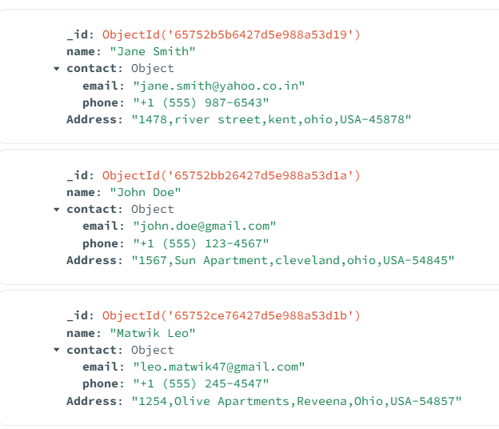

Screenshot 1: Displaying a sample document in MongoDB that stores customer information, showcasing the flexibility in handling diverse data attributes.

**Policy Details:**

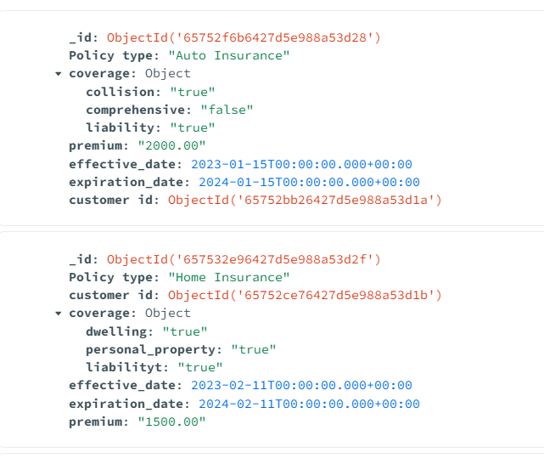 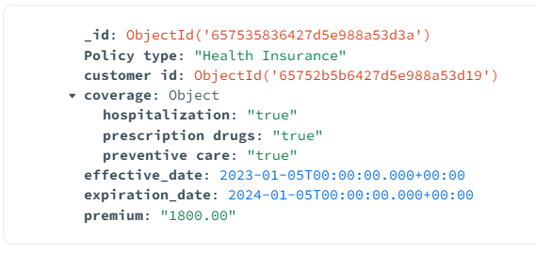

Screenshot 2 : Displaying a sample document in MongoDB that stores policy information, showcasing the flexibility in handling diverse data attributes.

**Damage Assessment Document with Images:(Claiming Process)**

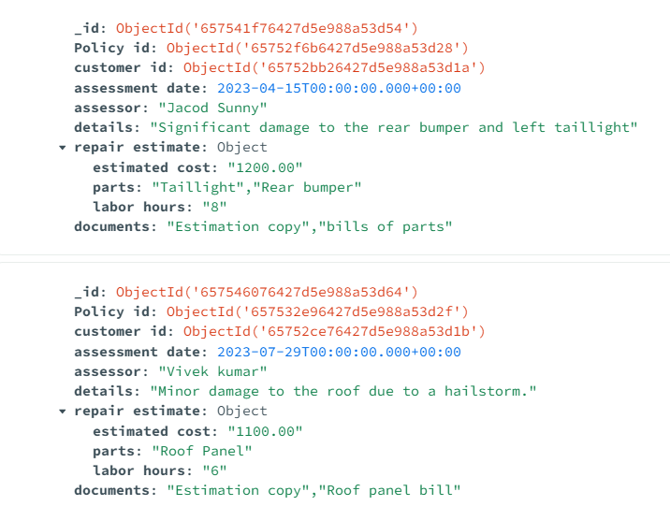

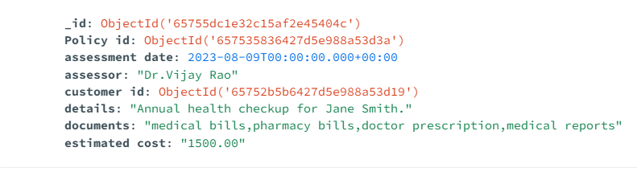

Screenshot 3: Illustrating a document that includes damage assessment details along with images, demonstrating MongoDB's capability to handle complex, unstructured data.

**Real-time Claims Processing Dashboard:(Claim Status)**

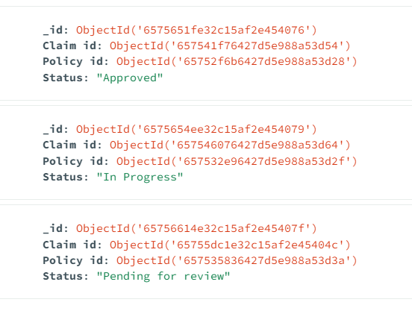

Screenshot 4: Developing a real-time dashboard that tracks the status of claims processing, emphasizing MongoDB's quick data retrieval for efficient and timely decision-making.

**Conclusion:**

In the ever-evolving landscape of the insurance industry, where responsiveness and efficiency are non-negotiable, the strategic embrace of MongoDB as a document-oriented database solution propels SwiftClaim Assurance into a realm of enhanced claims processing efficacy. The scenario investigation underscored the pivotal role of efficient data management in ensuring timely assistance to policyholders, with traditional relational databases falling short in the face of diverse and unstructured claims data.

SwiftClaim Assurance, as a global insurance giant, grapples with the intricacies of managing an expansive array of data, including documentation, images, and customer records. The traditional relational databases' struggle to navigate the unstructured nature and varied formats of this data became the impetus for exploring a more agile solution.

The challenges elucidated in the scenario find their justification in the capabilities of a document-oriented database, exemplified by MongoDB. The flexible schema of MongoDB emerges as a cornerstone solution for handling unstructured data efficiently, as evidenced in the prototype's portrayal of customer and policy details in Screenshot 1 and Screenshot 2. The adaptability to evolving data requirements stands out as a testament to MongoDB's versatility, a quality indispensable in an environment where data attributes are subject to dynamic variations.

Furthermore, MongoDB's prowess in managing complex data relationships shines through in the prototype's representation of a damage assessment document with images (Screenshot 3). The support for embedded documents and arrays provides an intuitive means of modeling intricate relationships between customers, policies, and damage assessments. This not only simplifies data representation but also augments the ease of retrieval and analysis, critical elements in the claims processing workflow.

The scalability imperative is met head-on by MongoDB's horizontal scalability, as depicted in Screenshot 4 featuring a real-time claims processing dashboard. In an industry where the volume of claims data is on a perpetual rise, MongoDB's ability to distribute the load across multiple servers ensures sustained optimal performance. The real-time dashboard accentuates MongoDB's quick data retrieval capabilities, empowering SwiftClaim Assurance with the agility needed for efficient and timely decision-making.

In conclusion, adopting MongoDB as a document-oriented database solution for SwiftClaim Assurance's claims processing system addresses the challenges posed by diverse and unstructured data sources. The prototype provides a tangible representation of how MongoDB supports the identified data requirements, enabling more efficient and scalable claims processing in the insurance sector. MongoDB's flexible document model, support for complex relationships, and scalability make it an optimal choice for an industry where streamlined claims processing is critical for customer satisfaction and operational efficiency.