***Computer Architecture Assignment***

***Assignment 1: Draw your Home Network Topology and explain how you are accessing the RPS Lab environment***.

* *Network Topology : The symbolic way of physical arrangement of the devices connected our a network to perform certain tasks like communication, share resources and to exchange data.*
* *Home Network Topology: The Home Network Topology uses the star topology approach, where all the devices are connected to the ISP(Router/Modem) either directly through Ethernet (LAN cable) or wireless through Wi-Fi. This setup provides access to resources within the home network and over the internet.*
* *Home network consists of various devices like computers, TVs, Laptops, Smart-phones, all interconnected to share resources and access the internet.*

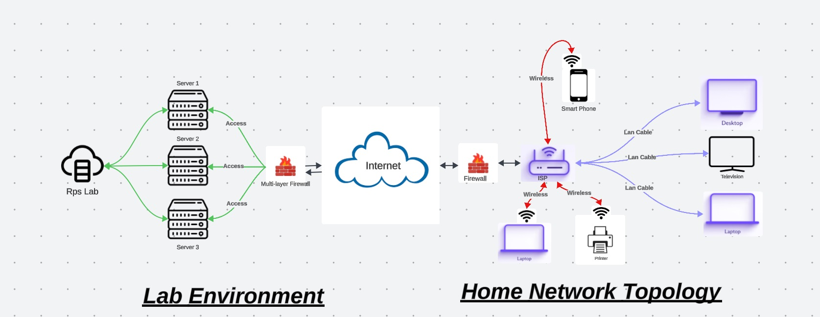

* *To Access The Rps Lab Environment: As to access the “Rps Lab” from a home network it is accessible by the help of ISP (Router/Modem). as it helps the users to access the internet where the rps lab is present.*
* *So by the help of the router the user sends request to the rps lab portal, through internet and after reaching the rps portal the Mulch-layered firewall present in the rps lab environments uses a variety of security measures in detecting the threats ,if any threats are present it send an acknowledgment, Otherwise if no threats are present the data is accessed by the different severs (depending on the type of the users_data) and finally the user access the Rps lab. Later the operations performed in the rps lab by the users are stored in the servers.*

**Assignment 2: Identify a real-world application for both parallel computing and networked systems. Explain how these technologies are used and why they are important in that context.**

* *Parallel Computing: In the parallel computing many tasks or processes are performed or carried out simultaneously. As large tasks are often divided into smaller tasks, which can be solved at the same time. The parallel computing as different forms like bit-level computing, Instruction-level computing. The parallel computing can achieve high-performance computing.*
* *But the parallel computing has drawn more attention as a result of the physical limitations that prohibit frequency scaling, simply refereed as the processor over-clocking.*
* *And parallel computing is primarily performed by multi-core processors, for better and faster performance in performing the tasks. So by using the multi-core processors, the power consumption and by processors over-clock causes over-heating issues in recent years.*
* *Parallel computing can achieve the data redundancy issue as the same task can be performed simultaneously, if one task throws an error the second task is performed by rectifying the error.*
* *Real-World Application for the parallel computing: The real-world applications for the parallel computing are modern laptops, modern desktops, smart-phones (Which supports dual-core processors), gaming development industries, video game industries, entertainment platforms, online-shopping platforms and in space research organizations (ISRO, NASA, SPACEX).*
* *One of the real-world application for parallel computing is video-game industries: As modern competitive video games like Valorant, CSGO, APEX Legends, COD and other advanced competitive games heavily rely on parallel computing, especially when it comes to performance optimization, better graphics rendering, and enhanced gameplay standards.*
* *Complex graphics rendering is needed in video games to produce realistic sights. Several processor cores or graphics processing units are utilized to divide rendering duties when using parallel computing techniques like multi-threading and GPU parallelism.*
* *Parallel computing allow developers to accelerate physics simulations, which helps the developers to render the different player movements, object renders and update the HUD elements.*
* *By introducing AI into the videos games to increase the interactions for the players with the NPCs (Non-playable characters) it had been too difficult to the developers to maintain the NPCs actions, So by the help of parallel computing the AI algorithms and pathfinders have improved and became less complex for the developers.*
* *In multiplayer video games the parallel computing is very important as it is simple to divide each players movements to maintain, observe the player during the whole session.*
* *To sum it up, the use of parallel computing is essential in enhancing the productivity, reliability, and multiplayer functionality of video games such as Valorant and other competitive games. Developers may produce engaging gaming experiences with stunning graphics, efficient gameplay, and flawless online connectivity by using parallel computing.*
* *Networked Systems: Network systems are made up of interconnected parts and devices which communicate to one another in order to share resources, exchange information, and boost communication. These systems make it easier for data to move between individuals, gadgets, and apps in different places.*
* *Real-World Application for the Networked systems is in competitive games:*
* *The Networked systems are very crucial in the competitive games like Valorant,CSGO,APEX Legends and other. The networked systems allows players to communicate, coordinate the state of the game across several clients, and permitting multiplayer gaming.*
* *The game servers acts as a central hub in creating, modifying, and terminating the session for the players in the multiplayer matches. And these game servers holds specialized set of rules and observe the players in the session, As these servers detect the players in cheating and using other mods.*
* *Most of the competitive games uses “client-server architecture”, where the game server acts as the authoritative source of truth for the game world. Players send input commands (such as movement, aiming, and shooting) to the server, which processes these commands, updates the game state, and broadcasts the results to all connected clients.*
* *The games like Valorant, CSGO uses network protocols such as UDP (User Data-gram Protocol) for fast and efficient communication between the game client and server. UDP is preferred for real-time multiplayer games because it offers lower latency and overhead compared to TCP (Transmission Control Protocol), although it sacrifices some reliability.*
* *And in tournaments these competitive games uses networked systems techniques as the tournament should be fair to all the players, as it becomes easy for the organization to detect the cheaters and to go all players the same configurations to have seamless tournament.*