**PROJECT REPORT**

**On**

1. **LEARNING WEBSITE**



**Bachelor of Technology**

**In**

**Computer Science & Engineering**

**Chandigarh Group of Colleges, Mohali**

Submitted To: Submitted By:

Ms. Shafi Jasuja Vinay Kumar

1802899

CSE-V2

Department of CSE CEC,LANDRAN

**ABSTRACT**

In our project we propose a method to help students to prepare for their campus placements or to learn new Trending Technologies which are in demand. It is Web based Project which makes use of different Technologies.Website contains different sections for different Technologies such as Interview Questions, Programming Languages, Block Chain etc. The best thing about Website is that it provides all the content for free and contains videos for each topic.

A Multiple Pager Website is created using HTML5 and CSS3 with different elements to show information. JavaScript is used to add Dynamic view to the Website . Python is also used in this project in order to built a Chat Bot which interact with students and resolve their doubts and recommend Videos or lectures on the basis of their Interest. The main Objective of this Project is to provide best resources which are available free at One Platform.

Programming Languages section includes languages like Java, C++, Python, JavaScript etc. There are separate sections for those who want to prepare or learn Android Development and Web Development. Website provides a complete Road Map to students to learn Technologies and Implement them.

After learning Technology their is need to practice it, so here comes the Website with another feature which includes Project Section . Project Section includes various projects on Android Development, Web Development, Data Science ,Machine learning etc.

**Keywords-** HTML5; Buttons; Div Container; recursive backtracking algorithm; time complexities; Web-based Sudoku solver; JavaScript,Python,Chat Bot,Android Development,Web Development,Data Science, Machine Learning, Artificial Intelligence, Block Chain etc..

**Introduction**

A learning system based on formalized teaching but with the help of electronic resources is known as E-learning. While teaching can be based in or out of the classrooms, the use of computers and the Internet forms the major component of E-learning. E-learning can also be termed as a network enabled transfer of skills and knowledge, and the delivery of education is made to a large number of recipients at the same or different times. Earlier, it was not accepted wholeheartedly as it was assumed that this system lacked the human element required in learning.

  
  
However, with the rapid progress in technology and the advancement in learning systems, it is now embraced by the masses. The introduction of computers was the basis of this revolution and with the passage of time, as we get hooked to smart phones, tablets, etc, these devices now have an importance place in the classrooms for learning. Books are gradually getting replaced by electronic educational materials like optical discs or pen drives. Knowledge can also be shared via the Internet, which is accessible 24/7, anywhere, anytime.  
  
E-learning has proved to be the best means in the corporate sector, especially when training programs are conducted by MNCs for professionals across the globe and employees are able to acquire important skills while sitting in a board room, or by having seminars, which are conducted for employees of the same or the different organizations under one roof. The schools which use E-learning technologies are a step ahead of those which still have the traditional approach towards learning.

**Problem Statement & Objectives**

Traditional System of learning is the oldest form of delivering education to students through face to face interaction between teachers and students. The schools are divided into grades which include both primary and secondary education system.

 Although this type of education system is practiced all over the world it is losing its popularity nowadays. Everything nowadays is part of the digital revolution, education is no exception.

 The traditional education system needs to be revised in order to continue delivering education successfully in the present scenario which we called the digitized world.

The traditional education system is well–organized institution with proper classroom, building and teacher faculties. Everything that is going to be taught is pre-planned not only regular activities but also extracurricular activities.

**2.1 Objectives**

E-Learning is a learning process with the combination of content that is both delivered digitally and through face-to-face learning. eLearning contributes to the shifts from traditional face-to-face learning to the use of web technological tools which enhances collaborative learning and presents an entirely new learning platform for students. eLearning has also been the principal form of distance education but now, it is also changing the instructions on higher education as it is now becoming a global agent in higher education.

* Enhance the quality of learning and teaching
* Meet the learning style or needs of students
* Improve the efficiency and effectiveness
* Improve user-accessibility and time flexibility to engage learners in the learning process

E-Learning is vast and an expanding platform with huge prospective in higher education. Since there are many challenges in making eLearning effective, it is important to know how to manage it and access to the resources.

Take a minute and just imagine if one is not having the roadmap to guide from start to finish is actually like plunging into eLearning without an effective strategy because learners would be lost in the learning content.

**E Learning Website**

**Summary**

Web-based learning is commonly referred to as eLearning or online learning. It essentially includes learning online through the courses that are offered on the net. Emails, live lectures, and videoconferencing are all possible through the net. This enables all the participants to give their views on a particular topic and then discuss them further. They also offer static pages like course materials that are printed for the benefit of all the participants. One of the main advantages of accessing pages on the web is that most of the web pages have hyperlinks that will lead you to another page and thus opens up a vast amount of information on the net.

**Advantages**

* You are able to link the various resources in several varying formats.
* It is a very efficient way of delivering courses online.
* Due to its convenience and flexibility, the resources are available from anywhere and at any time.
* Everyone, who are part time students or are working full time, can take advantage of web-based learning.
* Web-based learning promotes active and independent learning.
* As you have access to the net 24x7, you can train yourself anytime and from anywhere also.
* It is a very convenient and flexible option; above all, you don't have to depend on anyone for anything.
* Not only can you train yourself on a day to day basis, but also on weekends or whenever you have the free time to. There is no hard and fast rule.
* Through discussion boards and chats, you are able to interact with everyone online and also clear your doubts if any.

**Disadvantages**

* Most of the online assessments are limited to questions that are only objective in nature.
* There is also the problem of the extent of security of online learning programs.
* The authenticity of a particular student's work is also a problem as online just about anyone can do a project rather than the actual student itself.
* The assessments that are computer marked generally have a tendency of being only knowledge-based and not necessarily practicality-based.

**TECHNOLOGY USED**

* Operating System 64 Bit(Windows,Mac,Linux etc).
* **HTML5:** It is used to provide structure to the Website.Different buttons are created using HTML5 elements and images ,texts are also used to make it more understandable.
* **CSS3:** CSS3 is used to provide Website a cool look so Whenever someone come to website to play Sudoku solver the person not get bored. CSS3 various properties and selectors are used to make Website Interactive.
* **JavaScript:** JavaScript is used to write the logic behind the Sudoku Solver. The Algorithm is written in JavaScript which performs all operations. JavaScript Interact with HTML5 elements to perform different operations on the elements.
* **Visual Studio Code:** Visual Studio Code is the most used Code Editor for Web Development related work. It provides different Extensions to make work easier and auto complete option to make writing code in easier way.
* **Google Fonts:** Google fonts are used to provide interactive fonts to the text or Numbers which appear on the container containing different buttons.
* **Python:** Python is used to build Chat Bot which provides various features.
* **Responsive Design:** In order to make the website work efficiently on Mobile Phones,Tablets and Laptops it must be Responsive in nature.
* **Web Browser:** In order to run the Sudoku solver built by using Web Technologies we must need a latest browser which support Web Technologies.
* **Chat Bot:** Chat Bot will interact with students who came to learn new Technologies and provide them right career path for them on the basis of their Interest.

**Source Code With Working Images**

**HTML5**

<!DOCTYPE html>

<html>

<head>

<link rel="shortcut icon" type="png" href="/icon/favicon.png">

<meta charset="utf-8">

<meta http-equiv="X-UA-Comaptible" content="IE=edge">

<title>LearnEd</title>

<meta name="desciption" content="">

<meta name="viewport" content="width=device-width, initial-scale=1">

<link rel="stylesheet" type="text/css" href="style.css">

<script type="text/javascript" src="script.js"></script>

<script src="https://code.jquery.com/jquery-3.2.1.js"></script>

<script>

$(window).on('scroll', function() {

if ($(window).scrollTop()) {

$('nav').addClass('black');

} else {

$('nav').removeClass('black');

}

})

</script>

</head>

<body>

<!-- Navigation Bar -->

<header id="header">

<nav>

<div class="logo"><img src="/icon/logo.png" alt="logo"></div>

<ul>

<li><a class="active" href="">Home</a></li>

<li><a href="#portfolio_section">Portfolio</a></li>

<li><a href="#team_section">Team</a></li>

<li><a href="#services_section">Courses</a></li>

<li><a href="#contactus_section">Contact</a></li>

</ul>

<div class="srch"><input type="text" class="search" placeholder="Search here..."><img src="/icon/search.png" alt="search" onclick=slide()></div>

<a class="get-started" href="login.html">Get Started</a>

<img src="/icon/menu.png" class="menu" onclick="sideMenu(0)" alt="menu">

</nav>

<div class="head-container">

<div class="quote">

<p>The beautiful thing about learning is that nobody can take it away from you</p>

<h5>Education is the process of facilitating learning, or the acquisition of knowledge, skills, values, beliefs, and habits. Educational methods include teaching, training, storytelling, discussion and directed research!</h5>

<div class="play">

<img src="/icon/play.png" alt="play"><span><a href="#services_section" target="_blank">Watch Now</a></span>

</div>

</div>

<div class="svg-image">

<img src="/extra/svg1.jpg" alt="svg">

</div>

</div>

<div class="side-menu" id="side-menu">

<div class="close" onclick="sideMenu(1)"><img src="/icon/close.png" alt=""></div>

<div class="user">

<img src="creator/Profile.jpg" alt="Username">

<p>Vinay Kumar</p>

</div>

<ul>

<li><a href="#about_section">About</a></li>

<li><a href="#portfolio_section">Portfolio</a></li>

<li><a href="#team_section">Team</a></li>

<li><a href="#services_section">Services</a></li>

<li><a href="#contactus_section">Contact</a></li>

<li><a href="#feedBACK">Feedback</a></li>

</ul>

</div>

</header>

<!-- Some Popular Subjects -->

<div class="title">

<span>Popular Subjects on LearnEd</span>

</div>

<br><br>

<div class="course">

<center>

<div class="cbox">

<div class="det">

<a href="subjects/Machine.html"><img src="images/courses/book.png">Machine Learning</a>

</div>

<div class="det">

<a href="subjects/Android.html"><img src="images/courses/d1.png">Android Development</a>

</div>

<div class="det">

<a href="subjects/CodingLang.html"><img src="images/courses/paper.png">Coding Languages</a>

</div>

<div class="det">

<a href="subjects/web.html"><img src="images/courses/d1.png">Web Development</a>

</div>

</div>

</center>

<div class="cbox">

<div class="det">

<a href="subjects/DigitalMarketing.html"><img src="images/courses/computer.png">Digital Marketing</a>

</div>

<div class="det">

<a href="subjects/DataStructures.html"><img src="images/courses/data.png">Data Structures</a>

</div>

<div class="det">

<a href="subjects/Algorithms.html"><img src="images/courses/algo.png">Algorithms</a>

</div>

<div class="det det-last">

<a href="subjects/Projects.html"><img src="images/courses/projects.png">Projects</a>

</div>

</div>

</div>

<!-- ABOUT -->

<div class="diffSection" id="about_section">

<center>

<p style="font-size: 50px; padding: 100px">About</p>

</center>

<div class="about-content">

<div class="side-image">

<img class="sideImage" src="/extra/e3.jpg">

</div>

<div class="side-text">

<h2>Why to choose LearnEd ?</h2>

<p>Programming is a lot of fun because, unlike other subjects, you get to instantly apply the concepts you are learning.<br> At LearnEd, we strive to increase student interest by providing hands on practical training on every concept taught

in the classroom.<br> Along with training students with the latest technologies and programming languages, we also connect them to software companies via our placement assistance program. This program includes practicing a lot of interview

problems and mock interviews conducted by company representatives.<br>We create confident developers who think beyond industrial jobs and march their ideas into self-created entrepreneurship ventures.<br> Skill and innovative thinking

give developers the confidence to transform their ideas into real life products and hopefully go on to build million dollar companies.</p>

</div>

</div>

</div>

<!-- PORTFOLIO -->

<div class="diffSection" id="portfolio_section">

<center>

<p style="font-size: 50px; padding: 100px; padding-bottom: 40px;">Portfolio</p>

</center>

<div class="content">

<p>

“Education is the passport to the future, for tomorrow belongs to those who prepare for it today.” “Your attitude, not your aptitude, will determine your altitude.” “If you think education is expensive, try ignorance.” “The only person who is educated

is the one who has learned how to learn …and change.”

</p>

</div>

</div>

<div class="extra">

<p>We're increasing this data every year</p>

<div class="smbox">

<span><center><div class="data">5000+</div><div class="det">Enrolled Students</div></center></span>

<span><center><div class="data">62</div><div class="det">Total Courses</div></center></span>

<span><center><div class="data">1000+</div><div class="det">Placed Students</div></center></span>

<span><center><div class="data">60+</div><div class="det">Total Projects</div></center></span>

</div>

</div>

<!-- TEAM -->

<div class="diffSection" id="team_section">

<center>

<p style="font-size: 50px; padding-top: 100px; padding-bottom: 60px;">Our Team</p>

</center>

<div class="totalcard">

<div class="card">

<center><img src="creator/Profile.jpg"></center>

<center>

<div class="card-title">VINAY KUMAR</div>

<b>Founder</b>

<div id="detail">

<p>“ He is a Computer Scinece undergradute student at chandigarh group of collges landran, mohali , punjab. He have great Knowledge of Data Structures and Algorithms in Java & Web Development. Looking forward to achieve more and learn

more in life.“</p>

<div class="duty"></div>

<center><a href="https://www.instagram.com/vkvinay15/" target="_blank"><button class="btn-bhanu">Follow +</button></a></center>

</div>

</center>

</div>

<div class="card">

<center><img src="creator/Profile1.jpg"></center>

<center>

<div class="card-title">VARUN VERMA</div>

<b>Co-Founder</b>

<div id="detail">

<p>He is a Mechanical Engineering undergradute student at chandigarh group of collges landran, mohali , punjab. He have great Knowledge of Python Development and CAD Designing. Looking forward to achieve more and learn more in life.

“

</p>

<div class="duty"></div>

<a href="https://www.instagram.com/varun_verma_99/" target="_blank"><button class="btn-roshan">Follow +</button></a>

</div>

</center>

</div>

<div class="card">

<center><img src="creator/Profile2.jpg"></center>

<center>

<div class="card-title">ANMOL THAKUR</div>

<b>Co-Founder</b>

<div id="detail">

<p>He is a Mechanical Engineering undergradute student at chandigarh group of collges landran, mohali , punjab. He have great Knowledge of Graphic Designing and Video Editing. Looking forward to achieve more and learn more in life.</p>

<div class="duty"></div>

<a href="https://www.instagram.com/anmolthakur298/" target="_blank"><button class="btn-akhil">Follow +</button></a>

</div>

</center>

</div>

</div>

</div>

<!-- -->

<!-- Courses Offered -->

<div class="service-swipe">

<div class="diffSection" id="services_section">

<center>

<p style="font-size: 50px; padding: 100px; padding-bottom: 40px; color: black;">Our Courses</p>

</center>

</div>

<a href="subjects/CodingLang.html">

<div class="s-card"><img src="/icon/computer-courses.png">

<p>Programming Languages</p>

</div>

</a>

<a href="subjects/Machine.html">

<div class="s-card"><img src="/icon/brainbooster.png">

<p>Artificial Intelligence and Machine Learning</p>

</div>

</a>

<a href="subjects/Android.html">

<div class="s-card"><img src="/icon/online-tutorials.png">

<p>Android App Development</p>

</div>

</a>

<a href="subjects/DigitalMarketing.html">

<div class="s-card"><img src="/icon/papers.jpg">

<p>Digital Marketing</p>

</div>

</a>

<a href="subjects/BlockChain.html">

<div class="s-card"><img src="/icon/Blockchain.jpg">

<p>BlockChain</p>

</div>

</a>

<a href="subjects/web.html">

<div class="s-card"><img src="/icon/Full.jpg">

<p>Full Stack Web Development</p>

</div>

</a>

<a href="#contactus_section">

<div class="s-card"><img src="/icon/discussion.png">

<p>Discussion with Our Tutors & Mentors</p>

</div>

</a>

<a href="#contactus_section">

<div class="s-card"><img src="/icon/help.png">

<p>24x7 Online Support</p>

</div>

</a>

</div>

<!-- <div class="service-swipe" id="services_section">

<center><p style="font-size: 50px; padding-bottom: 40px; color: #2e2e2e;">Services</p></center>

<div class="back"></div>

<div class="service-container">

<div class="right-side">

<img id="img1" src="images/ss/ss5.png" alt="img">

<img id="img2" src="images/ss/ss6.png" alt="img">

<img id="img3" src="images/ss/ss4.png" alt="img">

<img id="img4" src="images/ss/ss8.png" alt="img">

</div>

<div class="left-side">

<ul>

<li><a id="s1" onmouseover="display(1)" href="#">Online Classes</a></li>

<li><a id="s2" onmouseover="display(2)" href="#">Projects</a></li>

<li><a id="s3" onmouseover="display(3)" href="#">Daily Quizes</a></li>

<li><a id="s4" onmouseover="display(4)" href="#">Help Support</a></li>

</ul>

</div>

</div>

</div> -->

<!-- Reviews by Students -->

<div id="makeitfull">

<a href="#review_section"><img src="/icon/makeitfull.png"></a>

</div>

<div class="review">

<div class="diffSection" id="review_section">

<center>

<p style="font-size: 40px; padding: 100px; padding-bottom: 40px; color: #2E3D49;">What the Students Say About Us?</p>

</center>

</div>

<div class="rev-container">

<div class="rev-card">

<div class="identity">

<img src="creator/ashish.jpg">

<p>Ashish Chanchlani</p>

<h6>Java</h6>

<div class="rating"><img src="/icon/star.png"><img src="/icon/star.png"><img src="/icon/star.png"><img src="/icon/star.png"><img src="/icon/star.png"></div>

</div>

<div class="rev-cont">

<p id="title">Review:</p>

<p id="content">

I did Java Fundamenetal course with Vinay Sir. It was a great experience. The brain teasers and assignments, actually the whole lot of content was really good. Some problems were challenging yet interesting. Was explained very well where ever I stuck...

</p>

</div>

</div>

<div class="rev-card">

<div class="identity">

<img src="creator/arush.jpg">

<p>Aarush Popli</p>

<h6>C/C++</h6>

<div class="rating"><img src="/icon/star.png"><img src="/icon/star.png"><img src="/icon/star.png"><img src="/icon/star.png"><img src="/icon/star.png"></div>

</div>

<div class="rev-cont">

<p id="title">Review:</p>

<p id="content">

When I was watching "Dear Zindagi", I could relate Sharukh Khan to Varun Bhaiya. The way Sharukh Khan was giving life lessons to Alia Bhatt, in the same way Arnav Bhaiya will give coding life lessons which will guide you throughout your code life...

</p>

</div>

</div>

<div class="rev-card">

<div class="identity">

<img src="/creator/bhuvan.jpg">

<p>Bhuvan Bam</p>

<h6>Web Development</h6>

<div class="rating"><img src="/icon/star.png"><img src="/icon/star.png"><img src="/icon/star.png"><img src="/icon/star.png"><img src="/icon/star.png"></div>

</div>

<div class="rev-cont">

<p id="title">Review:</p>

<p id="content">

LearnEd was an amazing experience for me. I belong to electronics department and had a little experience in coding but I think it has helped me think things through in a much more analytical manner. Coding is important no matter which branch you are in.

It gives you a better understanding about how to approach a problem...

</p>

</div>

</div>

<div class="rev-card">

<div class="identity">

<img src="creator/harsh.jpg">

<p>Harsh Beniwal</p>

<h6>Python</h6>

<div class="rating"><img src="/icon/star.png"><img src="/icon/star.png"><img src="/icon/star.png"><img src="/icon/star.png"><img src="/icon/star.png"></div>

</div>

<div class="rev-cont">

<p id="title">Review:</p>

<p id="content">

This was my first complete course at LearnEd. I attended the Python course in Winter 2020 and loved it which made me join the full course. Anmol bhaiya and Ayush Bhaiya(TA) have good knowledge about the field and were very helpful in making us understand

the concepts. I would certainly recommend this to anyone...

</p>

</div>

</div>

</div>

</div>

<!-- CONTACT US -->

<div class="diffSection" id="contactus_section">

<center>

<p style="font-size: 50px; padding: 100px">Contact Us</p>

</center>

<div class="csec"></div>

<div class="back-contact">

<div class="cc">

<form action="mailto:csecec.1802899@gmail.com" method="post" enctype="text/plain">

<label>First Name <span class="imp">*</span></label><label style="margin-left: 185px">Last Name <span class="imp">*</span></label><br>

<center>

<input type="text" name="" style="margin-right: 10px; width: 175px" required="required"><input type="text" name="lname" style="width: 175px" required="required"><br>

</center>

<label>Email <span class="imp">*</span></label><br>

<input type="email" name="mail" style="width: 100%" required="required"><br>

<label>Message <span class="imp">*</span></label><br>

<input type="text" name="message" style="width: 100%" required="required"><br>

<label>Additional Details</label><br>

<textarea name="addtional"></textarea><br>

<button type="submit" id="csubmit">Send Message</button>

</form>

</div>

</div>

</div>

<!-- FEEDBACK -->

<div class="title2" id="feedBACK">

<span>Give Feedback</span>

<div class="shortdesc2">

<p>Please share your valuable feedback to us</p>

</div>

</div>

<div class="feedbox">

<div class="feed">

<form action="mailto:roshank9419@gmail.com" method="post" enctype="text/plain">

<label>Your Name</label><br>

<input type="text" name="" class="fname" required="required"><br>

<label>Email</label><br>

<input type="email" name="mail" required="required"><br>

<label>Additional Details</label><br>

<textarea name="addtional"></textarea><br>

<button type="submit" id="csubmit">Send Message</button>

</form>

</div>

</div>

<!-- Sliding Information -->

<marquee style="background: linear-gradient(to right, #FA4B37, #DF2771); margin-top: 50px;" direction="left" onmouseover="this.stop()" onmouseout="this.start()" scrollamount="20">

<div class="marqu">“Education is the passport to the future, for tomorrow belongs to those who prepare for it today.” “Your attitude, not your aptitude, will determine your altitude.” “If you think education is expensive, try ignorance.” “The only person who is

educated is the one who has learned how to learn …and change.”</div>

</marquee>

<!-- FOOTER -->

<footer>

<div class="footer-container">

<div class="left-col">

<img src="/icon/logo - Copy.png" style="width: 200px;">

<div class="logo"></div>

<div class="social-media">

<a href="#"><img src="/icon\fb.png"></a>

<a href="#"><img src="/icon\insta.png"></a>

<a href="#"><img src="/icon\tt.png"></a>

<a href="#"><img src="/icon\ytube.png"></a>

<a href="#"><img src="/icon\linkedin.png"></a>

</div><br><br>

<p class="rights-text">Copyright © 2020 Created By Vinay Kumar All Rights Reserved.</p>

<br>

<p><img src="/icon/location.png"> Chandigarh Group of Colleges<br>Mohali, Punjab-140307</p><br>

<p><img src="/icon/phone.png"> +91-8894907427<br><img src="/icon/mail.png">&nbsp; csecec.1802899@gmail.com</p>

</div>

<div class="right-col">

<h1 style="color: #fff">Our Newsletter</h1>

<div class="border"></div><br>

<p>Enter Your Email to get News and updates from us.</p>

<form class="newsletter-form">

<input class="txtb" type="email" placeholder="Enter Your Email">

<input class="btn" type="submit" value="Submit">

</form>

</div>

</div>

</footer>

</body>

</html>

**CSS3**

@import url('https://fonts.googleapis.com/css?family=Montserrat:500&display=swap');

@import url('https://fonts.googleapis.com/css?family=Dancing+Script&display=swap');

@import url('https://fonts.googleapis.com/css?family=Open+Sans&display=swap');

@import url('https://fonts.googleapis.com/css2?family=Baloo+Bhaina+2:wght@500&display=swap');

@import url('https://fonts.googleapis.com/css2?family=Baloo+Bhai+2:wght@700&display=swap');

* {

box-sizing: border-box;

margin: 0;

padding: 0;

}

html {

scroll-behavior: smooth;

}

body {

background: #FFF;

font-family: 'Baloo Bhai 2', cursive;

}

/**************************Navabar and Heading Section*************************/

header {

height: 100vh;

}

.black {

box-shadow: 0 2px 10px rgba(0, 0, 0, 0.5);

}

nav {

padding-top: 20px;

padding-bottom: 20px;

top: 0;

position: fixed;

display: flex;

width: 100%;

z-index: 1000;

background: white;

justify-content: space-around;

transition: 1.5s;

align-items: center;

}

nav ul {

display: flex;

align-items: center;

}

nav ul li {

list-style: none;

margin: 5px 10px;

}

nav ul li a {

padding: 2px 10px;

color: #2e2e2e;

cursor: pointer;

transition: .5s;

text-decoration: none;

font-family: 'Baloo Bhai 2', cursive;

font-size: 22px;

}

nav ul li a:hover {

color: #fff;

background: #DF2771;

border-radius: 50px;

}

.active {

color: #fff;

border-radius: 5px;

background: #DF2771;

border-radius: 50px;

}

.srch {

padding: 2px 10px;

display: flex;

/* align-items: center; */

justify-content: center;

/* background: #0066ff; */

border: 1px solid;

border-radius: 20px;

}

.srch img {

width: 25px;

cursor: pointer;

}

.srch .search {

/* padding: 2px 10px; */

outline: none;

border: none;

background: transparent;

}

.get-started {

margin-left: 50px;

padding: 5px 20px;

border: 2px solid #DF2771;

border-radius: 20px;

text-decoration: none;

transition: .5s;

background-color: #DF2771;

color: #fff;

}

.get-started:hover {

color: #2e2e2e;

background: #fff;

}

.logo img {

width: 120px;

cursor: pointer;

transition: all 1s;

}

a,

button {

float: left;

font-family: 'Baloo Bhai 2', cursive;

font-weight: 500;

font-size: 15px;

color: #2E3D49;

display: block;

text-decoration: none;

text-align: center;

}

.head-container {

margin-top: 245px;

display: flex;

flex-wrap: wrap;

align-items: center;

justify-content: space-around;

}

.quote {

width: 600px;

transform: translateY(-50px);

}

.quote h5 {

margin-top: 20px;

color: #0009;

line-height: 20px;

text-shadow: 4px 4px 2px rgba(155, 236, 241, 0.8);

}

.quote p {

font-size: 50px;

color: #2e2e2e;

text-shadow: 4px 4px 2px rgba(155, 236, 241, 0.8);

}

.quote .play {

margin-top: 20px;

display: flex;

/* justify-content: center; */

align-items: center;

}

.quote .play img {

width: 45px;

cursor: pointer;

filter: drop-shadow(0 0 10px #0002);

}

.quote .play span a {

margin-left: 10px;

font-size: 20px;

font-weight: 900;

color: rgba(0, 0, 0, 0.8);

cursor: pointer;

}

.svg-image img {

width: 500px;

filter: drop-shadow(0 20px 10px rgba(0, 0, 0, 0.2));

}

/*****************Above section is of navabar and Heading***********/

/* SIDE MENU */

.menu {

cursor: pointer;

width: 25px;

display: none;

}

.side-menu {

width: 100%;

height: 100%;

background: rgba(182, 33, 90, 0.993);

position: absolute;

top: 0;

transition: .8s;

z-index: 2000;

transform: translateX(-100%);

}

.side-menu ul {

margin-top: 35%;

display: flex;

flex-direction: column;

justify-content: center;

/* background: #FA4B37; */

}

.side-menu ul li {

list-style: none;

/* background: #009900; */

display: flex;

justify-content: center;

align-items: center;

/* border-bottom: 1px solid #fff; */

/* padding: 10px 0px; */

}

.side-menu ul li:hover a {

background: #fff;

color: #DF2771;

}

.side-menu ul li a {

color: #FFF;

width: 100%;

font-size: 1em;

/* background: #2E3D49; */

text-decoration: none;

padding: 15px 0px;

}

.close img {

float: right;

width: 35px;

cursor: pointer;

margin: 10px;

}

.user {

display: flex;

justify-content: center;

align-items: center;

margin-top: 10%;

}

.user img {

width: 60px;

border-radius: 50%;

border: 2px solid #fff;

filter: drop-shadow(0 10px 20px #0004);

margin-right: 30px;

cursor: pointer;

}

.user p {

color: #fff;

cursor: pointer;

}

.user img,

.user p {

opacity: 1;

}

/*Common things in all sections*/

#about_section,

#portfolio_section,

#team_section,

#services_section,

#contactus_section {

font-family: 'Baloo Bhai 2', cursive;

color: #2E3D49;

position: relative;

}

.diffSection {

width: 100%;

/*position: relative;*/

justify-content: center;

align-items: center;

}

.diffSection .content {

margin: 10px;

text-align: center;

padding: 10px 100px;

font-size: 1.1em;

}

/*PORTFOLIO Section*/

.extra {

width: 100%;

}

.extra p {

padding: 30px;

padding-bottom: 150px;

font-size: 50px;

text-align: center;

color: black;

background-image: linear-gradient(rgba(0, 0, 0, 0), rgba(0, 0, 0, 0.7)), url("images/extra/b1.jpg");

background-size: cover;

background-attachment: fixed;

z-index: -9;

font-family: 'Baloo Bhai 2', cursive;

}

.smbox {

display: flex;

flex-wrap: wrap;

transform: translateY(-100px);

justify-content: center;

}

.smbox .data:hover {

color: black;

}

.smbox span {

margin: 1%;

background: #fff;

box-shadow: inset 0px 0px 25px rgba(0, 0, 0, 0.2), 0 0 40px rgba(0, 0, 0, 0.3);

border-radius: 50px;

padding: 30px 50px;

cursor: pointer;

}

.smbox span:hover {

transform: scale(1.3);

transition: .5s ease;

background-color: #f7b42c;

background-image: linear-gradient(315deg, #f7b42c 0%, #fc575e 74%);

}

.smbox .data {

font-size: 80px;

color: #FA6146;

}

.smbox .det {

font-size: 20px;

color: #272529;

font-family: 'Baloo Bhaina 2', cursive;

}

/*Title Section*/

.title {

/* margin-top: 160px; */

font-family: 'Baloo Bhai 2', cursive;

font-size: 30px;

text-align: center;

color: #2E3D49;

}

/*ABOUT Section*/

.about-content {

width: 100%;

position: relative;

justify-content: center;

flex-wrap: wrap;

display: flex;

align-items: center;

font-family: 'Baloo Bhaina 2', cursive;

}

.about-content .side-text {

width: 550px;

padding: 50px 40px;

background: #fff;

box-shadow: 2px 0 100px rgba(0, 0, 0, 0.3);

border-radius: 5px;

text-align: justify;

line-height: 22px;

opacity: 0;

transform: translateX(-100px);

transition: 1s ease-in-out;

}

.about-content .side-text-appear {

opacity: 1;

transform: translateX(0px);

}

.about-content .side-text h2 {

padding: 10px;

}

.about-content .side-text p {

padding: 10px;

}

.about-content .side-image img {

width: 90%;

border-radius: 5px;

}

.sideImage {

transform: translateX(100px);

opacity: 0;

transition: .8s ease-in-out;

}

.sideImage-appear {

opacity: 1;

transform: translateX(0px);

}

/*POPULAR SUBJECTS Section */

.cbox {

position: relative;

width: 100%;

display: inline-flex;

flex-wrap: wrap;

justify-content: center;

}

.cbox .det {

width: 250px;

height: 80px;

margin: 10px;

background: #fff;

cursor: pointer;

}

.cbox .det a {

justify-content: space-around;

width: 250px;

padding: 28px;

border-radius: 10px;

border: 2px solid #FA4B37;

border-radius: 50px;

font-size: 15px;

color: #272529;

font-weight: bolder;

text-decoration: none;

font-family: 'Baloo Bhaina 2', cursive;

}

.cbox .det a:hover {

background-color: #f7b42c;

background-image: linear-gradient(315deg, #f7b42c 0%, #fc575e 74%);

;

color: white;

}

.cbox .det a:hover img {

filter: brightness(100);

}

.cbox img {

width: 20px;

margin-right: 20px;

}

/*******TEAM SECTION******/

.totalcard {

width: 100%;

display: flex;

flex-wrap: wrap;

align-items: center;

justify-content: center;

margin-bottom: 50px;

}

.totalcard .card {

margin: 50px;

width: 300px;

border-radius: 10px;

background: #fff;

}

.totalcard .card {

box-shadow: inset 0 0 10px rgba(0, 0, 0, 0.4), 0 0 10px rgba(0, 0, 0, 0.3);

}

.card:nth-child(1) {

border-top: 5px solid red;

}

.card:nth-child(2) {

border-top: 5px solid green;

}

.card:nth-child(3) {

border-top: 5px solid blue;

}

.card:nth-child(1):hover {

box-shadow: inset 0px 0px 10px rgba(255, 0, 0, 0.5), 1px 1px 30px rgba(255, 0, 0, 0.5);

}

.card:nth-child(2):hover {

box-shadow: inset 0px 0px 10px rgba(0, 255, 0, 0.5), 1px 1px 30px rgba(0, 255, 0, 0.5);

}

.card:nth-child(3):hover {

box-shadow: inset 0px 0px 10px rgba(0, 0, 255, 0.5), 1px 1px 30px rgba(0, 0, 255, 0.5);

}

.totalcard .card img {

width: 100px;

height: 100px;

margin-top: 5px;

cursor: pointer;

border-radius: 50px;

transition-duration: .8s;

}

.totalcard .card img:hover {

transform: scale(3.5);

border-radius: 0;

box-shadow: 0 0 20px rgba(0, 0, 0, 0.5);

}

#detail p {

font-size: 15px;

line-height: 25px;

font-variant: small-caps;

text-align: center;

margin: 25px;

margin-bottom: 0px;

margin-top: 0px;

}

#detail button {

outline: none;

border-radius: 10px;

border-style: none;

border: 1px solid black;

padding: 9px 25px;

cursor: pointer;

transition-duration: .4s;

}

#detail a {

bottom: 80px;

text-decoration: none;

margin-bottom: 30px;

margin-top: 20px;

margin-left: 90px;

align-self: center;

}

.btn-bhanu:hover {

background: rgba(255, 0, 0, 0.5);

color: #fff;

}

.btn-roshan:hover {

background: rgba(0, 255, 0, 0.7);

color: #fff;

}

.btn-akhil:hover {

background: rgba(0, 0, 255, 0.5);

color: #fff;

}

.card-title {

font-size: 17px;

color: #343A40;

padding: 20px;

font-weight: 700;

}

/*Courses Offered Section*/

.service-swipe {

display: flex;

flex-wrap: wrap;

justify-content: center;

align-items: center;

background-image: linear-gradient(rgba(0, 0, 0, 0), rgba(0, 0, 0, 0.7)), url("images/extra/b3.jpg");

background-size: cover;

background-attachment: fixed;

}

.service-swipe .s-card img {

width: 100px;

}

.service-swipe a {

padding: 0;

margin: 40px 10px;

}

.service-swipe .s-card {

display: flex;

justify-content: space-around;

padding: 10px;

align-items: center;

text-align: center;

width: 350px;

height: 200px;

box-shadow: inset 0 0 20px rgba(255, 255, 255, 0.05), 0 0 50px rgba(0, 0, 0, 0.8);

border-radius: 5px;

cursor: pointer;

transition-duration: .5s;

}

.service-swipe .s-card p {

color: #f2f2f2;

font-size: 1.2em;

font-family: 'Baloo Bhaina 2', cursive;

}

.service-swipe .s-card:hover {

box-shadow: 0 0 50px rgba(255, 255, 255, 0.8);

transform: translateY(-10px);

background-color: skyblue;

}

/*Contact Us Section*/

.csec {

background: linear-gradient(to right, #FA4B37, #DF2771);

background-attachment: fixed;

position: absolute;

width: 100%;

height: 250px;

top: 200px;

content: '';

transform-origin: top right;

transform: skewY(-10deg);

z-index: -1;

}

.back-contact {

margin-top: 0px;

transform: translateY(-50px);

display: flex;

align-items: center;

justify-content: space-around;

}

.cc {

height: 400px;

width: 400px;

height: 500px;

border-radius: 10px;

justify-content: center;

box-shadow: 1px 1px 20px rgba(0, 0, 0, 0.4);

background: #fff;

}

.cc form {

margin: 5%;

margin-top: 40px;

width: 90%;

height: 90%;

}

.cc form label {

position: absolute;

color: #2E3D49;

font-size: 10px;

font-weight: 800;

}

.cc form input {

padding: 15px;

margin-bottom: 10px;

border-radius: 5px;

box-shadow: inset 0 0 5px lightgray;

border: 1px solid rgba(0, 0, 0, 0.2);

outline: none;

color: #2E3D49;

font-weight: 600;

}

.imp {

color: red;

}

form textarea {

width: 100%;

height: 100px;

box-shadow: inset 0 0 5px lightgray;

border: 1px solid rgba(0, 0, 0, 0.2);

border-radius: 5px;

outline: none;

color: #2E3D49;

font-weight: 600;

padding: 15px;

}

#csubmit {

margin-top: 20px;

background: linear-gradient(to right, #FA4B37, #DF2771);

border-radius: 5px;

border-style: none;

outline: none;

width: 100%;

padding: 15px 25px;

color: #fff;

font-size: 12px;

cursor: pointer;

}

/*REVIEW SECTION*/

#makeitfull {

display: flex;

justify-content: center;

transform: translateY(35px);

}

#makeitfull img {

width: 50px;

}

.review {

background: #F8F8F8;

width: 100%;

}

.rev-container {

padding: 10px 10%;

display: flex;

flex-wrap: wrap;

justify-content: space-around;

}

.rev-container .rev-card {

/*overflow: hidden;*/

width: 550px;

height: 240px;

margin-bottom: 40px;

background: #fff;

display: flex;

padding: 10px;

box-shadow: 2px 2px 20px rgba(0, 0, 0, 0.2);

}

.rev-card:hover {

box-shadow: 1px 1px 5px rgba(0, 0, 0, 0.2);

}

.identity {

display: flex;

flex-wrap: wrap;

justify-content: center;

padding: 10px;

}

.identity img {

width: 120px;

height: 120px;

transition-duration: .8s;

border-radius: 50%;

}

.identity img:hover {

transform: scale(2.2);

border-radius: 0px;

box-shadow: 0 0 20px rgba(0, 0, 0, 0.3);

}

.identity p {

width: 150px;

font-weight: bold;

color: #2E3D49;

text-align: center;

}

.identity h6 {

width: 150px;

text-align: center;

}

.identity .rating img {

width: 12px;

height: 12px;

margin-right: 5px;

}

.rev-cont {

overflow: hidden;

}

.rev-cont #title {

padding: 10px;

color: #2E3D49;

font-weight: bold;

}

.rev-cont #content {

padding: 10px;

font-size: .9em;

color: #2E3D49;

line-height: 22px;

text-align: justify;

font-family: 'Baloo Bhaina 2', cursive;

}

/*FEEDBACK Section*/

.title2 {

position: relative;

margin-top: 150px;

margin-left: 100px;

}

.title2 span {

font-weight: 700;

font-family: 'Baloo Bhai 2', cursive;

font-size: 30px;

color: #2E3D49;

}

.title2 .shortdesc2 {

padding: 10px;

font-family: 'Baloo Bhai 2', cursive;

font-size: 15px;

color: #2E3D49;

margin-bottom: 10px;

}

.feedbox {

margin-top: 50px;

width: 100%;

display: flex;

background-image: linear-gradient(rgba(0, 0, 0, 0), rgba(0, 0, 0, 0.7)), url("images/extra/b4.jpg");

background-size: cover;

padding: 50px 80px;

background-attachment: fixed;

}

.feed {

width: 800px;

height: 400px;

position: relative;

border-radius: 10px;

justify-content: center;

box-shadow: inset 0 0 90px rgba(0, 0, 0, 0.6), 0 0 80px rgba(0, 0, 0, 0.2);

background: rgba(0, 0, 0, 0.4);

}

.feed form {

width: 100%;

height: 100%;

padding: 20px;

}

.feed form label {

position: absolute;

color: #f2f2f2;

font-size: 10px;

font-weight: 800;

}

.feed form input,

.feed textarea {

padding: 15px;

border-radius: 5px;

box-shadow: inset 0 0 5px lightgray;

border: 1px solid rgba(0, 0, 0, 0.2);

outline: none;

color: #2E3D49;

background: #fff9;

font-weight: 600;

}

.feed form input {

margin-bottom: 15px;

width: 50%;

}

.feed form .fname {

width: 25%;

}

.feed form textarea {

width: 100%;

height: 100px;

}

.feed #csubmit {

margin-top: 25px;

background: linear-gradient(to right, #FA4B37, #DF2771);

border-radius: 5px;

border-style: none;

outline: none;

width: 100%;

padding: 15px 25px;

color: #fff;

font-size: 12px;

cursor: pointer;

}

/*SCROLLING TEXT Section*/

.marqu {

text-align: center;

justify-content: center;

color: #fff;

font-size: 20px;

padding: 10px;

}

/*FOOTER Section*/

footer {

color: #E5E8EF;

background: #000D;

padding: 50px 0;

}

footer .footer-container {

max-width: 1300px;

margin: auto;

padding: 0 20px;

display: flex;

justify-content: space-between;

align-items: center;

flex-wrap: wrap-reverse;

}

footer .social-media img {

width: 22px;

}

footer .logo {

width: 180px;

color: #fff;

}

footer .social-media a {

margin-right: 10px;

font-size: 22px;

text-decoration: none;

}

footer .right-col h1 {

font-size: 26px;

}

footer .border {

width: 100px;

height: 4px;

background: linear-gradient(to right, #FA4B37, #DF2771);

margin: 2px;

}

footer .newsletter-form {

display: flex;

justify-content: center;

align-items: center;

flex-wrap: wrap;

}

footer input::placeholder {

color: white !important;

}

footer .txtb {

flex: 1;

padding: 18px 40px;

font-size: 16px;

background: #343A40;

border: none;

font-weight: 700;

outline: none;

border-radius: 5px;

min-width: 260px;

margin-top: 20px;

color: white;

}

footer .btn {

margin-top: 20px;

padding: 18px 40px;

font-size: 16px;

color: #f1f1f1;

background: linear-gradient(to right, #FA4B37, #DF2771);

border: none;

font-weight: 700;

outline: none;

border-radius: 5px;

margin-left: 20px;

cursor: pointer;

transition: opacity .3s linear;

}

footer .btn:hover {

opacity: .7;

}

/*PROPERTIES FOR MAKING WEBSITE RESPONSIVE*/

@media screen and (max-width: 960px) {

.footer-container {

max-width: 600px;

}

.right-col {

width: 100%;

margin-bottom: 60px;

}

.left-col {

width: 100%;

text-align: center;

}

.social-media {

display: flex;

justify-content: center;

}

.logo {

transition: 1s;

margin-left: 30%;

}

nav ul,

.srch,

.get-started {

display: none;

}

.menu {

display: block;

}

nav {

padding-bottom: 20px;

border-bottom: 1px solid #0005;

/* position: fixed; */

/* top: 0; */

}

.quote p,

.quote h5,

.play {

justify-content: center;

text-align: center;

}

.quote p {

font-size: 30px;

}

.service-container .right-side img {

width: 90%;

}

.title {

margin-top: 160px;

}

}

@media screen and (max-width: 700px) {

footer .btn {

margin: 0;

width: 100%;

margin-top: 20px;

}

.svg-image img {

width: 90%;

margin: 20px;

/* align-self: center; */

}

}

@media screen and (max-width: 1000px) {

.feedbox form input,

.feedbox form .fname {

width: 100%;

}

}

**Javascript:**

// Changing the style of scroll bar

// window.onscroll = function() {myFunction()};

// function myFunction() {

// var winScroll = document.body.scrollTop || document.documentElement.scrollTop;

// var height = document.documentElement.scrollHeight - document.documentElement.clientHeight;

// var scrolled = (winScroll / height) * 100;

// document.getElementById("myBar").style.width = scrolled + "%";

// }

function scrollAppear() {

var introText = document.querySelector('.side-text');

var sideImage = document.querySelector('.sideImage');

var introPosition = introText.getBoundingClientRect().top;

var imagePosition = sideImage.getBoundingClientRect().top;

var screenPosition = window.innerHeight / 1.2;

if (introPosition < screenPosition) {

introText.classList.add('side-text-appear');

}

if (imagePosition < screenPosition) {

sideImage.classList.add('sideImage-appear');

}

}

window.addEventListener('scroll', scrollAppear);

// For switching between navigation menus in mobile mode

var i = 2;

function switchTAB() {

var x = document.getElementById("list-switch");

if (i % 2 == 0) {

document.getElementById("list-switch").style = "display: grid; height: 50vh; margin-left: 5%;";

document.getElementById("search-switch").style = "display: block; margin-left: 5%;";

i++;

} else {

document.getElementById("list-switch").style = "display: none;";

document.getElementById("search-switch").style = "display: none;";

i++;

}

}

// For LOGIN

var x = document.getElementById("login");

var y = document.getElementById("register");

var z = document.getElementById("btn");

var a = document.getElementById("log");

var b = document.getElementById("reg");

var w = document.getElementById("other");

function register() {

x.style.left = "-400px";

y.style.left = "50px";

z.style.left = "110px";

w.style.visibility = "hidden";

b.style.color = "#fff";

a.style.color = "#000";

}

function login() {

x.style.left = "50px";

y.style.left = "450px";

z.style.left = "0px";

w.style.visibility = "visible";

a.style.color = "#fff";

b.style.color = "#000";

}

// CheckBox Function

function goFurther() {

if (document.getElementById("chkAgree").checked == true) {

document.getElementById('btnSubmit').style = 'background: linear-gradient(to right, #FA4B37, #DF2771);';

} else {

document.getElementById('btnSubmit').style = 'background: lightgray;';

}

}

function google() {

window.location.assign("https://accounts.google.com/signin/v2/identifier?service=accountsettings&continue=https%3A%2F%2Fmyaccount.google.com%2F%3Futm_source%3Dsign_in_no_continue&csig=AF-SEnbZHbi77CbAiuHE%3A1585466693&flowName=GlifWebSignIn&flowEntry=AddSession", "_blank");

}

function searchdisplay() {

document.getElementById('searchpanel').style.display = "block";

}

function display(n) {

var img1 = document.getElementById('img1');

var img2 = document.getElementById('img2');

var img3 = document.getElementById('img3');

var img4 = document.getElementById('img4');

var s1 = document.getElementById('s1');

var s2 = document.getElementById('s2');

var s3 = document.getElementById('s3');

var s4 = document.getElementById('s4');

img1.style = 'display: none;';

img2.style = 'display: none;';

img3.style = 'display: none;';

img4.style = 'display: none;';

s1.style = 'background: #DF2771; color: #FFF;';

s2.style = 'background: #DF2771; color: #FFF;';

s3.style = 'background: #DF2771; color: #FFF;';

s4.style = 'background: #DF2771; color: #FFF;';

if (n == 1) {

img1.style = 'display: block;';

s1.style = 'background: #E5E8EF; color: #DF2771;';

}

if (n == 2) {

img2.style = 'display: block;';

s2.style = 'background: #E5E8EF; color: #DF2771;';

}

if (n == 3) {

img3.style = 'display: block;';

s3.style = 'background: #E5E8EF; color: #DF2771;';

}

if (n == 4) {

img4.style = 'display: block;';

s4.style = 'background: #E5E8EF; color: #DF2771;';

}

}

function sideMenu(side) {

var menu = document.getElementById('side-menu');

if (side == 0) {

menu.style = 'transform: translateX(0vh); position:fixed;';

side++;

} else {

menu.style = 'transform: translateX(-100%);';

side++;

}

}

**Check Full Code at: https://github.com/VinayKumar1512/ELearningWebsite**

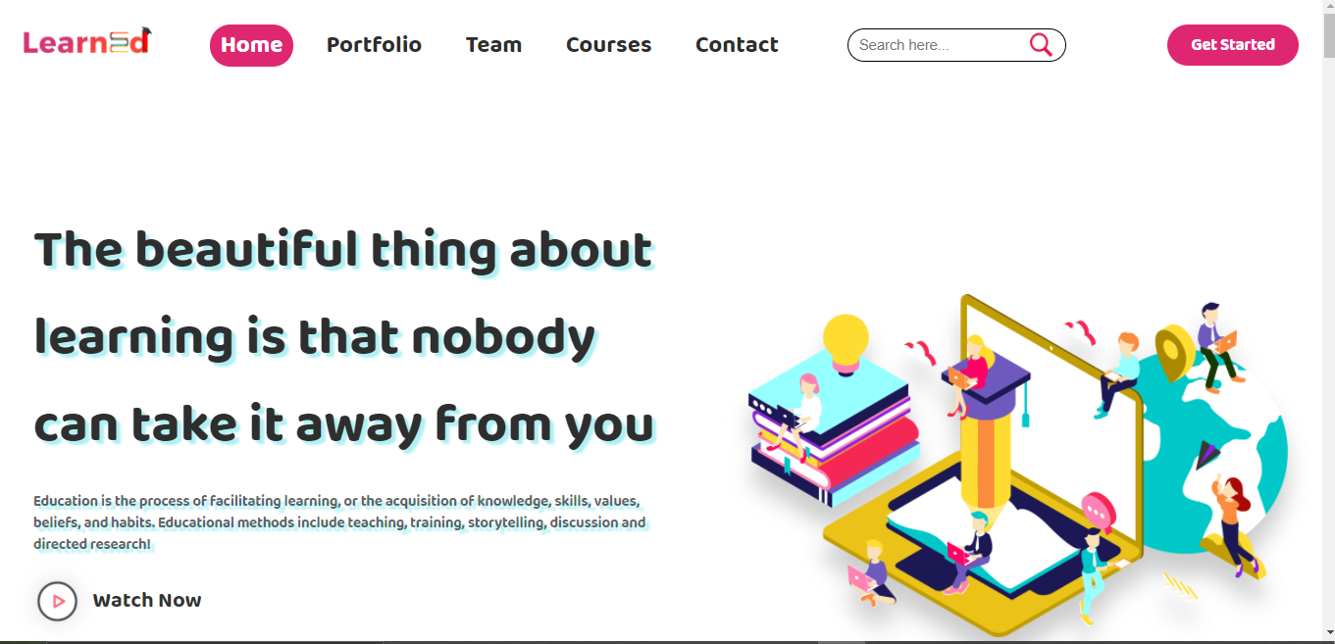

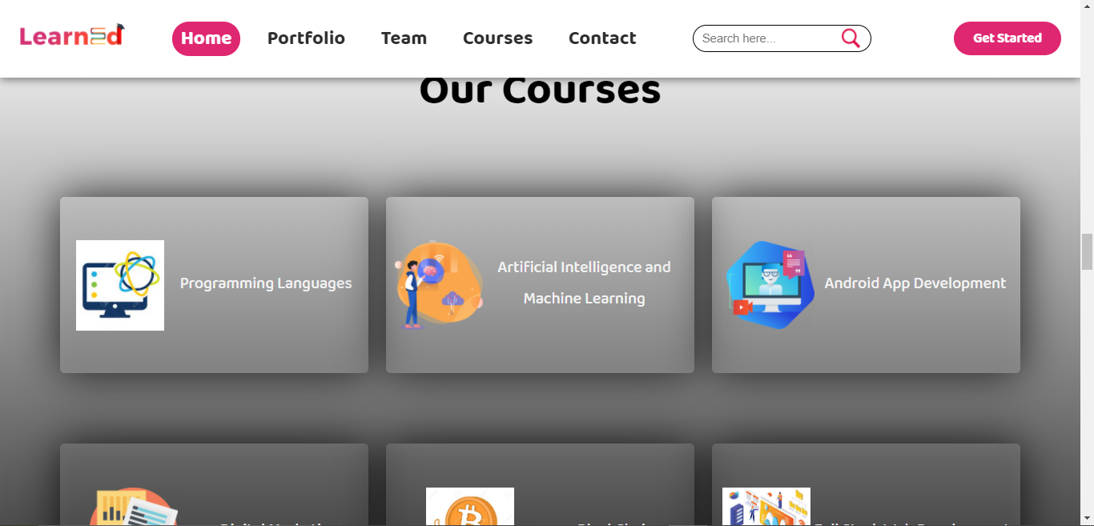

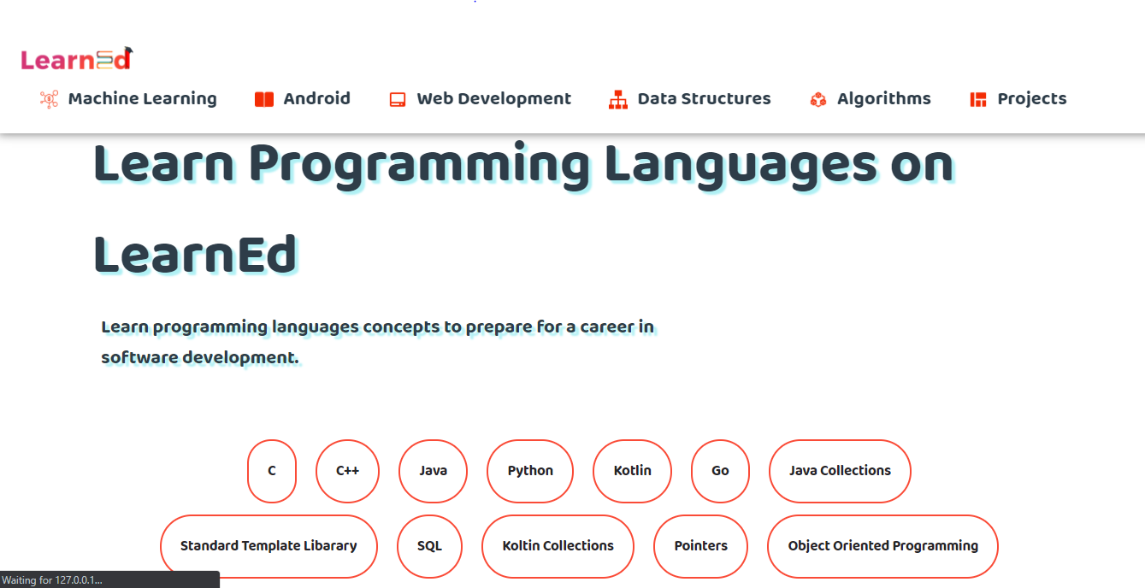

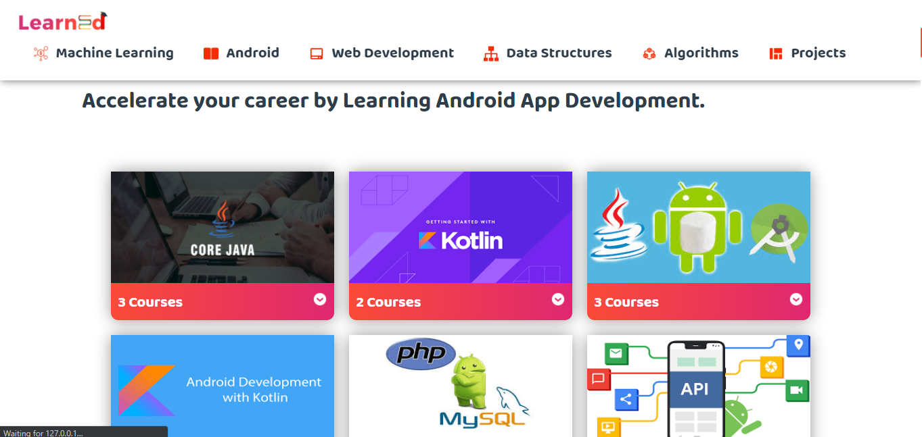

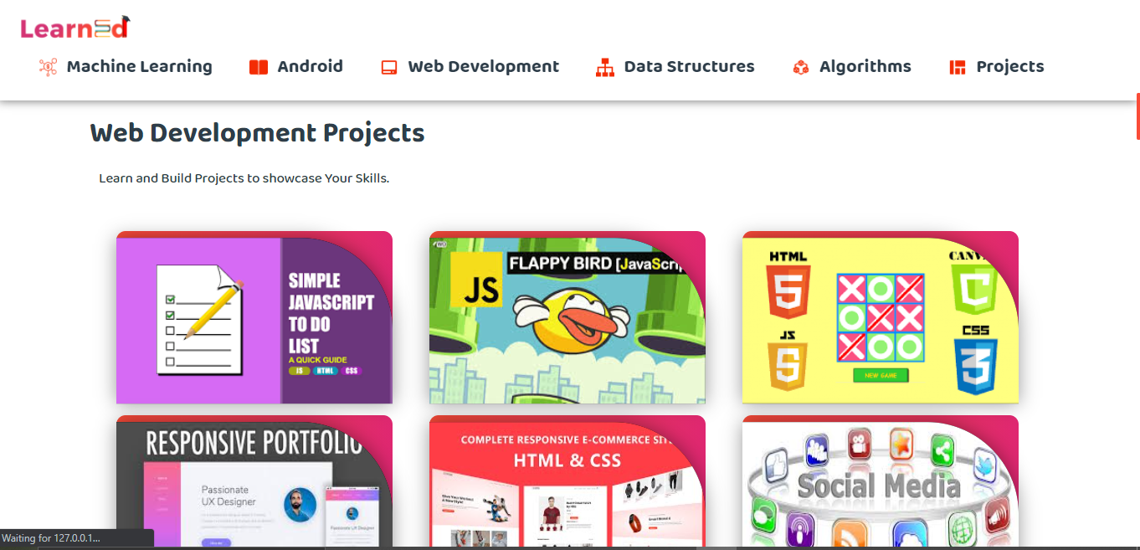

**Conclusion:**

* You are able to link the various resources in several varying formats.
* It is a very efficient way of delivering courses online.
* Due to its convenience and flexibility, the resources are available from anywhere and at any time.
* Everyone, who are part time students or are working full time, can take advantage of web-based learning.
* Web-based learning promotes active and independent learning.
* As you have access to the net 24x7, you can train yourself anytime and from anywhere also.
* It is a very convenient and flexible option; above all, you don't have to depend on anyone for anything.
* Not only can you train yourself on a day to day basis, but also on weekends or whenever you have the free time to. There is no hard and fast rule.
* Through discussion boards and chats, you are able to interact with everyone online and also clear your doubts if any.

**References:**

* GeeksforGeeks.
* Coding Blocks.
* FreeCodecamp.org.
* Youtube.com.