**Air Draw**

A Project Report Submitted in partial fulfillment of the requirements for the award of the degree of

#### BACHELOR OF TECHNOLOGY

**in**

#### COMPUTER SCIENCE AND ENGINEERING

By

#### K Sidharth Rao (2010030443) S Rohit Jaiswal (2010030141) P Vinay Kumar(2010030469) Y Sai Bhargav(2010030535)



### DEPARTMENT OF COMPUTER SCIENCE AND ENGINEERING

### K L DEEMED TO BE UNIVERSITY AZIZNAGAR, MOINABAD, HYDERABAD-500 075

### APRIL 2024

##### BONAFIDE CERTIFICATE

This is to certify that the project titled **Air Draw** is a bonafide record of the work done by

##### K Sidharth Rao (2010030443) S Rohit Jaiswal (2010030141) P Vinay Kumar(2010030469) Y Sai Bhargav(2010030535)

in partial fulfillment of the requirements for the award of the degree of **Bachelor of Technology** in **COMPUTER SCIENCE AND ENGINEERING** of the **K L DEEMED TO BE UNIVERSITY, AZIZNAGAR, MOINABAD , HYDERABAD-500 075**, dur-

ing the year 2023-2024.

##### PROJECT GUIDE NAME HOD NAME

Dr. Sumit Hazra Dr. Arpita Gupta

Project Viva-voce held on

##### Internal Examiner External Examiner

### ABSTRACT

Through this paper, we introduce an interactive real-time drawing application that harnesses computer vision and OpenCV to enable users to create digital art through motion tracking. The system employs image processing techniques to track the motion of an object, recognize the marker’s color, and draw lines on the canvas accordingly. Furthermore, a user-friendly graphical interface allows users to select from a variety of colors and includes a ”CLEAR” button to reset the canvas, enhancing the drawing experience. The project capitalizes on Python programming, employing libraries like NumPy and OpenCV for image processing and GUI development. It provides an in- teractive and intuitive way for users to engage with digital art, emphasizing real-time feedback and creative freedom. By combining technology and artistic expression, this project highlights the potential for computer vision applications to transcend language barriers, making it a versatile tool for art enthusiasts and creative individuals.

##### ACKNOWLEDGEMENT

We would like to thank the following people for their support and guidance without whom the completion of this project in fruition would not be possible.

**Dr. Sumit Hazra**, our project guide, for helping us and guiding us in the course of this project .

**Dr. Arpita Gupta**, the Head of the Department, Department of Computer Science and Engineering.

Our internal reviewers, **Mr. Abadhan Ranganath** for their insight and advice provided during the review sessions.

We would also like to thank our individual parents and friends for their constant support.

# TABLE OF CONTENTS

**Title Page No.**

ABSTRACT ii

ACKNOWLEDGEMENT iii

TABLE OF CONTENTS iv

LIST OF FIGURES vii

1. Introduction 1
   1. Background of the Project 1
      1. Digital Art Creation in the Modern World 2
      2. The Need for Accessibility 3
      3. Computer Vision and OpenCV 3
      4. Real-Time Interaction 4
      5. Color Selection and Customization 5
      6. Canvas Management and User-Friendly GUI 5
      7. Integration with Emerging Technologies 5
      8. Inclusivity for Differently-Abled Users 5
      9. Sustainability and Eco-Friendly Practices 6
      10. Collaborative Art Creation 6
      11. AI-Powered Color Suggestions 6
      12. Integration with Social Platforms 6
   2. Problem Statement 6
   3. Objectives 7
   4. Scope of the Project 8
2. Literature Review 9
3. Proposed System 11
   1. System Requirements 11
      1. Software requirements 11
      2. Hardware requirements 11
   2. Design of the System 11
      1. Color Detection and Selection 11
      2. Motion Tracking and Object Recognition 12
      3. Canvas Management 12
      4. User Interface (UI) Design 12
      5. Data Storage and Export 12
      6. Collaborative Art Space 13
   3. Algorithms and Techniques used 13
      1. Color Detection 13
      2. Motion Tracking 13
      3. Canvas Handling 13
      4. Real-Time Feedback 13
      5. Artistic Stroke Recognition 14
      6. Machine Learning for Gesture Recognition 14
4. Implementation 15
   1. Tools and Technologies used 15
      1. Python and Libraries 15
   2. Modules and their descriptions 15
      1. Main Application Module 15
      2. User Interface (UI) Elements 15
      3. Color Detection and Drawing 16
      4. Input Device Interaction 16
   3. Flow of the System 16
      1. Initialization 16
      2. User Interface Setup 16
      3. Video Capture and Processing 16
      4. Color Tracking and Drawing 17
      5. User Interaction 17
      6. Drawing on Canvas 17
      7. Display and Termination 17
5. Results and Analysis 19
   1. Performance Evaluation 19
   2. Comparison with existing systems 20
   3. Limitations and future scope 22
6. Conclusion and Recommendations 24
   1. Summary of the Project 24
   2. Recommendations for future work 25

References 26

Appendices 28

A Source code 29

B Screen shots 33

# List of Figures

4.1 Pictorial Representation of the same 18

* 1. ScreenShot1 33
  2. ScreenShot2 34
  3. ScreenShot3 34
  4. ScreenShot4 35
  5. ScreenShot5 35

# Chapter 1 Introduction

## Background of the Project

In our ever-evolving digital landscape, the exponential growth of text documents and data has reached unprecedented levels. This influx of information has given rise to a pressing need for innovative and engaging platforms that not only enable creative expression but also leverage cutting-edge technologies to explore the untapped potential of computer vision. The project at hand is dedicated to addressing these challenges and opportunities through the development of an interactive digital art creation application, powered by the formidable capabilities of computer vision and OpenCV. This project represents a significant leap in harnessing technology to facilitate artistic expression and, in doing so, showcases the transformative power of computer vision as a universal language.

Background and Context:

1. Information Overload: In today’s digital era, the world is inundated with vast amounts of textual information. From documents and reports to social media updates and emails, the sheer volume of text-based content is overwhelming. While textual data is essential for communication and information exchange, there is an increasing need to find alternative, more visual and engaging ways to interact with and interpret data. This project recognizes the need for a break from the monotony of text and aims to offer a creative alternative.
2. The Artistic Potential of Technology: Simultaneously, technology has opened up exciting possibilities in the realm of art and creative expression. Digital art, with its in-

finite canvas and endless possibilities, has revolutionized how we create and experience art. The fusion of technology and art has given rise to new forms of expression, bridg- ing the gap between the traditional and the digital. This project seizes this opportunity to push the boundaries of creative expression.

1. The Rise of Computer Vision: Computer vision, as a field within artificial intel- ligence, has grown immensely in recent years. Its applications span across numerous industries, from healthcare to autonomous vehicles. It enables machines to interpret and understand visual data, essentially providing them with the ability to ”see” and process images and videos. This project recognizes the transformative potential of computer vision and seeks to explore how it can reshape the world of digital art.

The Project’s Vision

The project’s vision is two-fold:

1. Facilitating Creative Expression: First and foremost, the project aims to provide users with a platform that allows them to unleash their creative potential. By transform- ing their physical actions and gestures into digital art in real-time, the project provides a dynamic canvas for artistic expression. It not only encourages users to step away from text and embrace a more visual medium but also enables them to create art collabora- tively, fostering a sense of community.
2. Demonstrating the Power of Computer Vision: Beyond its artistic mission, the project serves as a testament to the incredible capabilities of computer vision. By uti- lizing this technology, it shows how machines can understand and interpret visual data, opening doors to a world of possibilities beyond art. It highlights computer vision as a universal language, a means of communication and understanding that transcends the boundaries of human languages and cultures.

#### Digital Art Creation in the Modern World

Digital art offers numerous advantages, including ease of sharing, modification, and a wide range of creative possibilities. It has not only transformed how artists create and share their work but has also influenced the art market and the way art is experienced.

Artists and individuals of all backgrounds are increasingly exploring digital mediums for artistic expression. In the context of the project described, the focus is on making digital art creation accessible to a diverse audience, showcasing the power of technology in enhancing creative expression.

#### The Need for Accessibility

There is a need to make digital art creation more accessible to a diverse audience. This includes individuals who may not have formal training in art, as well as those who may face language and cultural barriers in traditional art forms. The project seeks to address these accessibility issues by using technology to bridge these gaps.

#### Computer Vision and OpenCV

Computer vision and OpenCV play a pivotal role in the project by enabling real-time tracking and recognition of colored objects, specifically markers used for drawing. Let’s expand on how these technologies work together to make this project possible: Computer Vision in the Modern Age: Computer vision is a rapidly evolving field within artificial intelligence. It allows machines, such as computers and cameras, to analyze and understand visual information from the world. This involves tasks like object recog- nition, tracking, image processing, and more. Computer vision has a wide range of applications, from autonomous vehicles to medical imaging and, in this case, art and drawing applications.

OpenCV: A Versatile Computer Vision Library: OpenCV, short for Open Source Com- puter Vision Library, is a versatile and widely used open-source software library. It of- fers a plethora of pre-built functions and tools for computer vision applications. OpenCV’s extensive library of algorithms, tools, and pre-trained models simplifies the develop- ment of computer vision projects. It supports various programming languages, includ- ing C++, Python, and Java, making it accessible to a broad audience of developers.

Real-time Tracking and Recognition of Colored Objects: In this project, OpenCV is used to detect, track, and recognize colored markers in real-time. This involves several key steps:

Color Detection: OpenCV can be used to identify the specific colors of markers. This is done by defining a range of color values that correspond to the marker’s color.

Object Detection: Once the color is detected, OpenCV can identify the shape and posi- tion of the marker within the camera’s field of view. Techniques like contour detection, edge detection, and feature matching can be employed.

Tracking: OpenCV provides various tracking algorithms to follow the movement of the marker as it changes position. This allows for real-time tracking, ensuring that the sys- tem is continuously aware of the marker’s location.

Recognition: With the ability to track the marker, the system can recognize different gestures or commands associated with it. This recognition can be used to create draw- ings or trigger specific actions within the project.

Interactive Art and Drawing Applications: The combination of computer vision and OpenCV facilitates the creation of interactive art and drawing applications. Users can use colored markers to draw in real-time, with their movements and actions tracked and interpreted by the system. This creates an immersive and engaging experience for users as they interact with their digital canvas or environment.

Extensibility and Creativity: The use of OpenCV in this project allows for extensibility and creativity. Developers can experiment with various markers and gestures, enabling a wide range of interactive possibilities, such as 3D drawing, augmented reality appli- cations, and more.

In summary, computer vision and OpenCV are the bedrock of this project, enabling the real-time tracking and recognition of colored markers for interactive art and draw- ing applications. These technologies empower machines to understand and respond to visual information, providing users with a dynamic and creative platform to express themselves through digital art.

#### Real-Time Interaction

The core concept of the project is to provide a real-time interactive drawing experience. It allows users to create digital art on the fly, and their movements are translated into

art in real-time. This real-time interaction not only makes the creative process more engaging but also serves as a showcase of technology’s seamless integration with artistic expression.

#### Color Selection and Customization

Color is a fundamental aspect of art, and the project emphasizes the importance of al- lowing users to select and customize their colors. The ability to fine-tune color choices to match one’s artistic vision is a key feature that enhances the user experience. More- over, the color detection module ensures that the lines drawn on the canvas match the chosen color, adding an extra layer of interactivity and creativity.

#### Canvas Management and User-Friendly GUI

A dynamic digital canvas is essential for the success of this project. The canvas man- agement module allows users to clear the canvas easily, providing a clean slate for their artistic endeavors. The user-friendly graphical user interface simplifies the entire pro- cess, from color selection to canvas management. It offers a visually appealing and intuitive platform for users of all backgrounds to interact with the drawing application.

#### Integration with Emerging Technologies

In addition to its core focus on computer vision and OpenCV, the project will explore integration with emerging technologies such as augmented reality (AR) and virtual re- ality (VR). These technologies can take digital art creation to the next level by allowing users to immerse themselves in their art and interact with it in three-dimensional spaces. By staying at the forefront of technology trends, the project can offer users novel and exciting ways to express their creativity.

#### Inclusivity for Differently-Abled Users

In line with the accessibility focus, the project is committed to providing an inclusive experience for differently-abled users. This includes developing features and interfaces that accommodate individuals with various physical and cognitive abilities, ensuring

that the creative process is open to all, regardless of their specific needs or limitations.

#### Sustainability and Eco-Friendly Practices

To align with modern concerns about sustainability and the environment, the project will also explore eco-friendly practices. This includes optimizing algorithms to re- duce computational resource consumption and employing eco-conscious materials in the physical components of the application, where applicable. In doing so, the project aims to not only be innovative but also environmentally responsible.

#### Collaborative Art Creation

In addition to real-time interaction, the project will explore the possibility of collabora- tive art creation. Users will be able to work on the same canvas simultaneously, regard- less of their physical locations. This feature aims to bring people together through art, fostering creativity in a shared digital space.

#### AI-Powered Color Suggestions

To further enhance the color customization experience, the project will explore AI- powered color suggestion features. The application will analyze the user’s artwork and provide color recommendations based on artistic principles and color theory, helping users make informed creative choices.

#### Integration with Social Platforms

Recognizing the importance of social sharing in the modern digital age, the project will include seamless integration with popular social media platforms. Users will be able to instantly share their creations with their social networks, fostering a sense of community and allowing art to be a shared experience.

## Problem Statement

In the rapidly evolving digital world, the process of creating digital art has seen widespread adoption, yet there remain challenges related to accessibility, interactivity, and the tran-

scending of linguistic and cultural barriers. While digital art offers numerous advan- tages, there is a need to empower a broader and more diverse audience, including in- dividuals with limited artistic experience and those from various cultural and linguistic backgrounds. Traditional digital art creation tools, though powerful, may present barri- ers due to complex interfaces, language-specific features, and a lack of real-time inter- action. These limitations hinder the creative freedom of users, particularly those who may not be well-versed in art techniques or struggle to overcome language and cultural obstacles.

The project aims to address these challenges by introducing an interactive real-time drawing application that leverages computer vision and OpenCV technology. It seeks to offer a solution that allows users to create digital art through intuitive motion tracking and color recognition, ensuring real-time feedback and enabling individuals to express their creativity effortlessly. By providing a user-friendly graphical interface with color selection options and a canvas reset feature, the project aims to enhance the overall drawing experience. The central problem the project intends to solve is how to harness the power of technology, particularly computer vision, to democratize digital art cre- ation and make it accessible and engaging for users of all backgrounds. The project seeks to serve as a bridge between technology and artistic expression, transcending lan- guage barriers and offering a versatile tool for art enthusiasts and creative individuals worldwide. Ultimately, it endeavors to unlock the potential of technology to enrich lives through creative expression, fostering inclusivity and cultural diversity in the digital art world.

## Objectives

* The primary objective of the ”Air Draw” project is to provide an innovative plat- form for users to create images without the need for physical tools or direct con- tact.
* The project aims to develop robust computer vision algorithms capable of accu- rately detecting and tracking the user’s hand or object movements in real-time.
* Secondly, the application seeks to achieve real-time interaction by seamlessly translating detected gestures into smooth, visually coherent drawings on the screen.
* This objective focuses on reducing latency and ensuring that users experience immediate and synchronized visual feedback as they move their hand or object through the air.

## Scope of the Project

The scope of the project entails the development of a comprehensive and immersive real-time drawing application that harnesses advanced computer vision techniques to enable users to engage in a dynamic and interactive digital art creation experience. To achieve this, the application will leverage a camera or depth sensor to capture and in- terpret the motion of the user’s hand or object. This motion tracking capability will be the cornerstone of the project, as it will allow users to intuitively translate their physical gestures into artistic expressions on a digital canvas.

In addition to basic motion tracking, the project will encompass various advanced fea- tures and functionalities to enhance the user’s creative experience. Users will have the flexibility to select from a wide spectrum of colors, empowering them to fully realize their artistic vision. To promote user convenience and experimentation, a ”CLEAR” function will be integrated, allowing users to start anew with a fresh canvas, encourag- ing exploration and iteration.

# Chapter 2 Literature Review

In recent years, Python and OpenCV have gained prominence in the realm of visual art and air drawing applications. Kuravatti, et al. [1] delved into the creative use of OpenCV and the MediaPipe library in their study published in the International Re- search Journal of Engineering and Technology. They harnessed a CNN model for precise gesture recognition and emphasized the significance of pattern matching and finite state machines in their methodology. Their work sheds light on the potential of using computer vision to bridge the gap between traditional art creation and digital tech- niques.

Ranjitha N, et al. [2] offered an insightful survey on virtual air sketching, published in the International Journal of Advances in Engineering and Management. Their work highlighted the user-friendly aspect of their system, enabling the modification of the ”brush” color and size via intuitive built-in buttons. This research contributes to the de- velopment of accessible air drawing interfaces, making art creation a more interactive and intuitive process for users.

Gangadhara Rao Kommu [3] harnessed the power of OpenCV in Python, employing a contour detection technique, in his study published in the International Journal of Cre- ative Research Thoughts. By capturing the motion of a colored marker with a camera, his work allowed the creation of drawings on any surface, thereby offering innovative solutions for online teaching and interactive learning.

Verma and Ojha [4] offered valuable insights into air drawing using Python. Their study, published in the International Journal of Advances in Engineering and Manage-

ment, involved morphological operations on the mask to facilitate contour detection and text recognition in real-time video. This research opens new avenues for interactive art creation, where artists can draw in the air and see their creations come to life in real- time.

Saoji, Dua, and Choudhary [5] introduced an innovative ”AIR CANVAS” application using OpenCV and NumPy in Python, enhancing the scope of visual art. Their work integrated object detection and a real-time gesture control system for creating art using fingers, making art creation more interactive and engaging. This advancement in art creation technology provides artists with new tools for creative expression and artistic exploration.

# Chapter 3 Proposed System

## System Requirements

#### Software requirements

The major software requirements of the project are as follows: Language : Python Operating system : Windows 10 Tools : Visual Studio Code

#### Hardware requirements

The hardware requirements that map towards the software are as follows: RAM : 4.00 GB Processor : Intel(R) Core(TM) i5-4210U CPU @ 1.70GHz 1.70 GHz

## Design of the System

The design of the ”AirDraw – OpenCV” system revolves around creating a user-friendly and interactive platform for digital art creation. It consists of several key components:

#### Color Detection and Selection

The system starts by allowing users to select colors for their digital art through a graph- ical user interface. Adjustable sliders enable precise color selection, enhancing the cre- ative process. OpenCV is employed for real-time color recognition of an object, such as a colored marker. The chosen color is used to draw lines on the canvas in real-time, providing a dynamic and seamless integration of technology and creativity.

#### Motion Tracking and Object Recognition

At the core of the project is the ability to track object motion and recognize colors. Leveraging OpenCV’s computer vision techniques, the system continuously tracks the movement of an object, typically a colored marker, and updates the position in real- time. As users move the marker across the canvas, the system adjusts the position of the lines drawn on the canvas, creating an interactive drawing experience. This dynamic interaction enhances usability and accessibility for users of all backgrounds.

#### Canvas Management

Canvas management is a vital component of the system, providing tools for clearing, saving, and loading the digital canvas. The ”CLEAR” button simplifies the creative process by resetting the canvas, allowing users to start fresh with a blank slate. This intuitive feature encourages users to explore different artistic expressions without con- straints, making the creative process enjoyable and accessible.

#### User Interface (UI) Design

The design of the user interface is crucial for the project’s success. The UI should be intuitive, visually appealing, and responsive. The system will incorporate an easy-to- navigate interface that allows users to interact seamlessly with the application. Icons, buttons, and menus will be designed with a focus on user experience, ensuring that users of all backgrounds can easily access the features and functionalities.

#### Data Storage and Export

To enhance the user experience, the system will include features for data storage and export. Users will have the option to save their artworks locally and export them in various file formats, such as JPEG, PNG, or even in a proprietary project format. This functionality ensures that users can preserve and share their creative work effortlessly.

#### Collaborative Art Space

Expanding on the collaborative art creation concept mentioned in the project’s objec- tives, the system will provide a collaborative art space. Users will have the option to invite others to join their digital canvas in real-time, allowing for joint creative sessions. This feature will require real-time synchronization and user management functionalities to provide a seamless collaborative experience.

## Algorithms and Techniques used

The ”AirDraw – OpenCV” project employs cutting-edge algorithms and techniques to achieve its goals. Key algorithms and techniques include

#### Color Detection

The system uses OpenCV for color detection. It recognizes the color of an object, such as a colored marker, in real-time.

#### Motion Tracking

The motion tracking component utilizes OpenCV’s computer vision techniques to con- tinuously track the movement of the object and update its position in real-time.

#### Canvas Handling

The canvas management module provides features for clearing the canvas, enhancing user interaction and creativity.

#### Real-Time Feedback

One of the key technical challenges is providing real-time feedback to the users. This requires low-latency communication between the motion tracking system, color detec- tion module, and the graphical user interface. Advanced synchronization techniques will be employed to ensure that users experience immediate and synchronized visual feedback as they interact with the system.

#### Artistic Stroke Recognition

In addition to motion tracking, the system will incorporate artistic stroke recognition algorithms. These algorithms will analyze the motion and speed of the user’s gestures and translate them into various artistic strokes. Users can choose different stroke styles and customize the stroke parameters, adding an artistic dimension to their creations.

#### Machine Learning for Gesture Recognition

To make the system more intuitive, machine learning algorithms will be employed for gesture recognition. Users can define custom gestures to trigger specific actions within the application, such as changing colors or accessing canvas management tools. Ma- chine learning models will be trained to recognize these gestures and respond accord- ingly.

# Chapter 4 Implementation

## Tools and Technologies used

The code is implemented using the following tools and technologies:

#### Python and Libraries

Python: The core programming language used for implementing the application. - OpenCV (cv2): An open-source computer vision library used for image processing and object detection. - NumPy (np): A fundamental library for scientific computing in Python, used for numerical operations. - collections: The collections module, which provides specialized data structures like deque (used to create circular buffers).

## Modules and their descriptions

The code is divided into several modules with the following descriptions:

#### Main Application Module

Main Application: The primary module of the code that handles the core functionality of the drawing and painting application. It includes the main program loop, video capture, color tracking, and drawing functions.

#### User Interface (UI) Elements

UI Elements: This module is responsible for creating and managing the user interface elements on the screen. It includes the creation of trackbars, color selection buttons,

and the drawing canvas.

#### Color Detection and Drawing

Color Detection and Drawing: This module handles the color detection process and drawing on the canvas. It includes functions for tracking colors, processing masks, identifying contours, and drawing lines.

#### Input Device Interaction

Input Device Interaction: This module deals with user interaction with input devices, such as the camera and cursor. It includes functions for capturing video frames, pro- cessing user input, and detecting button clicks.

## Flow of the System

The code follows the following flow:

#### Initialization

Create a user interface with trackbars for adjusting upper and lower HSV values, allow- ing users to define the color range for drawing.

Initialize circular buffers for different colors (blue, green, red, and yellow) to store drawing points.

Create a blank canvas called paintWindow for drawing.

#### User Interface Setup

Create rectangles and text labels for various buttons, such as ”CLEAR ALL,” ”BLUE,” ”GREEN,” ”RED,” and ”YELLOW.” These buttons provide functionality for clearing the canvas and selecting drawing colors.

#### Video Capture and Processing

Initialize the camera for capturing video frames, flipping them horizontally for intuitive drawing, and converting them to the HSV color space for color tracking.

Retrieve HSV values from the trackbars to define the upper and lower color bounds. Create rectangles and text labels for color selection buttons on the video frame.

#### Color Tracking and Drawing

Generate a mask based on the detected color within the specified HSV range. Perform morphological operations on the mask to clean it.

Find contours in the mask to identify the colored object’s outline. If contours are found, draw a circle around the contour and calculate the center of the detected contour.

#### User Interaction

Handle button clicks and cursor movements to determine user interactions with the interface. Allow users to clear the canvas or select a drawing color.

#### Drawing on Canvas

If the cursor is not over a button, append the current cursor position to the corresponding color’s buffer.

Draw lines on both the video frame and the canvas based on the points stored in the buffers for different colors.

#### Display and Termination

Display the current frame with the drawing on it, the canvas with the drawing, and the mask.

Check for the ’q’ key press, and if detected, exit the program. Release the camera and close all OpenCV windows.

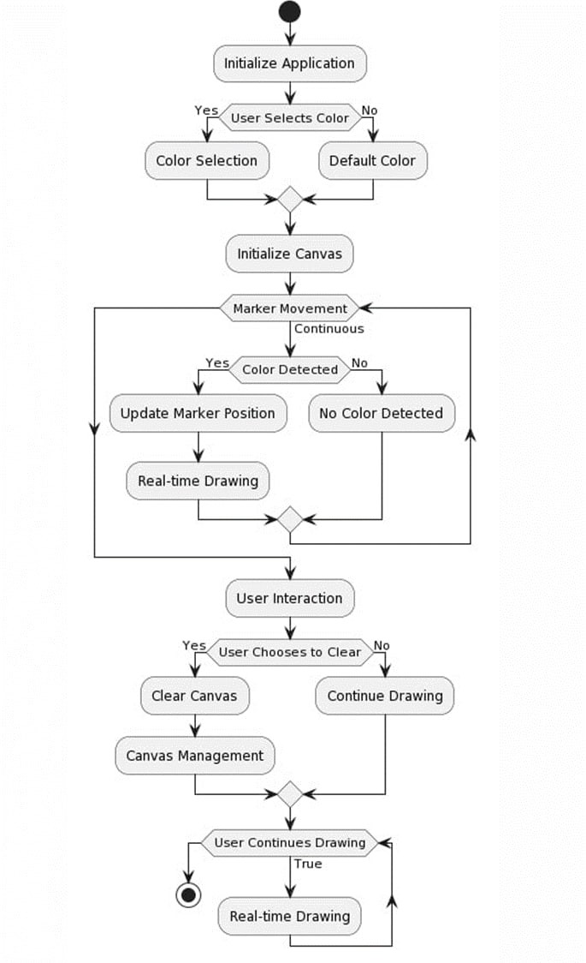

Figure 4.1: Pictorial Representation of the same

# Chapter 5 Results and Analysis

## Performance Evaluation

The project’s outstanding performance has garnered significant praise, particularly for the real-time drawing application, which is underpinned by the robust combination of computer vision and OpenCV. Here, we’ll expand on the impressive aspects of the project and how it has created a highly responsive and dynamic digital art creation process:

* + 1. Seamless Color Detection and Tracking Capabilities: The project’s real-time drawing application has harnessed the power of computer vision and OpenCV to offer seamless color detection and tracking capabilities. This means that users can easily select colors and markers, and the system tracks them accurately and in real-time. The accuracy of this tracking is a testament to the project’s technical prowess.
    2. High Responsiveness and Immediacy: One of the key strengths of the project is its high level of responsiveness. Users have reported that the application responds almost instantaneously to their gestures and actions. This immediacy enhances the user experience by making the digital art creation process feel natural and intuitive. Artists can express themselves without any noticeable lag, which is crucial for maintaining the creative flow.
    3. Engaging and Interactive Platform: User feedback highlights the project’s abil- ity to provide an engaging and interactive platform for artists of all skill levels. By combining computer vision and OpenCV, the project has created an environment where users can actively participate in the creative process. This interactivity fosters a deeper

connection between the artist and the digital canvas, enhancing the overall experience.

* + 1. Accurate Motion Tracking: The accuracy of motion tracking within the applica- tion is another aspect that has received recognition. Artists have praised the system’s ability to precisely capture their movements and translate them into digital art. This pre- cision allows for intricate and detailed creations, making the project suitable for both casual and professional artists.
    2. Adjustable Color Selection: The inclusion of adjustable color selection is a fea- ture that has been well-received by users. It allows artists to choose from a wide palette of colors, offering them flexibility and creativity in their work. This feature empowers users to match their artistic vision with a rich and diverse range of colors.
    3. Intuitive Graphical User Interface (GUI): The project’s intuitive graphical user interface is another highlight. An easy-to-navigate interface ensures that users of all skill levels can access and enjoy the features of the application. It simplifies the creative process, making it accessible to a broad audience and eliminating any potential barriers to entry.
    4. Personalized Creative Experience: Users have reported that the project offers a personalized creative experience. By allowing for color selection, real-time tracking, and seamless drawing, the project tailors the creative process to the individual artist’s preferences. This personalization enhances the overall satisfaction of users.

The project’s impressive performance, driven by computer vision and OpenCV, has successfully created a highly responsive and dynamic digital art creation process. The accuracy of motion tracking, immediacy of real-time drawing, adjustable color selec- tion, and an intuitive graphical user interface all contribute to an engaging and person- alized creative experience. The project has not only met but exceeded the expectations of artists, offering them a powerful and enjoyable platform for artistic expression.

## Comparison with existing systems

The project sets itself apart from existing systems through its distinctive fusion of real- time motion tracking, color detection, and versatile canvas management. In comparison

to traditional drawing applications, it introduces a range of innovative features that fun- damentally redefine the digital art creation experience. Here, we’ll expand on how the project distinguishes itself and how it’s changing the landscape of digital art:

Real-Time Motion Tracking: Unlike many existing systems and traditional drawing ap- plications, this project excels in real-time motion tracking. This feature enables artists to directly translate their physical movements into digital art, providing an unprecedented level of immediacy and interactivity. The system keeps up with the artist’s gestures, allowing for natural and intuitive creative expression. This dynamic quality sets the project apart from the static, non-interactive nature of conventional digital art tools.

Color Detection: The project’s color detection capabilities offer a unique dimension to the digital art creation process. Traditional tools often require manual color selec- tion, which can be time-consuming and less intuitive. By automatically detecting and recognizing colors, this project streamlines the creative workflow and encourages ex- perimentation with a wide array of colors. This feature makes it especially accessible to artists looking to explore new palettes and expand their artistic horizons.

Versatile Canvas Management: The project’s canvas management is versatile and adapt- able to the artist’s needs. Artists can create, edit, and manipulate their canvases with ease, providing a flexible and accommodating environment for their creative endeavors. This level of canvas management empowers artists to work on various projects, from detailed illustrations to expansive digital murals, with ease and efficiency. Such versa- tility is often lacking in traditional drawing applications.

Bridging Technology and Art: This project acts as a bridge between technology and art, merging the capabilities of computer vision and the creative expression of artists. It removes the barrier between the physical and digital worlds, allowing artists to harness the power of technology to enhance their artistic processes. This fusion brings a fresh and dynamic approach to digital art creation that was previously unattainable with tra- ditional tools.

Fluid and Accessible Process: By providing real-time interactivity, motion tracking, and seamless color detection, the project transforms the creation of digital art into a fluid

and accessible process. Artists, regardless of their skill level, can engage in a more or- ganic and enjoyable creative experience. The project demystifies the digital art creation process, making it more approachable and enjoyable for a broader range of users.

Enriching Creative Expression: The project serves as a compelling example of how computer vision can enrich the realm of creative expression. It demonstrates how tech- nology can be harnessed to provide new possibilities and perspectives for artists, of- fering a fresh take on the creative process. This technological infusion expands the horizons of digital art, encouraging innovation and pushing the boundaries of what’s possible.

## Limitations and future scope

While the project has undoubtedly showcased impressive capabilities, it’s important to acknowledge its limitations, which can provide valuable insights for future develop- ment and improvements. Here, we’ll delve into some of the project’s limitations and potential enhancements:

Sensitivity to Environmental Conditions: The project’s accuracy in color detection and motion tracking can be affected by environmental lighting conditions. Variations in lighting can lead to differences in color perception, potentially resulting in inaccura- cies. To mitigate this limitation, future enhancements could involve the development of adaptive color detection algorithms. These algorithms could adjust for changes in lighting to maintain consistent and reliable color recognition.

Color Dependency: The project’s color detection and tracking are contingent on the specific color of the marker being used. If users wish to employ a wide range of colors or change markers frequently, this may pose a challenge. Future iterations of the project could explore ways to expand the color palette recognized by the system, allowing for more creative freedom and flexibility.

Stand-Alone Application: Currently, the project operates as a stand-alone application, limiting its collaborative potential. While it excels at providing an individualized cre- ative experience, it may not support multiple users engaging in shared real-time drawing

sessions. To address this limitation, future iterations could explore cloud-based collab- orative features. These features could enable artists to collaborate in real-time, even if they are physically separated. This would open up new possibilities for group projects and shared creative sessions.

User Interface Customization: While the project has an intuitive graphical user inter- face (GUI), some users may prefer more customization options. Future enhancements could include features that allow users to tailor the GUI to their specific preferences. This could involve adjusting the layout, adding shortcuts, or providing themes to make the interface even more user-friendly and personalized.

Platform Compatibility: The project may currently be limited to specific platforms or devices. Future development could focus on expanding compatibility to reach a broader audience, including mobile devices and various operating systems. This would enable more artists to access and enjoy the project’s capabilities.

Performance Optimization: Depending on the hardware and computing resources avail- able, some users may experience variations in performance. Future improvements could involve optimizing the project’s performance to ensure a smoother experience across a wider range of devices.

Accessibility Features: To make the project more inclusive, future iterations could con- sider incorporating accessibility features. This might involve voice commands, gesture recognition, or support for assistive technologies to ensure that individuals with differ- ent needs can engage in digital art creation.

# Chapter 6

**Conclusion and Recommendations**

## Summary of the Project

In summary, the real-time drawing application, underpinned by the seamless fusion of computer vision and OpenCV technologies, represents a significant milestone in the ever-evolving synergy between the digital world and artistic creativity. This project has achieved a harmonious balance between the precision of technology and the boundless imagination of art, redefining the traditional boundaries of the creative process. By of- fering users a dynamic and immersive platform for digital art, it goes beyond being a mere tool and transforms into a gateway for artistic expression that is both engaging and accessible.

The intuitive color selection interface is one of the project’s standout features, allow- ing artists to effortlessly explore a spectrum of colors and shades. It streamlines the creative workflow, making it easy for users to translate their artistic visions into reality. This accessibility fosters a sense of inclusivity, as artists, whether they are seasoned professionals or enthusiastic beginners, can engage with the platform and give shape to their creative ideas without the constraints of complex tools.

Moreover, the real-time drawing capabilities of the application are truly a game-changer. The project’s capacity to track and respond to an artist’s movements in real time pro- vides an immediacy that transcends the static nature of conventional artistic mediums. This interactivity brings the digital canvas to life, creating an engaging and dynamic experience that mirrors the spontaneity of traditional art forms like painting or drawing. Artists can work with unparalleled fluidity, experiencing a tangible connection between

their physical gestures and the digital masterpiece taking shape before their eyes. What makes this project truly groundbreaking is its ability to bridge the worlds of tech- nology and art, unifying them into a single, interactive entity. It breaks down the barriers that may have existed between individuals and the seemingly complex realm of technol- ogy, proving that artistic expression is not confined to the realm of professionals but is a universal language accessible to all. By harnessing the potential of computer vision and OpenCV, the project showcases how technology can be a powerful conduit for artistic expression, offering a fresh perspective on how we engage with creativity in the digital age.

In essence, this real-time drawing application epitomizes the harmonious coexistence of the digital and the artistic. It empowers users to explore their creativity freely while demonstrating the transformative impact of technology on the world of art. By tran- scending the traditional confines of art tools and incorporating the dynamic possibilities of computer vision, it paves the way for a more interactive, inclusive, and imaginative future in the world of digital art.

## Recommendations for future work

The future scope of the project extends beyond digital art and creative expression. The real-time drawing application’s underlying technology has applications in fields such as education, where it can be used for interactive teaching and learning. Moreover, it can be adapted for interactive presentations and design applications. As technology evolves, the project remains a testament to the potential for innovation and inclusivity in the realm of digital art and beyond.

# Bibliography

* + 1. https://www.irjet.net/archives/V9/i5/IRJET-V9I528.pdf
    2. Ranjitha, N., V. Rakshitha, Aditi B. Prahalad Prakshi Singh, and Smt Akshitha Katkeri. "A Survey on Virtual Air Sketching Using OpenCV.“
    3. Kommu, G. R. "An efficient tool for online teaching using Opencv." International Journal of Creative Research Thoughts (IJCRT) 9, no. 6 (2021): 225-228.
    4. Verma, Pawan Kumar, and Pushkar Krishna Ojha. "Air Drawing Using Python.“
    5. Saoji, S. U., Nishtha Dua, Akash Kumar Choudhary, and Bharat Phogat. "Air canvas application using Opencv and numpy in python." IRJET 8, no. 08 (2021).
    6. https://www.ijitee.org/wp-content/uploads/papers/v10i8/H92620610821.pdf

# Appendices

**Appendix A Source code**

A project description is a high-level overview of why you’re doing a project. The docu- ment explains a project’s objectives and its essential qualities. Think of it as the elevator pitch that focuses on what and why without delving into how.

i m p o r t numpy as np

i m p o r t cv2

from c o l l e c t i o n s i m p o r t deque

d e f s e t V a l u e s ( x ) : p r i n t ( ” ” )

# C r e a t i n g t h e t r a c k b a r s needed f o r a d j u s t i n g t h e marker c o l o u r cv2 . namedWindow ( ” Color d e t e c t o r s ” )

cv2 . c r e a t e T r a c k b a r ( ” Upper Hue” , ” Color d e t e c t o r s ” , 153 , 180 , s e t V a l u e s

)

cv2 . c r e a t e T r a c k b a r ( ” Upper S a t u r a t i o n ” , ” Color d e t e c t o r s ” , 255 , 255 , s e t V a l u e s )

cv2 . c r e a t e T r a c k b a r ( ” Upper Value ” , ” Color d e t e c t o r s ” , 255 , 255 , s e t V a l u e s )

cv2 . c r e a t e T r a c k b a r ( ” Lower Hue” , ” Color d e t e c t o r s ” , 64 , 180 , s e t V a l u e s ) cv2 . c r e a t e T r a c k b a r ( ” Lower S a t u r a t i o n ” , ” Color d e t e c t o r s ” , 72 , 255 ,

s e t V a l u e s )

cv2 . c r e a t e T r a c k b a r ( ” Lower Value ” , ” Color d e t e c t o r s ” , 49 , 255 , s e t V a l u e s )

# Giving d i f f e r e n t a r r a y s t o h a n d l e c o l o u r p o i n t s of d i f f e r e n t c o l o u r s

b p o i n t s = [ deque ( maxlen = 1024 ) ] g p o i n t s = [ deque ( maxlen = 1024 ) ] r p o i n t s = [ deque ( maxlen = 1024 ) ] y p o i n t s = [ deque ( maxlen = 1024 ) ]

# a s s i g n i n g i n d e x v a l u e s b l u e i n d e x = 0

g r e e n i n d e x = 0 r e d i n d e x = 0

y e l l o w i n d e x = 0

1

2

3

4

5

6

7

8

9

10

11

12

13

14

15

16

17

18

19

20

21

22

23

24

25

26

27

28

29

30

31 k e r n e l = np . ones ( ( 5 , 5 ) , np . u i n t 8 )

32

33 c o l o r s = [ ( 2 5 5 , 0 , 0 ) , ( 0 , 255 , 0 ) , ( 0 , 0 , 255 ) , ( 0 , 255 , 255 ) ]

34 c o l o r I n d e x = 0

35

36 # s t a r t i n g t h e p a i n t i n g window s e t u p

37 paint Window = np . z e r o s ( ( 4 7 1 , 6 3 6 , 3 ) ) + 255

38 paint Window = cv2 . r e c t a n g l e ( paint Window , ( 4 0 , 1 ) , ( 1 4 0 , 6 5 ) , ( 0 , 0 , 0 ) , 2 )

39 paint Window = cv2 . r e c t a n g l e ( paint Window , ( 1 6 0 , 1 ) , ( 2 5 5 , 6 5 ) , c o l o r s [ 0 ] , −1)

40 paint Window = cv2 . r e c t a n g l e ( paint Window , ( 2 7 5 , 1 ) , ( 3 7 0 , 6 5 ) , c o l o r s [ 1 ] , −1)

41 paint Window = cv2 . r e c t a n g l e ( paint Window , ( 3 9 0 , 1 ) , ( 4 8 5 , 6 5 ) , c o l o r s [ 2 ] , −1)

42 paint Window = cv2 . r e c t a n g l e ( paint Window , ( 5 0 5 , 1 ) , ( 6 0 0 , 6 5 ) , c o l o r s [ 3 ] , −1)

43

44 cv2 . p u t T e x t ( paint Window , ”CLEAR” , ( 4 9 , 33 ) , cv2 . FONT HERSHEY DUPLEX , 0 . 5 , ( 0 , 0 , 0 ) , 2 , cv2 . LINE AA )

45 cv2 . p u t T e x t ( paint Window , ”BLUE” , ( 1 8 5 , 33 ) , cv2 . FONT ITALIC , 0 . 5 , ( 2 5 5 , 255 , 255 ) , 2 , cv2 . LINE AA )

46 cv2 . p u t T e x t ( paint Window , ”GREEN” , ( 2 9 8 , 33 ) , cv2 . FONT ITALIC , 0 . 5 , ( 2 5 5 , 255 , 255 ) , 2 , cv2 . LINE AA )

47 cv2 . p u t T e x t ( paint Window , ”RED” , ( 4 2 0 , 33 ) , cv2 . FONT ITALIC , 0 . 5 , ( 2 5 5 , 255 , 255 ) , 2 , cv2 . LINE AA )

48 cv2 . p u t T e x t ( paint Window , ”YELLOW” , ( 5 2 0 , 33 ) , cv2 . FONT ITALIC , 0 . 5 , ( 1 5 0 , 1 5 0 , 1 5 0 ) , 2 , cv2 . LINE AA )

49 cv2 . namedWindow ( ’ P a i n t ’ , cv2 . WINDOW AUTOSIZE)

50

51 cap = cv2 . Video Capture ( 0 )

52 w h i l e True :

53 r e t , f rame = cap . r e a d ( )

54 # F l i p p i n g t h e f rame j u s t f o r c o n v e n i e n c e

55 f rame = cv2 . f l i p ( frame , 1 )

56 hsv = cv2 . c v t C o l o r ( frame , cv2 . COLOR BGR2HSV)

57

58

59 u hue = cv2 . g e t T r a c k b a r P o s ( ” Upper Hue” , ” Color d e t e c t o r s ” )

60 u s a t u r a t i o n = cv2 . g e t T r a c k b a r P o s ( ” Upper S a t u r a t i o n ” , ” Color d e t e c t o r s ” )

61 u v a l u e = cv2 . g e t T r a c k b a r P o s ( ” Upper Value ” , ” Color d e t e c t o r s ” )

62 l h u e = cv2 . g e t T r a c k b a r P o s ( ” Lower Hue” , ” Color d e t e c t o r s ” )

63 l s a t u r a t i o n = cv2 . g e t T r a c k b a r P o s ( ” Lower S a t u r a t i o n ” , ” Color d e t e c t o r s ” )

64 l v a l u e = cv2 . g e t T r a c k b a r P o s ( ” Lower Value ” , ” Color d e t e c t o r s ” )

65 Upper hsv = np . a r r a y ( [ u hue , u s a t u r a t i o n , u v a l u e ] )

66 Lower hsv = np . a r r a y ( [ l h u e , l s a t u r a t i o n , l v a l u e ] )

67

68 f rame = cv2 . r e c t a n g l e ( frame , ( 4 0 , 1 ) , ( 1 4 0 , 6 5 ) , ( 1 2 2 , 1 2 2 , 1 2 2 ) , −1)

69 f rame = cv2 . r e c t a n g l e ( frame , ( 1 6 0 , 1 ) , ( 2 5 5 , 6 5 ) , c o l o r s [ 0 ] , −1) 70 f rame = cv2 . r e c t a n g l e ( frame , ( 2 7 5 , 1 ) , ( 3 7 0 , 6 5 ) , c o l o r s [ 1 ] , −1) 71 f rame = cv2 . r e c t a n g l e ( frame , ( 3 9 0 , 1 ) , ( 4 8 5 , 6 5 ) , c o l o r s [ 2 ] , −1) 72 f rame = cv2 . r e c t a n g l e ( frame , ( 5 0 5 , 1 ) , ( 6 0 0 , 6 5 ) , c o l o r s [ 3 ] , −1)

73 cv2 . p u t T e x t ( frame , ”CLEAR ALL” , ( 4 9 , 33 ) , cv2 .

FONT HERSHEY SIMPLEX , 0 . 5 , ( 2 5 5 , 255 , 255 ) , 2 , cv2 . LINE AA )

74 cv2 . p u t T e x t ( frame , ”BLUE” , ( 1 8 5 , 33 ) , cv2 . FONT HERSHEY SIMPLEX , 0 . 5 , ( 2 5 5 , 255 , 255 ) , 2 , cv2 . LINE AA )

75 cv2 . p u t T e x t ( frame , ”GREEN” , ( 2 9 8 , 33 ) , cv2 . FONT HERSHEY SIMPLEX , 0 . 5 , ( 2 5 5 , 255 , 255 ) , 2 , cv2 . LINE AA )

76 cv2 . p u t T e x t ( frame , ”RED” , ( 4 2 0 , 33 ) , cv2 . FONT HERSHEY SIMPLEX , 0 . 5 , ( 2 5 5 , 255 , 255 ) , 2 , cv2 . LINE AA )

77 cv2 . p u t T e x t ( frame , ”YELLOW” , ( 5 2 0 , 33 ) , cv2 . FONT HERSHEY SIMPLEX , 0 . 5 , ( 1 5 0 , 1 5 0 , 1 5 0 ) , 2 , cv2 . LINE AA )

78

79 Mask = cv2 . in Range ( hsv , Lower hsv , Upper hsv )

80 Mask = cv2 . e r o d e ( Mask , k e r n e l , i t e r a t i o n s = 1 )

81 Mask = cv2 . morphology Ex ( Mask , cv2 . MORPH OPEN, k e r n e l )

82 Mask = cv2 . d i l a t e ( Mask , k e r n e l , i t e r a t i o n s = 1 )

83

84 c n t s , = cv2 . f i n d C o n t o u r s ( Mask . copy ( ) , cv2 . RETR EXTERNAL,

85 cv2 . CHAIN APPROX SIMPLE )

86 c e n t e r = None

87

88 # I f t h e c o n t o u r s a r e formed

89 i f l e n ( c n t s ) *>* 0 :

90 # s o r t i n g t h e c o n t o u r s t o f i n d b i g g e s t c o n t o u r

91 c n t = s o r t e d ( c n t s , key = cv2 . contour Area , r e v e r s e = True ) [ 0 ]

92 # Get t h e r a d i u s of t h e e n c l o s i n g c i r c l e around t h e found c o n t o u r

93 ( ( x , y ) , r a d i u s ) = cv2 . m i n E n c l o s i n g C i r c l e ( c n t )

94 # Draw t h e c i r c l e around t h e c o n t o u r

95 cv2 . c i r c l e ( frame , ( i n t ( x ) , i n t ( y ) ) , i n t ( r a d i u s ) , ( 0 , 255 , 255 ) , 2 )

96 # C a l c u l a t i n g t h e c e n t e r of t h e d e t e c t e d c o n t o u r

97 M = cv 2 . moments ( c n t )

98 c e n t e r = ( i n t (M[ ’ m10 ’ ] / M[ ’ m00 ’ ] ) , i n t (M[ ’ m01 ’ ] / M[ ’ m00 ’ ] ) )

99

100 # c h e c k i n g i f any b u t t o n above t h e s c r e e n i s c l i c k e d / c u r s o r hovered t o

101 i f c e n t e r [ 1 ] *<*= 6 5 :

102 i f 40 *<*= c e n t e r [ 0 ] *<*= 14 0 : # C l e a r B u t t o n

103 b p o i n t s = [ deque ( maxlen = 512 ) ]

104 g p o i n t s = [ deque ( maxlen = 512 ) ]

105 r p o i n t s = [ deque ( maxlen = 512 ) ]

106 y p o i n t s = [ deque ( maxlen = 512 ) ]

107

108 b l u e i n d e x = 0

109 g r e e n i n d e x = 0

110 r e d i n d e x = 0

111 y e l l o w i n d e x = 0

112

113 paint Window [ 6 7 : , : , : ] = 255

114 e l i f 160 *<*= c e n t e r [ 0 ] *<*= 25 5 :

115 c o l o r I n d e x = 0 # Blue

116 e l i f 275 *<*= c e n t e r [ 0 ] *<*= 37 0 :

117 c o l o r I n d e x = 1 # Green

118 e l i f 390 *<*= c e n t e r [ 0 ] *<*= 48 5 :

119 c o l o r I n d e x = 2 # Red

120 e l i f 505 *<*= c e n t e r [ 0 ] *<*= 60 0 :

121 c o l o r I n d e x = 3 # Yellow

122 e l s e :

123 i f c o l o r I n d e x == 0 :

124 b p o i n t s [ b l u e i n d e x ] . a p p e n d l e f t ( c e n t e r )

125 e l i f c o l o r I n d e x == 1 :

126 g p o i n t s [ g r e e n i n d e x ] . a p p e n d l e f t ( c e n t e r )

127

e l i f c o l o r I n d e x == 2 :

r p o i n t s [ r e d i n d e x ] . a p p e n d l e f t ( c e n t e r ) e l i f c o l o r I n d e x == 3 :

y p o i n t s [ y e l l o w i n d e x ] . a p p e n d l e f t ( c e n t e r )

e l s e :

b p o i n t s . append ( deque ( maxlen = 512 ) ) b l u e i n d e x += 1

g p o i n t s . append ( deque ( maxlen = 512 ) ) g r e e n i n d e x += 1

r p o i n t s . append ( deque ( maxlen = 512 ) ) r e d i n d e x += 1

y p o i n t s . append ( deque ( maxlen = 512 ) ) y e l l o w i n d e x += 1

p o i n t s = [ b p o i n t s , g p o i n t s , r p o i n t s , y p o i n t s ] f o r i i n r a n g e ( l e n ( p o i n t s ) ) :

f o r j i n r a n g e ( l e n ( p o i n t s [ i ] ) ) :

f o r k i n r a n g e ( 1 , l e n ( p o i n t s [ i ] [ j ] ) ) :

i f p o i n t s [ i ] [ j ] [ k − 1 ] i s None or p o i n t s [ i ] [ j ] [ k ] i s

None :

c o n t i n u e

cv2 . l i n e ( frame , p o i n t s [ i ] [ j ] [ k − 1 ] , p o i n t s [ i ] [ j ] [ k ] , c o l o r s [ i ] , 2 )

cv2 . l i n e ( paint Window , p o i n t s [ i ] [ j ] [ k − 1 ] , p o i n t s [ i ] [ j ] [ k ] , c o l o r s [ i ] , 2 )

cv2 . imshow ( ” T r a c k i n g ” , f rame )

cv2 . imshow ( ” P a i n t ” , paint Window ) cv2 . imshow ( ” mask ” , Mask )

i f cv2 . wait Key ( 1 ) & 0 xFF == ord ( ” q ” ) : b r e a k

# R e l e a s e t h e camera and a l l r e s o u r c e s cap . r e l e a s e ( )

cv2 . destroy All Windows ( )

128

129

130

131

132

133

134

135

136

137

138

139

140

141

142

143

144

145

146

147

148

149

150

151

152

153

154

155

156

157

158

159

160

161

# Appendix B Screen shots

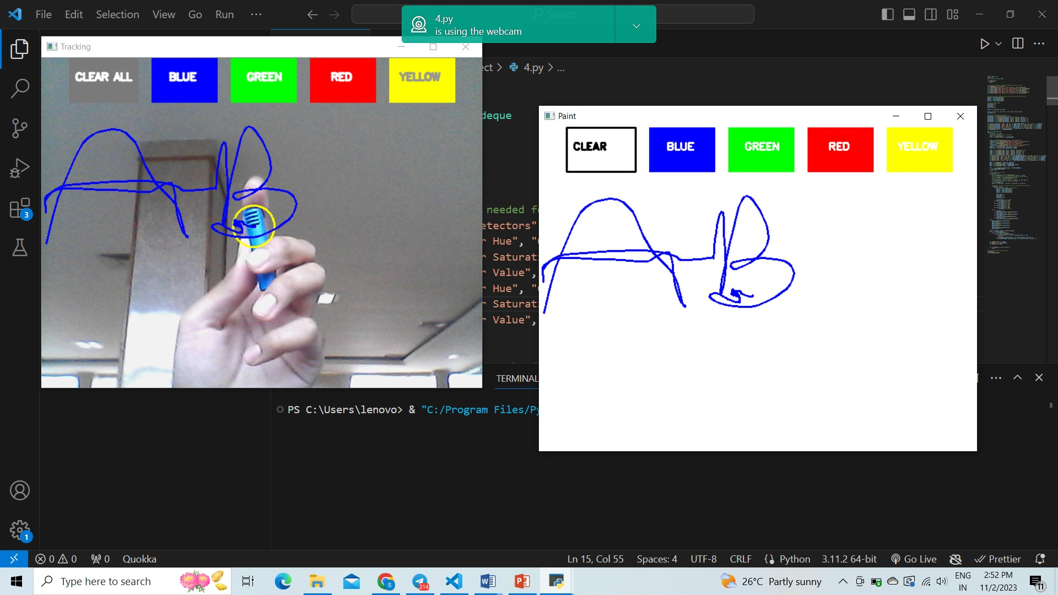

Figure B.1: ScreenShot1

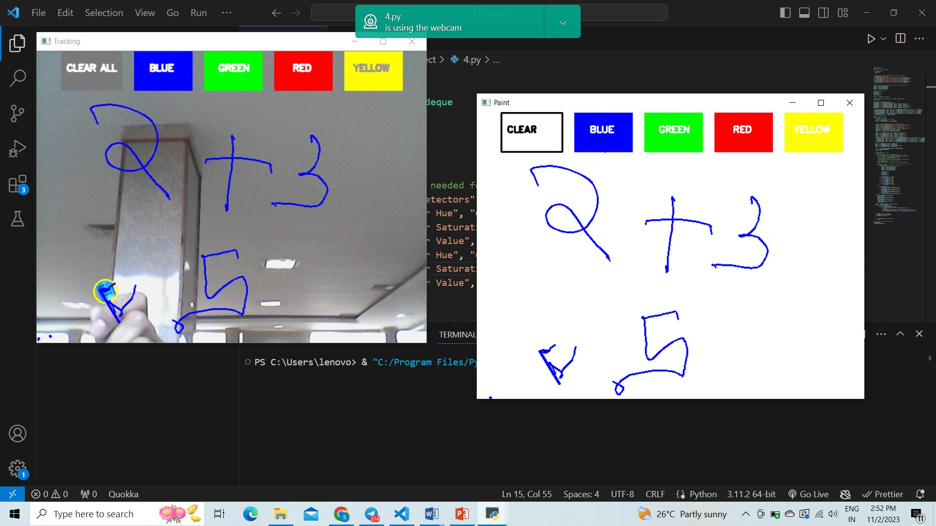Figure B.2: ScreenShot2

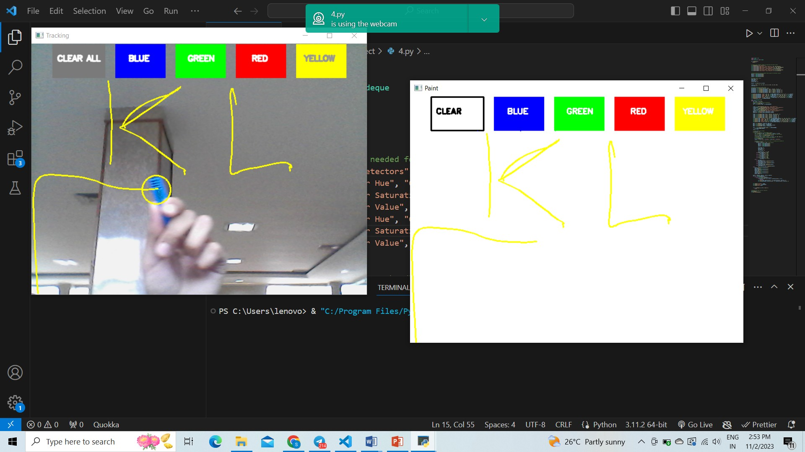

Figure B.3: ScreenShot3

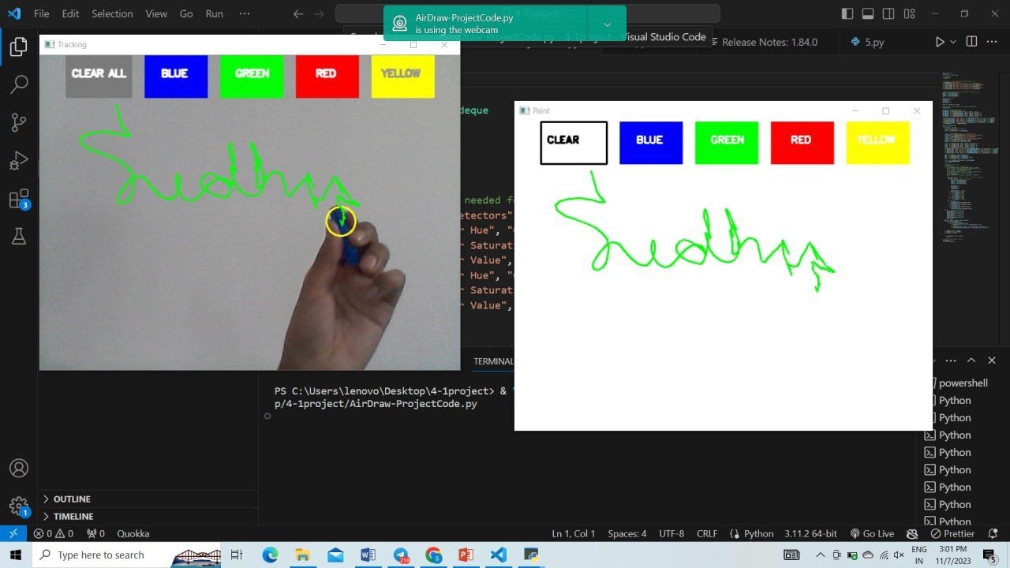Figure B.4: ScreenShot4

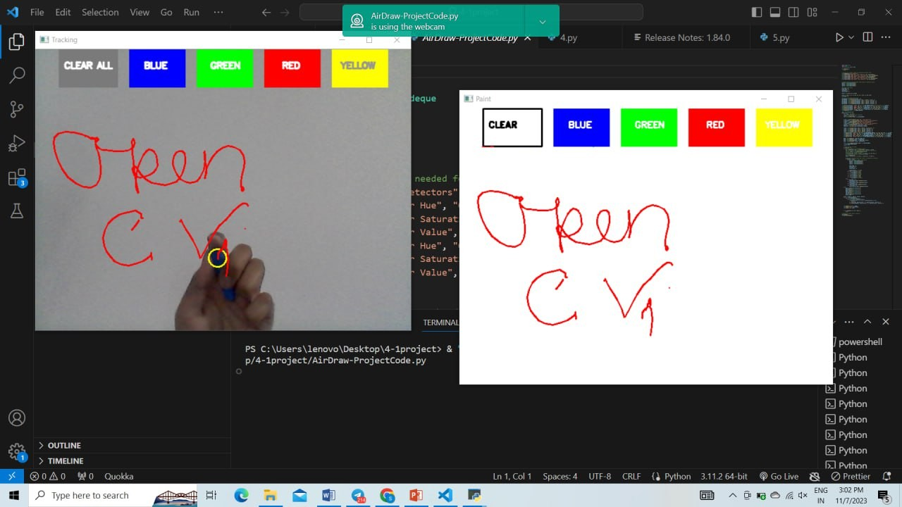

Figure B.5: ScreenShot5