Appium (2.X)  
  
Mobile is based on   
Android -> Google  
IOS -> Apple  
Windows -> microsoft  
  
Linux – OS  
  
Mobile application automation tool which supports Android,IOS,Windows.  
  
Android Apps -> Kotlin  
IOS Apps -> swift6

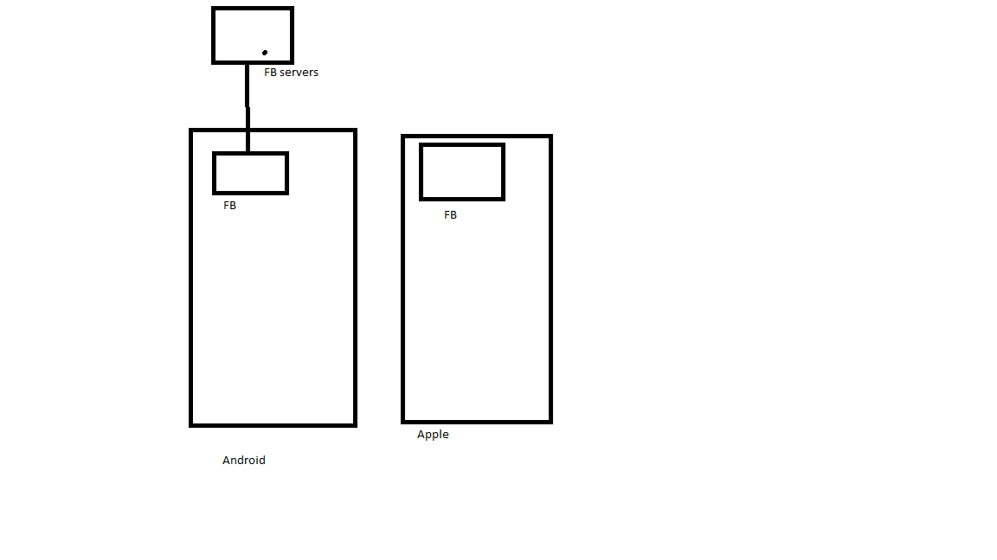  
https://appium.io/docs/en/latest/  
  
Advantages of appium   
1. Multi-platform support – Android,IOS, Windows  
2. Multi prog support - JS, Java, Python, java, Ruby, and .NET etc..  
3. Open source - <https://github.com/appium/appium>  
4. Free tool – no license  
  
  
Java -> Oracle  
3 stages in java application development  
1. Coding – java standards  
2. Complication  
3. Execution  
  
JDK  
<https://www.oracle.com/in/java/technologies/downloads/#jdk24-windows>

To set the jdk path  
Go to Control panel > System >Advanced system settings > Environment variables > New   
 key - JAVA_HOME  
value - C:\Program Files\Java\jdk-22  
  
Go to Path and click on New > %JAVA_HOME%\bin  
  
To cross check java installed   
cmd> java –version  
  
Eclipse download link   
https://www.eclipse.org/downloads/  
  
Java concepts -   
  
Tokens in java   
1. Keywords – predefined words in java  
Eg : class, public, static etc..  
2. Literals – values used in the prog.  
 Numeric  
 Character  
 String  
  
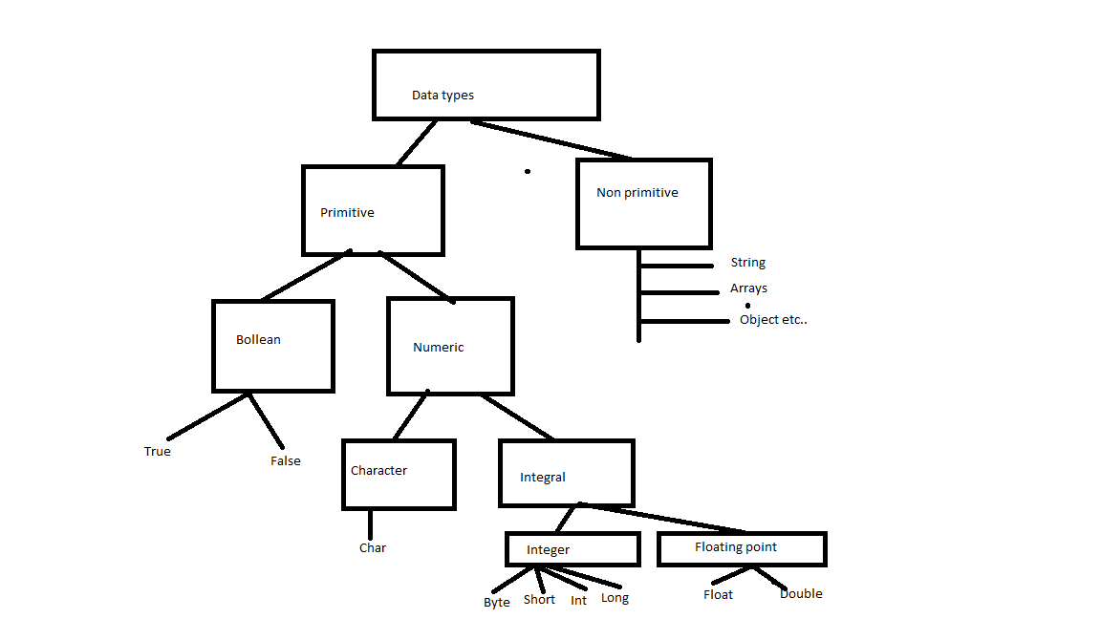  
  
Byte – 8  
Short – 16  
Int – 32  
Float – 64  
  
Access Modifiers  
public  
private  
default  
protected  
  
Control statements   
switch  
while  
for  
for each  
if  
else if  
else  
  
WAP to print all even numbers b/w 1 to 10?  
WAP to print all odd numbers b/w 1 to 10?  
WAP to print all multiples of 3 till 10?  
  
OOPS concepts   
1. Class  
2. Object  
3. Encapsulation  
4. Abstraction  
5. Inheritance  
6. Polymorphism  
  
Diff b/w class and object?  
Diff b/w Encapsulation and Abstraction?  
What is Inheritance?  
What is Polymorphism?  
  
2 types of Polymorphism :  
1. Method overloading  
2. Method overriding  
  
3 containers in java   
1. Class  
2. Abstract class  
3. Interface

Collections   
List  
Queue  
Set  
Map

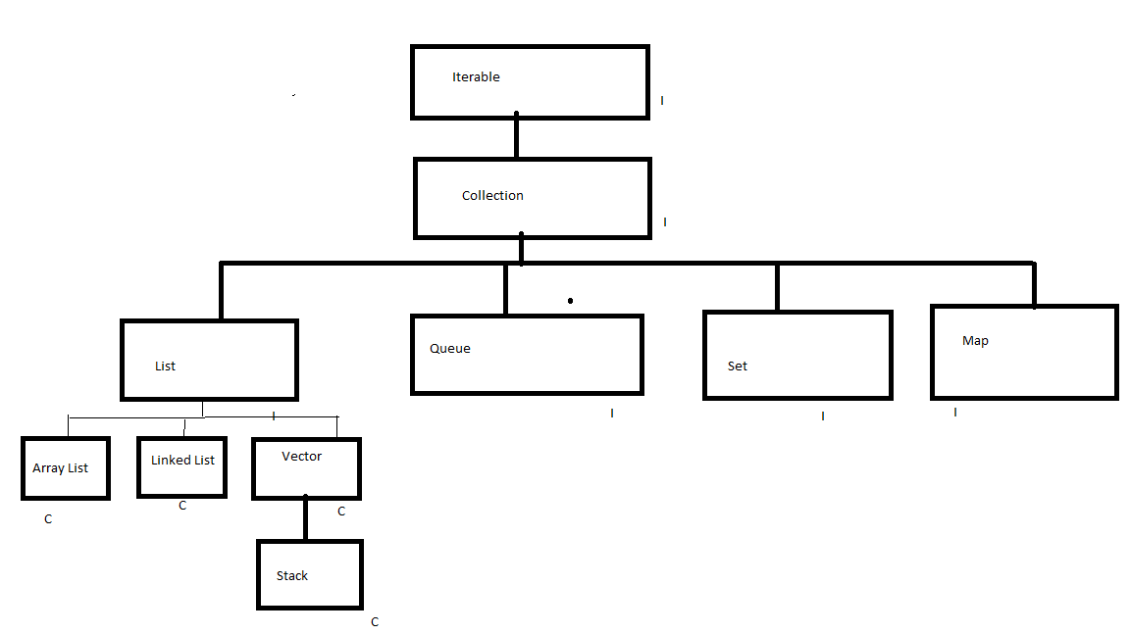

List

Array List  
Linked List  
Stack  
Vector

Queue  
Deque  
ArrayDeque  
Priority Queue  
  
Set  
Hash Set  
Linked HashSet  
SortedSet  
Navigable Set  
Tree Set  
  
Map  
HashTable  
HashMap  
LinkedHashMap  
SortedMap  
NavigbleMap  
TreeMap  
  
Adding elements to Queue?  
Retrieval of elements from the Queue?  
Deletion of elements from the Queue?  
Verification of elements in the Queue?  
Creation of Queue?  
  
Diff b/w vector & stack?  
Diff b/w ArrayList & Linked List?  
What is priority Queue?  
Diff b/w SortedSet & Navigable Set?  
What is Tree map and explain its implementation?  
Diff b/w vector and arrayList ?

Vector  
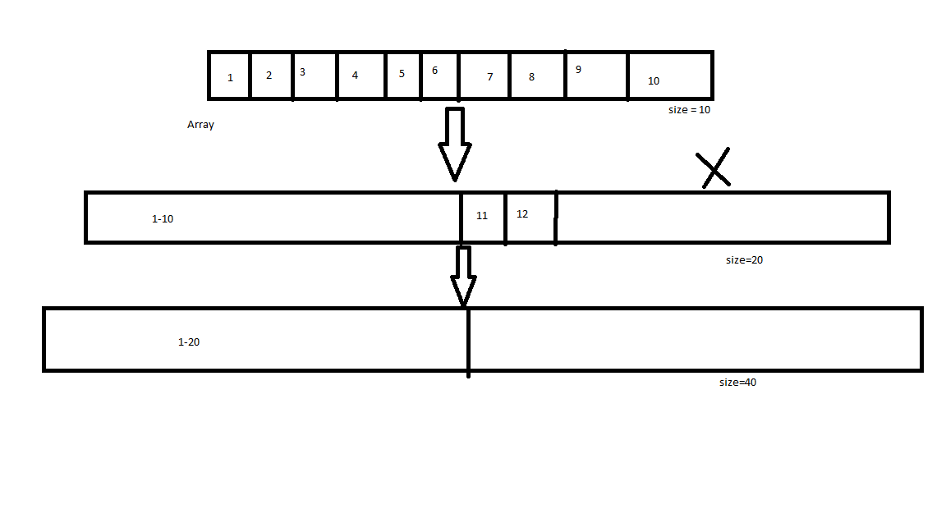

ArrayList  
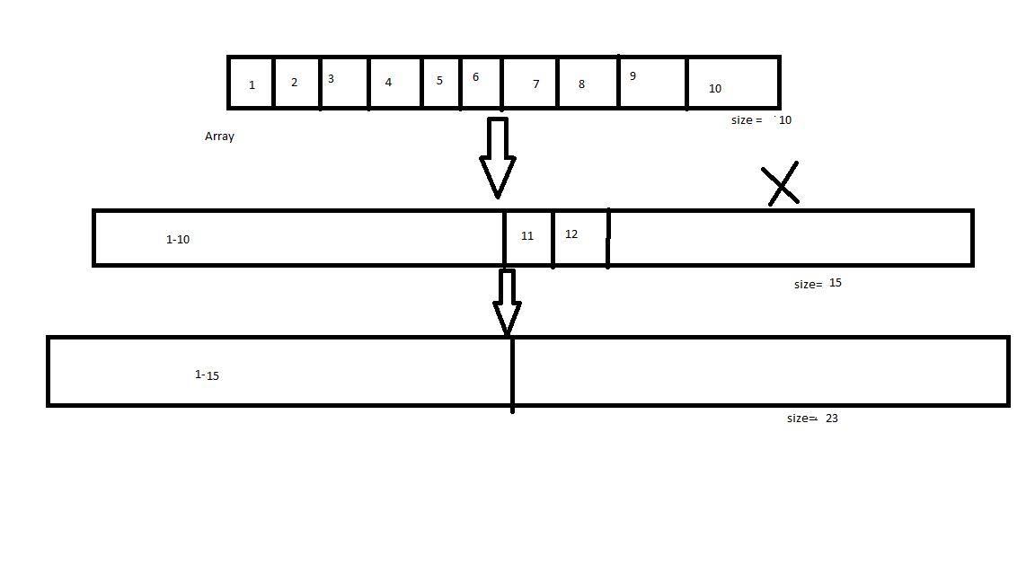

|  |  |  |
| --- | --- | --- |
|  | Vector | Array List |
| Default capacity | 10 | 0 |
| Initial capacity | 10 | 10 |
| Duplicates | Y | Y |
| null value | Y | Y |
| Insertion order | Y | Y |
| sorted order | N | N |
| random access | Y | Y |
| synchronized | Y | N |
| good at | multiple threading prog where the data increases exponentially | Data storage and retrieval |

Selenium  
Free -> no license needed  
Open Source ->https://github.com/SeleniumHQ/selenium/tree/trunk  
Web application automation tool  
  
Selenium 4 arch  
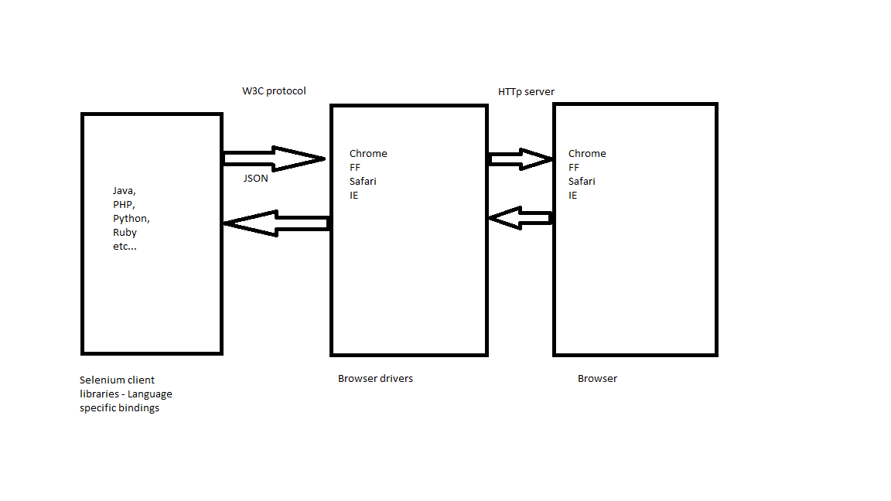  
  
  
  
  
  
  
Selenium Java arch  
  
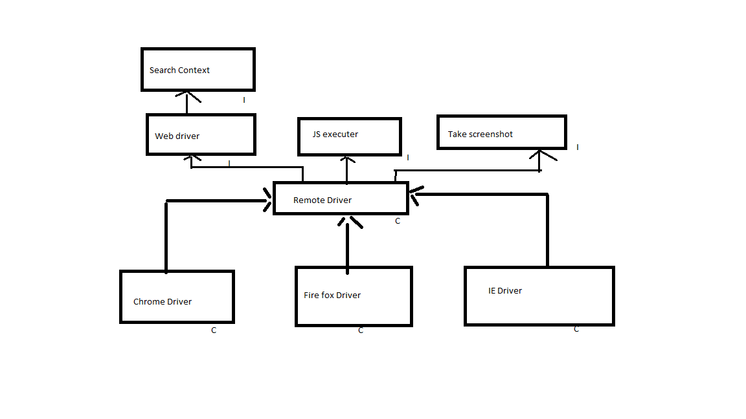  
Search Context (I)  
1. findElement()  
*It will returns 1 matched webelement  
*If element not found -> No such element found exception  
2. findElements()  
*It returns list of web elements  
*If elements not found -> empty list  
  
WebDriver(I)  
1. get() -> enters the url and wait until the page gets loaded successfully  
2. getCurrentUrl() -> returns the string of url present in the browser  
3. getTitle() -> returns the string of title present in the browser  
4. getPageSource() -> returns the string of page source present in the browser  
5. Close() -> will close only the current window  
6. Quit() -> will close all the active windows opened by the selenium  
7. getWindowHandle() -> returns the string of windowId present in the browser  
8. getWindowHandles() -> returns the list of windowid’s  
9. switchTo() -> windows/alerts/frames  
10.navigate() -> get()  
11. Manage() -> managing the windows/time outs  
WebElement   
1. Click() -> left mouse click  
2. Submit() -> internally calls click()  
3. sendKeys() -> typing the text from the keyboard  
4. Clear() -> clears the text / backspace from the keyboard  
5. getTagName() -> returns you the string of tag name  
6. getAttribute() -> returns you the value of the attribute in string format  
7. isSelected() -> returns true/false  
8. isEnabled() -> returns true/false  
9. isDisplayed() -> returns true/false  
10. getText()-> returns you the string of text displayed on webelement  
  
Locators -> static functions present in By class  
1. By.id()  
2. By.name()  
3. By.tagName()  
4. By.linkText()  
5. By.partialLinkText()  
6.By.className()  
7.By.cssSelector()  
8.By.xpath()  
  
Xpath  
Absolute - / -we are in the root element(html)  
Relative - // - any child

<input name=’n1></input>  
* anything which is present < - tagName  
* anything which is present next to tagName is called as attributes  
* anything which is present > - text  
  
xpath by attributes   
//tagName[@attributeName=’attributeValue’]  
//tagName[contains(@attributeName,’attributeValue’)]  
  
xpath by text   
//tagName[text()=’textValue’]  
//tagName[.=’textValue’]

//tagName[contains(text(),’textValue’)]  
//tagName[contains(.,’textValue’)]

AND & OR  
AND  
1 1 1  
1 0 0  
0 1 0  
0 0 0  
  
OR  
1 1 1  
1 0 1  
0 1 1  
0 0 0  
  
  
//tagName[@attributeName=’attributeValue’ AND text()=’textValue’]  
//tagName[@attributeName=’attributeValue’ OR text()=’textValue’]  
//tagName[@attributeName=’attributeValue’ AND @attributeName=’attributeValue’]  
//tagName[@attributeName=’attributeValue’ OR @attributeName=’attributeValue’]  
//tagName[contains(@attributeName,’attributeValue’) AND contains(text(),’textValue’)]  
//tagName[contains(@attributeName,’attributeValue’) OR contains(text(),’textValue’)]  
//tagName[contains(@attributeName,’attributeValue’) AND contains (@attributeName,’attributeValue’)]  
//tagName[contains(@attributeName,’attributeValue’) OR contains (@attributeName,’attributeValue’)]  
  
Merging the xpaths  
| - pipeline  
//tagName[@attributeName=’attributeValue’ AND text()=’textValue’] | //tagName[@attributeName=’attributeValue’ OR text()=’textValue’]  
  
Xpath by Axes  
1. Forward traversing - / or //  
2. Backward traversing - /..  
  
Xpath by Group index  
(//xpath)[index]  
(//tagName[@attributeName=’attributeValue’ AND text()=’textValue’])[1]  
  
  
APPIUM  
Free -> no license needed  
Open Source -> https://github.com/appium/appium   
mobile application automation tool  
  
We have 3 types of applications in mobile  
1. Web application -> chrome/safari  
2. Native application -> Kotlin/swift  
3. Hybrid application -> Native+Web view  
  
Installation  
windows -> Android automation (Android studio)  
mac -> Android+ios automation(Android studio and xcode)

1. Node js   
   <https://nodejs.org/en/download>  
   create a variable   
   NodeJS  
   C:\Program Files\nodejs\  
     
   To cross check go to cmd   
   node –version  
   >npm –version
2. Appium GUI  
   <https://github.com/appium/appium-desktop/releases>  
     
   [**Appium-Server-GUI-windows-1.22.3-4.exe**](https://github.com/appium/appium-desktop/releases/download/v1.22.3-4/Appium-Server-GUI-windows-1.22.3-4.exe)
3. Appium inspector  
   <https://github.com/appium/appium-inspector/releases>  
   [**Appium-Inspector-2025.3.1-win-x64.exe**](https://github.com/appium/appium-inspector/releases/download/v2025.3.1/Appium-Inspector-2025.3.1-win-x64.exe)
4. Android studio  
   <https://developer.android.com/studio?gad_source=1&gad_campaignid=21831783552&gbraid=0AAAAAC-IOZmw651yZRRJjFX5CiEWInWFE&gclid=CjwKCAjwgb_CBhBMEiwA0p3oOLxbqq6T5PFurTxVRIEDBtuOG4b95Q_9O1w2IrPOb0OO3dsaVntOURoCOhAQAvD_BwE&gclsrc=aw.ds>

android-studio-2024.3.2.15-windows.exe

Set the path of the Android home in system variables

ANDROID_HOME  
C:\Users\Admin\AppData\Local\Android\Sdk\  
  
Path  
%ANDROID_HOME%\platform-tools  
  
To cross check   
adb –version

1. Install appium via commands  
   npm install -g appium@latest  
   To unistall the appium  
   npm uninstall -g appium  
   To cross check appium installed  
   appium -v  
   where appium
2. Install appium-doctor  
   npm install -g appium-doctor  
   npm uninstall appium-doctor  
   To cross check  
   where appium-doctor  
   appium-doctor -h
3. To start/stop appium server   
   appium server / appium  
   Welcome to Appium v2.18.0  
   http://127.0.0.1:4723/  
     
   To stop the appium server  
   CTRL+C  
   Received SIGINT - shutting down

[AppiumDriver@6544] There are no active sessions for cleanup

1. appium --address 192.168.1.100 (IP address for the server to listen on)
2. appium –port 4724 (port number for the server to listen on)
3. appium --log-level info (set log level for the server)  
   appium --log-level debug  
   appium --log-level warn
4. appium --log-timestamp (prefix time stamps at server logs)
5. appium --local-timezone (set servers time zone)
6. appium --allow-insecure

appium --allow-insecure port --port 4724

1. appium -- relaxed-security (Enable all insecure features)  
   appium --port 4724 --relaxed-security

Appium 2 arch

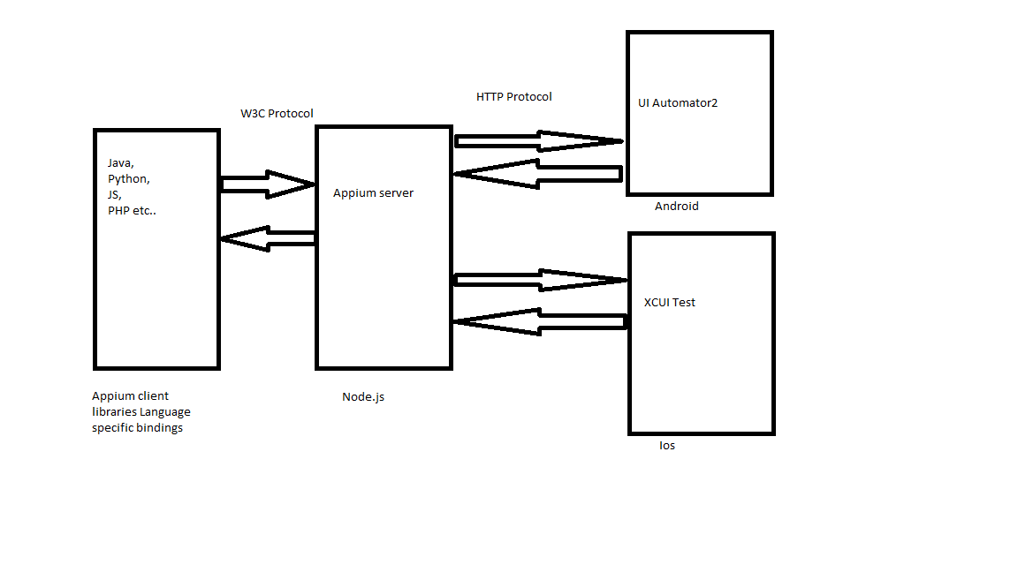

Appium Java arch  
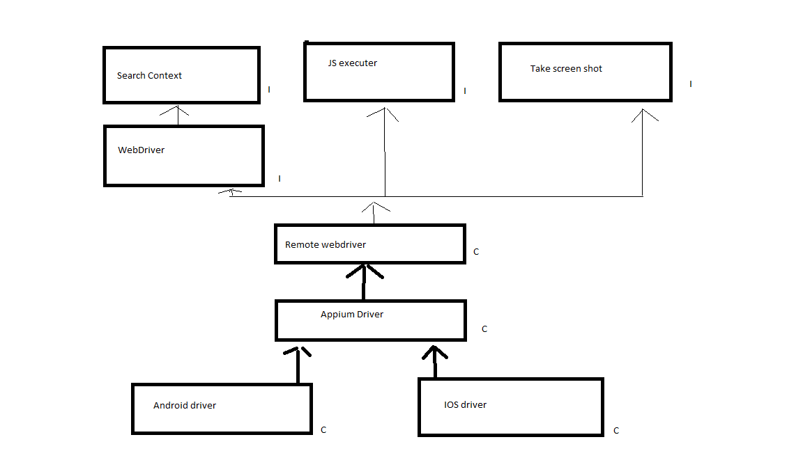

1. Appium driver installation  
   appium driver list   
   appium driver install uiautomator2  
   appium driver uninstall uiautomator2  
   appium driver list –updates
2. appium driver list  
   appium driver install xcuitest  
   appium driver uninstall xcuitest  
   appium driver list –updates

Android api levels  
https://apilevels.com/  
  
creation of AVD device  
  
adb devices -> To get the device name

To inspect the webelements from browser launched on the emulator   
chrome://inspect/#devices

***If version mismatch happens on the chrome then try to start the appium with below commands   
appium server --allow-insecure chromedriver_autodownload  
  
***Native application automation  
App package  
App Activity

Via logcat  
com.google.android.dialer/  
com.google.android.dialer.extensions.GoogleDialtactsActivity

Via cmd prompt  
adb shell  
dumpsys window windows | grep -E 'mObscuringWindow'  
  
exit -> to come out off adb shell

Eg : session ids  
e0384141-072a-4a6b-bfc5-5971fa3d7e67  
ca833c09-94a9-41e9-bdad-613c42dd3bf3  
  
org.openqa.selenium.SessionNotCreatedException: Could not start a new session.  
* session id not generated. There is an issue in configuration.  
Eg : Original error: Device emulator-5558 was not in the list of connected devices  
  
Locators :  
  
Android Locators  
1. AppiumBy.name

2. AppiumBy.id*

3. AppiumBy.accessibilityId *

4.AppiumBy.androidUIAutomator *

5.AppiumBy.androidViewTag

6.AppiumBy.Xpath *

7.AppiumBy.className

Ios Locators

1.AppiumBy. iOSClassChain *  
2.AppiumBy. iOSNsPredicateString *

3.AppiumBy.Xpath *

4. AppiumBy.accessibilityId *

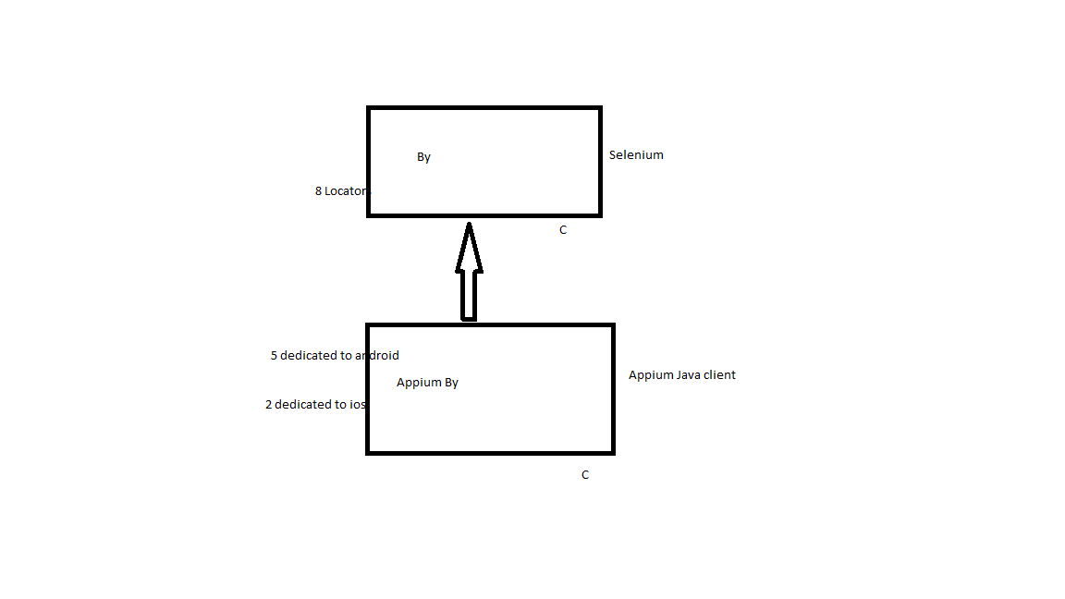

Appium inspector  
  
{

"deviceName": "Android",

"platformName": "Android",

"automationName": "uiAutomator2"

}

<android.widget.ImageButton index="0" package="com.google.android.dialer" class="android.widget.ImageButton" text="" checkable="false" checked="false" clickable="false" enabled="true" focusable="false" focused="false" long-clickable="false" password="false" scrollable="false" selected="false" bounds="[53,84][179,210]" displayed="true" />

Class name == tag name

AppiumBy.androidUIAutomator

new UiSelector().description(“accessibilityId”)  
new UiSelector().textContains(“textValue”)  
new UiSelector().resourceIdMatches(“resource id value”)  
new UiSelector().className(“class Name”)  
  
.index(0)  
.instance(0)  
  
Xpath will be followed by following formulas:

//tagName/className[@attributeName= ‘attributeVaue’]

Eg : //android.widget.FrameLayout[@content-desc=\"2,ABC\"]  
  
//tagName/className[contains(@attributeName,‘attributeVaue’)]  
  
AND OR

//tagName/className[@attributeName= ‘attributeVaue’ AND @attributeName= ‘attributeVaue’ ]

//tagName/className[@attributeName= ‘attributeVaue’ OR @attributeName= ‘attributeVaue’ ]

//tagName/className[contains(@attributeName,‘attributeVaue’) AND contains(@attributeName,‘attributeVaue’)]

//tagName/className[contains(@attributeName,‘attributeVaue’) OR contains(@attributeName,‘attributeVaue’)]

***  
We have used ui automator instead of xpath -

org.openqa.selenium.InvalidSelectorException: Could not parse selector expression `new UiSelector().//android.widget.EditText[@text="Last name"]`: No opening parenthesis after method name at position 17

|  |  |
| --- | --- |
| Xpath | UI Automator |
| //android.widget.TextView[@resource-id="com.google.android.dialer:id/search_action_text" and @text="Add to a contact"][1] | new UiSelector().resourceIdMatches("com.google.android.dialer:id/search_action_text").index(1).instance(0) |
| //android.widget.EditText[@text="First name"] | new UiSelector().textContains("First name") |
| //android.widget.Spinner[@content-desc="Phone"] | new UiSelector().description("Phone").index(1).instance(0) |
| //android.widget.CheckedTextView[@resource-id="android:id/text1" and @text="Home"] | new UiSelector().textContains("Home").resourceIdMatches("android:id/text1").index(1).instance(0) |

Connecting the real device  
  
Settings > About phone >Software information >Build number (tap 8 to 10 times)  
developer options will be on > stay awake (ON) > USB Debugging (ON)  
  
Allow to connect to this system (Allow)