**Meeting Appointment Scheduler**

Software Requirement Specification



**Project Group Number 14**

**Submitted By**

M. Vijay Siddharth( B16CS014 ) .

Vinay R. Nagalgaonkar ( B16CS017 ) .

**Revision History**

|  |  |  |  |
| --- | --- | --- | --- |
| Date | Version | Description | People |
| 15-2-18 | **1.0** | **First Draft** | **Group No.14** |
| 10-3-18 | **2.0** | **Second Draft** | **Group No. 14** |
|  |  |  |  |
|  |  |  |  |
|  |  |  |  |

**Table of Contents**

1. Introduction 4

1.1 Purpose 4

1.2 Scope 5

1.3 Constraints 6

1.4 Assumptions and Dependencies 7

1.5 Definitions, Acronyms and Abbreviations 8

1.6 References 9

2. Overall Description

2.1 Product Functions 10

2.2 User Characteristics 10

3. Specific Requirements

3.1 Functional Requirements 11-21

3.2 UML Diagrams 22

3.3 Non - Functional Requirements 23

3.4 Performance Requirements 23

4. Supporting Information

4.1 Appendix: UML Diagrams 24-32

**Software Requirements Specification**

**1 Introduction**

* 1. **Purpose**

This document describes everything in detail about the design and functioning of Meeting Appointment Scheduling software system. This document willdescribe the complete declarations and functioning of the software system along with illustration of the used cases. This is mainly for the users who may be a single person or a firm and help them to manage their appointments conveniently.

* 1. **Scope**

This software simplifies appointment request and allocation process thus reducing the meeting hassles for businesses and help them to stay connected anytime and anywhere. It can used by anyone from an employee to CEO of a company or an organisation or by a single individual.

Any user just needs to create an account in the software system and use the awesome features of the software system at will. Once the account of a user is created, the user can view his/her schedule, check for appointment requests and even make appointment requests to other users who are registered into the system.

* 1. **Constraints**

1. All the meetings for the corresponding appointments are done with mutual consent of both the meeting sides.
2. All the users must abide by the rules and regulations set by the interface.
3. Any Seeker cannot request an appointment in the slot which overlaps with any of his own previous appointments.
4. Any Acceptor cannot accept an appointment request in the slot which overlaps with any of his own previous appointments.
5. The Working Hours and Working days in a week are 9 am to 5 pm and Monday to Friday respectively.
6. Once the account of a user is created it cannot be deleted.
7. Any Acceptor cannot cancel any of his previously accepted appointments.
8. The time slot for a meeting for a said appointment cannot be more than an hour i.e. the time slots for a meeting must be restricted to 1 hour
   1. **Assumptions**
9. If an appointment is allocated and not cancelled before the date of meeting itself, then it will surely happen.
10. Both the sides participating in said meeting will attend it with mutual consent.
11. Acceptor is completely updated and aware with all incoming requests as notifications just as soon as they arrive.
12. The Transition time in between the meetings for a user is negligible.
13. The location of the meeting is the office of either the Seeker or the Acceptor.
14. All the users have sufficient space to conduct a meeting with the other respective users.
15. All the appointments requested by the Seekers are within the Working hours and Workingdays of the weeks.
    1. **Definitions , Acronyms and Abbreviations**

|  |  |
| --- | --- |
| Term | Definition |
| 1)Seeker | **A user who wishes to seek an appointment.** |
| 2)Acceptor | **A user which will decide to accept or decline the appointment requests made by the Seekers.** |
| 3)Interface | **The Software application for the Meeting Appointment Scheduler.** |
| 4)Valid Date | **Refers to the valid date of making a request for an appointment, which is from the next date of the present date till exactly 1 year ahead.** |
| 5)Working Hours and Working days in a week | **It refers to the time in which the meetings can be held between the users. Further, they are specified as follows :**  **Working hours: 9 am to 5 pm.**  **Working days: Monday to Friday.** |
| 6)Normal Appointment | **It refers to the type of appointment in which the Seeker will request for an appointment in the Valid Date except for the next 4 days from the present date.** |
| 7)Priority Appointment | **It refers to the type of appointment in which the Seeker will request for an appointment in the next 4 days from the present date.** |
| 8)Schedule | **It is the list of the meeting activities in the order in which they are taken up in a day.** |
| 9)Transitiontime | **It refers to the time in between the meetings for a person which is assumed to be negligible.** |
| 10)Timeline | **The list of schedules for a user for each valid date.** |
| 11)Notification | **It refers to the acquaintance of the incoming appointment request from a seeker.** |
| 12)Profile/Account | **The account of the user in the interface.** |

* 1. **References**

1. IEEE Recommended Practice for Software Requirements Specifications. IEEE Computer Society, 1998.
2. <https://en.wikipedia.org/wiki/Software_requirements_specification>
3. <https://www.tutorialspoint.com/software_testing_dictionary/software_requirement_specification.htm>
4. <https://www.uml-diagrams.org>

**2 Overall Description**

**2.1 Product Functions**

Since, the product is a software system for the purpose of Meeting Appointment Scheduling, it provides lucid and user-friendly functions for the same. The functions provided in the software system are Request Appointment, Cancel Appointment, View Schedule, View Timeline etc. The detailed description of the above mentioned functions as well as other functions is covered further in this document.

**2.2 User Characteristics**

The user can be anyone who wishes to have convenience in managing his meetings and appointments. All the users will have some common features, but after that they shall have distinguished features corresponding to their roles as Seeker and Acceptor. The Seekers will have the features to request and cancel an appointment, whereas the Acceptors will have the feature which will allow them to make a decision whether or not to accept or decline the incoming appointment requests.

**3 Requirements Specification**

**3.1 Functional Requirements**

**3.1.1**

|  |  |
| --- | --- |
| Use Case Name | Request Appointment |
| Trigger | Seeker requests an appointment for the meeting. |
| Precondition | 1. Seeker must be logged into the interface.  2. The desired acceptor must be registered in the interface.  3. The appointment date requested by the Seeker should be within a duration of one year and ahead of present date. |
| Basic Path | 1. Seeker must first login into the interface.  2. Fill out the following entries :   1. Registered Acceptor 2. Appointment Date 3. Appointment Time 4. Additional Information   3. Send the notification to the acceptor. |
| Alternative Paths | 1. Seeker must first login into the interface.  2. Cancel any previous allocated appointment.  3. Request a new appointment by  filling out the following entries :   1. Registered Acceptor 2. Appointment Date 3. Appointment Time 4. Additional Information   4. Send the notification to the acceptor. |
| Post-condition | 1. Appointment can be either accepted or declined.  2. If the appointment is accepted (and if not cancelled by seeker) then meeting would surely happen. |
| Exception Paths | 1. Invalid login credentials.  2. Appointment date or time is not valid. |
| Other | None |

**3.1.2**

|  |  |  |
| --- | --- | --- |
| Use Case Name |  | Normal Appointment |
| Trigger |  | Seeker requests an appointment for the meeting. |
| Precondition |  | 1. Seeker must be logged into the interface.  2. The desired acceptor must be registered in the interface.  3. The appointment date requested by the Seeker should be within a duration of one year and fifth day from the present date. |
| Basic Path |  | 1. Seeker must first login into the interface.  2. Fill out the following entries :   1. Registered Acceptor 2. Appointment Date 3. Appointment Time        d)  Additional Information  3. Send the notification to the acceptor. |
| Alternative Paths |  | 1. Seeker must first login into the interface.  2. Cancel any previous allocated appointment.  3. Request a new appointment by  filling out the following entries :   1. Registered Acceptor 2. Appointment Date 3. Appointment Time 4. Additional Information   4. Send the notification to the acceptor. |
| Post-condition |  | 1. Appointment can be either accepted or declined.  2. If the appointment is accepted(and if not cancelled by seeker) then meeting would surely happen. |
| Exception Paths |  | 1. Invalid login credentials.  2. Appointment date or time is not valid. |
| Other |  | None |

**3.1.3**

|  |  |
| --- | --- |
| Use Case Name | Priority Appointment |
| Trigger | Seeker requests an appointment for the meeting. |
| Precondition | 1. Seeker must be logged into the interface.  2. The desired acceptor must be registered in the interface.  3. The appointment date requested by the Seeker should be within four days from the present date. |
| Basic Path | 1. Seeker must first login into the interface.  2. Fill out the following entries :   1. Registered Acceptor 2. Appointment Date 3. Appointment Time        d)  Additional Information  3. Send the notification to the acceptor. |
| Alternative Paths | 1. Seeker must first login into the interface.  2. Cancel any previous allocated appointment.  3. Request a new appointment by  filling out the following entries :   1. Registered Acceptor 2. Appointment Date 3. Appointment Time 4. Additional Information   4. Send the notification to the acceptor. |
| Post-condition | 1. Appointment can be either accepted or declined.  2. If the appointment is accepted(and if not cancelled by seeker) then meeting would surely happen. |
| Exception Paths | 1. Invalid login credentials.  2. Appointment date or time is not valid. |
| Other | None |

**3.1.4**

|  |  |
| --- | --- |
| Use Case Name | Cancel Appointment |
| Trigger | Seeker cancels the already allocated appointment. |
| Precondition | 1. Seeker must consent the acceptor if he wishes to cancel the appointment.  2. He must be logged into the interface. |
| Basic Path | 1. Seeker must first login into the interface.  2. Cancel the allocated appointment. |
| Alternative Paths | None |
| Post-condition | Interface updates the schedule of both seeker and acceptor. |
| Exception Paths | Acceptor refuses to cancel the appointment. |
| Other | None |

**3.1.5**

|  |  |
| --- | --- |
| Use Case Name | Create User Account |
| Trigger | User creates an account in the interface. |
| Precondition | None |
| Basic Path | 1. User opens the interface.  2. Then creates an account by filling out the following:   1. User Name 2. Password 3. Timeline |
| Alternative Paths | None |
| Post-condition | None |
| Exception Paths | None |
| Other | None |

**3.1.6**

|  |  |
| --- | --- |
| Use Case Name | Login |
| Trigger | User logins into the interface. |
| Precondition | User must have an account in the interface. |
| Basic Path | 1. Enter the User Name.  2. Enter the Password. |
| Alternative Paths | None |
| Post-condition | None |
| Exception Paths | Invalid Login credentials. |
| Other | None |

**3.1.7**

|  |  |
| --- | --- |
| Use Case Name | View Schedule |
| Trigger | User wants to view schedule. |
| Precondition | User must be logged into the interface. |
| Basic Path | 1. User must first login into the interface.  2. Then user can view the schedule. |
| Alternative Paths | None |
| Post-condition | None |
| Exception Paths | Invalid Login credentials |
| Other | None |

**3.1.8**

|  |  |
| --- | --- |
| Use Case Name | View Profile |
| Trigger | User wants to view profile. |
| Precondition | User must be logged into the interface. |
| Basic Path | 1. User must first login into the interface.  2. Then user can view the profile. |
| Alternative Paths | None |
| Post-condition | None |
| Exception Paths | Invalid Login credentials |
| Other | None |

**3.1.9**

|  |  |
| --- | --- |
| Use Case Name | Update Schedule |
| Trigger | Acceptance by an acceptor for an appointment request or cancellation of an appointment by a seeker. |
| Precondition | Acceptor accepts an appointment or seeker cancels an appointment. |
| Basic Path | Interface updates the schedule when triggered. |
| Alternative Paths | None |
| Post-condition | None |
| Exception Paths | Appointment is rejected by acceptor. |
| Other | None |

**3.1.10**

|  |  |
| --- | --- |
| Use Case Name | Appointment Decision |
| Trigger | Acceptor decides whether to accept or reject the appointment. |
| Precondition | 1.  Acceptor must be logged into the interface. |
| Basic Path | 1. Acceptor must first login into the interface.  2. Then view the schedule and decide whether to accept or reject the appointment. |
| Alternative Paths | None |
| Post-condition | Interface updates the schedule based on the decision of the acceptor. |
| Exception Paths | Invalid Login credentials. |
| Other | None |

**3.2 UML Diagrams**

**3.2.1 Use case Diagram**

**3.2.2 Class Diagram**

**3.2.3 Sequence Diagram**

**3.2.4 Activity Diagram**

**(Refer the Appendix at the end for viewing the UML diagrams)**

**3.3 Non – Functional Requirements**

The Meeting Appointment Scheduling Software System shall operate on a local device by transacting with the database in the hard-disk of the device and showing notifications to the Acceptors about the appointment requests and schedule to all the users.

**3.4 Performance Requirements**

1) Fast Execution time of requests.

2) Storage Potential of data should be high.

**4 Supporting Information.**

**4.1 Appendix: UML Diagrams (as follows):**

**(A) Use Case Diagram:**

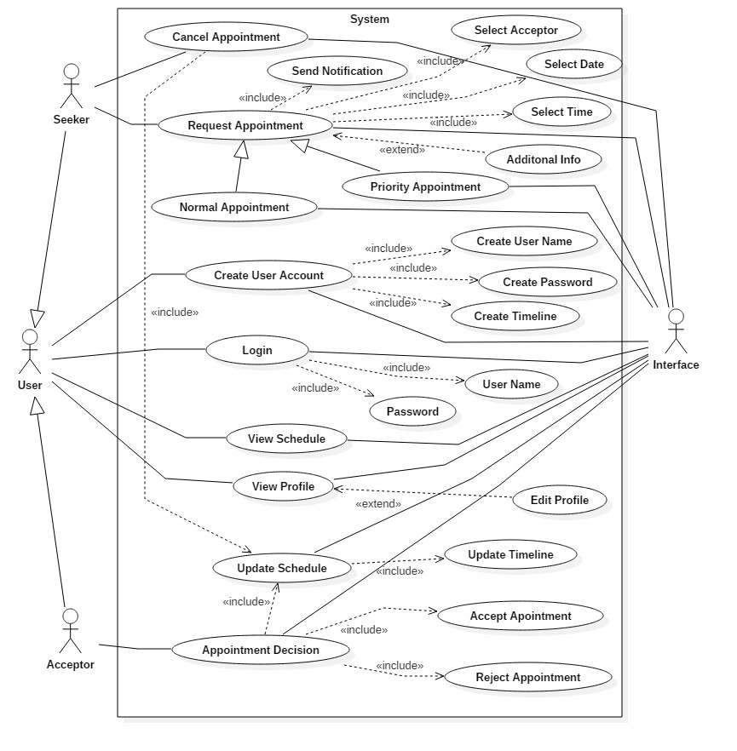

**(B) Class Diagram:**

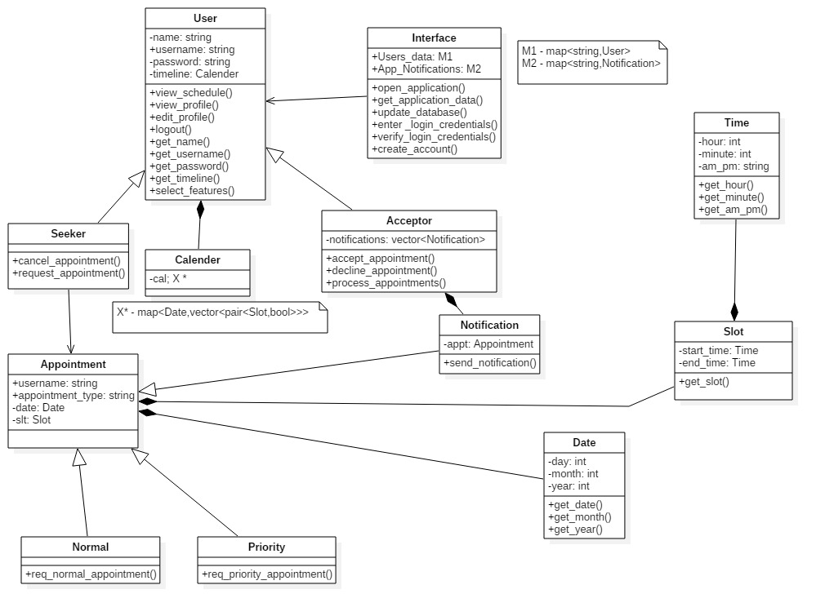

**(C) Sequence Diagrams:**

**[Note : The Messages on the arrows of the sequences diagrams below are actual functions which could not be displayed so due to Editor constraints. ]**

**1)** 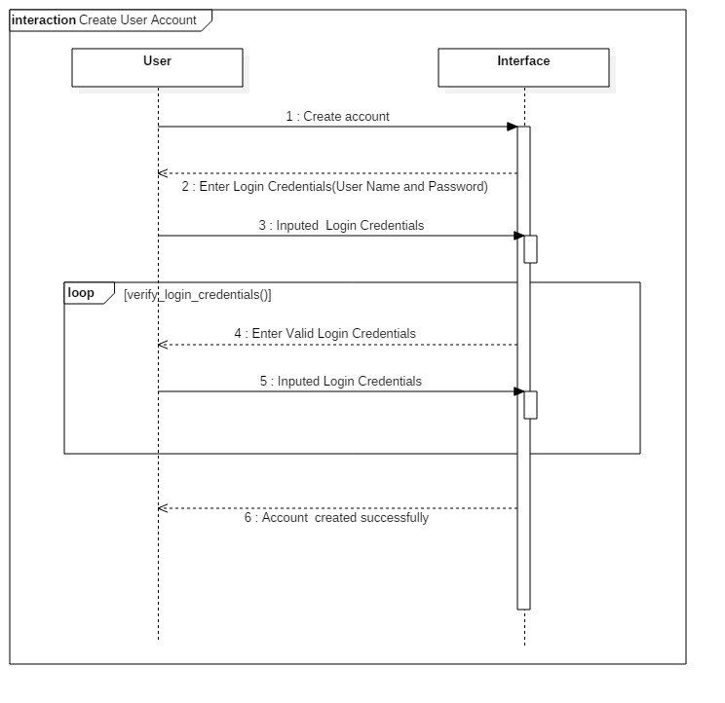

**2)**

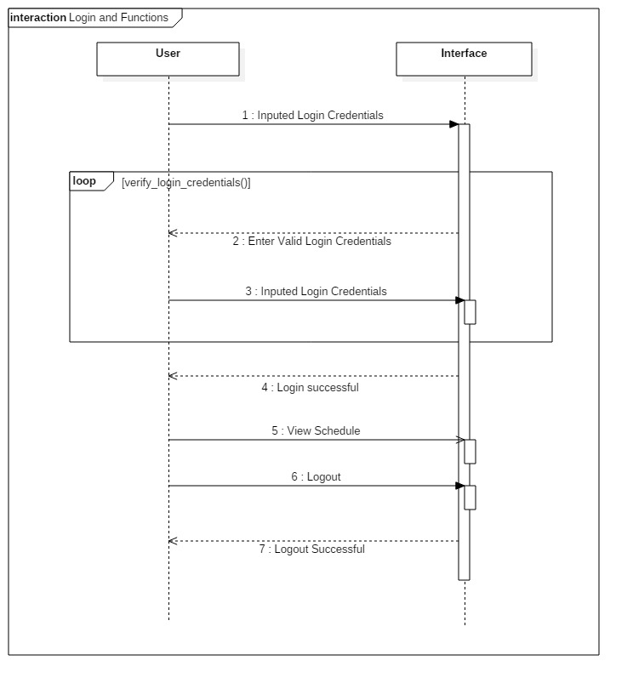

**3)**

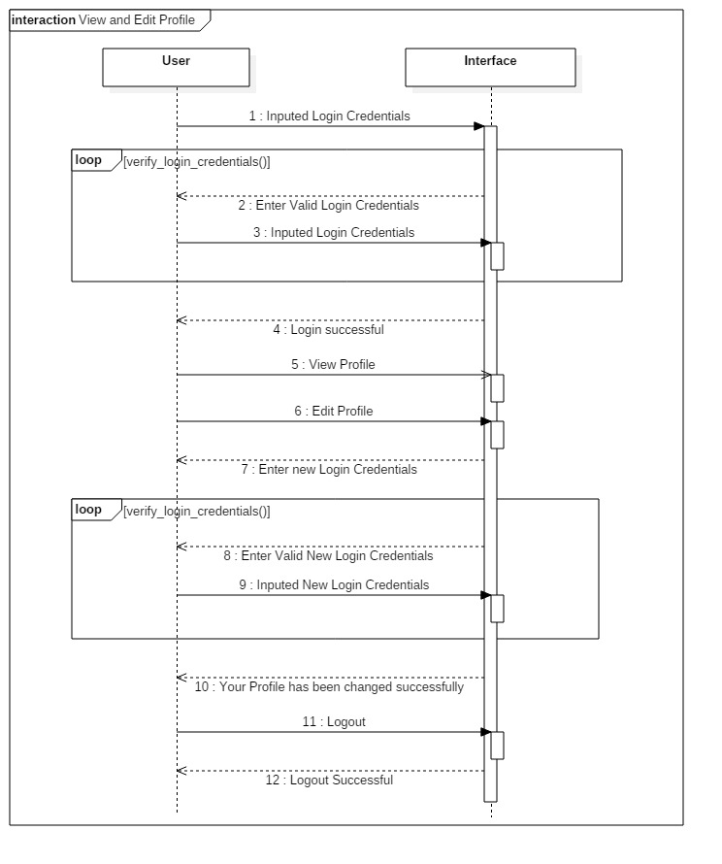

**4)**

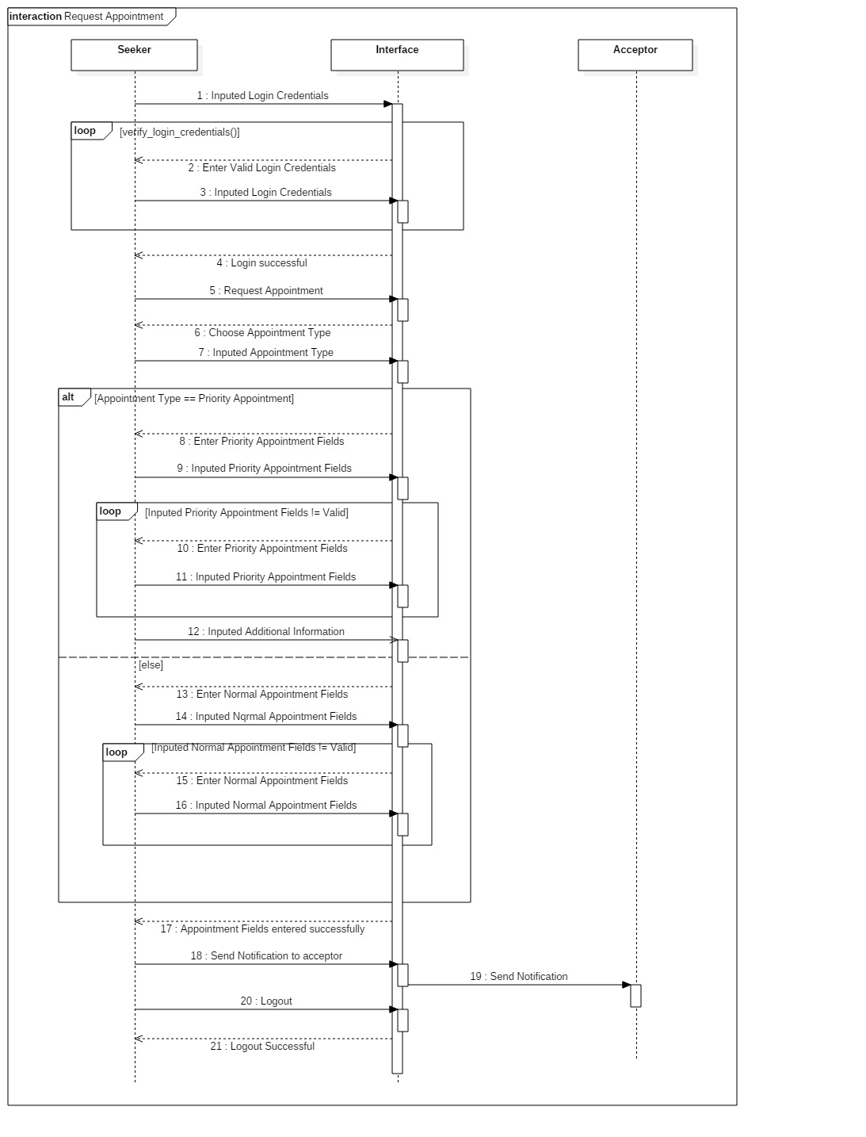

**5)**

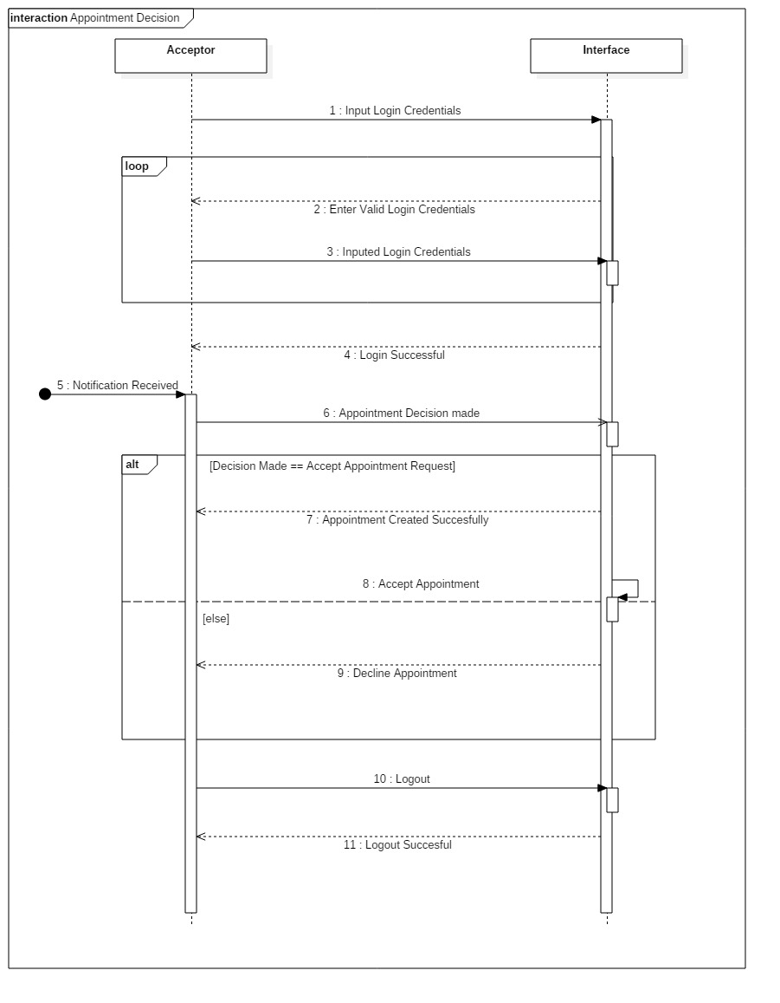

**6)**

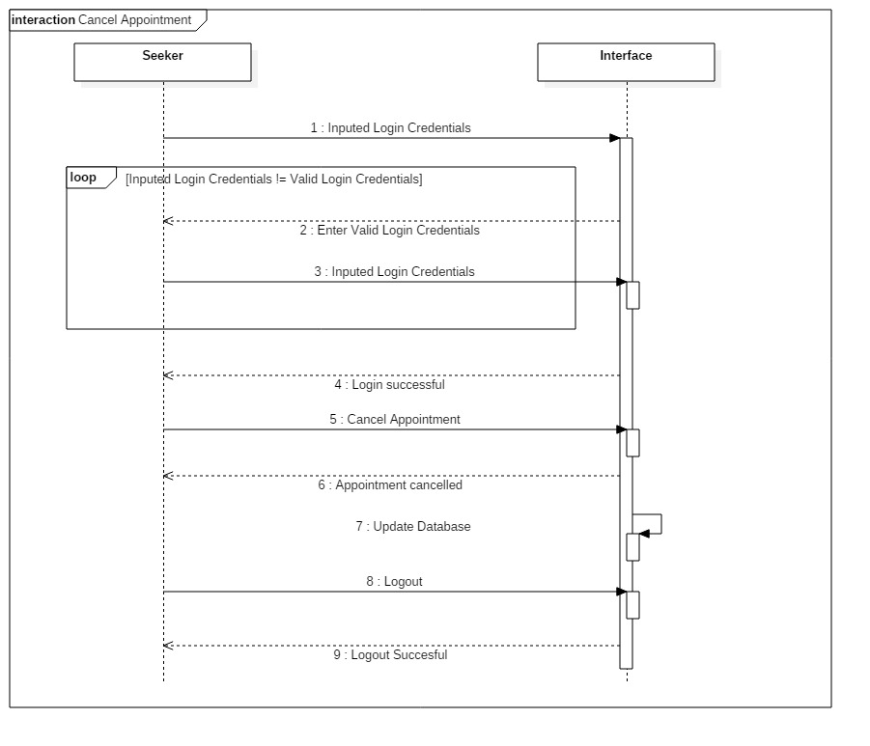

**(D) Activity Diagram:**

