**Lab Cycle1:**

**Create an app to navigate from one activity to another using an intent object and passing data**

Step1: start android studio

Step 2: go to activitymain.xml file

drag a text view and button in a activity layout

Step 3: go to the code section name the textview and button name as

android:text="**First Activity"**

android:text=**"Start Second Activity"**

Step 4:go to mainactivity.java and do the following changes

under the main class public class MainActivity extends AppCompatActivity {

**private Button button;**

Step 5: in the same class after setContentView(R.layout.*activity_main*);

**button = findViewById(R.id.*button*);**

**button.setOnClickListener(new View.OnClickListener() {**

@Override

public void onClick(View view) { //will appear default

call the method name as

**openSecondActivity();**

}

});

}

//now make a method second activity

**public void openSecondActivity()**

click underjava file --->com.example.myapplication---->rightclick and select new activity window.

Name the activity as SecondActivity

Step 6: go to the activity.xml----> design section

drag a text view and go to the code section and rename it as **“SecondActivity”**

Step 7: go to main activity.java

under

public void openSecondActivity()

{

need to create intent.java to create new activity through onclick event

**Intent i =new Intent(MainActivity.this,SecondActivity.class);**

**startActivity(i); //calling a method and pass the intent**

**OUTPUT Click on RUN**

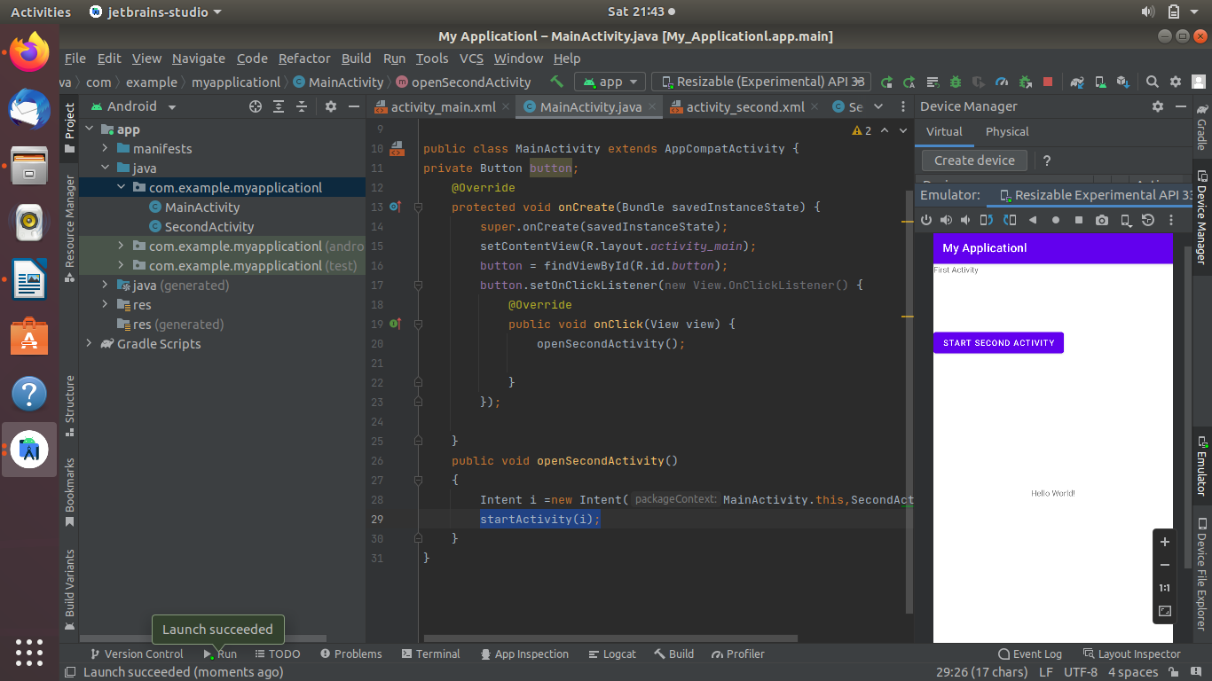

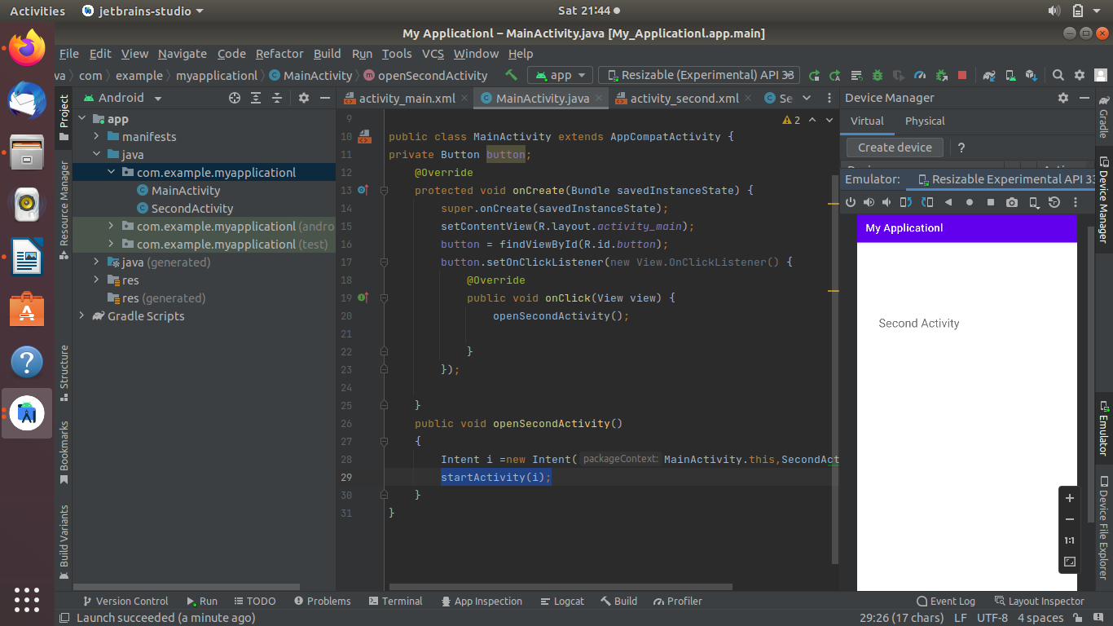

### passing DATA

### Create 2 acitivity

### MainActivity & SecondActivity

### 

### Define a key value pair in the second activity as

Under

public class SecondActivity extends AppCompatActivity {

public static final string Name = "Name";

public static final string Age = "Age";

### go to main.xml file and take 2 text view and plain texts and constraints

### 

### Rename the text as Name and Age

### Go to split section

### Under the text=age

android:text="Age"

android:textSize="22dp"

android:textColor="@color/black"

android:textStyle="bold"

### go to design and check it

### 

### Now go to main activity.java file

### Declare the required variables

public class MainActivity extends AppCompatActivity {

private EditText nameText, ageText;

private Button button;

private String name;

private int age;

### under the activity layout setContentView(R.layout.*activity_main*);

nameText = findViewById(R.id.mName);

nameText = findViewById(R.id.mAge);

button = findViewById(R.id.*button*);

button.setOnClickListener(new View.OnClickListener()

as soon as you type the onclick listner

public void onClick(View view) {

sendData();

create

public void sendData()

{

name=nameText.getText().toString().trim();

age=Integer.*parseInt*(ageText.gatText().toString().trim());

}

intent as

**Intent i=new Intent(MainActivity.this, SecondActivity.class);**

**after the intent**

**i.putExtra(SecondActivity.NAME,name);**

i.putExtra(SecondActivity.AGE,age);

startActivity(i);

now go to activity second.xml file

drage 2 text view and name it as mName &mAge

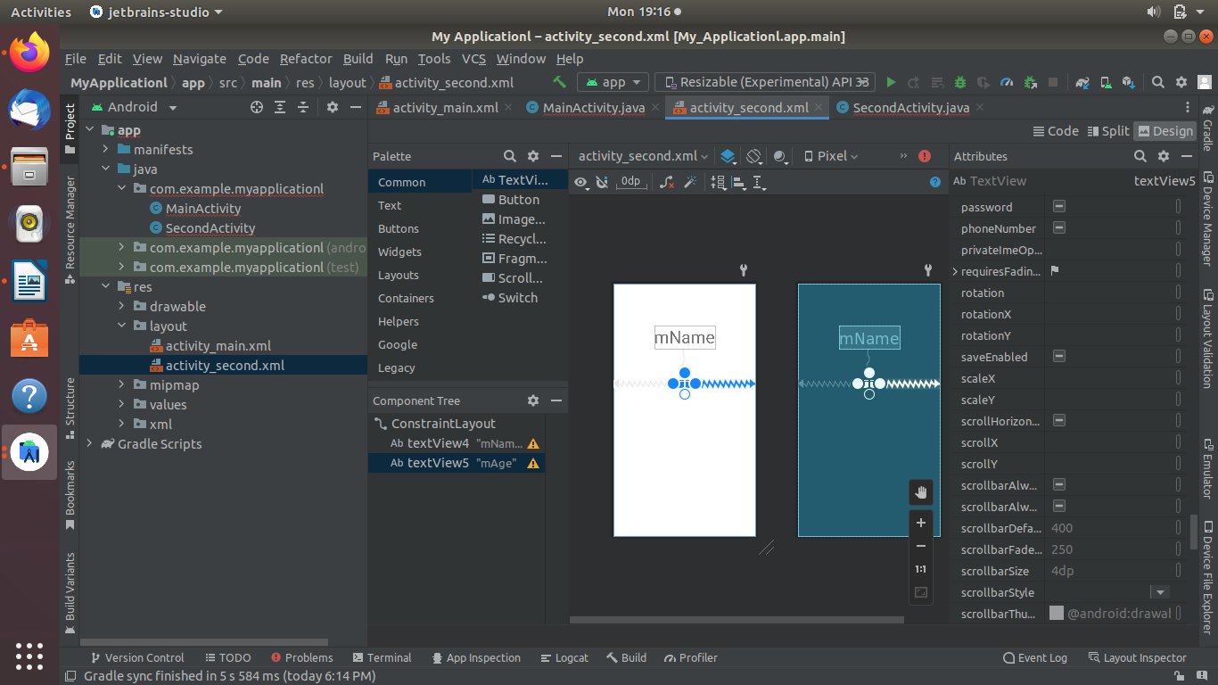

### go to second activity.jave file

### Define the variable under public static final string

**private TextView NameText,ageText;**

private String name;

private int age;

### then under setContentView(R.layout.*activity_second*);

nameText = findViewById(R.id.mName);

ageText = findViewById(R.id.mAge);

Intent i = getIntent();

name = i.getStringExtra(*Name*);

age = i.getIntExtra(AGE,0);

nameText.setText("HI!"+name);

ageText.setText("your age is"+age);

### atvtciiymain.xml file

<?xml version="1.0" encoding="utf-8"?>

<androidx.constraintlayout.widget.ConstraintLayout xmlns:android="http://schemas.android.com/apk/res/android"

xmlns:app="http://schemas.android.com/apk/res-auto"

xmlns:tools="http://schemas.android.com/tools"

android:layout_width="match_parent"

android:layout_height="match_parent"

tools:context=".MainActivity">

<TextView

android:id="@+id/mName"

android:layout_width="wrap_content"

android:layout_height="wrap_content"

android:layout_marginTop="100dp"

android:layout_marginEnd="100dp"

android:text="Name"

app:layout_constraintEnd_toStartOf="@+id/editTextTextPersonName"

app:layout_constraintTop_toTopOf="parent" />

<EditText

android:id="@+id/editTextTextPersonName"

android:layout_width="wrap_content"

android:layout_height="wrap_content"

android:layout_marginTop="100dp"

android:layout_marginEnd="30dp"

android:ems="10"

android:inputType="textPersonName"

android:hint="name"

android:textSize="20dp"

app:layout_constraintEnd_toEndOf="parent"

app:layout_constraintTop_toTopOf="parent" />

<TextView

android:id="@+id/mAge"

android:layout_width="wrap_content"

android:layout_height="wrap_content"

android:layout_marginTop="100dp"

android:layout_marginEnd="100dp"

android:hint="Age"

android:textSize="22dp"

android:textColor="@color/black"

android:textStyle="bold"

app:layout_constraintEnd_toStartOf="@+id/editTextTextPersonName2"

app:layout_constraintHorizontal_bias="0.495"

app:layout_constraintStart_toStartOf="parent"

app:layout_constraintTop_toBottomOf="@+id/textView" />

<EditText

android:id="@+id/editTextTextPersonName2"

android:layout_width="wrap_content"

android:layout_height="wrap_content"

android:layout_marginTop="50dp"

android:layout_marginEnd="10dp"

android:ems="10"

android:inputType="textPersonName"

android:hint="age"

android:textSize="20dp"

app:layout_constraintEnd_toEndOf="parent"

app:layout_constraintTop_toBottomOf="@+id/editTextTextPersonName" />

<Button

android:id="@+id/button"

android:layout_width="wrap_content"

android:layout_height="wrap_content"

android:layout_marginStart="100dp"

android:layout_marginTop="105dp"

android:layout_marginEnd="190dp"

android:layout_marginBottom="305dp"

android:text="Pass Data"

app:layout_constraintBottom_toTopOf="@+id/textView3"

app:layout_constraintEnd_toEndOf="parent"

app:layout_constraintStart_toStartOf="parent"

app:layout_constraintTop_toBottomOf="@+id/editTextTextPersonName2" />

</androidx.constraintlayout.widget.ConstraintLayout>

### second.xml file

<?xml version="1.0" encoding="utf-8"?>

<androidx.constraintlayout.widget.ConstraintLayout xmlns:android="http://schemas.android.com/apk/res/android"

xmlns:app="http://schemas.android.com/apk/res-auto"

xmlns:tools="http://schemas.android.com/tools"

android:layout_width="match_parent"

android:layout_height="match_parent"

tools:context=".SecondActivity">

<TextView

android:id="@+id/aName"

android:layout_width="wrap_content"

android:layout_height="wrap_content"

android:layout_marginStart="200dp"

android:layout_marginTop="120dp"

android:layout_marginEnd="200dp"

android:layout_marginBottom="100dp"

android:text="mName"

android:textSize="50dp"

app:layout_constraintBottom_toTopOf="@+id/textView5"

app:layout_constraintEnd_toEndOf="parent"

app:layout_constraintStart_toStartOf="parent"

app:layout_constraintTop_toTopOf="parent" />

<TextView

android:id="@+id/aAge"

android:layout_width="23dp"

android:layout_height="4dp"

android:layout_marginTop="100dp"

android:text="mAge"

android:textSize="20dp"

app:layout_constraintEnd_toEndOf="parent"

app:layout_constraintStart_toStartOf="parent"

app:layout_constraintTop_toBottomOf="@+id/textView4" />

</androidx.constraintlayout.widget.ConstraintLayout>

### mainactivity.java

package com.example.myapplicationl;

import androidx.appcompat.app.AppCompatActivity;

import android.content.Intent;

import android.os.Bundle;

import android.view.View;

import android.widget.Button;

import android.widget.EditText;

import android.widget.TextView;

public class MainActivity extends AppCompatActivity {

private TextView nameText, ageText;

private Button button;

private String name;

private int age;

@Override

protected void onCreate(Bundle savedInstanceState) {

super.onCreate(savedInstanceState);

setContentView(R.layout.*activity_main*);

nameText = findViewById(R.id.*mName*);

ageText = findViewById(R.id.*mAge*);

button = findViewById(R.id.*button*);

button.setOnClickListener(new View.OnClickListener() {

@Override

public void onClick(View view) {

sendData();

}

});

}

public void sendData()

{

name=nameText.getText().toString().trim();

age=Integer.*parseInt*(ageText.getText().toString().trim());

Intent i=new Intent(MainActivity.this, SecondActivity.class);

i.putExtra("name",name);

i.putExtra("AGE",age);

startActivity(i);

}

}

### secondactivity.java

package com.example.myapplicationl;

import androidx.appcompat.app.AppCompatActivity;

import android.content.Intent;

import android.os.Bundle;

import android.widget.TextView;

import org.w3c.dom.Text;

import java.text.BreakIterator;

public class SecondActivity extends AppCompatActivity {

public static final String *Name* = "NAME";

public static final String *Age* = "AGE";

private TextView NameText,ageText;

private String name;

private int age;

@Override

protected void onCreate(Bundle savedInstanceState) {

super.onCreate(savedInstanceState);

setContentView(R.layout.*activity_second*);

NameText = findViewById(R.id.*aName*);

ageText = findViewById(R.id.*aAge*);

Intent i = getIntent();

name = i.getStringExtra("name" );

age = Integer.*parseInt*(i.getStringExtra("AGE"));

NameText.setText("HI!"+name);

ageText.setText("your age is"+age);

}

}