**Image Service User Documentation**

1. Upload Image
2. Images List
3. Download Image
4. Delete Image

**Upload Image**

Invoke URL- https://{api_id}.execute-api.{region}.amazonaws.com/{stage_name}/images

Method – POST

Request Body :

{

    "userId": "123",

    "filename": "sample.jpg"

}

Response : Presigned Post URL. Updates DB with Meta Data

Client Side Script to upload Image into S3 using presiged URL

\stacks\s3_stack\lambdas\client_side_upload.py

Paste the response from Upload Image and run the script.

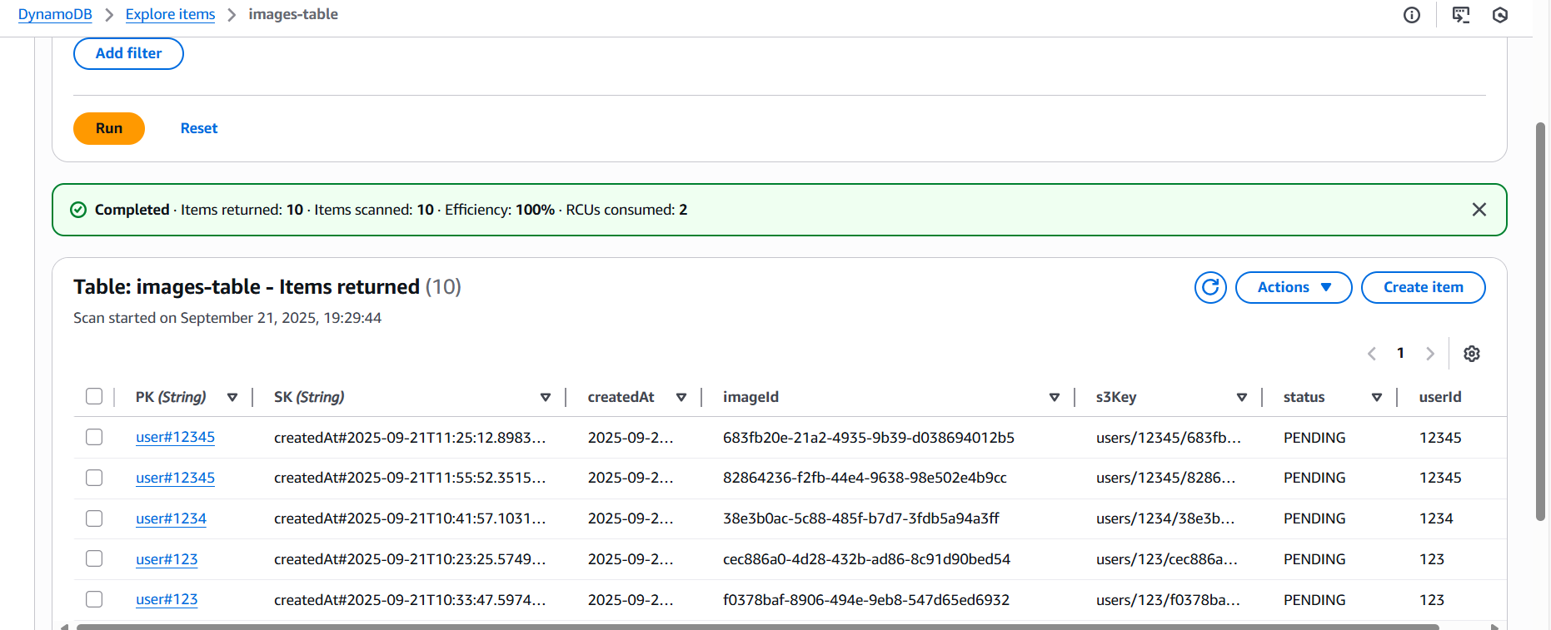

**List Images**

Invoke URL- https://{api_id}.execute-api.{region}.amazonaws.com/{stage_name}/images? UserID=<user_id>

Method – GET

PathParams – UserID=<user_id>

Response – Meta Data Images

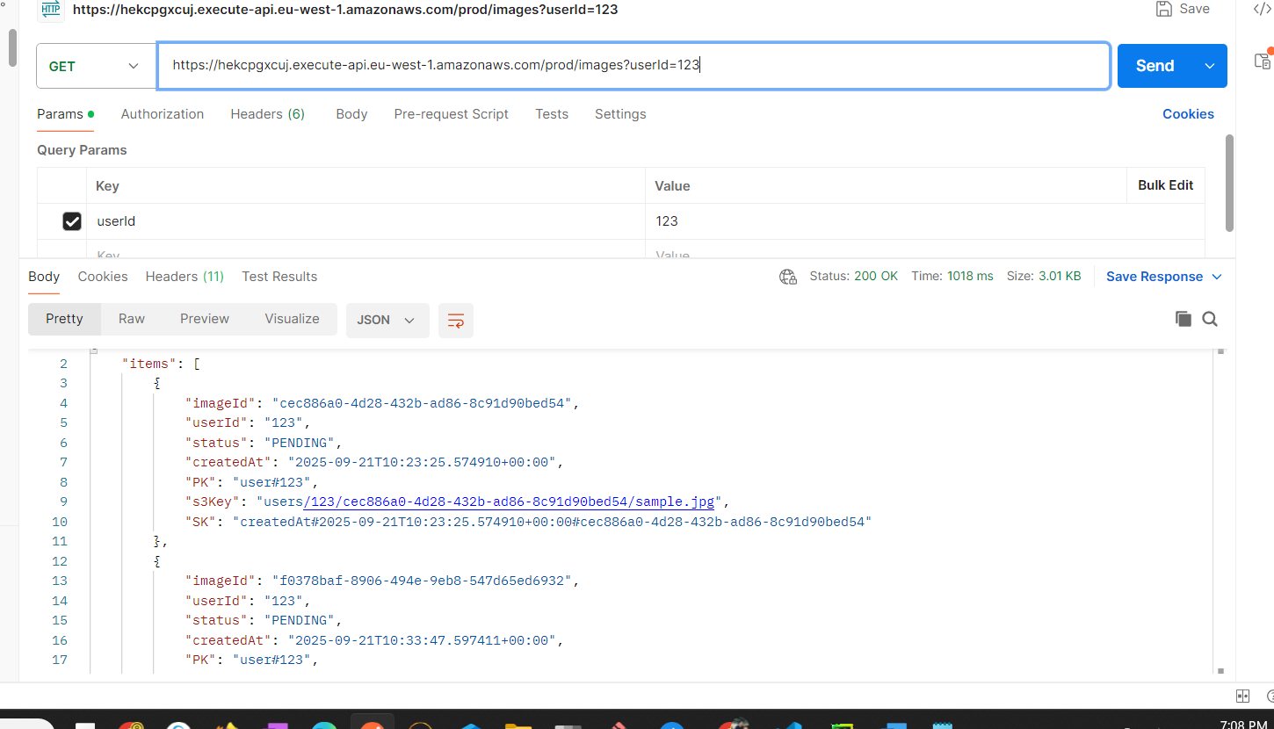

**Download or Get Image:**

Involve URL - https://<api_id>.execute-api.eu-west-1.amazonaws.com/prod/images/<ImageId>/

Method – Get

Path Parm - ImageId

Response – Presigned URL and Meta Data

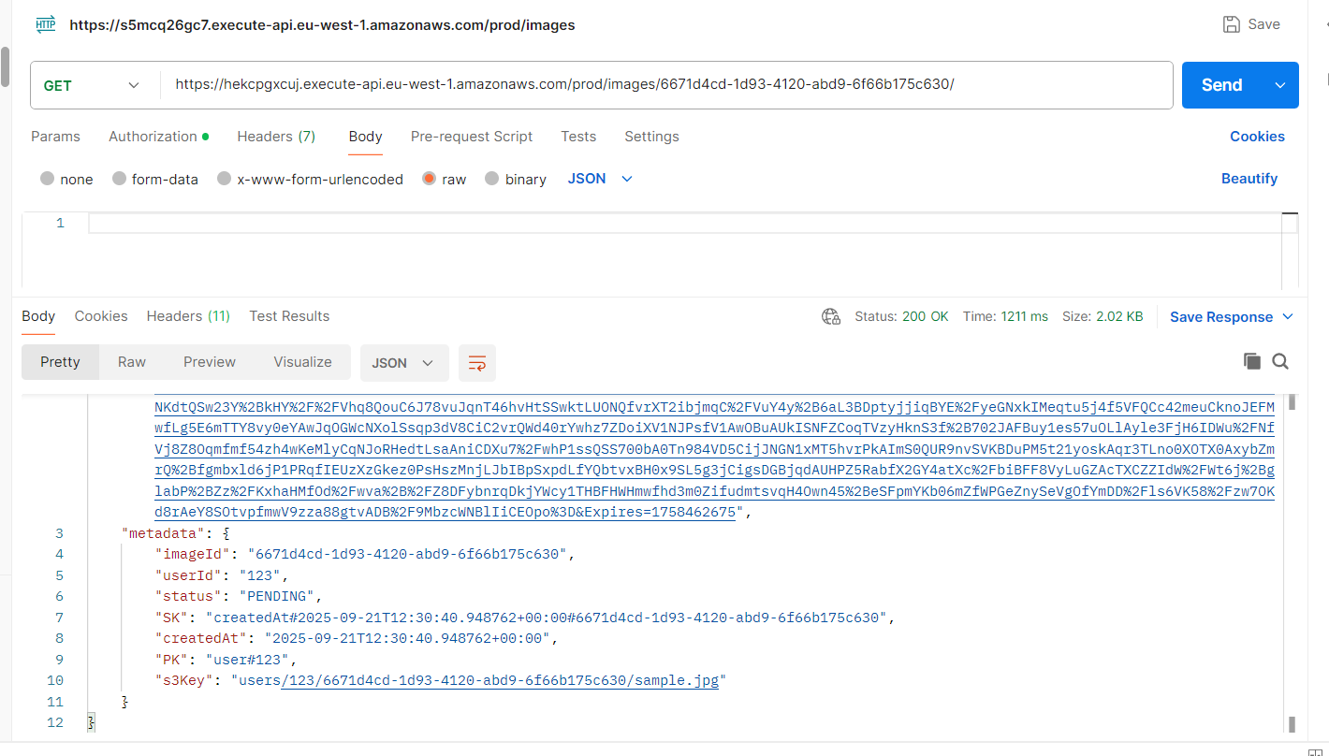

**Delete Image**

Involve URL - https://<api_id>.execute-api.eu-west-1.amazonaws.com/prod/images/<ImageId>/

Method – DELETE

Path Parm - ImageId

Response – Success / Failure Message

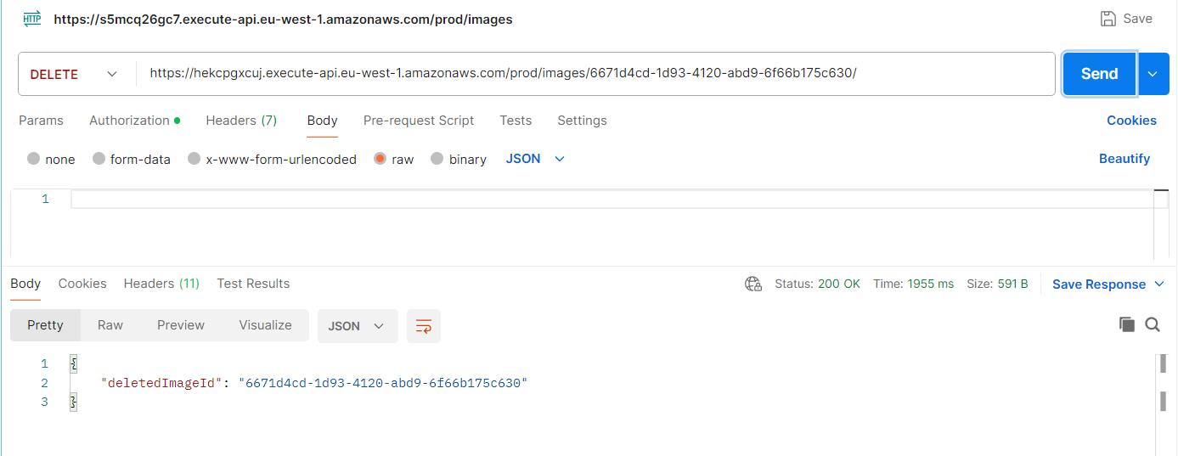

Before Delete

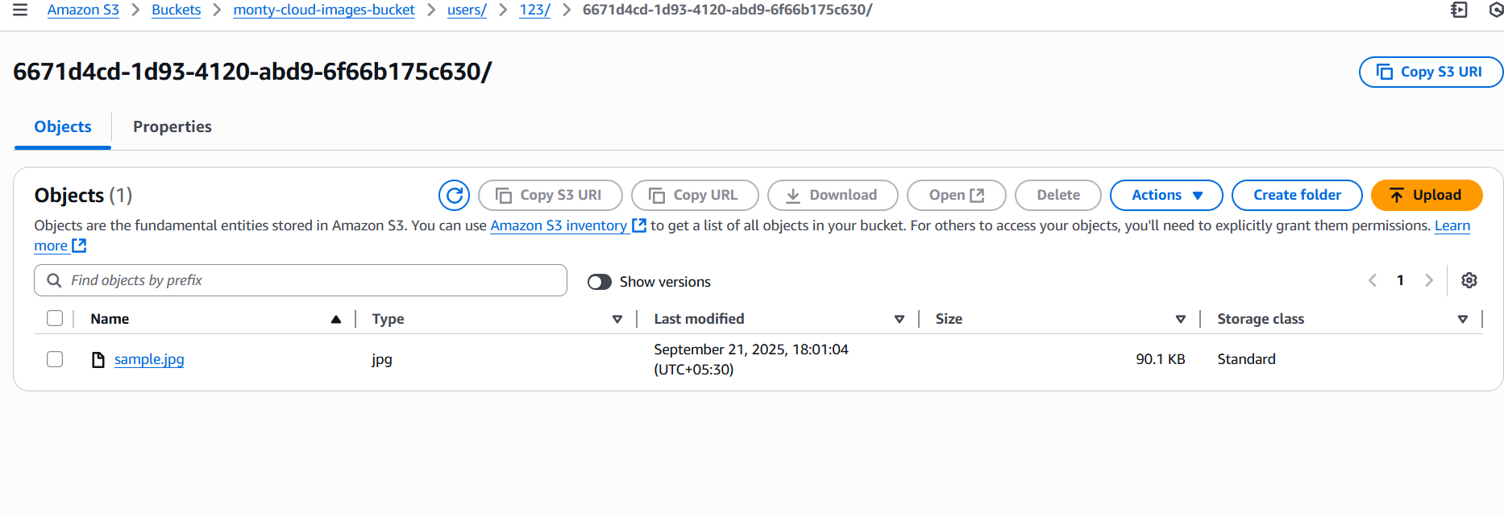

After Delete

