**Github Account Creation**

**Step-1** Create a GitHub account using the given link and then click on Sign up.

<https://github.com/>



**Step-2** Enter your details and then click on continue.

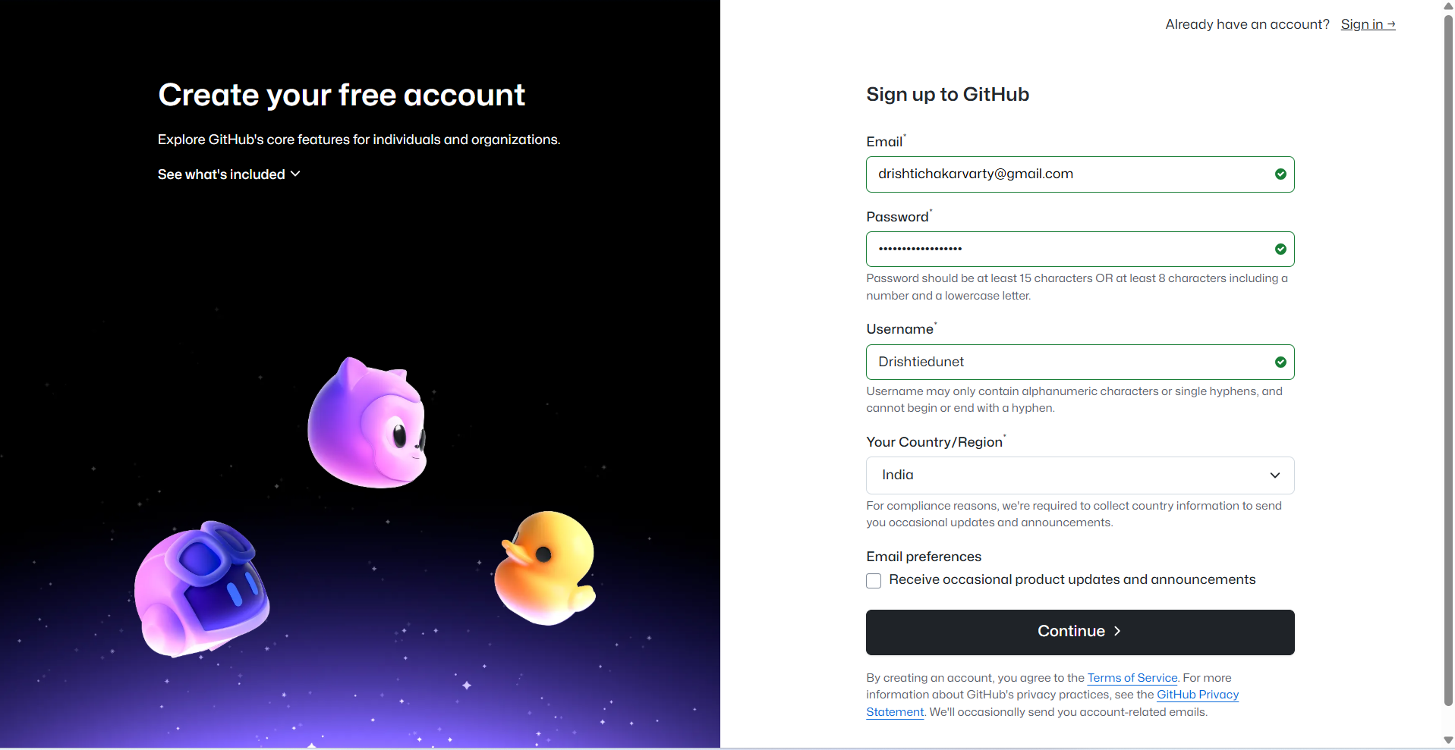

**Step-3** Now you have to enter the code received on your email id.

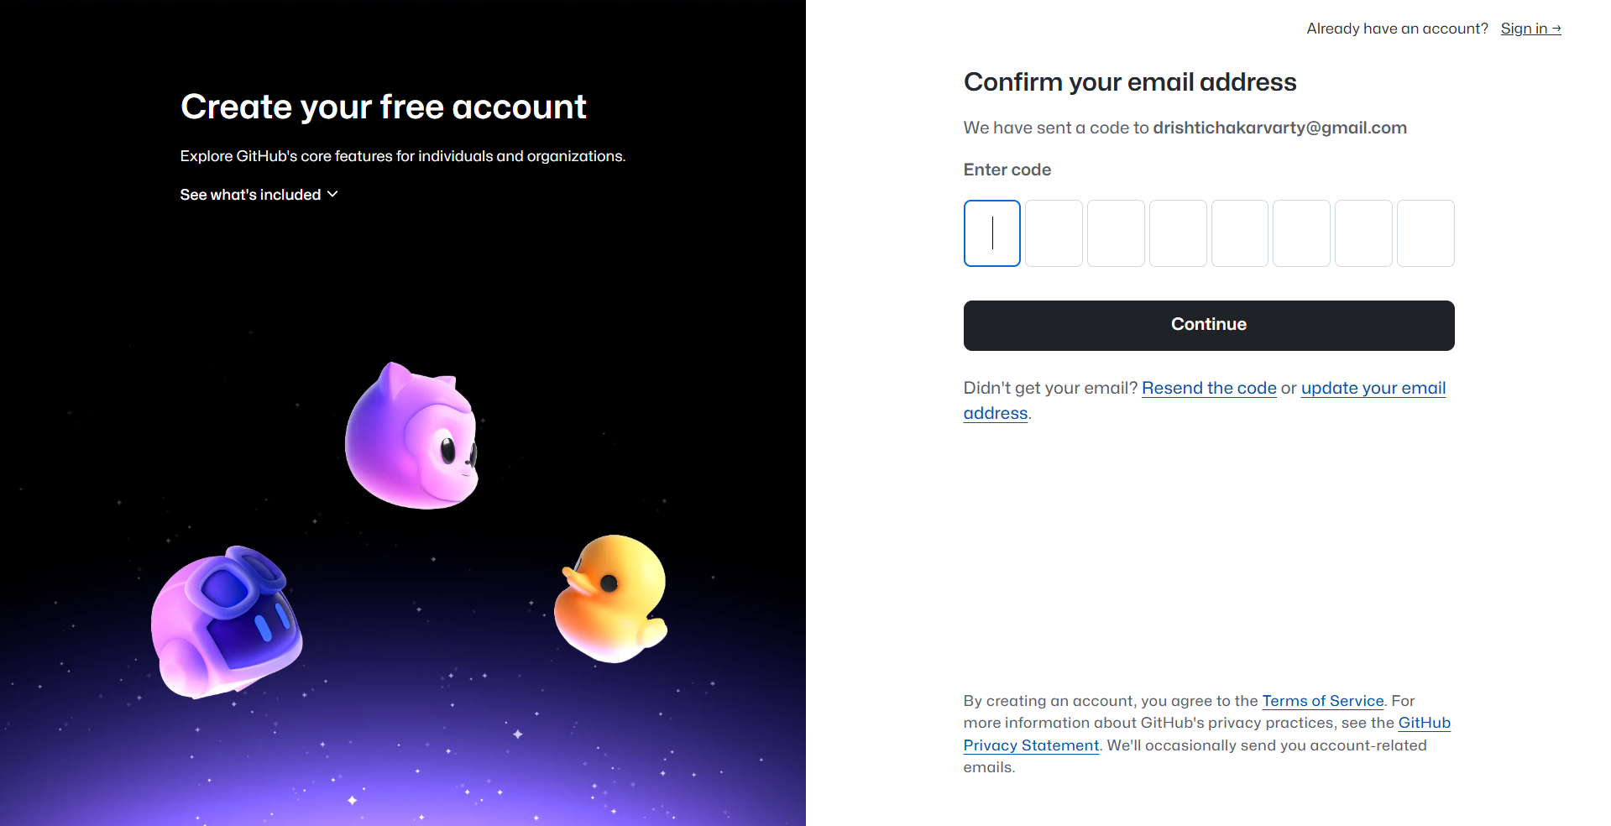

**Step-4** Now you will be redirected to the Sign in page.

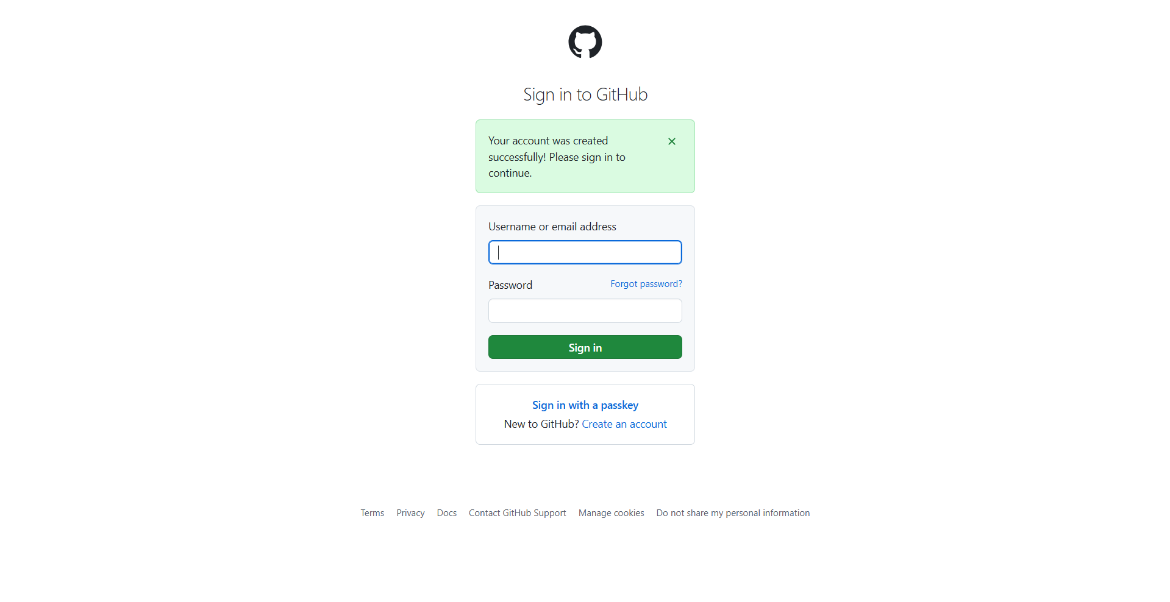

**Step-5** Enter your details and then click on Sign in.

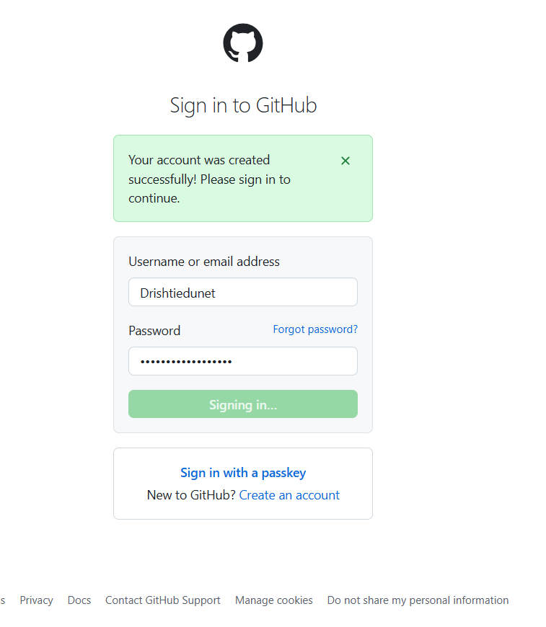

**Step-6** You will be redirected to the GitHub home page.

