Vinay Sagar Gonabavi

# Table of Contents

1. UI Flow…………………………………………………………………………………..03
2. UI Screens………………………………………………………………………………..05
   1. Welcome Screens…………………………………………………………………….05
   2. Selection Screen ……………………………………………………………………..07
   3. Preamble……………………………………………………………………………..08
   4. Question Page1………………………………………………………………………09
   5. Question Page2……………………………………………………………………….10
   6. Results Page………………………………………………………………………….11
   7. Performance Graph…………………………………………………………..………12

# UI Flow

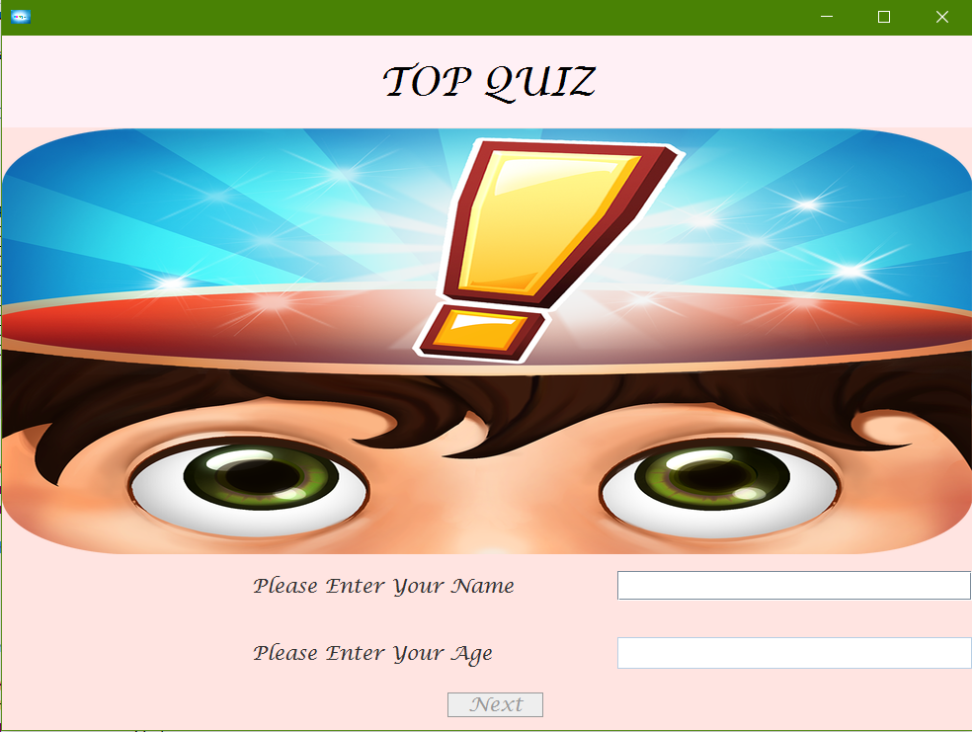

Click NEXT

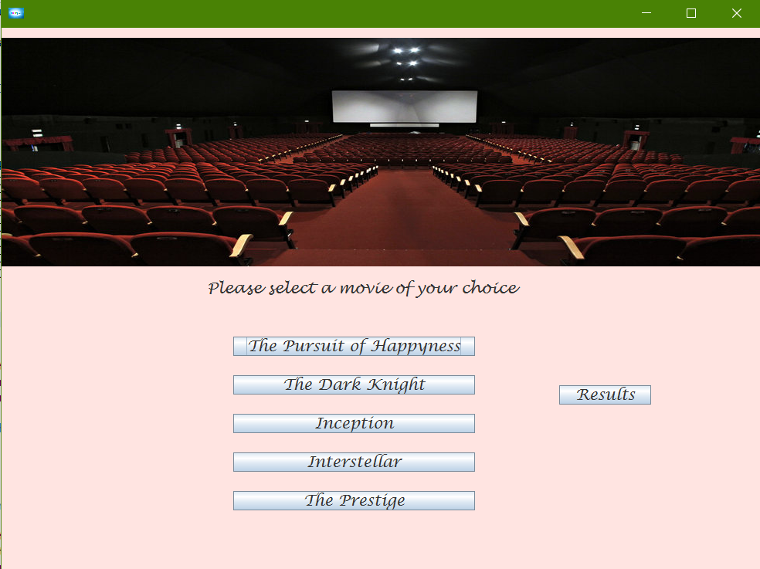 Click Results 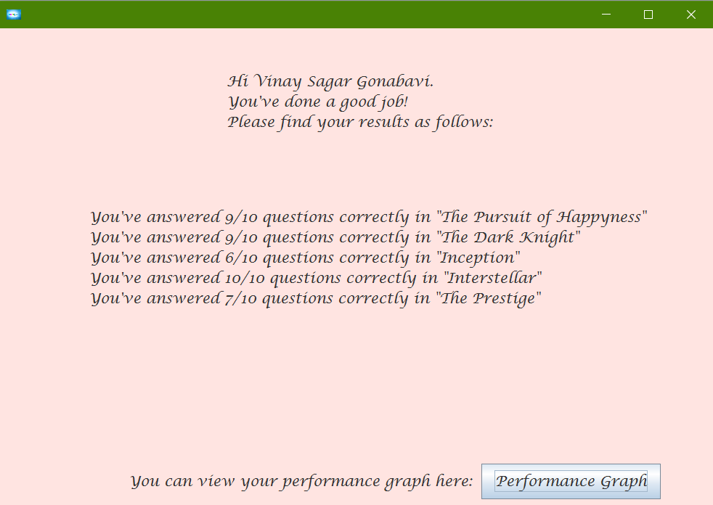

Next Category

Click Categories

Click Graph

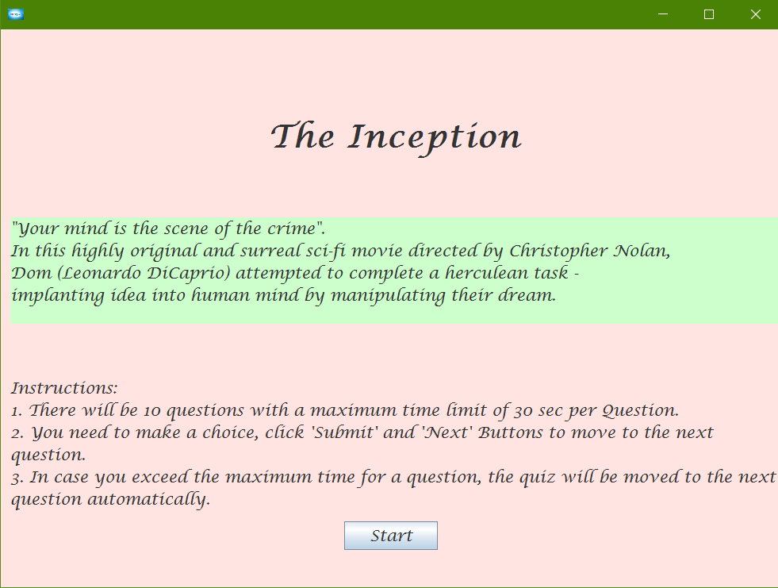 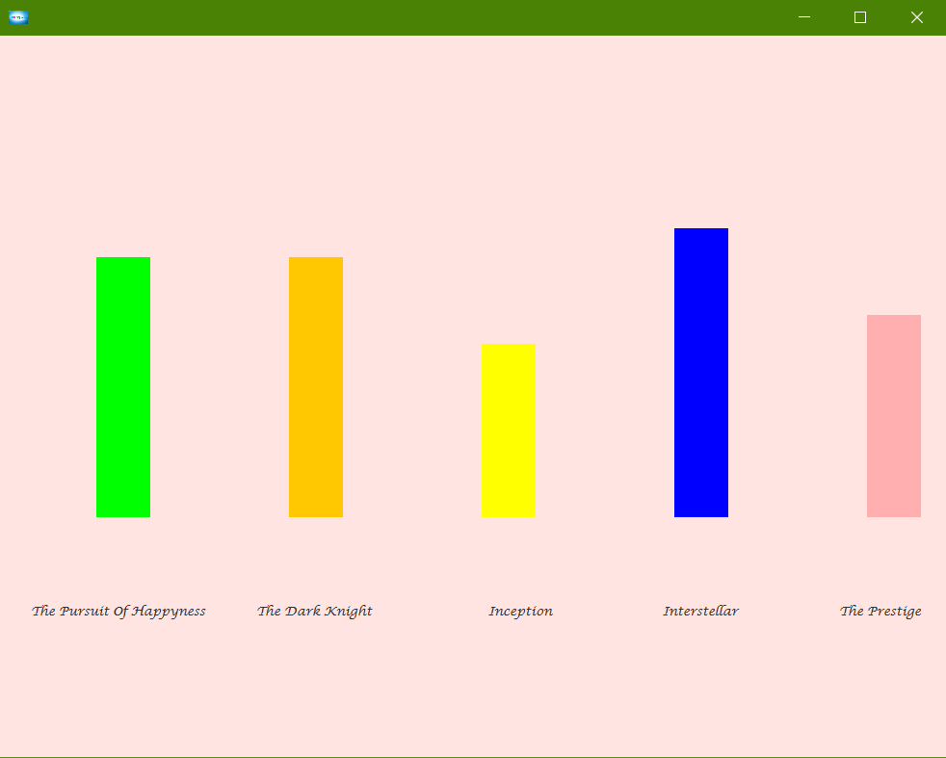

Click Start

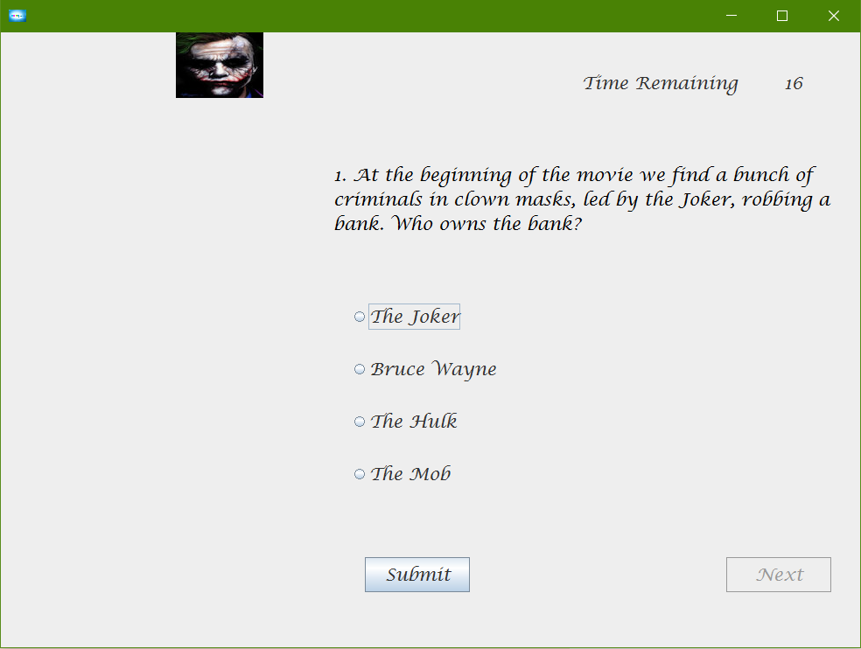 Click Next

# UI Screens

Welcome Screen



The field Name should be entered for the next fields to be enabled.

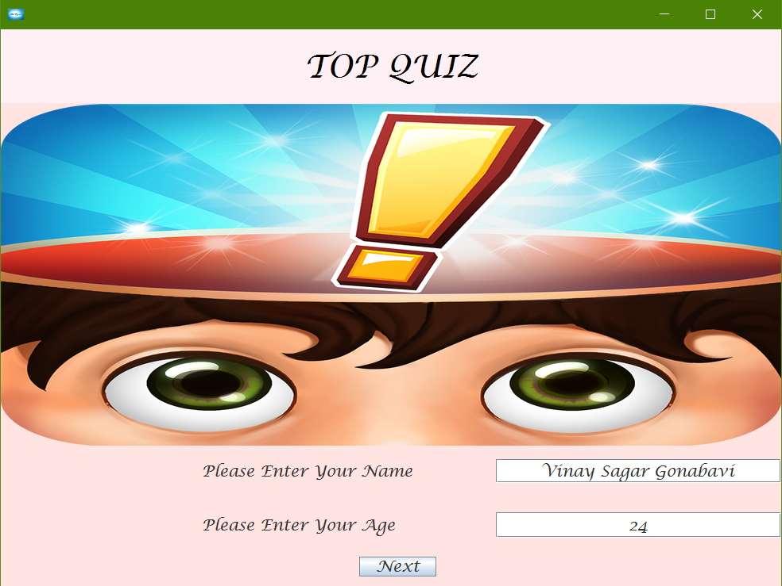

The Age should be entered for the ‘Next’ to be enabled

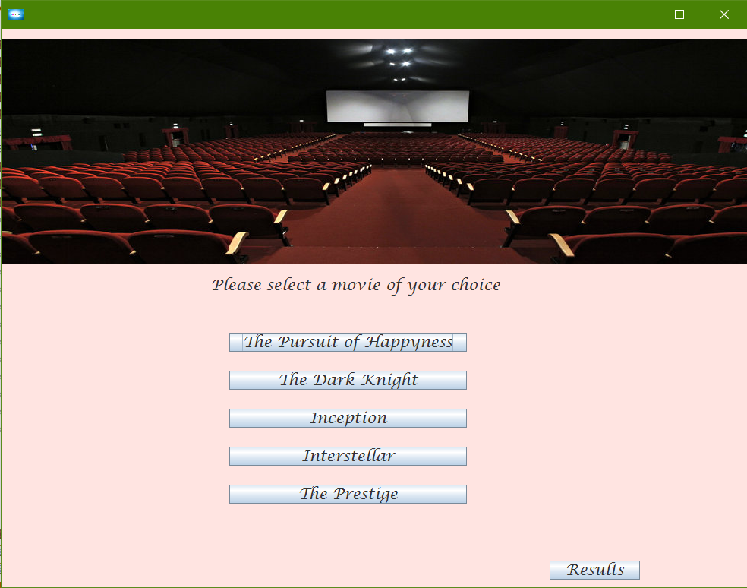

Any category can be chosen by the user and the results can be viewed after attempting any number of categories.



A Preamble page is created before each category test with a brief introduction to the category and the Instructions to be followed.

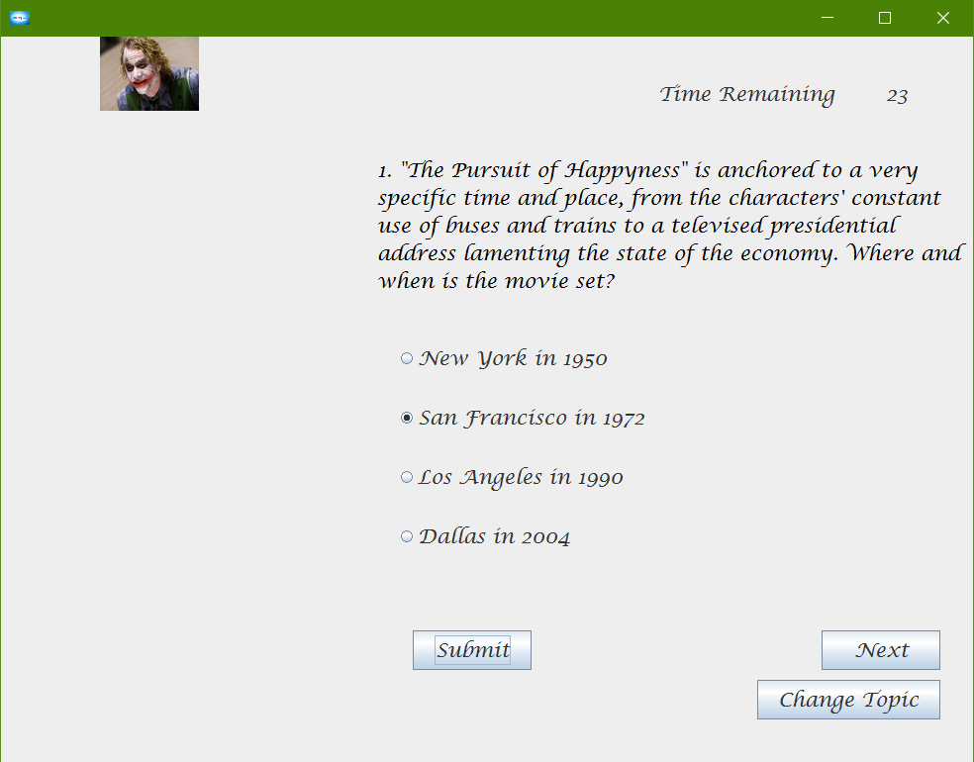

Each Question has four multiple choice options with only one at a time enable option. A choice can be made and submit has to be entered for the next button to be enabled. You can change the topic at any question of the test.

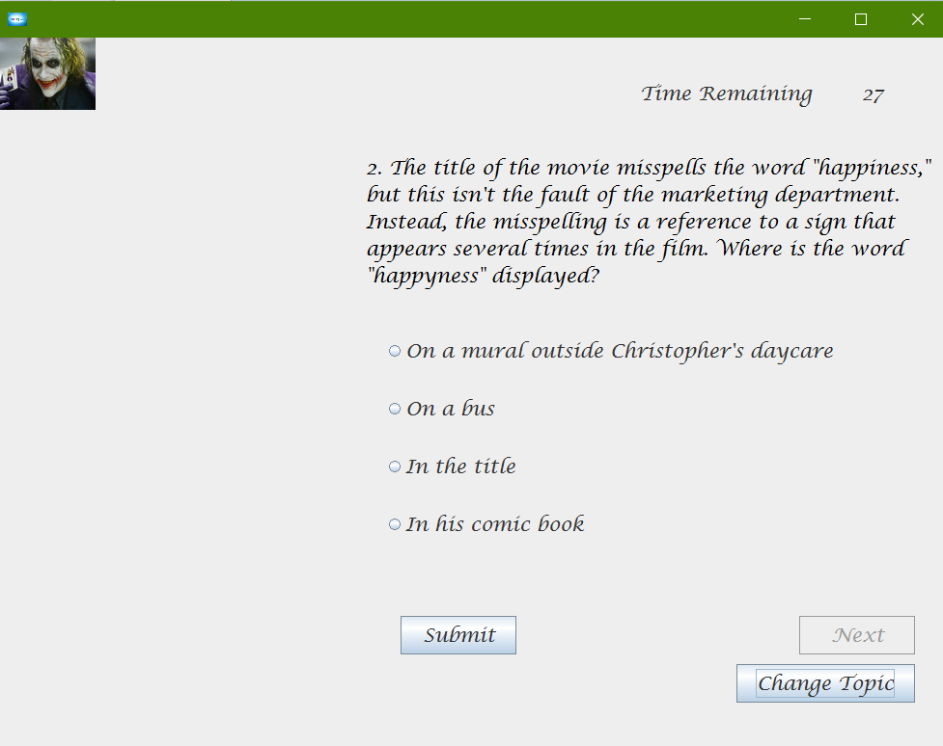

The animation changes with images of ‘The Joker’ having his expressions changed from happy to sad.



The Results button from the Category Selection Page navigates us to the Text Results Page.

Here the number of correct answered questions in each category is displayed with an option provided to view the Performance Graph.

# 



A bar graph with corresponding Category labels displays the performance in respective categories.