**PIZZA SALES SQL QUERIES**

CREATE DATABASE Pizza;

USE Pizza;

CREATE TABLE Sales (

pizza_id INT,

order_id INT,

pizza_name_id VARCHAR(50),

quantity TINYINT,

order_date DATE,

order_time TIME,

unit_price FLOAT,

total_price FLOAT,

pizza_size VARCHAR(50),

pizza_category VARCHAR(50),

pizza_ingredients VARCHAR(200),

pizza_name VARCHAR(50)

);

INSERT INTO Sales

(pizza_id, order_id, pizza_name_id, quantity, order_date, order_time, unit_price, total_price, pizza_size, pizza_category, pizza_ingredients, pizza_name)

VALUES (1, 1, 'hawaiian_m', 1, '2015-01-01', '11:38:36', 13.25, 13.25, 'M', 'Classic', 'Sliced Ham, Pineapple, Mozzarella Cheese', 'The Hawaiian Pizza');

**1). Total Revenue**: Summing the total price from all sales.

SELECT SUM(total_price) AS Total_Revenue FROM pizza.sales;

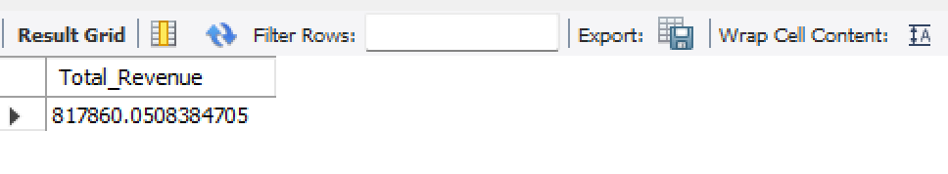

2). **Average Order Value**: Divides the total revenue by the number of distinct orders.

SELECT SUM(total_price) / COUNT(DISTINCT order_id) AS Average_Order_Value FROM pizza.sales;

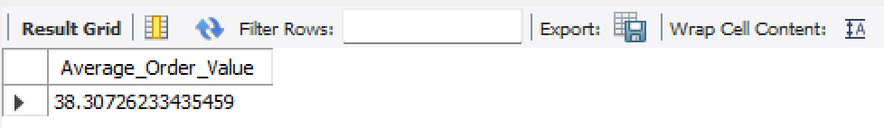

3). **Total Pizza Sold**: Sums up the total quantity of pizzas sold.

SELECT SUM(quantity) AS Total_Pizza_Sold FROM pizza.sales;

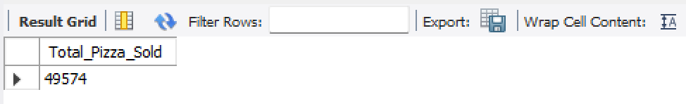

4). **Total Orders**: Counts the distinct number of orders.

SELECT COUNT(DISTINCT order_id) AS Total_Orders FROM pizza.sales;

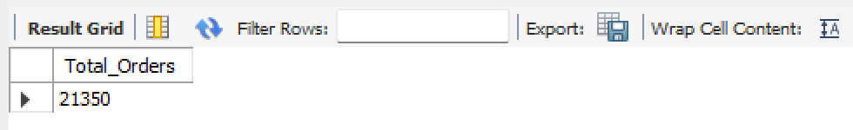

5). **Average Pizza Per Order**: Calculates the average number of pizzas per order.

SELECT SUM(quantity) / COUNT(DISTINCT order_id) AS Avg_Pizza_Per_Order FROM pizza.sales;

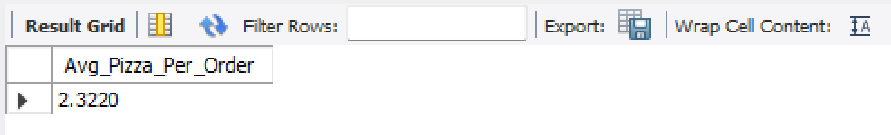

6). **Daily Trend for Total Orders**: Groups the total orders by day of the week.

SELECT DAYNAME(order_date) AS Order_Day, COUNT(DISTINCT order_id) AS Total_orders FROM pizza.sales GROUP BY DAYNAME(order_date);

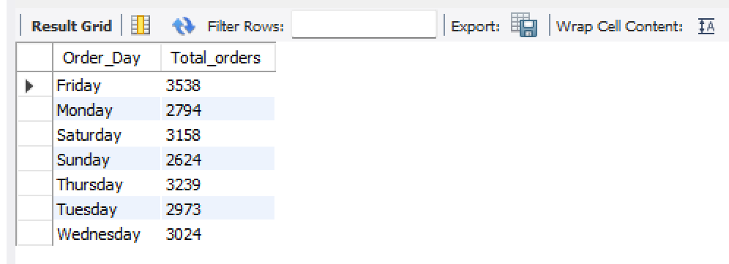

7). **Monthly Trend for Total Orders**: Groups the total orders by month, ordered by the total number of orders.

SELECT MONTHNAME(order_date) AS Month_Name, COUNT(DISTINCT order_id) AS Total_Orders

FROM pizza.sales

GROUP BY MONTHNAME(order_date)

ORDER BY Total_Orders DESC;

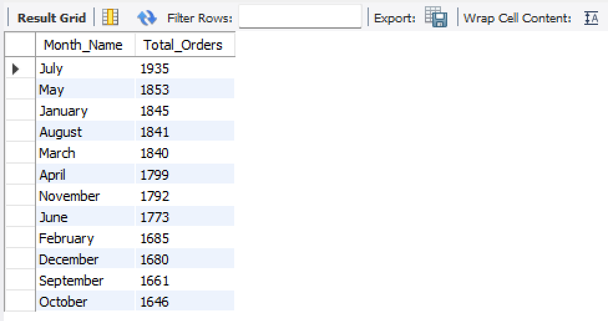

8). **Percentage of Sales by Pizza Category**: Computes the percentage of sales for each pizza category in January.

SELECT

Pizza_Category,

SUM(total_price) AS Total_Sales,

SUM(total_price) * 100 / (SELECT SUM(total_price) FROM pizza.sales WHERE MONTH(order_date) = 1) AS PCT

FROM

pizza.sales

WHERE

MONTH(order_date) = 1

GROUP BY

Pizza_Category;

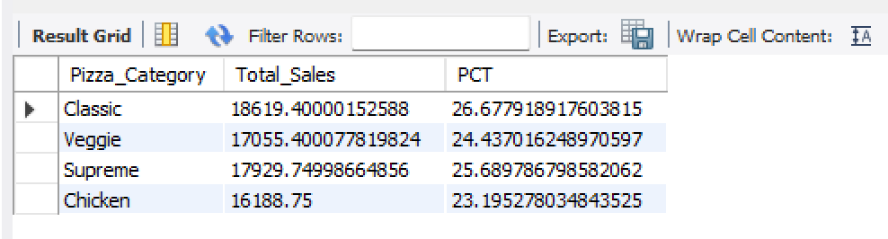

9). **Percentage of Sales by Pizza Size**: Calculates the percentage of sales by pizza size.

SELECT

Pizza_Size,

SUM(total_price) AS Total_Sales,

SUM(total_price) * 100 / (SELECT SUM(total_price) FROM pizza.sales) AS PCT

FROM

pizza.sales

GROUP BY

Pizza_Size

ORDER BY

PCT DESC;

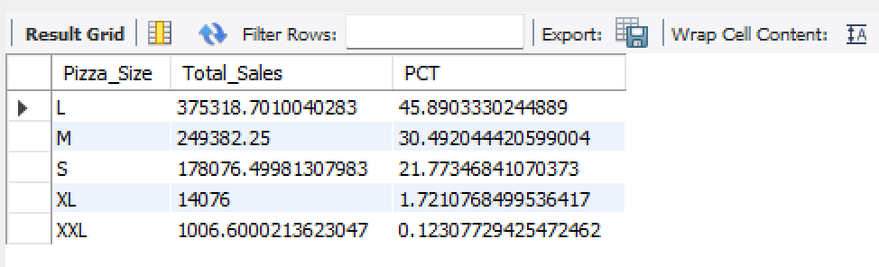

10). **Top 5 Pizzas by Revenue**: Lists the top 5 pizzas generating the highest revenue.

SELECT

pizza_name,

SUM(total_price) AS Total_Revenue

FROM

pizza.sales

GROUP BY

Pizza_Name

ORDER BY

Total_Revenue DESC

LIMIT 5;

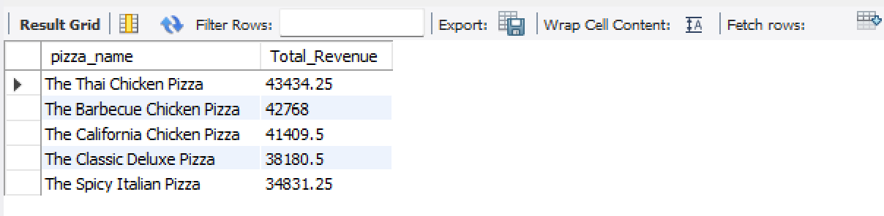

11). **Bottom 5 Pizzas by Revenue**: Lists the 5 pizzas generating the lowest revenue.

SELECT

pizza_name,

SUM(total_price) AS Total_Revenue

FROM

pizza.sales

GROUP BY

Pizza_Name

ORDER BY

Total_Revenue ASC

LIMIT 5;

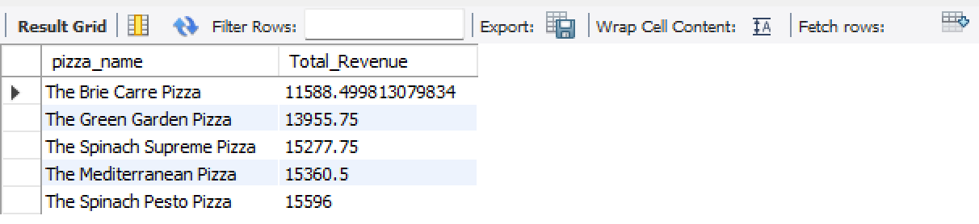

12). **Top 5 Pizzas by Quantity**: Lists the top 5 pizzas sold in terms of quantity.

SELECT

pizza_name,

SUM(quantity) AS Total_Quantity

FROM

pizza.sales

GROUP BY

Pizza_Name

ORDER BY

Total_Quantity DESC

LIMIT 5;

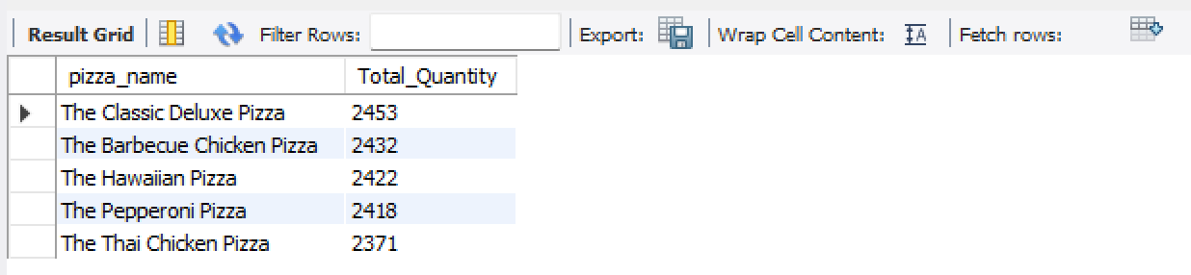

13). **Bottom 5 Pizzas by Quantity**: Lists the 5 pizzas sold in the lowest quantity.

SELECT

pizza_name,

SUM(quantity) AS Total_Quantity

FROM

pizza.sales

GROUP BY

Pizza_Name

ORDER BY

Total_Quantity ASC

LIMIT 5;

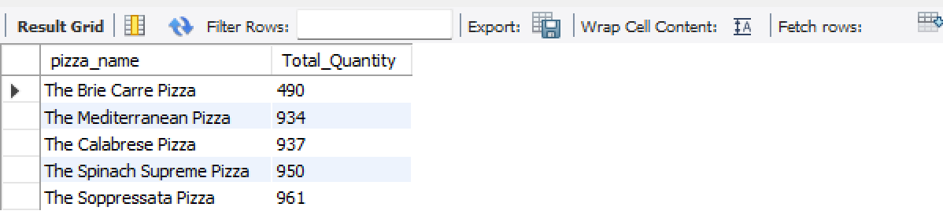

14). **Top 5 Pizzas by Orders**: Lists the top 5 pizzas with the most distinct orders.

SELECT

pizza_name,

COUNT(DISTINCT order_id) AS Total_Orders

FROM

pizza.sales

GROUP BY

Pizza_Name

ORDER BY

Total_Orders DESC

LIMIT 5;

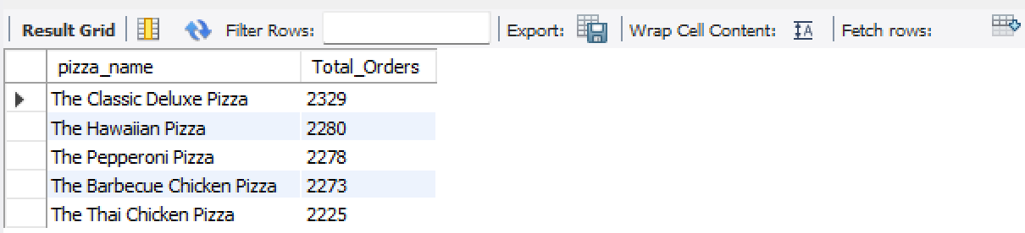

15). **Bottom 5 Pizzas by Orders**: Lists the 5 pizzas with the fewest distinct orders.

SELECT

pizza_name,

COUNT(DISTINCT order_id) AS Total_Orders

FROM

pizza.sales

GROUP BY

Pizza_Name

ORDER BY

Total_Orders ASC

LIMIT 5;

